SDM Module End Exam

Name : Gajendrakumar Munjajirao Bhokre

PRN:230345920031

1. login into Github account

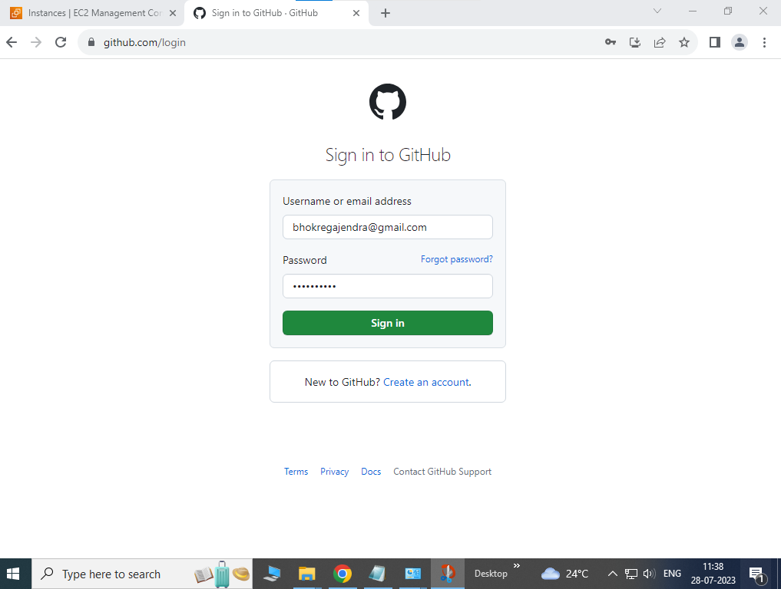

1. Create public Git Repository – “Fabrikam”

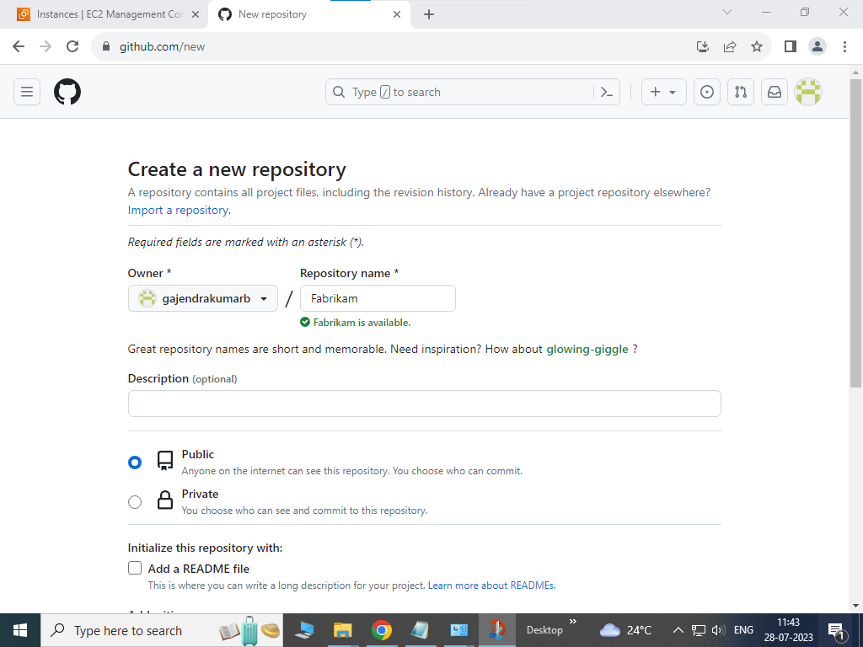

1. Clone Fabrikam Git Repo on Developer Machine

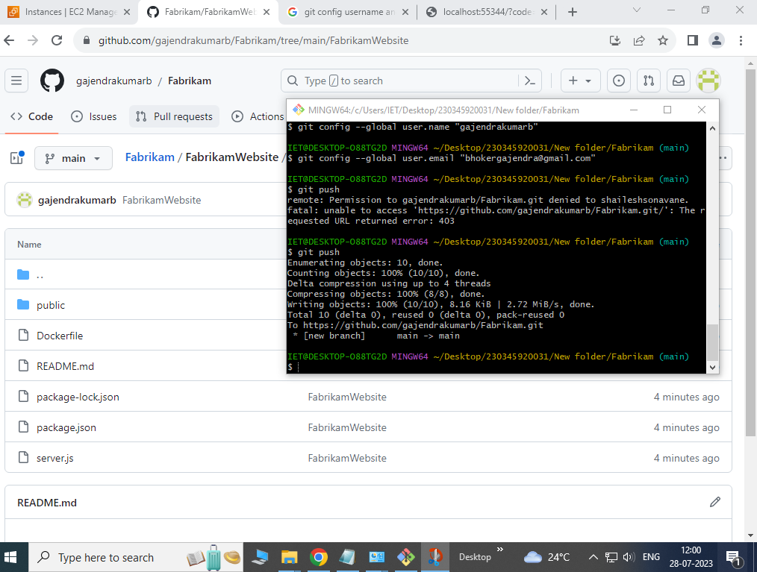

1. Upload Dockerfile, package.json and Server.js from local rep to github Fabrikam repository.



1. Create Amazon linux virtual Server

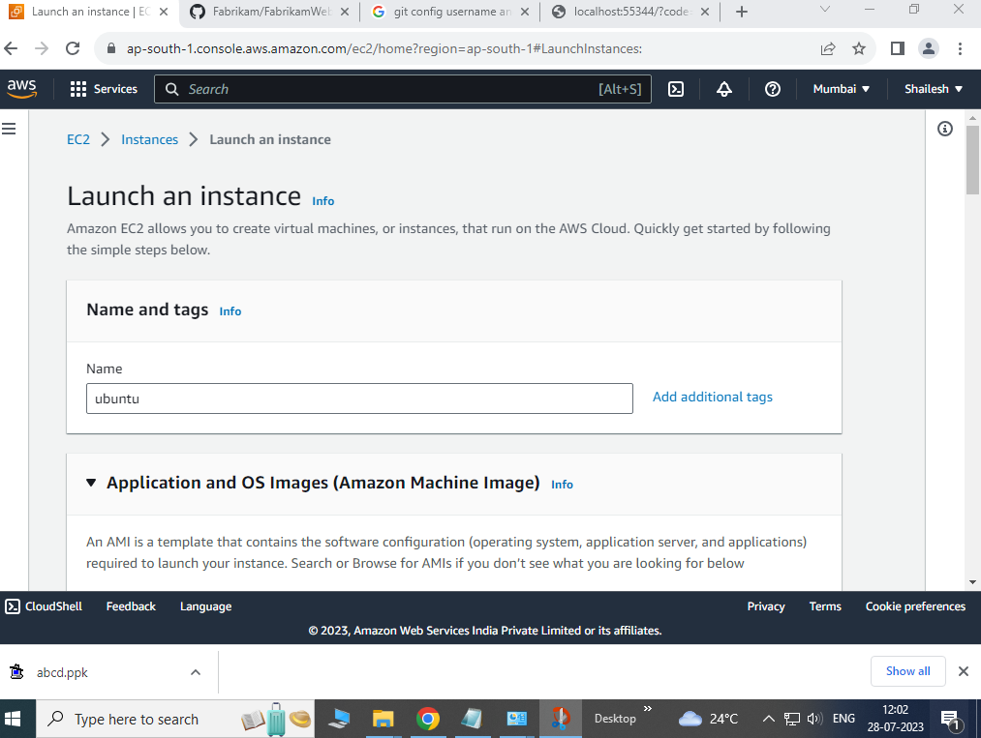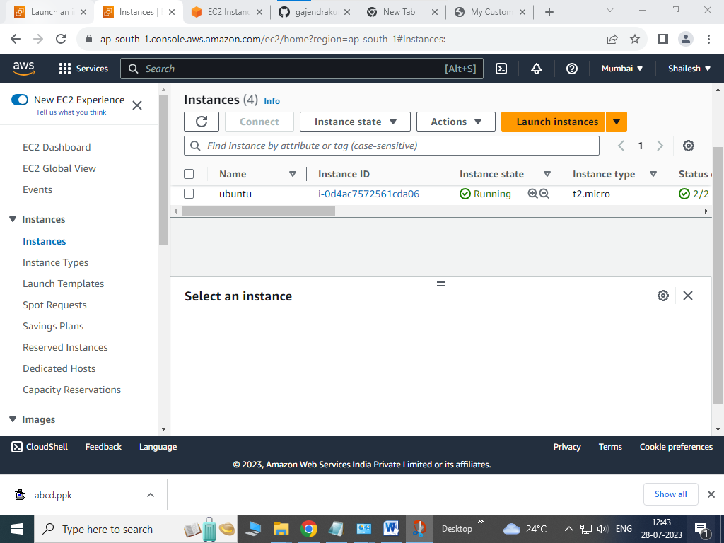

1. Access AWS virtual Server.

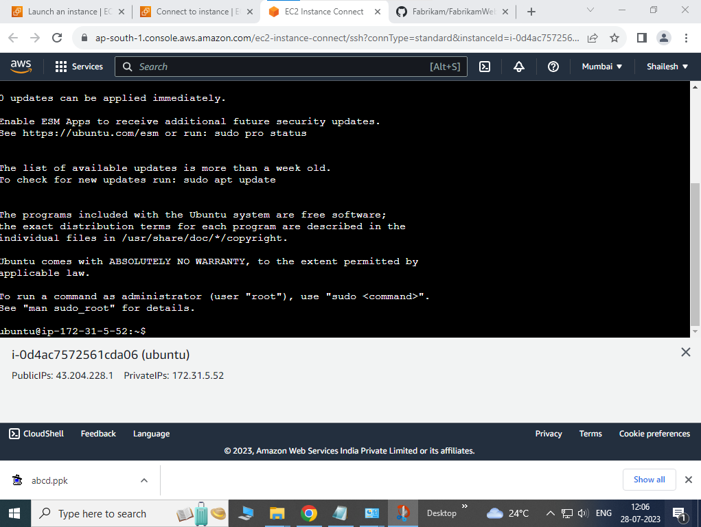

1. Update Linux shall with latest patch

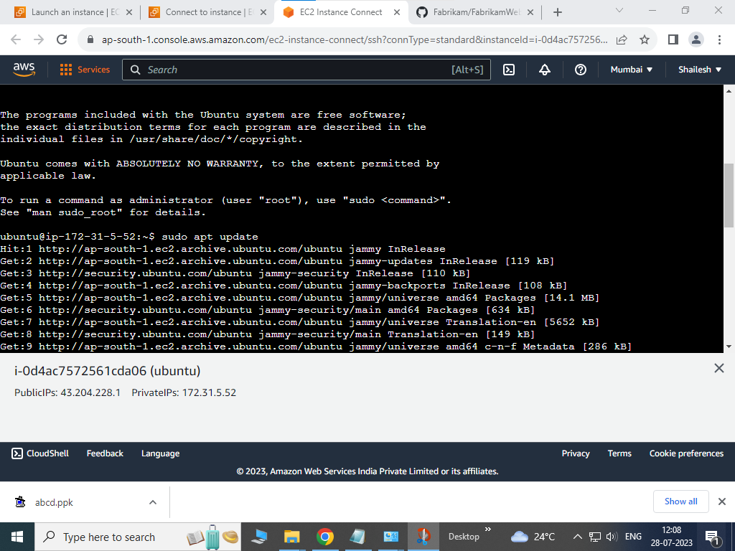

1. Install git client : sudo get-apt install git

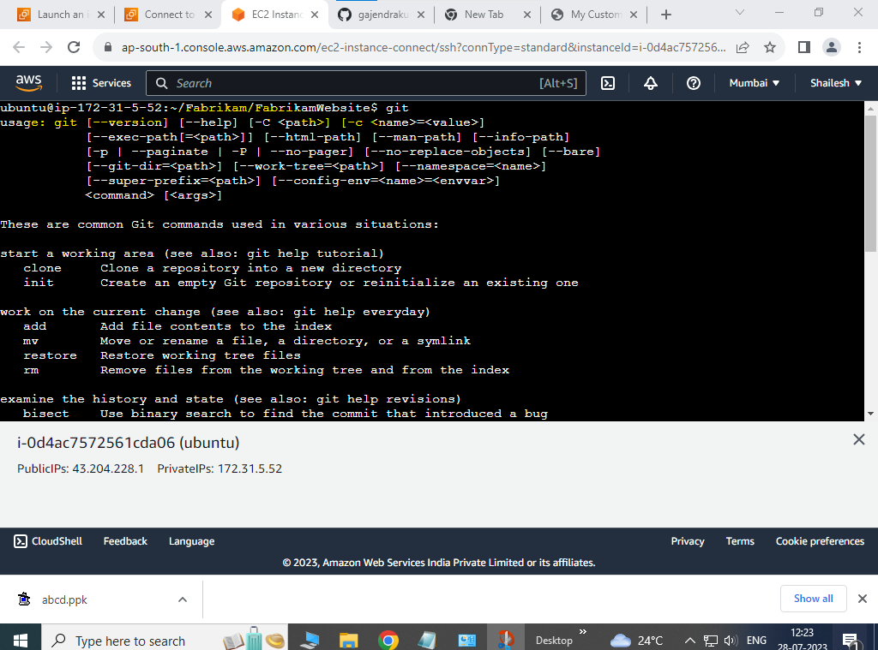

1. Clone Fabrikam git repo on virtual server

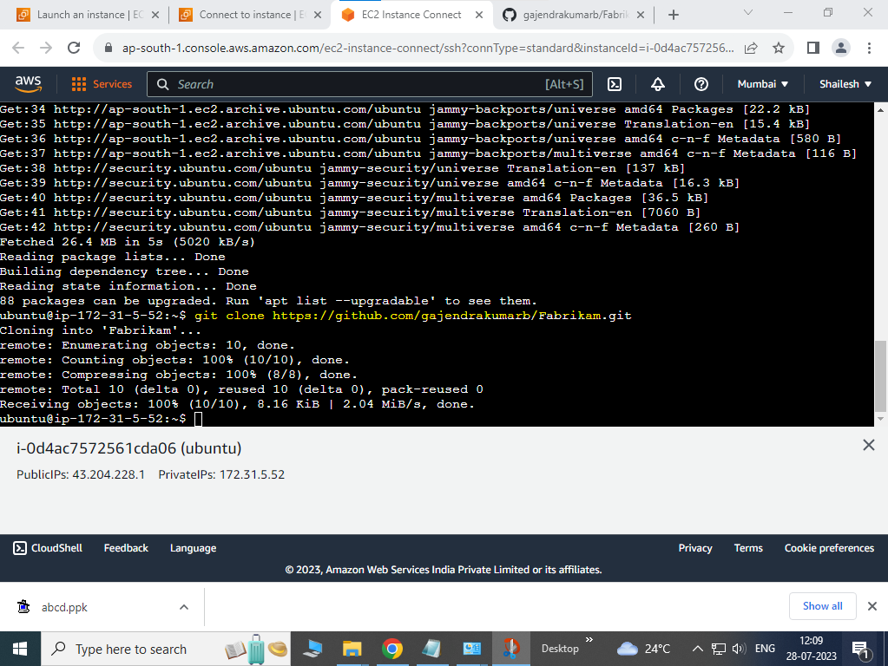

1. Install Docker on Virtual server

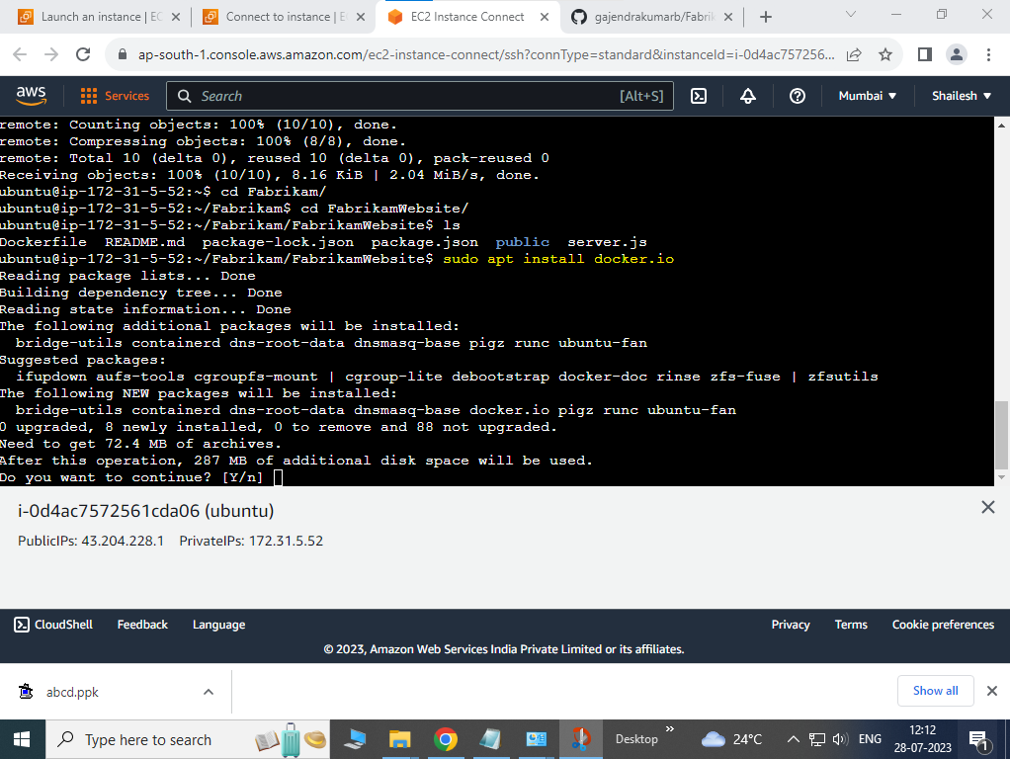

1. Show Docker status Running

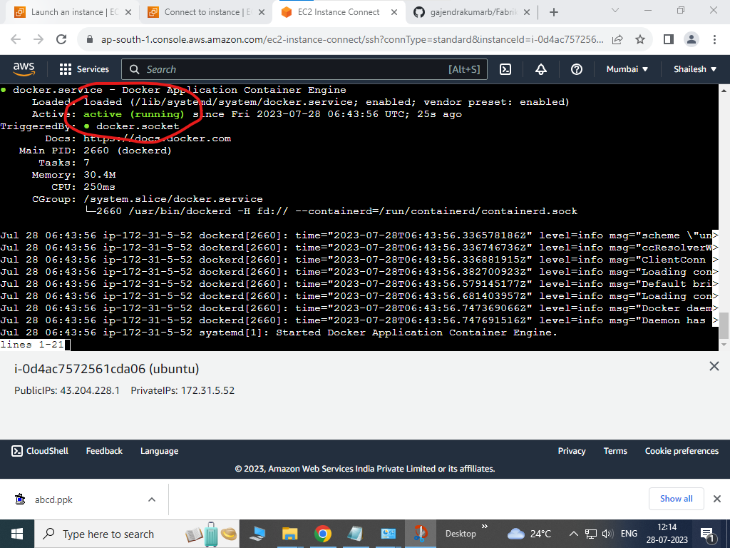

1. Build Docker image for Fabrikam application

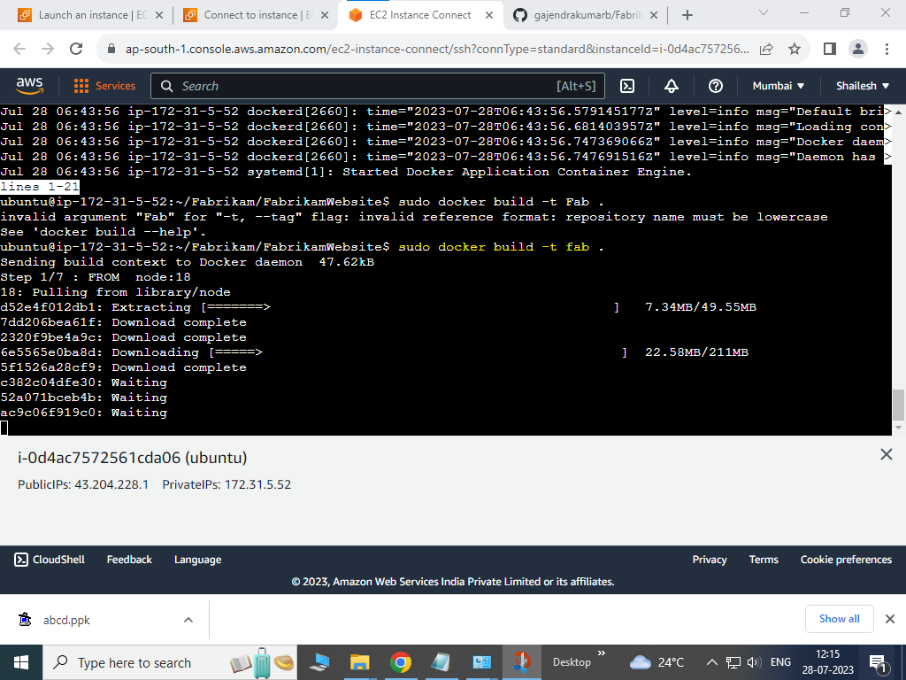

1. Ensure Docker Container image are downloaded to virtual server

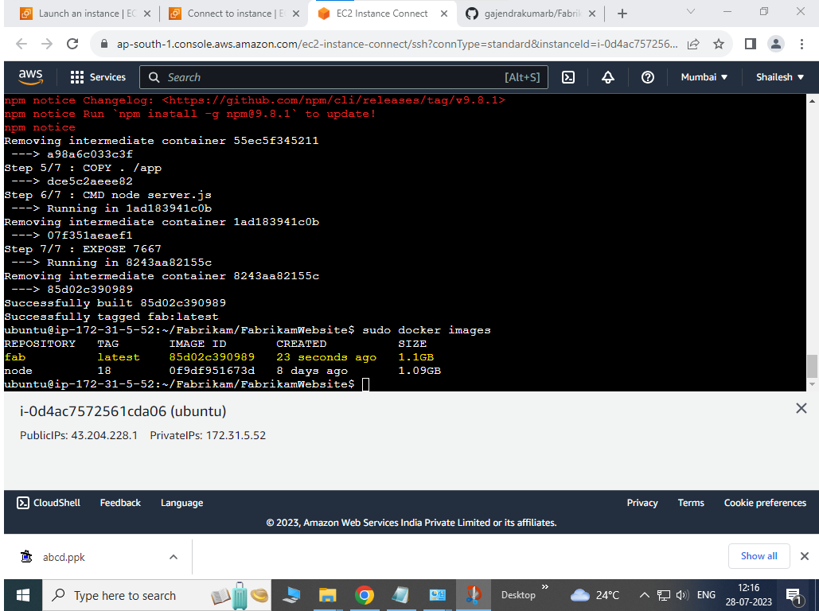

1. Run Docker Container instance on virtual server

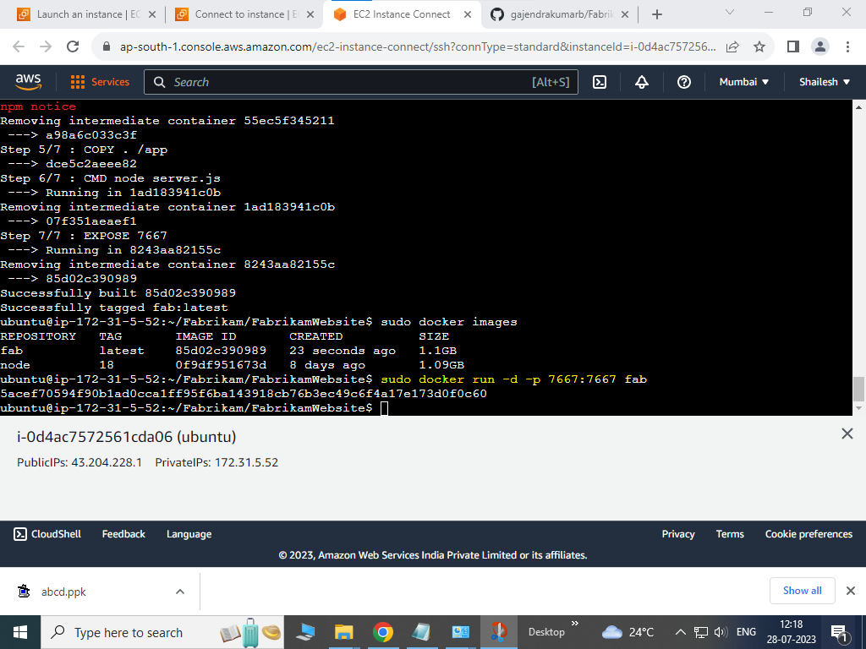

1. List Down container instances running on virtual server

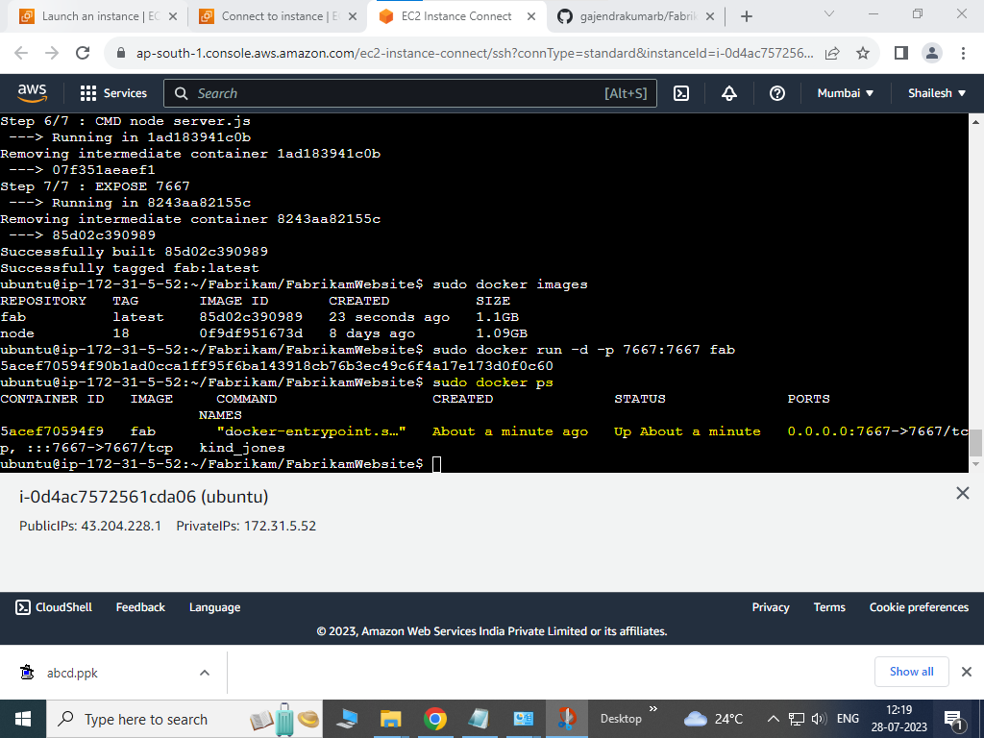

1. Allow all traffic to be accepted by setting inbound rules

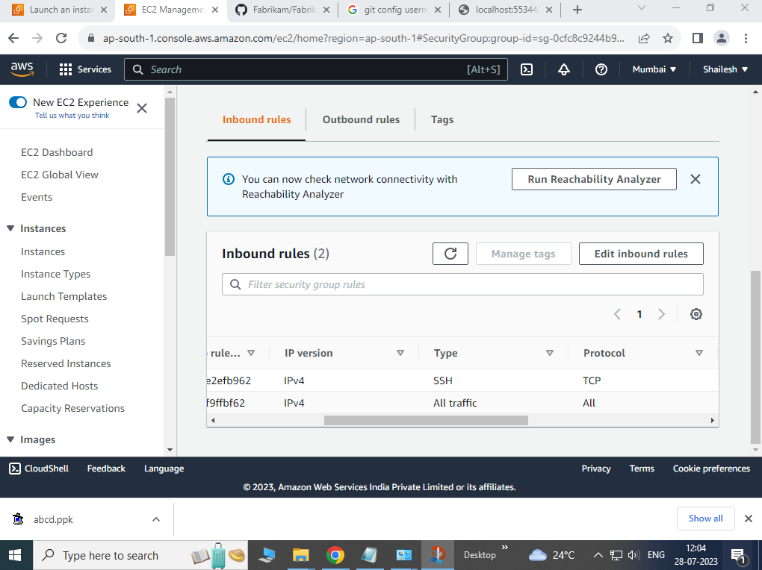

1. Access hosted website

