**Project Documentation**

# Project Title

* **Project Title:** FitFlex – Your Personal Fitness Companion

* **Team ID:**NM2025TMID47807

* **Team Leader:** Gajendran K [kandhasamygajendhiran@gmail.com]

* **Team Members:**

○ Dhanush N [dk7838573@gmail.com]

○ Dhanush R [sivansivan809837@gmail.com]

○ Elamparithi G [elamparithiy@gmail.com]

# 1. Introduction

FitFlex is an innovative fitness web application designed to transform the way users discover and engage with workouts. From beginners to seasoned fitness enthusiasts, it provides structured exercise routines, advanced search features, and a seamless user interface to explore diverse fitness categories.

# 2. Project Overview

**Purpose:**

To provide an accessible, user-friendly platform where individuals can discover, explore, and manage workout routines tailored to their fitness goals.

**Features:**

Dynamic exercise discovery from APIs

* Advanced search (by keyword, body part, or equipment)

* Visual workout exploration with images and videos

* Category-based browsing of exercises

* Detailed exercise instructions with related YouTube videos

* Community-driven experience with options for sharing

# 3. Architecture

* **Frontend:** React.js with Bootstrap / Tailwind CSS for styling

* **Backend:** (Optional – if only frontend, this may be omitted)

* **API Integration:** RapidAPI ExerciseDB & YouTube API

* **Database:** (Not applicable, since fitness data is fetched via APIs)

# 4. Setup Instructions

**Prerequisites:**

* Node.js & npm

* React.js

* Git

* Visual Studio Code

**Installation Steps:**

# Clone the repository

git clone [your project link]

# Navigate to project folder cd fitness-app-react

# Install dependencies npm install

# Start the development server npm start

**Access:** Visit [http://localhost:3000](http://localhost:3000/)

**5. Folder Structure** fitness-app-react/

│

├── src/

│ ├── components/ # Navbar, Hero, Search, Cards, Footer etc.

│ ├── pages/ # Home, Category, ExerciseDetails, About

│ ├── styles/ # CSS files

│ ├── App.js # Main application file

│ └── index.js # Entry point

│

├── public/ # Static assets

├── package.json # Dependencies & metadata └── README.md # Documentation

# 6. Running the Application

**Start frontend:**

npm start

●

**Access:** [http://localhost:3000](http://localhost:3000/)

# 7. API Documentation

* **Exercise Database (RapidAPI):**

* 1. /exercises/bodyPartList – Get body parts list

○ /exercises/equipmentList – Get equipment list

○ /exercises/equipment/{id} – Get exercises by equipment

○ /exercises/exercise/{id} – Get exercise details

* **YouTube API (RapidAPI):**

* 1. /search?query={exerciseName} – Fetch related workout videos

# 8. Authentication

* Not required (public data via APIs).

* Future enhancement: **User authentication** for saving workout routines.

# 9. User Interface

* **Hero Section:** Highlights trending workouts/challenges.

* **About Page:** Overview of FitFlex vision and goals.

* **Search Bar:** Enables quick search by keyword, body part, or equipment.

**Category Page:** Grid layout of exercise categories.

* **Exercise Page:** Detailed instructions, targeted muscles, difficulty, equipment, and YouTube demo videos.

# 10. Testing

* **Manual Testing:** Verified navigation, API responses, and UI responsiveness.

* **Tools:** Postman (API testing), Chrome Dev Tools (UI debugging).

# 11. Screenshots or Demo

* **Demo Video:**https://drive.google.com/file/d/1xbzVoqxeJRnvsh0FWv5D16EOANfwZ8U8/view?usp=sharing

* **Screenshots:** (Insert Hero, About, Search, Category, Exercise Page screenshots)

# 12. Known Issues

* API data loading delay due to external API response time.

* Limited offline support (requires active internet).

# 13. Future Enhancements

* User authentication & personalized dashboards

Progress tracking & workout history

* AI-powered workout recommendations

* Community forums and social sharing features

* Mobile app version (React Native)

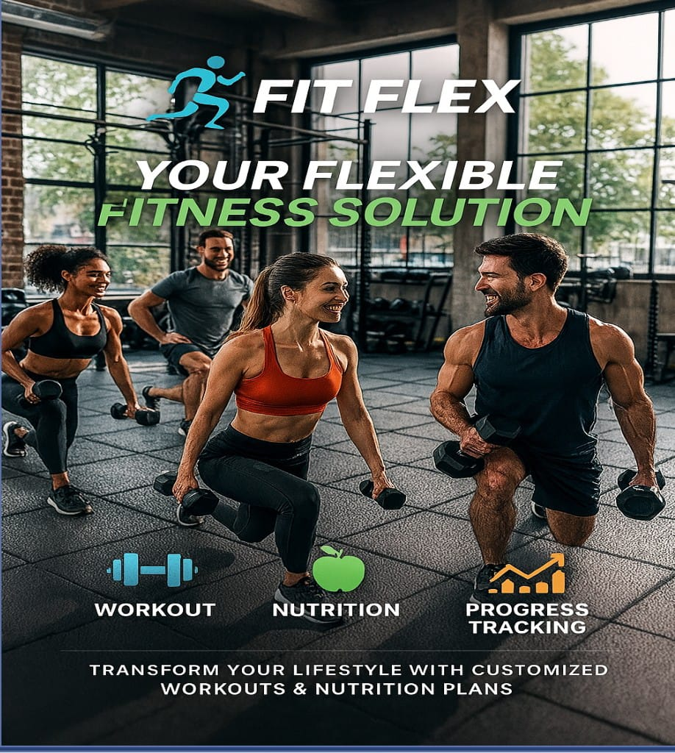

THANKS TO USING FOR MY APPLICATION