**A**

**Project Report**

**On**

**<<Chat Webapp>>**

**Submitted by**

**<<1st Gajera Harsh>>**

**(Enr.No. 196230316032, 5th Sem. I.T.)**

**<<2nd Malani Raj >>**

**(Enr.No.196230316060, 5th Sem. I.T.)**

**<<3rd Desai Harsh >>**

**(Enr.No.196230316025, 5th Sem. I.T.)**

**in partial fulfillment for the award of the degree**

***Of***

**DIPLOMA ENGINEERING**

***I***

**GOVERNMENT POLYTECHNIC, GANDHINAGAR**

**Information Technology Department**



CERTIFICATE

This is to certify that **Gajera Harsh** from Government Polytechnic, Gandhinagar having Enrollment No. **196230316032** has completed final project report having title **“Chat** **Webapp”** consulting individually or in a group under the guidance of the faculty named **Mr. Darshak Mehta,** during the term June-2021 to Oct-2021.

_______________________________

H.O.D.

**Ms. H. R. Patel**

_____________________________ Faculty Guide

**Mr. Darshak Mehta**

**Acknowledgement**

* The completion fo any project depend upon the co-operation,coordination,and Combined efforts of several resources of knowledge, inspiration and energy.
* Therefore we approach this important matter of project through these lines, trying our best to give credit where it deserves.
* I would first like to thank my project Guided Darshak Mehata
* I also like to specially thank my collage staff members for keeping our lab up-to-date and running and being willing to help and find solution to any problems.
* I also thank all our wonderful classmentes for those help

**Abstract**

* Chat Webapp is allows to user to chat with another usert or groups and communication each other
* Chat Webap is feture is create account and edit profile add contect and chat with each other and create group and chate with group
* This project is implemented with the Nodejs technology with mongodb Database backend support React,redux, is frontend support

**Index**

|  |  |  |
| --- | --- | --- |
| Sr no | Title | Sign. |
| 1 | Acknowledgement |  |
| 2 | Abstract |  |
| 3 | Introduction |  |
| 4 | Scope |  |
| 5 | Definition |  |
| 6 | Requirement Specification  - System Requirement  - User Requirement  - Function-Requirement  - Non-Function Requirement |  |
| 7 | Feasibility Study  - Schedule Feasibility  - Economic Feasibility  - Technical Feasibility |  |
| 8 | Process Model |  |
| 9 | Timeline chart |  |
| 10 | Use-case diagram |  |
| 11 | Context diagram |  |
| 12 | Data Flow Diagram |  |
| 13 | Activity Diagram |  |
| 14 | ER Diagram |  |
| 15 | Class Diagram |  |
| 16 | Data Dictionary |  |

**Introduction**

**Project profile**

Project Title : Chat Web App

Platform : Any Operation System

Front-End System : React,Html,Css,Javascript

Back-End system : Node js , Mongodb

Project Guide : Darashk Meheta

Sumbmited By : Mr. Gajera Harsh (196230316032)

Mr. Malani Raj (196230316060)

Mr.Desai Harsh (196230316025)

**Definition**

* Chat Webapp is explain about developing application through with chat.
* A chat Webapp refers to a text messaging application. See text messaging.
* It is Login with email and easily Logout .

**Scope**

* Easy to communication each other.
* Easy to chat in simple steps.
* Easy to send Photos and Videos

**Features Of Chat Web App**

* Message send privately.
* Create many groups
* Send instant messages.
* Send Pictures and Files in Web App.
* Transfer messages from iOS to Android.
* Login and Logout with email.
* When message can send, receiver can take this message then first this message will go in database
* Profile picture can change easily.
* Message can delete easily .
* In Web App We can Follow others ID.

**System Requirement**

**Software requirement :-**

Operating System :- Windows-10/7/8

Coding Language :- Javascript,Html,Css

IDE :- Visual Studio Code

Database :- MongoDb

Document :- Ms-Office

**Hardware Requirement :-**

RAM:- 2gb

Hard disk :- 320Gb HDD

**User Requirement**

**Function Requirement** :-

Output design :-

1. The various types of outputs in general are:
2. External outputs, whose destination is outside the organization
3. Internal output whose destination is within organization and they are the
4. Users’s main interface with the computers.
5. Operational output whose use is purely within the computer department
6. Interface output with involve the user in communicating directly

Output definition:-

1. Types of the output
2. Content of the output
3. Format of the output
4. Location of the output
5. Frequency of the output
6. Volume of the output
7. Sequence of the output

Ouptut media : -

in the next stage it is to be decided that which medium is the most apporpirate for the output . The main consideration when deciding about the output media are:

1. The need for a hard copy.
2. The response time required.
3. The location of the users
4. The software and hardware avalible

Input design:-

Input desin is a part of overall system design. The main objective during the input design is as given below:

1. To produce a cost-effective method of input
2. To achieve the highest possbe level of accuracy.
3. To ensure that the input is acceptable and understood by the user

Input media:

1. Type of input
2. Flaxibility of format
3. Speed
4. Accuracy
5. Verificationmethods
6. Rejection rates
7. Ease of correction
8. Strong and handling requiremts
9. Ease and handling requirement

**Non-Function Requirement:-**

1. **Flaxibility:**

The Software should be flexible enough to incorporate the facility to update the values.

1. **Safety Requirements:**

The Database may get crashed at any certain time due to virus or operating system failure. Therefore, it is required to track the database backup.

1. **Efficiency:**

The system must provide easy and fast access without consuming more cost and time.

**Feasibility Study**

**Schedule Feasibility: -**

A project will fail if it takes too long to be completed before it is useful. Typically this means estimating how long the system will take to develop , and if it can be feasibility is a measure of how reasonable the project timetable

**Economic Feasibility: -**

Project is also economical feasible. This doesn’t require any costly software of any hardware tools. Freely available those software tools which are required for this project.

**Technical Feasibility: -**

Project is technically feasible, here the study of available resources, existing software technology are to be considered. At develop the project, Sufficient resources like computers, software tools are available. A study of resources availability may affect the ability to achieve an acceptable system.

**Process Model**

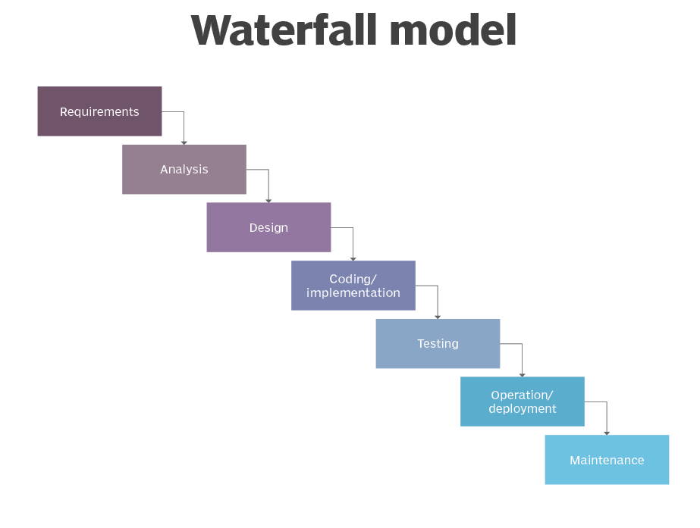

The Waterfall Model was the first Process Model to be introduced. It is also referred to as a **linear-sequential life cycle model**. It is very simple to understand and use. In a waterfall model, each phase must be completed before the next phase can begin and there is no overlapping in the phases.

The Waterfall model is the earliest SDLC approach that was used for software development.

The waterfall Model illustrates the software development process in a linear sequential flow. This means that any phase in the development process begins only if the previous phase is complete. In this waterfall model, the phases do not overlap.

**Timeline Chart**

|  |  |
| --- | --- |
| **Activity** | **Days** |
| Project Définition and Study of tools | 28 Days |
| Analysis of the system | 37 Days |
| Systme Design | 30 Days |
| Database Design | 27 Days |
| Implementation | 37 Days |
| Integration ans Testing | 18 Days |
| Documentation | 22 Days |

**Use case Diagram**

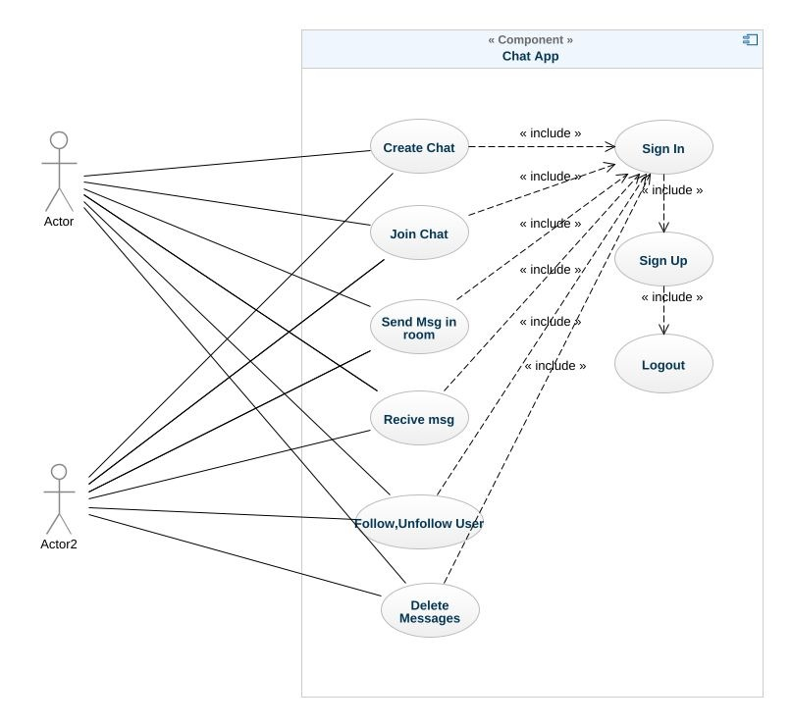

**Context Diagram**

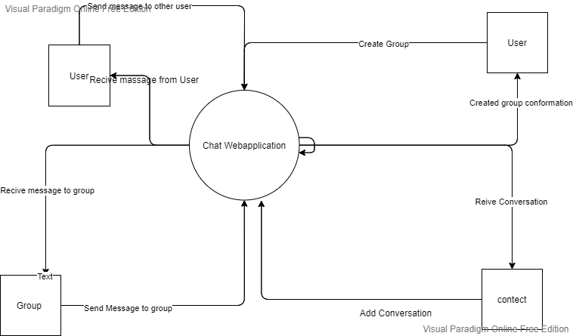

**Data Flow Diagram**

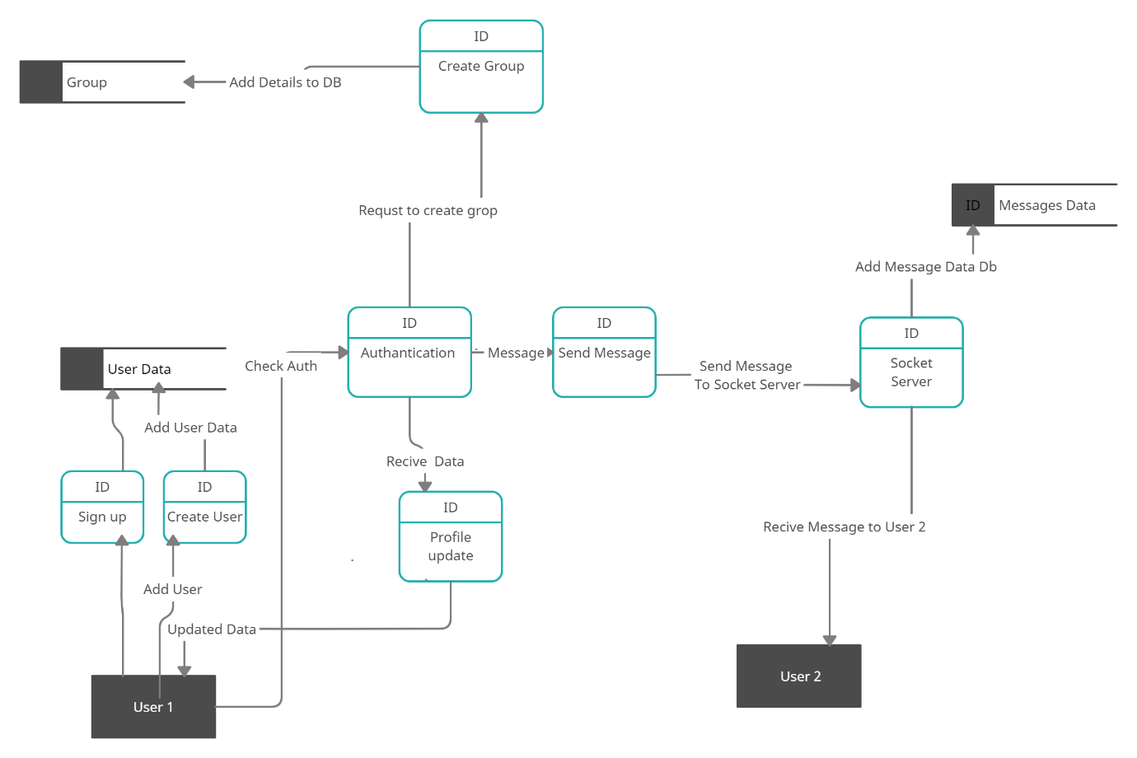

**Activity Diagram**

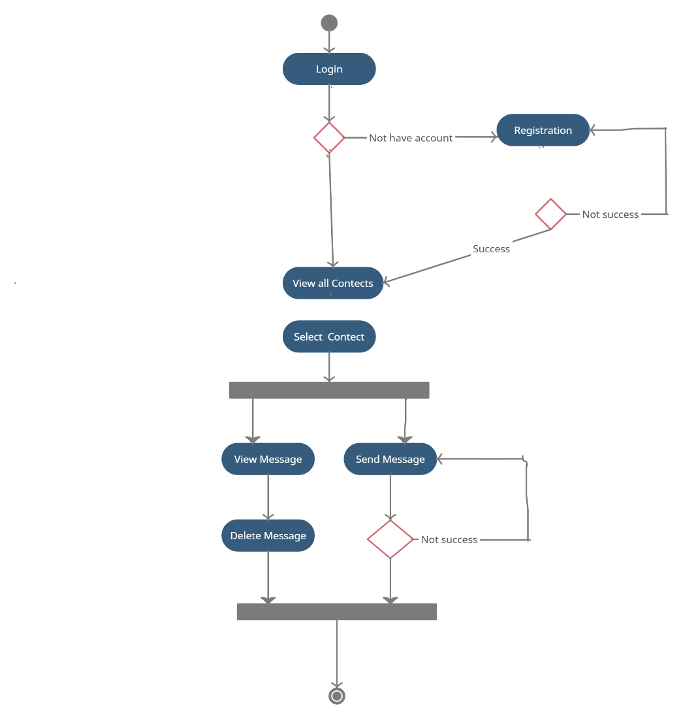

**ER Diagram**

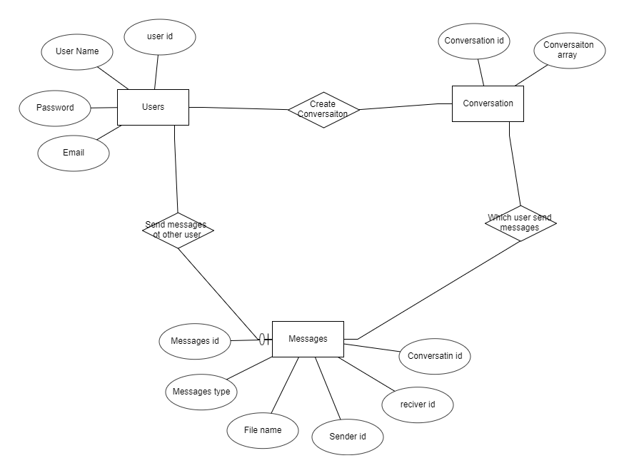

**Class Diagram**

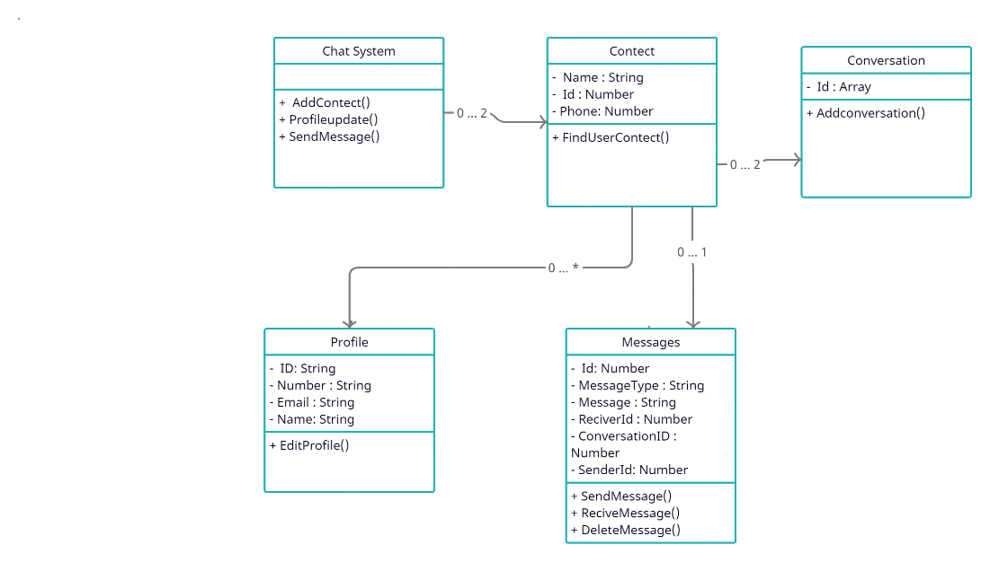

**Data Dictionary**

**Table 1 : User**

|  |  |  |  |
| --- | --- | --- | --- |
| **Field Name** | **Data Type** | **Size** | **Description** |
| Id | String | 100 | Unique id |
| Full Name | String | 250 | User Full Name |
| User Name | String | 240 | User Unique UserName |
| Email | String | 150 | User Email |
| Phone | Number | 15 | User Phone Number |
| Date-Time | Date | 250 | User Created Date Time |
| Password | String | 1000 | User Strong Passwordffd |
| Followers | Number | Undifind  Ex. 1000,3M | User Another User Floowers |

**Table 2 : Conversation**

|  |  |  |  |
| --- | --- | --- | --- |
| **Field Name** | **Data Type** | **Size** | **Description** |
| Id | String | 100 | Unique Id |
| Conversation | Array | 50 | [  First User id,  Second User id  ] |

**Table 3 : Message**

|  |  |  |  |
| --- | --- | --- | --- |
| **Field Name** | **Data Type** | **Size** | **Description** |
| ID | String | 100 | Unique Id |
| Conversation id | String | 100 | Conversation Table id |
| Sender Id | String | 100 | User Table Sender User id |
| Reciver Id | String | 100 | User Table Reciver User Id |
| Message Type | String | 100 | Like Text,Img,Jpg,File |
| Message Time | String | 100 | Message Sender Time |
| Message_Text | String | 100 | Message |

*****************************Project End********************************