

Grissom Construction

Property Address

c/o Carolyn Montgomery

22784 Hopewell Ave

Parker, CO 80138

c/o Todd Armstrong

10290 S Progress Way

#206

Parker, CO 80134

Mr. Todd Armstrong,

I was able to review the air conditioner referenced in the above address. This 4 ton unit is in VERY poor condition. The fins are folded over way beyond what can be repaired. The comb will actually not even pass through this unit. This unit has been out of production for quite some time. It is also utilizing R-22 gas which is no longer in production. Due to the unit needing full replacement the A coil will need to be updated as well as it also runs on R-22 gas. New units run on R-410A gas. R-22 and R410A run on different pressures. Cleaning of the line set will also need to take place due to the possibility of cross contamination.

The estimate is as follows:

Lennox 10ACC-048-230-04 Ton Condenser $4195

21” A coil Replacement $2295

Flush R-22 from system and add R410A refrigerant $295

Detach and Reset electrical from condenser $295

Disposal of unit $75

Total of replacement $7155

If you have any questions concerning the estimate. Please let me know.

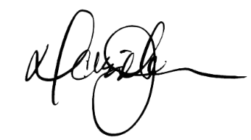

Darin Johnson

720-815-2700