CHAPTER 1

INTRODUCTION

Project Summary

Purpose & Goals

Technology

Project Summary
    - Now a day’s tourism is fast growing business and also government support for healthy tourism in their country. In present time web services is commonly used for get any type of information or commercial purpose. So, I planned to develop a website to offer information about tourist places and detailed about heritages of Junagadh. And also provide information about local shopping, food & restaurants and transportation facilities which are very useful for abroad tourist and also for local people.
    - This website is a dynamic website that provides facility to include data dynamically rather than uploading a full website on a server, so we add any new information as soon as possible. This website also provides searching facility with the content of the website, so user get information easily as per their requirement from this website.

  - Purpose & Goals

Provide information about:
- Heritage & Historical Places.
- History of Junagadh & Geographical Information.
- Shopping, Hotels & Restaurants information.
- Transportation Information like Railway, Bus Services etc…
- Support Tourism in Junagadh.

About Technology

- Node.js:


- Encourages a modular, event-driven architecture for building high-performance server-side applications.
- Leverages non-blocking I/O to handle multiple concurrent connections efficiently.
- Provides a rich ecosystem of npm packages for reusability and rapid development.
- Facilitates microservices architecture with native clustering support, promoting scalability and resilience in distributed systems

- EXPRESS:

- Simplifies creating RESTful APIs with a minimalist framework, offering flexible routing and middleware support.
- Promotes modular code organization by separating routes, controllers, and business logic.

- PostgreSQL:

- Offers a robust, open-source relational database system with advanced features and strong data integrity.
- Facilitates complex queries and indexing strategies, making it suitable for large-scale applications.
- Ensures ACID compliance, supporting reliable transactions and data consistency.

- Sequelize (ORM):

- Provides an abstraction layer for database operations, reducing boilerplate SQL code.
- Encourages modularity by defining data models, relationships, and migrations in a clear, maintainable structure.
- Simplifies query building and helps prevent common database interaction errors.

CHAPTER 2

PROJECT PROFILE

Project Planning and Scheduling

Risk Management

Schedule Representation

Project Planning and Scheduling

2.1.1 Project Development Approach

I develop a website gives facility to manage information dynamically through web browser.
Actually, this website includes two modules one for user side and another for admin side. In user side, user can only observe information and send feedback to the administrator. In admin side, administrator can perform operation on database such as insert, delete, update etc.

2.1.2 Project Planning

Project planning is very important for any website. The business model behind this project had to keep in mind as it is very important in this application building stage. After analyzing the business model, a business plan was finalized which was later followed throughout the application’s development. The various distribution of the application into phases is given below:

There are two modules
1. User
2. Administrator

Risk Management

2.2.1 Risk Identification

During the analysis of our whole application, we discovered some of the risks that could affect this website while developing and also while using. These are those risks:
- Technological Risk.
- Economical Risk.
- Political Risk.

2.2.2 Risk Analysis:
Here is the description of how the above-mentioned risks were to affect this website:
- Technological Risk: First of all, this website requires web browser that supports JavaScript and flash. The most common problems are low processor configuration, low buffer memory, low speed etc.…
- Economical Risk: this project is web application. there is no extra economical changes are there. This project is totally cheapest.
- Political Risk: There are many political risks such as wrong information about any place in city, images that are not permitted to show, also permit of all private organization which information includes in our website.

2.2.3 Risk Planning:
Here is how we deal with all the above said risks:

- Technological Risk: to avoid this risk, I planned that use JavaScript whenever it must be required and avoiding use of flash.
- Economical Risk: there is no need to solve economical risk. Because there is no problem about economic problem.
- Political Risk: permitting of the organization to display or advertisement information is solving this problem.

Schedule Representation

Database Design
Logical Design
Project Analysis
Project Profile Submission

Evaluation
Documentation
Code Implementation
Testing

The project schedule provides a road map for a software project manager. If it has been properly developed, the project schedule defines the task and milestones that must be tracked and controlled as the project proceeds. Tracking can be accomplished in a number of different ways.

- Conducting periodic project status meeting in which each team member reports progress and problems.

- Evaluating the results of all reviews conducted throughout the software engineering process.

- Determining whether formal project milestone have been accomplished by the schedule date.

- Comparing actual start date for each project task listed in the resource table.

- Meeting informally with practitioners to obtain their subjective assessment of progress to date and problems on the horizon.

- Using earned value analysis to assess progress quantitatively. Control is employed by a software project manager to administrator project resources, cope with problems, and direct project staff. If things are going well, control is light. But when problems occur, the project manager must exercise control to reconcile them as quickly as possible.

Project schedule provides plan for developing a system that is fully time compliable. The project schedule defines proper timing for each stage in process model.

Description | Estimated days | Actual Days
System Study | 8 | 15
Requirement Gathering | 8 | 7
Analysis | 8 | 12
System Design | 15 | 20
Coding | 40 | 30
Testing | 10 | 20

CHAPTER 3

SYSTEM REQUIREMENT SPECIFICATION

User Characteristics

Software and Hardware Requirement

Constraint

3.1 User Characteristics
There may be two type of user as following.
- Client(or user)
Client visits website and getting information about Junagadh.
- Administrator
Admin maintains website as per user requirements through comment and feedback.

3.2 Hardware and Software Requirements
This website requires following:

- Software Requirement
Tools/Technology | Front-end | - | Microsoft Visual Studio 2008.
 | Middle Layer | - | ASP.NET (with C# Language)
 | Back-end | - | SQL Server 2005.
 | Browser | - | Internet Explorer 6.0, Netscape Navigator, Firefox.
 | Operation System | - | Windows 98 and above

2.Hardware Requirement

Hardware
- Pentium IV, 750 MHz, 20GB HDD
- RAM : 512 MB minimum
- 400MB Minimum Free Space on Drive

3.3 Constraint

- User cannot modify website.
- Only administrator modifies website that has rights.

CHAPTER 4

ANALYSIS AND DESIGN

4.1 System Requirements
4.2 Feasibility Analysis
4.3 Requirement Validation
4.4 Requirement Gathering
4.5 Process Model
4.6 System Design

4.1 Requirements

    - Functional Requirements (Implementation of User Requirement)

- Maintain Junagadh Tourism information Allow user to add their comment and question about system.
- Administrator should modify website.
- Website should show current whether and map of the Junagadh.
- It should be provide auto complete searching with the content of the website.
- It should provide online ticket booking and reservation for railway, government buses and private buses.

    - Non-Functional Requirements

- System should be user friendly.
- There is no risk of unauthorized access, so in the system only given authorized person with username and password can be access.
- The system is fully connected with database.

4.2 Feasibility Analysis

Feasibility Analysis is very important factor in a web application. Feasibility studies precede technical development and project implementation. This website requires following analysis.

I have to build a web application that which can upload information dynamically as per requirement and it provides all information about Junagadh this website have to also search option as per content of website.

Technical Feasibility: -
- At least one person is required which works as administrator.
- Manual describing Task file are also available both as bind books and soft copy.
- A miscellaneous tool like SQL Server Data Manger is also available. SQL Data Manager is available with Operating System.
Economical Feasibility: -
- Software purchase cost incurred (which is zero in our case).
- Data Gathering costs which includes information gathering costs.
- Man Power which includes developer and guides

Operational Feasibility: -
- It will be easier and efficient to take various decisions and actions for the institute as it is based on the official Documents.
- People with a basic knowledge of computers would be able to use our system very effectively and easily, as the system would have and intuitive GUI. The officers have a working knowledge of computers so understanding the working of the system and using it would be easy from the decision maker's point of view.
Schedule Feasibility:-
- It is the most important part of the feasibility study because it deals with time-limits of the system to be complete
- The system schedule is first completing system design and after that all implementation will be performed. If system complete in 3 months so I can add more features.

4.3 Requirement Validation
This website is dynamic website, so following validation must be fulfilled.
- User has only rights of getting information
- Admin has rights of modifying website.

4.4 Requirement Gathering

The description of the services and the constraints are the requirement of the system and processes involved in the requirement engineering are
- Finding out,
- Analyzing,
- Documenting and
- Checking these services and constraints

There are basically following requirements for this website.
- This website has to dynamically upload features.
- It also has to searching facility.
- It has to provide information about Junagadh.

4.5 Process Model

Analysis
Design
Coding
Testing
Maintenance

The Process model is the sequence of operation which defines flow of the work in the system.

The process model includes following stages:
- System Analysis
It is first stage of process model. Which provides primary analysis of the system requirement and data gathering?
- System Design
As per analysis of system will be designed. It includes designing of template of website.
- System Coding
Design of system is implemented in this phase.
- System Testing
After coding each module is tested using different methods
- Maintenance
After completing system administrator maintain it as per user requirement.

4.6 System Design

4.6.1 Data Dictionary

Data Dictionary includes all the description about tables, in this website database used is SQL Server.

- Client Side
Shopping_Master

Column Name | Data type(size) | Description
Sid | Int | Auto increment id
Name | Varchar(50) | Name of mall or shop
smallimageurl | Varchar(500) | Small image path
largeimageurl | Varchar(500) | large image path
Shortdescr | Varchar(200) | Short description about mall or shop
Fulldescr | Varchar(MAX) | Full description about mall or shop
Address | Varchar(200) | Address of mall or shop
Telephone | Varchar(15) | Telephone number of mall or shop
Mobile | Varchar(15) | Mobile number of mall or shop
Email | Varchar(80) | Email address of mail or shop
Website | Varchar(80) | Website name of mail or shop

Search_Master
Column Name | Datatype(size) | Description
Sid | Int | Auto increment id
Sname | Varchar(100) | Name of search keyword
Surl | Varchar(500) | Path of search page

Login_Master
Column Name | Datatype | Description
Username | Varchar(10) | Username of admin
Sname | Varchar(20) | Password of admin
Food_Master
Column_Name | Datatype(size) | Description
Fid | Int | Auto increment id
Name | Varchar(50) | Name of mall or shop
smallimageurl | Varchar(500) | Small image path
largeimageurl | Varchar(500) | large image path
Shortdescr | Varchar(200) | Short description about restaurant
Fulldescr | Varchar(MAX) | Full description about restaurant
Address | Varchar(200) | Address of restaurant
Telephone | Varchar(15) | Telephone number of restaurant
Mobile | Varchar(15) | Mobile number of restaurant
Email | Varchar(80) | Email address of restaurant
Website | Varchar(80) | Website name of restaurant

Hotel_Master
Column Name | Datatype(size) | Description
Fid | Int | Auto increment id
Name | Varchar(20) | Name of Hotel
smallimageurl | Varchar(500) | Small image path
largeimageurl | Varchar(500) | large image path
Shortdescr | Varchar(200) | Short description about Hotel
Fulldescr | Varchar(MAX) | Full description about Hotel
Acrents | Varchar(50) | Ac room rents of hoels
NonAcrents | Varchar(50) | Non Ac room rents of hoels
Address | Varchar(200) | Address of hotel
Telephone | Varchar(15) | Telephone no. of hotel
Mobile | Varchar(15) | Mobile number of r Hotel
Email | Varchar(80) | Email address of Hotel
Website | Varchar(80) | Website name of Hotel

TouristPlaces_Master
Column Name | Datatype(size) | Description
Tid | Int | Auto increment id
Name | Varchar(20) | Name of Place
smallimageurl | Varchar(500) | Small image path
largeimageurl | Varchar(500) | large image path
Mapurl | Varchar(MAX) | Map url of location on goggle
Byplane | Varchar(100) | Distance through plane
Byrail | Varchar(100) | Distance through rail
Bybus | Varchar(100) | Distance through bus
shortdescr | Varchar(200) | Short description of place
Fulldescr | Varchar(MAX) | Full description of place
Fair_Master
Column Name | Datatype(size) | Description
Fid | Int | Auto increment id
Name | Varchar(20) | Name of Festival
smallimageurl | Varchar(500) | Small image path
largeimageurl | Varchar(500) | large image path
Shortdescr | Varchar(200) | Short description about Festival
Fulldescr | Varchar(MAX) | Full description about Festival
Fwhen | Varchar(500) | Address of Festival
Fwhere | Varchar(500) | Telephone number of Festival
Fwhocomes | Varchar(500) | Ac room rents of Festival

GovermentBus_Master
Column Name | Datatype(size) | Description
Gid | Int | Auto increment id
Rootname | Varchar(100) | Name of Festival
Via | Varchar(500) | Small image path
depturetime | Varchar(500) | Time of bus denture
Ticketprice | Varchar(200) | Price of ticket(Rs)
Bustype | Varchar(MAX) | Type of bus (e.g. luxury)
plateformno | Varchar(500) | Number of platform

PrivateBus_Master
Column Name | Datatype(size) | Description
Pid | Int | Auto increment id
Name | Varchar(20) | Name of Bus Company
smallimageurl | Varchar(500) | Small image path
largeimageurl | Varchar(500) | large image path
Shortdescr | Varchar(200) | Short description about Bus Company
Fulldescr | Varchar(MAX) | Full description about Company
Address | Varchar(200) | Address of t Company
Telephone | Varchar(15) | Telephone number of Company
Mobile | Varchar(15) | Mobile number of Company
Email | Varchar(80) | Email address of Company
Website | Varchar(80) | Website name of Company

CityBus_Master
Column Name | Datatype(size) | Description
cid | Int | Auto increment id
Rootname | Varchar(50) | Name of Festival
Via | Varchar(50) | Small image path
depturetime | Varchar(50) | Time of bus denture
Ticketprice | Varchar(50) | Price of ticket(Rs)
Bustype | Varchar(50) | Type of bus (e.g. luxury)
plateformno | Varchar(50) | Number of platform

Feedback_Master
Column Name | Datatype(size) | Description
Fid | Int | Auto increment id
Name | Varchar(30) | Name of user
Address | Varchar(100) | Address of user
City | Varchar(20) | City of user
Phoneno | Varchar(15) | Phone number of user
Comment | Varchar(500) | Comment given by user

Rail_Master
Column Name | Datatype(size) | Description
cid | Int | Auto increment id
Name | Varchar(150) | Name of Festival
Starting | Varchar(100) | Starting location of train
Ending | Varchar(100) | Ending location of train
Via | Varchar(200) | Via locations
depturetime | Varchar(50) | Time of train denture
Fclassac | Varchar(10) | Number of First class ac seats
Sclassac | Varchar(10) | Number of second class ac seats
Chairac | Varchar(10) | Number of chairs ac
Fclass | Varchar(10) | Number of first class seats
Sclass | Varchar(10) | Number of second-class seats
General | Varchar(10) | Number of general class seats
plateformno | Varchar(50) | Number of platform

FAQ_Master
Column Name | Datatype(size) | Description
Fid | Int | Auto increment id
Question | Varchar(500) | Question asked by user
Answer | Varchar(500) | Answer given by admin

Menu_Master
Column Name | Datatype(size) | Description
Mid | Int | Auto increment id
Menuname | Varchar(20) | Menu name
Menuurl | Varchar(500) | Menu url
Imageurl | Varchar(500) | Image of menu

4.6.2 Use case Diagram

Login
Get Information
Modify Information
Give Feedback
Implement Feedback
Logout
Admin
User

4.6.3 Class Diagram

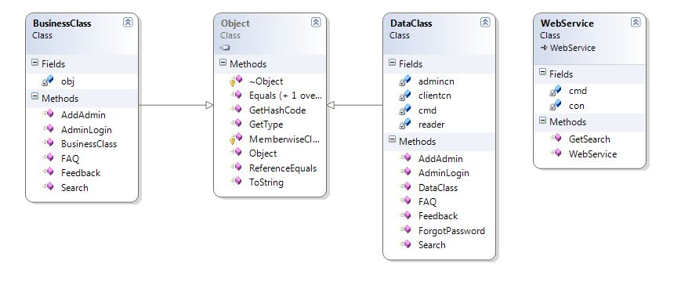

4.6.4 Sequence Diagram

Home
H
ome
F
o
o
d&
R
e
S
T
A
U
R
a
N
t
F
o
o
d&
R
e
S
T
A
U
R
a
N
t
T
o
u
r
i
s
t
P
l
a
c
e
s
Request
Request
Request
Detail
Of
Location
Search
Pages
Detail
Of
Hotels
Places
And
Festival
Gov
Buses
Request
Govbus
info
Map &
Whether
City
Tourism
Transportation

4.6.5 E-R Diagram

- User E-R Diagram

Junagadh Tourism
Shopping_Master
sid
name
smallimageurl
largeimageurl
shortdescr
fulldescr
address
telephone
mobile
email
website
Food_Master
fid
name
smallimageurl
largeimageurl
shortdescr
fulldescr
address
telephone
mobile
email
website
TouristPlaces_Master
tid
name
smallimageurl
largeimageurl
shortdescr
fulldescr
address
telephone
mobile
email
website
Fair_Master
fid
name
smallimageurl
largeimageurl
shortdescr
fulldescr
fwhen
fwhen
fwhocomes
PrivateBus_Master
pid
name
smallimageurl
largeimageurl
shortdescr
fulldescr
address
telephone
mobile
email
website
GovermentBus_Master
gid
rootname
via
depturetime
ticketprice
bustype
City_Master
gid
rootname
via
depturetime
ticketprice
bustype
Rail_Master
cid
name
starting
ending
via
depturetime
fclassac
sclassac
chairac
fclass
sclass
FAQ_Master
fid
question
answer
Feedback_Master
fid
name
address
city
phoneno
comment
Menu_Master
mid
mane
murl

4.6.6 Data Flow Diagram

- DFD 0 LEVEL

- DFD 1 LEVEL

- DFD 2 LEVEL

4.6.7 Activity Diagram
Home
Map & Whether
Geometry
History
City
Transportation
Tourism
Map & Whether
Geometry
History
Railway
GovBus
Private Bus
City Bus
TouristPlaces
Fair & Festival
Exit

CHAPTER 5

SYSTEM IMPLEMENTATION

Implementation Environment

User Side Screen Shot

Admin Side Screen Shot

Sample Coding

5.1 Implementation Environment

- Multiuser Environment
Junagadh Tourism website is multiuser system. It means any person can be access system from any corner of the world using internet.

- GUI Environment
The system is fully Graphical User Interface based, because user feels much better with graphical media. The system is website, so GIU performs very great role in entire picture.

5.2 User Side Screen Shot

The system is divided into two modules as following:

- Admin module
The administrator is an authorized person who manage website with operations such as add information, edit information, delete information, receive user comment, fulfill user comment and etc…

- User
Users of the system have not rights of modify system. They can only get information about Junagadh. Users can also send comments to the administrator of the system.

Home

- Map and Whether
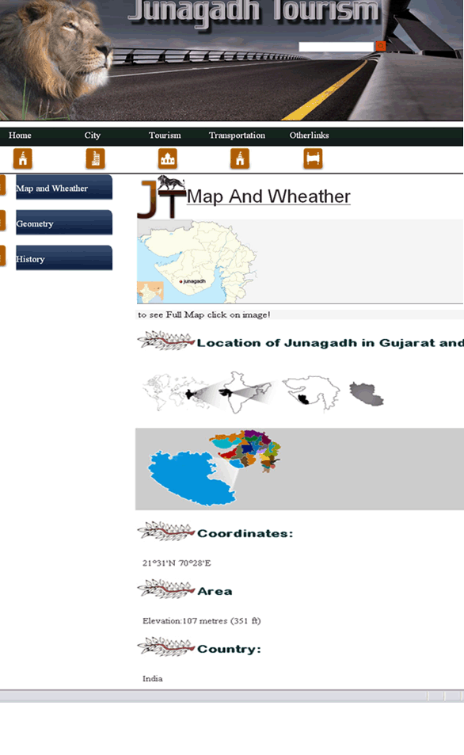

- Geometry
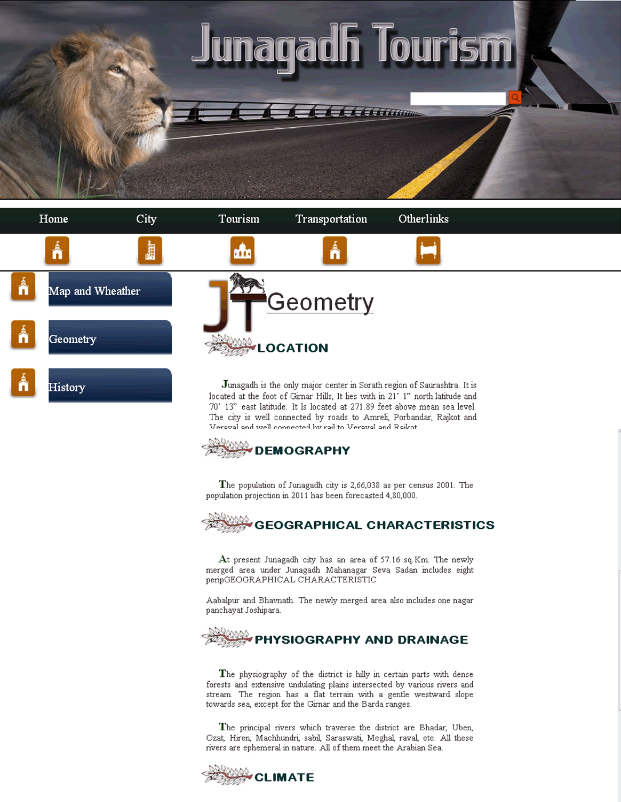

5.3 Admin Side Screen Shots

Operation:-

Login

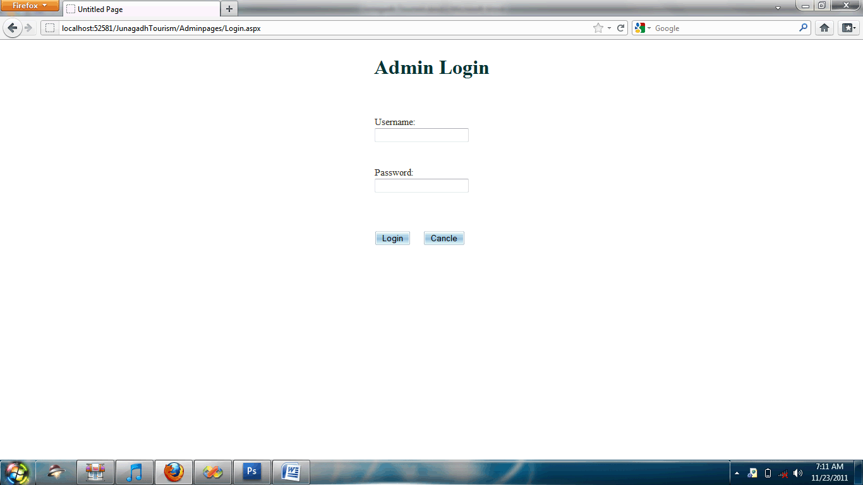

5.4 Sample Coding
- Image Upload Code in Form view
frmtouristplaces.DefaultMode = FormViewMode.Edit;
FormView frm = (FormView)frmtouristplaces;
FileUpload flusmall = (FileUpload)frm.FindControl("flusmall");
TextBox smallt = (TextBox)frm.FindControl("txtsmall");
if (flusmall.HasFile)
{
string spath = Server.MapPath("~/Upload/" + flusmall.FileName);
flusmall.SaveAs(spath);
smallt.Text = "~/Upload/" + flusmall.FileName;

}
frmtouristplaces.DefaultMode = FormViewMode.Edit;

FileUpload flularge = (FileUpload)frm.FindControl("flularge");
TextBox larget = (TextBox)frm.FindControl("txtlarge");
if (flularge.HasFile)
{
string lpath = Server.MapPath("~/Upload/" + flularge.FileName);
flularge.SaveAs(lpath);
larget.Text = "~/Upload/" + flularge.FileName;
}
frmtouristplaces.DefaultMode = FormViewMode.ReadOnly;

- Search Method

[WebMethod]
public List<string> GetSearch(string prefixText)
{
SqlConnection con = new SqlConnection(ConfigurationManager.ConnectionStrings["ConnectionString.ToString());
con.Open();
SqlCommand cmd = new SqlCommand("select * from Search_Master where sname like @Name+'%'",con);
cmd.Parameters.AddWithValue("@Name", prefixText);
SqlDataAdapter da = new SqlDataAdapter(cmd);
DataTable dt = new DataTable( );
da.Fill(dt);
List<string> SearchNames = new List<string>();
for(int i=0;i<dt.Rows.Count;i++)
{
SearchNames.Add(dt.Rows[i][1].ToString());
}
return SearchNames;
}
- View More Logic
<asp:LinkButton ID="lnkbtnviewmore" runat="server"
CommandArgument='<%# Eval("hid") %>'
onclick="lnkbtnviewmore_Click"
oncommand="lnkbtnviewmore_Command">View More...
</asp:LinkButton>
protected void lnkbtnviewmore_Command(object sender, CommandEventArgs e)
{
Session["hid"] = e.CommandArgument.ToString();
Response.Redirect("~/ClientPages/City/Hotelfull.aspx");
}

CHAPTER 6

TESTING

Testing Plan

Test case Modules

6.1 Testing Plan

The importance of software testing and its implication with respect to software quality cannot be overemphasized.

Software Testing is a critical element of software quality assurance and represents the ultimate review of specification, design and coding. It is with this motivating factor that about 30 to 40 percent of total project. Efforts are expanded on testing.

With the project nearing completion, we have taken up the activity of testing the individual forms and making sure that the interaction among the various forms is smooth and without any glitches. Before actually beginning to test, a few things should be born in mind. Among others these include:

- All tests should be traceable to customer requirements.
- Tests should be planned before the testing begins.
- To be effective, testing should be conducted by an independent third party.

6.2 Test Case Module

User Management Module
This module handles user registration, login, and profile management.
- Test Case ID: TC_UM_001
  - Test Scenario: Verify a user can successfully register with valid information.
  - Pre-conditions: The user is on the registration page.
  - Test Steps:
  - 1. Enter a unique username, valid email, and a strong password.
  - 2. Click the "Register" button.
  - Test Data:
    - Username: "test_user_01"
    - Email: "test01@example.com"
    - Password: "Password@123"
  - Expected Result: The user is successfully registered and redirected to the login page or a confirmation message is displayed.
- Test Case ID: TC_UM_002
  - Test Scenario: Verify a user cannot register with an email that is already in use.
  - Pre-conditions: An account already exists for "test01@example.com."
  - Test Steps:
  - 1. Enter a new username, an existing email, and a password.
  - 2. Click the "Register" button.
  - Test Data:
    - Username: "test_user_02"
    - Email: "test01@example.com"
    - Password: "Password@123"
  - Expected Result: An error message is displayed stating that the email is already registered.

Administrative Module
This is for the admin user who manages the website content and bookings.
- Test Case ID: TC_ADM_001
  - Test Scenario: Verify an admin can add a new tourist attraction to the website.
  - Pre-conditions: The admin is logged into the admin panel.
  - Test Steps:
    - Navigate to the "Manage Attractions" section.
    - Click "Add New."
    - Fill in the details for the new attraction (name, description, location, images).
    - Click "Save."
  - Test Data:
    - Attraction Name: "Willingdon Dam"
    - Description: "A scenic dam near Junagadh..."
    - Location: "Willingdon Dam Road"
  - Expected Result: The new attraction is successfully added to the database and is visible on the public-facing website.

CHAPTER 7

Limitation of Project

7.1 Limitation of Project

There are following limitation of this website:

- This website expand as tourism places,historical places etc… can be separate in different modules.

- You can use google map and animation java script to show different places in junagadh.

- Also adding reservation for transportation facility and booking facility for hotels and restaurants.

CHAPTER 8

CONCLUSION

8.1 Conclusion

This project helps in understanding the creation of an interactive web page and the technologies used to implement it. The design of the project which includes Data Model and Process Model illustrates how the database is built with different tables, how the data is accessed and processed from the tables. The building of the project has given me a precise knowledge about how ASP.NET is used to develop a website, how it Connects to the database to access the data and how the data and web pages are modified to provide the user with a shopping cart application.

Working within a dynamic and innovative corporate environment exposed me to industry best practices and modern development methodologies. The collaborative culture and mentorship at TechRover Solutions reinforced the importance of scalable, secure application design and continuous learning. This experience has been contributory in my professional development, equipping me with the technical expertise and confidence to tackle complex challenges in future projects.

Chapter 9

Reference

9.1 Reference

- https://bitbucket.org/techrover1/citadel-gateway/src/master/
- https://nodejs.org/en/learn/getting-started/introduction-to-nodejs
- https://expressjs.com/
- https://www.w3schools.com/postgresql/
- https://sequelize.org/docs/v6/
- https://bcrypt-generator.com/
- https://jwt.io/
- https://swagger.io/
- https://eslint.org/
- https://jestjs.io/
- https://www.testim.io/blog/supertest/
- https://chatgpt.com/

