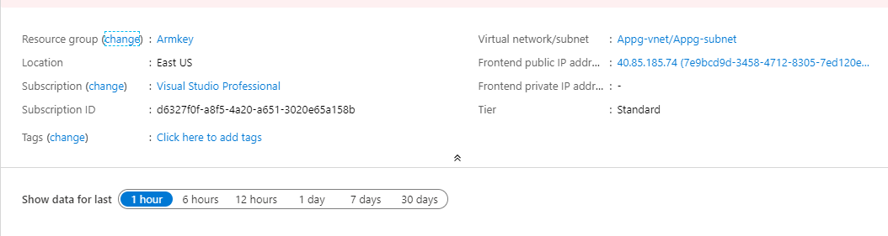
Application gateway

backend pool

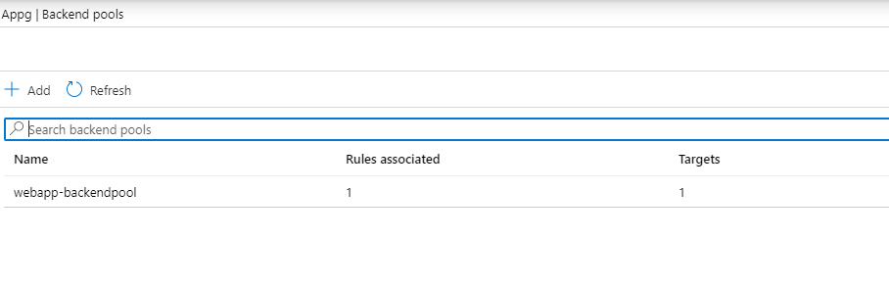

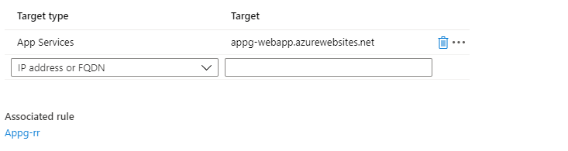

webapp

