CSA4723 – DEEP LEARNING FOR DISASTER MANAGEMENT
G.NAVEEN
192324110
6. Verifying the performance of a image pre-processing with Otsu’s function using Python
AIM:
To verify the performance of image preprocessing using Otsu’s thresholding method in Python, which automatically determines the optimal threshold value to separate the foreground and background of an image.
ALGORITHM:
Step 1: Import required libraries
Import necessary libraries such as cv2 (OpenCV), matplotlib, and numpy.
Step 2: Load the image
Read the input image in grayscale mode using OpenCV.
Step 3: Apply Gaussian blur (optional)
Smooth the image using cv2.GaussianBlur() to reduce noise before thresholding.
Step 4: Apply Otsu’s thresholding
Use cv2.threshold() with the flag cv2.THRESH_OTSU to automatically find the optimal threshold value.
Step 5: Display the threshold value
Print the automatically calculated threshold value.
Step 6: Display the results
Visualize the original image, histogram, and Otsu-thresholded image using matplotlib.
CODE:
import cv2
import numpy as np
from matplotlib import pyplot as plt

img = cv2.imread('picture.jpg', 0)

if img is None:
print("Error: 'image.jpg' not found. Please ensure the image file is in the correct directory.")
print("Creating a dummy 100x100 white image for demonstration purposes.")

…plt.axis('off')

plt.tight_layout()
plt.show()

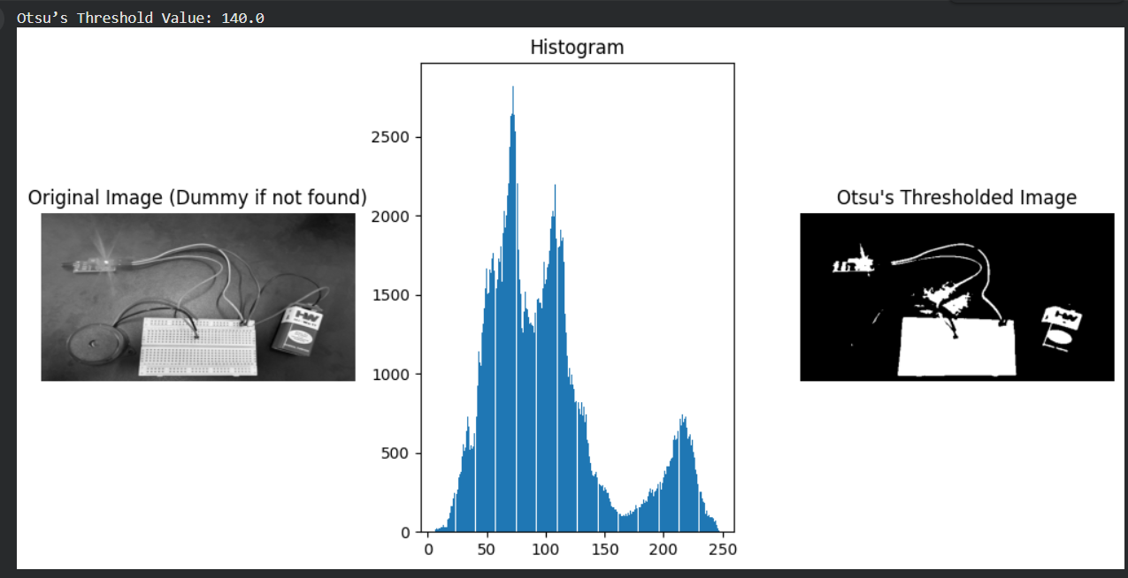

7. Verifying the performance of a image pre-processing with watershed algorithmusing Python
Aim: To verify the performance of image preprocessing using the Watershed algorithm in Python for effective image segmentation based on pixel intensity gradients.
Algorithm:
Step 1: Import necessary libraries
Use OpenCV, NumPy, and Matplotlib for image processing and visualization.
Step 2: Load and convert the image to grayscale
Read the input image and convert it to grayscale.
Step 3: Apply thresholding
Use binary or Otsu’s thresholding to separate foreground and background.
Step 4: Perform morphological operations
Use morphological opening and dilation to remove noise and identify sure background and sure foreground regions.
Step 5: Find unknown region
Subtract sure foreground from sure background to get uncertain areas.
Step 6: Apply connected components
Label the foreground objects.
Step 7: Apply the Watershed algorithm
Use OpenCV’s cv2.watershed() to perform segmentation.
Step 8: Visualize results
Display the segmented image.
Code:
import cv2
import numpy as np
from matplotlib import pyplot as plt

img = cv2.imread('picture.jpg')
gray = cv2.cvtColor(img, cv2.COLOR_BGR2GRAY)
ret, thresh = cv2.threshold(gray, 0, 255, cv2.THRESH_BINARY_INV + cv2.THRESH_OTSU)
kernel = np.ones((3,3), np.uint8)
opening = cv2.morphologyEx(thresh, cv2.MORPH_OPEN, kernel, iterations=2)
sure_bg = cv2.dilate(opening, kernel, iterations=3)
…plt.title('Watershed Segmentation')
plt.axis('off')
plt.show()
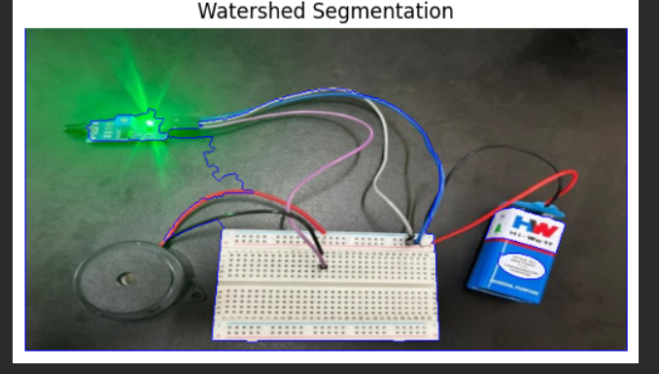
8. Constructing and verifying the working of Multi Level Perceptron model with different inputs, learning rate, and activation function using the Neural Network Playground software
Aim: To construct and verify the working of a Multi-Level Perceptron (MLP) model by varying the number of inputs, learning rate, and activation functions using the Neural Network Playground to observe how these parameters affect model learning and accuracy.
Algorithm:
Step 1: Open the Neural Network Playground tool at https://playground.tensorflow.org
Step 2: Select the input features
Choose input variables (e.g., X₁, X₂) and dataset type (e.g., spiral, circle, linear).
Step 3: Configure the MLP architecture
Select the number of hidden layers and the number of neurons in each layer.
Step 4: Choose the activation function
Pick an activation function such as ReLU, Tanh, or Sigmoid for the hidden layers.
Step 5: Set the learning rate
Adjust the learning rate (e.g., 0.01, 0.1, 0.3) to see how it influences convergence.
Step 6: Train the model
Click on “Play” to train the network and observe how the decision boundary evolves.
Step 7: Compare results
Observe the difference in performance and accuracy when varying inputs, learning rate, and activation functions.
Code:
import numpy as np
from sklearn.model_selection import train_test_split
from sklearn.neural_network import MLPClassifier
from sklearn.datasets import make_moons
from sklearn.metrics import accuracy_score

X, y = make_moons(n_samples=1000, noise=0.2, random_state=42)
X_train, X_test, y_train, y_test = train_test_split(X, y, test_size=0.2, random_state=42)
mlp = MLPClassifier(hidden_layer_sizes=(10, 10), activation='tanh', learning_rate_init=0.01, max_iter=1000, random_state=42)
mlp.fit(X_train, y_train)
y_pred = mlp.predict(X_test)
print("Accuracy:", accuracy_score(y_test, y_pred))
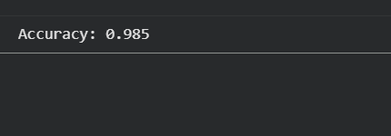

9. Performance Evaluation of Neural Network Architecture based on; Number of Hidden layers, Hidden Neurons, Learning rate and Activation function using the Neural Network Playground software.
Aim: To evaluate the performance of a Neural Network architecture by varying key hyperparameters — the number of hidden layers, number of hidden neurons, learning rate, and activation function — using the Neural Network Playground tool and analyze their effect on model accuracy and convergence.
Algorithm:
Step 1: Open the Neural Network Playground
Go to https://playground.tensorflow.org.
Step 2: Choose dataset and inputs
Select an appropriate dataset (e.g., spiral, circle, or linear) and choose input features (X₁, X₂).
Step 3: Configure hidden layers and neurons
Adjust the number of hidden layers and neurons per layer to test different architectures.
Step 4: Select activation function
Choose activation functions such as ReLU, Tanh, or Sigmoid to observe their influence on learning.
Step 5: Set learning rate
Modify the learning rate (e.g., 0.01, 0.1, 0.3) to analyze how fast or accurately the network learns.
Step 6: Train the model
Click “Play” to start training and observe the real-time change in decision boundaries and training accuracy.
Step 7: Record performance
Note how accuracy and training time vary with different configurations.
Step 8: Compare and conclude
Compare the models to determine the most optimal combination of architecture and hyperparameters for the selected dataset.
Code:
import numpy as np
from sklearn.model_selection import train_test_split
from sklearn.neural_network import MLPClassifier
from sklearn.datasets import make_moons
from sklearn.metrics import accuracy_score

X, y = make_moons(n_samples=1000, noise=0.2, random_state=42)
X_train, X_test, y_train, y_test = train_test_split(X, y, test_size=0.2, random_state=42)

configs = [
… print(f"Layers: {cfg['layers']}, Activation: {cfg['activation']}, LR: {cfg['lr']}, Accuracy: {accuracy_score(y_test, y_pred):.4f}")
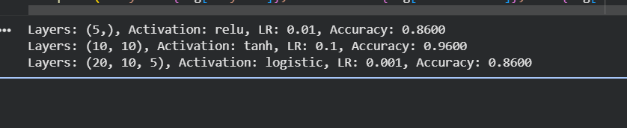
10. Performance evaluation of Linear regression Classifier using Breast cancer or Iris database.
Aim: To evaluate the performance of a Linear Regression classifier using the Breast Cancer or Iris dataset and analyze its accuracy and effectiveness in classifying data.
Algorithm:
Step 1: Import required libraries
Import libraries such as numpy, pandas, and sklearn for data loading, model building, and evaluation.
Step 2: Load the dataset
Load the Breast Cancer or Iris dataset using sklearn.datasets.load_breast_cancer() or load_iris().
Step 3: Split the dataset
Divide the dataset into training and testing sets using train_test_split().
Step 4: Train the Linear Regression model
Use LinearRegression() from sklearn.linear_model to fit the training data.
Step 5: Make predictions
Predict target values for the test data.
Step 6: Convert regression output to class labels
Since linear regression outputs continuous values, convert them into discrete classes using thresholding.
Step 7: Evaluate the model
Calculate performance metrics such as accuracy, confusion matrix, and classification report.
Step 8: Analyze and interpret results
Compare predicted and actual values to assess the classification performance.
Code:
import numpy as np
from sklearn.model_selection import train_test_split
from sklearn.linear_model import LinearRegression
from sklearn.datasets import load_breast_cancer
from sklearn.metrics import accuracy_score, confusion_matrix, classification_report

data = load_breast_cancer()
X = data.data
y = data.target
X_train, X_test, y_train, y_test = train_test_split(X, y, test_size=0.2, random_state=42)

model = LinearRegression()
model.fit(X_train, y_train)
y_pred = model.predict(X_test)
y_pred_class = [1 if i > 0.5 else 0 for i in y_pred]

print("Accuracy:", accuracy_score(y_test, y_pred_class))
print("Confusion Matrix:\n", confusion_matrix(y_test, y_pred_class))
print("Classification Report:\n", classification_report(y_test, y_pred_class))
