**CS445 - Lab 1 Collaborative Git**

1. **Exercise 1// local repository commands**
2. git init

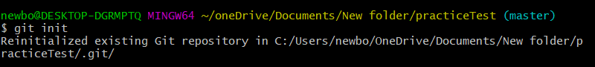

1. git status

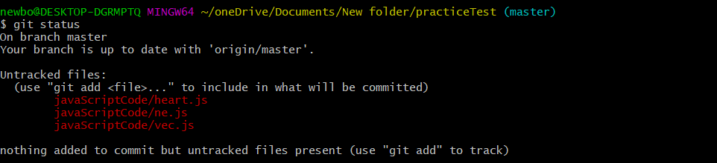

1. git diff



1. git add

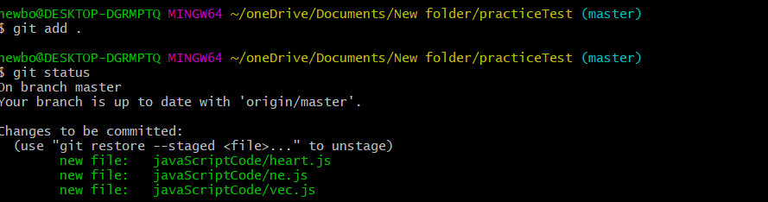

1. git commit.

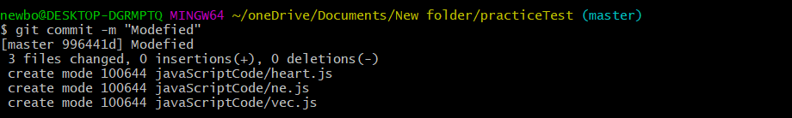

1. git commit –amend (updating the last commit)

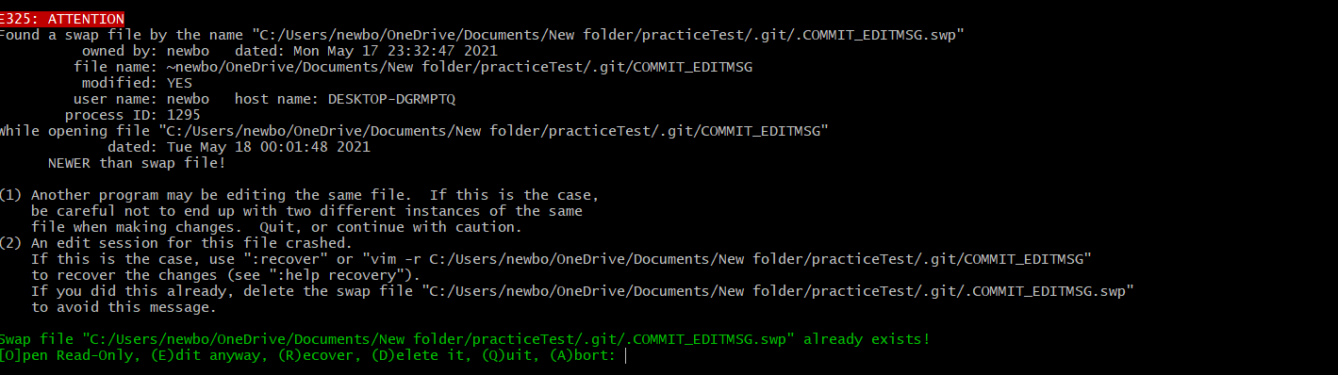

1. git log

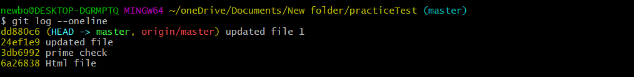

1. git show

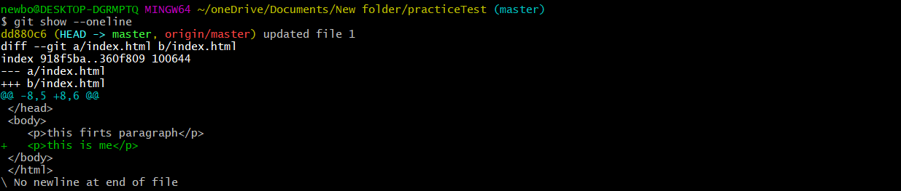

1. git tag



1. gits restore.



1. git branch



1. git checkout

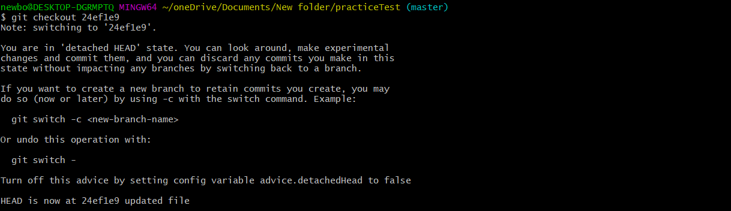

1. git merge



1. Create a conflict and solve the conflict.

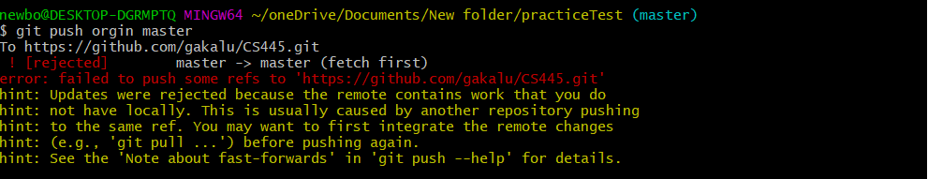

1. Undo changes from a certain commit git revert.

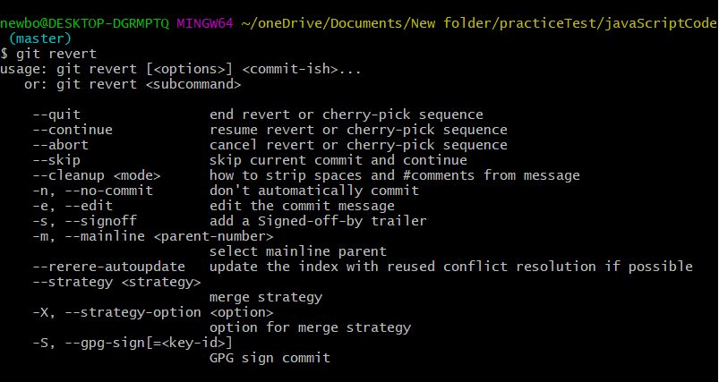

1. Erase commits with git reset.

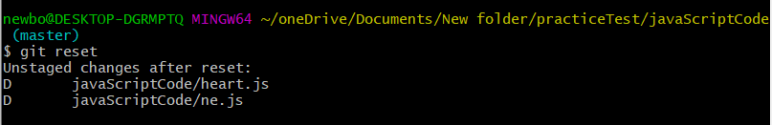

1. **Exercise 2// the remote repository commands**
2. Create a remote repository.

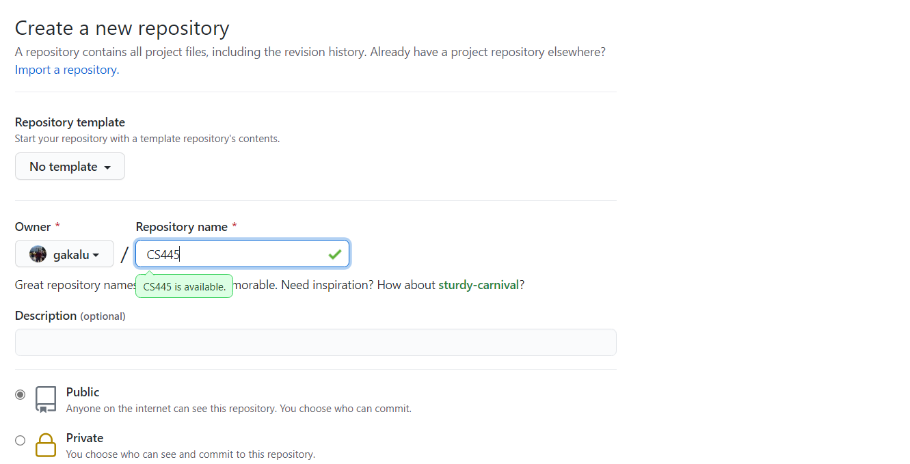

1. Create README.md.

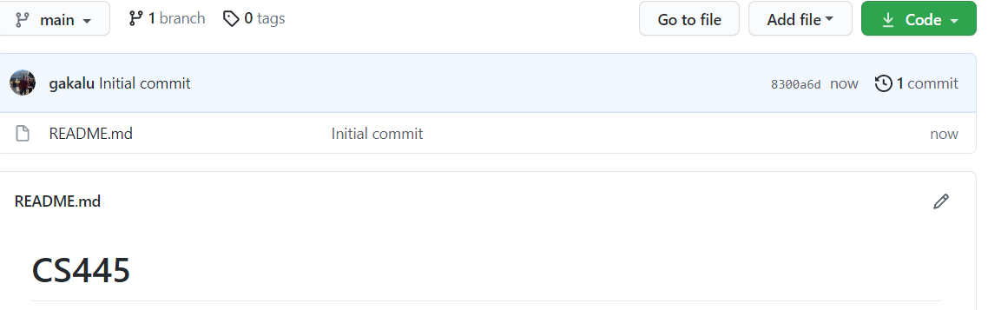

Add at least 5 markdown syntax (For example: Headers, Bold, Code, Unordered List, Links) [Cheatsheet](https://github.com/adam-p/markdown-here/wiki/Markdown-Cheatsheet)

1. git remote



1. git clone

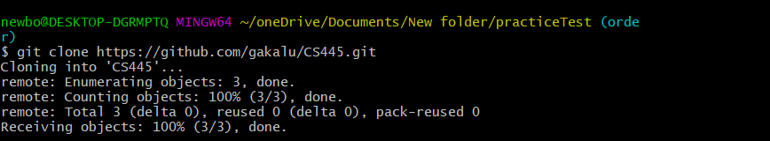

1. git push

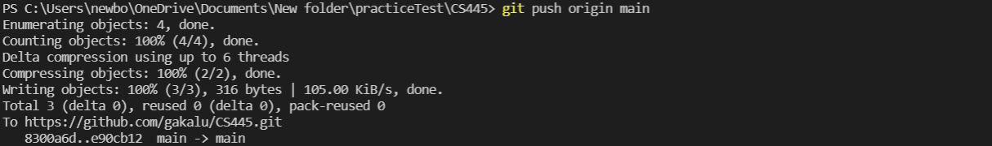

1. git fetch

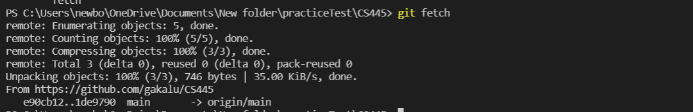

1. git pull.



1. **Exercise 3// the third-party repositories commands**
2. Star the repository.

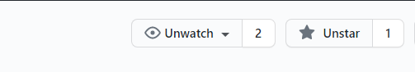

1. Watch the repository for any changes.



1. Fork the repository.



1. Clone your forked repository into your local machine.

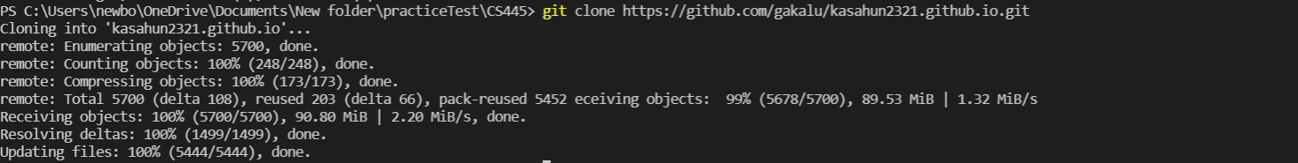

1. Create a new topic branch named using studentId-studentName, For example: 610001-JohnSmith.



1. Checkout your new branch



1. Add a new file with your name, example: hello.js.



1. Commit the changes.



1. Merge your studentId-studentName branch with the main branch.

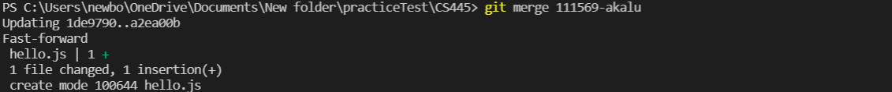

1. Push your changes to the remote repo.

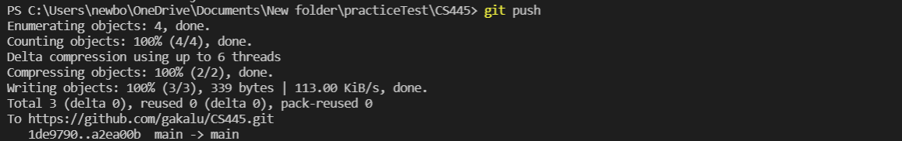

1. Create a new Pull Request to the upstream repo.

