Writeup

* Which store has maximum sales

The store number 20 has the maximun of sales.

* Which store has maximum standard deviation i.e., the sales vary a lot. Also, find out the coefficient of mean to standard deviation

The store 14 has the maximun standard deviation.

* Which store/s has good quarterly growth rate in Q3’2012

The store 16 has the better growth rate in Q3’2012

* Some holidays have a negative impact on sales. Find out holidays which have higher sales than the mean sales in non-holiday season for all stores together

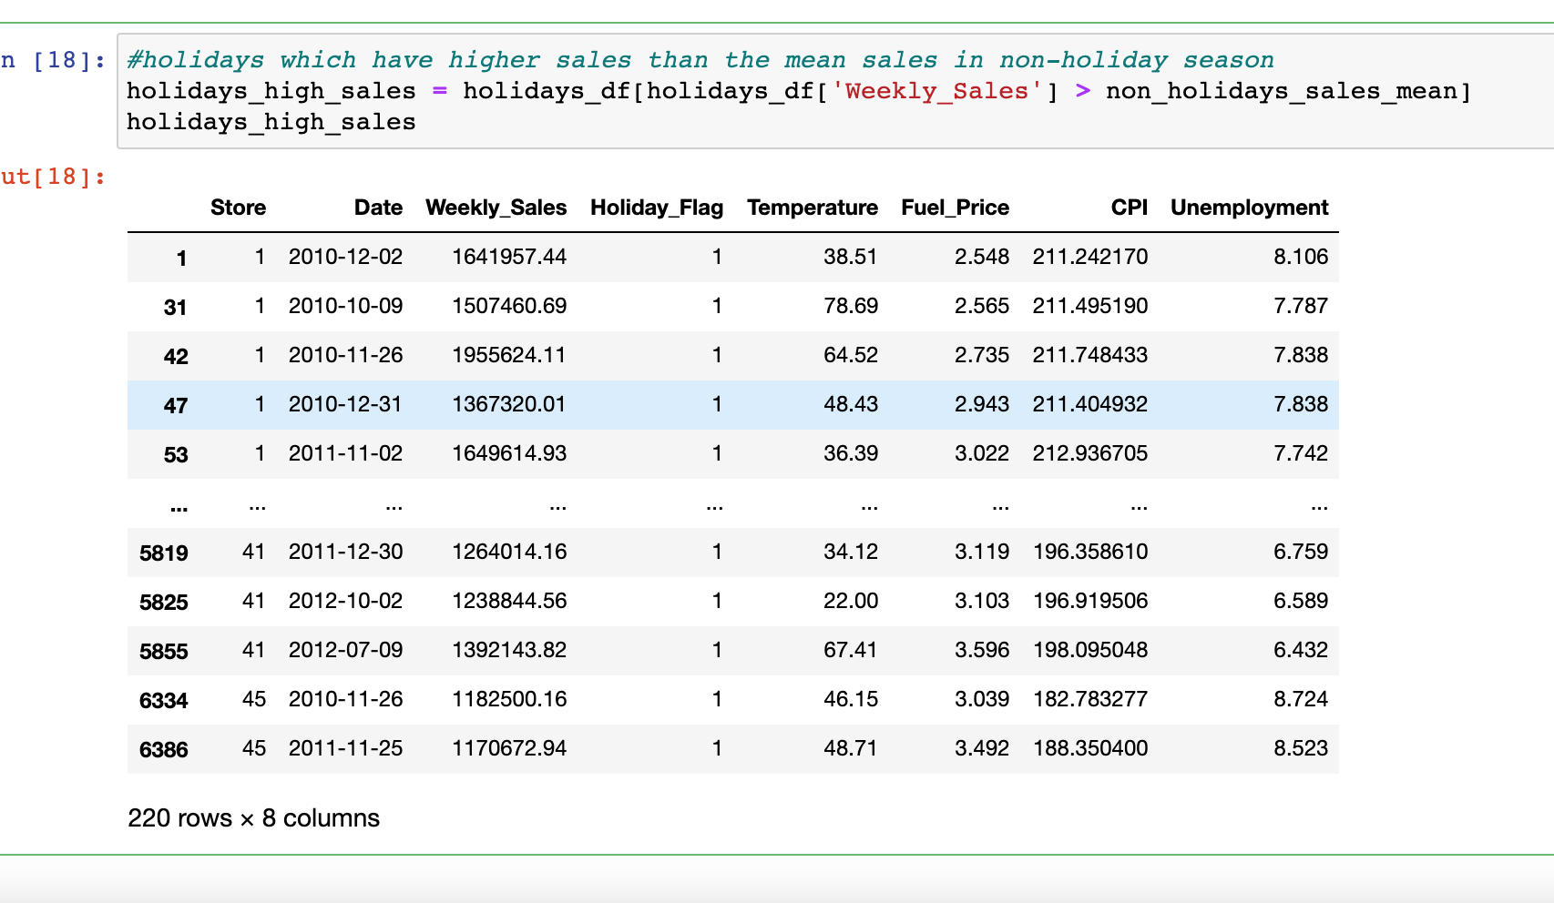

* Provide a monthly and semester view of sales in units and give insights
* For semester sales we can observe that the sales are lower at the beginning 1st semester of 2010 and 1st semester of 2013
* For monthly sales we can observe that the highest sales are recorded between jan-2011 to march 2011
* Monthly Sales Graph that highest sum of sales is recorded in between jan-2011 to march-2011.

