Project10

1- Definitions

a- what is the BIOS?

(Basic input output system) The booting system begins with the BIOS. The first step of the BIOS is the power-on self test (POST), which checks the hardware.

-The second step is the device enumeration and initialization

-the BIOS is made of of 2 parts,-The POST code and the run-time services

-To Boot an OS, the BIOS runtime searches for devices that are both active and bootable in the order of preference as defined by the CMOS.(CMOS is a chipset on the motherboard which powers on the ROM.

-The Bios then locates the MBR (Master boot record) and loads it in the RAM

b- what is wget?

Wget is a computer program or command that retrieves content from web servers. Its name derives from World Wide Web and get. It supports downloading via HTTP, HTTPS, and FTP.Downloads from a url to the server

c- what is grub?Grand unified Bootloader.displays flash screen. Its in the /boo/grub/directory. It loads the kernel

d- what is LILO?(Linux Loader) older version for Grub

e- what is a runlevel?

**A runlevel is a preset operating state on a Unix-like operating system. A system can be booted into (i.e., started up into) any of several runlevels, each of which is represented by a single digit integer.**

f- what is DevOps? (Development and Operation) its a newly created concept or a set of practices that emphasize the collaboration and communication of both software developers and information technology (IT) professionals while automating the process of software delivery and infrastructure changes.  It aims at establishing a culture and environment where [building](https://en.wikipedia.org/wiki/Software_build" \o "Software build), [testing](https://en.wikipedia.org/wiki/Software_testing" \o "Software testing), and [releasing software](https://en.wikipedia.org/wiki/Software_release_life_cycle" \o "Software release life cycle) can happen rapidly, frequently, and more reliably.

g- what is VCS? give 4 examples

version control systems are a category of software tools that help a software team manage changes to source code over time. Version control software keeps track of every modification to the code in a special kind of database. If a mistake is made, developers can turn back the clock and compare earlier versions of the code to help fix the mistake while minimizing disruption to all team members.

Examples

-Github

-SourceForge

-Git

-Google Code

h- **what is a code?**

 In **computer science a code can be defined as** the symbolic arrangement of data or instructions in a **computer** program or the set of such instructions

2- **why is version control system so important for companies?**

-Developing software without using version control is risky, like not having backups. Version control can also enable developers to move faster and it allows software teams to preserve efficiency and agility

-****Backup****. It carries the entire development history, and it's simple to compare files between revisions. It's faster than a simple backup

****-Sharing code between developers****. If you have at least two developers working on the same product simultaneously,It is a good way to reliably and consistently share code changes and merge them.

****-Finding and fixing bugs****. When your customers report a bug for a specific product version, you can quickly get the actual source snapshot in order to reproduce and fix it. Furthermore, if you have problem identifying the cause of a bug, you can use VCS to pinpoint the exact revision where it was introduced.

****Progress tracking****. When you commit your work in snapshots, it allows you (and your manager) to track progress on feature implementations and status of open bugs. VC systems are also easily integrated with tracking systems and [continuous integration](http://en.wikipedia.org/wiki/Continuous_integration" \l "Principles_of_continuous_integration) systems.

3 - what are some of the problem that DevOps is solving in companies?

- ****Speed things up**** One of the main benefits of DevOps is creating a more agile business, with shorter, iterative processes key to this, enabling the IT team to handle issues and innovate faster. Indeed, the impact can be significant -- with development to production cycles moving from months to hours.

****Collaboration between the various teams improves**** Collaboration is key to the success of DevOps. With DevOps, the different teams required to develop software becomes one team that takes full responsibility for the performance of applications. This team must work together efficiently, and there must be full visibility and consistency in the way they work, their goals, and the tools they work with.

4- kernel.org is an online free repository for different kernel version

a- use wget to download the latest stable kernel version (it would be display in a yellow rectangle on the kernel.org site, right click on the yellow rectangle to copy the link address)

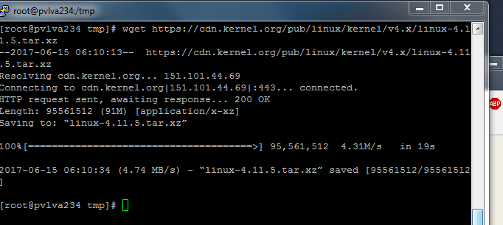

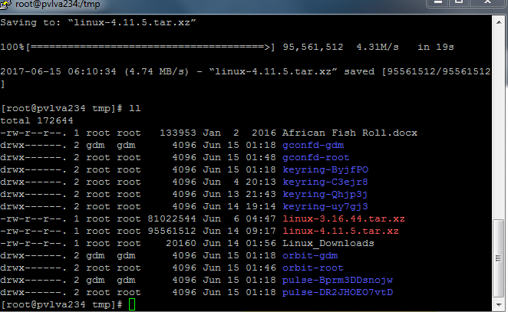

b- download the kernel version 3.16.44 and put it in /tmp (right click on tarball to copy the link address)

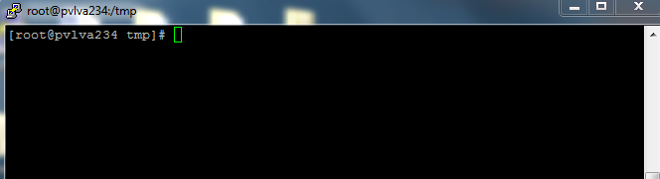

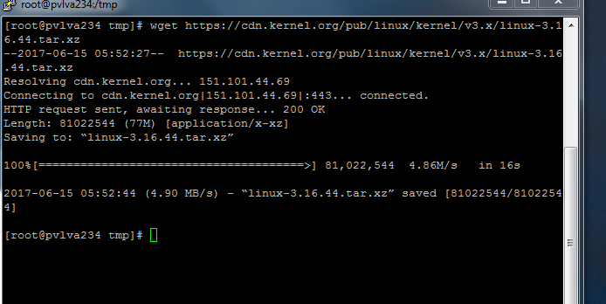

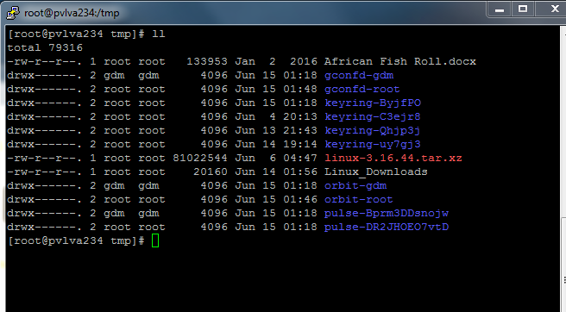

5- Reimport the centosproject2 server from the previous project and do a thorough inventory of the server.

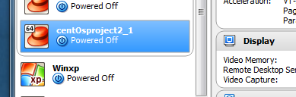

a- Os version

# uname -r

Cat /etc/issue

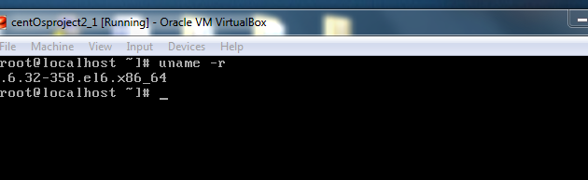

b- Number of CPU's

#nproc

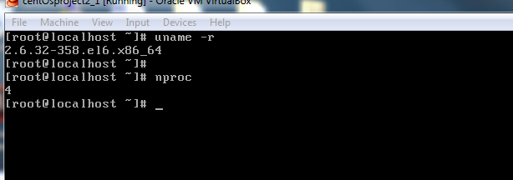

c- size of CPU

#lscpu

#sar -u

Cat /proc/cpu

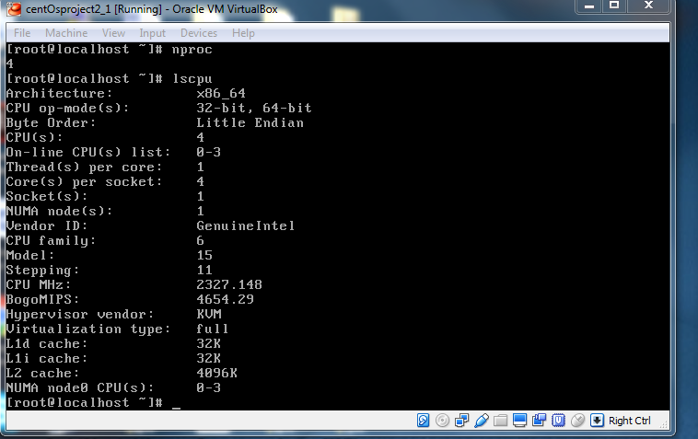

d- Size of Memory

Cat /proc/meminfof

#free -m

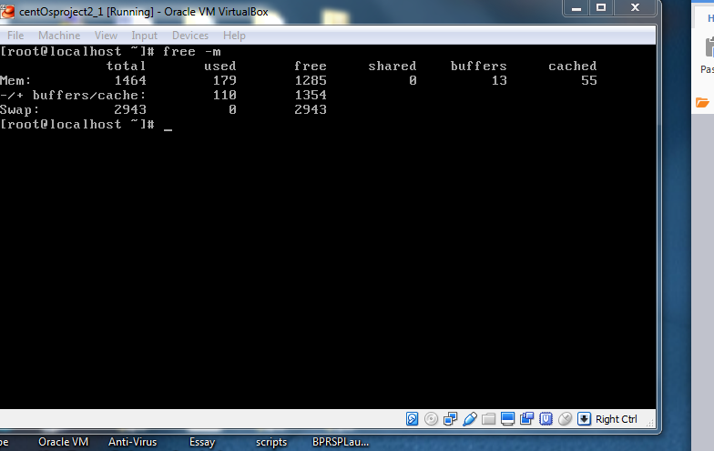

e- hard drive size

#fdisk -l

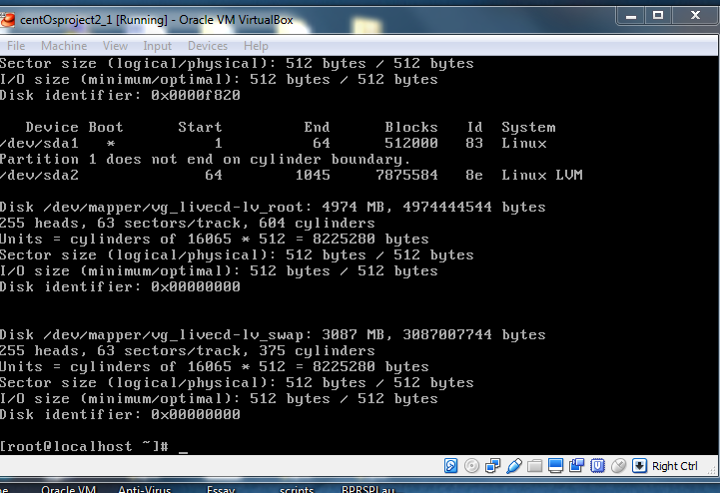

f- what is the dns on the server?

# cat /etc/resolv.conf

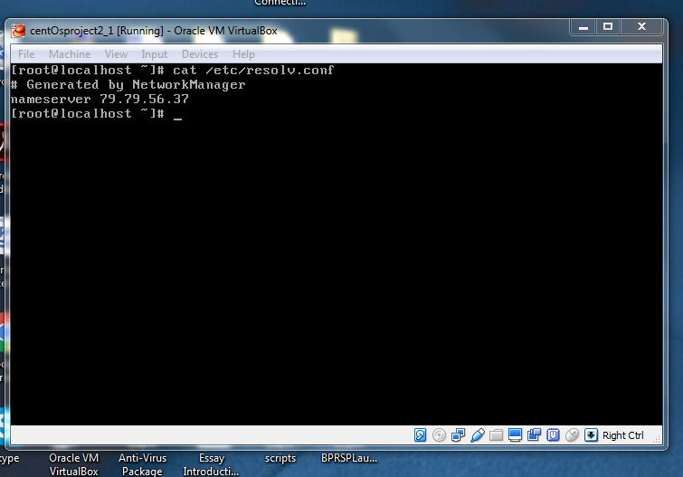

g- what is the hostname of the server?

#hostname or cat /etc/hosts

Uname -n

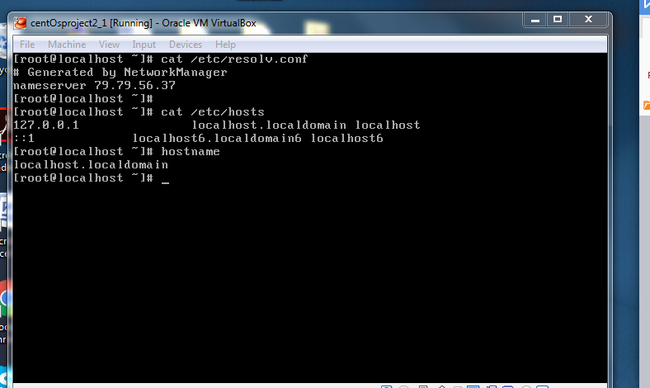

h- what the ip address?

#ifconfig

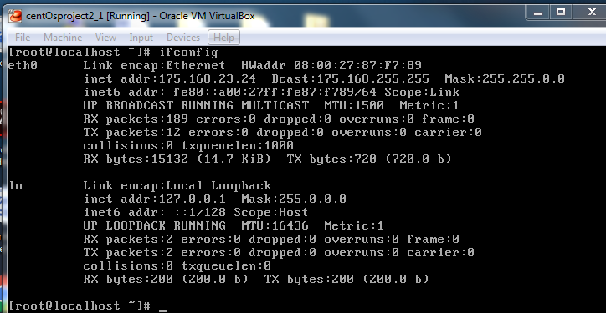

i- what is the default gateway on that server?

Cat /etc/sysconfig/network-scripts/ifcfg-eth0

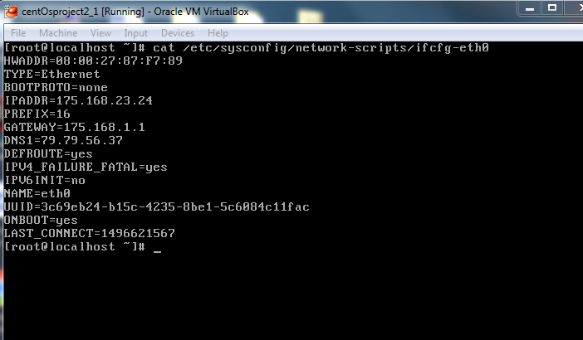

Or

#nm-tool

Or

#nm-tool | grep -I gateway

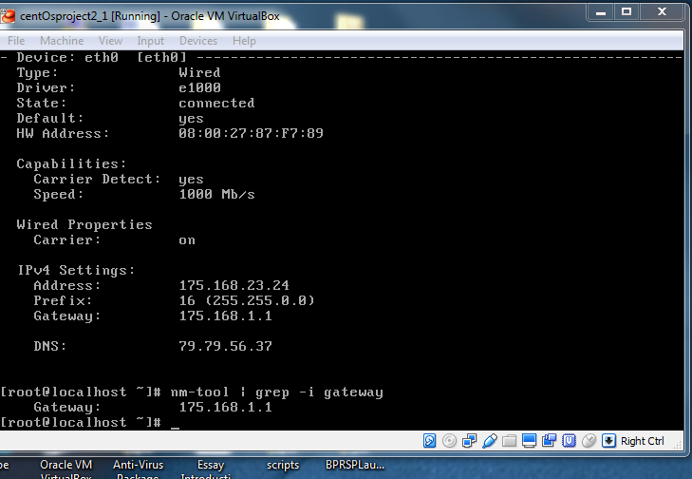

6- Describe the bootup process in linux.

1.BIOS. BIOS stands for Basic Input/Output System.

-Runs the POST, then locates the MBR

2. MBR. MBR stands for Master Boot Record located on the first sector of the hard drive, locates and executes the Grubloader or OS

3. GRUB. GRUB stands for Grand Unified Bootloader, it displays a splash screen with all the kernel available in the system

4. Kernel. Mounts the root file system as specified in the “root=” in grub.conf.

5. Init.Phase it identifies the default runlevel by reading the /etc/inittab file

6. Runlevel programs are executed from /etc/rc.d/rc\*.d

7- Please read the rest of definition from the general concept sheet.