Project13

1- What is a user account?

- Definition of: **user account**. **user account**. An established relationship between a **user** and a computer, network or information service. **User accounts** are assigned a username. Passwords are optional for computers and networks, but mandatory for registrations and subscriptions to online services.

2- what is a user's shell?

**Shell** is a user program or it's environment provided for user interaction. **Shell** is an command language interpreter that executes commands read from the standard input device (keyboard) or from a file. **Shell** is not part of system kernel, but uses the system kernel to execute programs, create files etc.

3- what is a user's home directory?

A **home directory**, also called a login **directory**, is the **directory** on Unix-like operating systems that serves as the repository for a **user's** personal files,**directories** and programs. It is also the **directory** that a **user** is first in after logging into the system.

4- create a user manolo with the uid of 33545

# useradd -c manolo -d /home/manolo -m manolo -u 33545

# id manolo

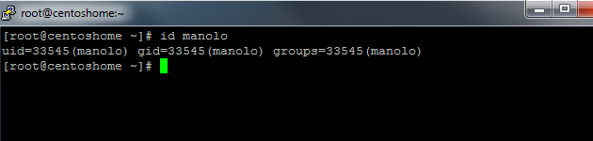

5- Create a group called sysmgrs

# groupadd sysmgrs

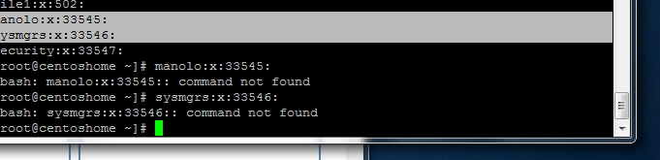

5- create a user sarah with sysmgrs as subgroup ( sarah's password is redhat)

# useradd -c sarah -d /home/sarah -m sarah -G sysmgrs

#passwd redhat

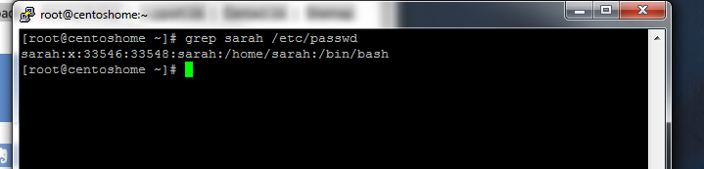

# id sarah -a

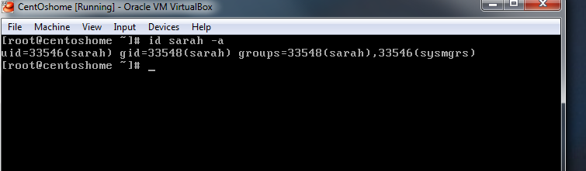

6- create a user natasha that can not access the shell

# useradd natasha -s /sbin/nologin

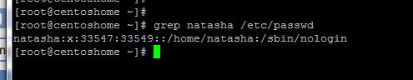

7- what is the permission 765 means?

= rwx rw- r-x

8- how do you check the permission on a file/directory?

# ls -l <file>

9- how do you check the owner of a file?

# id -a <user>

10- what command would you type to change the owner of a file?

# chown

11- what command would you type to change to group a file belongs to?

# groupmod

12- what is a softlink?

# # Softlink is a shortcut to a file or directory

A hardlink isn't a pointer to a file, it's a directory entry (a file) pointing to the same inode. Even if you change the name of the other file, a hardlink still points to the file. If you replace the other file with a new version (by copying it), a hardlink will not point to the new file. You can only have hardlinks within the same filesystem. With hardlinks you don't have concept of the original files and links, all are equal (think of it as a reference to an object). It's a very low level concept.

13- what is the difference between a symbolic link and a hard link?

Symbolic link is a special type of file that contains a reference to another file or directory as an absolute or relative path

14- user John and user jsmith are working on a same project and need to record their progress in the same file without accessing each other's home directory.

a- how can you help them with this?

= we can create a softlink so both users can have access to the project without interfering

b- consider that john's home directory is /home/ceo and that jsmith's home directory is /home/security, go ahead and right a procedure on how to accomplish that task.

#ln -s /home/ceo /home/security

# su to jsmith

# ll

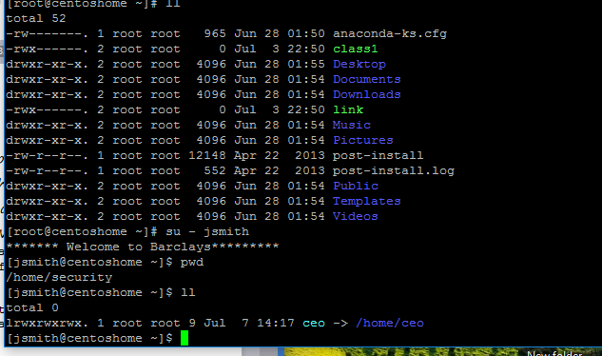

15- what command do you use to change the permission on a file.

# chmod <file>

16- what is an inode?

It is an identification number for each file and directory in a linux system.it comprises of detail information about the file and its owners.

17- how do you check the inode of a file?

# ls -li

18- set your homecentos to display the following message when the users login.

# vi /etc/profile

echo ***"This is a private computer system monitored 24/7, any unauthorized use will be subject to disciplinary mesure including job termination. If you do not have the proper authorization, please logout NOW!!!!***"

