Project14

1- what is sticky bit?

****Sticky Bit**** is mainly used on folders in order to avoid deletion of a folder and it’s content by other users though they having write permissions on the folder contents. If Sticky bit is enabled on a folder, the folder contents are deleted by only owner who created them and the root user. No one else can delete other users data in this folder(Where sticky bit is set).

2- what role does sticky play on a directory?

This is a security measure to avoid deletion of critical folders and their content(sub-folders and files), though other users have full permissions.

3- what directory on your server has sticky bit set on it?

# ls -l |grep tmp

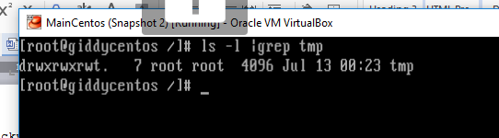

4- what is the difference between /usr/local/* and /usr/local*

5- what is ssh?

**ssh** (**SSH** client) is a program for logging into a remote machine and for executing **commands** on a remote machine. It is intended to replace rlogin and rsh, and provide secure encrypted communications between two untrusted hosts over an insecure network.

6- what is ssl?

**SSL** (**Secure Sockets Layer**) is the standard security technology for establishing an encrypted link between a web server and a browser. This link ensures that all data passed between the web server and browsers remain private and integral. ... To be able to create an**SSL** connection a web server requires an **SSL**Certificate.

7- why is putty considered secured?

# putty uses port 22, and messages via putty are encrypted.

8- what is selinux?

Security-Enhanced Linux (SELinux) is a security architecture integrated into the 2.6.**x** kernel using the Linux Security Modules (LSM). It is a project of the United States National Security Agency (NSA) and the SELinux community. SELinux integration into Red Hat Enterprise Linux was a joint effort between the NSA and Red Hat.

9- set your server's selinux to permissive mode

#getenforce

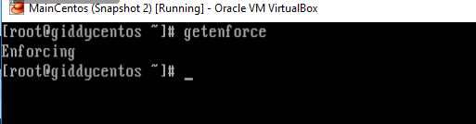

Vi /etc/sysconfig/selinux

To show the current mode of selinux

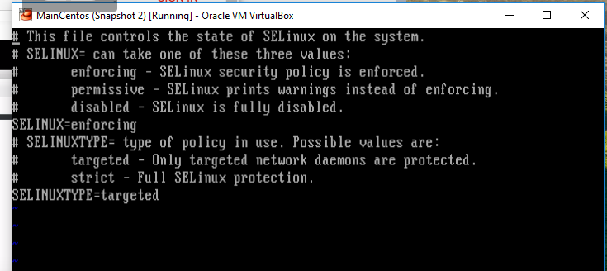

#setenforce

To get the mode

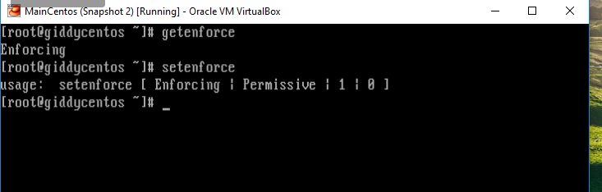

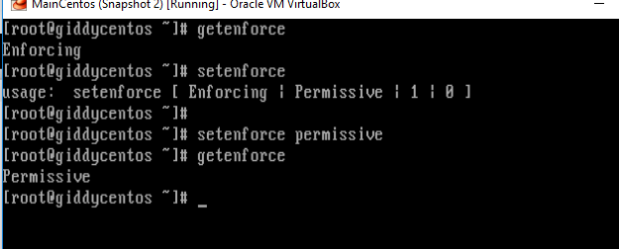

#setenforce permissive

10- Create a shared directory /home/managers with the following characteristics: /home/managers belong to group sysmgrs

This directory can be read, written and accessed by members of sysmgrs.

# mkdir /home/managers

#cd /home/managers

Any files created in /home/managers, the group is automatically set as sysmgrs

All other users should not be able to access (execute) the /home/managers directory. (The user root can always read and write, no matter the permissions)

11-what happen when you type a url on the browser until the page

1. browser checks cache; if requested object is in cache and is fresh, skip to #9
2. browser asks OS for server's IP address
3. OS makes a DNS lookup and replies the IP address to the browser
4. browser opens a TCP connection to server
5. browser sends the HTTP request through TCP connection
6. browser receives HTTP response and may close the TCP connection, or reuse it for another request
7. browser checks if the response is a redirect or a conditional response
8. if cacheable, response is stored in cache
9. browser decodes response (e.g. if it's gzipped)
10. browser determines what to do with response (e.g. is it a HTML page, is it an image, is it a sound clip?)
11. browser renders response, or offers a download dialog for unrecognized types

12- what is a three way hand shake?

A **three**-**way handshake** is a method used in a TCP/IP network to create a connection between a local host/client and server. It is a **three**-step method that requires both the client and server to exchange SYN and ACK (acknowledgment) packets before actual data communication begins.

13- what is the boot up process in linux?

- BIOS

- MBR

- Grub

- kernel

- Init

- Runlevel

14- how do you update the Os version of your linux server?

# yum update -y