Project15

1- what is the sed command ?

**ed** is a stream editor. A stream editor is used to perform basic text transformations on an input stream (a file, or input from a pipeline)

2- what is the awk command?

is a utility that enables a programmer to write tiny but effective programs in the form of statements that **define** text patterns that are to be searched for in each line of a document and the action that is to be taken when a match is found within a line.

3- what is the diff command?

**diff** analyzes two files and prints the lines that are different. Essentially, it outputs a set of instructions for *how to change one file to make it identical to the second file.*

4- sed command

a- create a test file with the content of passwd file,

#cp /etc/passwd test4

#vi test4

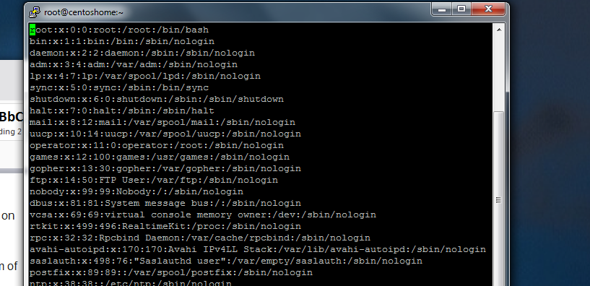

b- Type a single command to replace all the "nologin" by "bash"

#sed -i ‘s/nologin/bash/g’ test4

#vi test4 to verify

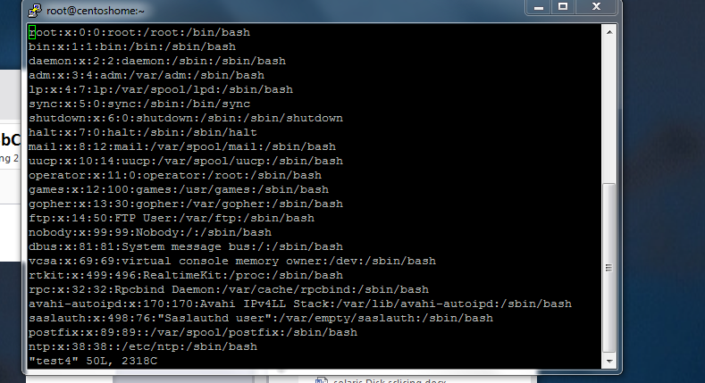

c- Type a command to insert "This file carries user accounts" at the top of your test file.

#sed -i ‘1i/"This file carries user accounts"’ test

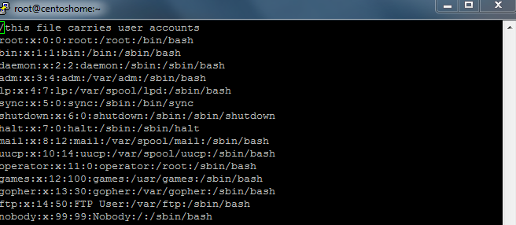

d- Type a command to insert "From here down are account created by the administrator"

right after the line with tcpdump.

5- Type a command to display the cpu size in MHZ ( you can filter the lscpu command to accomplish this.

#lscpu

#lscpu |tail -9 |grep MHz|awk ‘{print $2 “ “$3}’

MHz 2327.414

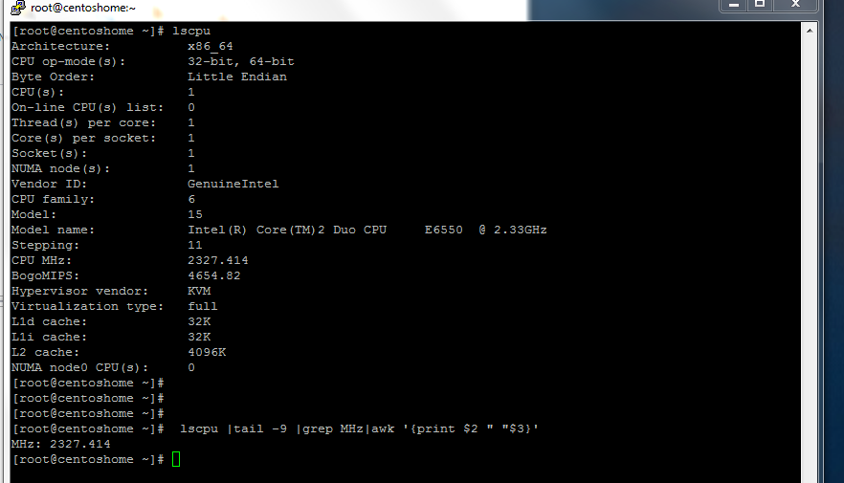

6- Type a command to display the total memory size ( just the size without any other output.

# free -m

# free -m |grep Mem| awk ‘{print $2}’

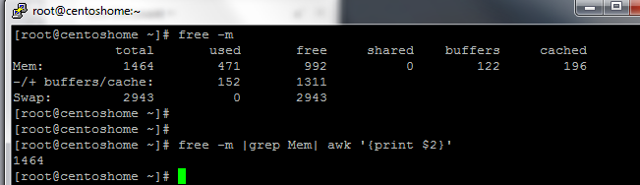

7- Type a command to display just the memory used

# free -m

#free -m |grep Mem| awk ‘{print $3}’

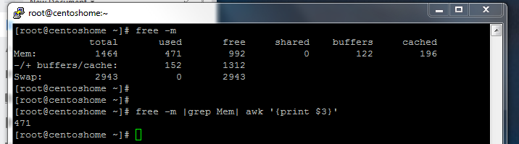

8- Type a command to display just the available memory

#free -m |grep Mem| awk ‘{print $4}’

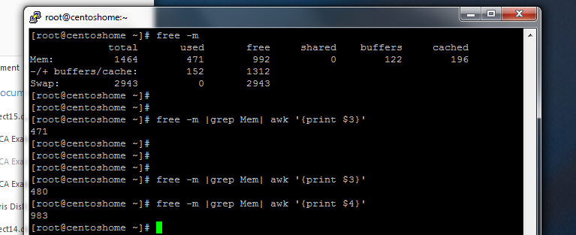

9- in which case do you use the diff command ?

The diff command used to check the difference between two files.

10- what is an inode and how do you checkt it ?

An inode is an identification number for each file and directory in the Linux system.

#ls -li

11- what is an exit code?

An exit code indicates is a command runs successfully or not

12- what is an exit code of 0 represent?

A 0 signifies a successful exit code

13- what is the sort command?

Sort command in unix or linux system is used to order the elements or text. Sort command has the capability of sorting numerical values and strings. The sort command can order the lines in a text file.

14- what command would you type to lock an account ?

# paswd -l <user>

15- what command would you type to unlock it?

# passwd -u <user>