Project16

1- What is ssh?

**SSH**, also known as Secure Socket Shell, is a network protocol that provides administrators with a secure way to access a remote computer. **SSH** also refers to the suite of utilities that implement the protocol.

2- What is the default port for ssh?

# port 22 is the defualt port for ssh

3- Can the default port be changed?

# it can be changed, but its not advisable

#**To Change the SSH Port for Your Linux Server**

1. Connect to your server via SSH (more info).
2. Switch to the root user (more info).
3. Run the following command: vi /etc/ssh/sshd_config
4. Remove # and change 22 to your desired port number.
5. Restart the sshd service by running the following command:
6. Service ssdh retart

4- What is the configuration file for ssh?

# .ssh

5- how do you check which port the ssh is configured on?

# more /etc/ssh/sshd_config

6- What is the difference between telnet and ssh?

**SSH** is a network protocol used to remotely access and manage a device. The key **difference between Telnet and SSH** is that **SSH** uses encryption, which means that all data transmitted over a network is secure from eavesdropping

**Telnet** is a protocol that allows you to connect to remote computers (called hosts) over a TCP/IP network (such as the Internet). Using **telnet** client software on your computer, you can make a connection to a **telnet** server (i.e., the remote host. The message is not encrypted

7- what is the command to keep ssh daemon on at next reboot?

# chkconfig sshd on

8- How do you disable root login thru ssh?

#vi /etc/ssh/sshd_config

**#PermitRootLogin yes**

Edit this to

**PermitRootLogin no**

Ensure that you are logged into the box with another shell before restarting sshd to avoid locking yourself out of the server.

**# /etc/init.d/sshd restart**

**Stopping sshd: [ OK ]**

**Starting sshd: [ OK ]**

9- Is it possible to login thru ssh without password? if no/yes why?

Yes you can access another system trough ssh without a password. If you

-Generate a public and private key which will give you access to the other system without a password

10- How do you set up a key based authentication thru ssh?

Login as a user

#mkdir .ssh

#chmod 700 .ssh

#Cd .ssh

#ssh-keygen

#hit enter x3

# ls to verify

11- what is a tar file?

# A tar command is used to rip a collection of files and directories into highly compressed archive file commonly call tarball or tar

12- What is the extention of a tarball file?

#.tar

13- what is gunzip?

#Is used to compress files

14- login to your server, create a tarbal file with the content of your home directory.

The tarball should be called yourname.tar

# tar -cvf gideonhome.tar /home

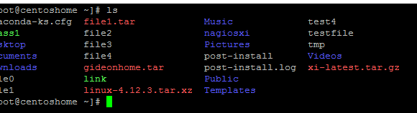

15- use gunzip tool to compress your tarball file.

# gzip gideonhome.tar

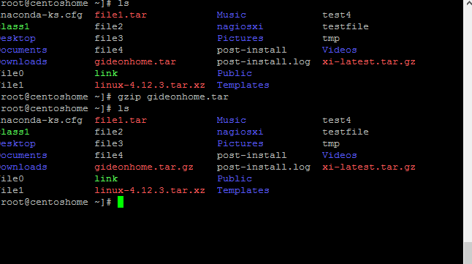

16- securely copy your compressed file to my server in /tmp (96.245.84.63 user=class3, passwd=school1)

# scp -r /gideonhome.tar.gz [class3@96.245.84.63:](mailto:class3@96.245.63:)/tmp

Use of -r because the tar.gz is not a normal file.

