**Project5**

**1- What is virtualisation?**

**In computing, virtualization refers to the act of creating a virtual (rather than actual) version of something, including virtual computer hardware platforms, storage devices, and computer network resources.**

**2- what are the two types of virtualisation thechnologies?**

**Type 1= Bare metal hypervisor**

**Type 2= Host Hypervisor**

**3- what is the difference between type1 and type2 hypervisor?**

**Type 1 hypervisors run directly on the system hardware. They are often referred to as a "native" or "bare metal" or "embedded" hypervisors in vendor literature**

**Type 2hypervisors run on a host operating system. When the virtualization movement first began to take off, Type 2 hypervisors were most popular.**

**4- what are some examples of type1 hypervisor OS ?**

**Citrix**

**Vmware workstation**

**Redhat virtual machinwmicro**

**KVM= kernel virtual machine**

**OVM= Oracle virtual machine**

**5- what are some advantages of virtualisation for companies ?**

**Advantages of Virtualization. The advantages of switching to a virtual environment are plentiful, saving you money and time while providing much greater business continuity and ability to recover from disaster. Reduced spending. ...Virtualizing requires fewer servers and extends the lifespan of existing hardware.**

**Save Space**

**Transportation**

**Save power**

6- create a VM in your virtualbox with the specs below:

name : homecentos

memory: 1500

Hard drive 25G

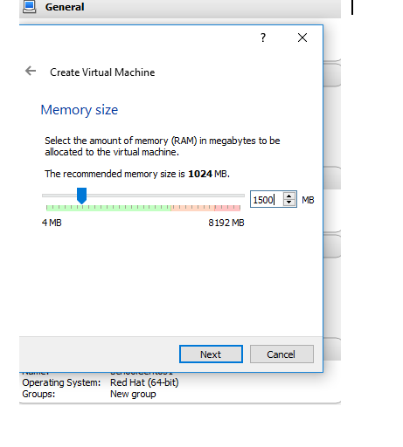

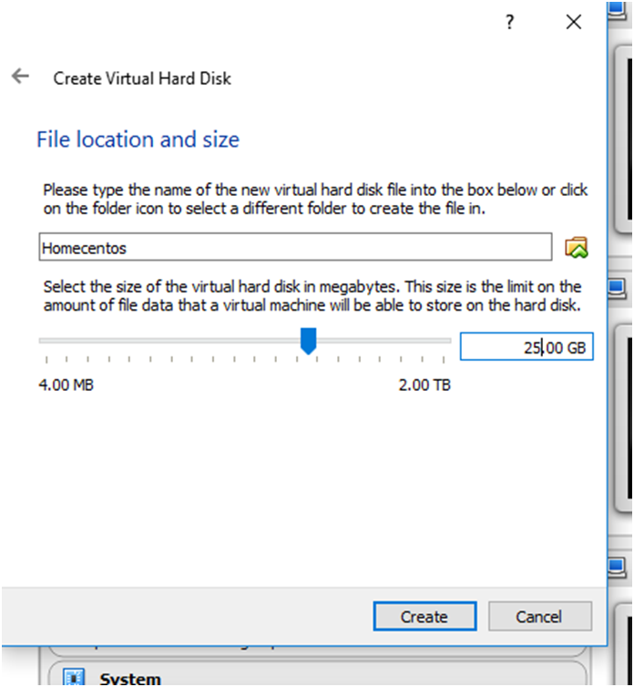

bridge the network , attach the centos iso image to it and install it.

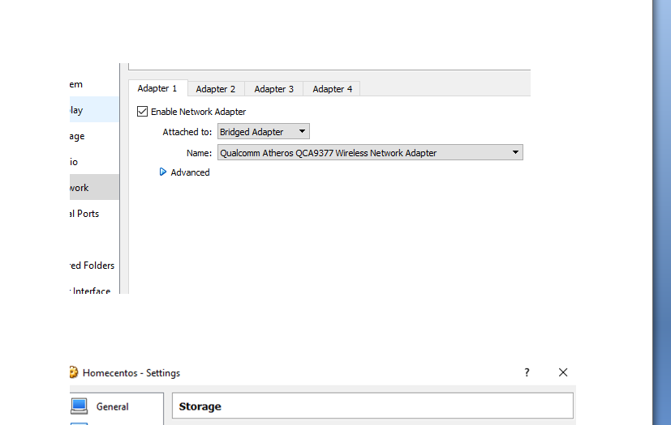

7-login to your newly installed server and create an account called john

with password = school1

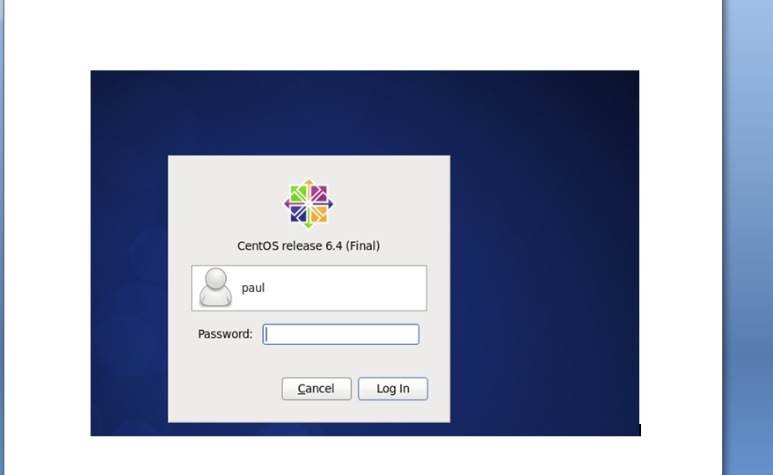

8-login as john and answer below questions

a- where are you in the server?

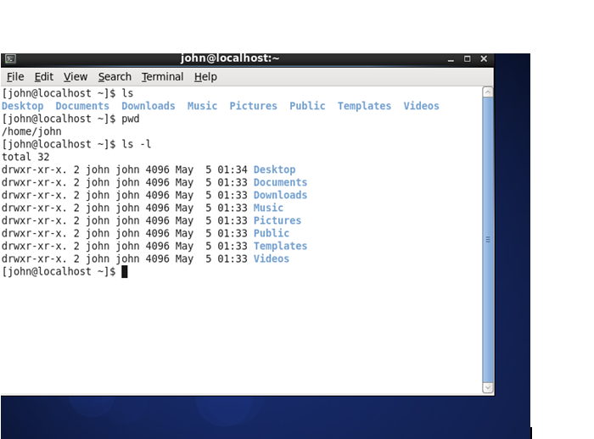

b- how many directories are in the directory where you are ?

=8

c- create a directory called finance

Mkdir finance

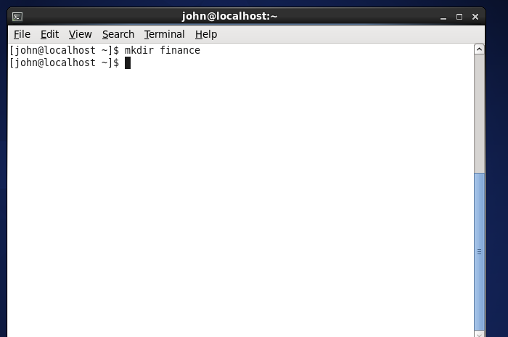

d- in finance , create a file called review

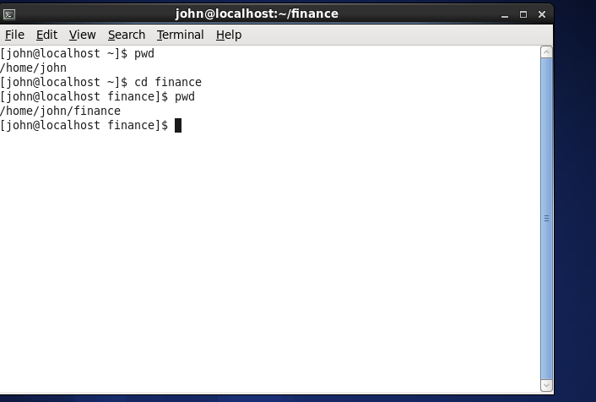

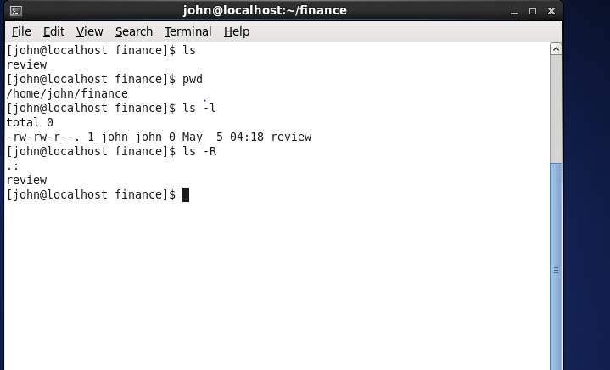

Vi review

e- put this message into the file review: "Linux is one of the best and easy software ... I cant believe I

understand it very well"

"The next goal is to have fun while making the big $$$$"



f- type a command to check the content of review

# head review or cat review

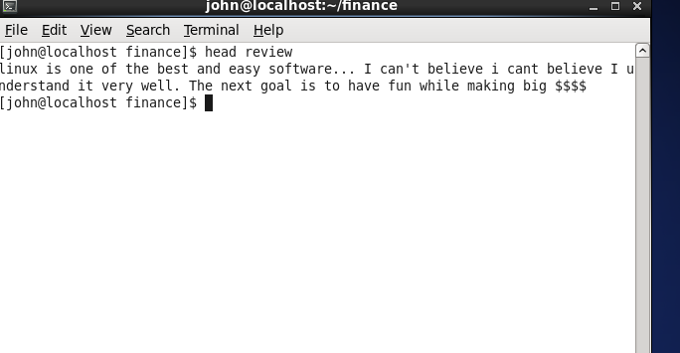

g- how long the server have been up?

$ uptime

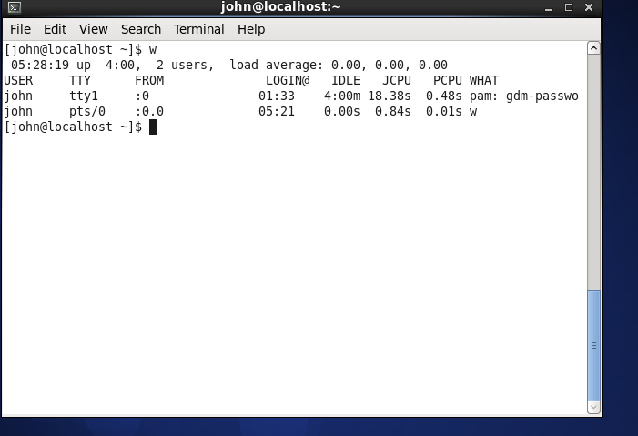

h- check the date on the server

$ date

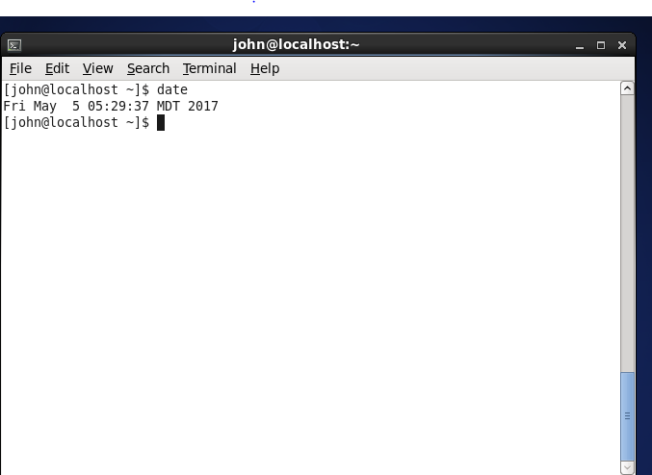

i- check the time on the server

$ date

j- check the ip address of your server

$ ifconfig -a