Project6

1- Definition

a- what is a PATH?

This is the user’s binaries.

#Usr/bin is for regular users

#usr/sbin is for super users

b- what is a path?

It is the route to a file or directory

c- What is ssh?

It is refereed to as secured shell.

It is a method for secure remote login from one computer to another.

d- What is putty?

**PuTTY** is a free and open-source terminal emulator, serial console and network file transfer application. It supports several network protocols

2- there is a file on your homecentos called secure

# locate secure

Or find / -name secure

a- what is the path to that file?

# /var/log/secure

b- create a copy of that file and name it secure_backup

# cp /var/log/secure secure_backup

c- In the /var/log directory, type a command to count the total number of

files and directories present.

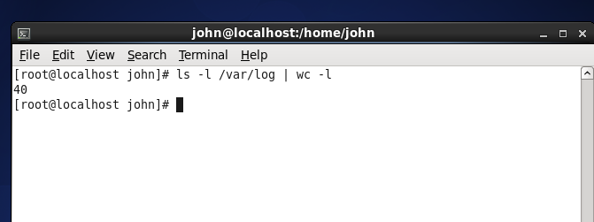

d- type a command to put the content of the file secure into another file called logmessage.

# # cat /var/log/secure >> logmessage

e- add the content of the file /etc/selinux/config into the same file (logmessage)

# cat /etc/selinux/config >> logmessage

f- type a command to filter all the string login from the file secure.

# grep string login secure

g- rename the file logmessage to logm

#mv logmessage logm

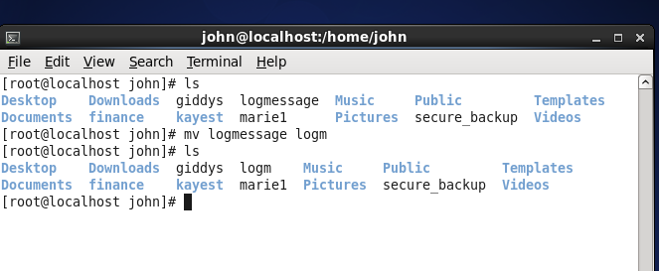

3- What is your best command ? ( explain why?)

# ls command

4- how do you create an empty touch ?

# touch

5- How do you create an empty directory?

# mkdir

6- whatch the video about vi editor in your video folder and practise.

( you can put the content of /etc/passwd in a new file and use that file for vi practice)