Project 8

1- what is a run level ?

It is a mode or state in which the Linux Server can be boot-up.

2- What is a default runlevel?

The Runlevel that the system is set at

3- What is the advantage of having different run levels?

4- What commands would you type to check the runlevel?

# runlevel

# who -r

5- what is the difference between run level 3 and runlevel 5?

Runlevel 3 runs without the GUI wheile Runlevel 5 runs with the Gui

6- why do you think companies prefer runlevel 3?

-Its faster to bootup the system

7- what is the difference between runlevel 1 and runlevel 2?

-The are both maintainance mode

-runlevel 1, only the root can login

-In runlevel 2 login is available and some services are turned on

8- what is the different between the present runlevel and the default runlevel?

-present runlevel is the run-level choosed by the user.

-default runlevels are the runlevels that came with the machine

9- how do you check the default runlevel on your system?

# cat /etc/inittab

10- where does the system checks for the default runlevel ?

- the ****/etc/inittab**** file

11- a client complains that the system is booting up but is staying in maintenance mode

12- what can be the problem?

- System is stuck in runlevel 1

Might be problem with default runlevel

Type init 3

13- How can you fix this problem?

# vi /etc/inittab

Change the id:1:initdefault to id:3 or 5:initdefault

14- consider you are on run level 5 , how do you change your system temporaly to runlevel 3?

# init 3

Vi /etc/inittab

Change to id:3:initdefault

15- One of your company clients is reported to have some issues with a server and you are assigned to the task .

a- import the prebuild CentOSproject.ova server from ftp://96.245.84.63/software/servers/ ( username=class3 password=school1 )

b- bridge the network on the imported server

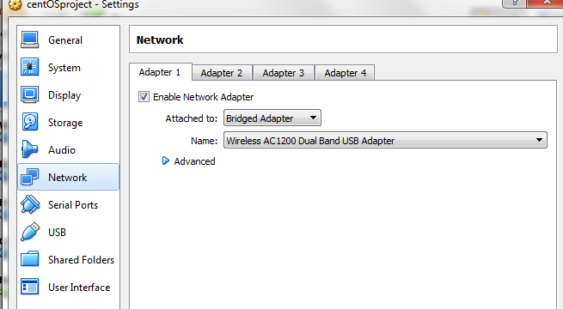

c- the server is having bootup issue please troubleshoot

d- What is the issue?

-Maybe the default runlevel has a problem

- probably in run level 0

e- how would you fix it ?

- Boot the server to a single user mode

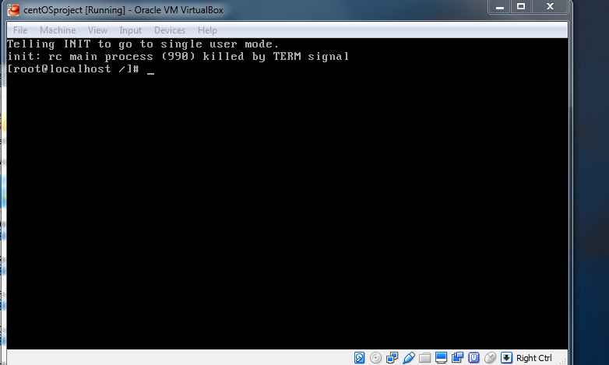

# vi /etc/inittab

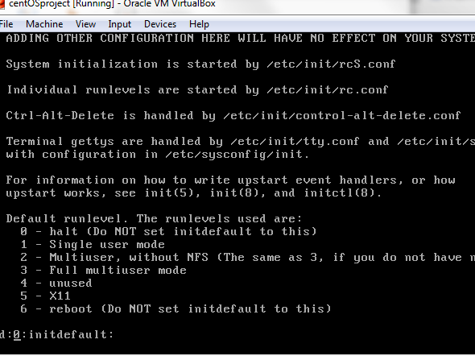

# change 0 to 3 to get to runlevel 3

f- Nobody is able to remember the root password. Go ahead and change the root password

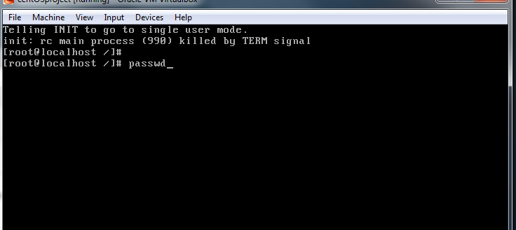

g- which file does the system checks for the default run level?

# the inittab file

h- type a command to check the version of the OS running on that system ?

# lsb_release -a

#cat /etc/issue

i- type a command to check the size of the cpu

# lscpu

j- type a command to check how many cpus the system has

#nproc

k- type a command to check the size of your hard drive

# fdisk -l

l- disable the GUI on the server permenently

# vi /etc/inittab

Id:3:initdefault

m- type a command to check if the system is 32 or 64 bits.

# getconf LONG_BIT

n- type a command to check the kernel version

# uname -r

To know if it is the most current version

o- type a command to check the memory size

# cat /proc/mominfo

# netstat -I

# free -m

p- type a command to check the default runlevel

# cat /etc/inittab

q- what command would you type to check the network interface on your

system ?

# ifconfig -a

r- put the content of grub.conf and messages file into a new file called text.

#finf / -name messages

# cat /etc/grub.conf >> text

# cat /var/log/messages >> text

s- type a command to check the size of text

# ls -lh text

t -Move the file text to the directory /tmp

# mv text /tmp

u- your colleague need to access the file text , go ahead and give him the path to text.

Give the server name

# /tmp/text

v- in /var/log directory, create a directory called log1 in log1 create

# cd /var/log

# pwd

# mkdir log1

# cd log1

a directory called ssi in ssi, create another directory called ret

# mkdir ssi

# ls ssi

# cd ssi

# pwd

# /var/log/log1/ssi

# mkdir ret

# ls

w- take a backup of the file messages , called it message.bak and put it in the newly created ssi directory.

# cp /var/log/messages mesaages.bak (already in the path)

or

# cp /var/log/messages /var/log/log1/ssi/message.backup

x- take a backup of the file /var/log/secure , called it secure.$(date +%F) and put it in the newly created ret directory.

# date +%F

# cp /var/log/secure secure.bk$(date +%F)

y- Please provide the path to both backup files

#/var/log/messages messages.bak

#/var/log/secure secure.bk

Or

#/var/log/log1/ssi/ messages messages.bak

#/var/log1/ssi/ret/secure secure.2017.06.03

z- What are some directory that you know in / (root) ?

Dev, home, usr, etc, lib, sbin, tmp

16- What is your greatest challenge?

-To remember some of the commands

-the problem

-the action taken

-the result

--outcome