Project 9

One of your client have received new servers that need to be introduced in their network and you are assigned to the task.

1- Download and then import the prebuilt CentOSproject2.ova server from ftp://96.245.84.63/software/servers/ ( username=class3 password=school1 )

a- bridge the network

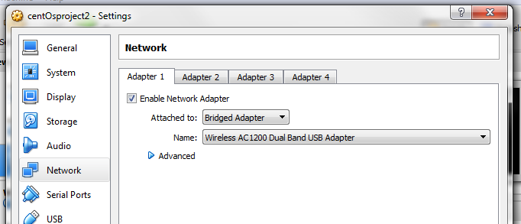

b- introduce the server to your home network ( you will need to check your

home network to get all the information/component you need. also choose an ip base on your home network. the hostname should be pvlva234 )

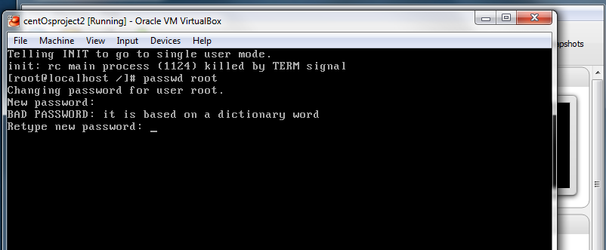

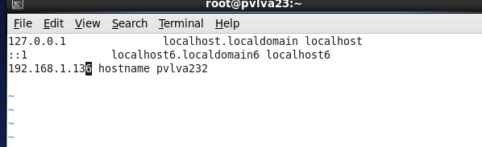

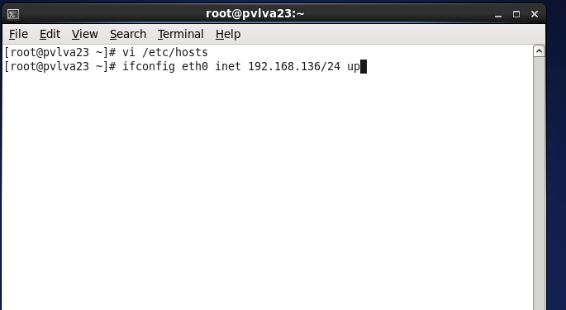

c- make sure it can ping other devices in the network

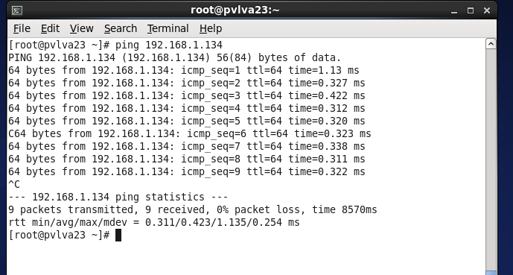

d- make sure you can ping the server from other devices

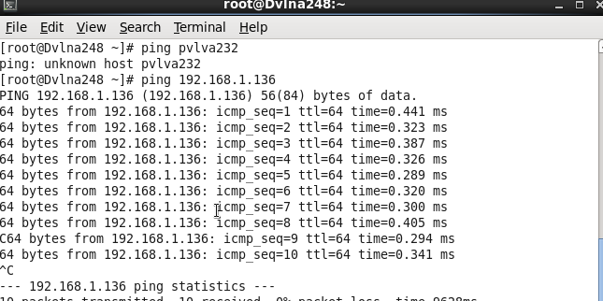

e- make sure the server can communicate with google.com

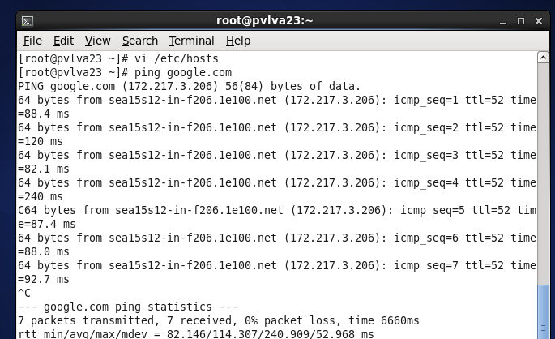

2- Check the Os version and then update it to the latest version.

#lsb_release -a

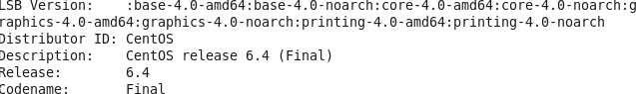

#yum update -y

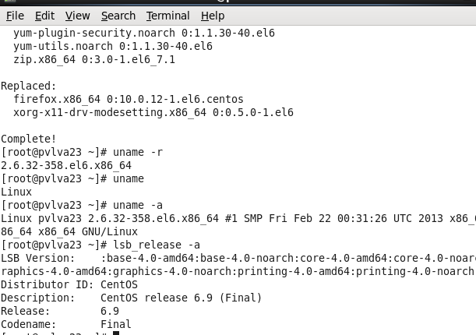

3- Check the new Os version and comment.

Changed from 6.4 to 6.9

4- In which file do you configure the dns?

In the # etc/resolv.conf file

5- What is your weakness?

I usually want to solve a problem before I take a break.

Note

I noticed if I boot the system to init 3 connection gets missing, but back to init 5 it works, I can putty, ping in and out of the system.

