project7

1- Define :

a- Unix UNIX is a group of Operating Systems (OS) with a Similar Kernel.

b- Kernel

the UNIX kernel is the heart (core)of the UNIX OS.

c- GUI

Graphical User Interface

d- Linux

Linux is an OS just like windows

e- Open Source **pen**-**source** software (OSS) is computer software with its **source**code made available with a license in which the copyright holder provides the rights to study, change, and distribute the software to anyone and for any purpose

2- What are some unix flavors?

SunoS - Solaris

HP UX

AIX - IBM

Mac Os - Apple

3- Who are the unix founders ?

Ken Thompson and Dennis Ritchie

4- what are some devices that runs linux?

-

5- who is the linux founder?

Linus Torvalds,

6- is linux an open source software?

Yes

7- One of your colleague complains that there is a service that goes off everytime the server reboot.

a- what can be the problem?

b- consider that the service or daemon in question is httpd , what command would you type

to keep it on when the server reboots?.

# chkconfig httpd on

8- For users to be able to access a server remotely, we need to setup that server to accept putty

= ssh connection.

a- what is the daemon that enables the putty connection?

= sshd

b- how do you check if it is running?

# service sshd status

c- check your homecentos's sshd

d- start it and make sure it stays on at next reboot.

# chkconfig sshd on

e- type a command to verify that the sshd daemon is permenently turn on.

Chkconfig sshd -- list sshd

f- login to your homecentos though putty.

g- from putty, create two accounts one for student and one for student1 ( give them redhat as password)

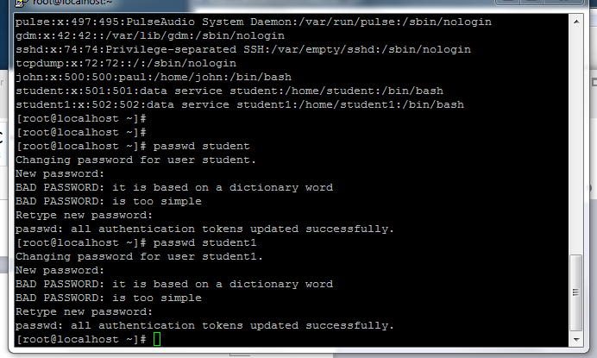

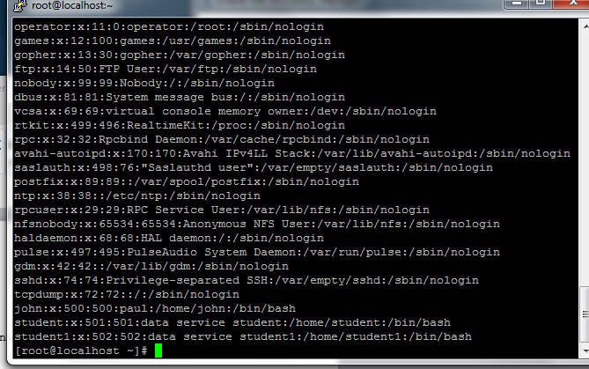

h- what is the content of the file grub.conf?

#cat /etc/grub.conf

