Part B: Basic Navigation Commands
1. pwd
Purpose
The pwd (Print Working Directory) command displays the complete path of the current directory in which the user is working. It helps users identify their current location within the Linux file system.
Screenshot:
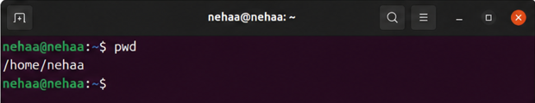

2. ls
Purpose
The ls (List) command displays the files and directories present in the current directory. It is commonly used to view the contents of a folder.
Screenshot:
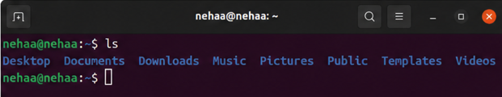

3. ls -la
Purpose
The ls -la command provides a detailed listing of all files and directories, including hidden files. It displays file permissions, ownership information, file sizes, and modification dates.
Screenshot:

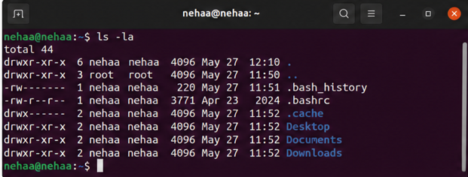
4. cd
Purpose
The cd (Change Directory) command is used to navigate between directories in the Linux file system. It allows users to move into a directory or return to a previous location.
Screenshot:
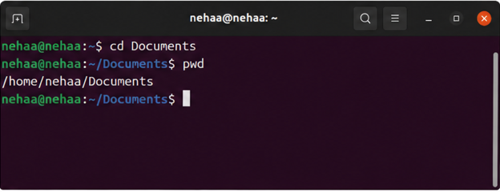

5. clear
Purpose
The clear command removes all previous output from the terminal screen and provides a clean workspace. It does not delete any data or commands.
Screenshot:
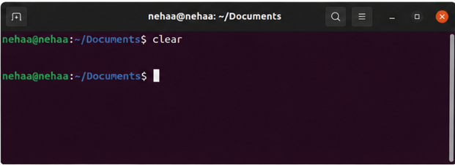

6. history
Purpose
The history command displays a list of commands that have been executed previously in the terminal session. It helps users review and reuse past commands.
Screenshot:
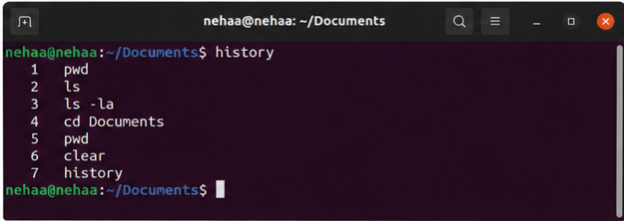
7. whoami
Purpose
The whoami command displays the username of the currently logged-in user. It is useful for verifying the active user account.
Screenshot:
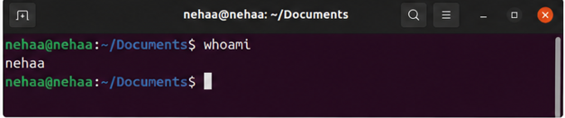
8. hostname
Purpose
The hostname command displays the name assigned to the Linux system. The hostname is used to identify the device on a network and distinguish it from other systems.
Screenshot:
