Introduction/Business Problem:

San Francisco crime statistics report an overall upward trend in crime based on data from 17 years with violent crime increasing and property crime increasing. Based on this trend, the crime rate in San Francisco for 2019 is expected to be higher than in 2016. This is as per report published at <https://www.cityrating.com/crime-statistics/california/san-francisco.html>.

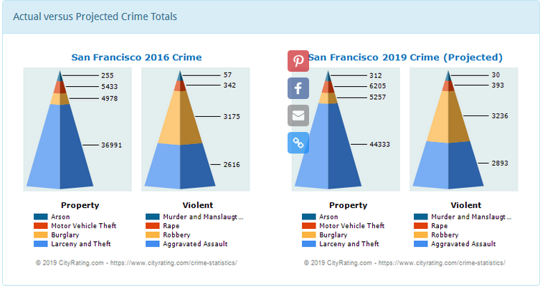

San Francisco has several police districts with varied types of crime in each district. This Project will attempt to address the trend in the top neighborhoods on crime categories so that the San Francisco police department can focus on the neighborhoods that have the highest crime and focus on the top crime categories by creating task forces to address the crime.