Contents

Introductions 2

The basics 2

In the dungeons 3

The Towns 4

Equipment 5

Potions 6

Bonus Mode 7

Keys Summary 7

Stack n’ Stash, a commentary

By Bill Board

# Introductions

G:\sdd year 12\SDD major work\project\sprites\signpost.png

# The basics

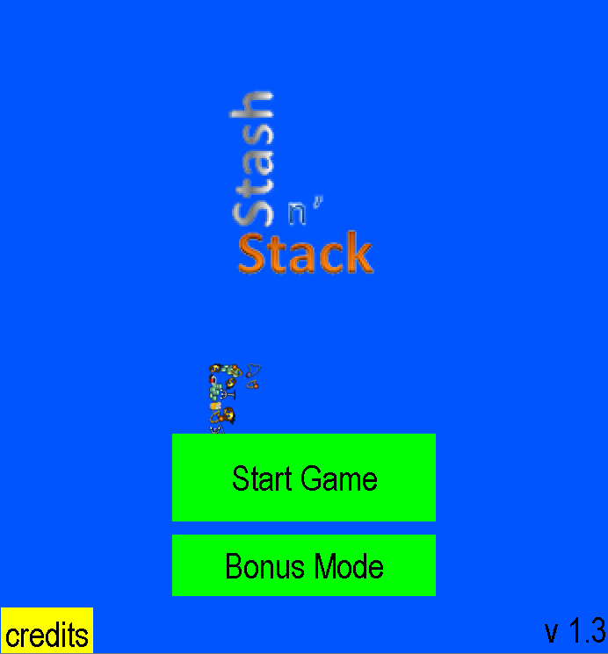

# 

# In the dungeons

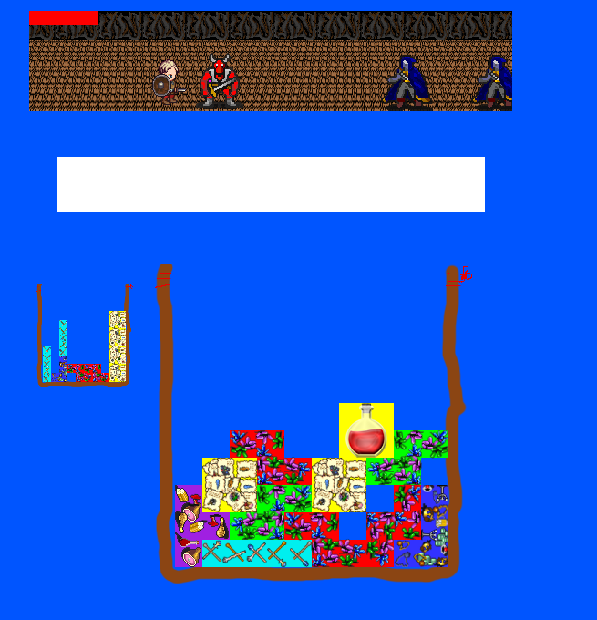

# 

# The Towns

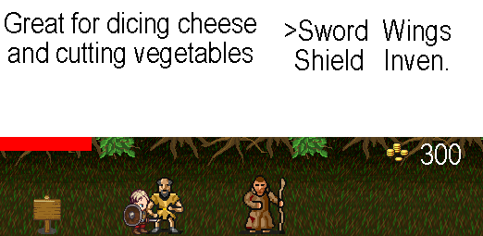

# Equipment

|  |  |  |
| --- | --- | --- |
| G:\sdd year 12\SDD major work\project\sprites\sword.png | The sword | Boosts Attack |
| G:\sdd year 12\SDD major work\project\sprites\shield.png | The Shield | Boosts Defence |
| G:\sdd year 12\SDD major work\project\sprites\Wings.png | A pair of wings | Boosts speed and also makes you walk faster |

# Potions

|  |  |
| --- | --- |
| G:\sdd year 12\SDD major work\project\sprites\Potions\empty.png | Empty bottle. Can be filled with any other potion. Does nothing by itself |
| G:\sdd year 12\SDD major work\project\sprites\Potions\red.png | Red Health potion. Restores 15 HP instantly. |
| G:\sdd year 12\SDD major work\project\sprites\Potions\purple.png | Purple Love potion. Increases Attack by 6 for 30 seconds. |
| G:\sdd year 12\SDD major work\project\sprites\Potions\green.png | Green Stench potion. Increases Defence by 6 for 30 seconds. |
| G:\sdd year 12\SDD major work\project\sprites\Potions\yellow.png | Yellow Laxative potion. Increases Speed by 6 for 30 seconds. |

# Bonus Mode

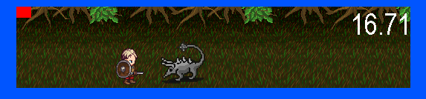

# Keys Summary

|  |  |
| --- | --- |
| Q and W | Rotate the selected block 90 degrees clockwise for W and anti clockwise for Q |
| A and S | Move the inventories left with A and right with S |
| Z | Talk to NPC or select option |
| X | Stop talking with NPC |
| E | Equip an equippable item |
| R | Use a potion or fill an empty bottle |
| T | Trade item with merchant |
| G | Sell everything in selected inventory |
| Delete | Remove block from inventory |
| Arrow keys | Move around in towns, select options in conversation and move around in Bonus mode |
| Space bar | Attack in bonus mode |
| Escape | Exit the credits back to the main menu |