| **Title:** |  |
| --- | --- |
| **SubTitle:** |  |
| **shortTitle:** | CuriousMinds_dye |
| **Module:** |  |

| **Est. Time:** | 2 x 45min |
| --- | --- |
| **For Grades:** | Year 9-10 (i.e. US G8-9); Level 4 or 5 |
| **Target Subject:** | Science (Chemical Engineering) |
| **Lesson Hook:** | Clothing color audit.  Maybe have students quantify colors found in clothing, backpacks, shoes, socks, etc. to? What would it be like if we couldn’t express ourselves with color choices? Maybe have small group discussions about pros and cons of uniformity. (If students have uniforms…maybe why that is good or bad and how students find other ways of self-expression). |
| **Driving Question(s):** | How do/did chemical engineers, Maori weavers, and Ancient Greeks produce pigments for textiles? |
| **Essential Question(s):** | What is gained or lost by these different approaches |
| **Learning Objectives:** | * Understand that chemical engineers develop economical commercial processes to convert raw material into useful products. * Compare and contrast the costs and benefits of synthetic vs natural dye production. * Relate the observed characteristic chemical and physical properties of a range of different materials to technological uses and natural processes. |
| **Tags (up to 10):** |  |

### Guiding Notes from Client (Matt C.)

| Module content/flow:  1. Aim: engagement and cultural relevance  - Examples of how natural product dyes are produced  - By Maori (e.g. traditional) and in Europe (e.g. Tyrian purple).  - Labour/energy intensive, variations in product quality, reliance on natural resources.  - Social and cultural connotations, i.e. availability, wealth, special uses, protected knowledge, connection to natural resources (appreciation and extinction).  2. Aim: benefits of chemical engineering  - Examples of chemical processes to produce dyes:  - By chemical synthesis: optimized for time and resource efficiency.  - By biochemical synthesis (trained bacteria): optimized for time and resource efficiency.* Maybe not for dyes, better for medicine module.  - Social and cultural connotations, i.e. availability, wealth, loss of 'special' uses, open/protected knowledge, disconnection from natural resources (appreciation and extinction).  3. Aim: Hook for students, ability for them to create whatever is important for them.  - Help them feel empowered and like they could do what's important to them, e.g. sustainability, resources available to all, moving from material poverty.  4. Convert students to chemical engineering at university.  - What do they need to study? |
| --- |

### Standards alignment notes:

| [NZ Curriculum](https://nzcurriculum.tki.org.nz/The-New-Zealand-Curriculum#collapsible14)  We should probably aim to align with achievement goals for Level 4 and/or 5.    * Chemistry & Society: “Relate the observed characteristic chemical and physical properties of a range of different materials to technological uses and natural processes.” P 24/51 |
| --- |

### 

### General Notes

| Matt W:   * Make it relevant to Maori: bring in a knowledge holder (a weaver) * Maybe we'll try to find some reading about weaving and dying in Maori community. * Build lesson around that. * Look at traditional dying in NZ and other parts of the world   + Ancient greeks   + color festivals in India * Compare to industrial processes   + democratization   + do colors lose cultural significance?   + remove depth of experience and cultural significance? (no artisanal or ritual practices, nor like affluence respect connotations) * Key: Why is chemical engineering important? How do you get on the engineering train? * Ending Call-to-Action: You grow up and become a chemical engineer & create more sustainable dyes. And here’s how you could do that… |
| --- |

**Notes on Culturally Responsive Design Principles (Te Hurihanganui)**

| from: [Te Hurihanganui](https://www.education.govt.nz/our-work/overall-strategies-and-policies/te-hurihanganui/) (the NZ Ed overhaul to “design an approach to  address bias, strengthen equity and accelerate educational  achievement and wellbeing of ākonga Māori.” The name comes from the Maori creation story.    [**More Details here on Te Hurihanganui**](https://assets.education.govt.nz/public/Documents/our-work/Te-Hurihanganui/f-MOE19458-Te-Hurihanganui-Blueprint-Full-PRINT.pdf)  **Particularly relevant design goals:**   1. allow ākonga Māori to see themselves strongly represented throughout the curriculum, including in readers, journals, and assessment tools 2. reflect both Māori and Pākehā (white NZers) worldviews, and don’t overrepresent the latter |
| --- |

**Contacts for follow-up:**

* Paula Rigby- lives in Christchurch; an expert weaver, dyer; harakeke

## Resources:

#### Culturally Responsive Teaching

* **[Guide to Supporting Akonga Maori](https://inclusive.tki.org.nz/guides/supporting-akonga-maori/)** (Watch [the video](https://www.youtube.com/watch?v=5cTvi5qxqp4)) If you’re short on time, ~26min is especially relevant
  + at 51:00
  + 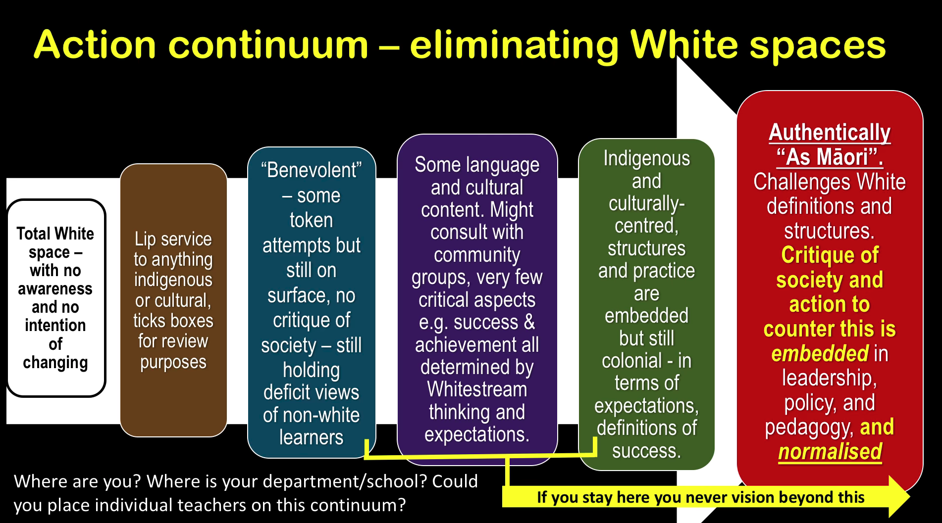
* [Traditional Dyeing practices](https://agestewart.wordpress.com/category/traditional-dyeing-process-2/)
* [Harakeke](https://www.doc.govt.nz/nature/native-plants/harakeke-flax/) (New Zealand Flax; used for weaving)
* [Te Reo Maori Dictionary](https://maoridictionary.co.nz/search?idiom=&phrase=&proverb=&loan=&histLoanWords=&keywords=Whakatauk%C4%AB)

#### Background on Dye

* [Where synthetic dyes come from](https://www.fsw.cc/where-synthetic-organic-dyes-from/)
* [Teri dye (used by Maori) information](https://teri-dyes.co.nz/)
* [kinda activist Medium piece about natural vs. synthetic dyes](https://medium.com/climate-conscious/just-by-looking-at-their-colour-can-you-tell-if-clothes-are-sustainable-cb5d47fd61fe)
* <https://goodonyou.eco/natural-traditional-and-diy-dyes-from-around-the-world/>

### Te Reo Maori Vocab

Māori (te reo) vocab: ([Dictionary link](https://maoridictionary.co.nz/search?idiom=&phrase=&proverb=&loan=&histLoanWords=&keywords=kia+ora))

accentuate/draw out accented syllable

* ākonga: student(s)
* ao: 1. v. to dawn; 2. adj. bright; 3. n. world, globe, global; 4. n. Earth
* Aotearoa: New Zealand
* haere rā: bye (said to someone leaving)
* [harakeke](https://www.doc.govt.nz/nature/native-plants/harakeke-flax/): flax
* tamariki: children (younger than rangatahi)
* kaiako: teacher, instructor
* kaiārahi: (noun) guide, escort, counsellor, conductor, leader, mentor, pilot, usher.
* karakia: incantation, ritual chant, chant, intoned incantation
* kaupapa: 1. level surface, floor; 2. topic, policy, subject, program
* kia ora: hello, cheers, good luck, best wishes
* kōrero: to tell, say, speak
* mahi raranga: work of baskets (weaving)
* mana: 1. v. to be legal/valid; 2. n. prestige, authority, control, power, agency
* mana ōrite: equality
* [mātanga](https://maoridictionary.co.nz/search?idiom=&phrase=&proverb=&loan=&histLoanWords=&keywords=M%C4%81tanga): 1. (modifier) sophisticated, experienced, skilled.; 2. (noun) experienced person, expert, specialist, consultant, professional, practitioner, old hand, analyst.
* mātauranga: knowledge, wisdom (education)
* nga mihi: acknowledgments
* muka: prepared flax fiber for weaving
* [Pākehā](https://maoridictionary.co.nz/search?idiom=&phrase=&proverb=&loan=&histLoanWords=&keywords=P%C4%81keh%C4%81+): adj. foreign; noun, New Zealander of European descent (contrast with Tauiwi)
* rangatahi: youth (e.g. high schoolers) (older than tamariki)
* [tauiwi](https://maoridictionary.co.nz/search?idiom=&phrase=&proverb=&loan=&histLoanWords=&keywords=tauiwi): foreigner, outsider
* te: 1. (determiner) the (singular) - used when referring to a particular individual or thing; used like the article "the", but can also be like Sir or Mr.
* te ao Māori: Māori knowledge, values
* and beliefs
* [whānau](https://maoridictionary.co.nz/search?idiom=&phrase=&proverb=&loan=&histLoanWords=&keywords=whanau): extended family, family group, a familiar term of address to a number of people - the primary economic unit of traditional Māori society
* [Whakataukī](https://maoridictionary.co.nz/search?idiom=&phrase=&proverb=&loan=&histLoanWords=&keywords=Whakatauk%C4%AB): proverb

## **Loose Structure**

* Ship without videos…then add videos.
* Selling point to hit on throughout: Chemical Engineering is about 1) solving problems, 2) optimizing systems for public benefit (sustainability), 3) potentially reconciling inherent conflicts between society and technology

## Pitch Bullets

**What’s the point?** Get kids to see and understand that chemical engineering is a career where people design systems that convert raw materials into products that make people’s lives easier and better.

**How do we get them interested?**

1st engagement strategy: is a color audit of their own clothes (take advantage of inherent self-interest, hehe) to reflect on the meaning of color and the ability to express oneself through textiles.

2nd engagement strategy: Analysis of 3 super well crafted narratives highlighting different technologies throughout history that enabled people to express themselves with different dye colors (Maori, Ancient Greek Tyrian purple, and mauveine invented by an 18 year old by accident…you could be the next William Henry Perkin )

3rd engagement strategy: Put them in the driver’s seat making decisions and designing solutions. Product is a fashion line that implements one of the dyeing technologies, requiring them to do unit conversion, analyze graphs and calculate efficiencies to defend their system choices.

**What will they be learning?**

Paired-down chemical engineering process laying out the inputs, dye process, and outputs in context to resources, times, and energy.

Student’s will take on the role of the chemical engineer in terms of looking at different technologies and what new thing we would to optimize that process for their own fashion line.

What types of classes they would need to take in High school to get them on that career path

-----

Day 1: Engagement Hook and immersion in systems thinking related to dye production

**Warm-Up**

Color audit: students collect data (put a 1 in the box of the nearest color on the chart below and add up the rows to get sub-dyeversity indices (e.g. Shirt index) and then add up for a total.



* 1. Presentation prompts/explains warm-up activity.
  2. Then have Share Out CTA (call to action). Who had the highest/lowest scores? Why did you choose these colors/ just this color?
  3. Rhetorical question, how many of these are uncolored/natural materials (harakeke, wool, cotton, leather, canvas?) Give image examples showing irregularity, colors, etc. of natural materials.
  4. All the others are made possible by dyes.
  5. ppt slide with historical and contemporary use of dye throughout time
     1. “Humans have tried to express themselves through colorful clothing throughout time.” Or something like that, with examples.
     2. Distinguish pigments from dyes (which we’ll focus on)
        1. Pigments= usually inorganic; don’t chemically bind to thing they’re applied to
        2. Dyes= usually organic (contain C); chemically bind to textiles (so they don’t wash off or fade as easily).
        3. [Here’s a BAD video we could use/redo to show this](https://www.youtube.com/watch?v=dcluowSR5Go)
     3. Is there already a YouTube clip we can use??
     4. turned into a 90 second video in second phase
        1. <https://en.wikipedia.org/wiki/Bandhani> tie-dyeing is 4000 years old
        2. nice history of tie-dyeing <https://www.sciencehistory.org/distillations/fit-to-be-dyed>
        3. Another dye history: <https://library.si.edu/exhibition/color-in-a-new-light/making>
        4. [Perhaps the clearest history writeup](https://www.open.edu/openlearn/history-the-arts/history/history-science-technology-and-medicine/history-science/the-birth-synthetic-dyeing)
        5. [Pangaia marketing info about dye tech](https://pangaia.com/pages/dyes-and-the-dyeing-process)
  6. Reflection on what life would be like without this form of self-expression.
     1. transition into the purpose of lesson?
        1. to learn about three methods of dye extractions
        2. chemical engineering process?

1. Historical context:
   1. Presentation guides…Students broken up into 3 groups and become experts in their article; one of:
   2. Readings need to cover the details in the concept map (but not give it away). Straightforward, but not obvious.
   3. If we can, try to make the narratives interesting…what story can we weave in there, so they’re actually engaged…wanting to read this thing, more than a chore.
   4. Center each around the most interesting person and story we can find.
      1. Article about Maori traditional dyeing practices
      2. Article about Tyrian purple in Ancient Greece
      3. Article about how modern dyes are produced
   5. Student experts fill out concept maps on their worksheet and guide peers in filling out theirs. In addition, maybe
   6. Teacher reconvenes the whole class to debrief/make sure everybody’s on the same page.
   7. For the rest of class/for homework, they have to do some kind of analysis to evaluate the scalability/sustainability of each approach (say to make a purple shirt), and to reflect/synthesize the overall pros and cons of 3 technologies, including social/emotional implications.
2. After Jigsaw, presentation guides teacher-led debrief. Comparing and contrasting the technologies and instilling takehomes.

**Worksheet 1 Deets:**

1. Includes Warm-Up activity calculating a dye-versity index.
2. Place for student to write down which thing they’ve been assigned to become the expert in.
3. Concepts maps for all 3 technologies. They will fill in theirs first and then the other 2 in consultation with groupmates.
   1. Concept map reinforces for Chemical Engineering design process. Inputs -> Process -> Outputs.







Cliffhanger for Day 1? Exit ticket/reflection is 2 parter: Which process do you think is the most efficient (for scaling); what is the biggest limiting factor of each one that prevents it from scaling (if there is one)?

Day 2: Taking on the role of a chemical engineer, their goal is to: Producing X amount of G garments using one of the 3 technologies.

1. Brief summary of Day 1,
   1. what is diff between chemist and chemical engineer
   2. question about tyrian purple process
   3. questions about Maori dye process
   4. Overall takeaway about processes in general
      1. inputs > process > outputs & waste
      2. early technologies initial yields/outpupts
         1. should we reveal “unit”?
      3. how can we scale this up?
2. pivot to new task: “You’re a chemical engineer. Chem E’s transform raw materials into products (just as the concept maps showed in Day 1).
   1. You’re challenge is to dye 1M garments using one of the processes by maximizing one of the limiting variables”
      1. different routes to optimize: raw materials, energy, or time
   2. Later this should be done by a 90-120sec video.
      1. [What is Chemical Engineering?](https://youtu.be/twjiiHwNIKU) (pretty good video!)
   3. What ChemE do applied to our activity:
      1. chemically engineer the raw material to avoid running out
3. Flexibility to choose path, but bounded “solution space”. Students should interpret graphs of curves for the different variables.
   1. At first we walk them through interpreting this figure (see [Jamboard](https://jamboard.google.com/d/1rrHGa-Nhg77C2sRmstbLHBXvVsjfvue9dgX5AMK_vAU/edit?usp=sharing))
      1. 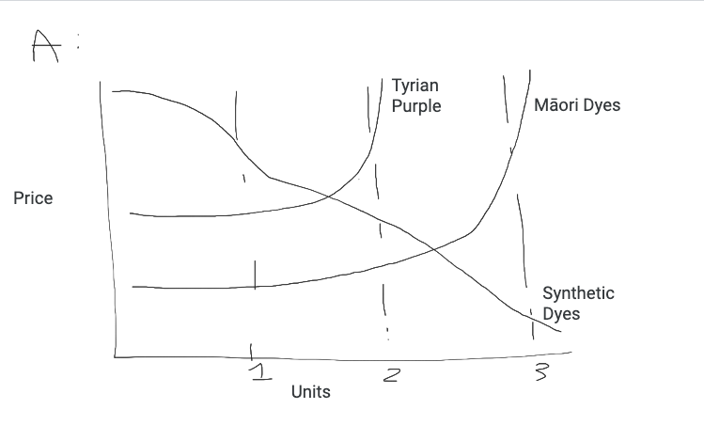
      2. start with blank graph.
         1. x-axis represents…
         2. y-axis represents…
         3. what is a unit? different for each tech
      3. Walk through reading the graph with mauvine/fossil fuels
         1. “schematic” or picture diagram of mauvine process
         2. initial cost to set up the coal mining (one point)
         3. 100 shirts made by one unit (xxx grams)
         4. after initial cost, price goes down and becomes cheaper to dye clothes
   2. Add the other two tech into the graph
      1. tradeoffs for tyrian purple
      2. tradeoff for maori dye
4. Reflect on social significance of resulting garments, potentially inherent conflict with mass production and meaningfulness.

Day 3:

1. Then we say: Alert! New scientific technology (pretend) allows us to produce the compounds in Maori dies and Murex snails within E. coli, producing new curves:
   1. 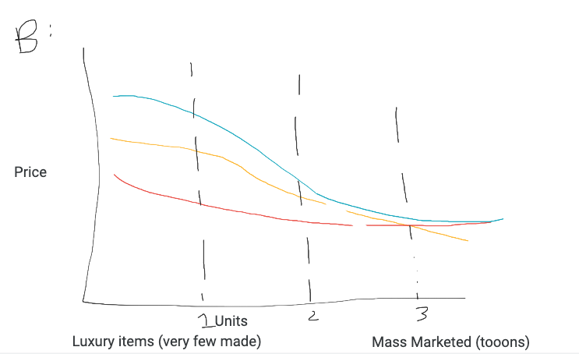
2. Use this graph to reflect and design your product.
3. We should provide some kind of Pros/Cons Table showing tradeoffs in color
4. Activity: Do calculations to fill out madlib of product pitch
   1. Company name:
   2. Creating X type of product
   3. using Y technology
   4. We produce N units
   5. You should buy this at _________ because _______.
5. Calculations include 3 Sci-Fi options that are like weapon mods in a game that plug into the formula used to calculate energy, time or resources that go into unit cost.
6. Include profit in the equation. (maybe it’s fixed)
7. Then teacher debriefs…but really…which of these companies maximized benefits and minimized costs?

What’s the bounding box? What’s the takeaway?

## Questions for Matt C:

What are the 5 biggest, most relevant solutions that have been solved with chemical engineering?

1. Providing petrol fuels to everyone on the planet
2. Providing fertilizers to almost everyone on the planet
3. Providing clean water to almost everyone on the planet (desalination + water treatment)
4. Providing antibiotics and vaccines to everyone on the planet who wants them
5. Heat transfer and humidity control for providing air conditioning and heat to people, buildings, and chemical processes

What are the 5 biggest, most daunting challenges that ChemE has not yet solved?

1. Scaling up and distribution of non-carbon based energy sources
2. Recycling of dilute waste streams to recover and close loop on rare metals
3. Economically affordable capture of carbon dioxide from major point sources
4. Recovering energy content of sewage and other waste biomass
5. Increasing energy and atom efficiency of all processes everywhere

For the video, I think we’re going to want to interview a diverse group of ChemEs (you could be one)...can you list some leads for us? We could include contacts in the US, NZ, and/or elsewhere. Definitely want to have a Maori person, women and men of diverse backgrounds and personalities. Maybe like 8? It’s a short video, but I think it would be interesting to have a tightly edited sequence where people are talking about why they got into this field--in a meaningful, authentic way. And interspersing that with a more scripted phrase like “I wanted to do something that matters,” that everybody says. Then smash cut the completed phrase with combined clips from several people. So it’s like you’re having one conversation with a diverse set of people who are united around a common cause and career. Anyway, if you like this idea, maybe just jot down a list of candidates from your network that you think would be good to feature (or potential leads where we could find someone). We can also put out a call on Twitter if we need more.

## Further Reading:

- [Middle East Eye | “Smelly Snails and deep purple: This ancient dye costs $2,700 per gram”](<https://www.middleeasteye.net/discover/colour-purple-dyeing-techniques-phoenician-sea-snails>)

## Learning Assets:

(To weave into the lesson)

* [NZ Careers: Chemical Engineering](https://www.careers.govt.nz/jobs-database/engineering/engineering/chemical-engineer/)

Last resort (existing, but kinda subpar assets):

* [What Does a Chemical Engineer Do? - Careers in Science and Engineering](https://www.youtube.com/watch?v=k-7B_YfHWXQ) (Just..annoying style)
* [What is Chemical Engineering?](https://www.youtube.com/watch?v=j_VEavNH2gs) (like a laundry list)
* [What is Chemical Engineering?](https://www.youtube.com/watch?v=twjiiHwNIKU) (decent, but a lot of extraneous detail and jargon)
* [Chemical Engineering at the University of Michigan](https://youtu.be/wwm1lG8iuLg)
* [What is Chemical Engineering?](https://youtu.be/twjiiHwNIKU) (pretty good video!)

Cultural Significance of Color/Dyes

* [The Brilliant History of Color in Art](https://youtu.be/Eoq0rUwk6NU)
* [The surprising pattern behind color names around the world](https://youtu.be/gMqZR3pqMjg)
* [The Nature of Color at the American Museum of Natural History](https://youtu.be/U2BMqRVOdCk)
* [The meaning of colours in different cultures](https://youtu.be/VBQPLHhfaKQ)

Images of Tyrian Dyeing Process

* Ghassen Nouira’s FB group <https://www.facebook.com/groups/6084852021>

Biotechnology examples

* [How Algae Could Change The Fossil Fuel Industry](https://www.youtube.com/watch?v=yCNkmi7VE0I&ab_channel=Stories)
  + [We Can Power The World With Algae!](https://youtu.be/ExOXF1x3N1g) (explainer about prev vid)
* [How the Technology Works - algae to biofuels](https://youtu.be/QP_HbQ5cWSk) (very early 2000s)
* <https://vimeo.com/467919582>

How synthetic dyes are bad for climate

## ChemE Video:

* Target 2 min
* What is it?
* Why is it an interesting, valuable career?
* Showcase diverse ChemEs (esp. a person with Maori background, if we can find someone)
* Describe challenges of scaling sustainably (use dye example, as a review for P1)
* Call to action--We need people in chemical engineering to help us solve big problems like this…to create newer, better methods of production that improve quality of life, while reducing environmental harm.

Cold Emails:

Kia Ora,

I am a scientist and educator working with the University of Canterbury's Engineering Department to create a set of outreach lessons focused on dyeing technologies.

We are reaching out to you in hopes of recruiting a collaborator with expertise in traditional dyeing techniques (e.g. using raurēkau or tānekaha bark) who would be interested in helping us shape this lesson.

The lessons we’re developing are targeted at year 9 and 10 students, and in particular we want to encourage Māori and Pasifika students to see chemical engineering as a viable and interesting career path. For the relevant part of the lesson, we would like to develop a short narrative (≤600 word) that provides historical and/or contemporary context for how Māori artists extract and fix dyes onto textiles.

Would you or any of the facilitators at Te Rito Weaving School be interested in speaking with us and guiding the development of lesson resources? We have some funds to compensate an interested party for their time.

Thank you in advance!

Ngā mihi,

Matt

Matt Wilkins

Founder, CEO

[Galactic Polymath](http://galacticpolymath.com/)

To Toi Maori

Kia Ora,

I am a scientist and educator working with the University of Canterbury's Engineering Department to create a set of outreach lessons focused on three dyeing technologies.

We are reaching out to you in hopes of recruiting a paid collaborator (perhaps from Te Roopu Raranga Whatu) with experience in dyeing mātauranga (e.g. using raurēkau or tānekaha bark) who would be interested in helping us shape the design of this lesson. The lesson activities are targeted at year 9 and 10 students, and will be made available for free online and shared with teachers in NZ and the US.

The goal of our collaboration is to showcase indigenous technology and the cultural significance of naturally dyed products in a sensitive and authentic, but also concise way. For the relevant part of the lesson, we would like to develop a short narrative (≤600 word) that provides historical and/or contemporary context for how Māori artists extract and fix dyes onto textiles.

Initially, we would like to set up a brief (20-30 minute) virtual chat between the collaborator, myself and the lesson co-developer (Stephanie Castillo). I would be grateful for any contacts who might be interested in working with us. We will compensate them for their time and are happy to offer editorial control over the final outputs of our collaboration.

Thank you in advance!

Ngā mihi nui,

Matt