Think of this document as a sketch—a rough container for the titles, ideas, overall structure, links, and draft language for the lesson(s) we will be developing in the coming weeks.

| **Title:** | Genetic Rescue to the Rescue |
| --- | --- |
| **SubTitle:** | Preventing extinction through gene flow |
| **shortTitle:** | geneticRescue |
| **Module:** | conservationGenetics |

**Sponsored By** (blurb ~30 words):

| The Lab of Sarah Fitzpatrick, PhD:  NSF DEB 2016569 |
| --- |

[Client Goals Document](https://drive.google.com/open?id=14LiluzO0WscsMx0J0EOb0B-HeyBfqVIJ)

| **Est. Time:** | 5?-day unit |
| --- | --- |
| **For Grades:** | 9-12 |
| **Target Subject:** | Science |
| **Lesson Hook:** | Florida panther conservation |
| **Driving Question(s):** | Can genetic rescue succeed in bringing a population back from the verge of extinction? |
| **Essential Question(s):** | * How do we use scientific methods to measure and develop solutions for our negative impacts on the world? |
| **Tags (up to 10):** | genetic rescue, genetics, conservation, fish, cat, natural selection, variation, evolution, extinction |

## Learning Goals:

### Listed in [meta/standards_GSheetsOnly](https://docs.google.com/spreadsheets/d/119Yqmty-yPtGfEcibUf76pre9gI7DkpL/edit?usp=sharing&ouid=109450450310463970706&rtpof=true&sd=true)

## Guiding Standard:

NGSS Science

We will tailor the lesson to teach all the pieces of this, while also hitting the other learning objectives.

**LS4.C-H1** Evolution is a consequence of the interaction of four factors: (1) the potential for a species to increase in number, (2) the genetic variation of individuals in a species due to mutation and sexual reproduction, (3) competition for an environment’s limited supply of the resources that individuals need in order to survive and reproduce, and (4) the ensuing proliferation of those organisms that are better able to survive and reproduce in that environment.

Also closely-tied target standards:

**LS4.B-H1** Natural selection occurs only if there is both (1) variation in the genetic information between organisms in a population and (2) variation in the expression of that genetic information–that is, trait variation–that leads to differences in performance among individuals.

LS4.C-H2 Natural selection leads to adaptation, that is, to a population dominated by organisms that are anatomically, behaviorally, and physiologically well suited to survive and reproduce in a specific environment. That is, the differential survival and reproduction of organisms in a population that have an advantageous heritable trait leads to an increase in the proportion of individuals in future generations that have the trait and to a decrease in the proportion of individuals that do not.

### See Full standard alignment summary in [**alignment-reference_all-standards_GSheets**](https://docs.google.com/spreadsheets/d/119Yqmty-yPtGfEcibUf76pre9gI7DkpL/edit#gid=1024605089)

## Lesson Outline

### Structural Overview

Parts 1-3 serve as a narrative hook and background refresher for relevant genetics concepts necessary to understand Dr. Fitzpatrick’s work. Sets up the bounding narrative of Florida panther genetic rescue to get students engaged in the topic, that will eventually segue to understanding model systems and analyzing parallel data in Trinidadian guppies (in Part 4-5). Parts 1-3 represent an “adapter” that engages and scaffolds student understanding in order to connect with Dr. Fitzpatrick’s work.

[Presentation 1](https://docs.google.com/presentation/u/0/d/1Zui07LwU041nPLQDNkwIAl-N1HXMm0e2e75h3XRQamM/edit)

### Part 1: Saving a Species: Genetic Rescue and the Florida Panther (30 min)

1. Polymath Puzzle Warm-Up? A rebus: “Can we say+V the mountain lions of the southeast?” 🥫 🧑‍🤝‍🧑 🗣️+V the 🗻 🦁🦁 of the 🧭SE 🇺🇸 ?
2. Introduce Florida Panther as the case study
   1. Puma distribution
   2. Decimation of the population
   3. Side Notes as additional info as time allows for teacher
3. Intro to the problem with first 1 min of this [Uproar documentary](https://www.youtube.com/watch?v=S98srPEViJs): Uno, a blinded panther as a charismatic story for a charismatic species; intro to different perspectives around cougars.
   1. As students take notes
4. Brief Q&A: What voices/perspectives did you hear?
   1. Did everybody like panthers?
   2. What are some of the reasons you think people might like or dislike panthers?
5. Background, setting the stage for decline (1:30-2:52): ending with “If we lose them as a society...we lose.”
   1. Students Think-Pair-Share: what are some of the potential impacts of losing Florida Panthers. Consider biological, ecological, and social impacts and decide on the most important impact in each category (Worksheet with table)
   2. Each pair shares and explains their top impact in each category.
   3. Have a discussion about the top impacts selected
6. Review population estimate by year graph with students (note: graph needs to be updated with 50 as max pop to make the graph easier to read)
   1. Introduce how low population numbers like this can lead to inbreeding
   2. Introduce some of the effects of inbreeding in populations (see/move(?) slide 50) – why does this lead to “unhealthy” cats?
7. End by teasing next day and alternative reflection options?
   1. Res[ource for inspiration](https://www.edutopia.org/article/7-smart-fast-ways-do-formative-assessment)

### Part 2: Genetics Mini-Review (General note for this section: extremely jargon heavy; needs to be made more accessible to students)

1. Repeat/review synopsis of Part 1 (1-2 slides); Set up unhealthy cats section (why we’re going into all these genetic concepts).
2. Background/review of related genetic concepts:
   1. nucleotides
   2. alleles
      1. Note: shorten example sequences
   3. dominant/recessive
      1. Note: On slides where representing Alleles with Capital and lowercase letters add an equal sign to make the association clearer From Mom: GCAATTCCCCCCGA = A; From Dad: GCAATTCCCCCTGA = a
   4. Genotype/phenotype (add slide with example)
3. Unhealthy cats section...recessive genetic problems
   1. Examine a genetic trait such as immunity to parasites
   2. Check-in on understanding of genotype of phenotype
   3. Review passing of traits through offspring
   4. Students do Genotype/Phenotype activity in small groups (suggested activity below, but can be changed)
      1. Each group pulls two paper “panther” parents (pre-marked with genotypes) out of a bag, determine phenotype of each, then predict geno/phenotype of offspring
      2. Students write the genotypes onto offspring (blank paper panthers) and all groups add their offspring to the bag and pull two panthers again.
      3. Repeat multiple times (Groups should see more offspring with homozygous recessive alleles)
      4. Note: Can add calculation of genotype/phenotype percentages each offspring to add in math component
   5. Short discussion: What did students notice about the additional offspring. How did the alleles change over time? What does this mean for the panthers?
   6. Have students recall some of the effects of inbreeding
      1. Give specific examples of genetic disorders from inbreeding
         1. Hole in septum
         2. Kinked tails and cowlicks
   7. Introduce example with 3 genes
      1. Review alleles on each gene and whether the recessive is deleterious
      2. Check-in on understanding phenotype with 3 genes
   8. Repeat genotype/phenotype activity with paper panthers with the 3 alleles
      1. Ask students what they notice in successive offspring (should see the loss of some dominant alleles)
      2. Introduce term genetic diversity – Q&A for students: Based on what you’ve seen/heard so far, do Florida Panthers have high or low genetic diversity?
   9. Inform students that in the next section we’ll talk about what can be done
   10. End by teasing next day and alternative reflection options?
       1. Res[ource for inspiration](https://www.edutopia.org/article/7-smart-fast-ways-do-formative-assessment)

### 

### Part 3: Role Play: (Genetic) Rescuing the Florida Panther

1. Introduce Role Play Scenario

a. Description of Scenario

b. Introduce the 3 proposed options with background on what each means, what each will require to provide students context (worksheet with bullet points?)

* + 1. (No $, but Free??) Let them die...it’s hopeless anyway
    2. (?$$M) Bring them into captivity and do a selective breeding program
    3. (?$M) Employ “genetic rescue” and bring in panthers from another population to expand the gene pool

2. Break students into groups and assign each group a proposed option

a. Each group will list 3 pros and cons for their option and write them on a poster board/giant sticky notes which will be displayed in the room (or using jamboard or screen share if virtual)

b. Groups will do a walkaround and visit the boards of the other groups displaying pros and cons of the other options and discuss within their group (4 min walkaround/discussion per group)

c. After the walkaround, students vote on the option they prefer

i. Teacher reviews each option and asks for volunteers to share why they did or did not select it.

ii. Reveal which scenario was selected for Florida Panthers and why

1. End by saying we’ll go more into genetic rescue in depth tomorrow.
2. Alternative reflection options?
   1. Res[ource for inspiration](https://www.edutopia.org/article/7-smart-fast-ways-do-formative-assessment)

### Learning Goals for Parts 4-5

2. Predict how increasing genetic variation by introducing new individuals (i.e. by conducting genetic rescue) will impact population size.

3. Summarize how human activities fragment animal populations and how habitat fragmentation limits gene flow, reducing genetic variation.

4. Create a logic model showing how genetic rescue occurs; i.e. how the introduction of new individuals to a small, inbred population on the verge of extinction provides needed genetic variation for the population to survive and recover.

5. Demonstrate understanding of how reduction in both population size and genetic variation in endangered species lead to the "extinction vortex"—the increasing likelihood of small populations to blink out due to low population size and recessive genetics from inbreeding.

6. Propose a model organism to use for research on species that are endangered or infeasible to study.

7. Interpret scatter plot data from a model organism (Trinidadian guppies) and compare to related data in an endangered species (Florida panthers) to draw broader conclusions about the effectiveness of genetic rescue.

### 

### Part 4: How do we save a species without risking its extinction? Studying the unstudiable

The purpose of this lesson is to transition from the bounding narrative of panthers to a worked example of studying genetic rescue in a model organism (Trinidadian guppies). Students will learn about the stakes (what can go wrong) with genetic rescue and think about why model organisms are important for studying species that are endangered or intractable to study. They will then analyze the parallel datasets in the guppy and panther systems to deepen understanding of what genetic rescue is and when/why it is important.

### Links:

* [Presentation 1](https://docs.google.com/presentation/u/0/d/1Zui07LwU041nPLQDNkwIAl-N1HXMm0e2e75h3XRQamM/edit)
* [Presentation 2](https://docs.google.com/presentation/d/1Gnbn8YNfX2UTx9A85dIE-U0PN7Lp2fG6pp14AziPUT4/edit#slide=id.ge620142883_0_1)
* [Background scientific paper on genetic rescue in guppies for this lesson](https://onlinelibrary.wiley.com/doi/epdf/10.1111/eva.12356)
* GP Original Video 1: Intro to Genetic Rescue
  + [Script](https://docs.google.com/document/d/1w0RJd03dT2a13pcCw-NvqaQo2Wc-XvxjGXe0Nhs4Zn8/edit#)
  + [Storyboard](https://docs.google.com/presentation/d/1R2jbz4E0HfW7PVTEKuszyn7TeRIQTn7fyTEcMcLvEIA/edit#slide=id.ge7f7f5e6f7_0_9)
  + [**Rendered video segments**](https://drive.google.com/drive/folders/1JRTNxwFhWxbCC-GD5sZLX_XY8d0xBh1D)
* [GP Original Video 2 script](https://docs.google.com/document/d/1w0RJd03dT2a13pcCw-NvqaQo2Wc-XvxjGXe0Nhs4Zn8/edit#)

### Outline:

1. Polymath Puzzle warmups
   1. Get students thinking about phenotypic variation and distinguishing variation within and across traits. This will provide a useful analog for discussing phenotypic and genetic variation.
2. Watch vid 1 ([storyboard](https://docs.google.com/presentation/d/1R2jbz4E0HfW7PVTEKuszyn7TeRIQTn7fyTEcMcLvEIA/edit#slide=id.ge971905975_0_3); [script](https://docs.google.com/document/d/1w0RJd03dT2a13pcCw-NvqaQo2Wc-XvxjGXe0Nhs4Zn8/edit#); [**rendered sections**](https://drive.google.com/drive/folders/1JRTNxwFhWxbCC-GD5sZLX_XY8d0xBh1D))
   1. Review of Day 1. What is genetic rescue? Why is it necessary? What could go wrong? What model organism could we use to study genetic rescue of endangered species without possibly leading to extinction?
   2. Interrupt the video with some *formative* discussion and/or worksheet prompt(s).
   3. For example, after the section on Extinction Vortexes, ask students to fill in the blanks for a logic model of genetic rescue. (Something like this on their Part 2 worksheet, which hasn’t been created yet).



* 1. And have them think about an extinction vortex in graph terms.
  2. Potentially go over both questions as a class (i.e. embed correct worksheet responses in the powerpoint) to ensure understanding before moving on. (Assess deeper understanding of extinction vortex later).

1. Watch remaining part of video 1 (Intro to Genetic Rescue). Have students brainstorm in groups. What organism could meet the requirements?
   1. What model organism would you use to study genetic rescue?
      1. (Basically, we need to replicate the conditions of endangered species in a common species).
      2. Conditions for the model organism should be:
         1. Have inbred populations or can be selectively bred to create inbred lines with reduced genetic variation
         2. Affordable or common in nature
         3. Fast development (short time between generations; [e.g. days or months])
2. Share out/discuss student ideas (Teachers guide needs to have tips...how to support this discussion...mainly asking students if/how they meet the specs)
3. Watch Video 2 (2 min?) [**See Script**](https://docs.google.com/document/d/1w0RJd03dT2a13pcCw-NvqaQo2Wc-XvxjGXe0Nhs4Zn8/edit#heading=h.ld5nqvok1kc6)
   1. A list of common models for genetic rescue:
      1. fruit flies
      2. flour beetles
      3. nematodes
      4. yeast
      5. partridge pea
   2. We’re going to focus on Trinidadian guppies
   3. introduce Dr. [Sarah Fitzpatrick](mailto:sfitz@msu.edu), describing her study system.
   4. Then narrator (Stephanie) returns to pose another question to students: Making predictions. How can we know if genetic rescue worked?

**Overview of the rest of the lesson**

Rest of the lesson focuses on setting up and testing hypotheses. Have students think about how we test whether genetic rescue worked in guppies. Make recommendations about the practicality of genetic rescue in other systems. Reveal what happened in the Florida panthers. Reflection questions/products that crystallize take homes for students.

* 1. Predicted relationships?
     1. (i.e. we expect population to increase significantly a generation or two after the new individuals are introduced)
     2. genetic variation (heterozygosity) should increase, and as a result, population should also increase (though not necessarily linearly).

1. Students are given 2 graphs (of heterozygosity~ and 2 data tables. Need to label axes and title from data table.
   1. Data for guppies: (from /[data](https://docs.google.com/spreadsheets/d/1G9gZn7mdjsl6EHy7QMy4ESK_Y0GzbWvs/edit#gid=1343885706))

| **Stream** | **Month** | **PopSize** | **Heterozygosity** |
| --- | --- | --- | --- |
| **Caigual** | Jan-09 | **20** | **0.43** |
| Caigual | Feb-09 | 18 | 0.46 |
| Caigual | Mar-09 | 14 | 0.46 |
| Caigual | May-09 | 32 | 0.46 |
| Caigual | Jun-09 | 384 | 0.47 |
| Caigual | Jul-09 | 429 | 0.49 |
| Caigual | Aug-09 | 440 | 0.49 |
| Caigual | Sep-09 | 397 | 0.51 |
| Caigual | Oct-09 | 397 | 0.63 |
| Caigual | Nov-09 | 337 | 0.58 |
| Caigual | Dec-09 | 289 | 0.65 |
| Caigual | Jan-10 | 273 | 0.75 |
| Caigual | Feb-10 | 277 | 0.78 |
| Caigual | Mar-10 | 313 | 0.79 |
| Caigual | Apr-10 | 420 | 0.76 |
| Caigual | May-10 | 597 | 0.77 |
| Caigual | Jun-10 | 1067 |  |
| Caigual | Jul-10 | 1075 |  |
| Caigual | Aug-10 | 1034 |  |
| Caigual | Sep-10 | 978 |  |
| Caigual | Oct-10 | 898 |  |
| Caigual | Nov-10 | 883 |  |
| Caigual | Dec-10 | 755 |  |
| Caigual | Jan-11 | 709 |  |
| Caigual | Feb-11 | 658 |  |
| Caigual | Mar-11 | 583 |  |
| Caigual | Apr-11 | 592 |  |
| Caigual | May-11 | 790 |  |
| Caigual | Jun-11 | 914 |  |

Unlabeled graphs they will label from the table (found in [assets](https://drive.google.com/drive/folders/1xoA6hxidYxHvElfBdQjqSojy_eoZ9swB?usp=sharing)/)

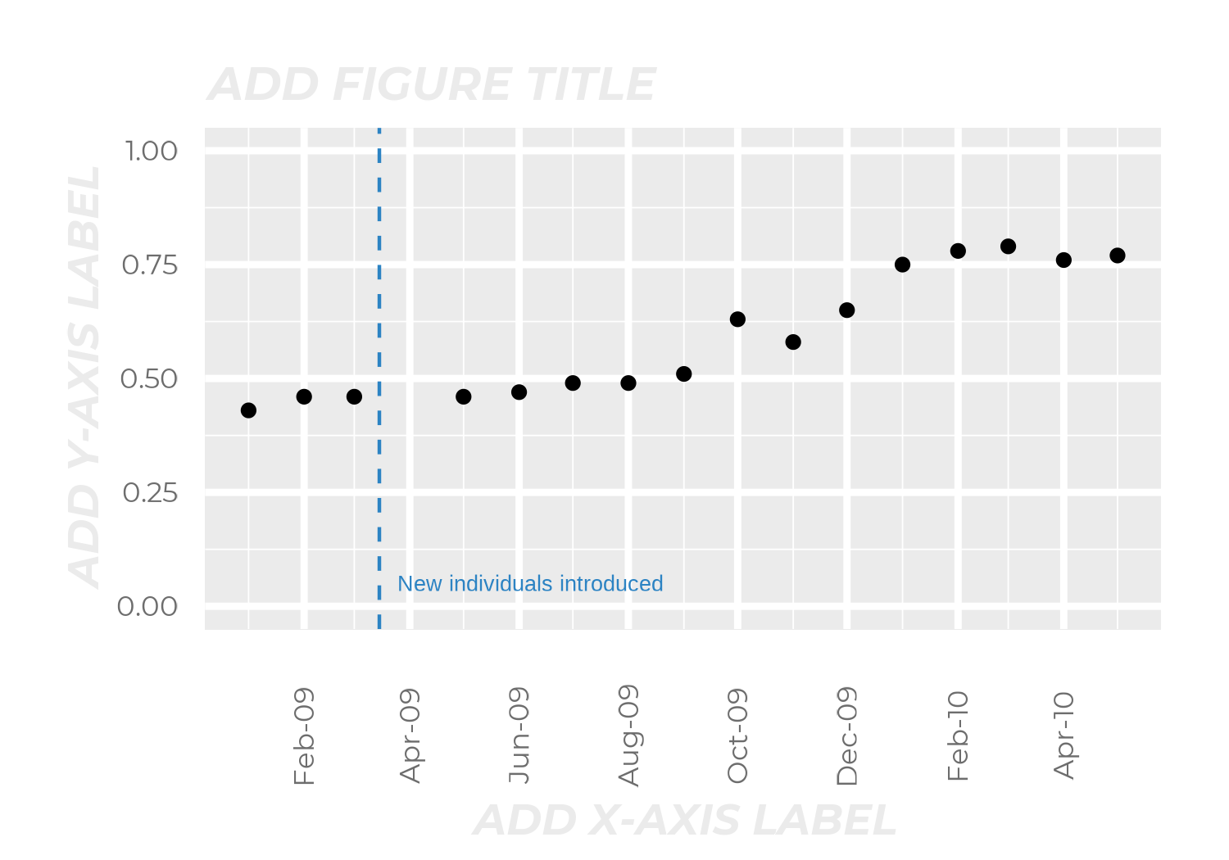

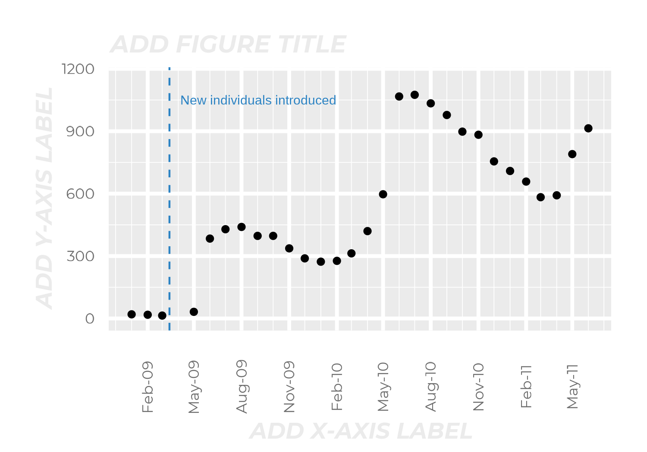

LABELED GRAPHS

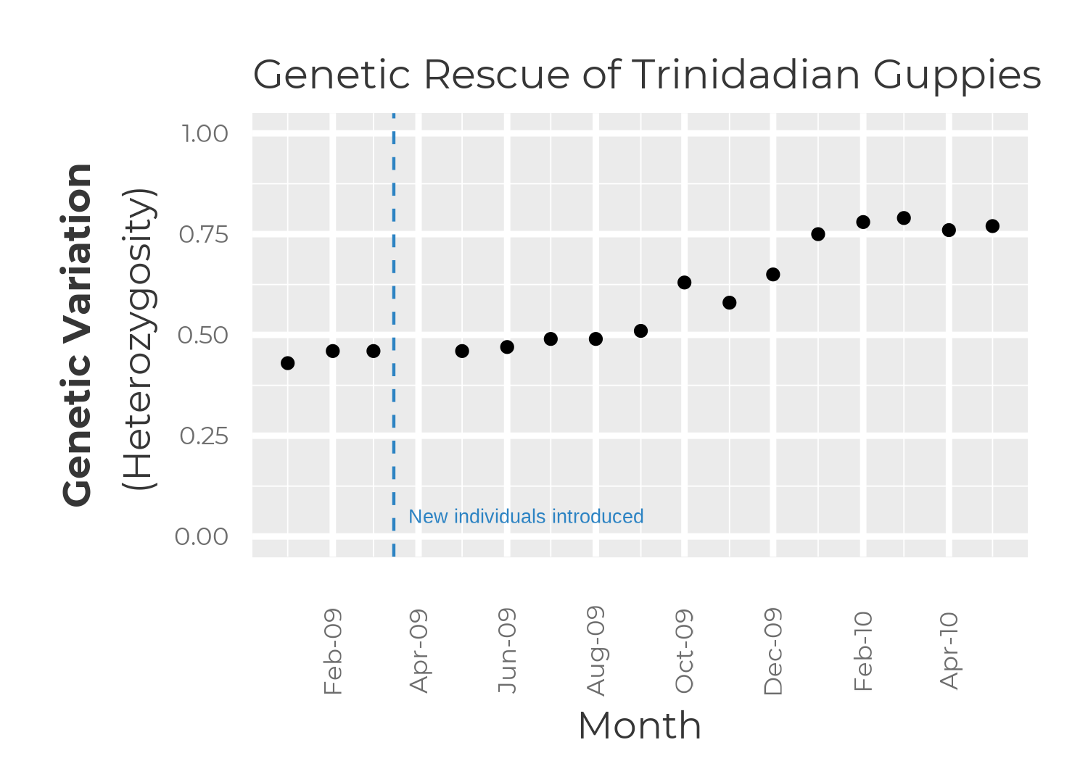

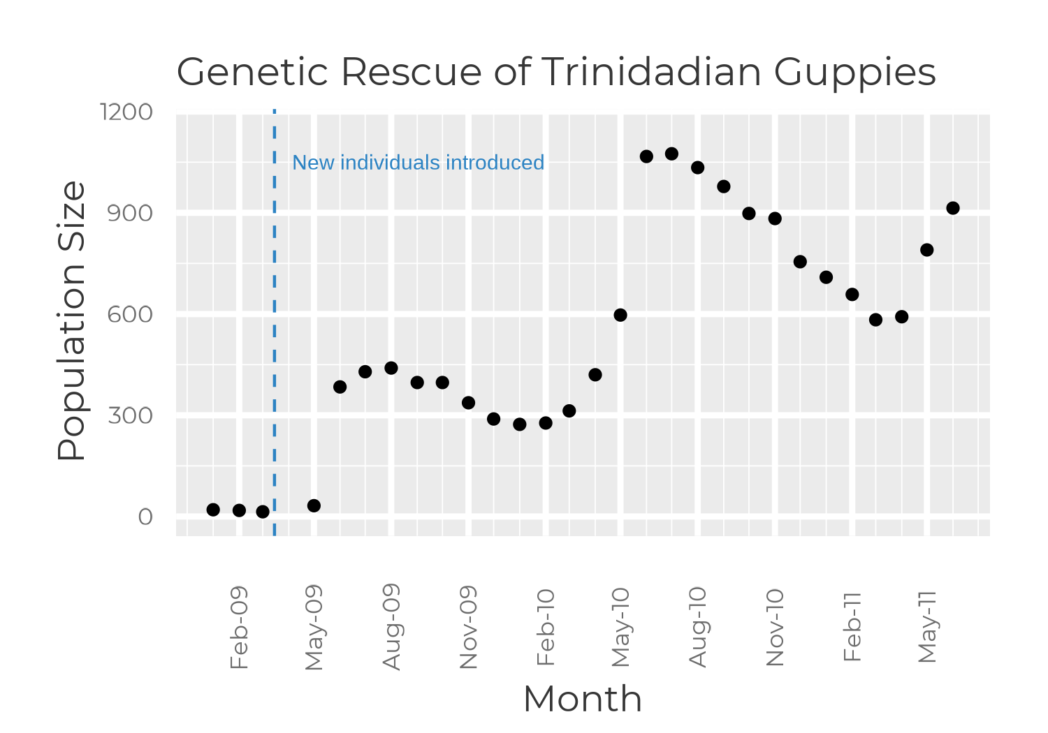

1. Interpret success of the experiment
2. Explore different parts of the data. (Was the population increasing rapidly at the end of the experiment?
   1. What would we have concluded if we had ended the experiment after the first year?
3. Reveal the panther data in the same way (have them label the graphs from the tables). Panther data is in /data.
4. Was the panther genetic rescue successful? Was genetic variation successfully increased to the same degree as in the guppies?
5. Close with ending part of the [Video about Uno](https://www.youtube.com/watch?v=S98srPEViJs)?
6. Leave it with multiple endings for teachers
   1. Assign a reflection prompt
   2. Let students explore cat collision data and make recommendations (though this is the subject of a pending grant and if funded would be a larger extension lesson)
   3. Have them explore IUCN data to find a species they think might be a good candidate for genetic rescue?

### SCRAPS:

1. Review how the guppy data inform what happened with the panthers (how they rebounded).
2. Are there caveats from the guppy data that also apply to the panthers? (i.e. something about particular idiosyncratic effects from the identity/level of divergence from the source population that can impact outcomes (i.e. leading to reduction in local adaptation or just some weird new trait))
3. Update what’s happened with panthers.
4. Introduction of habitat fragmentation as the new greatest threat to panthers (instead of sterility/ inbreeding depression)

Initial product ends at Part 3 (maybe all we can budget for at the moment, but we’ll see how it goes). Other “add-on,” modular lesson ideas

**FUTURE ADD-ONS?**

1. Make a curated list (modified from Fitz’s existing dataframe) of endangered/vulnerable species and have kids research which ones they would recommend for genetic rescue and why. Make a proposal for mitigation, given a budget and/or other constraints.

### Future Extension(s) If the Alongside Wildlife Foundation funds our grant:

* Connect to cougar conflict in the Western US. Fragmentation, rancher conflict, collisions, etc.
* [Have kids explore collision data in FL](https://geodata.myfwc.com/datasets/florida-panther-mortality/explore?filters=eyJEYXRlIjpbMTQ5Mzk2NDkyNzE4OS41NiwxNjA5NTQ1NjAwMDAwXX0%3D&location=26.491578%2C-81.497011%2C12.39). Make recommendations of which road(s) to prioritize?
* Learn about latest genomic results on species concepts (controversy of protecting something that’s not really that genetically distinct)?
* Learn about persistent low genetic diversity (need for more genetic rescue)

## Resources:

| Media |
| --- |
| * [Range map showing how weird the FL population is](https://en.wikipedia.org/wiki/Puma_(genus)#/media/File:Cougar_range_map_2010.png) |
| Explainers/Basic background: |
| * [USFWS Florida Panther Profile](<https://www.fws.gov/refuge/florida_panther/wah/panther.html>) * [Nat Geo: Planned roads could imperil Florida's panthers—and last remaining wilderness](<https://www.nationalgeographic.com/animals/article/florida-toll-road-threatens-wildlife-panthers?loggedin=true>) * [The Florida Panther: Past, Present and Future](<https://edis.ifas.ufl.edu/publication/UW402>) * [America’s cat is on the comeback](<https://www.americanscientist.org/article/americas-cat-is-on-the-comeback>) |
| Further Reading |
| * [Of kings and Alpine ibex: the amazing resurrection of a species from near-extinction](https://natureecoevocommunity.nature.com/posts/59792-of-kings-and-alpine-ibex-the-amazing-resurrection-of-a-species-from-near-extinction) |
| Scientific papers: |
| * **Main study the guppy data in the lesson comes from:** [Gene ﬂow from an adaptively divergent source causes rescue through genetic and demographic factors in two wild populations of Trinidadian guppies](https://onlinelibrary.wiley.com/doi/epdf/10.1111/eva.12356) * [Endangered Florida panther population size determined from public reports of motor vehicle collision mortalities](https://besjournals.onlinelibrary.wiley.com/doi/pdf/10.1111/1365-2664.12438) * [American Society of Mammologists notes on Florida panther species status](https://www.mammalsociety.org/uploads/committee_files/ASM-SCBNA%20Letter%20on%20Florida%20Panther%205-year%20Review.pdf) * [The impact of genetic restoration on cranial morphology of Florida panthers (Puma concolor coryi)](https://www.researchgate.net/profile/Kyle-Finn/publication/274814227_The_impact_of_genetic_restoration_on_cranial_morphology_of_Florida_panthers_Puma_concolor_coryi/links/5d108db4a6fdcc2462a039df/The-impact-of-genetic-restoration-on-cranial-morphology-of-Florida-panthers-Puma-concolor-coryi.pdf) * [De Novo Assembly and Annotation from Parental and F1 Puma Genomes of the Florida Panther Genetic Restoration Program](https://www.g3journal.org/content/ggg/9/11/3531.full.pdf) * [Read this Science paper from 1892!](https://www.jstor.org/stable/1766860?seq=1#metadata_info_tab_contents) * [Puma genomes from North and South America provide insights into the genomic consequences of inbreeding](https://www.nature.com/articles/s41467-019-12741-1.pdf) |
| Interactive widgets: |
| * [panther road mortality](https://geodata.myfwc.com/datasets/florida-panther-mortality/explore?filters=eyJEYXRlIjpbMTQ5Mzk2NDkyNzE4OS41NiwxNjA5NTQ1NjAwMDAwXX0%3D&location=26.491578%2C-81.497011%2C12.39) (possible fodder for project add-on?? Currently waiting on a funding decision for this extension) |
| Possible Contacts/collaborators: |
| * [Madelon Van De Kerk](https://www.researchgate.net/profile/Madelon-Kerk-2) (maybe can get us Panther data and/or give feedback on lesson accuracy) * [Larisa De Santis of Vanderbilt](https://www.vanderbilt.edu/evolution/person/larisa-r-g-desantis/)...maybe can consult about Pizzlies as another example of the pros & cons of gene flow caused by climate change |

## Data:

Panthers

* [Survival of panther age/sex categories](https://docs.google.com/spreadsheets/d/1C_rDlJETi0ByvfBQfIz9eqCMh6twb3Xk_7TOwGcG3Is/edit?usp=sharing)
* [Heterozygosity and population size](https://docs.google.com/spreadsheets/d/14JzEVne6jCYenV3_nrUgQiCpEEaiTTulCK16i9D4IUQ/edit?usp=sharing)

Guppies

Extensions:

* [Dalmatian backcross project?](https://ckcusa.com/blog/2019/november/the-dalmatian-back-cross-project/)

## Abstracts & Other Text Blocks

**Abstract (<250 words)**

|  |
| --- |

**Scientific Background (200–350 words)**

| ### Scientific Background  Further Reading: Add links with markdown format: [*link text*](*link URL*)  - [A Puma Hunter Is Enlisted to Track Down and Help Save Florida Panthers [Excerpt]](https://www.scientificamerican.com/article/a-puma-hunter-is-enlisted-to-track-down-and-help-save-florida-panthers-excerpt/) |
| --- |

**Lesson <-> Research Connections (200–350 words)**

| ### Lesson Connections to this Research |
| --- |