# **User Manual**

## **Overview**

This application allows users to upload a sheet and generate required graphs for data analysis. The application runs on **Streamlit**, making it easy to interact with. You can either run the Python script directly or use the provided .exe file for a more convenient experience.

## **Prerequisites**

Before running the application, install the required dependencies. Use the following command in your terminal:

**pip install -r requirements.txt**

Alternatively, install them manually:

**pip install streamlit pandas plotly openpyxl ezodf**

### **Requirements.txt Contents:**

The following dependencies are required and included in requirements.txt:

**streamlit==1.29.0**

**pandas==2.2.1**

**plotly==5.18.0**

**openpyxl==3.1.2**

**ezodf**

## **Running the Application**

### **Option 1: Running via Python Script**

1. Open a terminal or command prompt.
2. Navigate to the directory containing main_final.py.
3. Run the command:

**streamlit run main_final.py**

1. The application will launch in your default web browser.

### **Option 2: Using the** .exe **File**

For ease of use, an executable file main_final.exe is available, which directly launches main_final.py in Streamlit browser mode.

1. Locate main_final.exe in your directory.
2. Double-click the .exe file.
3. The application will open in your default web browser automatically.

## **Application Features**

* **File Upload Button**: Upload your sheet to generate graphs.
* **Automatic Graph Rendering**: Once the sheet is uploaded, the application will process the data and display the required graphs.
* **Downloadable Graphs and corrected Data**: The graphs once processed will be available for download . The corrected and processed data will also be available for download

## **Troubleshooting**

* **Issue: Application does not open**
  + Ensure Python and Streamlit are installed (**pip install streamlit**).
  + If using the .exe file, verify that all dependencies are available.
* **Issue: Graphs not displaying**
  + Ensure the uploaded file is formatted correctly.
  + Check for missing or incorrect data in the sheet.
  + Please ensure that sheet name is constant in every months sheet

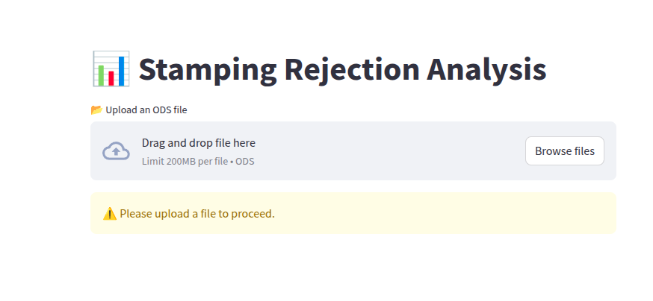



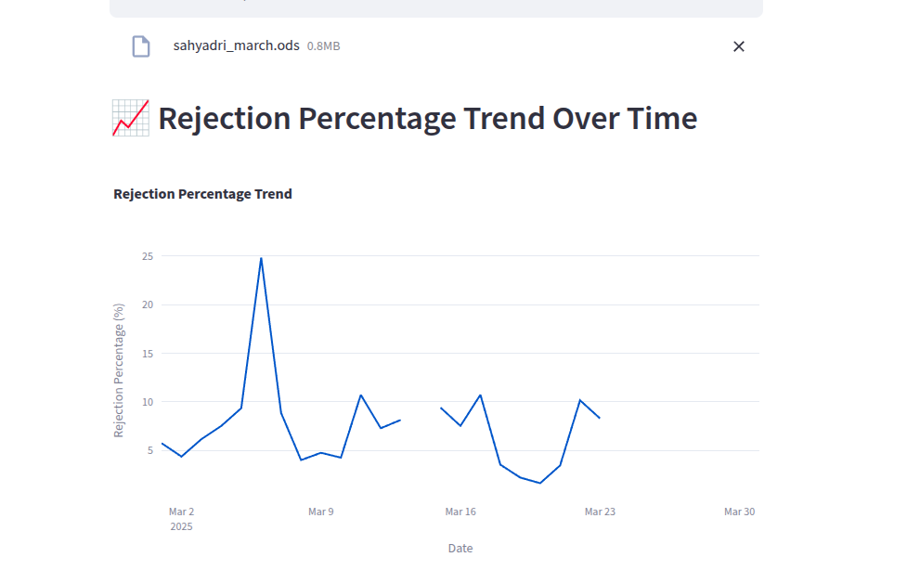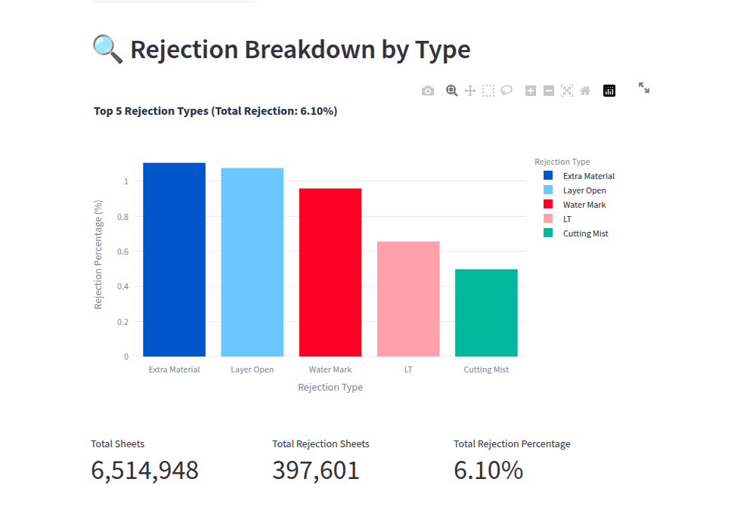

Developer Details

Sanskar Kulkarni +916901461930 [vilas.sanskar231@vit.edu](mailto:vilas.sanskar231@vit.edu)

Raj Bapat +919403636928 [raj.bapat23@vit.edu](mailto:raj.bapat23@vit.edu)

Sanyam Kothari +918669554684 [sanyam.kothari23@vit.edu](mailto:sanyam.kothari23@vit.edu)

Rriddhi Rathi +919764448485 [rriddhi.rathi23@vit.edu](mailto:rriddhi.rathi23@vit.edu)

Roshan Raut +919075179293 [roshan.raut23@vit.edu](mailto:roshan.raut23@vit.edu)