***COMSATS UNIVERSITY***

**WAH CAMPUS**

***Submitted By***

***Name:*** *Shayan Babar*

***Registration No:***  *Fa19-Bcs-051*

***Class/Section:*** *BSCS/6D*

***Submitted To***

***Teacher Name: Dr Majid Mumtaz***

***Date of Submission: 07-06-2022***

# Applying user login using Gmail

# Creating project

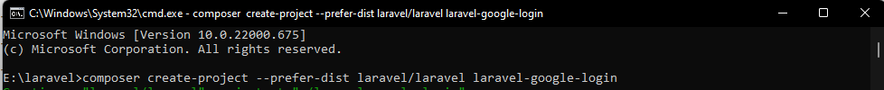

# Database allocation

# Install Sociallte package

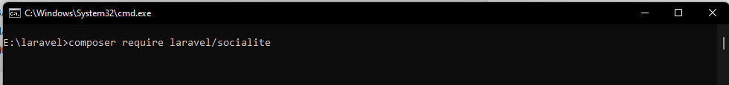

# add aliese and providers in **config/app.php**.

# Configure Google Credentials in Laravel

Will update this later on

# Get Secrets from google

# Make Auth

composer require laravel/ui –dev

php artisan ui bootstrap –auth

npm install && npm run dev

# Add Column in users table



# Migrate



# Create Controller

# Routes

# sign up link

# Sign up

# Now lets register using gmail

When u click register page following pops up

Select account working

