***COMSATS UNIVERSITY***

**WAH CAMPUS**

***Submitted By***

**Project Name: IMDB**

**Entity: Movies**

***Name:*** *Shayan Babar*

***Registration No:***  *Fa19-Bcs-051*

***Class/Section:*** *BSCS/6D*

***Submitted To***

***Teacher Name: Dr Majid Mumtaz***

***Date of Submission: 20-05-2022***

# What is Composer? Create a Laravel project….?

Composer is an application-level dependency manager for the PHP programming language that provides a standard format for managing dependencies of PHP software and required libraries. It was developed by Nils Adermin and Jordi Bogging, who continue to manage the project.

**First in cmd line**

composer create-project laravel/laravel imbd\

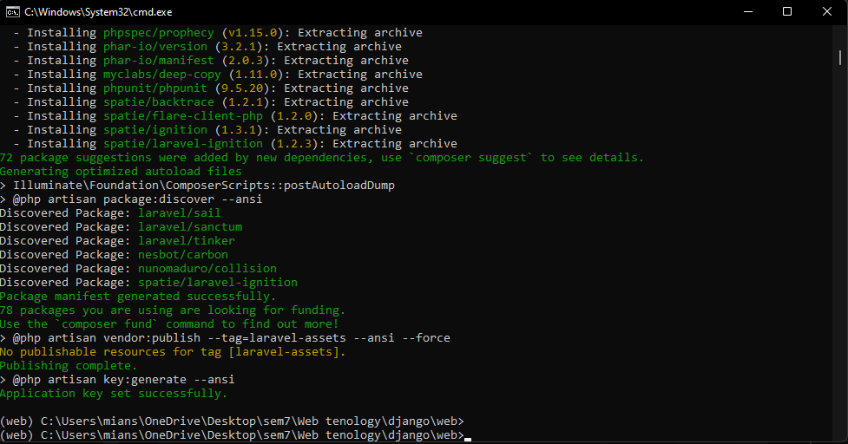

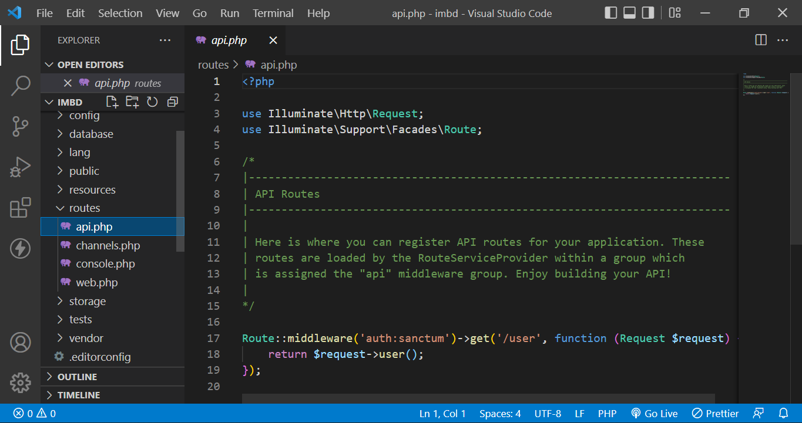

# Question2 crud operation on your semester project

**

**Step#2:** **python manage.py startapp movies**

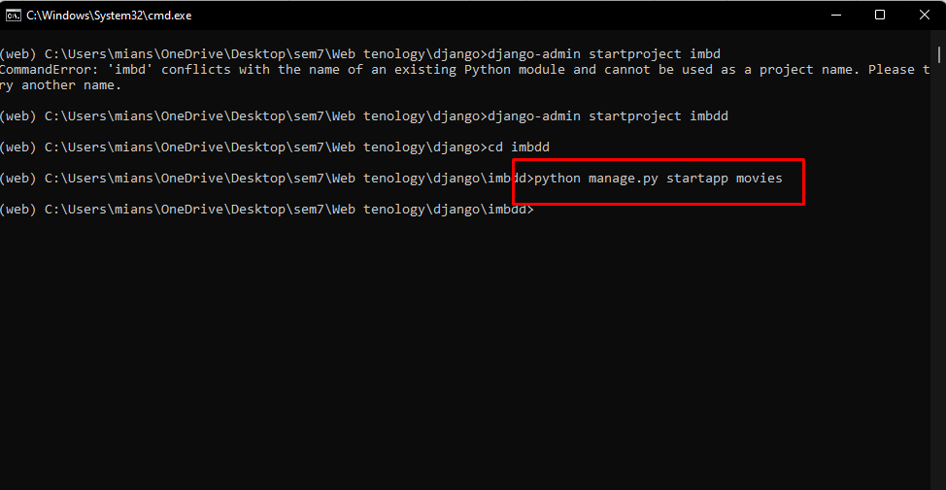

**Now open the moelds.py file in movies app and add following code**

from platform import release

from django.db import models

from django.urls import reverse # Used to generate URLs by reversing the

import uuid

# Create your models here.

class movies(models.Model):

    id = models.UUIDField(primary_key=True, default=uuid.uuid4, help_text='Unique ID for this particular book across whole library')

    movie_name = models.CharField(max_length=40, help_text='Enter Movie')

    summary = models.TextField(max_length=1000, help_text='Enter a brief description of the book')

    Actorname=models.CharField(max_length=25,help_text='Enter Actors name')

    release_date=models.DateField(null=True, blank=True)

    # Methods

    def get_absolute_url(self):

        """Returns the URL to access a particular instance of MyModelName."""

        return reverse('model-detail-view', args=[str(self.id)])

    def __str__(self):

        """String for representing the MyModelName object (in Admin site etc.)."""

        return self.movie_name

**Step#4**

python manage.py makemigrations

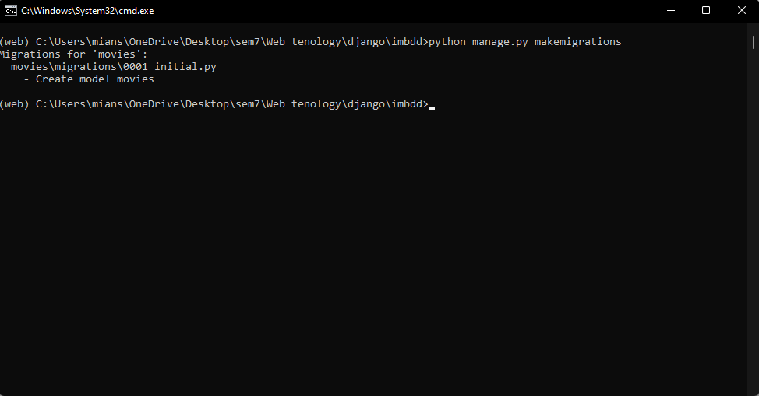

**Step #5**

python manage.py migrate

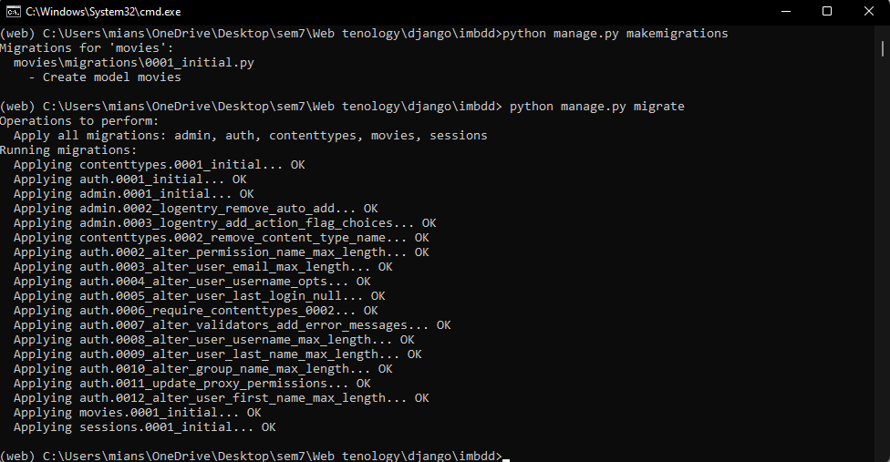

**Step#6:** python manage.py migrate and superuser

**Step#7:Python manage.py runserver (to server the file)**

**Open in local host**

**Step#8 adding the routes**

**Open the urls.py file in imbdd folder an following**

**Now create a urls.py file in movies app folder**

**Leave it empty for now**

**Step#8 change admin.py file as below**

## Step#9 time to add some movies

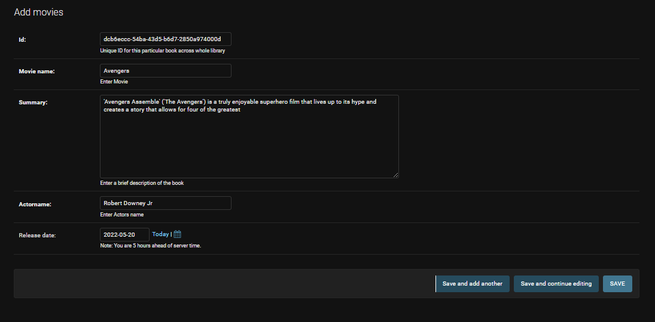

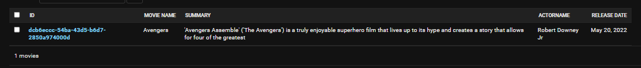

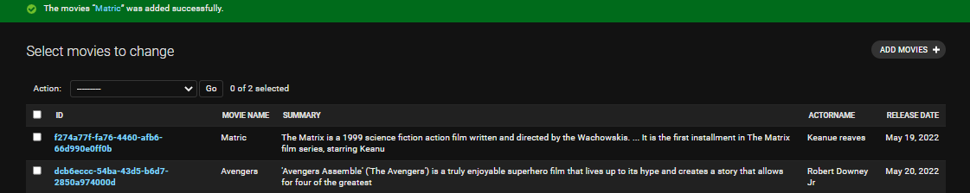

## Step#9 lets create a view template

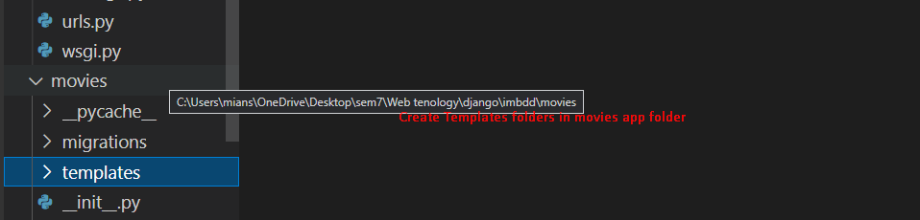

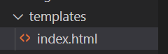

## To create a simple html view add following code

<html lang="en">

<head>

    <meta charset="UTF-8">

    <meta http-equiv="X-UA-Compatible" content="IE=edge">

    <meta name="viewport" content="width=device-width, initial-scale=1.0">

    <title>Document</title>

    <style>

        td,th{

            border: 2px solid black;

        }

    </style>

</head>

<body>

    <h1>Articles</h1>

    <ul>

    <table>

        <tr>

            <th>id</th>

            <th>movie_name </th>

            <th>summary</th>

            <th>actorname</th>

            <th>release_date</th>

        </tr>

        {% for article in object_list %}

        <tr>

        <td>{{ article.id }}</td>

        <td> {{article.movie_name}}</td>

        <td>{{article.summary}}</td>

        <td>{{article.actorname}}</td>

        <td>{{article.release_date}}</td>

        </tr>

    {% empty %}

        <li>No articles yet.</li>

    {% endfor %}

    </table>

    </ul>

</body>

</html>

**Now in views.py add following code**

**Now adding urls for this**

**Open**



## So a generic list view is also creates

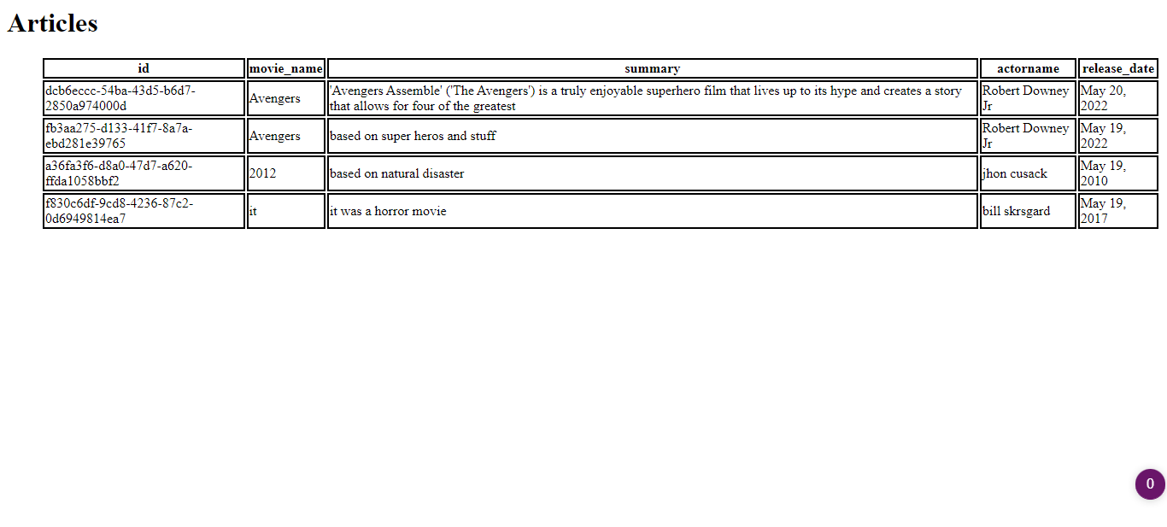

**Now lets add a del icon**

Now add delete url

Now lets create a view for delete

## Update functionality=>first add update.html file in templates folder



## Make urls:



## Make views

## Finally:

# Conclusion:

Hence crud implemented on both using custom and build in methods.

🡨------------------------------------------------🡪