**Racial Disproportion in New York Historic Arrest Data**

Galad Dirie

1003938741

CCT 111

**Introduction**

|  |  |  |
| --- | --- | --- |
| **Ethnicity** | **Percentage** | **Total Arrests** |
| BLACK | 0.485444 | 2433510 |
| WHITE HISPANIC | 0.260037 | 1303555 |
| WHITE | 0.120666 | 604892 |
| BLACK HISPANIC | 0.080398 | 403034 |
| ASIAN / PACIFIC ISLANDER | 0.040935 | 205205 |
| UNKNOWN | 0.010043 | 50347 |
| AMERICAN INDIAN/ALASKAN NATIVE | 0.002204 | 11050 |
| OTHER | 0.000272 | 1363 |

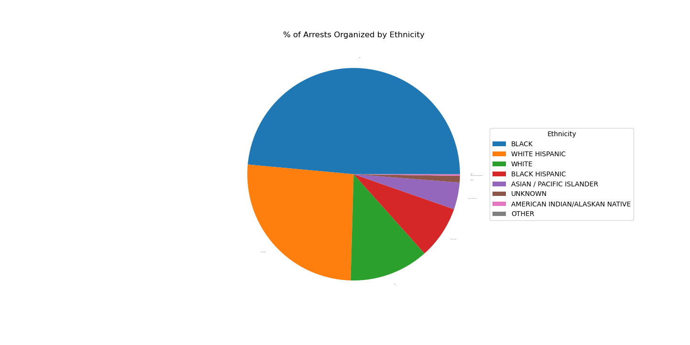The experience people have with Police enforcement vary wildly, but ethnicity and race is far to often a factor in that experience. There is a large disparity and inequality in policing presence, incarceration rates, police brutality, etc. in the United States. This essay will look specifically at arrests in the state of New York from 2006-2019 and will identify biases and why minorities are disproportionately arrested more per capita, specifically black people. In New York, the population estimation from the U.S. Census Bureau (2019) are 69.6%-Whites, 17.6%-Black, 19.3%-Hispanic, 9.0%-Asian. The NYPD’s Historic arrest Data black people comprise 48% of all arrests, while white individuals make up 12%.

Despite being 17.6% of the population, black people were arrested four times more often, adjusting for population, in this period black people had arrest per capita (BLACK: 0.71, WHITE: 0.044) 16 times larger than white people.

**Stop, Frisk, and Bias**

The NYPD implemented the controverisal policy Stop and Frisk. The program is heavily critized for apparent racial profiling, nearly 76% of people stoped under this program are inoccent, 90% of recorded stops in 2016 and 2017 were people of color says Stolper(2018). Rather cause of the profiling is a symptom of the program rather than the cause, it empowers police offers to act on suspicions generated from racial sterotypes.

*“We did find evidence of stops that are best explained as “racial incongruity” stops: high rates of minority stops in predominantly white precincts. Indeed, being “out of place” is often a trigger for suspicion… Racial incongruity stops are most prominent in racially homogeneous areas. For example, we observed high stop rates of African-Americans in the predominantly white 19th Precinct, a sign of race-based selection of citizens for police interdiction”* (Gelman et al., 2007)

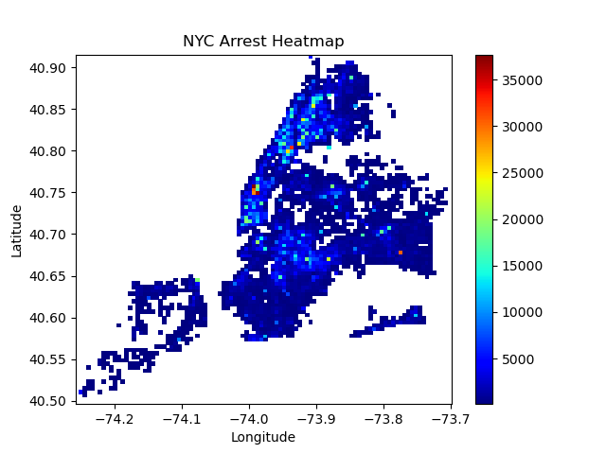

Stolper(2018) describes racial disparities in fare evasion arrests, more than 94 percent of all stops occurred within a half kilometer of a subway station. He notes that more fare evasion arrests were made in high crime areas but high crime areas in that are predomintly black and hispanic were stopped more than high crime areas that are predomintly white, this pattern can be seen most plainly in Manhattan for fare evasion but the pattern transfers over for all types of arrests made. This heat map shows all recorded arrests in new york in areas with atleast 50 arrests from 2006 to 2019. Gelman et al. (2007) notes that the NYPD’s records indicate that they were stopping people of color more often than whites even when the best estimates of the rate of crimes committed by each group was considered. In 2013 the US District Court and determined that the NYPD is required to produce detailed data for any and all stops.

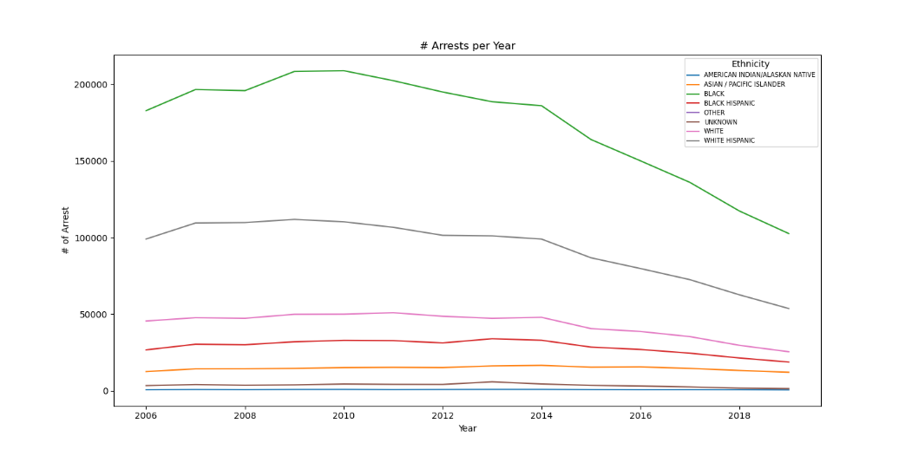

Since 2013 this disproportionat gap has decreased significatnly, there was 55% less arrests for people of color in 2019 vs. 2006. It is clear that racial sterotyping and bias has had a large influence in policing in New York, before the stricter criteria for stop and frisks was put 88% of stops were innocent, when the stricter criteria was put into place stop innocence only dropped 12% while people of color saw a sharp decline in arrests, black people were arrested 46% less, but with 90% of stops still being people of color the bias still persits in NYPD.

**Prepetuation and Intergenerational incarceration**

The high arrest rate among people of color isnt soley do to discrimination and racial profiling. A part of the issue is the prepetuation of behaviours in communities of color. Swisher (2012) finds that a biological father’s incarceration during childhood is found to be associated with increased delinquency for all youth, very little difference between race groups. The high levels of youth delinquency encourage police presence and enforcement, perpetuating racial stereotypes, this in turn leads to more fathers being incarcerated, in a self-fulfilling cycle its decimating communities of color. The intergenerational effect of incarceration has been noted as a large risk factor, Roettger(2011) found parental incarceration was powerful influence creating many negative outcomes such as antisocial behavior and offending, to decreasing psychological well-being and even socioeconomic attainments in adulthood.

Intergenerational incarceration is just one of many factors in the disproportionate participation in criminal activities and delinquency. Although Police Policy has a vital role in the arrest and incarceration of young men, Western (2009) found that he paths from concentrated economic disadvantage to mass imprisonment runs partly through the mechanism of crime. Economically disadvantaged men are more likely at a given point in time to go to prison than others.

*“Black Americans’ higher crime rates are a function of their greater exposure to criminogenic conditions: concentrated disadvantage, low collective efficacy, and a cultural landscape divorced from mainstream society. Thus, some scholars predict that the crime rates for Black Americans would more closely resemble those of White Americans if a greater number of Black Americans lived in communities that more closely resembled those of White Americans”* (Martin et al., 2011).

Martin et al.(2011) idenfiyed the issues black americans face that explains the disportionate prescense in crime rates, they suggest that Improving the structural conditions would reduce Black Americans’ overrepresentation in crime statistics.

**Conclusion**

New york’s arrests data has a clear disproportionate overrepresentation of people of color, although making 17% of the population black people were resposnible fore 45% of the arrests made .The disproportionate arrests made in New York can be explained through the socio-economic situation that faces people of color, but a large factor in this case was discriminatory policy, stop and frisk. The Policy allows officers to act upon racial sterotypes, activly and subconsiously. Before regulation stop and frisk had 88% innocence rate, after regulation iit dropped to 76% but black arrests droped by 46%, even with 90% of stops being people of color, Idenfiying a clear racial bias towards people of color in New York,

**Appendix**

2020 has been a divisive year, with racial tensions at a all time high its important for everyone to step back and look at the facts and problems. The problems facing people of color are complex, and although rascim, police, and policy play a vital role with the issues facing people of color, they arent all to blame and are only a piece in the complex socio-economic problem. Its important that we understand that the Bias exist and its iimportant to idenify so we can understand the situation. This data is important because it idenfies policing behaviours such and policy that negtrivily affects people of color.

**Refrences**

Gelman, A., Fagan, J., & Kiss, A. (2007). An Analysis of the New York City Police Department’s “Stop-and-Frisk” Policy in the Context of Claims of Racial Bias. Journal of the American Statistical Association, 102(479), 813–823. <https://doi.org/10.1198/016214506000001040>

Martin, M. J., McCarthy, B., Conger, R. D., Gibbons, F. X., Simons, R. L., Cutrona, C. E., & Brody, G. H. (2011). The Enduring Significance of Racism: Discrimination and Delinquency Among Black American Youth. Journal of Research on Adolescence, 21(3), 662–676. https://doi.org/10.1111/j.1532-7795.2010.00699.x

Roettger, M. E., & Swisher, R. R. (2011). Associations Of Fathers’ History Of Incarceration With Sons’ Delinquency And Arrest Among Black, White, And Hispanic Males In The United States . Criminology, 49(4), 1109–1147. Https://Doi.Org/10.1111/J.1745-9125.2011.00253.X

Stolper, H., & Jones, J. (2018). The Enduring Discriminatory Practice of Stop & Frisk. Retrieved from <https://www.cssny.org/news/entry/stop-and-frisk>

Swisher, R. R., & Roettger, M. E. (2012). Father’s Incarceration and Youth Delinquency and Depression: Examining Differences by Race and Ethnicity. Journal of Research on Adolescence, 22(4), 597–603. <https://doi.org/10.1111/j.1532-7795.2012.00810.x>

U.S. Census Bureau. (2019). Quick facts New York. Retrieved from <https://www.census.gov/quickfacts/fact/table/NY/PST045219>

Western, B., & Wildeman, C. (2009). The Black Family and Mass Incarceration. *The ANNALS of the American Academy of Political and Social Science*, *621*(1), 221–242. https://doi.org/[10.1177/0002716208324850](https://doi-org.myaccess.library.utoronto.ca/10.1177/0002716208324850)