INTERNATIONAL CYBERSECURITY AND DIGITAL FORENSICS ACADEMY

INTRO TO CRITICAL INFRASTRUCTURE FOR IT LEARNERS

LAB 01 INTRODUCTION TO PROGRAMMABLE LOGIC CONTROLLERS
Student Name: Muhammad Mukhtar Bello
Registration Number: C11/26/ACIS/17371
Course: Intro to Critical Infrastructure for IT Learners
Lab Number: Lab 01
Date: 24 September 2026

1. Introduction
A Programmable Logic Controller (PLC) is an industrial computer used to monitor inputs, process control logic, and operate outputs in automated systems. PLCs are widely used in industrial and critical-infrastructure environments because they can continuously monitor field devices and control equipment such as motors, pumps, valves, and other actuators.
This laboratory introduced the basic components and operation of PLCs through the OpenPLC Editor. The laboratory focused on understanding discrete and analog inputs and outputs, inspecting a ladder-logic motor-control example, and identifying normally open contacts, normally closed contacts, latching contacts, and output coils.
All activities were performed within the assigned laboratory virtual-machine environment.

2. Laboratory Environment
Item | Details
Virtualization Platform | Oracle VirtualBox
PLC Virtual Machine | ICDFA-provided PLC VM
Network Configuration | Isolated/Host-Only laboratory network
IP Address in Provided VM | 192.168.56.103
Laboratory Software | OpenPLC Editor
PLC Project | Ladder Diagram
Control Example | Motor_Control

Network Address Note
The laboratory handout lists 192.168.1.10 as the expected example address. However, the provided virtual machine used the address 192.168.56.103. The address was recorded as provided by the laboratory environment and was not manually changed.
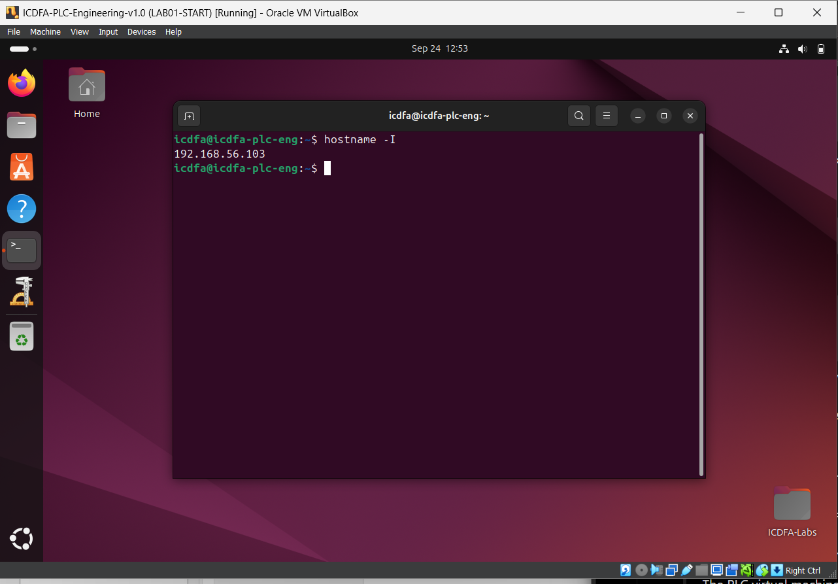
Figure 1 Verification of the PLC virtual machine IP address (192.168.56.103)

3. Laboratory Procedure

3.1 Starting the PLC Virtual Machine
The ICDFA PLC virtual machine was opened using Oracle VirtualBox. The VM was configured for an isolated laboratory network rather than a bridged connection.
A clean starting snapshot was created before proceeding with the laboratory activities.
Snapshot Name: LAB01-START
The PLC virtual machine was then started and accessed using the laboratory account.
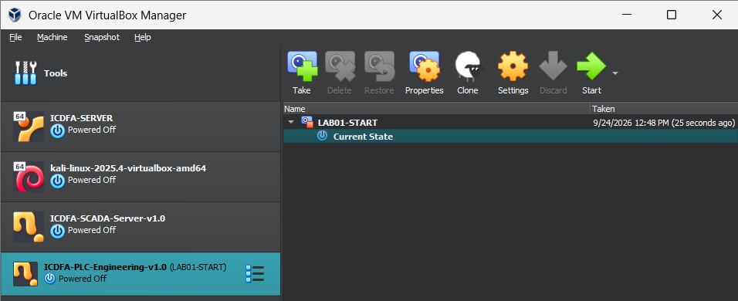
Figure 2 Snapshot Evidence

3.2 Verifying the Network Address
After logging into the PLC virtual machine, the network address was checked using the terminal. The virtual machine reported the IPv4 address:
192.168.56.103
This address was recorded in the laboratory report because it differed from the example address provided in the laboratory handout.

3.3 Opening OpenPLC Editor
The OpenPLC Editor was launched from the PLC virtual machine. The initial editor window was blank before the laboratory project was opened.
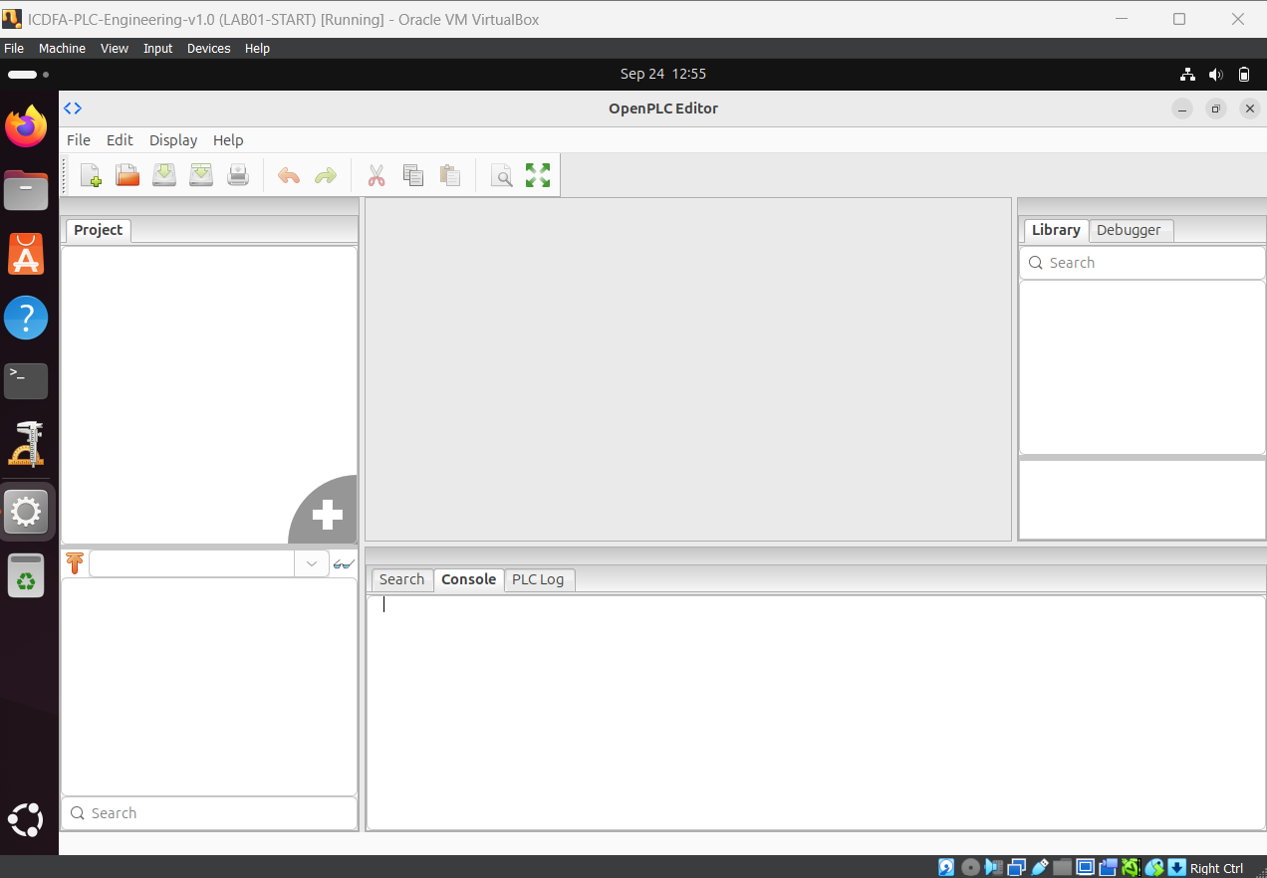
Figure 3 Balnk OpenPlc Editor
The provided PLC Programming Language Examples were then accessed through the OpenPLC Editor.

3.4 Opening the Ladder Diagram Project
The provided Ladder Diagram project was opened. The project tree contained the relevant PLC resources, including:
- Ladder Diagram
- Motor_Control
- Res0
The Motor_Control section was opened for inspection.
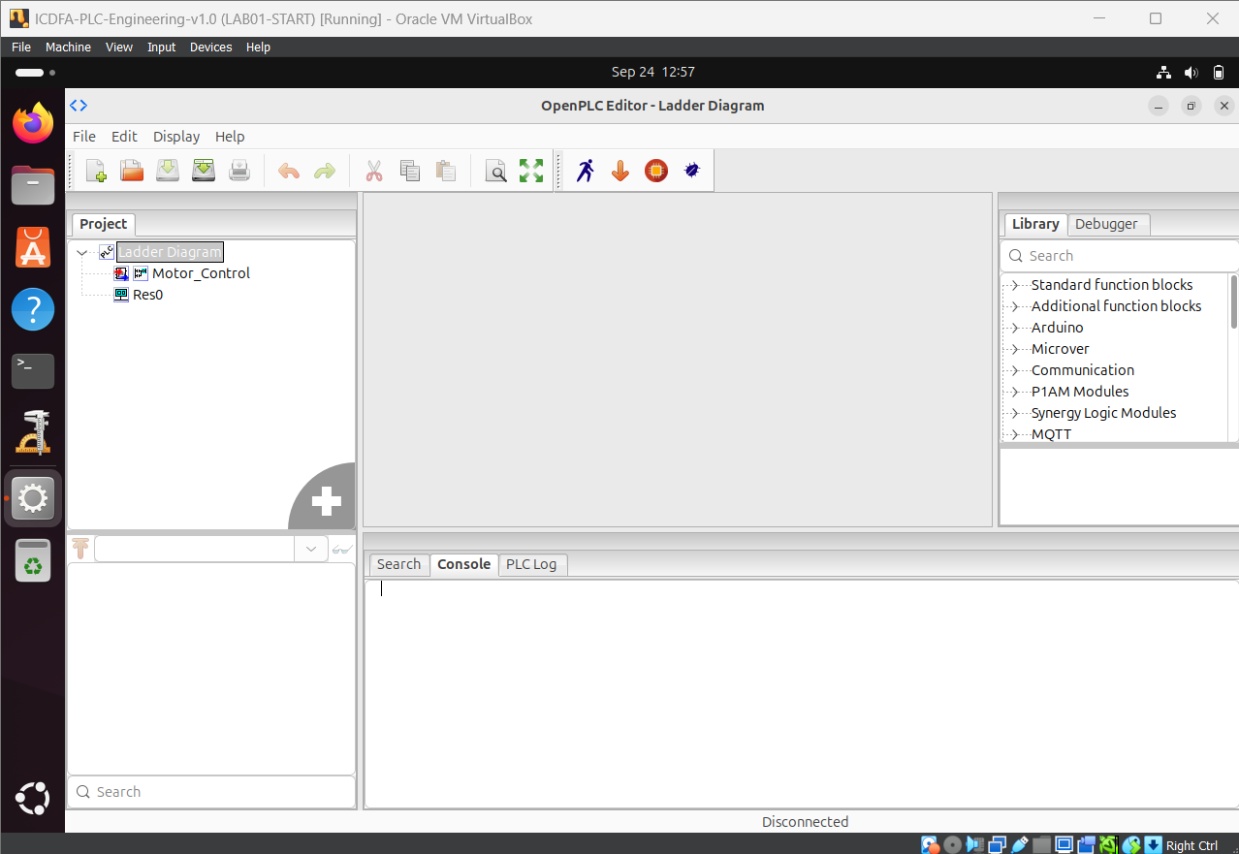
Figure 4 OpenPLC project tree showing the Ladder Diagram and Motor_Control project.
4. Motor-Control Ladder Diagram Analysis
The Motor_Control ladder diagram contained two vertical power rails and a control rung.
The main elements observed were:
- STOP
- START
- MotorOutput contact
- MotorOutput coil
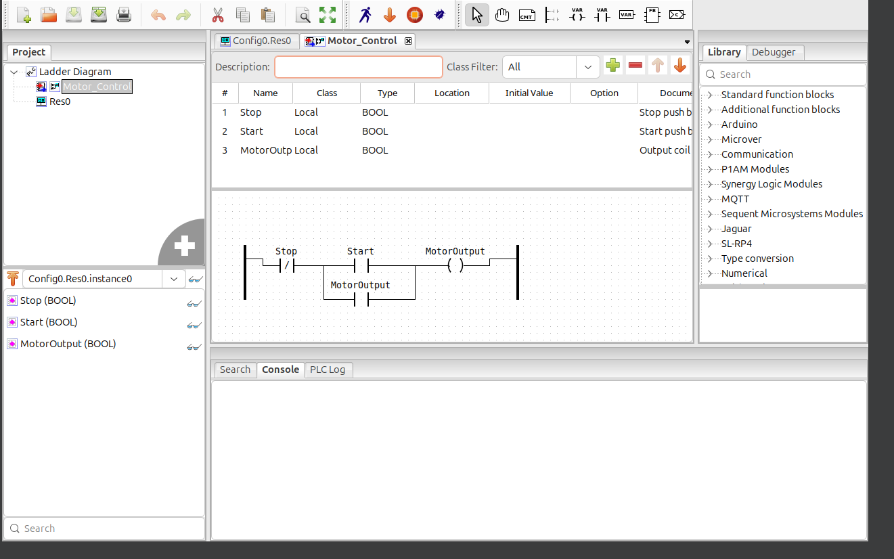
Figure 5 OpenPLC Motor_Control ladder diagram showing the Stop contact, Start contact, MotorOutput latching contact, and MotorOutput coil.

4.1 STOP Contact
The STOP element is represented by a normally closed (NC) ladder contact:
|/| STOP
Under normal conditions, the contact allows the control path to remain complete. When the stop condition is activated, the contact opens logically and interrupts the path to the output coil.
Normally closed logic is commonly used for stop functions because interruption of the expected control condition can cause the controlled equipment to stop.

4.2 START Contact
The START element is represented by a normally open (NO) contact:
| | START
When the Start condition is activated, the contact closes logically and provides a path through which the MotorOutput coil can become energized.

4.3 MotorOutput Latching Contact
A second MotorOutput element is represented as a normally open contact:
| | MotorOutput
This contact is connected on a parallel branch with the START contact.
Its purpose is to provide a self-holding or latching path. Once the MotorOutput coil becomes energized, the MotorOutput contact can maintain the control path after the initiating Start condition is removed.

4.4 MotorOutput Coil
The MotorOutput coil is located toward the right side of the rung:
( MotorOutput )
The coil becomes energized when the logical conditions on the rung are satisfied. In an industrial application, an output of this type could ultimately control a motor starter or contactor.

5. Operation of the Motor-Control Logic
The logic can be represented conceptually as:
STOP AND (START OR MotorOutput) → MotorOutput

Initial condition
When the motor is initially stopped:
- STOP is in its normal closed state.
- START is open.
- MotorOutput is not energized.
- The MotorOutput auxiliary contact is therefore also open.
The MotorOutput coil remains de-energized.

Starting the motor
When the START condition becomes active, the normally open START contact closes. This completes the required logic path and energizes the MotorOutput coil.

Latching operation
Once MotorOutput becomes energized, its parallel contact also closes. This provides an alternative path around the START contact.
Therefore, when START returns to its normal inactive state, the MotorOutput contact can maintain the energized state of the output.
This is known as self-holding or latching.

Stopping the motor
When the STOP condition is activated, its normally closed contact opens. This breaks the path to the MotorOutput coil.
MotorOutput then becomes de-energized, and its auxiliary latching contact also opens. The system consequently returns to its stopped state.

6. PLC I/O Classification
PLC inputs and outputs can be classified as either discrete or analog.
- Discrete signals represent distinct states, such as ON/OFF or 1/0.
- Analog signals represent continuously varying values, such as temperature, pressure, flow, or level.
I/O Type | Industrial Example | Description
Discrete Input | Emergency-stop pushbutton | Provides an ON/OFF state to the PLC indicating whether the emergency stop has been activated.
Analog Input | Pressure transmitter | Provides a continuously varying measurement of process pressure, commonly through a 4–20 mA signal.
Discrete Output | Motor contactor | Allows the PLC to switch a motor circuit ON or OFF.
Analog Output | Control valve | Provides a varying control signal, such as 4–20 mA, for controlling valve position.

7. Knowledge Check

Question 1: What is the difference between an input module and an output module?
Answer:
An input module receives signals from field devices such as sensors, switches, and transmitters and passes those signals to the PLC processor. An output module receives control instructions from the PLC processor and sends signals to field devices such as motors, valves, lights, and other actuators.

Question 2: Why is a normally closed contact commonly associated with stop or emergency-stop logic?
Answer:
A normally closed contact is commonly used for stop or emergency-stop logic because the control circuit remains complete during normal operation and opens when the stop condition occurs. This arrangement can also support fail-safe behavior because a broken connection or loss of the expected control signal can interrupt the circuit and cause the controlled equipment to stop.

Question 3: Give one example of a discrete I/O signal and one example of an analog I/O signal.
Answer:
A discrete I/O example is an emergency-stop pushbutton, which provides an ON/OFF state. An analog I/O example is a pressure transmitter, which provides a continuously varying measurement, such as through a 4–20 mA signal.

Question 4: What operational risk can arise when industrial automation devices become network-connected?
Answer:
Network-connected industrial automation devices can become exposed to unauthorized access, malware, or other network-based attacks. If an attacker gains control of an automation device, the attack could interfere with PLC commands or monitoring and potentially cause equipment malfunction, production disruption, safety problems, or loss of system availability.

8. Reflection
Network-connected PLCs provide important operational benefits because they allow industrial systems to be monitored and managed more efficiently. Connecting PLCs to industrial networks can allow operators and engineers to collect information from equipment, monitor processes remotely, identify faults more quickly, and coordinate different parts of an industrial system. Network connectivity can therefore improve visibility, maintenance, efficiency, and response to operational problems.
However, connecting PLCs to networks also introduces cybersecurity considerations. A PLC that was previously isolated from other systems may become exposed to unauthorized access, malware, exploitation of vulnerable services, or misuse of legitimate credentials. A cybersecurity incident affecting a PLC can have consequences beyond data loss because the device may directly control physical equipment. An attacker could potentially disrupt production, change process conditions, or interfere with the availability of an industrial process.
For this reason, industrial environments need appropriate network segmentation, access control, monitoring, secure configuration, and careful management of connections between IT and operational technology systems. Security measures must also consider operational safety and availability because defensive actions that are appropriate in an ordinary IT environment may have different consequences in an industrial control system.

9. Conclusion
This laboratory provided an introduction to Programmable Logic Controllers and their role in industrial automation. The OpenPLC Editor was used to inspect a ladder-logic motor-control example containing a normally closed Stop contact, normally open Start contact, a MotorOutput latching contact, and a MotorOutput coil.
The laboratory also demonstrated the difference between discrete and analog PLC I/O through industrial examples. The motor-control circuit showed how a latching contact can maintain an output after the initial Start condition is removed and how the Stop condition can interrupt the control path.
The exercise also demonstrated why network connectivity introduces cybersecurity considerations for industrial control systems. Understanding basic PLC operation is important for cybersecurity learners because security controls must account for both the digital and physical effects of industrial automation systems.

