INTERNATIONAL CYBERSECURITY AND DIGITAL FORENSICS ACADEMY

INTRO TO CRITICAL INFRASTRUCTURE FOR IT LEARNERS

LAB 02 — PLC PROGRAMMING LANGUAGES
Student Name: Muhammad Mukhtar Bello
Registration Number: [INSERT YOUR REGISTRATION NUMBER]
Course: Intro to Critical Infrastructure for IT Learners
Laboratory: Lab 02 — PLC Programming Languages
Date: [INSERT DATE]

1. Introduction
Programmable Logic Controllers (PLCs) are widely used in industrial control systems and critical infrastructure. PLCs can be programmed using different programming languages depending on the type of control task and the preference of the programmer.
This laboratory exercise focuses on five PLC programming representations: Ladder Diagram (LD), Function Block Diagram (FBD), Structured Text (ST), Instruction List (IL), and Sequential Function Chart (SFC).
The main practical example used in this laboratory is a motor start/stop control circuit. The same control requirement is represented using different PLC programming languages. This helps demonstrate that different programming languages can be used to achieve the same control objective.

2. Objectives
The objectives of this laboratory exercise were to:
- Compare different PLC programming languages.
- Identify the main features of Ladder Diagram programming.
- Understand how the same motor-control logic can be represented using Function Block Diagram.
- Understand Structured Text representation of control logic.
- Examine Instruction List representation.
- Understand how Sequential Function Chart represents a process as steps and transitions.
- Identify Boolean tags used in the motor-control program.
- Compare the strengths, limitations, and industrial applications of the five programming representations.

3. Laboratory Environment
The laboratory was performed using the ICDFA-provided PLC virtual machine in an isolated/host-only network environment.

Software and Environment
Item | Description
Virtualization Platform | Oracle VirtualBox
PLC Environment | ICDFA PLC Virtual Machine
Programming Software | OpenPLC Editor
Network Type | Host-only / isolated network
PLC IP Address | 192.168.56.103
Example Program | PLC Programming Language Examples
Main Control Example | Motor_Control
Note: The laboratory handout provided 192.168.1.10 as the expected address, but the actual address assigned to the PLC VM in this environment was 192.168.56.103. The actual address was documented rather than manually changing the VM configuration.

Figure 1: PLC VM Network Configuration
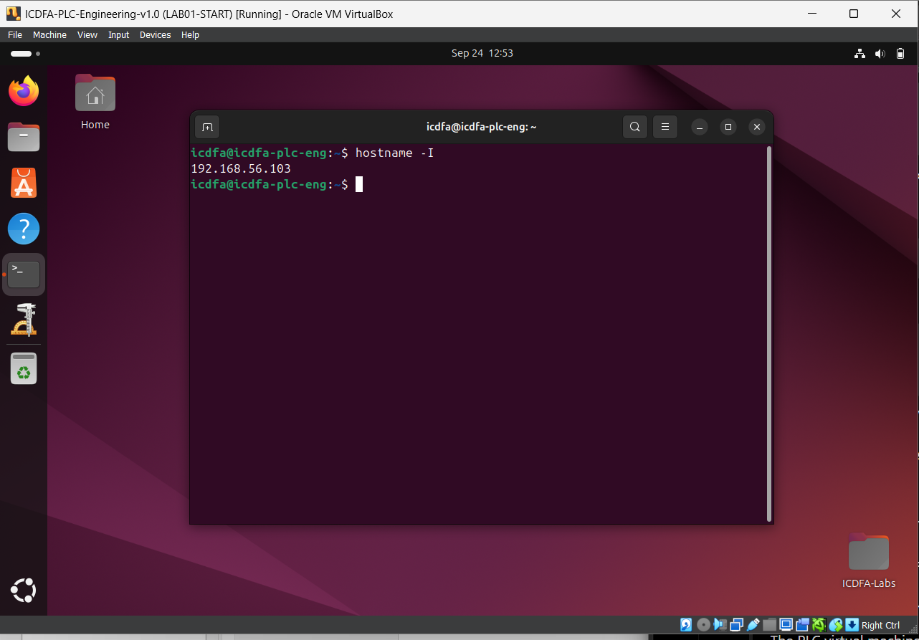
Figure 1 Actual IP address of the PLC virtual machine.

4. Laboratory Preparation
The PLC virtual machine was started from a clean laboratory environment. A snapshot was created before beginning the laboratory exercise.

Snapshot Name
LAB02-START
[IF YOU CREATED THIS SNAPSHOT, KEEP THIS STATEMENT. IF NOT, CREATE THE SNAPSHOT AND THEN KEEP IT.]
The OpenPLC Editor was then launched and the provided PLC Programming Language Examples were opened.

5. Ladder Diagram (LD)
The first programming representation examined was the Ladder Diagram.
The Ladder Diagram example was opened from the PLC Programming Language Examples. The Res0 resource was expanded and the instance0 section was opened. The motor-control program was identified as Motor_Control.
The motor-control logic contains:
- STOP — normally closed contact.
- START — normally open contact.
- MotorOutput — auxiliary contact used for latching.
- MotorOutput — output coil.
The logic can be represented conceptually as:
STOP AND (START OR MotorOutput) → MotorOutput
When the Start button is activated, the MotorOutput coil becomes energized. The MotorOutput contact provides the latching path, allowing the motor output to remain active after the Start button is released. When the Stop condition is activated, the normally closed Stop contact opens and the motor output is de-energized.
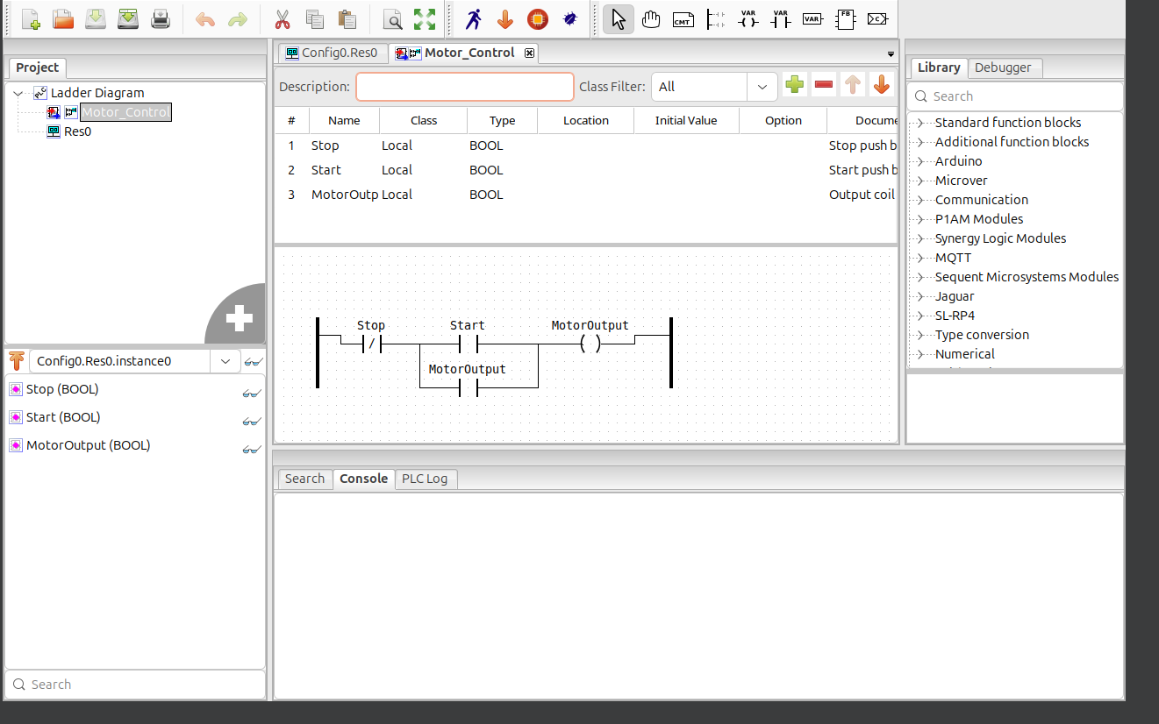
Figure 2 Motor start/stop control implemented using Ladder Diagram.

6. Motor-Control Tags and Boolean Data
The tag/variable list was examined to identify the variables used by the motor-control program.
The main control variables are Boolean because they represent two possible states, such as ON/OFF, TRUE/FALSE, or 1/0.
Tag | Data Type | Purpose
START | BOOL | Represents the motor start command
STOP | BOOL | Represents the motor stop command
MotorOutput | BOOL | Represents the motor output/control state

Figure 3: Motor-Control Tags
[INSERT SCREENSHOT OF THE TAG/VARIABLE LIST HERE.]
Figure 3 Boolean tags used in the motor-control program.

7. Function Block Diagram (FBD)
The Function Block Diagram example was opened from the PLC Programming Language Examples.
The Motor_Control_FBD program was examined to see how the same motor-control requirement is represented using connected function blocks instead of ladder contacts and coils.
In FBD, the control logic is represented using graphical blocks and connections. The blocks receive input signals and produce output signals.
The motor-control logic still performs the same basic functions:
- Receive the Start command.
- Maintain the motor output after starting.
- Respond to the Stop command.
- Turn the motor output off when the stop condition occurs.
The main difference is that the logic is shown through function blocks and signal connections rather than ladder contacts and coils.
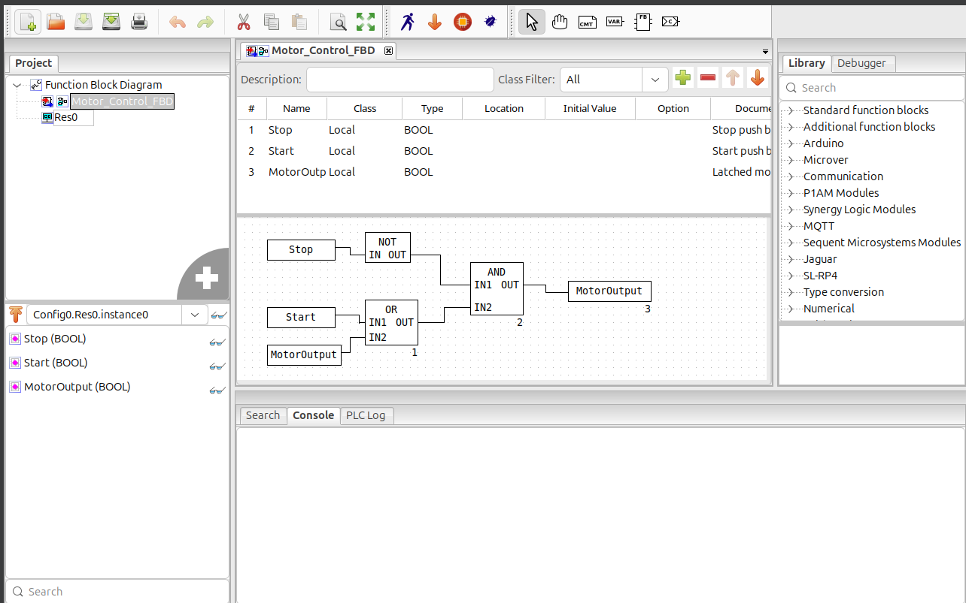
Figure 4 Motor-control logic represented using Function Block Diagram.

My Observation
[WRITE 1–3 SENTENCES BASED ON WHAT YOU ACTUALLY SEE.]
Example:
The FBD program represents the motor-control logic using connected function blocks. The blocks receive the start and stop signals and control the motor output while maintaining the required latching behaviour.
Replace the example above if your actual FBD contains different blocks or connections.

8. Structured Text (ST)
The Structured Text example was opened and the MotorControlST program was examined.
Structured Text represents PLC control logic using text-based programming statements instead of graphical contacts and coils.
The same motor-control requirement can therefore be expressed through conditions and Boolean logic.
The main idea remains the same:
- The Start condition turns the motor output on.
- The output can maintain its running state.
- The Stop condition turns the output off.
Structured Text is useful when the control logic involves more complicated conditions, calculations, or algorithms.
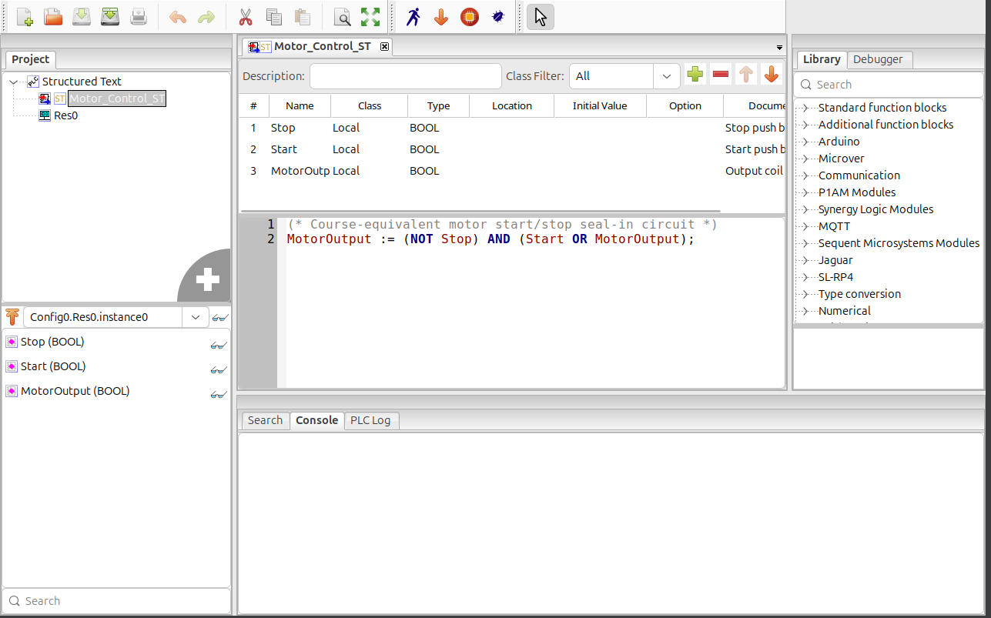
Figure 5 Motor-control logic represented using Structured Text.

My Observation
The Structured Text representation uses written programming statements instead of graphical ladder contacts. This makes the logic more compact and is useful for complex conditions and calculations.
[IF THE ACTUAL CODE YOU SEE IS DIFFERENT, DESCRIBE WHAT YOU SEE INSTEAD OF USING THIS SENTENCE.]

9. Instruction List (IL)
The Instruction List example was opened and the MotorControl program was examined.
Instruction List uses short, low-level textual instructions to represent PLC logic. Compared with Structured Text, the instructions are more direct and closer to the basic operations performed by the PLC.
Typical Instruction List operations can include instructions such as:
- LD — Load
- AND — Logical AND
- OR — Logical OR
- ST — Store
The exact instructions depend on the program provided in the laboratory environment.
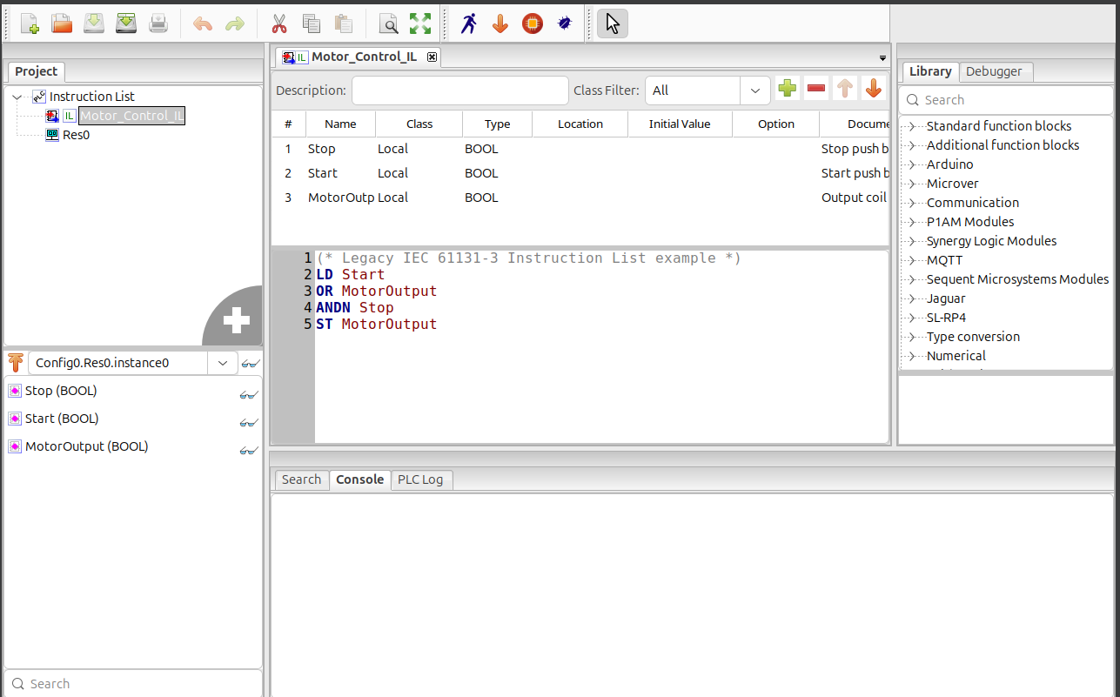
Figure 6 Motor-control logic represented using Instruction List.

My Observation
The main difference between Instruction List and Structured Text is the way the logic is written. Instruction List uses short individual instructions, while Structured Text uses a higher-level programming style that is easier to use for more complex conditions.

10. Sequential Function Chart (SFC)
The Sequential Function Chart example was opened and the MotorControl_SFC program was examined.
SFC represents control logic as a sequence of steps and transitions.
Instead of placing all the motor-control logic in one ladder rung or a block of text, the process can be divided into different stages.
For example, a simple motor-control sequence can be understood as:
Stopped → Start Condition → Running → Stop Condition → Stopped
The steps represent the current state of the process, while transitions determine when the system should move from one step to another.
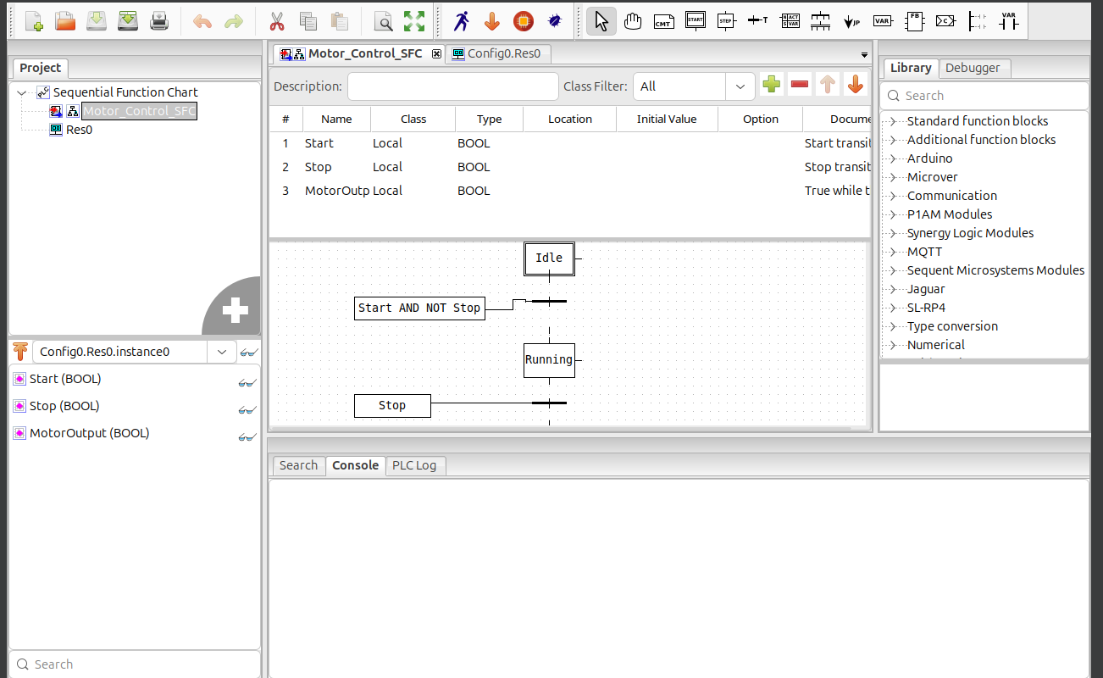
Figure 7 Motor-control sequence represented using Sequential Function Chart.

My Observation
The SFC representation shows the process as a sequence of steps and transitions. This makes it useful for systems where operations must occur in a specific order.
[ADJUST THIS DESCRIPTION IF YOUR ACTUAL SFC SHOWS DIFFERENT STEPS OR TRANSITIONS.]

11. Comparison of PLC Programming Languages
The five representations examined in this laboratory can be compared as follows:
Representation | Strengths | Limitations | Suitable Industrial Use
Ladder Diagram (LD) | Easy to understand and similar to relay-control circuits | Large programs can become difficult to manage | Motor control, machine control and discrete automation
Function Block Diagram (FBD) | Provides a visual representation of functions and signal connections | Many connected blocks can become complex | Process control, signal processing and automation
Structured Text (ST) | Good for complex calculations, conditions and algorithms | Less familiar to technicians who mainly use relay-style logic | Complex control logic, calculations and data processing
Instruction List (IL) | Compact and direct representation of PLC instructions | Less readable for beginners | Low-level or legacy PLC logic
Sequential Function Chart (SFC) | Clearly represents steps and process sequences | Not necessary for simple single-condition logic | Batch processes, sequential machines and multi-stage automation

12. Same Motor-Control Requirement in Different Languages
Although the five representations look different, they can represent the same basic motor-control requirement.
The control objective is:
Start the motor when the Start command is activated, keep the motor running through a latching mechanism, and stop the motor when the Stop command is activated.

Ladder Diagram
The requirement is represented using contacts and a coil.
STOP AND (START OR MotorOutput) → MotorOutput

Function Block Diagram
The same logic is represented using connected function blocks and signal paths.

Structured Text
The logic is represented using programming statements and Boolean conditions.

Instruction List
The logic is represented using short PLC instructions such as load, logical operations and store operations.

Sequential Function Chart
The logic can be represented as process states, for example:
Stopped → Starting/Running → Stopped
Therefore, the programming representation changes, but the required control behaviour remains the same.

13. Importance of Consistent Tags
Tags are names assigned to variables or signals used by the PLC program.
For example:
- START represents the start command.
- STOP represents the stop command.
- MotorOutput represents the motor output.
The meaning of these tags must remain consistent when moving between different programming representations.
If a tag changes meaning, the control logic could operate incorrectly. For example, if a variable intended to represent the Stop command is incorrectly treated as the Start command, the motor-control behaviour could become unsafe.
Therefore, consistent tag names and data types help ensure that the same control requirement is maintained across different programming languages.

14. Knowledge Check

Question 1: Why is Ladder Diagram intuitive for technicians familiar with relay logic?
Ladder Diagram is intuitive because its contacts, coils and control paths are visually similar to traditional relay-control circuits. Technicians who already understand electrical relay logic can therefore understand the PLC logic more easily.

Question 2: What is an advantage of Structured Text for complex calculations and conditions?
Structured Text allows complex calculations, conditions and logical operations to be written using programming statements. This can make complicated control logic more compact and easier to manage than creating a large number of graphical contacts and blocks.

Question 3: When might Sequential Function Chart be more appropriate than a single ladder rung?
Sequential Function Chart is more appropriate when a process contains several stages that must occur in a particular order. It allows the programmer to represent the process using steps and transitions, making the sequence easier to understand.

Question 4: Why must tag meanings remain consistent when the representation or language changes?
Tag meanings must remain consistent so that the control logic continues to perform the same function when represented in another programming language. Changing the meaning of a tag can cause incorrect or unexpected control behaviour.

15. Practical Evidence
The following screenshots were captured from the OpenPLC Editor during the laboratory exercise.
Evidence | Required Screenshot | Status
Figure 1 | PLC VM/IP address | [INSERT]
Figure 2 | Ladder Diagram — Motor_Control | [INSERT]
Figure 3 | Tag/Variable List | [INSERT]
Figure 4 | Function Block Diagram — Motor_Control_FBD | [INSERT]
Figure 5 | Structured Text — MotorControlST | [INSERT]
Figure 6 | Instruction List — MotorControl | [INSERT]
Figure 7 | Sequential Function Chart — MotorControl_SFC | [INSERT]

16. Safety and Laboratory Integrity
The laboratory was performed using the provided virtual machine in an isolated laboratory environment.
The PLC environment was not connected to a production industrial control system. No external scanning or testing of production systems was performed.

17. Conclusion
This laboratory provided practical experience with different PLC programming representations. The five representations examined were Ladder Diagram, Function Block Diagram, Structured Text, Instruction List and Sequential Function Chart.
The motor-control example demonstrated that the same control objective can be represented in different ways. Ladder Diagram provides a graphical representation similar to relay logic, while Function Block Diagram uses connected function blocks. Structured Text uses programming statements, Instruction List uses low-level instructions, and Sequential Function Chart represents a process using steps and transitions.
The exercise also demonstrated the importance of Boolean variables and consistent tag meanings when implementing control logic. Understanding these different representations is useful for cybersecurity and critical-infrastructure professionals because PLCs are an important component of industrial control systems.

