INTERNATIONAL CYBERSECURITY AND DIGITAL FORENSICS ACADEMY

INTRO TO CRITICAL INFRASTRUCTURE FOR IT LEARNERS

LAB 03 BUILDING YOUR FIRST PLC PROGRAM

Student Name: Muhammad Mukhtar Bello
Registration Number: C11/26/ACIS/17371
Course: Intro to Critical Infrastructure for IT Learners
Lab: Lab 03 Building Your First PLC Program
Laboratory Platform: VirtualBox / ICDFA PLC Virtual Machine
PLC Training IP Address: 192.168.56.103
Date: 26/09/2026

1. Introduction
Programmable Logic Controllers (PLCs) are used in industrial environments to monitor processes and control equipment automatically. In this laboratory, a simple automated tank-filling system was developed using OpenPLC Editor and Ladder Diagram programming.
The program represents a tank with a level sensor, automatic fill command, fill valve, high- and low-level alarms, and an emergency-stop condition. The tank operates within a range of 0 to 10 ft. Automatic filling begins when the tank reaches the empty/start setpoint of 2.0 ft and stops when the tank reaches the full setpoint of 8.0 ft.
The program was developed and tested entirely within the assigned ICDFA virtual laboratory environment.

2. Objectives
The objectives of this laboratory were to:
- Create a new OpenPLC Ladder Diagram project.
- Define Boolean and Real variables for a tank-filling process.
- Configure automatic tank-filling logic.
- Implement high- and low-level alarm conditions.
- Implement an emergency-stop condition.
- Compile and validate the PLC program.
- Test the program under different operating conditions.
- Document the results using screenshots and a test table.

3. Laboratory Environment
The laboratory was performed using the ICDFA-provided PLC virtual machine running through VirtualBox.
Item | Details
Virtualization Platform | VirtualBox
PLC Environment | OpenPLC
PLC VM Address | 192.168.56.103
Project Name | TankFill
Programming Language | Ladder Diagram (LD)
PLC Runtime | OpenPLC local runtime
The laboratory network was kept within the assigned training environment as required by the laboratory instructions.

4. Project Creation
A new OpenPLC project named TankFill was created. A new POU named TankFill was created using Ladder Diagram (LD) as the programming language.
The project was saved in the ICDFA laboratory environment and later successfully compiled and started using the OpenPLC runtime.
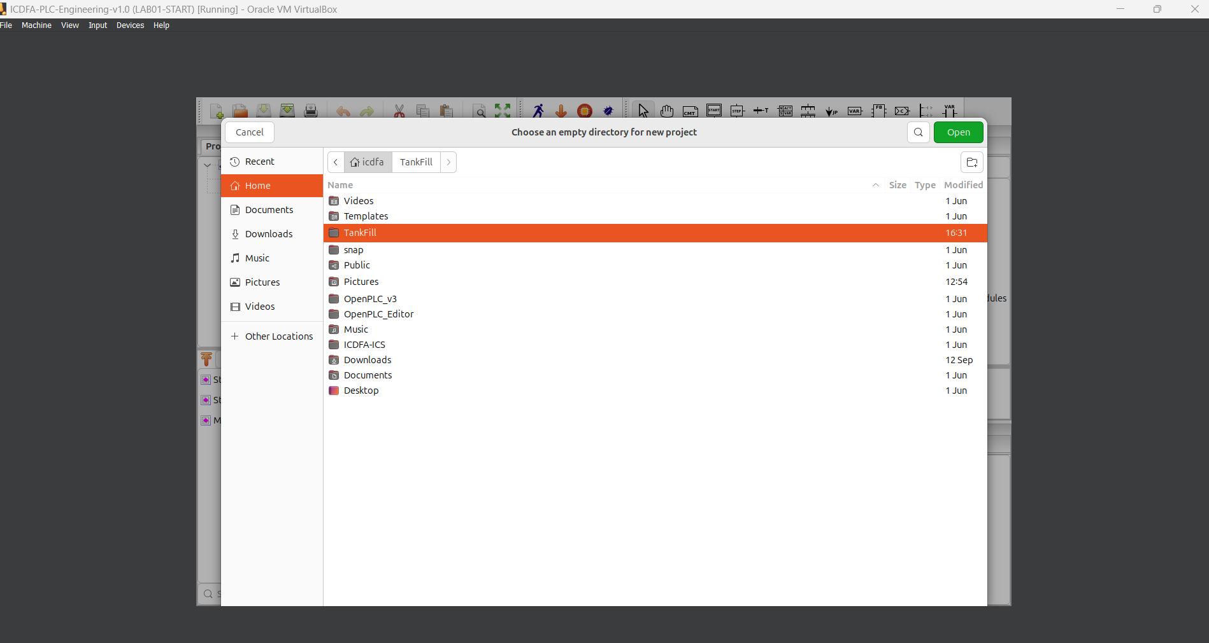
Figure 1: TankFill project and Ladder Diagram POU.

5. Variable Configuration
The following variables were created for the tank control system.
Variable | Data Type | Purpose | Setpoint/Initial Value
TankFillAuto_Cmd | BOOL | Automatic fill command/latch | —
TankValveOpen | BOOL | Fill valve command/status | —
Estop_Cmd | BOOL | Emergency-stop condition | FALSE
TankLevelHi_Alarm | BOOL | High-level alarm | —
TankLevelLo_Alarm | BOOL | Low-level alarm | —
TankLevel_LIT | REAL | Measured tank level | 5.0 ft
TankEmpty_SP | REAL | Automatic fill start setpoint | 2.0 ft
TankFull_SP | REAL | Automatic fill stop setpoint | 8.0 ft
TankLoAlarm_SP | REAL | Low-level alarm setpoint | 1.0 ft
TankHiAlarm_SP | REAL | High-level alarm setpoint | 9.0 ft
The Boolean variables were used for discrete conditions such as alarms, commands and valve states. REAL variables were used for tank level measurements and numerical setpoints.
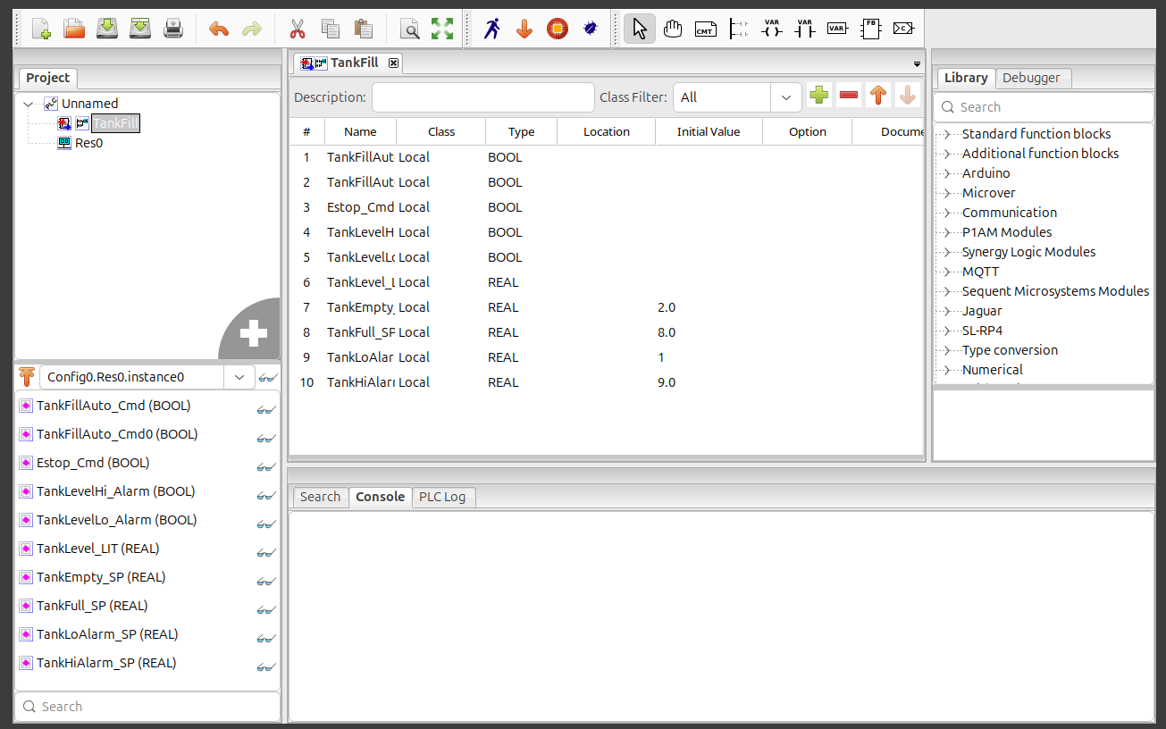
Figure 2: TankFill variable and tag configuration.

6. Tank Operating Setpoints
The tank control system was configured using four main setpoints:
- Automatic fill start: 2.0 ft
- Automatic fill stop: 8.0 ft
- Low-level alarm: 1.0 ft
- High-level alarm: 9.0 ft
Therefore, the basic operating behavior was:
1.0 ft Low-level alarm
2.0 ft Automatic filling starts
5.0 ft Normal operating/filling condition
8.0 ft Automatic filling stops
9.0 ft High-level alarm

7. Ladder Logic Implementation

7.1 Valve Control Rung
The first rung controls the tank fill valve.
The logic is:
TankFillAuto_Cmd AND NOT TankLevelHi_Alarm
|
v
TankValveOpen
The automatic fill command must be active and the high-level alarm must not be active before the valve is commanded open.
The high-level alarm is therefore able to prevent normal filling when the tank reaches the high-level alarm condition.
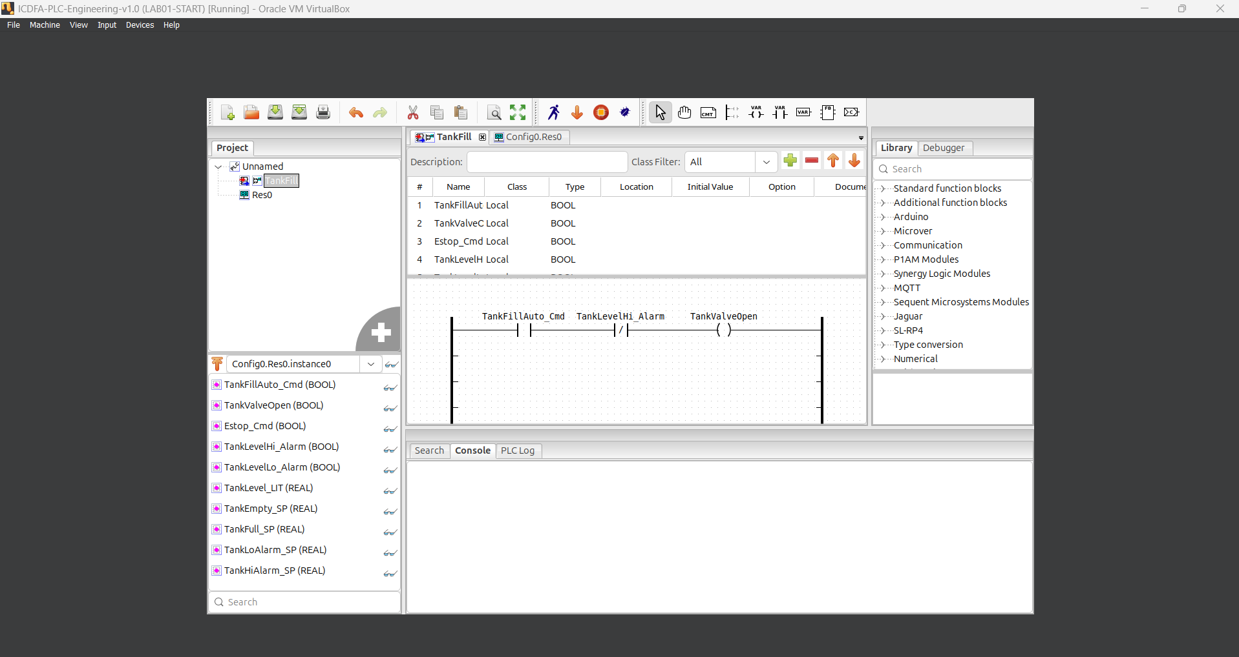
Figure 1 Tank fill valve control rung.

7.2 Automatic Start Rung
The automatic filling command is set when the tank level reaches or falls below the empty/start setpoint.
The implemented condition is:
TankLevel_LIT <= TankEmpty_SP
Since:
TankEmpty_SP = 2.0 ft
the automatic fill command is set when the tank level is 2.0 ft or below.
The condition activates:
SET TankFillAuto_Cmd
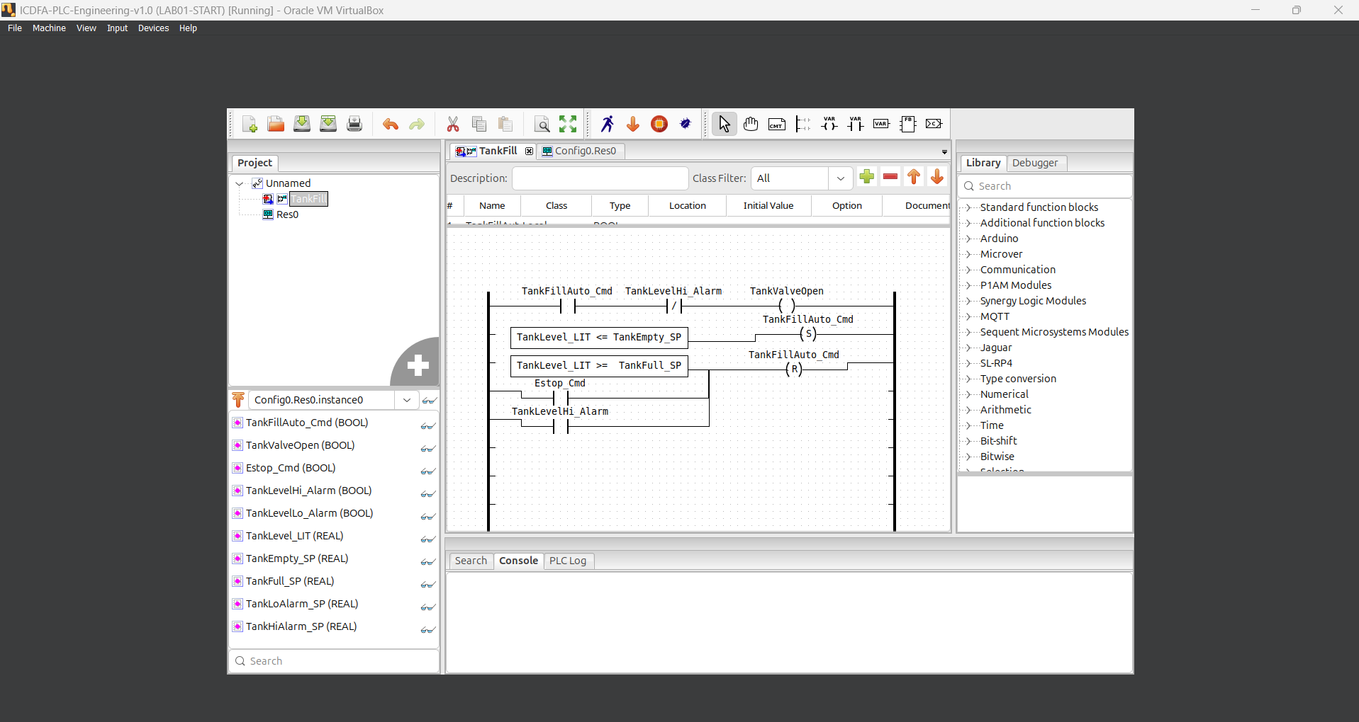
Figure 2 Automatic tank-fill start logic.

7.3 Automatic Stop and Safety Reset
A RESET condition was implemented to stop automatic filling when any of the following conditions occurs:
TankLevel_LIT >= TankFull_SP
OR
Estop_Cmd
OR
TankLevelHi_Alarm
The resulting action is:
RESET TankFillAuto_Cmd
The full-tank setpoint is:
TankFull_SP = 8.0 ft
Therefore, the automatic fill command is reset when the tank reaches 8.0 ft or when either the emergency stop or high-level alarm becomes active.
Figure 3 Automatic stop and safety reset logic.

7.4 High-Level Alarm
The high-level alarm was configured using the condition:
TankLevel_LIT >= TankHiAlarm_SP
The high-level alarm setpoint is:
TankHiAlarm_SP = 9.0 ft
When the tank reaches or exceeds 9.0 ft, the variable:
TankLevelHi_Alarm
becomes TRUE.
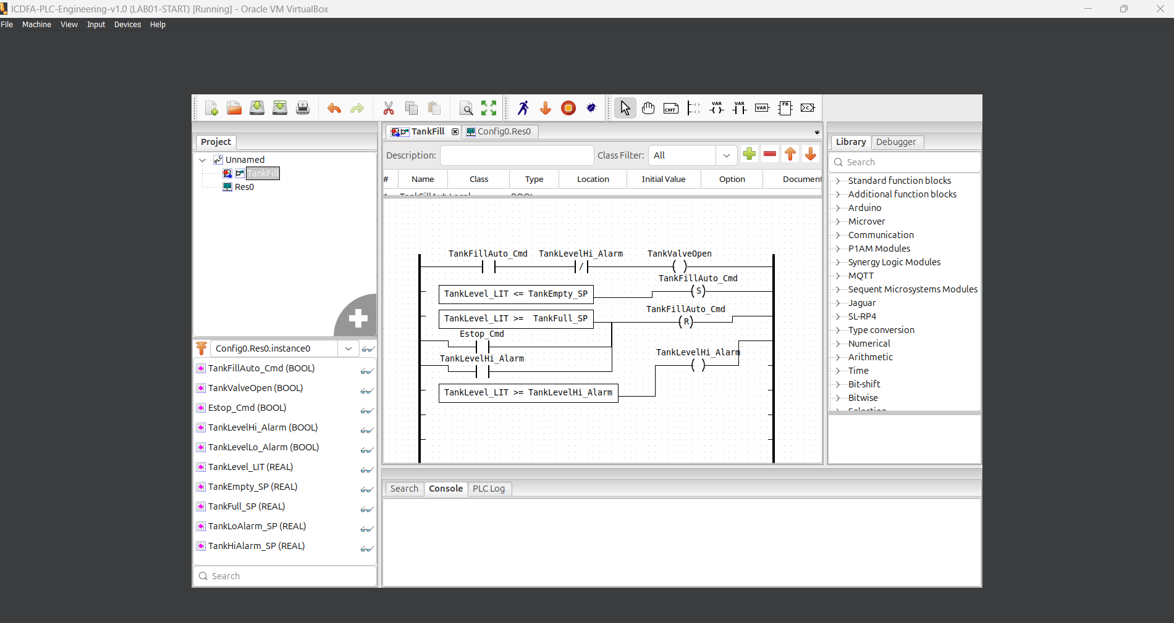
Figure 4 High-level alarm logic.

7.5 Low-Level Alarm
The low-level alarm was configured using:
TankLevel_LIT <= TankLoAlarm_SP
The low-level alarm setpoint is:
TankLoAlarm_SP = 1.0 ft
When the tank reaches or falls below 1.0 ft, the variable:
TankLevelLo_Alarm
becomes TRUE.
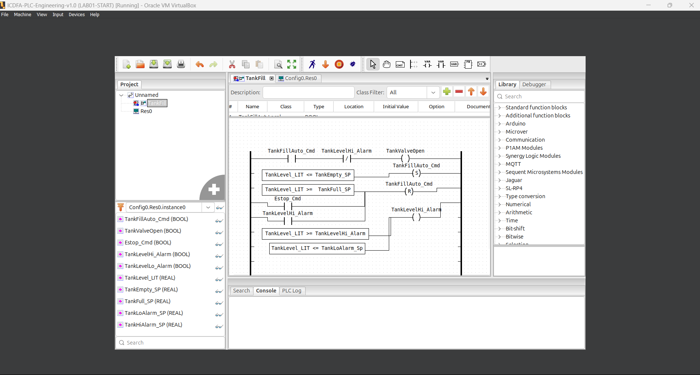
Figure 5 Low-level alarm logic.
Figure 7:

8. Complete Ladder Program
After all the individual rungs were created, the complete TankFill Ladder Diagram was inspected to confirm that all variables, contacts, comparisons and coils were connected correctly.
The completed program contained:
- Valve-control logic.
- Automatic-start logic.
- Automatic-stop/reset logic.
- High-level alarm logic.
- Low-level alarm logic.
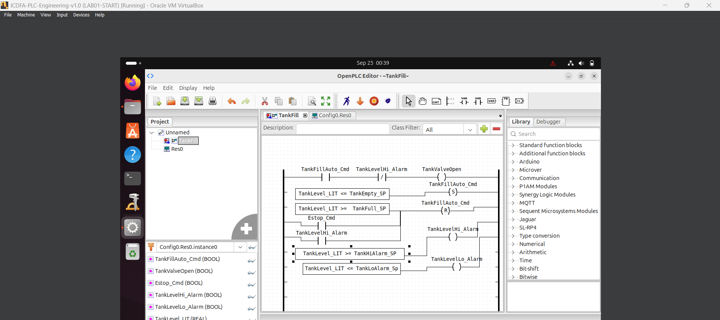
Figure 6 Complete TankFill Ladder Diagram.

9. Program Validation and Compilation
The completed PLC program was saved and compiled using the OpenPLC build process.
The initial compilation identified two errors involving a REAL initial value and an incorrect high-level alarm comparison. These errors were corrected before the final build.
The final compilation completed successfully.
The successful build output included:
C code generated successfully.
Successfully built.
PLC installed successfully.
PLCobject : PLC started
Starting PLC
This confirmed that the corrected PLC program could be compiled, installed and started by the OpenPLC runtime.
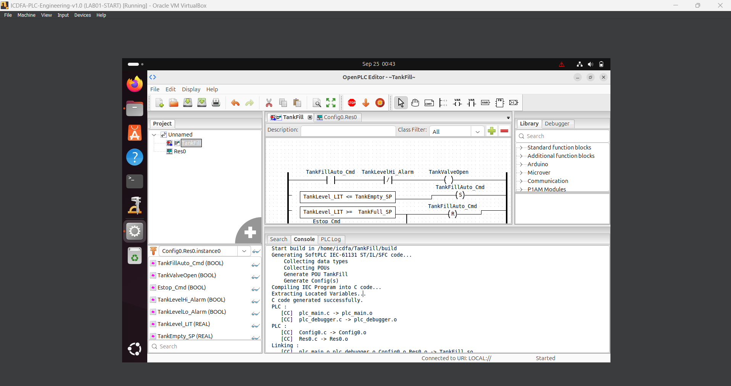
Figure 7 Successful compilation, installation and startup of the TankFill PLC program.

10. Logic Testing
The completed program was tested using six required scenarios. The tank-level and emergency-stop values were changed within the laboratory environment to verify the expected behavior of the PLC logic.

10.1 Test Results
No. | Scenario | Tank Level | E-Stop | Expected/Observed Result
1 | Empty tank | 2.0 ft | OFF | Automatic fill command activated
2 | Normal filling | 5.0 ft | OFF | Normal filling condition maintained
3 | Full tank | 8.0 ft | OFF | Automatic filling stopped
4 | High-level alarm | 9.0 ft | OFF | High-level alarm activated and filling stopped
5 | Low-level alarm | 1.0 ft | OFF | Low-level alarm activated
6 | Emergency stop | 5.0 ft | ON | Automatic filling stopped

11. Test 1 Empty Tank
The tank level was set to 2.0 ft, which is equal to the automatic fill-start setpoint.
The condition:
TankLevel_LIT <= TankEmpty_SP
was therefore TRUE.
The automatic fill command was activated and the valve-control logic allowed the fill valve to operate.
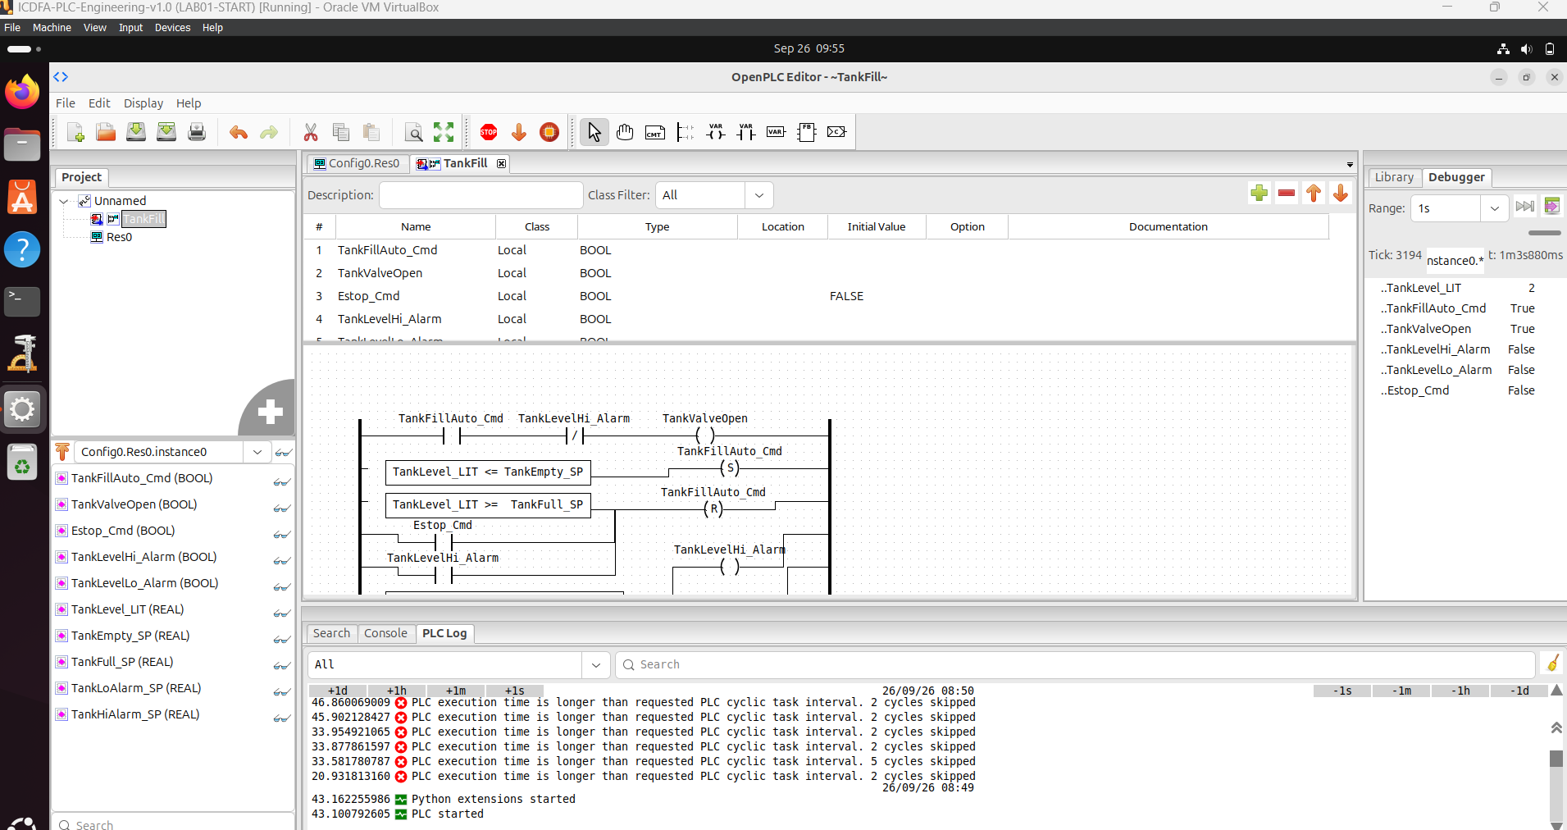
Figure 8 Empty-tank test at the 2.0 ft automatic fill-start setpoint.

12. Test 2 Normal Filling
The tank level was set to 5.0 ft, which is between the automatic start and stop setpoints.
At this level, neither the low-level nor high-level alarm condition was active. The test represented normal filling/operating conditions.
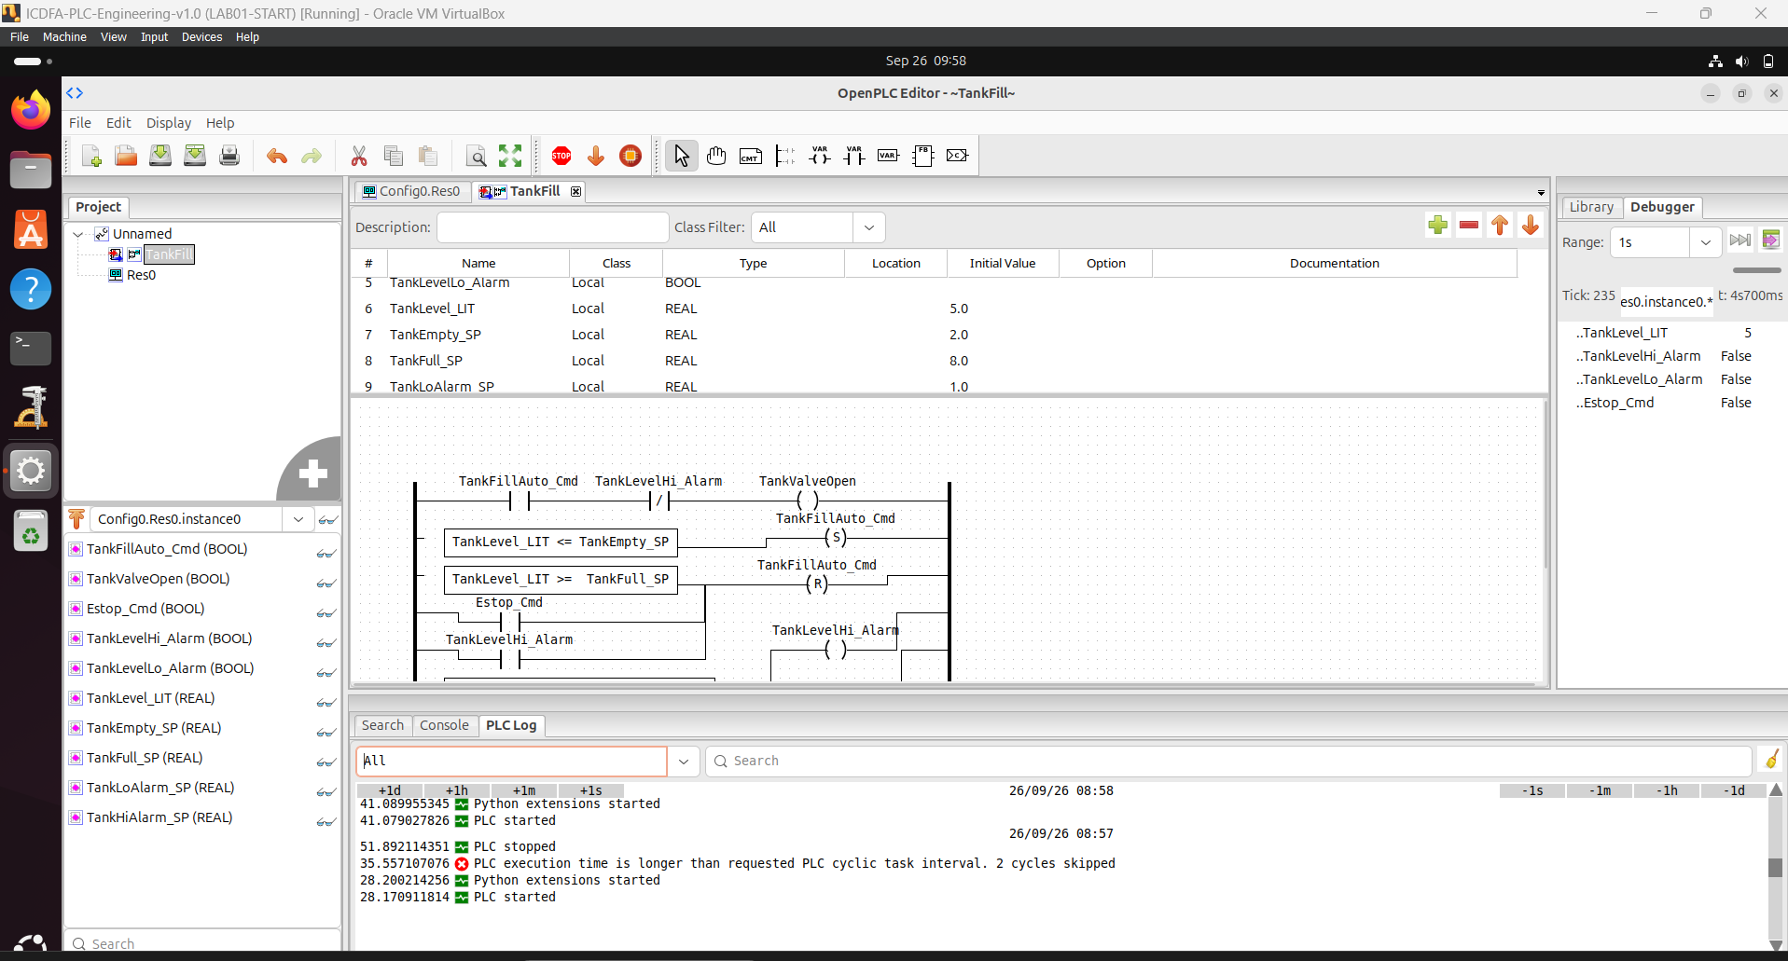
Figure 9 Normal filling condition with the tank level at 5.0 ft.

13. Test 3 Full Tank
The tank level was set to 8.0 ft.
The full-tank condition:
TankLevel_LIT >= TankFull_SP
became TRUE because both values were 8.0 ft.
The RESET logic therefore deactivated the automatic fill command and stopped normal filling.
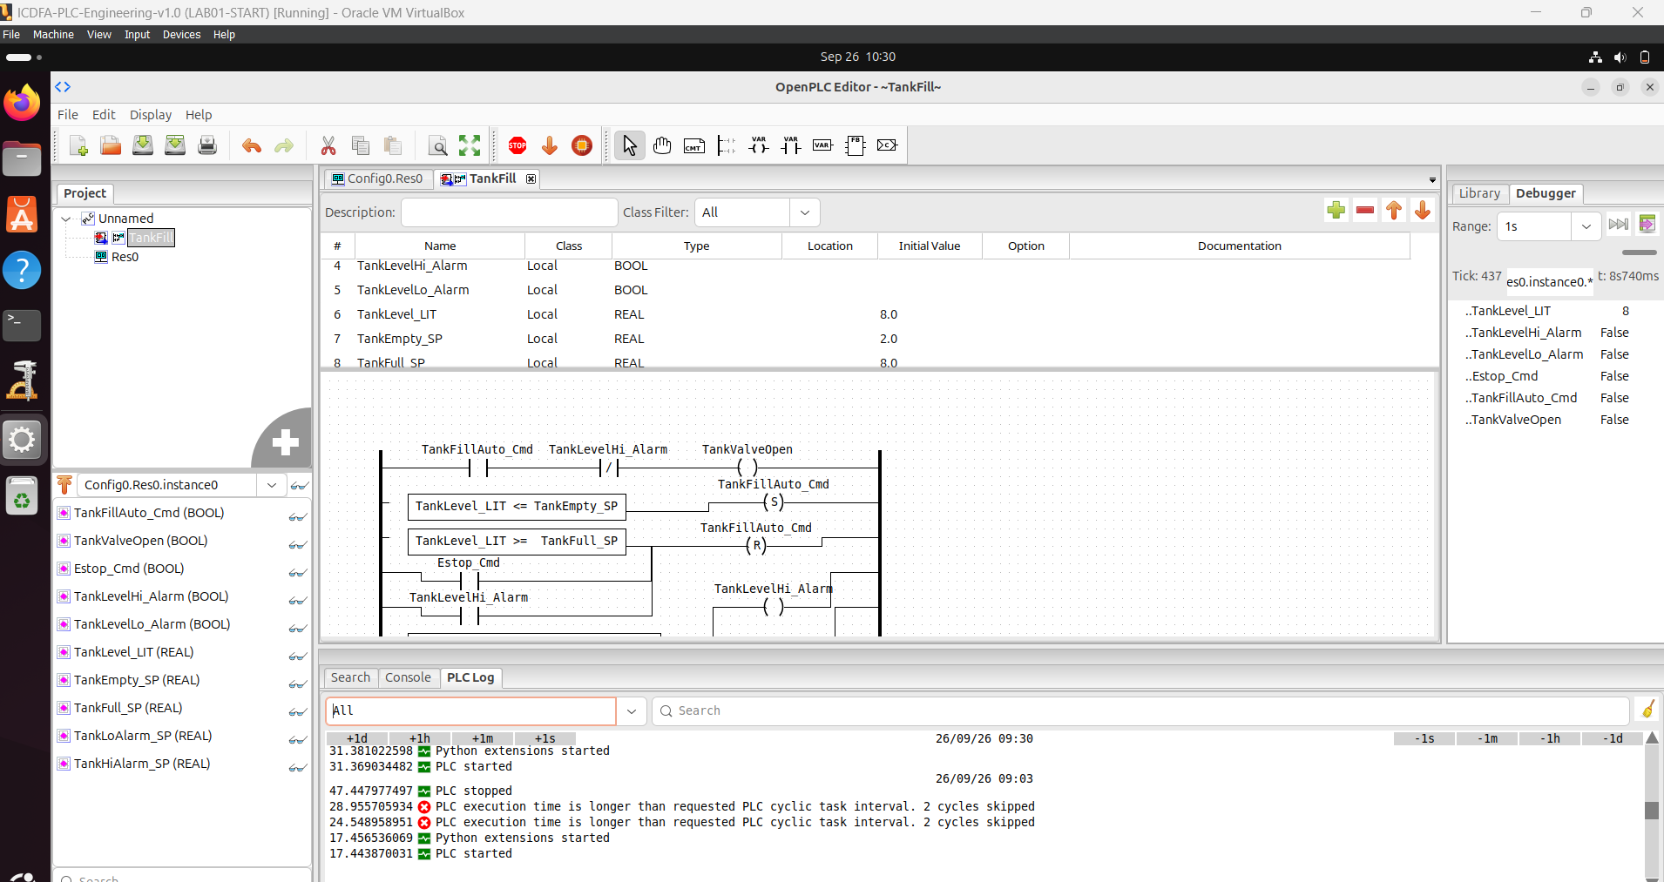
Figure 10 Full-tank test at the 8.0 ft automatic fill-stop setpoint.

14. Test 4 High-Level Alarm
The tank level was set to 9.0 ft.
The high-level condition:
TankLevel_LIT >= TankHiAlarm_SP
became TRUE.
The high-level alarm was activated, and the safety/reset logic prevented automatic filling from continuing.
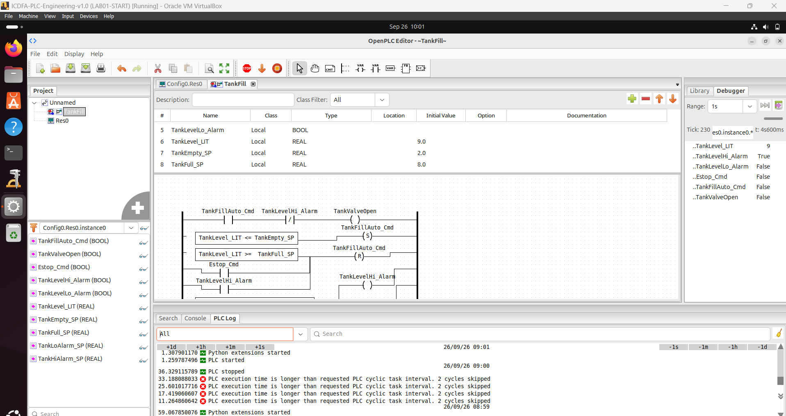
Figure 11 High-level alarm test at the 9.0 ft alarm setpoint.

15. Test 5 Low-Level Alarm
The tank level was set to 1.0 ft.
The low-level condition:
TankLevel_LIT <= TankLoAlarm_SP
became TRUE.
The low-level alarm was activated. At the same time, the tank level was also below the 2.0 ft automatic-fill start setpoint, so the automatic-fill logic could request filling.
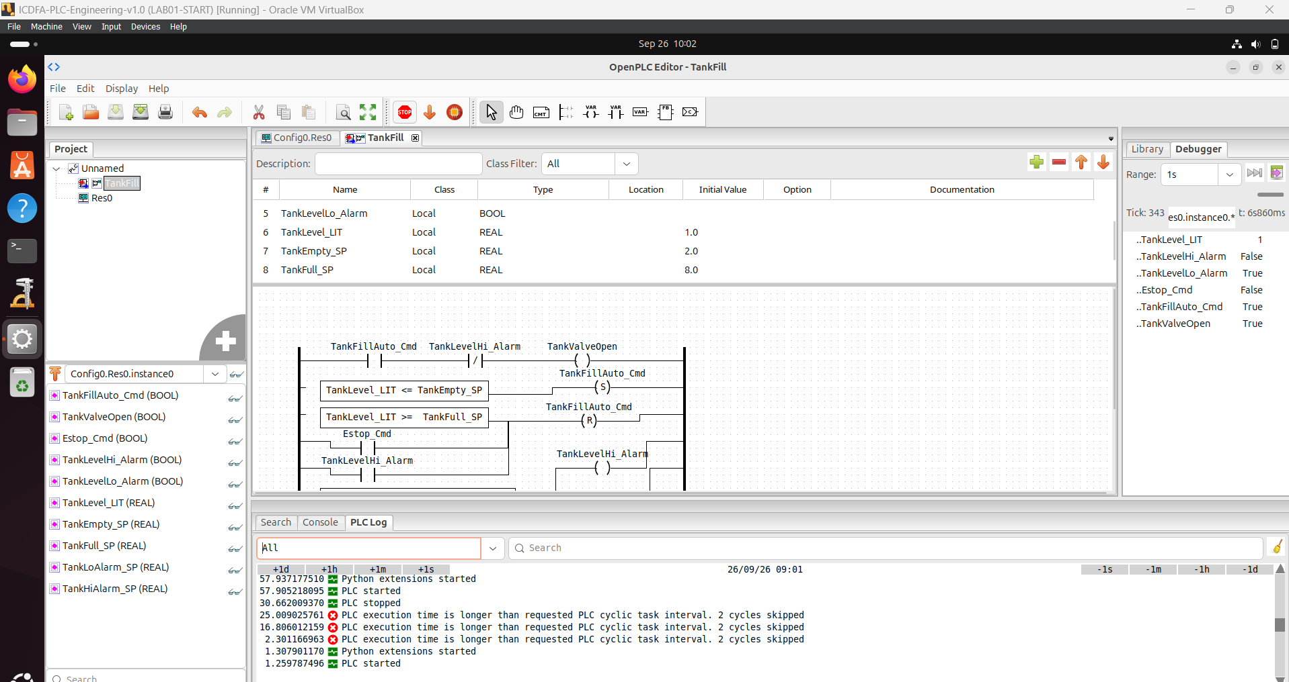
Figure 12 Low-level alarm test at the 1.0 ft alarm setpoint.

16. Test 6 Emergency Stop
For the emergency-stop test, the tank level was set to 5.0 ft and:
Estop_Cmd = TRUE
was applied.
Although 5.0 ft is within the normal operating range, the emergency-stop condition activated the RESET logic and stopped the automatic fill command.
This demonstrated that the emergency-stop condition overrides normal automatic control.
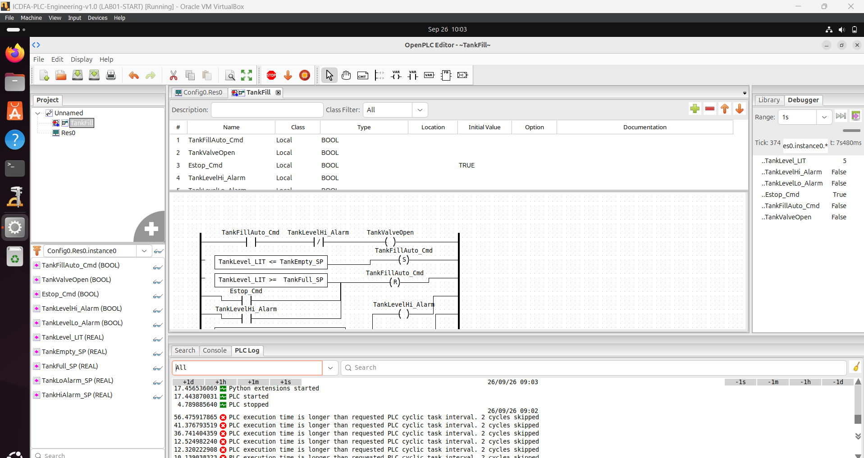
Figure 13 Emergency-stop test demonstrating the override of automatic filling.

17. Safety Explanation
An emergency-stop condition is important because normal automatic control may continue operating equipment when a hazardous situation occurs. The emergency stop provides a condition that overrides the normal automatic filling logic.
In this program, Estop_Cmd is included in the RESET logic for TankFillAuto_Cmd. Therefore, when the emergency-stop condition becomes TRUE, the automatic fill command is reset and the fill valve is no longer commanded by the automatic control logic.
Emergency-stop functionality should always be validated carefully in a safe simulation or controlled test environment before a PLC program is connected to physical industrial equipment.

18. Knowledge Check

Question 1: Why are BOOL and REAL appropriate data types for this project?
BOOL is appropriate for discrete conditions such as the emergency stop, valve status, automatic-fill command and alarm states because these conditions have TRUE or FALSE states. REAL is appropriate for the tank level and setpoints because these values represent numerical measurements that can contain decimal values, such as 2.0 ft or 8.0 ft.

Question 2: What is the purpose of a SET/RESET pair for TankFillAuto_Cmd?
The SET/RESET pair allows the automatic-fill command to remain active after the starting condition occurs and then be turned off when a stopping or safety condition occurs. In this project, SET starts automatic filling when the tank level is at or below 2.0 ft, while RESET stops it when the tank reaches 8.0 ft, the emergency stop is activated, or the high-level alarm becomes active.

Question 3: What should happen if the tank reaches 9 ft while the fill valve remains commanded open?
The high-level alarm should become active because 9 ft is the high-level alarm setpoint. The high-level alarm is also included in the automatic reset logic, so the automatic fill command should be reset and the fill valve should stop being commanded open.

Question 4: Why should PLC logic be validated in simulation before use with physical equipment?
Simulation allows the logic to be checked without exposing real equipment, workers or an industrial process to incorrect control behavior. It helps identify programming errors, incorrect conditions and unexpected outputs before the program is connected to physical equipment.

19. Conclusion
This laboratory demonstrated the development of a basic PLC-based automatic tank-filling system using OpenPLC and Ladder Diagram programming.
The project included Boolean and REAL variables, automatic filling, a fill valve command, high- and low-level alarms, and an emergency-stop condition. The program was successfully compiled and started using the OpenPLC runtime.
Six operating scenarios were tested: empty tank, normal filling, full tank, high-level alarm, low-level alarm and emergency stop. The tests demonstrated the intended behavior of the control logic and showed how safety conditions can override normal automatic operation.
The laboratory provided practical experience in PLC programming, industrial process control, logic validation and basic safety considerations within an isolated virtual training environment.

