LAB 05 BUILDING A SCADA HUMAN MACHINE INTERFACE
Student Name: Muhammad Mukhtar Bello
Registration Number: 17371
Course: Introduction to Critical Infrastructure / SCADA
Laboratory: Lab 05 – Building a SCADA Human Machine Interface
Platform: FUXA v1.3.2 and OpenPLC
Date: 02/10/2026

1. Introduction
A Human Machine Interface (HMI) provides an interface through which an operator can monitor and interact with an industrial process. In a SCADA environment, the HMI presents process information such as tank levels, valve states, alarms, and equipment status in a form that can be easily understood by an operator.
In this laboratory exercise, a tank-filling process HMI was designed using FUXA. The interface was developed to represent a tank, process piping, a motor-actuated valve, and a tank-level indication. The design was kept simple and focused on operational awareness rather than unnecessary visual effects.
The laboratory also introduced the process of connecting an HMI to an OpenPLC-controlled process using industrial communication tags. Where possible, the FUXA interface was prepared for connection to the PLC simulation.

2. Objectives
The objectives of this laboratory were to:
- Design a basic SCADA HMI for a tank-filling process using FUXA.
- Create a tank, process pipe, valve, and level indication.
- Configure the tank-level indication with an engineering range of 0–10 ft.
- Prepare the HMI for communication with an OpenPLC-based process.
- Understand how PLC data can be represented on an HMI.
- Apply high-performance HMI principles by using a simple and restrained interface.
- Understand the importance of accurate and current PLC data for operator awareness.

3. Software and Environment
The following software and virtual machines were used:
Component | Description
HMI/SCADA Software | FUXA v1.3.2
PLC Platform | OpenPLC Runtime
Virtualisation Platform | Oracle VirtualBox
HMI Interface | FUXA Web Editor
Registration Number | 17371
The FUXA editor was accessed through the local web interface:
http://127.0.0.1:1881/editor

4. HMI Project Creation
A new FUXA project was created for the laboratory using the registration number and laboratory identifier.
Project Name: 17371_LAB05
A neutral grey background was selected and the grid was enabled to assist with accurate positioning and alignment of the HMI objects.

Screenshot Evidence
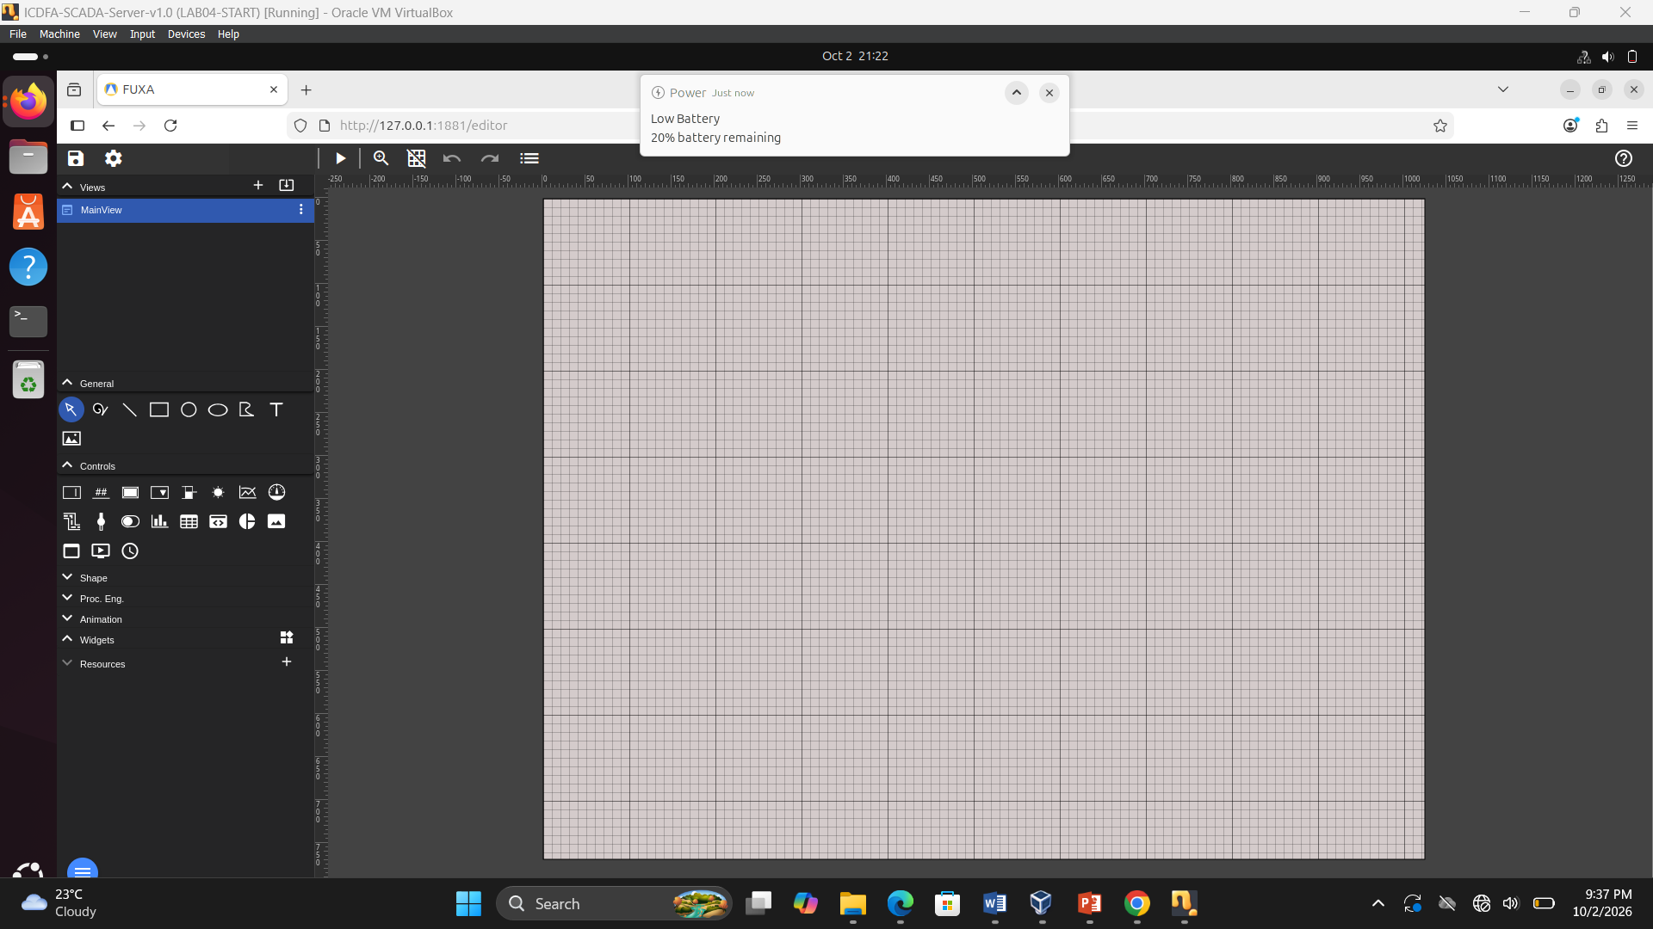
Figure 1 New 17371_LAB05 FUXA HMI project with the grid enabled.

5. Tank Process HMI Design
A tank graphic was added to represent the main process vessel. The tank forms the central element of the HMI because the process being represented is based on monitoring and controlling tank filling and draining.
The tank was positioned so that the level indication and other process components could be viewed clearly by an operator.

Screenshot Evidence
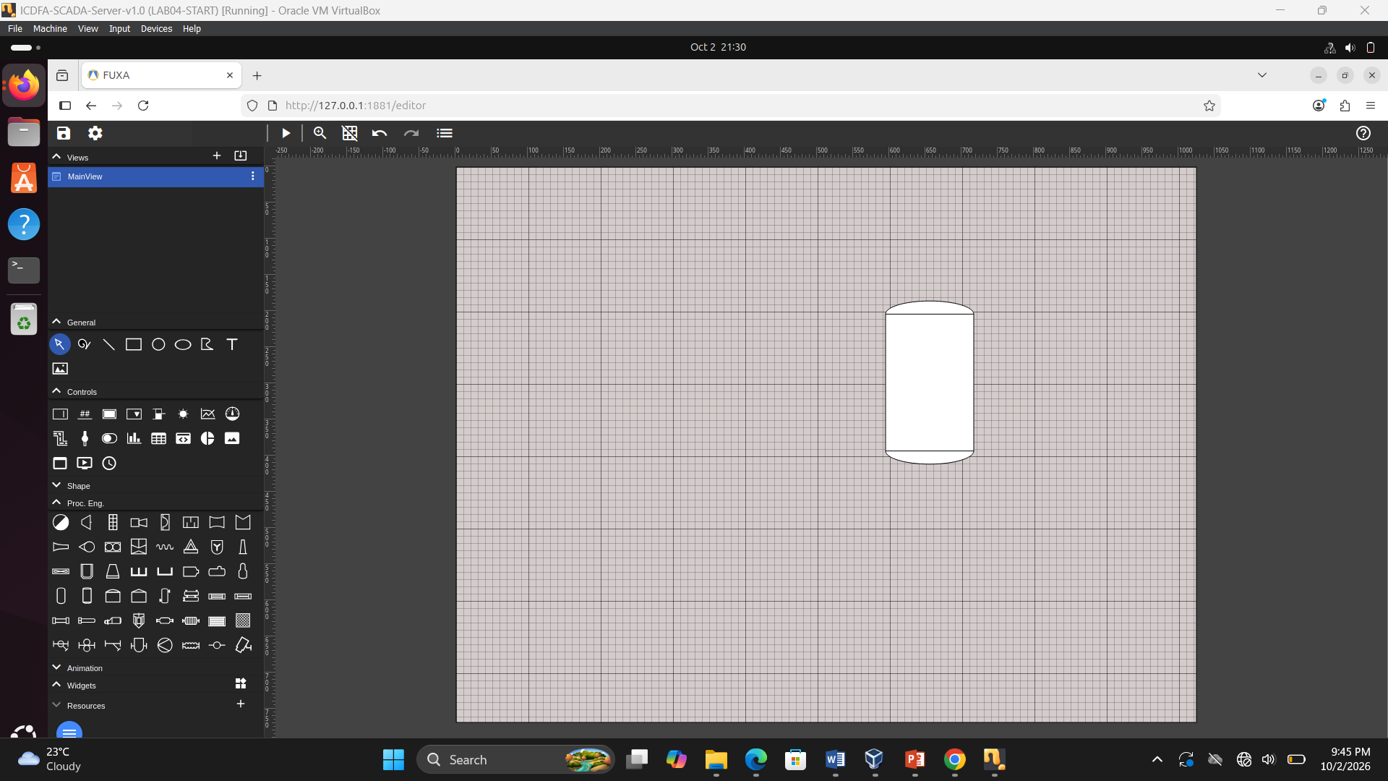
Figure 2 Tank process graphic positioned on the FUXA HMI workspace.

6. Tank Level Indication
A level indication was added to the tank HMI to represent the quantity of liquid inside the tank. The engineering range was configured from 0 to 10 ft, corresponding to the intended tank-level range in the laboratory exercise.
The level indicator provides an operator with a direct representation of the current tank level and can be associated with the PLC tank-level variable when the live PLC connection is available.

Screenshot Evidence
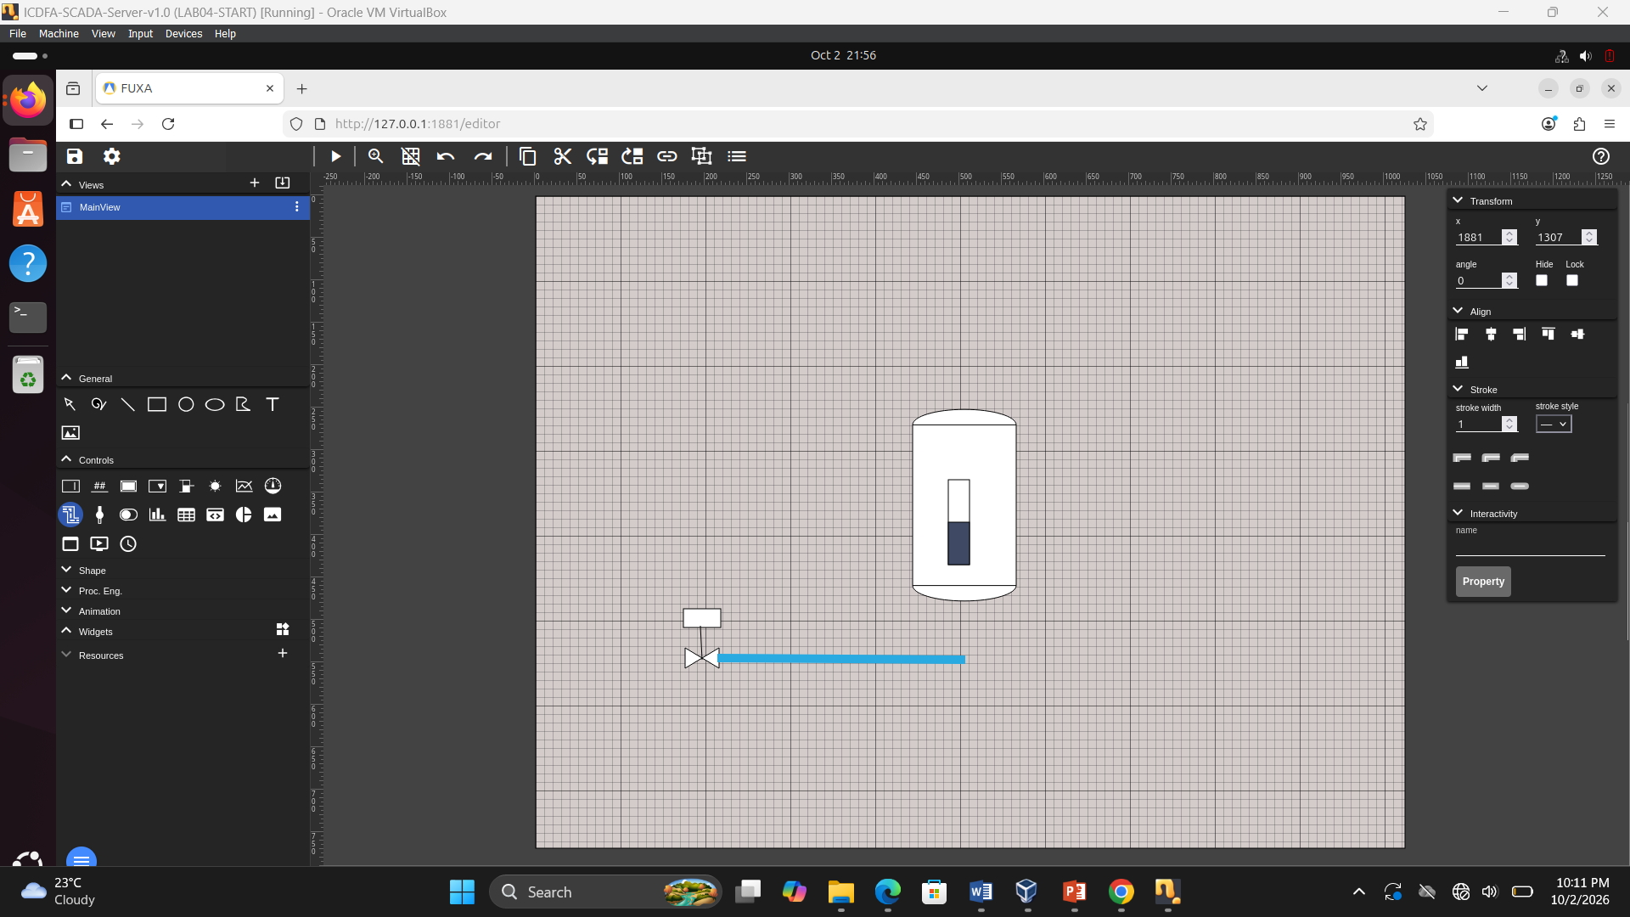Figure 3: Tank level indication configured with a 0–10 ft engineering range.

7. Process Piping and Fill Valve
Process piping was added to represent the flow path into and out of the tank. A motor-actuated valve was also included to represent the filling control element.
The valve is intended to provide a visual indication of whether the filling path is open or closed. In a fully connected system, the valve indication would be linked to the corresponding PLC output.

Screenshot Evidence
Figure 4: Process piping and motor-actuated fill valve added to the HMI.

8. HMI Layout and Situational Awareness
The HMI was designed using a simple layout so that the main process information could be identified without unnecessary visual distractions.
The tank was placed as the main process object, while the level indication, piping, and valve were arranged around it to represent the physical process flow. The use of a neutral background and limited visual effects helps the operator focus on important process information.
A high-performance HMI should communicate important process conditions clearly. Excessive animation, bright colours, decorative graphics, and unnecessary movement can make it more difficult for an operator to identify abnormal conditions.

Screenshot Evidence
Figure 5: Completed HMI design showing the tank, level indication, piping, and valve.

9. OpenPLC Runtime
The OpenPLC Runtime was available on the PLC virtual machine and was confirmed to be running as a system service.
The OpenPLC Runtime service was running from the OpenPLC installation located in:
/home/icdfa/OpenPLC_v3

Screenshot Evidence
Figure 6: OpenPLC Runtime service running on the PLC virtual machine.

10. PLC Simulation Program
The laboratory provided a TankFillSim.st Structured Text program intended to simulate the tank-filling process.
The program contains process variables for:
- Run command
- Reset command
- Fill valve
- Drain valve
- Cycle completion
- High-level indication
- Low-level indication
- Tank level
- Process state
- Timing functions
The intended operation is for the simulation to fill the tank, hold the level for a specified period, and subsequently drain the tank before repeating the process.
During the laboratory, an attempt was made to compile the supplied Structured Text program. The program generated intermediate files such as POUS.c, POUS.h, and VARIABLES.csv, but the OpenPLC compilation process reported missing configuration files including Config0.c, Config0.h, and Res0.c.
Because of this compilation issue, the complete live PLC simulation could not be confirmed during this laboratory session.

Screenshot Evidence
Figure 7: OpenPLC compilation result showing the compilation/configuration error encountered during the laboratory.

11. FUXA Project Preparation
The FUXA environment was successfully accessed and the tank process project was prepared.
The FUXA installation was already available on the SCADA virtual machine, and the FUXA editor could be accessed through the local web interface.
The project was prepared with the required process objects so that PLC data could subsequently be associated with the HMI objects once the PLC simulation and communication path were fully operational.

Screenshot Evidence
Figure 8: FUXA HMI project prepared for the tank process.

12. PLC-to-HMI Data Mapping
The intended communication architecture uses PLC process variables as data sources for the HMI.
The laboratory specifies the following principal mappings:
HMI Variable | Intended PLC Address | Purpose
Tank Level | %IW80 / Input Register 80 | Displays tank level
Tank Valve Open | %QX0.0 / Coil 0 | Indicates fill-valve state
The Tank Level variable represents the current level of liquid in the tank and is intended to be displayed by the level indicator.
The Tank Valve Open variable represents the state of the fill valve. A value indicating an open valve would allow the HMI to show that the tank is being filled.
The live PLC-to-FUXA mapping could not be fully verified because the supplied PLC simulation program did not successfully complete the required OpenPLC compilation process.

13. HMI and SCADA Architecture
The intended architecture of the laboratory system is:

14. High-Performance HMI Design Principles
The HMI design follows basic high-performance HMI principles by avoiding unnecessary decoration and excessive animation.
The interface uses a neutral background and focuses attention on the process equipment and important operating information. The tank, level indication, piping, and valve provide information directly related to the process.
This approach improves situational awareness because an operator can quickly identify the main equipment and understand the current process state. Important abnormal conditions can also be made more noticeable without filling the entire interface with unnecessary colours or animations.

15. Knowledge Check

15.1 What is a P&ID and how does it influence HMI layout?
A P&ID, or Piping and Instrumentation Diagram, represents the equipment, piping, valves, instruments, and control relationships within an industrial process.
A P&ID can influence HMI layout by providing a representation of how the physical process is connected. The HMI can use a similar arrangement so that operators can easily relate the graphical display to the actual process. For example, the tank, inlet pipe, outlet pipe, and valve can be positioned according to their relationship in the physical process.

15.2 Why do high-performance HMIs avoid unnecessary animation and excessive colour?
High-performance HMIs avoid unnecessary animation and excessive colour because they can distract the operator and make important information harder to identify.
A simple interface allows abnormal conditions and important changes to stand out more clearly. Colours and animation should therefore be used mainly when they communicate useful operational information.

15.3 What is the difference between Tank Level and Tank Valve Open data?
Tank Level represents a measurement of the amount or height of liquid in the tank. In this laboratory, the intended engineering range is 0–10 ft.
Tank Valve Open represents the state of the valve. It is a Boolean-type condition that can indicate whether the valve is open or closed.
Therefore, Tank Level is a process measurement, while Tank Valve Open represents an equipment state.

15.4 What are the operational consequences of stale or incorrect PLC data?
Stale or incorrect PLC data can cause an operator to have an inaccurate understanding of the process.
For example, if the HMI displays an old tank level, the operator may believe that the tank contains less or more liquid than it actually does. Similarly, an incorrect valve status may cause the operator to believe that a valve is closed when it is actually open.
In an industrial environment, inaccurate information can therefore contribute to incorrect operational decisions and potentially unsafe process conditions.

16. Laboratory Results
The following aspects of the laboratory were completed or verified:
Activity | Status
FUXA v1.3.2 available | Completed
FUXA editor accessed | Completed
Lab 05 project created | Completed
Neutral HMI background/grid | Completed
Tank process graphic | Completed
Tank level indication | Completed
0–10 ft level range | Completed
Process piping | Completed
Fill valve representation | Completed
HMI layout | Completed
OpenPLC Runtime available/running | Completed
TankFillSim compilation | Not completed successfully
Live PLC–FUXA data communication | Not verified
Live tank-level animation | Not verified
Live valve-state animation | Not verified
The HMI design and preparation were completed. However, the final live PLC-to-FUXA demonstration could not be fully verified because the supplied TankFillSim.st program encountered an OpenPLC compilation/configuration error.

17. Conclusion
This laboratory demonstrated the basic process of developing a SCADA Human Machine Interface using FUXA. A tank-filling process was represented using a tank graphic, level indication, process piping, and a motor-actuated valve.
The exercise also demonstrated the relationship between the PLC control layer and the SCADA/HMI layer. The PLC is responsible for executing the process-control logic, while the HMI provides the operator with a graphical representation of process conditions.
The FUXA environment and HMI design were successfully prepared. The supplied tank simulation program was also investigated, but its complete live operation could not be confirmed because the OpenPLC compilation process reported missing project configuration files. Consequently, live PLC-to-FUXA data updates were not claimed as completed.

