ACICP302ICS - Modbus/TCP OT Security Simulation Lab

Final Laboratory Report
Student Name: Muhammad Mukhtar Bello
Registration Number: C11/26/ACIS/17371
Date Completed: 11 October 2026 (WAT)
VM Environment: Isolated Ubuntu Guest
Course Source Commit: a66f9bcf253eb3fe31c68ad52794cd535421da8

Activity 00: Lab Preflight & Safety Boundary
Prior to starting the simulation, the environment was isolated by disconnecting the network adapter. The canonical source code was verified to ensure no external IP bindings existed and that all services were safely restricted to the local loopback interface (127.0.0.1)
OT ARCHITECTURE
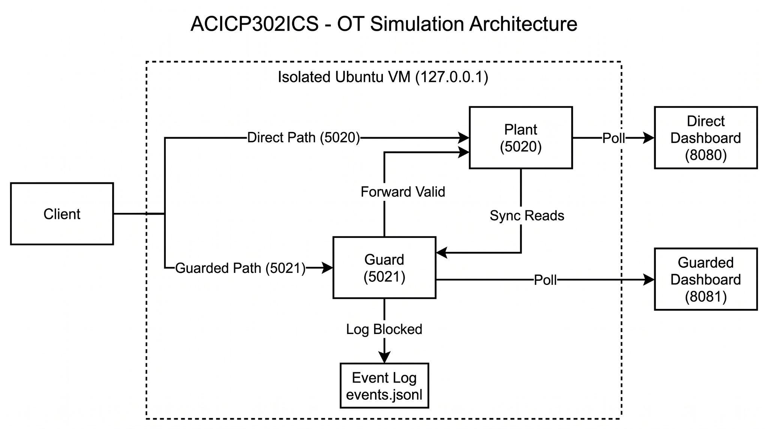
Evidence: Commit Hash and Safety Checks
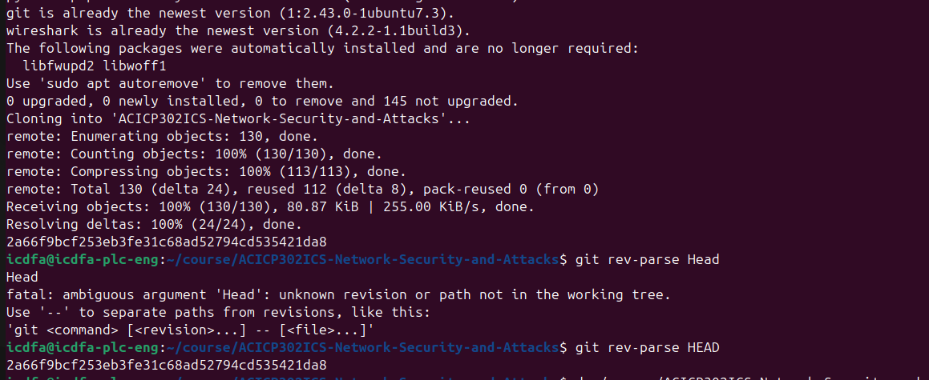
Showing git rev-parse HEAD and the empty grep for unsafe IPs
Evidence: Loopback Validation
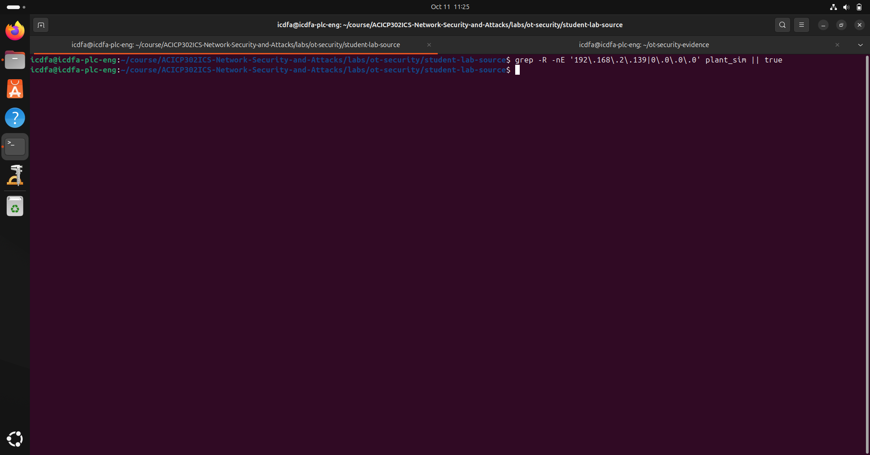
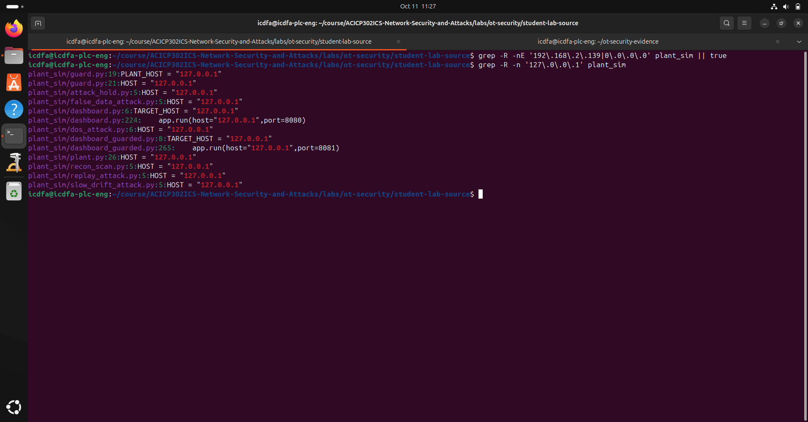
Showing the grep output for 127.0.0.1

Activity 01: Architecture and Plant Baseline
The simulation architecture consists of a direct Modbus/TCP plant server (port 5020) and a defensive proxy guard (port 5021) that validates incoming writes before forwarding them to the plant. Two HTTP dashboards (ports 8080 and 8081) read state telemetry via Modbus Function Code 3.
Evidence: Normal Baseline Operation
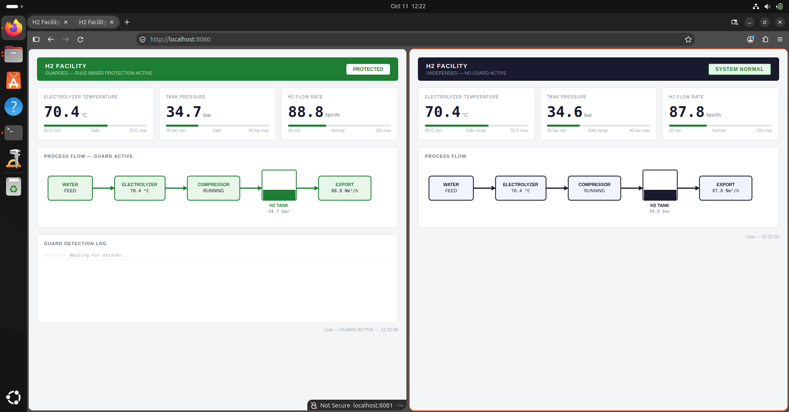
baseline_dashboards.png Showing the Direct and Guarded Dashboards running side-by-side displaying ~70°C, ~34 bar, ~90 Nm3/h)

Activity 02: Modbus/TCP Data Model & Normal Operations
By inspecting plant.py and guard.py, the physical process variables were mapped to the following Modbus Holding Registers: plant.py and guard.py analysis:-
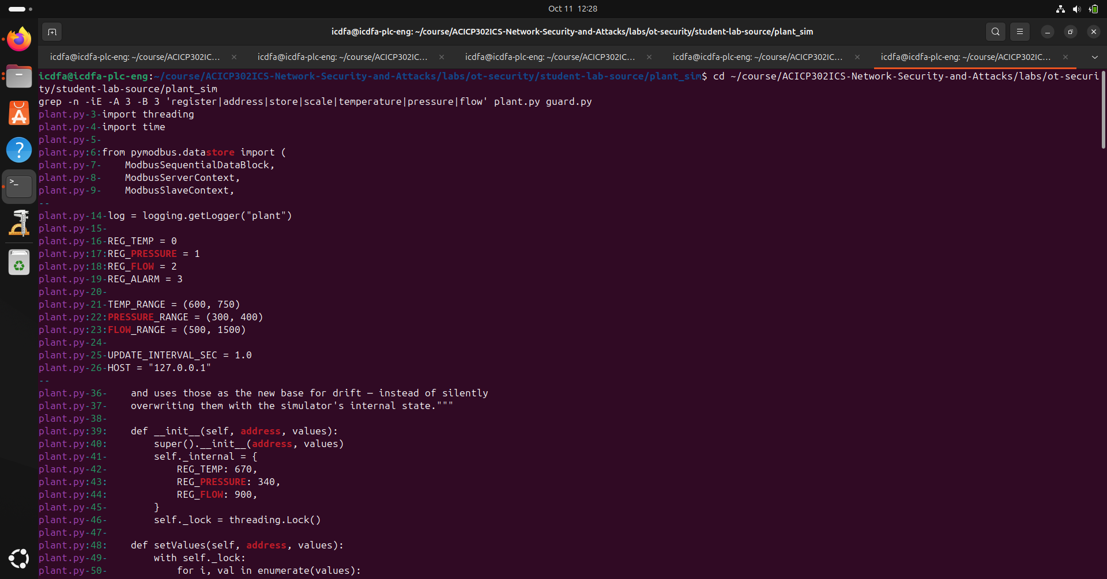
Process Variable | Register Address | Scale / Unit | Normal Operating Range | Alarm Threshold | Guard Max Step | Guard Drift Limit (3-Step Window)
Temperature | 0 (40001) | /10 (°C) | 60.0 to 75.0 °C | N/A | 3.0 °C (30) | 2.0 °C (20)
Pressure | 1 (40002) | /10 (bar) | 30.0 to 40.0 bar | >= 39.5 bar | 5.0 bar (50) | 2.0 bar (20)
Flow Rate | 2 (40003) | /10 (Nm³/h) | 50.0 to 150.0 Nm³/h | N/A | 10.0 Nm³/h (100) | 4.0 Nm³/h (40)
System Alarm | 3 (40004) | None (Binary) | 0 (Normal) | 1 (Active) | N/A | N/A
Normal Transaction Roles: The Plant simulator acts as the Modbus server. The dashboards act as Modbus clients, polling the server with Function Code 3 (Read Holding Registers) starting at Address 0 for 4 registers. The server returns integers (e.g., 670, 340, 900, 0), which the clients divide by 10 to display decimal values.

Activity 03: Packet Visibility and Protocol Analysis
Loopback traffic on port 5020 was captured using Wireshark to verify the unencrypted Modbus/TCP payload. The captured response packet directly correlates with the baseline dashboard values.
Evidence: Decoded Modbus/TCP Response
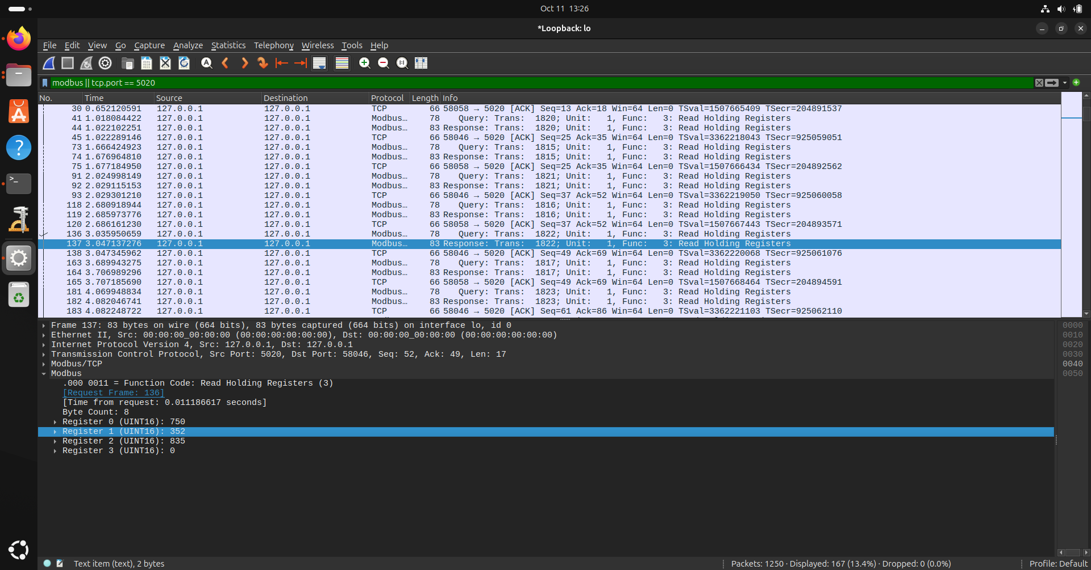
wireshark_analysis.png (Showing the Wireshark packet details with the 4 registers: 750, 352, 835, 0

Activity 04: Local Service Exposure & Risk Mapping
The local services were mapped to verify isolation and assess the risk of unauthorized access if exposed externally.
Component Role | Protocol / Port | Process Significance | Risk of External Exposure
Plant Simulator | Modbus/TCP (5020) | Direct write access to process state. | CRITICAL: Attackers can bypass the guard and manipulate physical parameters.
Defensive Guard | Modbus/TCP (5021) | Validates writes before forwarding. | HIGH: Susceptible to DoS or constrained manipulation within thresholds.
Direct Dashboard | HTTP (8080) | Displays real-time physical data. | MEDIUM: Information disclosure.
Guarded Dashboard | HTTP (8081) | Displays validated process data. | MEDIUM: Information disclosure.

Activity 05: Defensive Guard Analysis
The defensive proxy (guard.py) intercepts writes and applies the following rule-based checks before forwarding them to the plant:
Guard Check / Rule | Condition Checked | Action if Violated | Audit Evidence / Log Event
Absolute Range Check | Is requested value outside safe physical bounds? | Block write, discard packet. | BLOCKED write to reg X: absolute range check failed
Max Step-Size Check | Is jump from current value too large? | Block write, discard packet. | BLOCKED write to reg X: max step size exceeded
Rolling Drift Check | Does cumulative 3-step change exceed limits? | Block write, discard packet. | BLOCKED write to reg X: rolling drift limit exceeded
Limitations & Residual Risk: The guard lacks client authentication, evaluates variables in isolation without cross-correlation (e.g., temperature vs. pressure relationship), and can be entirely bypassed if an attacker targets port 5020 directly.

Activity 06 & 08: Controlled Security Validation
Three approved attack scenarios were executed against both the unprotected plant (5020) and the guarded proxy (5021) to validate the security controls.
Scenario | Target Port | Observed Result | Recovery Verified
1. Out-of-Range Attack | Direct 5020 | 53/56 writes bypassed safe range. Peak pressure reached 95.0 bar. Alarm triggered. | Yes
 | Guarded 5021 | 0/53 writes bypassed safe range. Peak pressure stayed at 38.0 bar. Attack contained. | Yes
2. False Data Injection | Direct 5020 | Rapid swings. Peak Temp: 110.0C, Pressure: 55.0bar, Flow: 200.0Nm3/h. | Yes
 | Guarded 5021 | Guard dropped packets. Values stayed within safe range. Attack contained. | Yes
3. Slow Drift Attack | Direct 5020 | Values slowly crept into danger zone (peaked at 40.0 bar due to internal clamping). | Yes
 | Guarded 5021 | Attack contained. Guard successfully identified and blocked cumulative drift. | Yes
Evidence: Guard Validation Log (events.jsonl)

JSON
{"timestamp": "2026-10-11 14:12:08", "reason": "50.0 bar outside safe range 30.0-40.0 bar; step of 10.1 bar exceeds max 5.0 bar; cumulative drift of 10.7 bar over last 3 accepted writes exceeds 2.0 bar limit"}
{"timestamp": "2026-10-11 14:12:46", "reason": "51.4 bar outside safe range 30.0-40.0 bar; step of 12.2 bar exceeds max 5.0 bar; cumulative drift of 12.3 bar over last 3 accepted writes exceeds 2.0 bar limit"}
Scenario 1: Hold Attack
Evidence: Hold Attack against unprotected dashboard
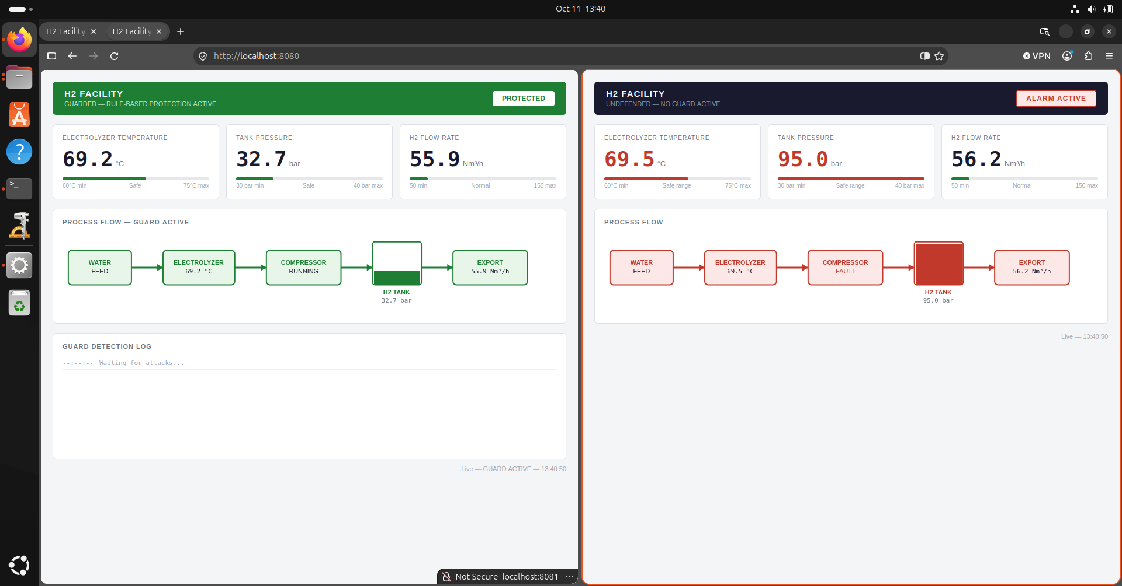
Evidence: Hold Attack against protected dashboard
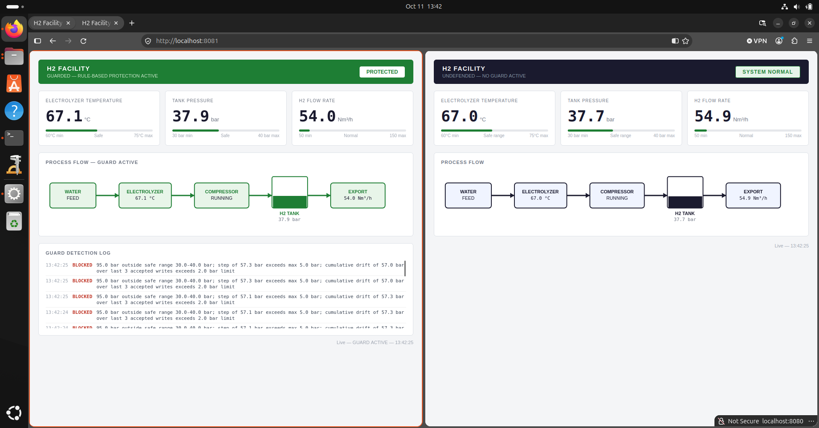

Hold Attack Terminal Output
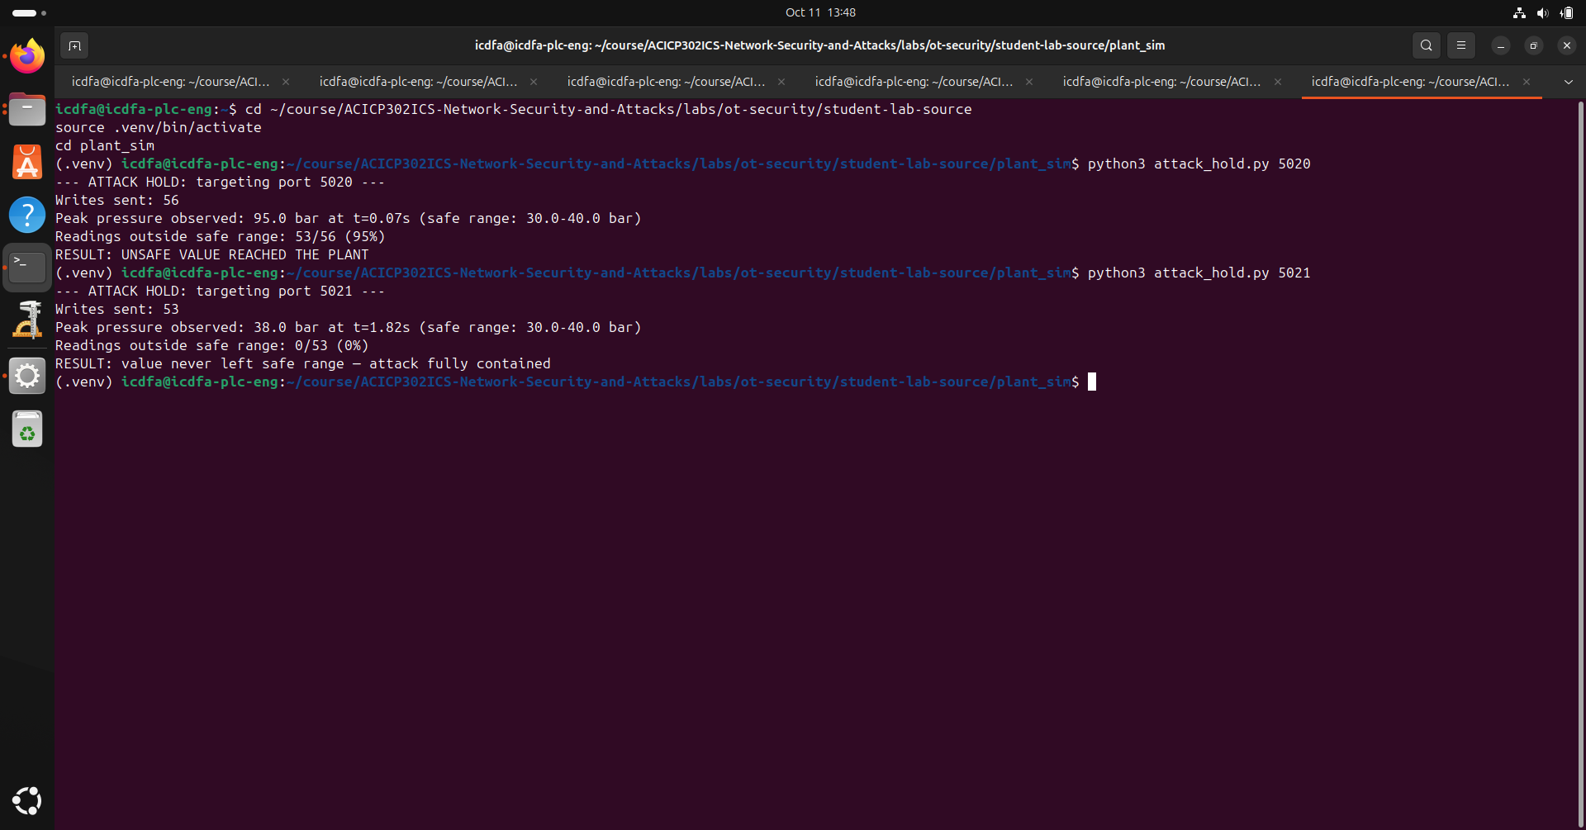

Scenario 2: False Data
False Data Attack Against unprotected Dashboard

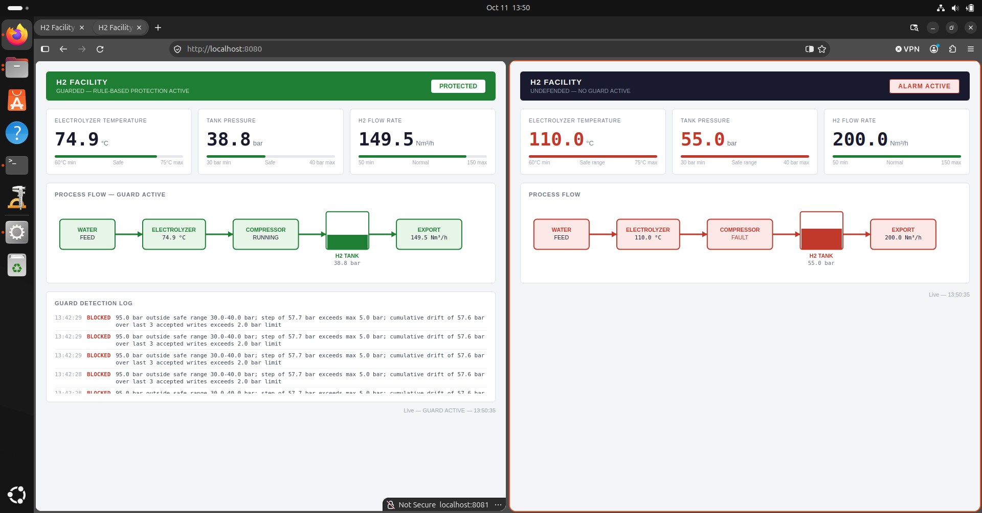
False Data Attack Against protected Dashboard
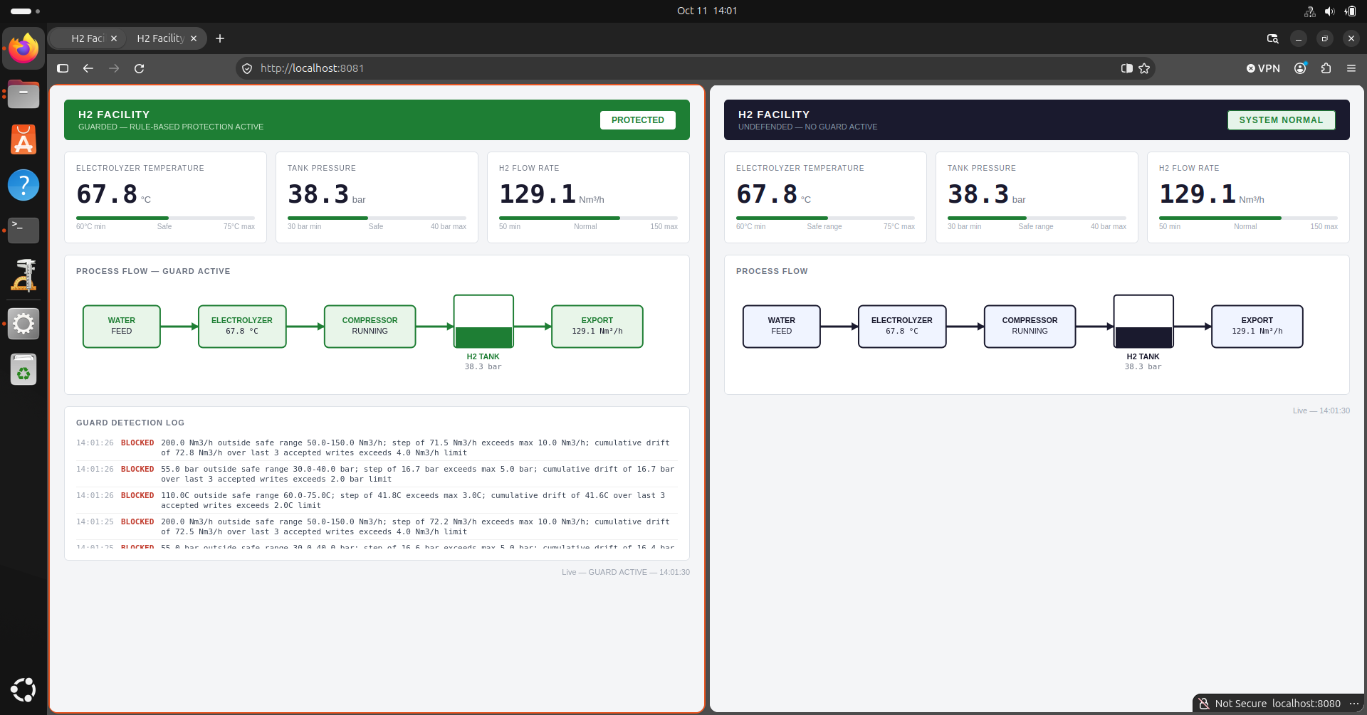
False Data Attack Terminal Output
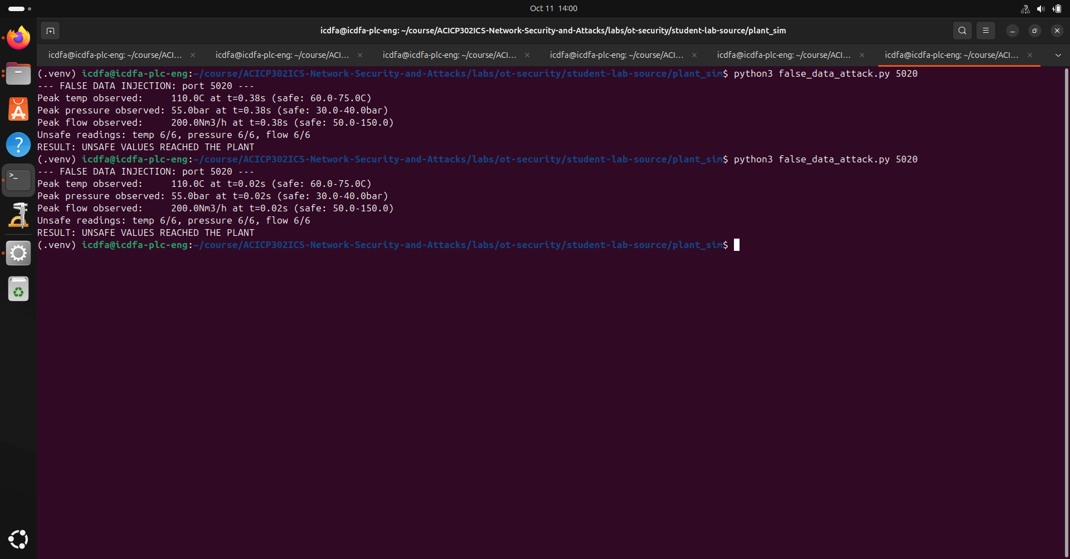
Scenario 3: Slow drift Attack
Slow drift Attack Against Unprotected dashboard
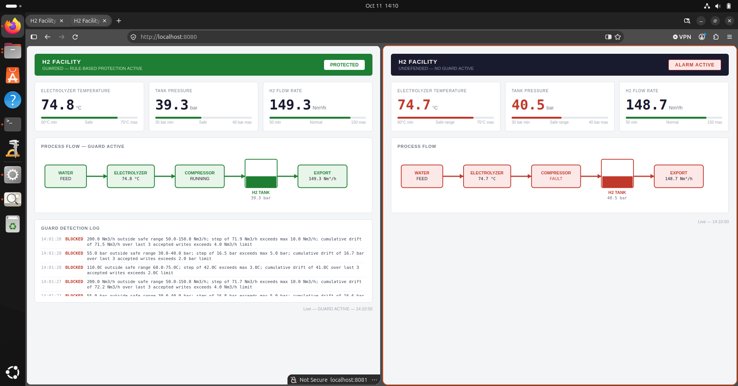
Slow drift Attack Against protected dashboard
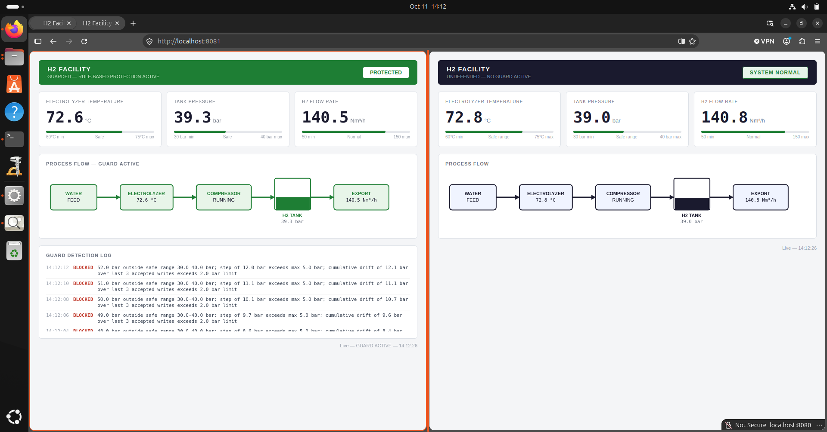
Slow drift Attack Terminal Output
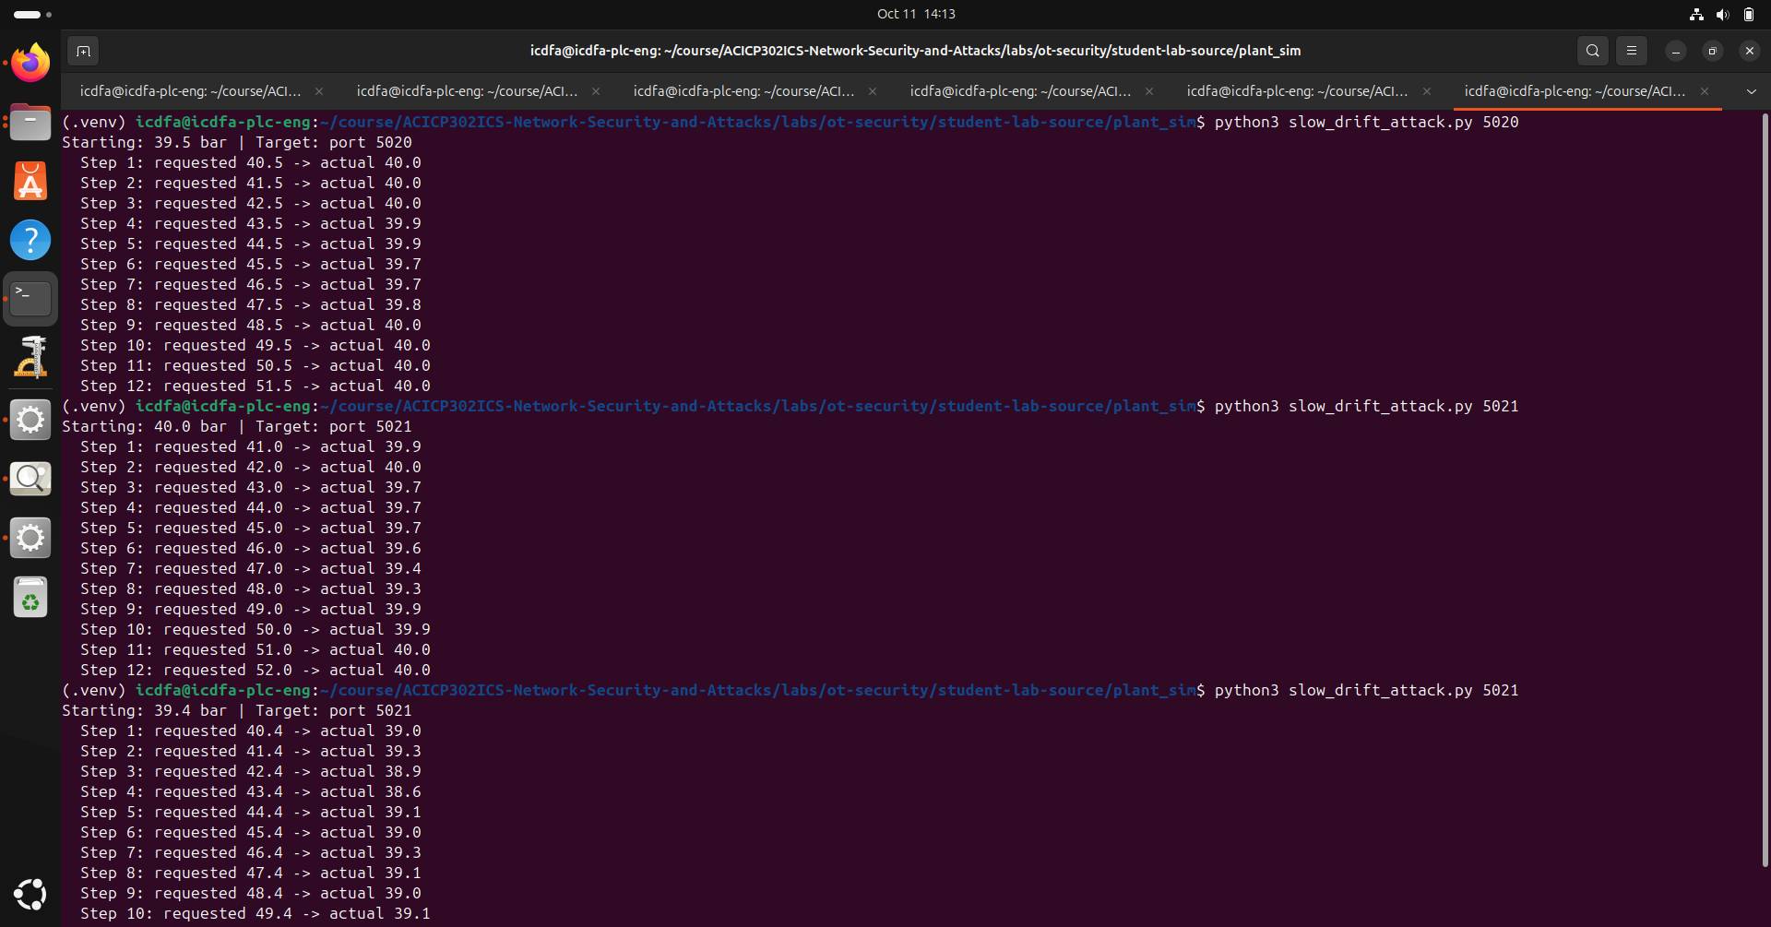

Activity 07: Cleanup and Recovery Verified
I confirm that all simulation processes (plant.py, guard.py, dashboard.py, dashboard_guarded.py) have been stopped, the virtual environment deactivated, and all listening ports verified closed via ss -tulpn. The assigned Ubuntu VM has been restored to a safe, clean state.
Evidence: Clean state
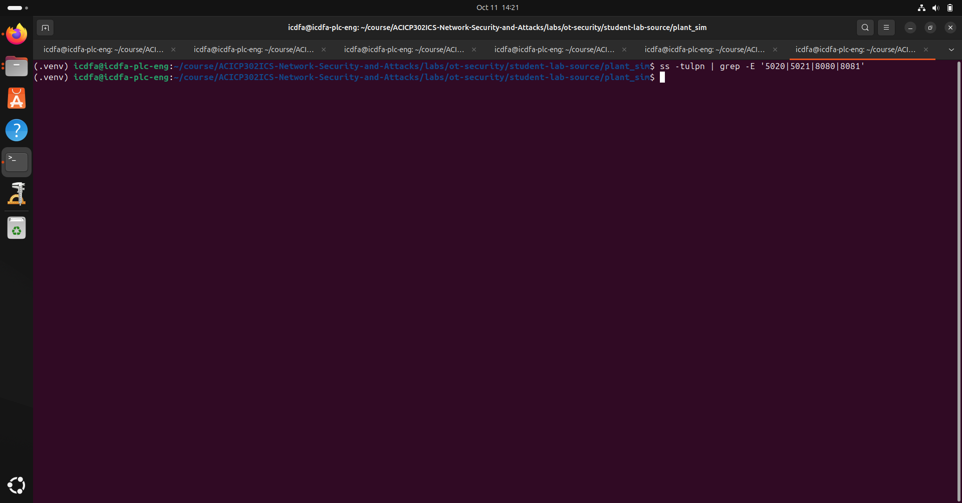

Appendix