condFDR_analysis

### Overlapping SNPs in dyslexia and clap-beat summary statistics

There are 8,288,850 SNPs in the clap-beat, 7,995,922 SNPs in the dyslexia summary statistics files. **7,027,342** of these SNPs are present in both files.

### Conditional and conjunctional FDR analysis with the *condFDR* package

Here I followed the default p-value threholds provided in the Github tutorial, but they mention that these thresholds are rather arbitrary, so we can change these for future analysis.

#### condFDR

A p-value threshold of 1e-5 was applied on the p-values that we condition on. This yields 21,821 SNPs when we condition clap-beat p-values on dyslexia p-values, and 18,026 SNPs when dyslexia is conditioned on clap-beat. Here I do not apply a threshold on conditional FDRs.

#### conjFDR

Here I applied the same threshold (p < 1e-5) on conjunctional FDR p-values and ended up with 38,943 SNPs for both clap-beat and dyslexia with a conjunctional FDR value < 1e-5.

### Clap-beat GWAS, conditional and conjunctional FDR of clap-beat on dyslexia

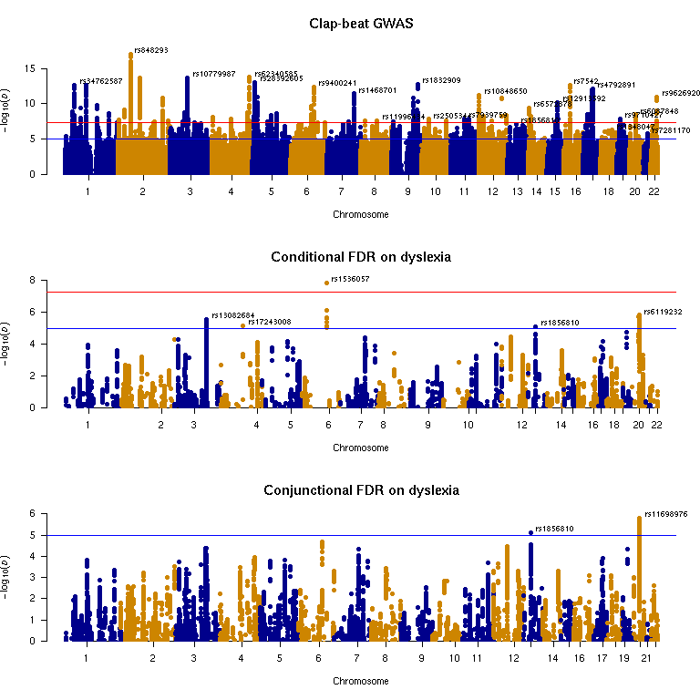

### Dyslexia GWAS, conditional and conjunctional FDR of dyslexia on clap-beat

