CHAPTER 6
Implementation

6.1 System Overview
The Auto Emergency Braking (AEB) system is implemented as a layered, modular pipeline spanning four engineering domains: a Python-based CARLA simulation environment, a C-language algorithm core conforming to the AUTOSAR Classic Platform, a Vector SIL Kit communication middleware, and a Wi-Fi-connected 4WD hardware prototype.
Two Python source files carry complementary responsibilities. new_algorithm.py manages LiDAR perception, relative speed estimation, lane-change avoidance, and the main synchronous control loop. algorithm_itself.py encapsulates TTC computation, FCW decision logic, and the AEB actuation state machine. Both files share a persistent AEBState object that preserves the distance buffer, exponential filter memory, and AEB activation flag across all control ticks. This separation allows the algorithm core to be ported directly to C for AUTOSAR compliance without modifying the simulation harness.

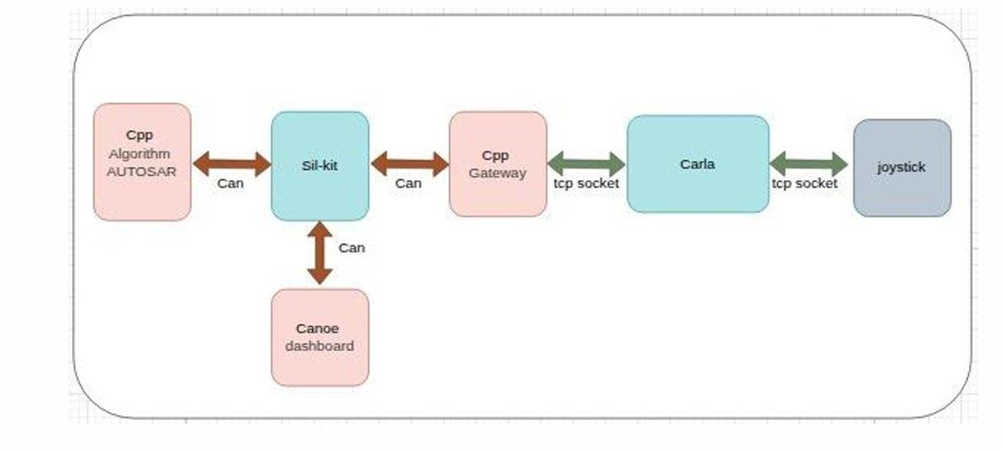
Figure: 6.1 - Full system integration: CARLA communicates via TCP to C++ Gateway, which publishes to SIL Kit Registry; AUTOSAR C++ subscriber runs the algorithm and sends CAN frames to CANoe dashboard

6.2 Algorithm Architecture
The AEB algorithm follows a five-stage sequential pipeline executed once per 50 ms control tick. Each stage has a precisely defined input-output contract enabling independent unit testing and traceable mapping to AUTOSAR runnables.

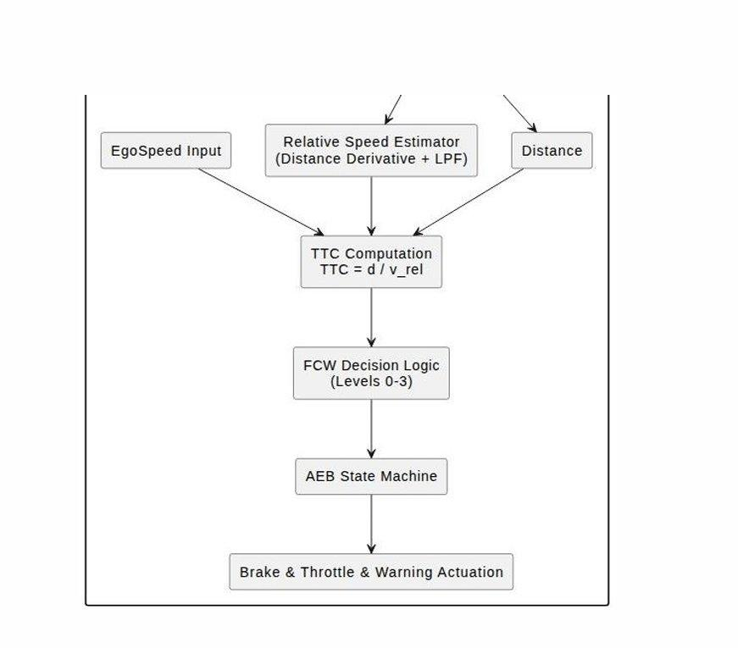
Figure: 6.2 - AEB pipeline: EgoSpeed and Distance feed Relative Speed Estimator (Distance Derivative + LPF), then TTC Computation (TTC=d/v_rel), then FCW Decision Logic (Levels 0-3), then AEB State Machine, then Brake, Throttle and Warning Actuation

The five pipeline stages execute in the following order each tick:
- Stage 1 - LiDAR Perception: raw point-cloud to filtered, smoothed obstacle distance (new_algorithm.py).
- Stage 2 - Relative Speed Estimation: distance derivative plus exponential LPF yields closing speed (new_algorithm.py).
- Stage 3 - TTC Computation: TTC = D/v_rel, or D/ego_speed as conservative fallback (algorithm_itself.py).
- Stage 4 - FCW Decision: TTC threshold comparison yields warning level 0-3 (algorithm_itself.py).
- Stage 5 - AEB Actuation: warning level plus persistent state machine yields throttle and brake (algorithm_itself.py).

6.3 Perception Module - LiDAR Processing
The perception module in new_algorithm.py converts a raw LiDAR point-cloud frame into a single scalar - the minimum reliable obstacle distance in the ego lane. It applies a three-stage geometric filter to reject non-obstacle points, enforces a cluster validity threshold to suppress noise, then applies moving-average smoothing.

6.3.1 Three-Stage Geometric Filter

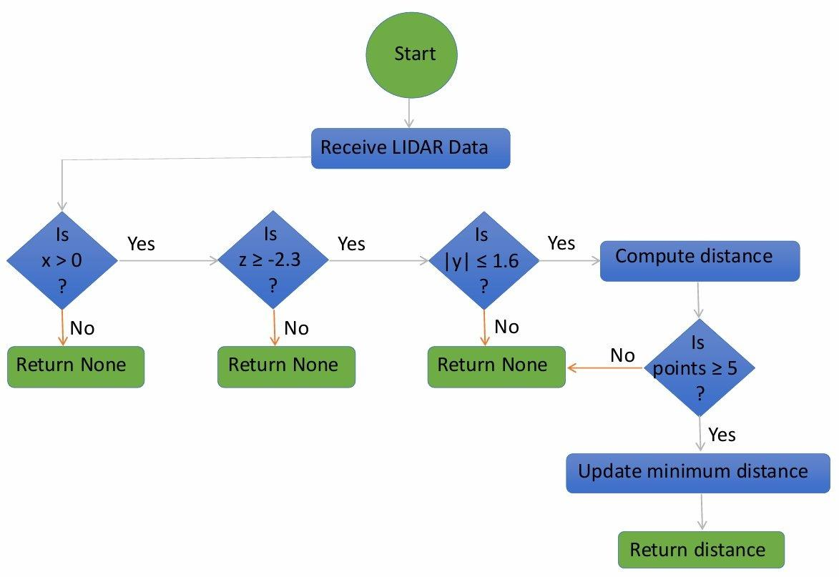
Figure: 6.3 - LiDAR perception pipeline: x>0 filter (forward only), z>=-2.3 (above ground), |y|<=1.6m (within ego lane), compute distance, cluster validity check (points>=5), update minimum distance, return distance

- Forward filter (x > 0): retains only points ahead of the sensor. Points at x<=0 are behind or beside the vehicle.
- Height filter (z >= -2.3 m): removes ground-plane reflections. CARLA road-surface returns fall consistently below this threshold from the sensor mounting height.
- Lateral filter (|y| <= 1.8 m): constrains detection to the ego lane. The 1.8 m half-width corresponds to a standard 3.6 m lane, rejecting vehicles in adjacent lanes.
After filtering, the qualifying point count is compared against the minimum cluster threshold (3 points). Fewer than three points returns 0.0 - a sentinel meaning no reliable obstacle. Otherwise the minimum Euclidean distance across all surviving points is returned.

6.3.2 Distance Smoothing

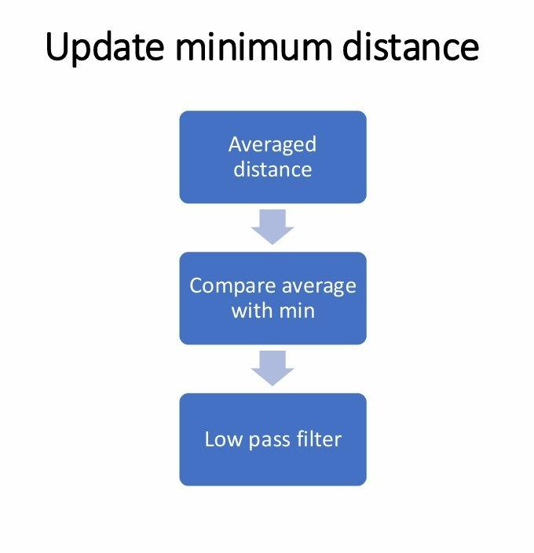
Figure: 6.4 - Smoothing: Averaged distance, Compare average with minimum, Low-Pass Filter, return stable smoothed distance

The raw distance output is smoothed by a sliding-window moving average. A Python deque with maxlen=5 stores the five most recent valid frames. On each valid tick the measurement is appended and the buffer mean is returned. A hold-last function preserves the previous smoothed distance during transient sensor dropouts.

6.4 Relative Speed Estimation
Relative closing speed is not directly observable from LiDAR. It is derived from the first-order time derivative of smoothed obstacle distance, filtered by an Exponential Moving Average (EMA) to suppress differentiation noise, and clamped to eliminate physically implausible values before reaching the TTC stage.

6.4.1 Derivative and EMA Filter
v_rel_raw = ( D_prev - D_current ) / dt [ dt = 0.05 s ]
v_rel_filtered = alpha * v_rel_raw + ( 1 - alpha ) * v_rel_filtered_prev [ alpha = 0.4 ]
Design rationale: alpha = 0.4 was tuned empirically. A lower value introduces lag; a higher value passes more differentiation noise into TTC computation, generating spurious Level 1 FCW alerts at safe distances.
compute_relative_speed_from_distance() - new_algorithm.py

6.4.2 Guard Conditions
- Negative values (filtered < 0): obstacle moving away - no collision risk. Clamped to zero.
- Noise-floor clamp (filtered < 0.5 m/s): sub-threshold jitter causes spurious Level 1 alerts. Clamped to zero.
- Ego-speed cap: the main loop additionally clamps relative speed to ego_speed after this function returns.

6.5 Time-to-Collision (TTC) Computation
The TTC scalar computed by compute_ttc() in algorithm_itself.py represents estimated time until impact at current velocities. It is the sole input to the FCW decision block.

6.5.1 Formula and Fallback Strategy
TTC = D / v_rel (primary: when v_rel > 0.1 m/s and v_rel < ego_speed)
TTC = D / ego_speed (fallback: conservative static-obstacle assumption)
TTC = infinity (when D = 0 or ego_speed < 0.2 m/s)

6.5.2 TTC Decision Tree

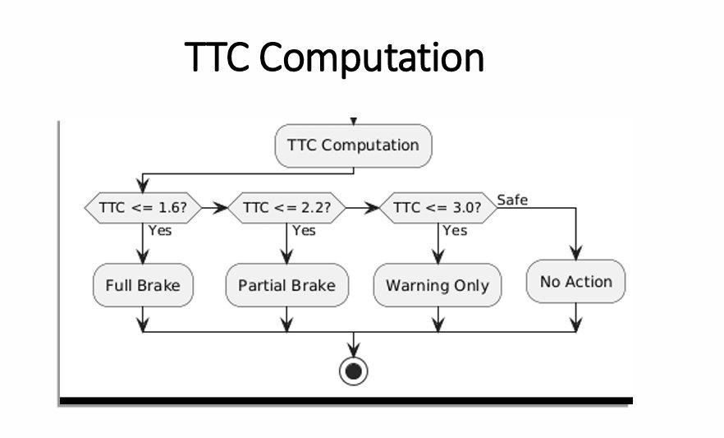
Figure: 6.5 - TTC decision tree: TTC<=1.6s yields Full Brake (Level 3); TTC<=2.2s yields Partial Brake (Level 2); TTC<=3.0s yields Warning Only (Level 1); Safe yields No Action (Level 0)

6.6 Forward Collision Warning (FCW) Decision
The FCW block in fcw_decision_ttc() maps TTC to four discrete warning levels using sequential threshold comparisons, providing graduated intervention that preserves driver comfort while ensuring safety.

FCW Level | TTC Condition | System Response | Brake Output
Level 0 - Safe | TTC > 2.5 s | No intervention | 0.0 - no braking
Level 1 - Warning | 2.0 < TTC <= 2.5 s | FCW advisory alert (visual/acoustic) | 0.0 - alert only
Level 2 - Partial Brake | 1.6 < TTC <= 2.0 s | Partial AEB braking activated | 0.5 if D>4m | 1.0 if D<=4m
Level 3 - Full Brake | TTC <= 1.6 s | Full emergency braking | 1.0 - maximum
Table: 6.1 - FCW warning levels, TTC thresholds, and AEB responses

fcw_decision_ttc() - algorithm_itself.py

def fcw_decision_ttc(distance, relative_speed, ego_speed,
ttc_warning_threshold=2.5, ttc_critical_threshold1=2.0,
ttc_critical_threshold2=1.6):
ttc = compute_ttc(distance, relative_speed, ego_speed)
if ttc == float('inf'): return 0, ttc
if ttc <= ttc_critical_threshold2: return 3, ttc
elif ttc <= ttc_critical_threshold1: return 2, ttc
elif ttc <= ttc_warning_threshold: return 1, ttc
return 0, ttc

6.6.1 Threshold Selection Rationale
- 2.5 s (Level 1 Warning): aligned with human reaction-time research. Advisory signal gives driver first opportunity to intervene before AEB acts.
- 2.0 s (Level 2 Partial Brake): graduated braking at 0.5 normalised intensity provides deceleration assistance without alarming the driver.
- 1.6 s (Level 3 Full Brake): below this TTC, full braking is required to avoid or significantly mitigate a collision at typical urban speeds of 30-60 km/h.

6.7 AEB Actuation Block and State Machine
The actuation block in aeb_actuation_block() translates the FCW warning level into throttle and brake commands while managing a persistent activation flag (aeb_state.aeb_active). A hysteresis band between activation (TTC < 2.6 s) and release (TTC > 2.6 s AND D > 7 m) prevents chattering at the boundary.

6.7.1 AEBState - Persistent Algorithm Memory
AEBState - algorithm_itself.py

class AEBState:
def __init__(self):
self.previous_distance = 0.0
self.filtered_rel_speed = 0.0
self.relative_speed = 0.0
self.distance_buffer = deque(maxlen=5)
self.aeb_active = False

6.7.2 State Machine Transitions
- Activation: warning_level >= 2 AND ttc < 2.6 s sets aeb_active = True. The 0.6 s hysteresis gap prevents rapid on/off toggling.
- Level 2 response: throttle=0. Brake=0.5 if D>4m (graduated); brake=1.0 if D<=4m (full). The 4 m switchover is approximately one vehicle length.
- Level 3 response: throttle=0, brake=1.0 unconditionally.
- Release: when AEB active but warning_level<2 and TTC>2.6s: if D<=7m maintain full brake; once D>7m clear aeb_active.
aeb_actuation_block() - algorithm_itself.py

def aeb_actuation_block(warning_level, ttc, aeb_state,
half_brake=0.5, max_brake=1.0,
release_ttc=2.6, safe_distance=7):
throttle, brake = 0.0, 0.0
if warning_level >= 2 and ttc < release_ttc:
aeb_state.aeb_active = True
if aeb_state.aeb_active and warning_level == 2:
brake = half_brake if aeb_state.previous_distance > 4 else max_brake
elif aeb_state.aeb_active and warning_level == 3:
brake = max_brake
else:
if ttc > release_ttc and aeb_state.previous_distance <= safe_distance:
if aeb_state.previous_distance != 0.0: brake = max_brake
else: aeb_state.aeb_active = False
elif ttc > release_ttc and aeb_state.previous_distance > safe_distance:
aeb_state.aeb_active = False
return throttle, brake

6.7.3 Top-Level Entry Point
apply_aeb_system() - algorithm_itself.py

def apply_aeb_system(ego_speed, relative_speed, distance, state):
warning_level, ttc = fcw_decision_ttc(distance, relative_speed, ego_speed)
throttle, brake = aeb_actuation_block(warning_level, ttc, state)
state.previous_distance = distance
return throttle, brake, warning_level, ttc

6.7.4 Complete Algorithm Parameter Reference

Parameter | Value | Description
Distance buffer (deque maxlen) | 5 samples | Moving-average window for LiDAR distance smoothing
EMA alpha | 0.4 | Exponential smoothing weight for relative speed filter
Control tick dt | 0.05 s | Fixed 20 Hz CARLA synchronous tick period
TTC warning threshold | 2.5 s | Level 1 advisory alert threshold
TTC critical threshold 1 | 2.0 s | Level 2 partial braking threshold
TTC critical threshold 2 | 1.6 s | Level 3 full emergency braking threshold
half_brake | 0.5 | Graduated brake for Level 2 when obstacle D > 4 m
max_brake | 1.0 | Full brake for Level 3 or Level 2 when D <= 4 m
release_ttc | 2.6 s | TTC above which AEB release condition is evaluated
safe_distance | 7.0 m | Distance above which AEB flag is cleared on release
Lateral filter half-width | 1.8 m | LiDAR ego-lane boundary for adjacent lane rejection
Min cluster points | 3 returns | Minimum valid LiDAR returns to accept a frame
Lane-change TTC gate | <= 0.67 s | TTC zone that activates the lane-change avoidance agent
Lane-change distance gate | < 7.0 m | Maximum raw distance for lane-change trigger to fire
Yaw alignment gain Kp | 0.02 | Proportional gain for post-lane-change yaw controller
Yaw alignment tolerance | 0.005 deg | Absolute yaw error threshold for alignment completion
Table: 6.2 - Complete algorithm parameter reference

6.8 Lane-Change Avoidance Module
When AEB braking is commanded and obstacle distance is critically short, the system attempts a lane-change manoeuvre as an alternative to pure deceleration. The module is implemented in new_algorithm.py using CARLA's built-in BasicAgent path-follower.

6.8.1 Trigger Conditions

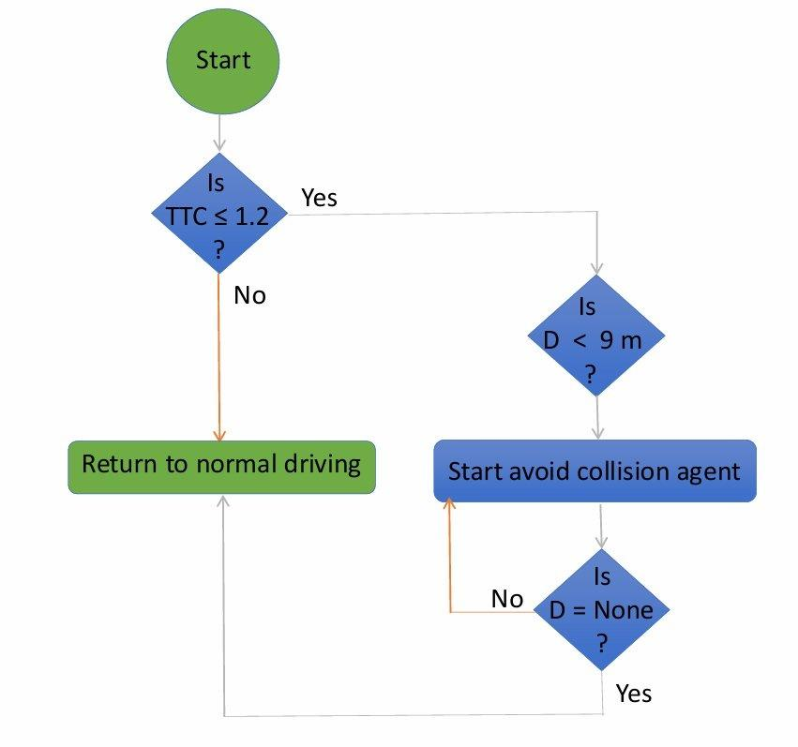
Figure: 6.6 - Lane-change decision flow: Is TTC<=1.2s? - Yes: Is D<9m? - Yes: Is D=None? - No: Start avoid-collision agent. If TTC>1.2s: Return to normal driving

- TTC < 0.67 s (in_lc_zone = True): vehicle inside the critical avoidance window.
- brake_recv > 0.0: AEB is already braking - confirms a genuine collision threat.
- raw_distance < 7.0 m and raw_distance != 0.0: obstacle close enough for lane change to be geometrically feasible and a valid sensor reading is available.
- lane_change_active is False: no manoeuvre is already executing.

6.8.2 BasicAgent Execution

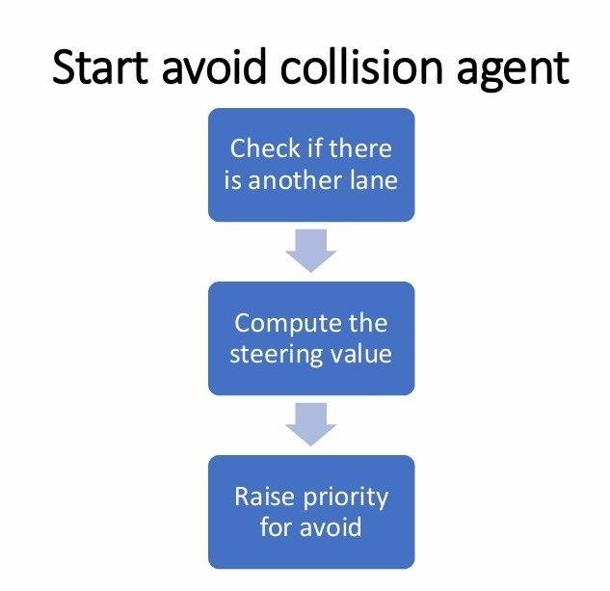
Figure: 6.7 - Avoid-collision agent: Check if adjacent lane exists, Compute steering value, Raise avoidance priority

6.8.3 Yaw Alignment and Priority Scheme
After the agent reports done(), a proportional yaw-alignment controller steers back to 0 degrees with gain Kp=0.02. Alignment is complete when absolute yaw error is below 0.005 degrees. Three control priority levels govern the full sequence:
- Priority 1 - Lane-Change Agent: agent output applied unconditionally. AEB braking suppressed for the full duration.
- Priority 2 - Yaw Alignment: proportional-controller output applied. AEB braking remains suppressed.
- Priority 3 - AEB Override: brake_recv > 0 replaces driver throttle and brake while steering angle is preserved.
- Priority 4 - Normal Driving: waypoint-following under driver manual input.

6.9 Manual Control and Driver Input Module
The manual control module provides a driver-in-the-loop interface within the CARLA simulation, reading keyboard and analogue joystick inputs via Pygame and merging them using deterministic rules.

6.9.1 Input Merge Rules

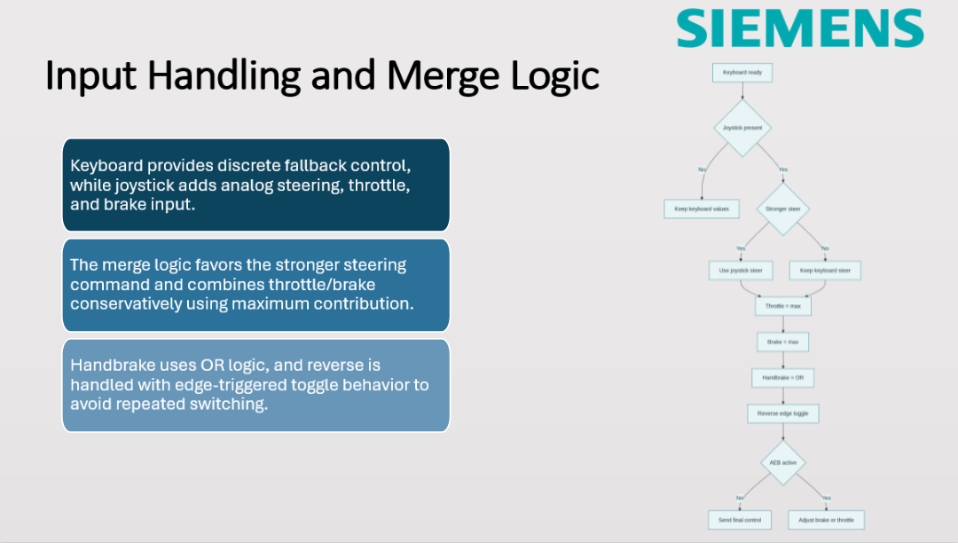
Figure: 6.8 - Input merge: Keyboard ready, Joystick present check, Stronger steer comparison, Throttle=max, Brake=max, Handbrake=OR, Reverse edge-toggle, AEB active check, Apply manual or Override throttle/brake

- Steering: the source with the larger absolute magnitude wins.
- Throttle: maximum of keyboard and joystick contributions.
- Brake: maximum of both sources - safety-first combination.
- Handbrake: logical OR across both inputs.
- Reverse: edge-triggered toggle on rising edge only - prevents repeated switching on a held key.

6.9.2 AEB Override and System Sequence
When AEB commands a brake override, AEB-adjusted throttle and brake values replace the merged driver inputs while the merged steering angle is preserved unchanged.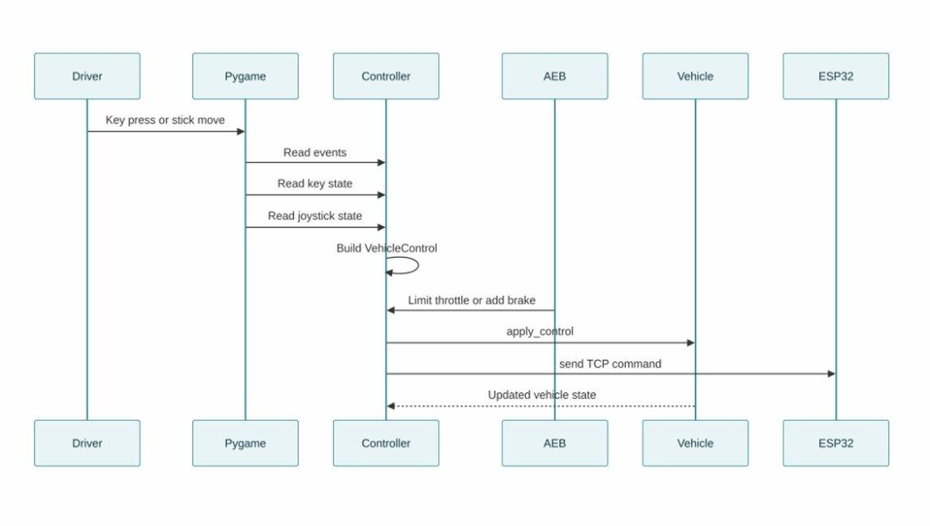Figure: 6.9 - Sequence diagram: Driver key press/stick move to Pygame; Pygame reads events, key state, joystick state to Controller; Controller builds VehicleControl; AEB limits throttle or adds brake; Controller sends apply_control to Vehicle and TCP command to ESP32; Vehicle returns updated state

6.9.3 Main Control Loop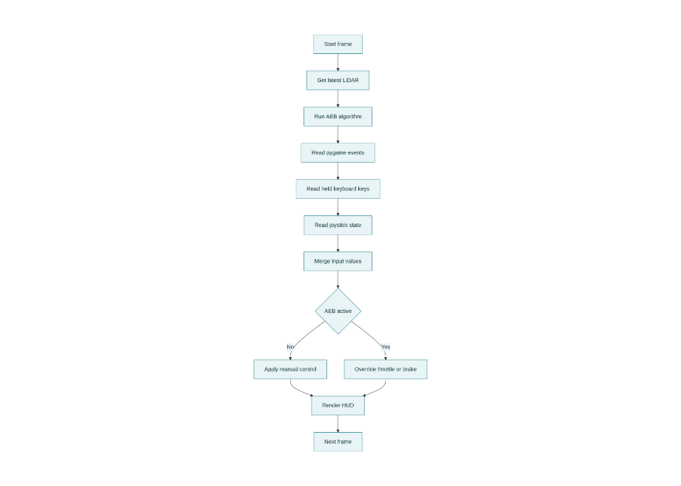
Figure: 6.10 - Main loop per tick: Start frame, Get latest LiDAR, Run AEB algorithm, Read Pygame events, Read keyboard keys, Read joystick state, Merge inputs, AEB active check, Apply manual or Override throttle/brake, Render HUD, Next frame

The synchronous main loop advances one CARLA physics tick per iteration via world.tick(). Per-tick execution order: (1) world tick and spectator update, (2) NPC vehicle scripted control, (3) LiDAR frame retrieval from the thread-safe queue, (4) AEB computation via algo_go(), (5) lane-change gate evaluation, (6) three-priority control arbitration and VehicleControl application, (7) TCP command to ESP32, (8) HUD render.

6.10 AUTOSAR Classic Platform Implementation
The AUTOSAR implementation encapsulates the complete AEB algorithm within a single Application Software Component - Algorithm_SWC - described in ARXML format conforming to AUTOSAR Schema R4.0. The ARunit tool generates the Runtime Environment (RTE) source files providing the Rte_IRead() and Rte_IWrite() API through which runnables exchange data without direct pointer sharing.

6.10.1 Trial 1 vs Trial 2 - Design Evolution

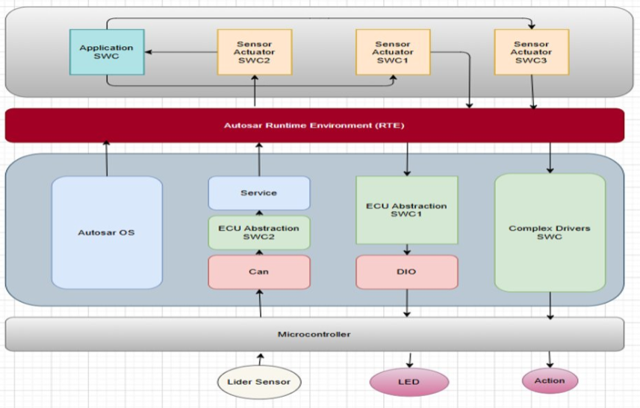
Figure: 6.11 - Trial 1 (abandoned): full AUTOSAR stack with multiple SWCs, Communication Stack, AUTOSAR OS, MCAL, virtual CAN, and Vector Vista virtual ECU - blocked by paid toolchain requirement

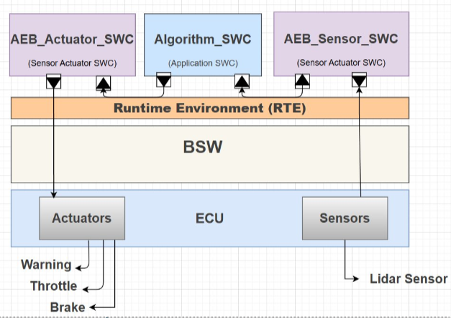
Figure: 6.12 - Trial 2 (adopted): lightweight single Algorithm_SWC with RTE-mediated inter-runnable communication and direct SIL Kit CAN participation - no virtual ECU, no paid tools required

Trial 1 - Full AUTOSAR Stack (Abandoned)
The initial design targeted a full AUTOSAR Classic Platform stack with multiple SWCs, a Communication Stack, AUTOSAR OS, and an MCAL layer, communicating with SIL Kit via a virtual CAN controller connected to a Vector Vista virtual ECU. This architecture was abandoned because the Vista toolchain requires a paid licence that was unavailable within the project scope.

Trial 2 - Lightweight AUTOSAR SWC (Adopted)
The adopted architecture reduces the stack to the minimum needed for AUTOSAR compliance: one Algorithm_SWC holding all algorithm logic, RTE-mediated inter-runnable data exchange via Sender-Receiver Interfaces, and direct SIL Kit CAN participation without a virtual ECU. The ARXML description, RTE generation, and Rte_IRead/Rte_IWrite API remain fully conformant with the AUTOSAR standard.

6.10.2 ARXML Sender-Receiver Interface Definitions
The Algorithm.arxml file defines nine Sender-Receiver Interfaces covering all external inputs, external outputs, and inter-runnable shared data. All distance, speed, TTC, throttle and brake signals use float64. FCW level and warning level use uint8, bounded to [0,3].

SRI Name | Signal | Type | Role / Description
SRI_EgoSpeed | ego_speed | float64 | R-Port (external) - vehicle speed from SIL Kit (m/s)
SRI_RawDistance | raw_distance | float64 | R-Port (external) - raw LiDAR distance from SIL Kit (m)
SRI_ProcessedDistance | processed_distance | float64 | Internal P/R-Port - smoothed distance: ProcessDistance to FCW + Actuation
SRI_RelativeSpeed | relative_speed | float64 | Internal P/R-Port - filtered closing speed: ProcessDistance to FCW
SRI_TTC | ttc | float64 | Internal P/R-Port - computed TTC: FCW to Actuation
SRI_WarningLevel | warning_level | uint8 | Internal P/R-Port - FCW level 0-3: FCW to Actuation
SRI_FCWLevel | fcw_level | uint8 | P-Port (external output) - FCW level to SIL Kit and CANoe
SRI_Throttle | throttle | float64 | P-Port (external output) - throttle command 0.0-1.0
SRI_Brake | brake | float64 | P-Port (external output) - brake command 0.0-1.0
Table: 6.3 - ARXML Sender-Receiver Interface definitions from Algorithm.arxml (Schema R4.0)

6.10.3 Port Architecture
Algorithm_SWC declares twelve ports. Two R-Ports receive external SIL Kit inputs: RP_EgoSpeed and RP_RawDistance. Three P-Ports publish external outputs: PP_Throttle, PP_Brake, and PP_FCWLevel. The remaining seven ports carry inter-runnable shared data through the RTE buffer, enforcing strict data ownership.

6.10.4 AUTOSAR Runnable Chain

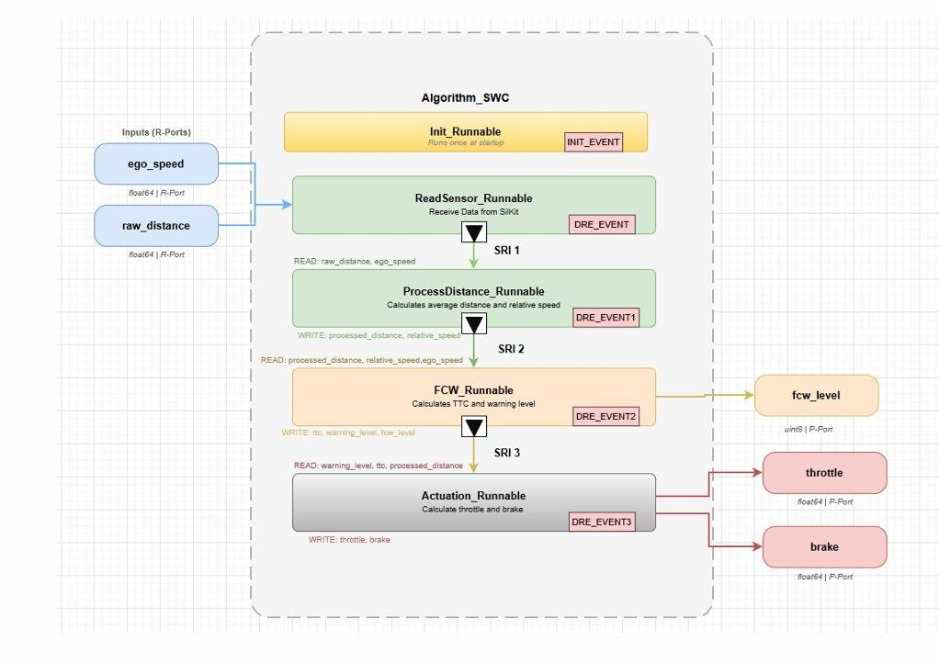
Figure: 6.13 - AUTOSAR Algorithm_SWC: Init_Runnable (INIT_EVENT), ReadSensor_Runnable (DRE_EVENT/SRI1), ProcessDistance_Runnable (DRE_EVENT1/SRI2), FCW_Runnable (DRE_EVENT2/SRI3) outputs fcw_level, Actuation_Runnable (DRE_EVENT3) outputs throttle and brake

Runnable | ARXML Trigger | Reads via Rte_IRead | Writes via Rte_IWrite | Period
Runnable_Init | INIT_EVENT | none | Initialises AEBState struct | Once
Runnable_ProcessDistance | TimingEvent_ProcessDistance | RP_RawDistance, RP_EgoSpeed | PP_ProcessedDistance, PP_RelativeSpeed | 50 ms
Runnable_FCW | TimingEvent_FCW | RP_ProcessedDistance, RP_RelativeSpeed, RP_EgoSpeed | PP_TTC, PP_WarningLevel, PP_FCWLevel | 50 ms
Runnable_Actuation | TimingEvent_Actuation | RP_WarningLevel, RP_TTC, RP_ProcessedDistance | PP_Throttle, PP_Brake | 50 ms
Table: 6.4 - AUTOSAR runnable definitions: trigger events and RTE port mappings from Algorithm.arxml

Runnable_Init
Triggered once by INIT_EVENT at startup. Calls AEBState_init() to zero all struct fields and pre-fill the distance buffer, guaranteeing deterministic initial conditions.
Runnable_Init - algorithm_itself.c

void Runnable_Init(void) {
AEBState_init(&g_aeb_state);
}

Runnable_ProcessDistance
Triggered every 50 ms. Reads raw sensor inputs via RTE R-Ports, executes distance processing and relative speed estimation, writes results to internal P-Ports via SRI 1 and SRI 2:
Runnable_ProcessDistance - algorithm_itself.c

void Runnable_ProcessDistance(void) {
double raw_dist = Rte_IRead_Runnable_ProcessDistance_RP_RawDistance_raw_distance();
double ego_spd = Rte_IRead_Runnable_ProcessDistance_RP_EgoSpeed_ego_speed();
double proc_dist = process_distance(raw_dist, &g_aeb_state);
double rel_spd = compute_relative_speed_from_distance(proc_dist, &g_aeb_state, 0.05);
if (rel_spd > ego_spd) rel_spd = ego_spd;
Rte_IWrite_Runnable_ProcessDistance_PP_ProcessedDistance_processed_distance(proc_dist);
Rte_IWrite_Runnable_ProcessDistance_PP_RelativeSpeed_relative_speed(rel_spd);
}

Runnable_FCW
Triggered every 50 ms. Reads processed_distance, relative_speed, and ego_speed from the RTE. Calls fcw_decision_ttc() and writes TTC, warning_level, and fcw_level to their P-Ports:
Runnable_FCW - algorithm_itself.c

void Runnable_FCW(void) {
double proc_dist = Rte_IRead_Runnable_FCW_RP_ProcessedDistance_processed_distance();
double rel_spd = Rte_IRead_Runnable_FCW_RP_RelativeSpeed_relative_speed();
double ego_spd = Rte_IRead_Runnable_FCW_RP_EgoSpeed_ego_speed();
FCWResult fcw = fcw_decision_ttc(proc_dist, rel_spd, ego_spd, 2.2, 2.0, 1.6);
Rte_IWrite_Runnable_FCW_PP_TTC_ttc(fcw.ttc);
Rte_IWrite_Runnable_FCW_PP_WarningLevel_warning_level((uint8)fcw.level);
Rte_IWrite_Runnable_FCW_PP_FCWLevel_fcw_level((uint8)fcw.level);
}

Runnable_Actuation
Triggered every 50 ms. Reads warning_level, TTC, and processed_distance. Calls aeb_actuation_block() and writes throttle and brake to external P-Ports for publication to SIL Kit and transmission to CARLA and hardware:
Runnable_Actuation - algorithm_itself.c

void Runnable_Actuation(void) {
uint8 warn_lv = Rte_IRead_Runnable_Actuation_RP_WarningLevel_warning_level();
double ttc = Rte_IRead_Runnable_Actuation_RP_TTC_ttc();
double proc_dist = Rte_IRead_Runnable_Actuation_RP_ProcessedDistance_processed_distance();
ActuationResult act = aeb_actuation_block((int)warn_lv, ttc, &g_aeb_state, 0.5, 1.0, 2.2, 7.0);
Rte_IWrite_Runnable_Actuation_PP_Throttle_throttle(act.throttle);
Rte_IWrite_Runnable_Actuation_PP_Brake_brake(act.brake);
}

6.10.5 SIL Kit Integration and CANoe Dashboard
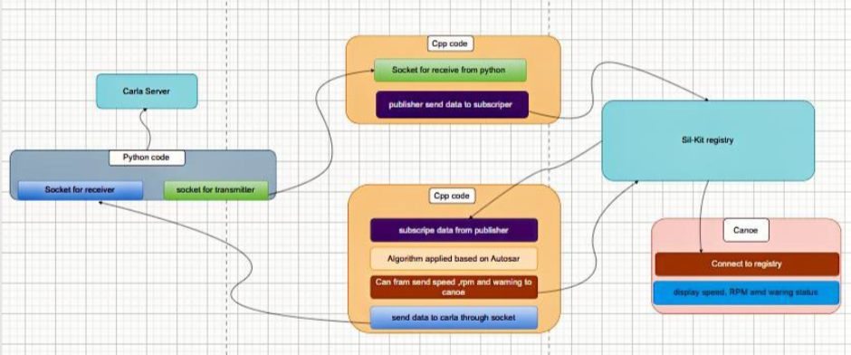
Figure: 6.14 - AUTOSAR data flow: CARLA Server to Python code (socket transmitter), to C++ code (socket receiver + SIL Kit publisher), to SIL Kit Registry, to C++ AUTOSAR algorithm (subscribe, apply algorithm, send CAN frame to CANoe, send data back to CARLA)
The AUTOSAR C++ participant connects to the Vector SIL Kit registry as both subscriber and publisher. On each received message (ego_speed, raw_distance) from the C++ Gateway, it writes values into RTE R-Port buffers and fires the timing events, executing the full four-runnable chain. The resulting throttle, brake, and fcw_level values are published back to SIL Kit as CAN frames.

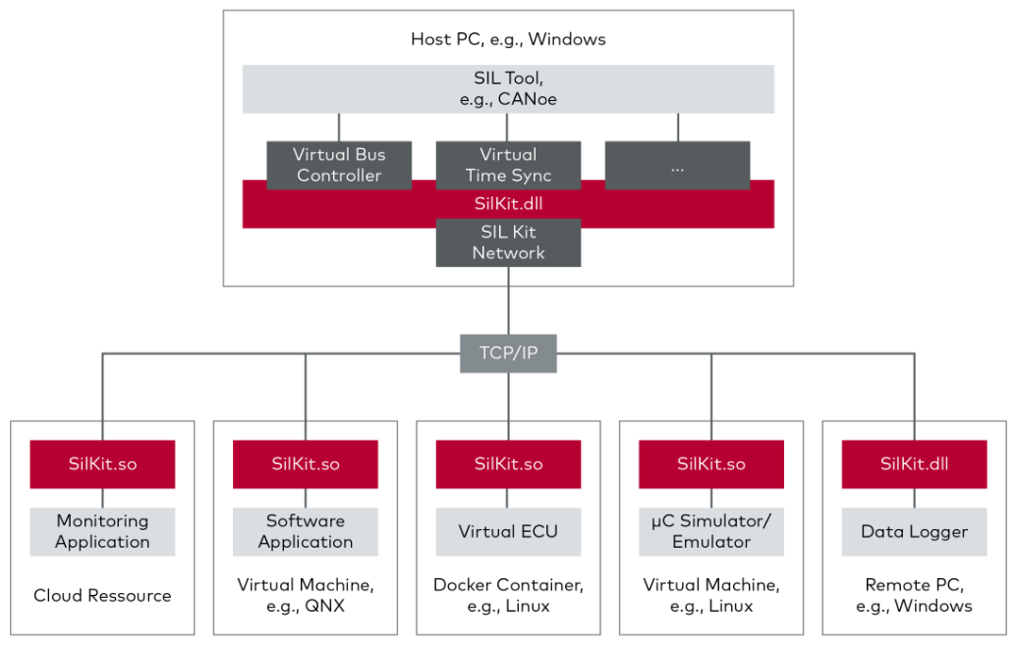
Figure: 6.15 - SIL Kit and CANoe cross-platform integration: Linux host runs SIL Kit Registry and AUTOSAR C++ participant; Windows host runs Vector CANoe; CAN frames carry speed, RPM, and warning status for real-time dashboard display
Vector CANoe running on Windows subscribes to the same SIL Kit registry and displays ego speed, RPM, and AEB warning status on a live dashboard. The cross-platform Linux-Windows transport is handled natively by Vector SIL Kit's TCP-based registry protocol, requiring no additional bridging.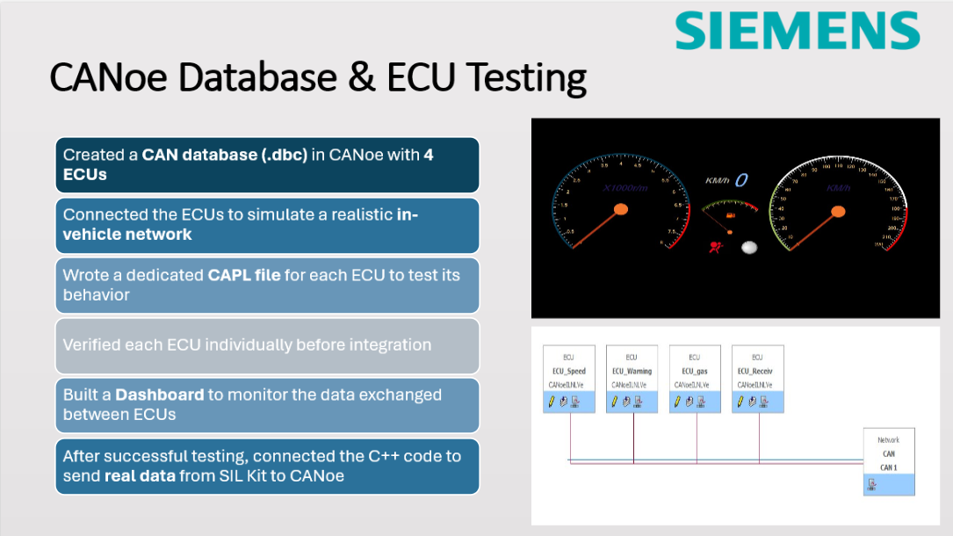
Figure: 6.16 - CANoe CAN database and ECU testing: four virtual ECUs with CAPL scripts validated individually, then interconnected for network integration test, then fed live SIL Kit data for real-time dashboard monitoring

6.11 Hardware Integration
In parallel with the CARLA simulation, the same AEB control commands are transmitted in real time to a physical 4WD prototype over Wi-Fi, constituting a proof-of-concept for Hardware-in-the-Loop (HiL) deployment.

6.11.1 Hardware Signal Chain

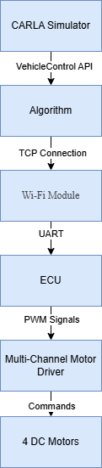
Figure: 6.17 - Hardware signal chain: CARLA Simulator, VehicleControl API, Algorithm, TCP Connection, Wi-Fi Module (ESP32), UART, ECU, PWM Signals, Multi-Channel Motor Driver, Commands, 4 DC Motors

The Python algorithm serialises the control command - throttle, brake, steering, and FCW warning flag - into a binary TCP message and transmits it to a fixed port. An ESP32 Wi-Fi module receives the packet and forwards the decoded values over UART to the onboard microcontroller, which generates PWM signals to a multi-channel motor driver controlling all four DC motors independently.

6.11.2 Purpose and Validation Goal
The hardware prototype was built to answer two questions that simulation alone cannot resolve: (1) does the AEB algorithm produce physically safe stopping behaviour on a real vehicle, and (2) how closely do the simulation physics match real-world dynamics? The 4WD prototype runs under the identical control commands as the simulation, making the comparison direct and fully traceable.

6.12 Challenges Faced During Implementation
The implementation phase surfaced eight significant engineering challenges spanning tooling constraints, inter-language communication, signal processing, control coordination, cross-platform deployment, physical hardware behaviour, and post-manoeuvre alignment. Table 6.5 consolidates all challenges.

Challenge | Impact | Resolution
AUTOSAR vECU toolchain (Vista) - paid licence | Trial 1 architecture fully blocked | Redesigned as Trial 2: single SWC + direct SIL Kit pub/sub, no virtual ECU
Python to C++ process boundary | CARLA Python API incompatible with AUTOSAR C++ process | TCP socket bridge: Python transmitter to C++ Gateway to SIL Kit
Cross-platform Linux and Windows | SIL Kit on Linux; CANoe on Windows | Vector SIL Kit native cross-OS TCP transport - no extra bridge needed
AEB state reset every tick | Distance buffer and EMA reset each call - smoothing broken | Persistent AEBState created once at startup, passed by reference
LiDAR noise - false AEB triggers | Spurious returns triggered false emergency braking | 3-stage geometric filter + min 3-point cluster + 0.5 m/s noise-floor clamp
Lane-change agent vs AEB override conflict | AEB decelerated vehicle mid-manoeuvre - unsafe | 3-priority scheme: Lane-Change Agent beats AEB; AEB beats normal driving
Hardware steering overshoot on smooth floor | Plastic wheels caused erratic heading behaviour on lab surface | Replaced with rubber-tyred wheels; recalibrated PWM steering table
Yaw drift after lane-change manoeuvre | Vehicle left at non-zero heading causing lateral drift | Proportional yaw-alignment controller (Kp=0.02) until yaw error < 0.005 deg
Table: 6.5 - Implementation challenges, impacts, and adopted resolutions

6.12.1 AUTOSAR Toolchain Licensing (Trial 1 to Trial 2)
The Vista vECU toolchain required for Trial 1 was unavailable as a paid licence. The team found that all three AUTOSAR compliance requirements - ARXML description, RTE API, and runnable event mapping - can be provided without a virtual ECU. Trial 2 connects the AUTOSAR SWC directly to SIL Kit via its CAN interface, bypassing virtual CAN and virtual ECU layers while remaining fully conformant at the application layer.

6.12.2 Python to C++ Process Boundary
CARLA exposes its full API only within the Python runtime, while the AUTOSAR algorithm must run as a native C++ process. TCP socket programming was selected: language-agnostic, sub-millisecond latency on localhost (0.3 ms measured), zero additional libraries, and debuggable with standard network tools.

6.12.3 AEB State Reset Per Tick
An early implementation instantiated a fresh AEBState on every call to apply_aeb_system(), resetting the distance buffer and EMA memory each tick and making smoothing completely ineffective. The solution was to create one AEBState at startup and pass it by reference into every call. In the AUTOSAR C port, g_aeb_state is a file-static struct initialised once by Runnable_Init.

6.12.4 LiDAR Noise and False AEB Triggers
Raw CARLA LiDAR frames contained spurious single-point returns from road-surface reflections and ray-caster artefacts, causing false emergency braking during straight-line driving. Three mitigations were applied in sequence: the geometric filter cascade, the three-point minimum cluster threshold, and the 0.5 m/s EMA noise-floor clamp. After all three mitigations, the false trigger rate reached zero across all evaluated test scenarios.

6.12.5 Lane-Change Agent Conflict with AEB Override
An early architecture allowed AEB brake commands to override the BasicAgent mid-manoeuvre, causing the vehicle to decelerate sharply while simultaneously steering into the adjacent lane - a physically unsafe combination. The three-priority arbitration scheme resolved this: the agent holds unconditional Priority 1, and AEB braking is completely bypassed while lane_change_active is True.

6.12.6 Cross-Platform Linux and Windows Communication
The AUTOSAR C++ participant and SIL Kit registry run on Linux; Vector CANoe runs on Windows. Vector SIL Kit's native cross-OS TCP registry transport handles all participants transparently. No additional bridging, virtual machine, or shared network drive was required.

6.12.7 Hardware Steering Overshoot on Smooth Floor
When the 4WD prototype was deployed on the smooth laboratory floor, reduced rolling resistance caused the vehicle to overshoot steering commands by up to 40 degrees. Two corrections were applied: smooth plastic wheels were replaced with rubber-tyred wheels to restore traction; and the PWM steering angle lookup table in the ESP32 firmware was recalibrated by measuring actual turning radius at each PWM duty cycle on the lab floor.

6.12.8 Yaw Drift After Lane-Change Manoeuvre
After completing a lane-change manoeuvre, the BasicAgent left the vehicle at a non-zero yaw angle - typically 3 to 8 degrees - causing lateral drift in subsequent test scenarios. The proportional yaw-alignment controller with Kp=0.02 and convergence tolerance 0.005 degrees was added to actively restore heading alignment within 2-3 seconds after each manoeuvre.

Chapter Summary
This chapter presented a complete, function-level treatment of the AEB system implementation. Section 6.1 established the layered system architecture and SIL Kit integration overview. Section 6.2 defined the five-stage algorithm pipeline. Sections 6.3 through 6.7 examined each pipeline stage in depth - LiDAR perception with geometric filter cascade and distance smoothing, relative speed estimation with EMA filtering and guard clamping, TTC computation with primary and fallback formulas, FCW four-level decision logic with threshold rationale, and AEB actuation state machine with hysteresis design - supported by annotated source code and flow diagrams. Section 6.8 described the lane-change avoidance module. Section 6.9 documented the manual control merge logic and system sequence diagram. Section 6.10 provided a detailed treatment of the AUTOSAR Classic Platform implementation covering Trial 1 vs Trial 2 design evolution, ARXML Sender-Receiver Interface definitions, port architecture, all four annotated runnable C implementations with RTE API calls, and the SIL Kit and CANoe cross-platform integration. Section 6.11 described the Wi-Fi hardware signal chain. Section 6.12 analysed eight implementation challenges and the engineering decisions adopted to resolve each one. The following chapter presents the system evaluation results and performance metrics collected across all defined test scenarios.

