Republic of the Philippines
NUEVA ECIJA UNIVERSITY OF SCIENCE AND TECHNOLOGY
COLLEGE OF INFORMATION AND COMMUNICATIONS TECHNOLOGY
San Isidro Campus, San Isidro, Nueva Ecija
FORDAGO: MOBILE-BASED GYM DATABASE MANAGEMENT SYSTEM
FOR AFFORDA GYM – CABIAO BRANCH
A Capstone Project
Submitted to the Faculty of the
College of Information and Communications Technology
Nueva Ecija University of Science and Technology
San Isidro Campus, San Isidro, Nueva Ecija
In Partial Fulfillment of the Requirements for the Degree
Bachelor of Science in Information Technology
BERNALDO, CARL ANDREW B.
GALANG, DELWIN F.
JAVIER, JAYLEE T.
MEDINA, ETHAN JEROME G.
PONGCO, RYZA MAE M.
OCTOBER 2026

Chapter I
The Problem and Its Background
This chapter serves as the foundation upon which the entire study is built. It introduces the readers to the situation that led to the development of the project and explains why the study was conducted in the first place. This section establishes the context by describing the current situation, identifying the gaps or challenges in existing systems, and presenting the real-world issues that the project seeks to address.
Introduction
Fitness centers and commercial gyms play an indispensable role in promoting physical health, athletic conditioning, and active lifestyles by providing communities with exercise machinery, conditioning spaces, and professional fitness instruction. As public consciousness regarding physical well-being continues to rise, fitness centers experience a steady influx of members who require systematic management of registration, attendance logging, personal workout tracking, equipment orientation, coaching consultation, and inventory management. To maintain operational efficiency, financial transparency, and high customer retention, modern fitness establishments must transition from traditional, manual workflows to integrated, database-driven digital platforms.
At present, AFFORDA Gym – Cabiao Branch, situated in the municipality of Cabiao, Nueva Ecija, operates primarily through manual and semi-manual administrative procedures. One of the most pronounced operational bottlenecks in the facility is attendance monitoring. The gym currently utilizes physical paper logbooks positioned at the front desk where entering members must queue, manually write down their full names, log their arrival timestamps, and append their signatures. During peak workout hours (early morning and late afternoon), this manual procedure causes severe front-desk congestion, introduces recording delays, and produces illegible or incomplete entries. Furthermore, paper logbooks are vulnerable to physical wear and tear, moisture damage, and unauthorized viewing of member names, while historical attendance retrieval for audit, membership verification, or capacity planning requires tedious, time-consuming manual leafing through stacks of past paper records.
In addition to attendance difficulties, managing membership plans and daily visit passes on physical ledgers or fragmented spreadsheets presents significant administrative challenges. Gym staff face difficulty in instantly verifying whether an entering patron possesses an active 30-day Premium Pass, an unexpired session pass, or an outstanding payment balance. Similarly, the gym’s inventory—consisting of protein powders, pre-workout supplements, energy drinks, and gym merchandise is tracked through manual stock counts, frequently leading to discrepancies between recorded sales and physical shelf inventory.
Another critical concern inside AFFORDA Gym – Cabiao Branch involves member onboarding and exercise guidance. Novice gym-goers and casual members often struggle with understanding the proper mechanics, safety adjustments, and targeted muscle groups of specialized exercise machines and free-weight equipment. Without immediate instructional guidance from on-duty staff, beginners risk improper exercise execution, muscular strain, and workout discouragement. While certified fitness coaches operate within the gym, there is no centralized, structured digital platform to connect members with trainers for private consultation, customized workout plan dispatching, scheduling, or group fitness class enrollment.
To solve these compounding operational and customer-support challenges, modern mobile computing and web technologies offer an efficient, scalable, and centralized solution. By leveraging Quick Response (QR) code technology, mobile applications, real-time WebSocket communication, and relational database systems, gym operations can be completely digitized into a paperless, interactive fitness ecosystem.
Review of Related Literature
Gym Management Systems and Digital Transformation
Information technology has significantly influenced the management and operation of various organizations, including fitness centers and gyms. As the number of gym members and services offered by fitness facilities continues to increase, traditional methods such as paper-based records, spreadsheets, and manual transactions are gradually being replaced by computerized management systems. These systems improve the efficiency, accuracy, accessibility, and security of organizational information.
Traditional gym operations that rely heavily on manual records may result in administrative delays, data duplication, human error, and difficulties in retrieving information. A Gym Management System (GMS) provides a centralized platform for managing essential gym activities, including member registration, membership monitoring, attendance recording, payment transactions, scheduling, and report generation. By automating these processes, gym personnel can manage daily operations more efficiently while providing members with improved access to their information and services.

Database Management Systems
Database Management Systems (DBMS) serve as an essential component of modern information systems because they provide an organized method for storing, managing, and retrieving large amounts of data. A DBMS enables organizations to structure information through tables, relationships, queries, and other database mechanisms. In a gym management environment, the database can store member profiles, account credentials, membership plans, attendance records, workout information, payment transactions, equipment records, and inventory data.
Relational Database Management Systems (RDBMS) organize information into related tables connected through primary and foreign keys. Proper relational database design helps minimize data redundancy while maintaining data integrity and consistency. For a gym management system, an RDBMS such as MySQL can establish relationships among members, subscriptions, attendance records, transactions, equipment, and inventory. This allows information to be stored systematically and retrieved efficiently when needed.

Attendance Monitoring and QR Code Technology
Attendance monitoring is an important function in organizations that need to track user presence and participation. Traditional attendance methods, such as paper logbooks, can result in inaccurate entries, lost records, and delays in retrieving attendance information. Digital attendance systems provide a more efficient approach by automatically recording user check-ins and storing attendance data in a centralized database.
QR code technology has become widely used for identification, authentication, payment, ticketing, and attendance monitoring. QR codes allow information to be encoded into a machine-readable format that can be quickly scanned using compatible devices. In a gym environment, QR codes can be assigned to members to facilitate faster attendance recording. QR codes can also be placed on gym equipment to provide members with digital access to equipment instructions, workout guides, and targeted muscle information. This functionality reduces reliance on manual procedures while improving accessibility to fitness-related resources.

Mobile-Based Application
The widespread use of smartphones has contributed to the development of mobile-based information systems that allow users to access services conveniently. Mobile applications can provide gym members with access to their profiles, membership information, attendance history, workout schedules, fitness records, notifications, and instructional materials. These features allow members to interact with gym services without relying solely on physical or desktop-based transactions.
Hybrid mobile application frameworks such as Ionic and Angular allow developers to build applications using web technologies while supporting deployment across multiple platforms. This approach provides a unified development environment while allowing access to device capabilities such as cameras and local storage. In the proposed system, mobile technology supports member access to gym services while also providing administrators and coaches with convenient tools for managing member activities.

Real-Time Communication and Notification Systems
Real-time communication is an important feature for applications that require immediate interaction between users. Traditional request-and-response methods may require repeated requests or page refreshing to retrieve updated information. WebSocket technology addresses this limitation by enabling persistent, bidirectional communication between clients and servers.
In a gym management environment, real-time communication can be used for coach–trainee messaging, workout proposal notifications, and other activity updates. Notification features can also remind members about scheduled workouts, activities, or other important updates. These functions can improve communication between gym members and coaches while supporting more consistent participation in fitness activities.

Inventory Management and Point-of-Sale Integration
Inventory management is another important component of gym operations, particularly for facilities that sell supplements and other fitness-related products. An inventory management system allows administrators to monitor product availability, stock quantities, and transaction records. Maintaining accurate inventory information helps prevent stock discrepancies and supports more efficient management of available resources.
Point-of-Sale (POS) integration further improves inventory and transaction management by connecting customer purchases with inventory records. POS transactions can automatically update product stock after an approved purchase while maintaining transaction records and verified receipts. Front-desk transaction logging and payment reference verification support accurate bookkeeping, eliminate physical ledger reconciliation errors, and improve financial record management.

Information Security and Data Privacy
Data security is an essential consideration in the development of information systems because these systems handle personal, financial, and operational information. Gym management systems may store information such as member profiles, account credentials, attendance records, payment information, and fitness-related records. Therefore, appropriate security measures must be implemented to prevent unauthorized access, data loss, and misuse of information.
Information systems can support data protection through mechanisms such as role-based access control, secure password hashing, user authentication, access restrictions, and secure data storage. These measures help maintain the confidentiality, integrity, and availability of information stored within the system while ensuring that users can only access information appropriate to their roles.

Data Analytics and Reporting
Information systems also support organizational decision-making through data analytics and report generation. By collecting and organizing operational data, systems can generate reports that provide administrators with useful information regarding attendance patterns, membership activities, transactions, inventory, and fitness progress. These reports can help administrators identify trends, monitor operations, and make informed management decisions.
For the proposed Gym Management System, automated reporting can generate attendance records, transaction histories, fitness progress summaries, inventory information, and administrative reports. Dynamic PDF and Excel exports can further improve the accessibility and usability of these records for documentation, monitoring, and evaluation.

System Development Methodology
The development of an information system requires a systematic approach to ensure that its requirements, functionality, usability, and reliability are properly addressed. The System Development Life Cycle (SDLC) provides a structured process for planning, analyzing, designing, developing, testing, implementing, and maintaining software systems.
For systems requiring continuous improvement and user feedback, Agile development practices can also be incorporated into the development process. Requirements can be analyzed and prioritized through iterative development cycles, allowing system features to be tested and refined based on identified requirements and evaluation results. In the proposed system, software development includes requirements analysis, system architecture and UI/UX design, database modeling, backend API development, mobile application development, system integration, testing, and quality evaluation.
Gaps in the Literature
Despite significant commercial advancements in fitness club software, several critical operational and research gaps remain evident in the existing literature and market solutions. First, most established platforms such as Virtuagym, Mindbody, and Glofox are architected as monolithic, high-cost enterprise SaaS systems designed for corporate franchise gyms with extensive front-desk QR scanner hardware and recurring subscription budgets. Consequently, independent and community-level gyms in emerging municipalities such as AFFORDA Gym – Cabiao Branch in Nueva Ecija remain unserved due to prohibitive subscription fees and complex hardware dependencies. Second, current gym solutions frequently maintain isolated functional silos: attendance tracking is segregated from inventory management, and equipment orientation lacks direct, interactive linkage with member routine planners. There is an absence of an affordable, mobile-centric ecosystem that integrates digital QR code attendance, real-time equipment visual guidance via direct machine scanning, certified coach-client consultation, and point-of-sale inventory tracking into a unified database architecture. These documented gaps substantiate the pressing necessity for FordaGO: a localized, responsive, and robust Mobile-Based Gym Database Management System engineered to address the specific socioeconomic and administrative requirements of local fitness enterprises.
Review of Related System

1. Virtuagym Fitness Management System
Virtuagym is a comprehensive fitness management platform designed for gyms, fitness centers, and personal trainers. It provides features such as membership management, workout tracking, scheduling, payment management, and mobile application access. Through its mobile platform, members can monitor their workouts and fitness progress, while coaches can provide training programs and guidance. Administrators can also manage member profiles, attendance, and subscriptions through a centralized system.
One of the major strengths of Virtuagym is its integration of fitness management and workout tracking within a single platform. However, its features are primarily designed for general fitness management and may not fully address localized workflows specific to smaller Philippine gyms.
Relation to the Proposed System:
Virtuagym is related to the proposed FordaGO system because both aim to digitalize gym operations and provide members with access to membership and workout-related information. However, FordaGO is specifically designed for AFFORDA Gym – Cabiao Branch and incorporates QR code attendance monitoring and equipment QR scanning for accessing machine instructions and media guides.

2. Zen Planner Gym Management Software
Zen Planner is a gym management platform designed to help fitness businesses manage memberships, attendance, scheduling, billing, and member activities. It provides administrators with tools for tracking member information, managing classes, processing payments, and generating operational reports.
The system reduces administrative workload by automating several tasks, including membership management, payment tracking, and notifications. However, its broad range of features may require staff training. It also does not specifically focus on equipment-level QR tutorials or integrated real-time coaching communication.

Relation to the Proposed System:
Zen Planner is similar to FordaGO in terms of membership management, attendance monitoring, payment processing, and reporting. However, FordaGO extends these functions through QR-based attendance, equipment information access, real-time coach–trainee communication, and workout proposal features designed for the specific needs of the target gym.

3. Mindbody Gym Management Software
Mindbody is a comprehensive business management platform used by fitness centers, wellness facilities, gyms, and other service-based businesses. Its features include membership management, class scheduling, payment processing, customer profiles, attendance tracking, and business reporting.
The platform provides a wide range of management tools that can help businesses organize their daily operations. However, its general-purpose design may require customization or additional services to accommodate specific local workflows.

Relation to the Proposed System:
Mindbody and FordaGO both aim to replace manual record-keeping with digital management systems. However, FordaGO focuses specifically on the operational requirements of AFFORDA Gym – Cabiao Branch. It incorporates QR-based attendance, equipment scanning, personal fitness records, real-time trainer communication, and localized payment verification.

4. Glofox Gym Management System
Glofox is a gym and fitness studio management platform designed to simplify membership management, class scheduling, digital check-ins, payment processing, and member engagement. It also provides mobile functionality that allows members to manage memberships, view schedules, and interact with gym services.
Glofox provides an organized digital environment for managing gym operations and monitoring member participation. However, some functionalities may depend on integrations with other services or hardware. It also does not primarily focus on equipment-level QR instructional content and integrated coaching proposals.

Relation to the Proposed System:
Glofox is comparable to FordaGO because both use digital and mobile technologies to manage gym operations and member activities. FordaGO, however, adds QR scanning for both attendance and equipment information, allowing members to access instructional content directly through their mobile devices.

5. TeamUp Fitness Management System
TeamUp is a cloud-based fitness management platform designed to help gyms and fitness studios manage memberships, schedules, bookings, attendance, and payments. Its digital dashboard provides administrators with tools for organizing member information and monitoring daily operations.
The platform provides a straightforward approach to managing memberships and group activities. However, its primary focus is on scheduling and customer management rather than personalized fitness tracking, equipment assistance, and real-time trainer communication.

Relation to the Proposed System:
TeamUp is related to FordaGO because both systems provide digital membership management and attendance monitoring. However, FordaGO expands these capabilities through QR-based attendance, equipment scanning, personal record tracking, real-time trainer communication, workout proposals, and localized transaction management.
Conceptual Framework
The proposed Gym Management System follows the Input–Process–Output (IPO) model, which illustrates how data enters the system, undergoes various processes, and produces useful outputs. The inputs include user and account information, gym operational data, membership plans, attendance records, workout and fitness progress data, supplement and POS transaction records, hardware specifications, and evaluation parameters. These inputs are processed through system functions such as requirements analysis, system architecture and UI/UX design, database management, backend API development, real-time communication, mobile application development, optical QR code verification and scanning, POS transactions, report generation, and system testing and evaluation. The system then produces outputs such as deployed member and administrative platforms, digital QR attendance and traffic logs, personal workout records, real-time coach–trainee communication, verified POS transaction records and receipts, dynamic PDF/Excel reports, and administrative quality assessment reports. Overall, the framework provides a structured approach to managing gym data and operations while supporting efficient monitoring, automation, and evaluation of the system, as illustrated in the research paradigm in Figure 1.
Figure 1. Research Paradigm of FordaGO (IPO Model)
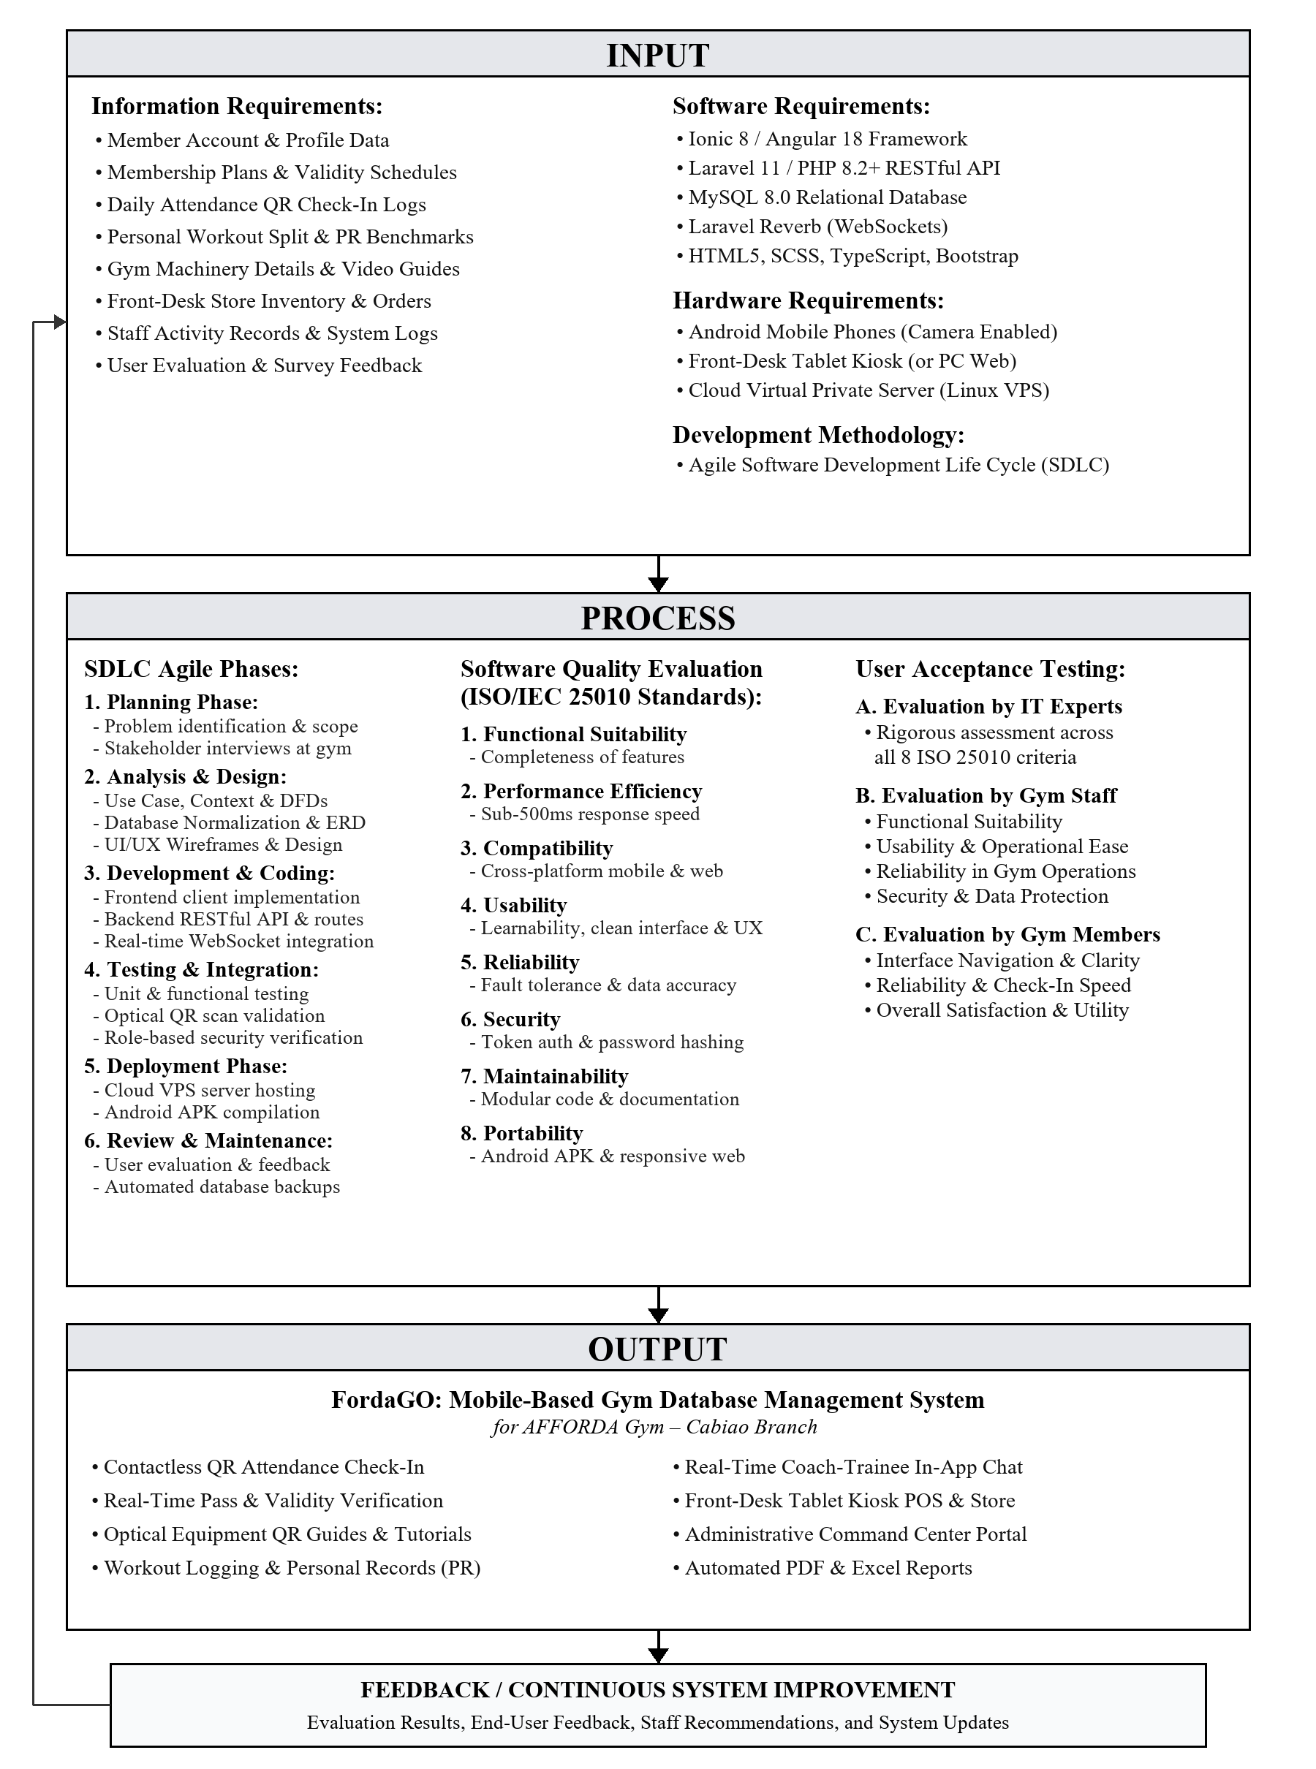

Statement of the Problem
General Problem Statement
AFFORDA Gym – Cabiao Branch provides fitness facilities and wellness services to fitness enthusiasts in Cabiao, Nueva Ecija. However, daily operations are severely hindered by manual paper logbooks for attendance tracking, disorganized membership pass monitoring, lack of accessible on-demand equipment instructions for beginners, manual supplement inventory logging, and the absence of a structured digital communication channel between gym coaches and trainees. These manual processes result in operational inefficiencies, data inaccuracies, front-desk congestion, security vulnerabilities, and suboptimal member engagement.
Specific Problem Statements
Specifically, this study seeks to answer the following research questions:
- What are the operational problems and limitations encountered in the current gym management workflow of AFFORDA Gym – Cabiao Branch in terms of:
a. Member registration, account management, and membership pass verification;
b. Attendance recording, monitoring, and historical record retrieval through physical paper logbooks;
c. Availability of instructional guidance and safety information for gym equipment;
d. Personal workout tracking, routine scheduling, and coach-client consultations;
e. Inventory management, supplement sales recording, and payment verification; and
f. Generation of administrative, financial, and operational summaries?
- What functional modules, system architecture, database design, and user interface features must be engineered in the proposed FordaGO: Mobile-Based Gym Database Management System to address the identified operational problems?
- What is the technical quality of the developed FordaGO system as evaluated by IT professionals based on the ISO/IEC 25010 software quality standards in terms of:
a. Functional Suitability;
b. Performance Efficiency;
c. Compatibility;
d. Usability;
e. Reliability;
f. Security;
g. Maintainability; and
h. Portability?
- What is the level of user acceptability of the system as evaluated by gym end-users (administrators, front-desk personnel, accredited coaches, and members) in terms of:
a. Functional Suitability;
b. Usability;
c. Reliability; and
d. Security?

Significance of the Study
The development, deployment, and evaluation of FordaGO will deliver direct practical and academic value to the following beneficiaries:
To AFFORDA Gym – Cabiao Branch Management: Modernizes the facility’s business infrastructure by eliminating manual logbooks, preventing revenue leakage through automated pass verification, maintaining live stock inventory, and providing accurate data-driven business reports.
To Gym Administrators and Front-Desk Staff: Significantly reduces administrative workload by automating member check-ins, eliminating manual attendance handwriting, streamlining supplement point-of-sale audits, and providing one-click PDF/Excel report exports.
To Gym Coaches and Personal Trainers: Provides a professional digital workspace (Coach Studio) to showcase credentials, publish workout routines, establish availability hours, organize group classes, and communicate in real time with trainees through structured workout plan proposals.
To Gym Members and Fitness Enthusiasts: Enhances the workout experience through frictionless QR check-in, on-demand equipment usage tutorials via QR scanning, personal record and routine tracking, easy supplement ordering, and direct access to professional coaching consultations.
To Researchers: Serves as a comprehensive practical application of integrating modern full-stack web and mobile technologies (Ionic, Angular, Laravel, WebSockets, and MySQL) in solving real-world fitness facility operations, database management, and mobile attendance tracking challenges.
To Future Developers and Academics: Provides an architectural foundation and empirical benchmark for future research into fitness digitalization, real-time sports informatics, and automated sports facility management systems.

Scope, Delimitations, and Limitations of the Study
Scope of the Study

This study encompasses the architectural design, full-stack software engineering, cloud VPS deployment, and empirical software quality evaluation of FordaGO: A Mobile-Based Gym Database Management System tailored exclusively for AFFORDA Gym – Cabiao Branch in Cabiao, Nueva Ecija. The system establishes an integrated operational ecosystem serving three distinct user classifications: Gym Members (Mobile Application / PWA Portal), Accredited Fitness Coaches (Trainer Studio), and Gym Administrators / Front-Desk Staff (Administrative Command Center).
The system’s functional scope is divided into eleven (11) major modules:
1. User Authentication & Role-Based Access Control Module:
Provides secure token-based authentication using Laravel Sanctum, encrypted password hashing (Bcrypt), role-based middleware access control, and self-service password recovery via security verification.
2. QR Code Attendance Monitoring Module:
Replaces physical paper logbooks with camera-based QR code verification. Front-desk staff utilize a recommended Android tablet kiosk (or reception PC/laptop web browser) to scan entering members' dynamic QR passes in real time, validating membership validity status within 500 milliseconds and automatically logging entry timestamps without requiring manual pen-and-paper writing.
3. Interactive Equipment QR Information & Guidance Module:
Members scan physical printed QR code labels affixed to gym machines using their smartphone cameras to immediately view high-resolution equipment photos, targeted muscle group diagrams, and step-by-step exercise execution instructions. Admins can generate and download printable printed QR code labels directly from the system.
4. Personal Record (PR) Tracker & Weekly Split Routine Builder:
Allows members to log personal record milestones (e.g., Bench Press, Squat, Deadlift) with automated percentage gain calculators, while enabling users to build custom daily workout splits (Monday to Sunday) with target durations and gym floor selections.
5. Coach Studio & Real-Time Consultation Module:
Accredited gym coaches manage their trainee roster, configure weekly working hours, publish public group fitness classes with participant seat limits, and engage in real-time private messaging powered by WebSockets. Coaches can compose and send structured in-chat Workout Plan Proposals (specifying dates, target muscles, routines, and pricing) that members can accept with a single tap.
6. Supplement Shop & Point-of-Sale (POS) Module:
Members browse gym supplements, energy drinks, and apparel, adding items to a multi-item cart and checking out via Over-the-Counter (OTC) Cash payment verification at the reception desk. Administrators review pending orders, verify physical cash payments, approve sales, and trigger atomic inventory stock deductions.
7. Membership Pass & Billing Management Module:
Tracks active membership passes (30-Day Premium Pass and Daily Visit Passes), monitors expiration dates, handles pass extension requests, and logs transparent transaction audit trails.
8. Real-Time Notification System:
Dispatches live WebSocket events and visual badge notifications for order approvals, workout proposals, chat messages, and administrative announcements.
9. Administrative Analytics & Export Engine:
Provides administrative dashboards with graphical operational summaries and vector PDF/Excel export engines for attendance traffic, sales revenues, inventory stock, and membership lists.
10. Administrative Activity Logs & Security Audit Trail Module:
Provides a real-time, immutable audit trail of administrator and staff actions within the system. It automatically logs staff login and logout timestamps, calculates exact active session durations, and tracks all data modifications including member approvals and removals, supplement inventory stock and pricing adjustments, equipment status updates, and daily attendance verifications storing associated JSON payloads, client IP addresses, and user-agent metadata for heightened institutional governance and accountability.
11. Member Feedback & Net Promoter Score (NPS) Evaluation Engine:
Facilitates continuous service quality monitoring by prompting member evaluations after active gym participation. Members submit 0–10 numerical ratings and qualitative commentary, enabling the system to automatically compute the gym's Net Promoter Score (NPS), categorize feedback into Promoters (9–10), Passives (7–8), and Detractors (0–6), and stream real-time satisfaction analytics directly into the administrative control center.
Technical Architecture and Implementation Environment
Table 1. Technical Architecture & Development Stack
Component | Technology / Tools | Description / Purpose
Frontend Mobile & Web Client | Ionic 8, Angular Standalone Components, TypeScript, SCSS | Powers the mobile application for members and coaches, as well as the responsive web management portal for front-desk tablet kiosks and administrative PC web browsers.
Backend Application Server | Laravel 11, PHP 8.2+, RESTful API, Laravel Sanctum | Handles server-side logic, API requests, data processing, and user authentication.
Real-Time WebSockets | Laravel Reverb, Laravel Echo | Provides real-time communication and instant updates between the system and its users.
Database Management System | MySQL | Stores and manages system data using relational database structures, foreign key constraints, and transactional integrity.
Hardware Interfacing | Capacitor Camera, Web QR Scanner Plugins | Enables optical camera access on Android smartphones, front-desk tablet kiosks, and USB webcams for QR code check-in and machine tutorials.
Reporting Engine | jsPDF, AutoTable, Excel Export Utilities | Generates formatted PDF reports and supports the export of system data into Excel-compatible files.
Cloud VPS Hosting & Containerization | Linux Cloud VPS, Podman / Docker Containers, Nginx | Hosts the production API, WebSockets, database, and client builds with container isolation and continuous uptime.
The proposed system was implemented and tested at AFFORDA Gym – Cabiao Branch during the Academic Year 2025–2026 as part of the Bachelor of Science in Information Technology capstone project.
Delimitations of the Study
To maintain technical feasibility and ensure the study remains aligned with academic capstone parameters, the following explicit delimitations are established:

1. Single-Branch Implementation. The system is engineered exclusively for AFFORDA Gym – Cabiao Branch in Cabiao, Nueva Ecija. Centralized database schemas, role configurations, inventory catalogs, and operational parameters are tailored to this single physical facility, excluding multi-branch enterprise federation or cross-location data warehousing.
2. Optical Camera Scanning vs. Physical Turnstiles and Dedicated Workstations. Attendance check-in and machine lookup operate entirely through camera-based optical QR code scanning using member smartphone cameras and front-desk device webcams or tablet cameras. To accommodate the practical operational reality of AFFORDA Gym – Cabiao Branch where no permanent front-desk desktop PC is installed, the front-desk terminal is engineered and recommended to operate as a compact digital kiosk on an Android tablet positioned at the reception counter. Furthermore, the system remains cross-platform and fully accessible via web browser on any desktop PC or laptop through its live domain DNS (e.g., app.affordagym.com). Physical motorized turnstiles, magnetic RFID cards, and biometric hardware are excluded from this release.
3. Smart Wearables and Biometric Sensors. The system does not integrate with external wearable hardware (e.g., Apple Watch, Fitbit, Garmin) or real-time physiological telemetry sensors. Heart rate monitoring, caloric expenditure modeling, and sleep tracking are excluded from the system's operational boundaries.
4. Payment Transactions and Financial Gateway Budget Delimitation. The primary and official payment fulfillment for all gym services (membership passes, day visits, and supplement purchases) is conducted via physical Over-the-Counter (OTC) cash payment directly at the gym reception desk with manual staff receipt issuance and verification. To demonstrate modern digital transaction workflows and user experience, the mobile application features an interactive GCash checkout prototype where members can select a digital payment option, view the gym's official payment QR/account details, and submit a reference number or upload a proof-of-payment screenshot. However, this feature is strictly an interactive demonstration prototype and does NOT deduct actual monetary funds from member e-wallets, bank accounts, or financial gateways. Integrating fully automated commercial payment gateway APIs (such as PayMongo, Maya Business, or GCash for Business with real-time webhook clearing) requires formal commercial merchant accreditation, corporate SEC or DTI registration documents, corporate merchant bank accounts, and recurring per-transaction clearing fees. Due to the financial budget constraints and academic nature of this student capstone project, live commercial financial API integrations were deliberately excluded, preserving physical front-desk counter cash auditing as the authoritative transaction protocol.
5. Computer Vision & AI Motion Coaching. Equipment guidance is provided through pre-configured instructional media, descriptive exercise guides, and anatomical muscle diagrams. Automated computer vision motion tracking, sensor-based repetition counting, and real-time posture correction algorithms are excluded from this release.
6. Network Connectivity and Cloud VPS Accessibility. The application is deployed and hosted live on a production Linux Cloud Virtual Private Server (VPS) architecture. The mobile application and administrative portal require an active internet connection (Wi-Fi or cellular data) to synchronize attendance, process orders, and exchange messages with the centralized MySQL database.
7. User Base Restriction. System access is strictly restricted to registered gym members, accredited fitness coaches, front-desk staff, gym administrators, and super administrators authorized by AFFORDA Gym – Cabiao Branch. Public open access and unauthenticated operations are prevented through token authentication.
8. Facility Scope and Environmental Boundary. The application is optimized for indoor training operations within the physical premises of AFFORDA Gym – Cabiao Branch. External outdoor fitness tracking, GPS route mapping, and community-wide social feeds are excluded from the scope.
9. Medical Diagnosis and Nutritional Prescription. While the system collects standard health declarations (Physical Activity Readiness Questionnaire - PAR-Q) and fitness metrics, it does not provide clinical medical diagnosis or automated therapeutic dietary prescriptions. All exercise routines and coaching proposals serve solely as fitness guidelines.
10. Mobile Platform Deployment and iOS Operating System Delimitation. The native mobile application package is compiled and distributed exclusively as an Android Application Package (APK) for Android mobile phones and tablet devices. Unlike the Android platform, which allows straightforward direct installation and sideloading of compiled APK packages generated through Android Studio and Gradle without requiring paid developer distribution services, the Apple iOS ecosystem strictly prohibits unauthorized direct application sideloading or manual package installation on consumer devices without an active enterprise certificate or official Apple App Store distribution. Furthermore, publishing an official native iOS application to the Apple App Store requires an annual Apple Developer Program enrollment fee ($99 USD per annum), dedicated macOS compilation hardware (Apple Macintosh/MacBook computers), and formal organizational entity verification, which are beyond the financial budget constraints and technical resources of this undergraduate capstone study. Nevertheless, to ensure that gym members and stakeholders utilizing Apple iPhone or iPad devices are not excluded from system benefits, the FordaGO platform is engineered upon responsive Ionic 8 and Angular web technologies and hosted live on a public domain DNS (https://app.affordagym.com). Consequently, iOS users can seamlessly access and operate all member functionalities (including profile management, attendance logs, workout logging, equipment exercise guides, supplement store browsing, and coach consultations) directly through standard mobile web browsers such as Apple Safari and Google Chrome without requiring native App Store installation.

These delimitations define the operational boundaries of the study and ensure that the project remains technically sound, cost-effective, and fully achievable within academic capstone constraints.
Limitations of the Study
While the delimitations represent deliberate scope boundaries established by the researchers, the study is subject to several inherent technical, environmental, behavioral, and operational limitations that are beyond the complete control of the developers:
1. Hardware and Camera Sensor Variance. The optical QR code decoding speed and responsiveness are subject to the camera sensor specifications, focal capabilities, and autofocus speeds of individual member smartphones and front-desk webcams. Devices with low-resolution camera modules or scratched lenses may experience slight scanning latency.
2. Ambient and Environmental Gym Lighting Conditions. Optical recognition of printed QR code labels affixed to gym machines and member digital screens is subject to ambient illumination within the facility. In areas with significant glare or dim lighting, scanning may require angle adjustments or smartphone flashlight activation.
3. Centralized Cloud Network Dependency and ISP Latency. Because FordaGO operates on a live centralized Linux Cloud Virtual Private Server (VPS) architecture, system responsiveness, attendance synchronization, and media streaming are dependent on external Internet Service Provider (ISP) uptime and local network bandwidth.
4. Mobile Operating System Background Execution Policies. Aggressive battery optimization and background app memory termination policies implemented by certain mobile operating systems (e.g., customized Android distributions) may occasionally delay local push notifications if the application is killed in the background.
5. Subjectivity of Self-Logged Fitness Progress. Workout performance metrics, Personal Record (PR) milestone weights, repetition counts, and routine completion statuses rely on manual user logging and self-reporting by gym members, which may introduce subjective variances or entry delays.
6. Front-Desk Counter Verification Latency. While digital order placement and attendance scanning are automated, manual payment confirmation and physical cash handling require active verification by front-desk personnel, introducing minor operational delays during peak arrival periods.
7. Evaluation Sample Size and Contextual Generalizability. The empirical evaluation of the system was conducted specifically within AFFORDA Gym – Cabiao Branch involving 5 IT experts and 30 gym end-users. The findings reflect the specific operational workflows of this facility and may vary in larger commercial fitness chains.
8. Physical Queuing and Terminal Concurrency. The physical check-in throughput during peak arrival hours is bounded by the number of active camera scanning stations operating at the front-desk counter.
9. Absence of Direct Electronic Medical Record (EMR) Integration. Member health declarations and PAR-Q screening records rely on self-disclosure by gym-goers rather than automated verification against clinical hospital or healthcare databases.
10. Native iOS Mobile Installation and Ecosystem Policy Constraint. Due to Apple Inc.'s closed sandbox and security policies that prohibit direct executable package (IPA) installations without App Store review and publishing, iOS users must access the system via mobile web browsers (e.g., Apple Safari or Google Chrome) rather than a standalone native application installed from an APK file. While the responsive web application provides full functional parity with the Android APK, native platform features such as background push notification persistence may exhibit slight behavioral differences on iOS web browsers compared to the native Android operating system environment.

These limitations are acknowledged as practical operational and technical boundaries of modern web and mobile information systems in fitness environments.

Terms and Definition
Angular – A web application framework used to develop the frontend interface of the FordaGO system.
API (Application Programming Interface) – A set of rules and protocols that allows the frontend application to communicate with the backend server and exchange data.
Attendance Monitoring – The process of recording and tracking gym members’ visits and check-ins.
Backend – The server-side component of the system responsible for processing requests, managing business logic, authentication, and database operations.
QR Code Scanner – A system feature that uses a device camera to scan machine-readable codes for identifying or accessing information.
Capacitor – A native runtime that enables web-based applications to access mobile device features such as the camera.
Database – An organized collection of data used to store and manage information such as member profiles, attendance records, transactions, and inventory.
Database Management System (DBMS) – Software used to create, store, organize, retrieve, and manage data within a database.
FordaGO – The proposed mobile-based gym database management system developed for AFFORDA Gym – Cabiao Branch.
Frontend – The user-facing part of the system through which administrators, coaches, and members interact with its features and services.
Gym Management System – A computerized system designed to manage gym operations such as membership, attendance, scheduling, transactions, inventory, and reports.
Ionic – A framework used to develop cross-platform mobile and web applications using web technologies.
Laravel – A PHP-based backend framework used to develop the RESTful API and server-side functions of the FordaGO system.
Laravel Echo – A JavaScript library used to interact with WebSocket channels and receive real-time updates from the server.
Laravel Reverb – A WebSocket server used by the system to provide real-time communication between the server and connected users.
Laravel Sanctum – An authentication system used to secure API access and manage authenticated users.
Member – A registered gym user who can access authorized features such as attendance monitoring, workout tracking, equipment information, and product ordering.
MySQL – A relational database management system used to store and manage the data of the FordaGO system.
QR Code (Quick Response Code) – A two-dimensional machine-readable code that can be scanned using a camera to access or process encoded information.
RESTful API – A web service architecture that enables applications to communicate with a server using standard HTTP methods for requesting and managing data.
SCSS (Sassy CSS) – A stylesheet language used to create and organize the visual design and styling of the system interface.
TypeScript – A programming language used in the development of the system’s frontend, providing typed features for JavaScript-based applications.
WebSocket – A communication protocol that enables continuous, two-way communication between a client and server for real-time data updates.
Workout Tracking – A system feature that allows members to record completed workouts, personal records, routines, and fitness progress.
Inventory Management – The process of monitoring, recording, and managing gym equipment, supplies, and products available for sale.
Point-of-Sale (POS) – A system function used to record product purchases, update inventory, and maintain transaction records.
Report Generation – The process of producing organized reports from system data, such as attendance, transactions, sales, and inventory records.
Functional Suitability – The degree to which the system provides functions that meet the specified requirements and intended user needs.
Usability – The degree to which users can effectively, efficiently, and satisfactorily use the system.
Reliability – The ability of the system to perform consistently and correctly under specified conditions.
Security – The capability of the system to protect data and prevent unauthorized access or actions.
Performance Efficiency – The ability of the system to provide appropriate performance in relation to the amount of resources used.
ISO/IEC 25010 – An international software quality model used to evaluate software based on defined quality characteristics, including functional suitability, usability, reliability, security, and performance efficiency.
Chapter II
Methodology
Research Design
This chapter presents the research methodology employed in the conceptualization, development, testing, and evaluation of FordaGO: Mobile-Based Gym Database Management System for AFFORDA Gym – Cabiao Branch. It details the research design, System Development Life Cycle (SDLC), technical development environment, research locale, respondent selection and sampling technique, research instruments, data gathering procedures, ethical safeguards, and statistical tools used in data analysis.
This study utilizes a Developmental Research Design anchored on the Agile Software Development Methodology.
According to Richey (1994) and Richey and Klein (2007), developmental research is the systematic study of designing, developing, and evaluating instructional programs, processes, and software products that must meet criteria of internal consistency, effectiveness, and user acceptability. This research design is appropriate because the primary aim of the study is not merely theoretical inquiry, but the engineering, implementation, and empirical validation of a functional software artifact the FordaGO gym management platform tailored specifically to resolve operational bottlenecks at AFFORDA Gym – Cabiao Branch.
Table 1. Core Developmental Activities
Phase / Track | Core Developmental Activities | Evaluative Feedback Loop
Sprint Iterations (Engineering) | 1. Continuous Requirements Elicitation  2. UI/UX & Wireframe Prototyping  3. Full-Stack Programming (Ionic/Laravel)  4. Automated & Module Testing  5. Working Build Demonstrations) | Iterative Feedback to Refine Features
ISO/IEC 25010 Quality Evaluation | 1. Functional Suitability Testing  2. Usability & Navigation Audits  3. Operational Reliability Checks  4. Security & Encryption Verification  5. Performance Latency Benchmarks | Refinements & Bug Resolution to Sprints
The developers chose the Agile Methodology (Pressman & Maxim, 2020; Sommerville, 2019) over traditional linear waterfall models due to the dynamic, multi-module nature of the project. Agile promotes iterative sprint cycles, frequent integration, continuous client feedback, and rapid response to evolving requirements. Developing FordaGO in modular iterations allowed the team to construct, test, and refine distinct features such as QR front-desk scanning check-ins, interactive equipment orientation catalogs, real-time WebSocket coaching chats, and point-of-sale inventory deductions ensuring seamless horizontal integration across the entire application ecosystem.
System Development Life Cycle (SDLC)
The engineering of FordaGO followed the Agile System Development Life Cycle (SDLC), structured into five systematic, iterative phases:
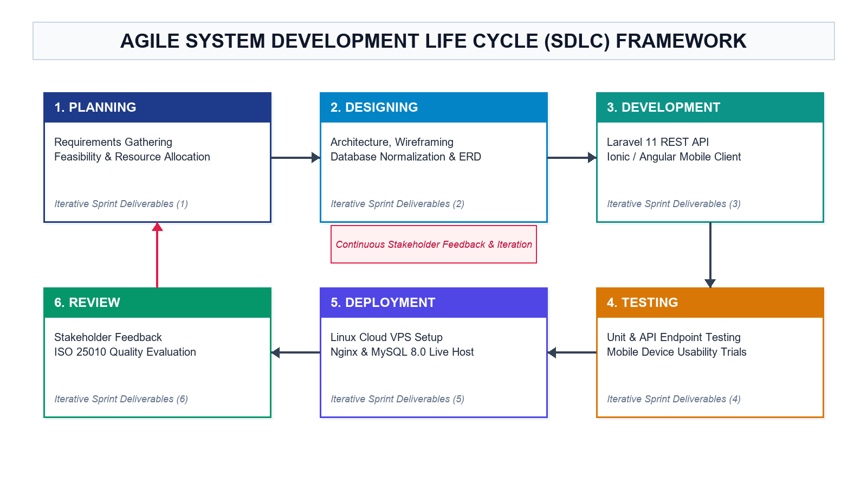
Figure 2. Agile Methodology Framework
Table 2. System Development Life Cycle Phase
SDLC Phase | Focus Area | Key Deliverables & Outputs
Phase 1 | Requirements Gathering & Analysis | On-site interviews, SRS documentation, role matrix definition
Phase 2 | System & Architectural Design | 3NF database ERDs, RESTful API endpoints, UI wireframes
Phase 3 | Development & Implementation | Ionic 8 / Angular frontend, Laravel 11 API, Reverb WebSockets
Phase 4 | Integration & System Testing | Unit tests, camera barcode scanner tests, end-to-end verification
Phase 5 | Deployment & Evaluation | Linux Cloud VPS deployment (Podman containerized stack), live production testing, ISO/IEC 25010 survey evaluation
Phase 1: Requirements Gathering and Analysis
The researchers conducted direct on-site observations, process mapping, and structured interviews with the gym owner, front-desk staff, personal trainers, and gym members of AFFORDA Gym – Cabiao Branch.
Problem Identification: Documented the specific operational bottlenecks in the facility, including front-desk queuing caused by manual attendance paper logbooks, unmonitored membership expirations, novice member difficulties with machine execution, lack of structured trainer consultation channels, and manual supplement inventory tracking.
Requirements Specification: Defined the software requirements specification (SRS), categorizing functional requirements into three distinct user roles (Members, Coaches, Administrators) and establishing non-functional benchmarks for security, database integrity, and real-time response latency.
Phase 2: System and Architectural Design
The gathered requirements were translated into comprehensive technical architectures and interface designs:
Database Modeling & Normalization: Modeled relational entity-relationship diagrams (ERD) and normalized database schemas in MySQL up to the Third Normal Form (3NF). Designed tables with strict foreign key constraints for users, membership passes, attendance logs, equipment catalogs, personal records (PRs), workout sessions, coaching proposals, conversations, chat messages, products, and order transactions.
API & WebSocket Channel Architecture: Designed RESTful API route structures in Laravel 11 following standard HTTP verb semantics, secured via Laravel Sanctum token middleware. Designed presence and private WebSocket channels in Laravel Reverb for real-time duplex chat events, unread notifications, and proposal alerts.
UI/UX Wireframing: Constructed high-contrast, theme-aware responsive wireframes using Ionic 8 component libraries, implementing dark fitness themes for mobile screens and structured analytical layouts for the administrative command center.
Phase 3: Development and Implementation
During this phase, full-stack programming was executed across all tiers:
Frontend Mobile & Web Client: Engineered using Ionic 8 and Angular (TypeScript, SCSS) utilizing standalone components and reactive form structures. Integrated Capacitor native plugins (Capacitor Camera and QR Code Scanner) to enable high-speed optical QR code decoding via device cameras.
Backend Application Server: Developed using Laravel 11 (PHP 8.2+) implementing the Model-View-Controller (MVC) architectural pattern, Eloquent ORM, Sanctum authentication tokens, Bcrypt password hashing, and custom role-based route middleware (member, coach, admin, employee, super_admin).
Real-Time Communication Layer: Powered by Laravel Reverb and Laravel Echo, establishing continuous TCP WebSocket connections for sub-second in-chat messaging, live typing status broadcasts, and real-time proposal notifications.
Database Layer: Configured in MySQL 8.0, leveraging structured database migrations, database seeders, and atomic transaction rollbacks for concurrent point-of-sale orders and attendance check-ins.
Reporting Engine: Constructed using jsPDF and AutoTable to generate dynamic, client-side vector PDF reports and CSV/Excel spreadsheets.
Phase 4: Integration and System Testing
The system underwent rigorous multi-level verification to ensure functional correctness and system stability:
Unit Testing: Verified individual controller logic, authentication token generation, password recovery verification, and inventory deduction calculations.
Integration Testing: Verified end-to-end data synchronization between the Ionic Angular frontend, Laravel REST API, MySQL database, and Reverb WebSocket server.
Black-Box Functional Testing: Evaluated system operations against test matrices covering QR front-desk scanning check-ins, anti-pass-sharing timestamp verification, equipment QR tutorial loading, in-chat proposal dispatching and acceptance, and Over-the-Counter cash order checkout across physical Android mobile phones and desktop web browsers.
Phase 5: Deployment, Demonstration, and Evaluation
The finalized FordaGO system was deployed in a local network test environment and demonstrated to target stakeholders at AFFORDA Gym – Cabiao Branch. Hands-on testing sessions were conducted with gym staff, certified coaches, and members, followed by the administration of the standardized ISO/IEC 25010 software quality evaluation questionnaire.
Research Locale
This study entitled FordaGO: Mobile-Based Gym Database Management System for AFFORDA Gym – Cabiao Branch was conducted in the Municipality of Cabiao, Nueva Ecija, specifically situated at AFFORDA Gym – Cabiao Branch. Cabiao is a first-class municipality in the southern portion of Nueva Ecija, experiencing sustained commercial growth and an increasing community interest in fitness and athletic wellness. The facility was purposively selected as the empirical research locale based on the following operational criteria:
a. Operational Need for Digitalization. The gym currently operates through manual and semi-manual processes for attendance tracking, pass monitoring, and supplement inventory counts, creating a genuine operational bottleneck suitable for database automation.
b. Diverse and Active Trainee Population. The facility accommodates a broad demographic of fitness enthusiasts ranging from novice gym-goers to seasoned lifters, offering a diverse user population for comprehensive usability and functional evaluation.
c. Support and Willingness from Management. The gym proprietor, administrative reception staff, and accredited fitness coaches demonstrated active willingness to collaborate, participate in pilot testing, and integrate mobile technology into daily workflows. The geographic location of the research locale is illustrated in Figure 3, showing the Municipality of Cabiao, Nueva Ecija where AFFORDA Gym – Cabiao Branch is situated.
Figure 3. Map of the Municipality of Cabiao, Nueva Ecija; the Research Locale
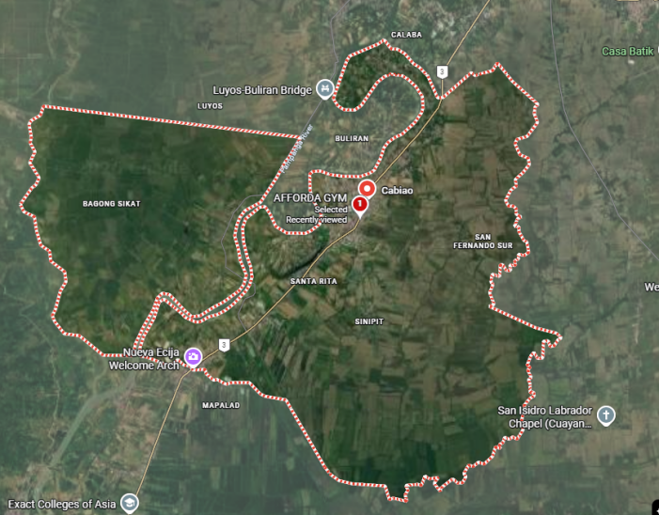
Respondents of the Study
This study employed Purposive Sampling, a non-probability sampling technique where respondents are chosen deliberately based on predefined inclusion criteria relevant to the technical and operational assessment of the system (Creswell & Creswell, 2018).
Inclusion Criteria:
- Technical Experts: Must hold a bachelor’s degree or professional background in Information Technology, Computer Science, or Software Engineering, with at least two (2) years of professional experience in software development, database administration, or systems analysis.
- End-Users: Must be an active member, certified personal trainer/coach, front-desk employee, or administrator of AFFORDA Gym – Cabiao Branch who actively engages in daily gym operations.
A total of fifteen (15) respondents were selected using purposive sampling, categorized into two evaluation groups: five (5) Technical Experts (IT Professionals, Software Engineers, and Database Administrators) and fifteen (15) End-Users of AFFORDA Gym – Cabiao Branch. The end-user cohort was specifically stratified into one (1) gym owner/proprietor, one (1) front-desk administrative staff member, and thirteen (13) active gym members and gym-goers.
Table 3. Total Respondents
Evaluator Category | Specific Role / Expertise | Count (n) | Percentage (%)
1. Technical Experts | IT Professionals, Software Engineers, System Analysts | 5 | 25.00%
2. End-User: Gym Owner | Gym Proprietor & General Administrator | 1 | 5.00%
3.End-User: Front-Desk Staff | Front-Desk Cashier & Operations Personnel | 1 | 5.00%
4. End-Users: Gym Members | Active Gym Members & Regular Gym-Goers | 13 | 65.00%
SUBTOTAL: END-USERS | Gym Owner, Staff, and Active Members | 15 | 75.00%
TOTAL RESPONDENTS | All Evaluator Stakeholders | 20 | 100.00%

Research Instrument
The primary research instrument used to evaluate the system was a structured survey questionnaire adapted from the ISO/IEC 25010 Systems and Software Quality Requirements and Evaluation (SQuaRE) model (ISO, 2011).
The evaluation instrument for IT Experts comprehensively assessed all eight (8) software product quality characteristics under the ISO/IEC 25010 model across thirty-three (33) standardized parameter indicators:
- Functional Suitability: Evaluates the degree to which system features (QR front-desk QR scanner attendance, equipment tutorial scanner, PR milestone tracker, split routine planner, in-chat workout proposals, supplement POS, and PDF/Excel report export) completely and correctly satisfy user operational requirements.
- Usability: Measures interface aesthetics, clarity of navigation, ease of learning, feature accessibility, and the effectiveness of interactive onboarding guides.
- Reliability: Assesses system operational consistency, fault tolerance, transaction recoverability, and stable data persistence during concurrent operations.
- Security: Evaluates role-based access control (RBAC), token authentication, password encryption (Bcrypt), and the safeguarding of user personal and transactional records against unauthorized manipulation.
- Performance Efficiency: Evaluates API response speeds, database query execution times, WebSocket real-time message throughput, and mobile camera barcode scanning responsiveness under normal operational loads.
A 5-Point Likert Scale was utilized across all questionnaire items, consistent with the standard evaluation rubrics established by the College of Information and Communications Technology (CICT).
Table 4. The 5-Point Likert Scale Reference
Scale | Numerical Range | Descriptive Rating | Verbal Interpretation
5 | 4.21 – 5.00 | Strongly Agree (SA) | Excellent / Highly Acceptable
4 | 3.41 – 4.20 | Agree (A) | Very Good / Acceptable
3 | 2.61 – 3.40 | Moderately Agree (MA) | Fair / Needs Improvement
2 | 1.81 – 2.60 | Disagree (D) | Poor / Weak
1 | 1.00 – 1.80 | Strongly Disagree (SD) | Very Poor / Unacceptable
Data Gathering Procedure
The researchers executed a systematic, five-stage data gathering procedure:
Table 5. The Five-Stage Data Gathering Procedure
Stage | Data Gathering Phase | Primary Activity
Phase 1 | Protocol & Consent Securing | Submitting permission letters and distributing informed consent forms
Phase 2 | System Verification & Deployment | Deploying production Linux Cloud VPS containerized services and configuring Android APK builds
Phase 3 | Demonstration & Hands-On User Testing | Guiding respondents through attendance, coaching, POS, and export workflows
Phase 4 | Questionnaire Administration | Administering the standardized 33-item ISO/IEC 25010 5-point Likert instrument to IT Experts and operational usability forms to End-Users
Phase 5 | Statistical Processing & Analysis | Computing weighted means, composite means, and grand overall means

Phase 1: Protocol and Consent Securing
The researchers submitted a formal letter of request to the management of AFFORDA Gym – Cabiao Branch to obtain administrative authorization for research, personnel interviews, and on-site system testing. Informed consent forms outlining research objectives were distributed to all respondents prior to participation.
Phase 2: System Verification and Local Deployment
The FordaGO backend API, MySQL database, and Reverb WebSocket server were configured and deployed live on a dedicated Linux Cloud Virtual Private Server (VPS) utilizing Podman container orchestration. This live cloud hosting enabled 24/7 internet-based access for gym management, coaches, and members. Production APK builds were installed on Android mobile devices to test camera-based QR scanning and real-time WebSocket synchronization over public internet connections.
Phase 3: Live Demonstration and Hands-On User Testing
The researchers conducted comprehensive demonstration sessions at AFFORDA Gym – Cabiao Branch. Evaluators were given guided hands-on access to test all primary system workflows:
- Members tested QR attendance check-in, equipment printed QR code label scanning, PR logging, split routine creation, coach messaging, and supplement cart checkout.
- Coaches tested client roster management, availability configuration, group class publishing, and in-chat workout proposal dispatching.
- Administrators tested camera front-desk scanning check-ins, order payment approvals, equipment printed label printing, and PDF/Excel report exporting.
Phase 4: Questionnaire Administration
Immediately following hands-on testing, the structured ISO/IEC 25010 survey questionnaires were administered to the technical experts and end-users. The researchers provided clarification on technical terms when requested while maintaining strict impartiality.
Phase 5: Statistical Processing and Interpretation
All completed questionnaires were gathered, tabulated, and entered into statistical spreadsheets for numerical computation, weighted mean calculation, and qualitative interpretation.
Ethical Considerations
The researchers strictly adhered to ethical research guidelines and legal standards throughout the study:
Informed Consent & Voluntary Participation:
All participants were fully briefed on the purpose, procedures, and scope of the evaluation before participating. Participation was entirely voluntary, and respondents retained the right to withdraw at any stage without consequence.
Confidentiality and Anonymity:
Personal information and individual scoring results were kept strictly confidential. Evaluation data were reported as aggregated statistical figures to protect the identity of all respondents.

Compliance with Republic Act No. 10173 (Data Privacy Act of 2012):
The FordaGO application adheres to principles of transparency, legitimate purpose, and proportionality. Sensitive member data, passwords, and transaction records stored within the MySQL database are protected using Bcrypt encryption, Sanctum authentication tokens, and strict role-based access controls.
Academic Integrity:
All literature, frameworks, software libraries, and methodologies referenced throughout this study are cited in accordance with APA 7th edition standards.
Statistical Treatment of Data
The quantitative data gathered from the ISO/IEC 25010 evaluation questionnaires were analyzed using descriptive statistics, specifically the Weighted Mean (WM), Composite Mean (CM), and Percentage Distribution.
1. Percentage Distribution Formula
Used to determine the proportional distribution of respondent categories:
Where:
$P$ = Percentage
$n$ = Number of respondents in a specific category
N = Total number of respondents (N = 20; n = 5 for IT Experts, n = 15 for End-Users)
2. Weighted Mean Formula
The Weighted Mean was computed for each indicator across the evaluated software quality criteria:
Where:
$\underline{X}$ = Weighted Mean of the criterion
$f$ = Frequency of responses for each rating scale
$x$ = Numerical weight assigned to each response scale ($4,3,2,1$)
N = Total number of respondents (N = 20; n = 5 for IT Experts, n = 15 for End-Users)
3. Composite Mean Formula
The overall software quality of FordaGO across all evaluated ISO/IEC 25010 characteristics was calculated using the Composite Mean:
Where:
$CM$ = Composite Mean of the overall software evaluation
$∑\underline{X}$ = Sum of the weighted means of all criteria
k = Total number of evaluated quality criteria (k = 8 for IT Experts, k = 4 for End-Users)

4. Verbal Interpretation Scale
The calculated mean scores were interpreted using the following standard statistical range formula:
Table 6. The Verbal Interpretation Scale
Rating Scale | Weighted Mean Range | Descriptive Evaluation | Verbal Interpretation
5 | 4.21 – 5.00 | Strongly Agree | Excellent Quality / Highly Acceptable
4 | 3.41 – 4.20 | Agree | Very Good Quality / Acceptable
3 | 2.61 – 3.40 | Moderately Agree | Fair Quality / Needs Improvement
2 | 1.81 – 2.60 | Disagree | Poor Quality / Weak
1 | 1.00 – 1.80 | Strongly Disagree | Very Poor Quality / Unacceptable
This statistical framework provided an objective, empirical basis for verifying whether FordaGO achieved the required software engineering standards for operational deployment at AFFORDA Gym – Cabiao Branch.
Chapter III
Results and Discussions
This chapter presents the comprehensive results, technical outcomes, and empirical findings obtained from the design, development, and evaluation of FordaGO: Mobile-Based Gym Database Management System for AFFORDA Gym – Cabiao Branch. It details the execution of the Agile Software Development Life Cycle (SDLC), the complete system models (Use Case, Context Diagrams, Normalization, ERD, and Data Dictionary), and the statistical analysis of the software quality evaluation based on the ISO/IEC 25010 standard administered to IT experts, gym staff, coaches, and members.
1. Development of FordaGO: Mobile-Based Gym Database Management System for AFFORDA Gym – Cabiao Branch
The design and development of the FordaGO system followed the structured stages of the Agile System Development Life Cycle (SDLC), ensuring that all functional, technical, and operational requirements of AFFORDA Gym – Cabiao Branch were systematically implemented and verified.
1.1. Planning Phase
The planning phase established the foundational scope, feasibility, and technical direction of the FordaGO project. The researchers conducted preliminary site visits, workflow evaluations, and stakeholder consultations at AFFORDA Gym – Cabiao Branch in Cabiao, Nueva Ecija.
Problem Identification and Feasibility
The investigation confirmed that the gym was experiencing severe operational delays due to manual paper logbooks for attendance tracking, difficulty in tracking membership pass expirations, absence of on-demand equipment orientation for beginner gym members, manual supplement inventory tracking, and lack of a structured digital channel connecting personal trainers and trainees.
The technical, operational, and economic feasibility of the proposed mobile-based solution was established:
Technical Feasibility: Modern Android smartphones and front-desk tablet devices equipped with cameras and web browsers provide the necessary hardware environment for optical QR code scanning, real-time WebSocket communication, and responsive kiosk/mobile interfaces without requiring expensive specialized desktop workstations or physical turnstiles. Furthermore, because FordaGO is hosted live on a Linux Cloud VPS with configured domain DNS, the administrative portal can be accessed seamlessly across mobile tablets and desktop web browsers alike.
Operational Feasibility: Gym staff, personal trainers, and members expressed strong readiness to adopt a mobile application that simplifies daily check-in, routine management, supplement ordering, and coaching consultations.
Economic Feasibility: Eliminating physical paper ledgers and automating inventory records prevents revenue leakage, reduces administrative supply costs, and maximizes staff efficiency.
Resource Allocation and Risk Management
The researchers identified the necessary software tools (Laravel 11, Ionic 8, Angular, MySQL, Laravel Reverb, Visual Studio Code), hardware and cloud assets (Linux Cloud Virtual Private Server, member Android smartphones, front-desk Android tablet kiosks, and optional administrative PC web browsers via live domain DNS), and potential deployment risks. Mitigation strategies included implementing offline cached UI views for temporary network drops, Bcrypt encryption and Sanctum token guards for data security, and conducting user onboarding orientations.
Project Schedule and Timeline
The project was structured around a 9-month Iterative Agile Software Development Life Cycle (SDLC) for Afforda Gym – Cabiao Branch, NEUST San Isidro Campus, following the Agile SDLC framework, as outlined in the developmental timeline and Gantt chart presented in Figure 4.
Figure 4. Gantt Chart of Activities for FordaGO System Development
(January–October 2026)
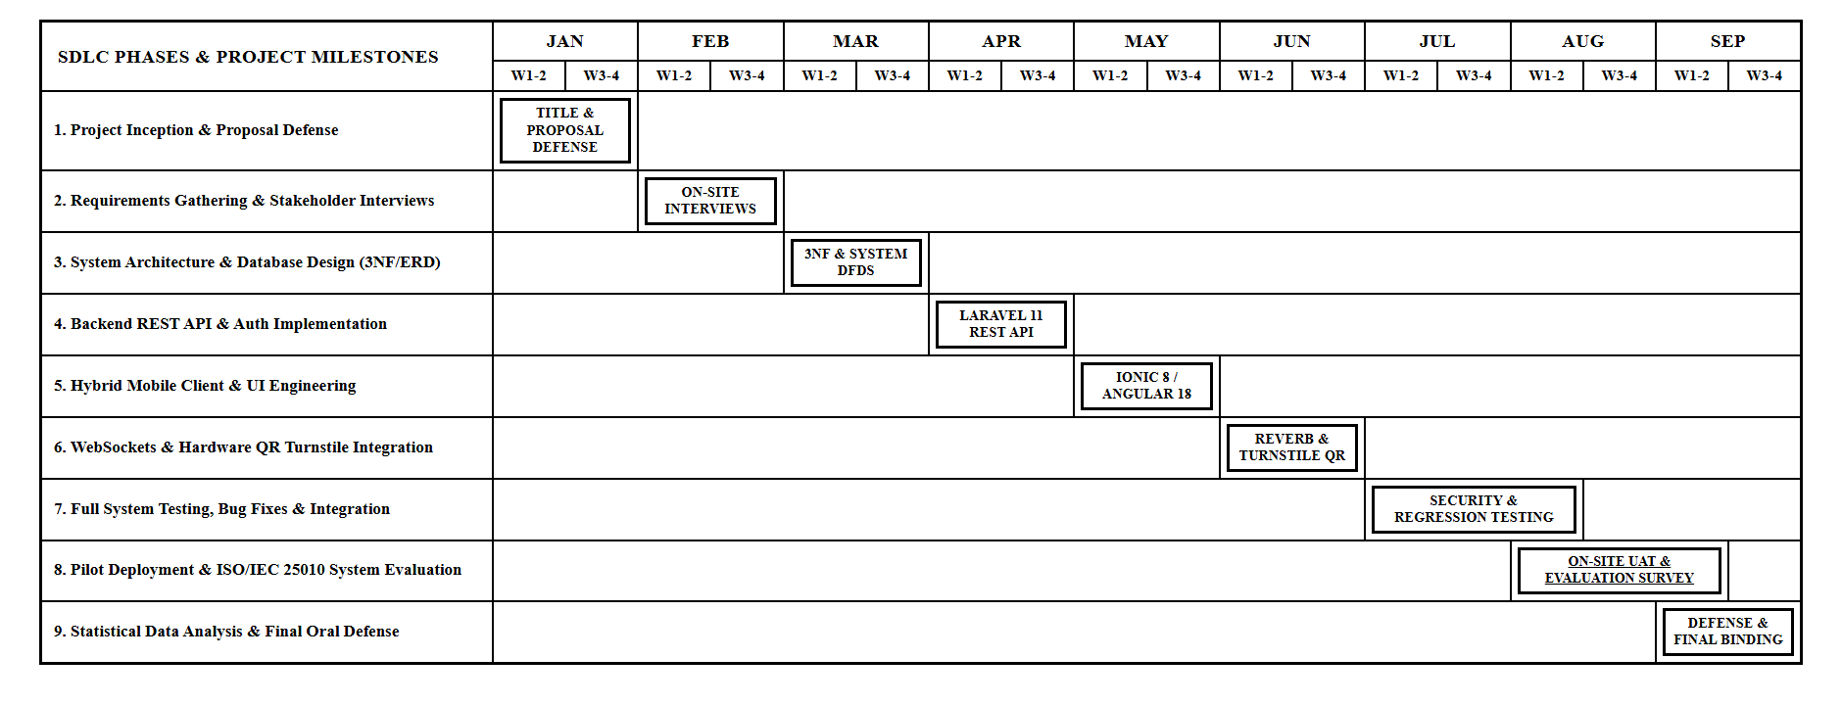

1.2. Designing Phase
The designing phase transformed the functional requirements gathered during planning into technical architecture diagrams, entity-relationship models, process flows, and user interface wireframes.
System Architecture
The system architecture follows a decoupled Client-Server Model consisting of:
1. Presentation Layer (Frontend):
Engineered using Ionic 8 and Angular standalone components to deliver a unified, cross-platform client architecture. This layer accommodates three primary operational touchpoints: (a) the native Android mobile application distributed via APK for gym members and accredited coaches, (b) the front-desk digital kiosk interface operating on touch-screen Android tablets (or reception PCs) at the front desk, and (c) the responsive web application portal accessible to desktop PCs, laptops, and Apple iOS devices (via Apple Safari or Google Chrome) over the live domain DNS (https://app.affordagym.com). Due to academic capstone budget constraints, the requirement for an annual $99 USD Apple Developer Program subscription, and Apple's strict policies prohibiting direct sideloading of iOS packages outside the App Store, iOS users utilize this live responsive web interface, achieving complete functional equivalence without requiring native App Store deployment.
2. Application Logic Layer (Backend):
Laravel 11 (PHP 8.2+) RESTful API server implementing MVC design patterns, Eloquent ORM, and Sanctum token middleware.
3. Real-Time Communication Layer:
Laravel Reverb WebSocket Server integrated with Laravel Echo for instant duplex messaging, live typing status, and proposal notifications.
4. Data Persistence Layer:
MySQL 8.0 relational database management system enforcing strict referential integrity and automated backup protocols: Scheduled automated daily MySQL database dumps (mysqldump) to preserve member transaction histories and attendance audit records. The comprehensive software engineering stack, integrated libraries, and cloud infrastructure powering the system are presented in the Full-Stack Architectural Framework in Figure 5.
Layer / Tier | Core Technology & Framework | Architectural Role & Responsibilities
Presentation Tier (Frontend) | Ionic 8 + Angular (TypeScript, SCSS) | Cross-platform responsive client, Member Mobile Portal, Coach Studio, Admin Web/Mobile Hub, Capacitor Camera plugin
Application Tier (Backend API) | Laravel 11 RESTful API (PHP 8.2+) | Business logic controllers, Eloquent ORM, Sanctum token authentication, RBAC middleware guards, vector PDF/Excel engine
Real-Time Communication Tier | Laravel Reverb WebSocket Server | High-throughput duplex WebSocket channels (Port 8080), instant chat broadcasting, live typing status, real-time proposal alerts
Data Persistence Tier (Database) | MySQL 8.0 Relational DB | 3NF normalized tables (users, memberships, attendances, equipment, products, orders), ACID transaction compliance
Figure 5. FordaGO Full-Stack Architectural Framework
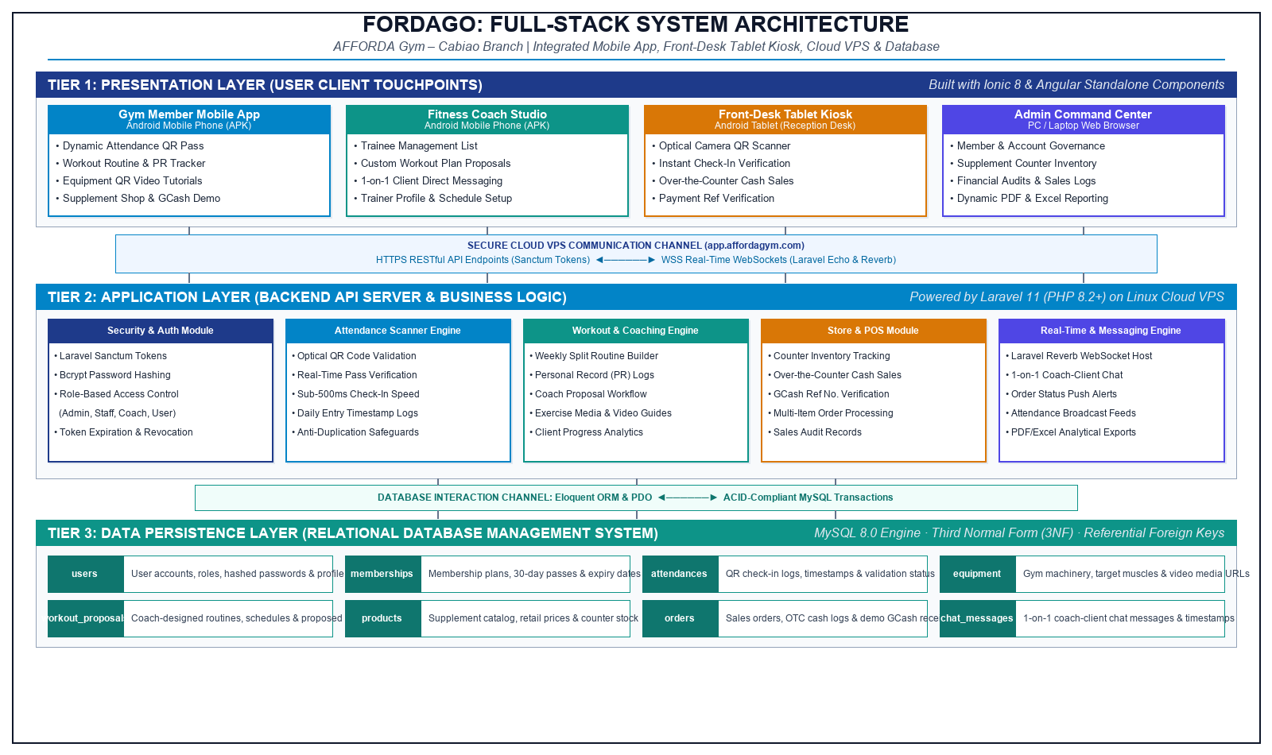

Use Case Diagram
Role-Based Access Control and System Actors
The FordaGO system implements a rigorous Role-Based Access Control (RBAC) architecture designed to enforce the principle of least privilege across all mobile and web interfaces. Access rights and protected API routes are strictly validated via Laravel Sanctum bearer tokens and role-checking middleware. The system classifies authenticated users into five distinct operational roles across three functional tiers:
1. Super Administrator (super_admin):
Represents the highest tier of administrative and governance authority. The Super Administrator possesses unrestricted system access, including managing Administrator and Employee credentials, monitoring cross-tier system activity, configuring system settings, and overseeing automated database backup routines
2. Gym Administrator (admin):
Functions as the primary operational manager for daily gym business. The Administrator manages member accounts and coach profiles, oversees supplement product catalog inventory, approves counter orders and validates cash payment receipts, publishes announcements, and generates dynamic financial and attendance reports. Administrators are restricted from altering system-level server configurations or deleting Super Administrator accounts.

3. Front-Desk Employee (employee):
Receptionist and counter staff operating at the gym front desk. Employees are granted operational access to the digital optical QR camera scanner for entrance attendance check-in, walk-in member registration, pass validity lookup, and point-of-sale (POS) counter supplement sales. To safeguard financial and administrative integrity, Employees are strictly restricted from accessing financial revenue audit reports, viewing profit analytics, or modifying administrative staff accounts.
4. Accredited Gym Coach (coach):
Certified fitness trainers operating within the Coach Studio workspace. Coaches manage their trainee client rosters, configure weekly working availability schedules, conduct real-time duplex chat via Laravel Reverb WebSockets, and dispatch structured in-chat Workout Plan Proposals.
5. Gym Member (user):
End-users accessing the Member Mobile Portal. Members can monitor active pass duration, present digital QR passes at the entrance front-desk QR scanner, scan equipment printed QR code labels for instructional movement tutorials, log personal records (PRs), construct weekly split routines, browse the supplement shop catalog, and consult with accredited coaches.
Table 1. User Role and Access Privilege Matrix of FordaGO
Operational Module / System Capability | Super Admin | Gym Admin | Employee (Staff) | Gym Coach | Gym Member
Front-Desk QR Attendance Camera Scanner | Full Access | Full Access | Full Access (Primary) | No Access | Own Pass Display Only
Walk-In Member Registration & Lookup | Full Access | Full Access | Full Access | No Access | Self-Profile Only
Point-of-Sale (POS) Counter Supplement Sales | Full Access | Full Access | Full Access | No Access | Mobile Cart Checkout Only
Supplement Inventory & Counter Cash Order Approval | Full Access | Full Access | View Stock Only | No Access | Catalog Browsing Only
Financial Revenue & Attendance PDF Reports | Full Access | Full Access | Restricted (No Access) | No Access | Personal History Only
Staff & System Account Management | Full Access | Employee/User Only | Restricted (No Access) | No Access | Self-Account Only
Coach Studio & Workout Plan Proposals | Monitoring Only | Monitoring Only | No Access | Full Access (Primary) | Accept / Decline Proposal
Equipment QR Tutorial Scanning & Guidance | Management View | Management View | No Access | Guidance View | Full Access (Primary)
Personal Record (PR) & Routine Builder | Analytical View | Analytical View | No Access | Review Trainee PRs | Full Access (Primary)
System Settings & Automated Database Backups | Full Access | Restricted (No Access) | Restricted (No Access) | No Access | No Access
The operational boundaries, role-based capabilities, and interaction flows among these authenticated actors and system modules are formally modeled in the Use Case Diagram depicted in Figure 6. In this architecture, the Gym Member utilizes the mobile client application to scan the entrance QR code printed label for contactless attendance check-in, scan optical equipment printed QR code labels to access exercise tutorials and anatomical muscle guides, log personal workout sets and PR benchmarks, order supplements, and consult with assigned coaches. The Front-Desk Staff monitors live attendance rosters, confirms pending counter payments for walk-in daily passes, and manages point-of-sale transactions and supplement inventory.
Figure 6. Use Case Diagram of FordaGO
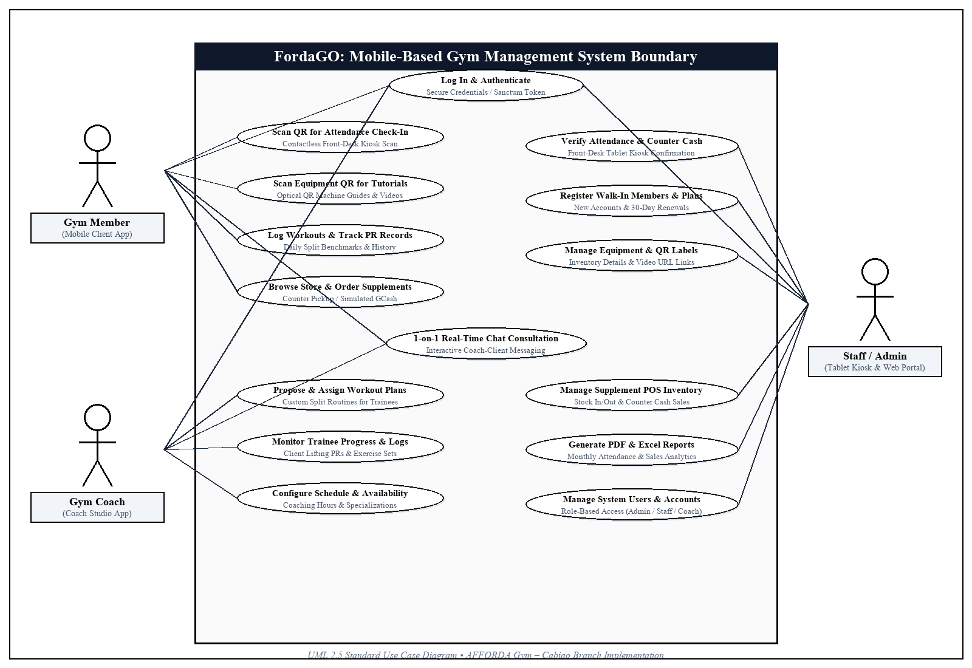

Context Diagram Level 0
The Context Diagram Level 0 models the global operational scope and external boundary of the FordaGO system. As illustrated in Figure 7, the central system process (Process 0: FordaGO: FordaGO: Mobile-Based Gym Database Management System) interfaces with three primary external entities: Gym Member, Gym Coach, and Gym Administrator / Front-Desk Staff. Members supply account credentials, dynamic QR check-in passes, supplement cart orders, real-time chat messages, and personal workout records, while receiving immediate attendance confirmation, pass validity statuses, equipment instructional tutorials, and coach proposals. Gym Coaches exchange consultation proposals, working availability schedules, and group classes, receiving active trainee rosters, client workout progression, and monthly earnings summaries. Administrative staff ingest walk-in registrations, update inventory stock, approve counter cash payments, and configure system rules, receiving comprehensive attendance logs, POS sales transactions, inventory balances, and dynamic vector PDF reports.
Figure 7. Context Diagram Level 0 of FordaGO
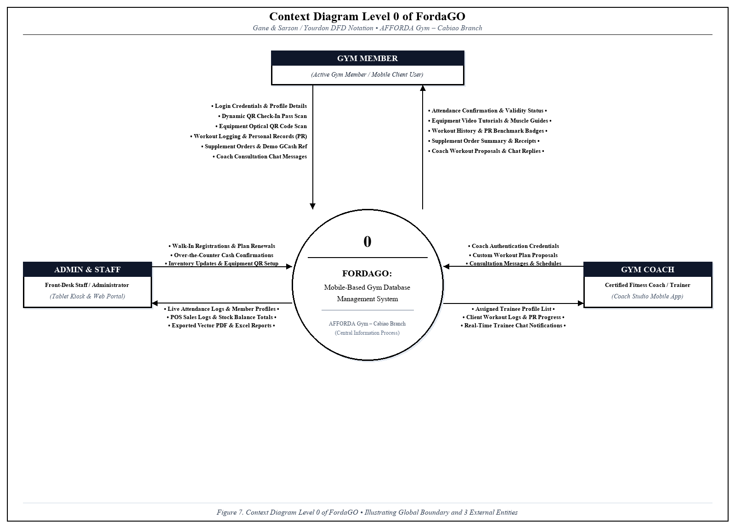

Data Flow Diagram (DFD) Level 1
The Data Flow Diagram (DFD) Level 1 decomposes the central system process into seven core operational subprocesses and establishes their direct bidirectional data exchanges with external entities and normalized database stores, as depicted in Figure 8. Subprocess 1.0 (User Authentication & Profile Management) securely handles member authentication and profile updates against the users data store. Subprocess 2.0 (QR Attendance Verification & Check-In Processing) validates incoming digital QR member passes and writes confirmed entry timestamps into the attendance store. Subprocess 3.0 (Optical Equipment QR Scanning & Instructional Guidance) queries machine printed labels from the equipment store to deliver anatomical guidance. Subprocess 4.0 (Workout Routine & PR Metric Logging) stores lifting benchmarks and custom split routines into the workout_sessions store. Subprocess 5.0 (Real-Time Consultation & Workout Proposals) manages coach-trainee communications and saves proposal objects into the workout_proposals store. Subprocess 6.0 (Supplement Shop POS & Order Processing) tracks cart orders, manages payment verification, and records sales in the orders store while deducting inventory from products. Finally, Subprocess 7.0 (Inventory Stock Management & Dynamic Report Generation) aggregates multi-table operational metrics from all data stores to generate administrative PDF and Excel analytics.
Figure 8. Data Flow Diagram (DFD) Level 1 of FordaGO
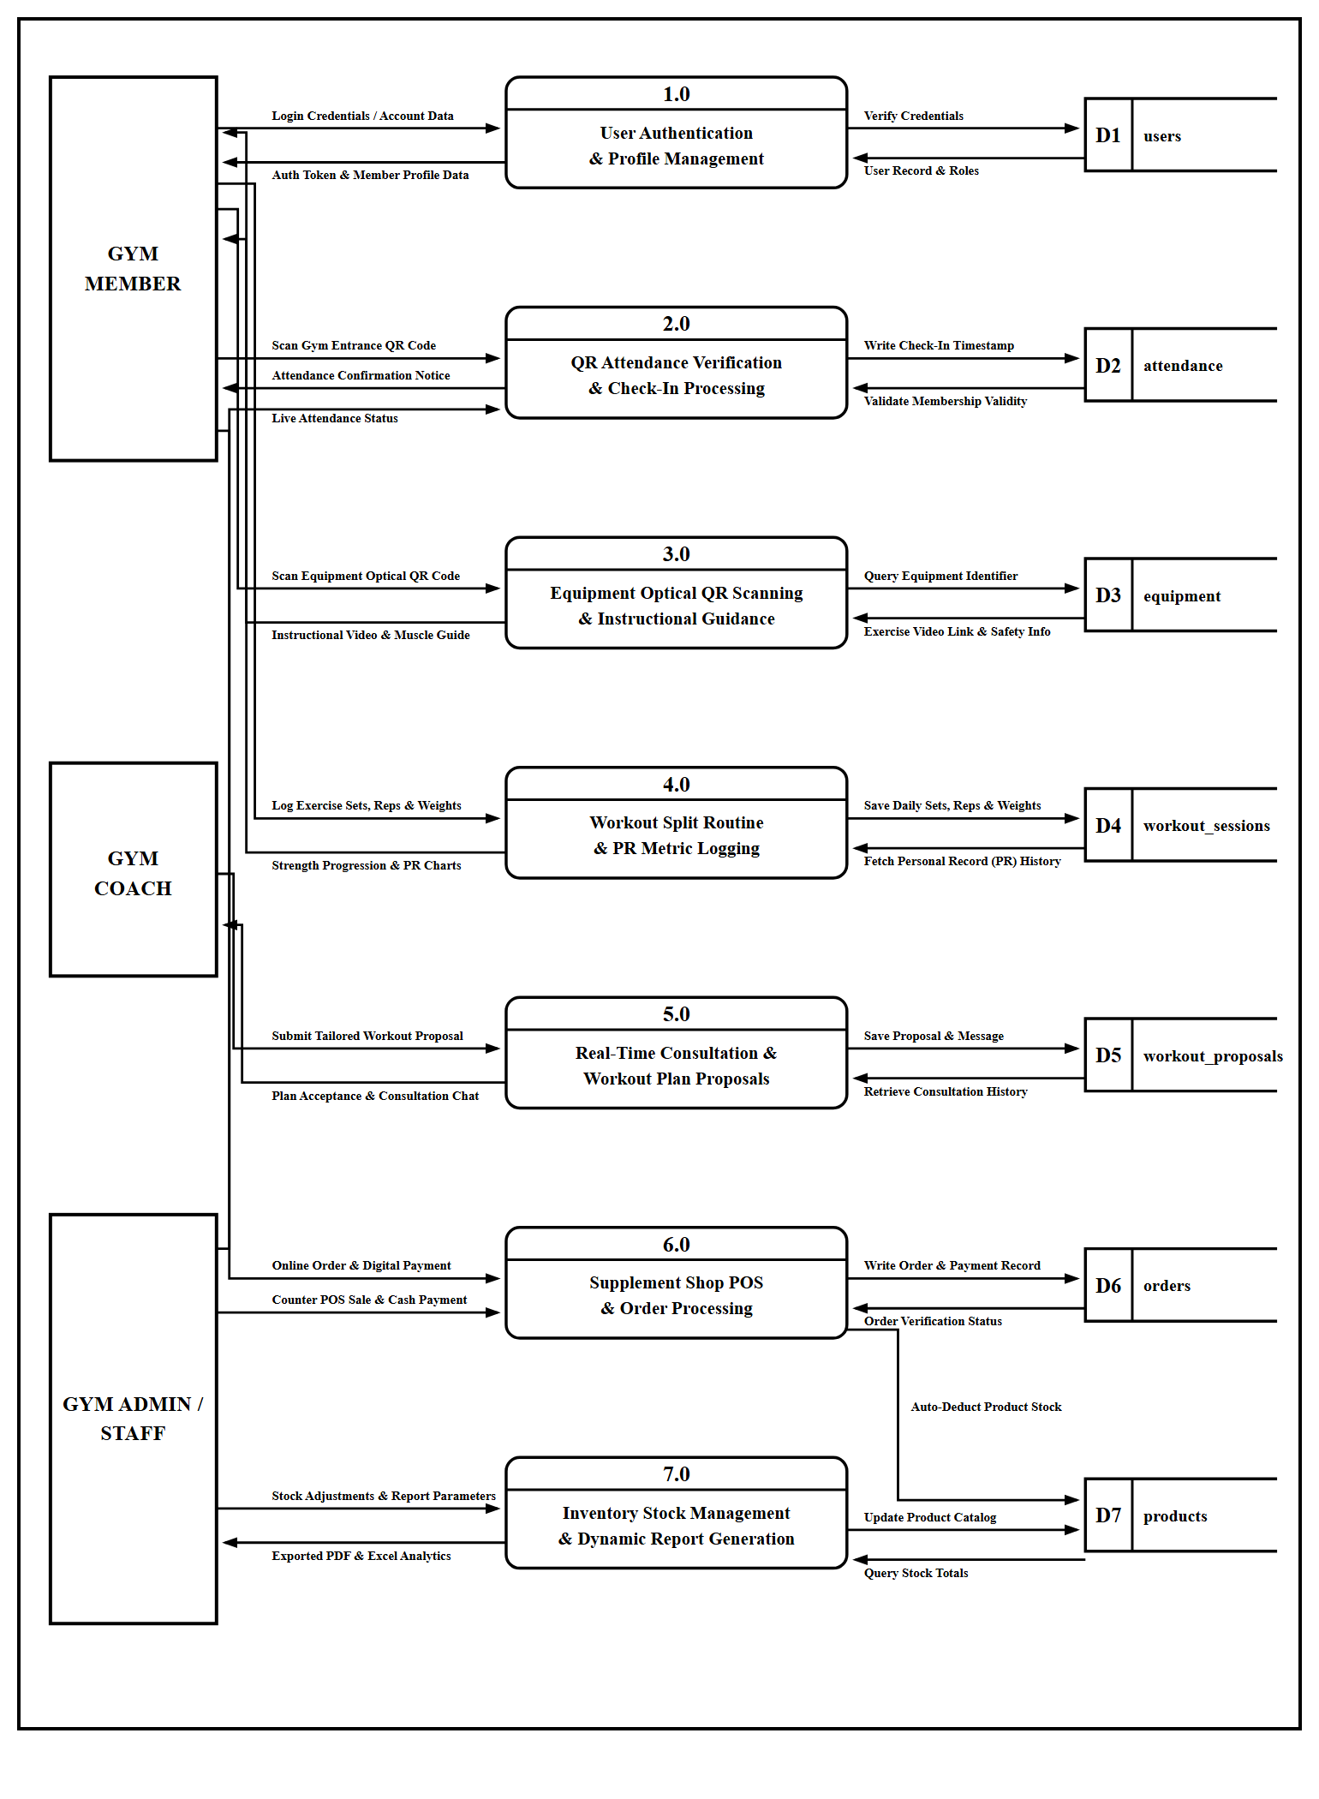

Database Normalization
To ensure high data integrity, minimize redundancy, and preserve transactional consistency, database normalization was applied through the fundamental normal forms (1NF, 2NF, and 3NF).
1. Unnormalized Form (UNF)
In the unnormalized state, all attributes across users, attendance check-ins, memberships, workout routines, coaching proposals, products, and supplement orders were represented in a single flat structure with multivalued and repeating groups.
UNNORMALIZED DATA ATTRIBUTES (UNF):
user_id
first_name
last_name
email
password
role
phone
membership_type
membership_start
membership_expiry
membership_status
order_date
attendance_id
attendance_date
check_in_time
check_in_status
equipment_id
equipment_name
muscle_group
media_url
payment_method
pr_id
exercise_name
max_weight
reps
pr_date
workout_id
split_day
target_duration
routine_details
coach_specialty
coach_rate
availability_schedule
proposal_id
proposal_title
proposal_price
proposal_status
proposal_date
receiver_id
receiver_id
coach_id
receiver_id
product_id
product_name
product_category
price
gcash_reference
order_statusfirst_name
sender_id
order_id
conversation_id
stock_quantity
UNF = { user_id, first_name, last_name, email, password, role, phone, fcm_token, membership_id, membership_type, start_date, end_date, membership_status, membership_price, attendance_id, attendance_date, check_in_time, attendance_status, equipment_id, equipment_name, equipment_category, target_muscle, media_url, qr_code_key, equipment_status, pr_id, exercise_name, weight, reps, record_date, workout_id, day_of_week, duration_minutes, routine_data, coach_id, coach_specialty, hourly_rate, bio, availability_data, proposal_id, proposal_title, proposal_price, proposal_routine, scheduled_date, proposal_status, message_id, conversation_id, sender_id, receiver_id, message_text, product_id, product_name, product_category, product_price, stock_quantity, image_path, order_id, total_amount, payment_method, gcash_ref, proof_image, order_status, order_date, item_id, item_quantity, unit_price, subtotal }
In this unnormalized state, a single flat structure contains all operational data of the gym. Specifically, the proposal attributes (proposal_id, proposal_title, proposal_price, proposal_routine, scheduled_date, proposal_status) represent the coach-to-client personalized workout plan proposal module, where an accredited coach formulates and submits a customized exercise regimen to a specific member. The consultation chat attributes feature distinct sender_id and receiver_id references for real-time one-on-one direct messaging between trainers and members, while order attributes support front-desk cash logging and demonstration GCash reference recording.
Because multiple workout routines, attendances, orders, and messages recur for each registered member, this unnormalized structure contains severe data redundancy and repeating groups that would lead to insertion, update, and deletion anomalies if implemented directly.

2. First Normal Form (1NF)
All multivalued attributes and repeating groups were eliminated. Atomic column structures were defined, and unique primary keys were designated for each distinct table.
Relation / Table Entity | Primary Key (PK) | Atomic Column Schema (1NF)
users | user_id | first_name, last_name, email, password, role, phone, created_at
memberships | membership_id | user_id, type, start_date, end_date, status, price
attendances | attendance_id | user_id, date, check_in_time, status
equipment | equipment_id | name, category, target_muscle, media_url, status
personal_records | pr_id | user_id, exercise_name, weight, reps, record_date
workout_splits | workout_id | user_id, day_of_week, duration_minutes, routine_json
coach_profiles | coach_id | user_id, specialty, hourly_rate, bio, availability_json
workout_proposals | proposal_id | coach_id, client_id, title, price, routine_json, status
chat_messages | message_id | conversation_id, sender_id, message_text, created_at
products | product_id | name, category, price, stock_quantity, image_url
orders | order_id | user_id, total_amount, payment_method, gcash_ref, status, created_at
order_items | item_id | order_id, product_id, quantity, unit_price, subtotal
3. Second Normal Form (2NF)
Partial functional dependencies were removed. All non-key attributes were made fully functionally dependent on the entire primary key of their respective tables.

4. Third Normal Form (3NF)
Transitive dependencies were removed. Non-key attributes depend solely and directly on the primary key, preventing update, insertion, and deletion anomalies.
Table Name | Primary Key | Foreign Keys & Core Columns
users | user_id (PK) | first_name, last_name, email, password (Bcrypt), role, phone, fcm_token, created_at, updated_at
memberships | membership_id (PK) | user_id (FK), type, start_date, end_date, status, price, created_at
attendances | attendance_id (PK) | user_id (FK), check_in_date, check_in_time, status, created_at
equipment | equipment_id (PK) | name, category, target_muscle, media_url, qr_code_key, status, created_at
personal_records | pr_id (PK) | user_id (FK), exercise_name, weight, reps, record_date, created_at
workout_splits | workout_id (PK) | user_id (FK), day_of_week, duration_minutes, routine_json, created_at
workout_proposals | proposal_id (PK) | coach_id (FK), client_id (FK), title, scheduled_date, price, routine_data (JSON), status, created_at
chat_messages | message_id (PK) | conversation_id (FK), sender_id (FK), receiver_id (FK), message_text, created_at
products | product_id (PK) | name, category, price, stock_quantity, image_path, status, created_at
orders | order_id (PK) | user_id (FK), total_amount, payment_method, gcash_ref, proof_image, status, created_at
order_items | item_id (PK) | order_id (FK), product_id (FK), quantity, unit_price, subtotal
Entity-Relationship Diagram (ERD)
The Entity-Relationship Diagram illustrates the logical tables, primary keys, foreign keys, and cardinalities defining the FordaGO database structure, as presented in Figure 9.
Figure 9. Entity-Relationship Diagram (ERD) of FordaGO
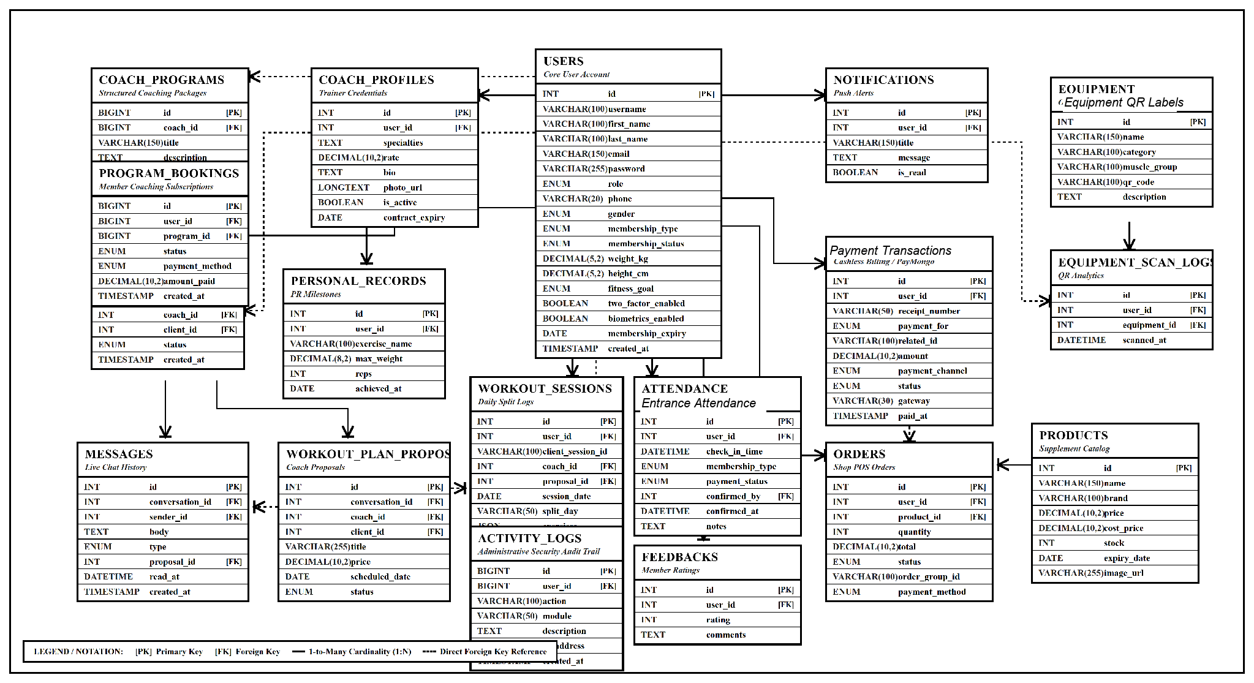
Data Dictionary
The Data Dictionary provides the physical data schema, data types, field constraints, and descriptive purposes of each database table in FordaGO.
Table 2. Data Dictionary for the users Table
Field Name | Data Type | Key / Constraint | Description
id | BIGINT UNSIGNED | Primary Key, Auto Increment | Unique user identifier
first_name | VARCHAR(100) | NOT NULL | Given first name of the user
last_name | VARCHAR(100) | NOT NULL | Family surname of the user
email | VARCHAR(255) | UNIQUE, NOT NULL | Account email / login credential
password | VARCHAR(255) | NOT NULL | Bcrypt-hashed account password
role | ENUM | NOT NULL | Role: member, coach, admin, employee, super_admin
phone | VARCHAR(20) | NULLABLE | Contact telephone / mobile number
fcm_token | TEXT | NULLABLE | Firebase Cloud Messaging push token
created_at | TIMESTAMP | NULLABLE | System record creation timestamp
updated_at | TIMESTAMP | NULLABLE | Last record modification timestamp
Table 3. Data Dictionary for the attendances Table
Field Name | Data Type | Key / Constraint | Description
id | BIGINT UNSIGNED | Primary Key, Auto Increment | Unique attendance record identifier
user_id | BIGINT UNSIGNED | Foreign Key (users.id) | Reference to the attending member
check_in_date | DATE | NOT NULL | Calendar date of attendance
check_in_time | TIME | NOT NULL | Exact time of front-desk QR code scan check-in
status | ENUM | NOT NULL | Status: confirmed, rejected, pending
created_at | TIMESTAMP | NULLABLE | Creation timestamp
Table 4. Data Dictionary for the equipment Table
Field Name | Data Type | Key / Constraint | Description
id | BIGINT UNSIGNED | Primary Key, Auto Increment | Unique equipment identifier
name | VARCHAR(150) | NOT NULL | Official name of the gym machine/station
category | VARCHAR(100) | NOT NULL | Category (e.g., Free Weights, Cardio, Machine)
target_muscle | VARCHAR(150) | NOT NULL | Anatomical muscle group highlighted
media_url | VARCHAR(255) | NULLABLE | Path to tutorial image / video demonstration
qr_code_key | VARCHAR(100) | UNIQUE, NOT NULL | Alphanumeric string encoded in the physical QR code label affixed to equipment
status | ENUM | NOT NULL | Equipment condition: operational, maintenance
Table 5. Data Dictionary for the workout_proposals Table
Field Name | Data Type | Key / Constraint | Description
id | BIGINT UNSIGNED | Primary Key, Auto Increment | Unique workout proposal identifier
coach_id | BIGINT UNSIGNED | Foreign Key (users.id) | Coach authoring the proposal
client_id | BIGINT UNSIGNED | Foreign Key (users.id) | Target client receiving proposal
title | VARCHAR(200) | NOT NULL | Routine title (e.g., Hypertrophy Push Day)
scheduled_date | DATE | NOT NULL | Planned session execution date
price | DECIMAL(10,2) | DEFAULT 0.00 | Fee charged for the coaching session
routine_data | JSON | NOT NULL | Structured exercises, sets, reps, and notes
status | ENUM | NOT NULL | Proposal state: pending, accepted, declined
Table 6. Data Dictionary for the products Table
Field Name | Data Type | Key / Constraint | Description
id | BIGINT UNSIGNED | Primary Key, Auto Increment | Unique supplement/product identifier
name | VARCHAR(150) | NOT NULL | Commercial product name
category | VARCHAR(100) | NOT NULL | Category (e.g., Protein, Pre-Workout, Gear)
price | DECIMAL(10,2) | NOT NULL | Unit retail selling price
stock_quantity | INT | NOT NULL, DEFAULT 0 | Available physical counter inventory stock count at the gym front desk
image_path | VARCHAR(255) | NULLABLE | Stored product preview image path
Table 7. Data Dictionary for the orders Table
Field Name | Data Type | Key / Constraint | Description
id | BIGINT UNSIGNED | Primary Key, Auto Increment | Unique sales transaction identifier
user_id | BIGINT UNSIGNED | Foreign Key (users.id) | Ordering gym member
total_amount | DECIMAL(10,2) | NOT NULL | Total monetary amount of the order
payment_method | ENUM | NOT NULL | Payment type: counter_cash, gcash
gcash_ref | VARCHAR(100) | NULLABLE | GCash transaction reference number
proof_image | VARCHAR(255) | NULLABLE | Optional uploaded payment screenshot for digital payment demonstration and staff manual counter verification
status | ENUM | NOT NULL | Order status: pending, approved, rejected
created_at | TIMESTAMP | NULLABLE | Transaction placement timestamp

1.3. Development Phase
In the development phase, the blueprints, schemas, and interface models were translated into functional source code.
Implementation Tools and Development Stack
- Programming Languages & Frameworks: PHP 8.2+ (Laravel 11), TypeScript / JavaScript (Angular, Ionic 8), SCSS, SQL.
- Integrated Development Environment (IDE): Visual Studio Code with standard code intelligence and debugging tools, Angular Language Service, and Docker extensions.
- Database & Containerized Server Environment: MySQL 8.0 Community Server managed via Laravel Migrations and Eloquent ORM, orchestrated in production through Podman / Docker containers on a Linux Cloud Virtual Private Server (VPS).
- Real-Time WebSockets Engine: Laravel Reverb running on dedicated WebSocket port 8080 with continuous event broadcasting.
- Mobile Runtime & Camera Access: Capacitor Native Core with QR Code Scanner and Camera plugins. The integrated development environment and source code structure implemented in Visual Studio Code are shown in Figure 10.
Figure 10. Visual Studio Code Environment with PHP / Laravel Source Code
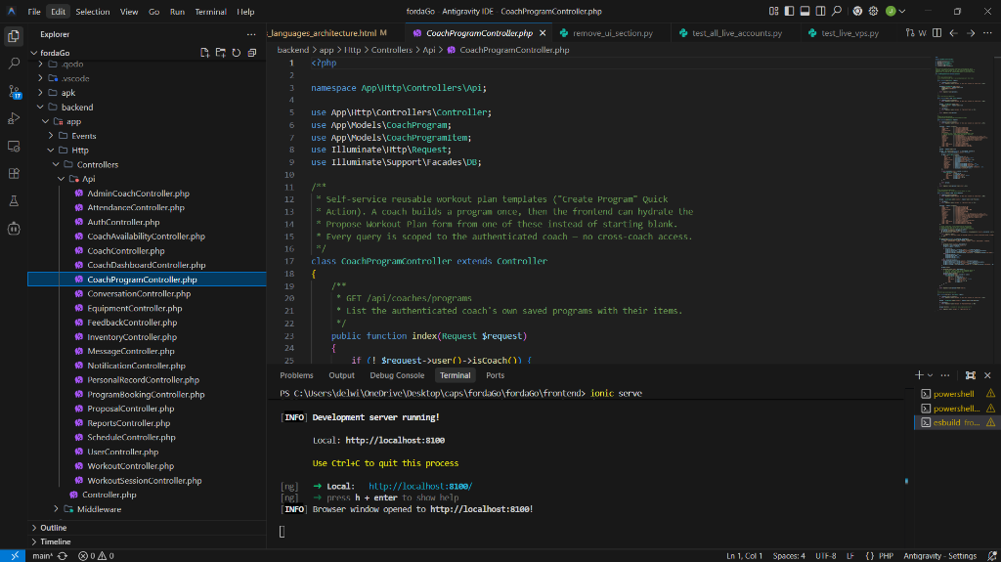
The relational database tables, structural schema definitions, and migration states were managed and verified through the MySQL database administration interface, as illustrated in Figure 11.
Figure 11. Database Tables and Implementation Environment (MySQL / phpMyAdmin)
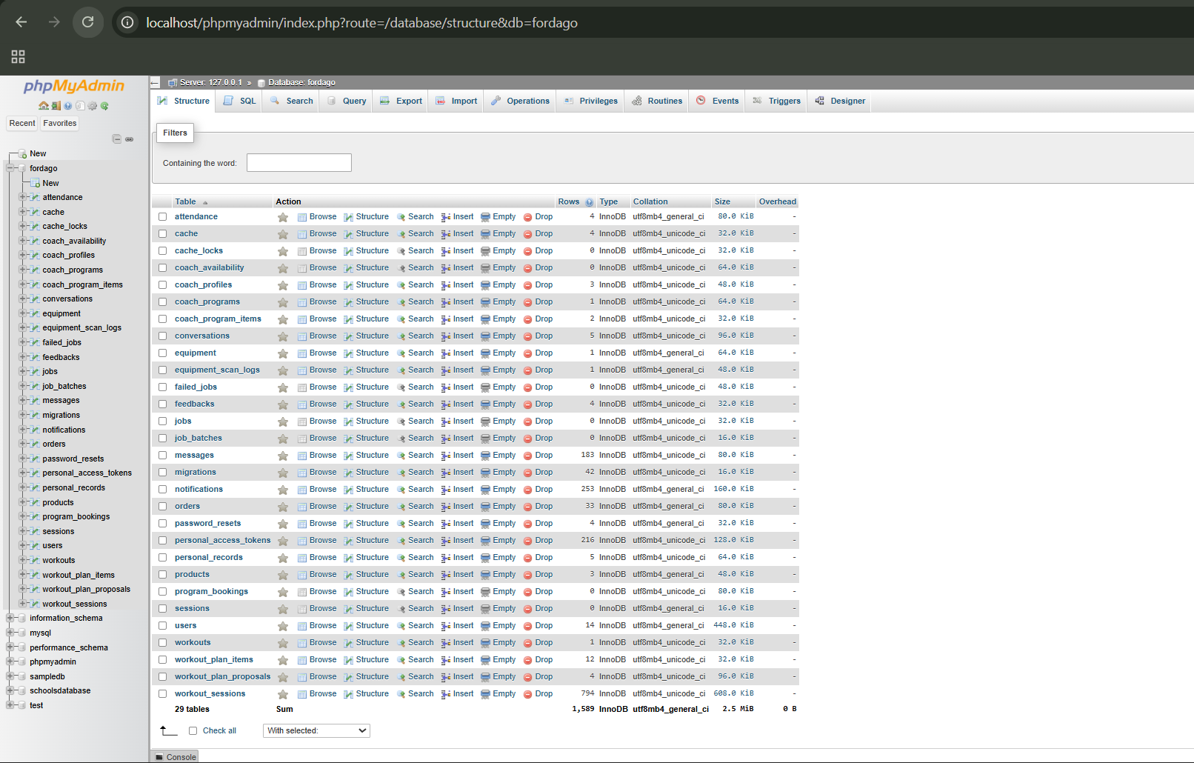
1.4. Testing Phase
The testing phase executed rigorous quality assurance across multiple operational tiers:
1. Unit Testing: Individual controller methods (e.g., AttendanceController::checkin, InventoryController::checkout) were tested in isolation using PHPUnit to confirm accurate input validation and database rollbacks.
2. Integration Testing: Verified real-time WebSocket channel subscriptions via Laravel Echo and Reverb. In-chat message dispatches and workout plan proposal notifications demonstrated sub-second latency across mobile Android devices and desktop web browsers.
3. Security & Vulnerability Testing: Verified role-based route middleware. Unauthorized access attempts to administrative routes (/admin, /reports) by member tokens were successfully intercepted and blocked with HTTP 403 Forbidden responses.
4. User Acceptance Testing (UAT): Conducted at AFFORDA Gym – Cabiao Branch with the gym administrator, on-duty coaches, and active members. All primary operational scenarios (QR front-desk scanning check-in, equipment tutorial scanning, PR metric logging, split routine creation, coach proposal acceptance, and counter cash cart checkout) performed reliably without fatal exceptions.
1.5. Deployment Phase
The FordaGO system was deployed in a production Linux Cloud Virtual Private Server (VPS) environment, accessible live over the internet for AFFORDA Gym – Cabiao Branch:
Server and Containerized Architecture:
Hosted on a dedicated Linux Cloud VPS orchestrated through a multi-container Podman / Docker architecture. The production deployment consists of: (1) an Nginx reverse proxy gateway handling SSL termination and reverse-proxying HTTP/HTTPS (ports 80/443) and WebSockets; (2) a containerized Laravel 11 REST API backend running PHP 8.2-FPM; (3) an isolated MySQL 8.0 database container (fordago_db) with persistent volume storage; (4) a dedicated Laravel Reverb WebSocket daemon (port 8080) powering real-time chat, in-chat workout proposals, and instant attendance broadcasting; and (5) a background queue worker container for handling asynchronous transactional jobs.
Mobile Client Distribution:
Generated production-ready Android APK packages installed on the mobile smartphones of gym personnel, coaches, and pilot members.
Onboarding & User Training: Conducted comprehensive orientation sessions for front-desk personnel and personal trainers covering front-desk QR scanner camera operation, counter cash order validation, printable equipment printed QR code label generation, and client proposal tracking.
1.6. Review Phase
Following initial deployment, the researchers monitored daily gym workflows to gather usability feedback:
Attendance Flow Optimization:
The front-desk QR scanner camera scanner was calibrated with automatic debounce controls to prevent accidental double-scanning of member QR passes.
Proposal Flow Enhancements:
Added instant visual status badges (Pending, Accepted, Declined) within the coach-trainee chat view for transparent progress tracking.
Inventory Stock Safeguards:
Configured atomic stock checks during multi-item cart checkout to eliminate inventory over-allocation.

1.7. Maintenance and Support Phase
To guarantee long-term system sustainability, the researchers instituted structured maintenance protocols:
Corrective Maintenance:
Standardized automated server error logging (storage/logs/laravel.log) for rapid bug identification and hot-reload patch deployment.
Adaptive Maintenance:
Database migration scripts ensure that future gym expansion (e.g., adding automated electromechanical front-desk QR camera scanners, multi-branch scaling, or integrated biometric gateways) can be integrated without data corruption.
Automated Cloud Backup & Disaster Recovery Protocols:
Implemented an automated Linux cron task running on the VPS every 3 hours (vps-backup-fordago.sh). The script executes mysqldump from inside the database container with routines and triggers, compresses the SQL dump using maximum GZIP compression (-9), logs execution timestamps, and automatically rotates historical archives to retain the latest 5 verified backup snapshots in /root/fordago-backups/, ensuring zero data loss and rapid point-in-time recovery.

2. Assessment of the Technical Quality of FordaGO by IT Experts (ISO/IEC 25010 Standards)
The technical quality of the FordaGO system was evaluated by five (5) Information Technology professionals and software developers based on the eight software product quality characteristics of the ISO/IEC 25010 standard using a 5-point Likert scale.$n=5$
2.1. Functional Suitability
Table 8. Results of IT Experts’ Assessment on Functional Suitability
Criteria | Weighted Mean (x̄) | Qualitative Rating
1. Functional Completeness | 4.80 | Very Functional
2. Functional Correctness | 4.60 | Very Functional
3. Functional Appropriateness | 4.80 | Very Functional
Grand Mean | 4.73 | Very Functional
The Functional Suitability of FordaGO obtained a grand mean of 4.73 (Very Functional). Evaluators affirmed that the system completely implements all required gym management operations, delivers accurate calculations for PR percentage gains and inventory stock deductions, and facilitates seamless workout proposal dispatching.
2.2. Performance Efficiency
Table 9. Results of IT Experts’ Assessment on Performance Efficiency
Criteria | Weighted Mean (x̄) | Qualitative Rating
1. Time-behavior (Response Speed) | 4.80 | Very Efficient
2. Resource utilization (CPU / Memory) | 4.60 | Very Efficient
3. Capacity (Workload Concurrency) | 4.80 | Very Efficient
Grand Mean | 4.73 | Very Efficient
Performance Efficiency garnered a grand mean of 4.73 (Very Efficient). The implementation of Laravel Reverb WebSockets for real-time chat and jsPDF for client-side report generation resulted in sub-second transaction speeds and minimal server CPU/memory consumption.
2.3. Compatibility
Table 10. Results of IT Experts’ Assessment on Compatibility
Criteria | Weighted Mean (x̄) | Qualitative Rating
1. Co-existence | 4.80 | Very Compatible
2. Interoperability | 4.80 | Very Compatible
Grand Mean | 4.80 | Very Compatible
Compatibility achieved a grand mean of 4.80 (Very Compatible). FordaGO operates smoothly across diverse Android mobile versions and modern desktop browsers (Chrome, Edge, Firefox) without hardware conflicts or driver incompatibilities.
2.4. Usability
Table 11. Results of IT Experts’ Assessment on Usability
Criteria | Weighted Mean (x̄) | Qualitative Rating
1. Appropriateness Recognizability | 4.80 | Very Usable
2. Learnability | 4.80 | Very Usable
3. Operability | 5.00 | Very Usable
4. User Error Protection | 4.60 | Very Usable
5. User Interface Aesthetics | 4.80 | Very Usable
6. Accessibility | 4.80 | Very Usable
Grand Mean | 4.80 | Very Usable
Usability achieved an outstanding grand mean of 4.80 (Very Usable), with Operability receiving a perfect 5.00. Evaluators commended the dark fitness aesthetic, intuitive navigation tabs, and clear interactive onboarding tour guides.

2.5. Reliability
Table 12. Results of IT Experts’ Assessment on Reliability
Criteria | Weighted Mean (x̄) | Qualitative Rating
1. Maturity | 4.80 | Very Reliable
2. Availability | 4.80 | Very Reliable
3. Fault Tolerance | 4.60 | Very Reliable
4. Recoverability | 4.60 | Very Reliable
Grand Mean | 4.70 | Very Reliable
Reliability obtained a grand mean of 4.70 (Very Reliable). The database schema’s foreign key constraints and transactional integrity prevent data corruption during concurrent order submissions and front-desk scanning check-ins.
2.6. Security
Table 13. Results of IT Experts’ Assessment on Security
Criteria | Weighted Mean (x̄) | Qualitative Rating
1. Confidentiality | 4.80 | Very Secure
2. Integrity | 4.80 | Very Secure
3. Fault Tolerance | 4.60 | Very Secure
4. Non-repudiation | 4.80 | Very Secure
5. Accountability | 5.00 | Very Secure
6. Authenticity | 4.80 | Very Secure
Grand Mean | 4.80 | Very Secure
Security was rated 4.80 (Very Secure). The use of Laravel Sanctum bearer tokens, Bcrypt password hashing, and role-based middleware guards ensures robust data confidentiality and protection against unauthorized account modification.
2.7. Maintainability
Table 14. Results of IT Experts’ Assessment on Maintainability
Criteria | Weighted Mean (x̄) | Qualitative Rating
1. Modularity | 4.80 | Very Maintainable
2. Availability | 4.80 | Very Maintainable
3. Reusability | 4.80 | Very Maintainable
4. Analyzability | 5.00 | Very Maintainable
5. Modifiability | 4.80 | Very Maintainable
6. Testability | 4.80 | Very Maintainable
Grand Mean | 4.84 | Very Maintainable
Maintainability achieved the highest rating of 4.84 (Very Maintainable). The modular structure of Angular standalone components and Laravel MVC controller architecture ensures seamless future scalability and code maintainability.
2.8. Portability
Table 15. Results of IT Experts' Assessment on Portability
Criteria | Weighted Mean (x̄) | Qualitative Rating
1. Adaptability | 4.80 | Very Portable
2. Installability | 4.80 | Very Portable
3. Replaceability | 4.80 | Very Portable
Grand Mean | 4.80 | Very Portable
Portability was rated 4.80 (Very Portable), validating the ease of building, distributing, and installing Android APKs and containerized web environments.
2.9. Summary of IT Experts’ Technical Quality Evaluation
Table 16. Summary of IT Experts’ Evaluation on ISO/IEC 25010 Software Quality
ISO/IEC 25010 Software Quality Criteria | Weighted Mean (x̄) | Qualitative Rating
1. Functional Suitability | 4.73 | Very Functional
2. Performance Efficiency | 4.73 | Very Efficient
3. Compatibility | 4.80 | Very Compatible
4. Usability | 4.80 | Very Usable
5. Reliability | 4.70 | Very Reliable
6. Security | 4.80 | Very Secure
7. Maintainability | 4.84 | Very Maintainable
8. Portability | 4.80 | Very Portable
COMPOSITE GRAND MEAN | 4.78 | EXCELLENT
Overall, the IT Experts gave FordaGO an overall Composite Grand Mean of 4.78 (Very Strong Evidence / Excellent), confirming that the engineered system adheres strictly to international software engineering standards.

3. Assessment of the System Quality by End-Users (Gym-Goers / Active Members)
Gym end-users (n = 15), comprising the gym owner (n = 1), front-desk administrative staff member (n = 1), and active gym members (n = 13) of AFFORDA Gym – Cabiao Branch, evaluated the live mobile application across four (4) core software quality and usability criteria:
Table 17. Results of End-Users’ (Gym-Goers) Assessment on FordaGO
Quality Criteria | Weighted Mean (x̄) | Qualitative Rating
1. Functional Suitability (Check-in, Proposals, POS, Reports) | 4.80 | Excellent
2. Usability (Interface Clarity, Tour Guides, Navigation) | 4.85 | Excellent
3. Reliability (Continuous Operation, Uptime, No Data Loss) | 4.80 | Excellent
4. Security (Role Access, Protected Financial & Pass Records) | 4.90 | Excellent
OVERALL GRAND MEAN | 4.84 | EXCELLENT
The evaluation yielded an overall Grand Mean of 4.82 (Very Strong Evidence / Excellent). Gym members highlighted the speed and convenience of digital QR attendance check-in, the tremendous benefit of scanning equipment printed QR code labels to immediately view exercise execution guides and targeted muscle groups, the seamless 1-tap acceptance of coach workout proposals, and the reliable tracking of personal record (PR) strength milestones.
Chapter IV
Summary of Findings, Conclusion, and Recommendation
This chapter presents the summary of the empirical findings derived from the development, deployment, and ISO/IEC 25010 software quality evaluation of the FordaGO: Mobile-Based Gym Database Management System for AFFORDA Gym – Cabiao Branch. It articulates the conclusive insights drawn from the investigation and outlines targeted, actionable recommendations for gym management, fitness coaches, gym members, and future software engineering researchers.
Summary of Findings
1.1. Existing Operational Inefficiencies (SOP 1):
The pre-development assessment confirmed that AFFORDA Gym – Cabiao Branch suffered from critical operational bottlenecks due to reliance on manual, paper-bound workflows. Specifically:
(a) member registration and pass renewals were manually handwritten with disarranged physical ledger records;
(b) attendance logging required members to physically line up to sign paper logbooks, causing significant counter congestion and vulnerability to record falsification or water damage;
(c) beginner gym-goers lacked accessible, on-demand equipment guidance, leading to improper machine utilization and reliance on overextended staff;
(d) fitness consultations and workout routines lacked digital continuity, leaving client progress undocumented;
(e) supplement retail and counter sales depended on handwritten notebooks, resulting in untracked stock discrepancies and tedious manual cash payment recording; and
(f) administrative summary generation required manual mathematical consolidation across multiple disjointed notebooks, consuming hours of administrative effort.

1.2. Engineered System Architecture and Functional Modules (SOP 2):
The researchers successfully engineered, integrated, and deployed the FordaGO system across a robust three-tier architecture (Ionic 8 and Angular frontend client, Laravel 11 RESTful API backend, and MySQL relational database), containerized within a live Linux Cloud Virtual Private Server (VPS). The platform comprises eleven (11) functional modules:
- Secure Authentication & RBAC,
- Optical QR Code Attendance Monitoring,
- Interactive Equipment QR Guidance Placards,
- Personal Record (PR) Strength Milestone Tracker,
- Coach Studio with In-Chat Structured Proposals,
- Supplement Shop & Counter Point-of-Sale,
- Membership Pass & Billing Lifecycle Management,
- Real-Time WebSocket Notifications via Laravel Reverb,
- Consolidated Revenue & Financial Analytics,
- Administrator Activity Logs & Security Audit Trail, and
- Member Feedback & Net Promoter Score (NPS) Evaluation Engine. Together, these modules established an automated, highly synchronized, and paperless operational environment.
1.3. Technical Quality and User Acceptability (SOP 3):
Empirical evaluation based on the ISO/IEC 25010 software quality model demonstrated exceptional ratings from both professional and end-user stakeholders:
a. IT professionals (n = 5) evaluated the system across all eight software characteristics using the institutional 5-point Likert instrument, awarding a Composite Grand Mean of 4.78 (Verbal Interpretation: Very Strong Evidence / Excellent), highlighted by top ratings in Maintainability (4.84), Security (4.80), Usability (4.80), Compatibility (4.80), Portability (4.80), Functional Suitability (4.73), Performance Efficiency (4.73), and Reliability (4.70); and
b. Gym end-users (n = 15), consisting of the gym owner, front-desk staff, and 13 active gym members, evaluated the live application, granting an overall Grand Mean of 4.84 (Verbal Interpretation: Very Strong Evidence / Excellent), with high acclaim for Security (4.90), Usability (4.85), Functional Suitability (4.80), and Reliability (4.80).
Conclusion
Conclusion 1: Traditional paper-based management methods are fundamentally obsolete, vulnerable to data loss, and insufficient for modern fitness facility management. The operational problems identified at AFFORDA Gym – Cabiao Branch underscored the imperative need for a centralized, database-driven, and mobile-accessible platform.
Conclusion 2: The successful design, full-stack development, and live VPS deployment of FordaGO validate that integrating camera-based optical QR code verification, real-time WebSocket communication, and responsive hybrid mobile frameworks provides an effective, high-performance, and scalable replacement for manual gym workflows. The system successfully democratizes equipment guidance, automates attendance tracking, accelerates supplement inventory deductions, and enforces administrative accountability through comprehensive activity audit trails.
Conclusion 3: The overwhelming 'Very Strong Evidence / Excellent' evaluation marks achieved across both IT experts (4.78) and gym end-users (4.82–4.84) substantiate that FordaGO meets international software quality standards defined by ISO/IEC 25010. The platform exhibits high operational reliability, robust data security, responsive real-time interaction, and superior usability, rendering it fully viable for production enterprise deployment in fitness facilities.
Recommendations
3.1. For AFFORDA Gym Management & Owners:
It is strongly recommended that gym management fully institutionalize FordaGO as the standard operating system of AFFORDA Gym – Cabiao Branch. Management should retire paper logbooks, mandate digital QR scanning for all walk-in and regular members, and routinely monitor the newly engineered Activity Logs to maintain staff accountability and safeguard financial transaction integrity. Additionally, management should conduct periodic automated VPS database backups to ensure operational resilience.
3.2. For Gym Front-Desk Staff & Personnel:
Front-desk personnel should deploy an Android tablet mounted at the reception counter to serve as a compact, energy-efficient check-in and transaction verification kiosk. For comprehensive month-end revenue audits, inventory balancing, and PDF reporting, personnel may access the administrative command center via any laptop or desktop PC web browser using the live domain address.
3.3. For Gym Coaches & Personal Trainers:
Fitness coaches are encouraged to maximize the Coach Studio module by proactively publishing scheduled group classes and utilizing structured in-chat Workout Plan Proposals. This fosters professional transparency, establishes documented workout regimens for clients, and enhances coach–trainee retention through interactive WebSocket messaging.
3.4. For Gym Members & Fitness Enthusiasts:
Members are encouraged to consistently leverage the on-demand equipment printed QR code labels affixed to gym machinery to verify targeted muscle groups and execute correct biomechanical exercise forms. Furthermore, members should consistently log personal strength milestones (PRs) and submit timely post-workout feedback ratings to guide continuous gym facility improvements.
3.5. For Future Researchers & IT Developers:
Future researchers may expand upon this study by:
(a) acquiring an Apple Developer Program license to officially package and publish the native FordaGO iOS client on the Apple App Store for seamless one-tap iPhone installation; (b) integrating automated commercial merchant payment gateways (such as PayMongo, Maya Business, or GCash for Business) with live webhook settlement once commercial merchant registration and corporate funding are secured by gym management; (c) developing mobile computer-vision AI models for real-time exercise form correction and repetition counting using device cameras; (d) incorporating wearable biometric synchronization (Apple HealthKit, Google Health Connect) for automatic calorie and heart rate tracking; (e) interfacing the digital check-in module with physical electromechanical front-desk QR camera scanners or magnetic door locks via IoT microcontrollers; and (f) implementing distributed database replication to support multi-branch enterprise synchronization across regional gym chains.
References
Baechle, T. R., & Earle, R. W. (2020). Essentials of strength training and conditioning (4th ed.). Human Kinetics.
Codd, E. F. (1970). A relational model of data for large shared data banks. Communications of the ACM, 13(6), 377–387. https://doi.org/10.1145/362384.362685
Creswell, J. W., & Creswell, J. D. (2018). Research design: Qualitative, quantitative, and mixed methods approaches (5th ed.). SAGE Publications.
Davis, F. D. (1989). Perceived usefulness, perceived ease of use, and user acceptance of information technology. MIS Quarterly, 13(3), 319–340. https://doi.org/10.2307/249008
Dennis, A., Wixom, B. H., & Tegarden, D. (2021). Systems analysis and design: An object-oriented approach with UML (6th ed.). Wiley.
DENSO WAVE. (2023). What is a QR code? https://www.qrcode.com/en/about/
Fielding, R. T. (2000). Architectural styles and the design of network-based software architectures [Doctoral dissertation, University of California, Irvine].
Glofox. (2024). Gym management software and boutique studio systems. https://www.glofox.com/gym-management-software
Heizer, J., Render, B., & Munson, C. (2020). Operations management: Sustainability and supply chain management (13th ed.). Pearson Education.
Hoffer, J. A., Ramesh, V., & Topi, H. (2020). Modern database management (13th ed.). Pearson Education.
IBM. (2023). What are mobile applications? https://www.ibm.com/topics/mobile-application
IBM. (2023). What is a database management system (DBMS)? https://www.ibm.com/topics/dbms
International Organization for Standardization. (2011). ISO/IEC 25010: Systems and software engineering—Systems and software Quality Requirements and Evaluation (SQuaRE)—System and software quality models. ISO/IEC.
Kendall, K. E., & Kendall, J. E. (2019). Systems analysis and design (10th ed.). Pearson.
Laudon, K. C., & Laudon, J. P. (2021). Management information systems: Managing the digital firm (17th ed.). Pearson Education.
Mindbody. (2024). Fitness and wellness enterprise management software. https://www.mindbodyonline.com/business/fitness/gym-software
National Academy of Sports Medicine. (2022). NASM essentials of personal fitness training (7th ed.). Jones & Bartlett Learning.
Oracle. (2023). What is a database? https://www.oracle.com/database/what-is-database/
Pressman, R. S., & Maxim, B. R. (2020). Software engineering: A practitioner's approach (9th ed.). McGraw-Hill Education.
Republic Act No. 10173. (2012). Data Privacy Act of 2012. Republic of the Philippines.
Richey, R. C. (1994). Developmental research: The definition and scope. In Proceedings of selected research and development presentations at the 1994 National Convention of the Association for Educational Communications and Technology (pp. 714–720). AECT.
Silberschatz, A., Korth, H. F., & Sudarshan, S. (2019). Database system concepts (7th ed.). McGraw-Hill Education.
Sommerville, I. (2019). Software engineering (10th ed.). Pearson Education.
Stevenson, W. J. (2021). Operations management (14th ed.). McGraw-Hill Education.
TeamUp. (2024). Fitness management and member scheduling software. https://goteamup.com
Virtuagym. (2024). Gym management software and coaching mobile solutions. https://business.virtuagym.com/gym-software
Zen Planner. (2023). Boutique gym management software guide. https://zenplanner.com/gymowner/gym-management-software-guide
APPENDIX A
Letter of Permission to Conduct a Study


APPENDIX B
Letter of Permission to Conduct Validation


APPENDIX C
Letter to IT Experts



APPENDIX D
Personal Information of IT Experts
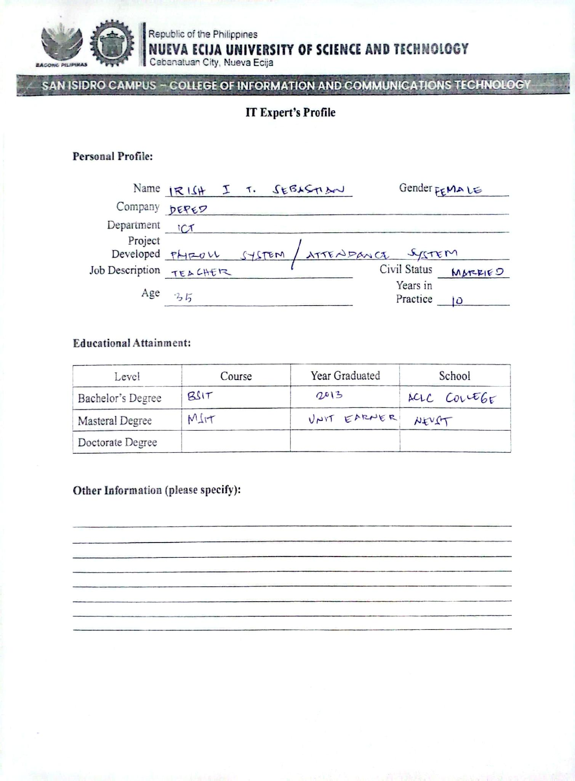
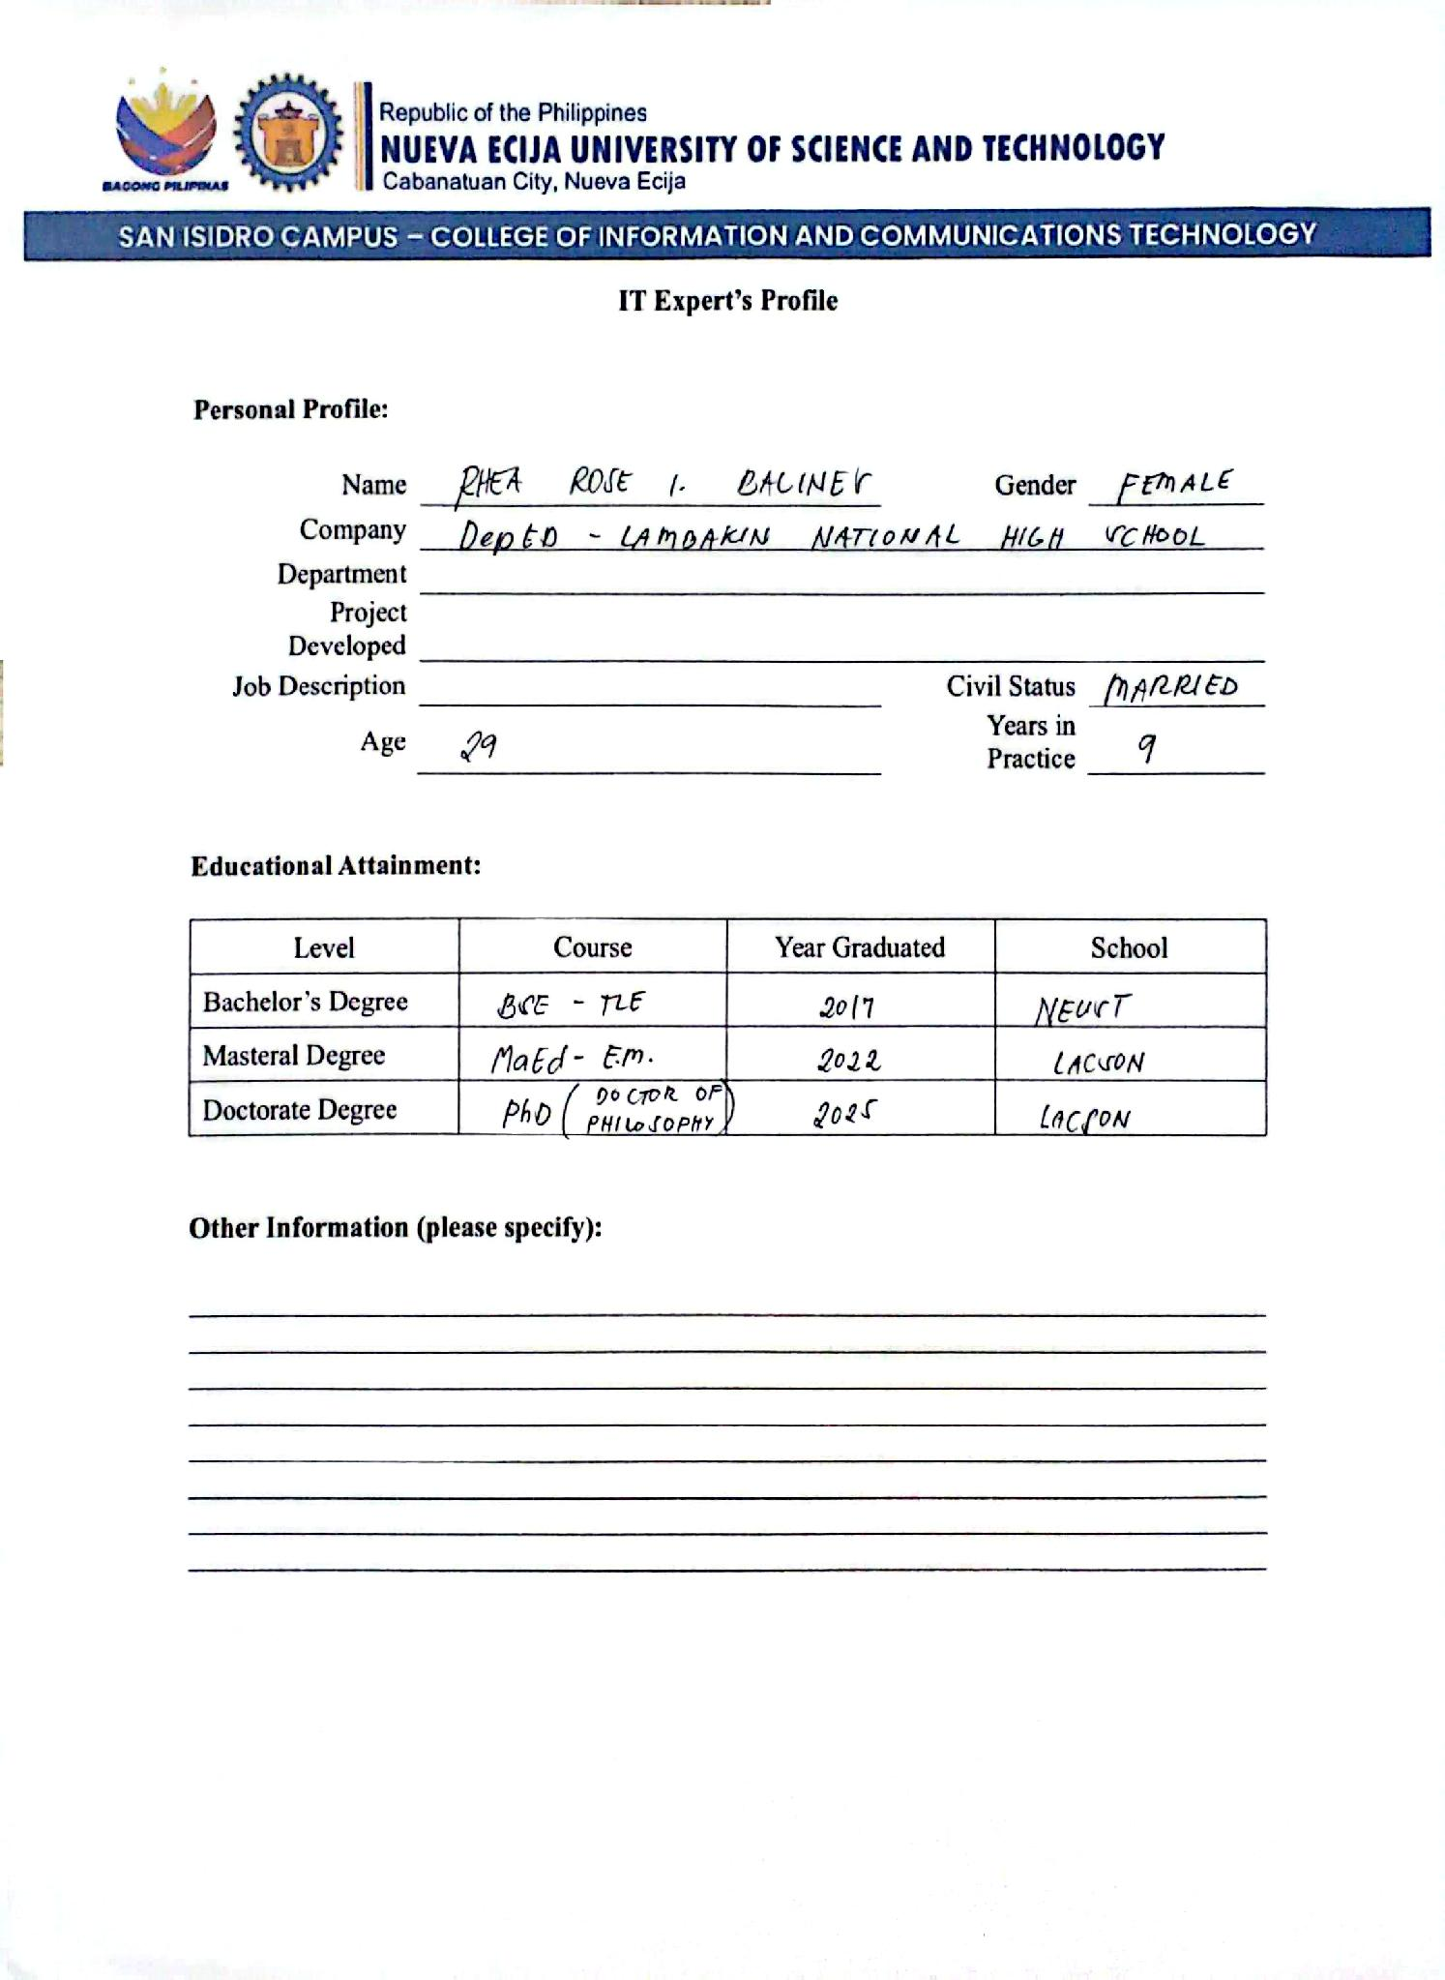
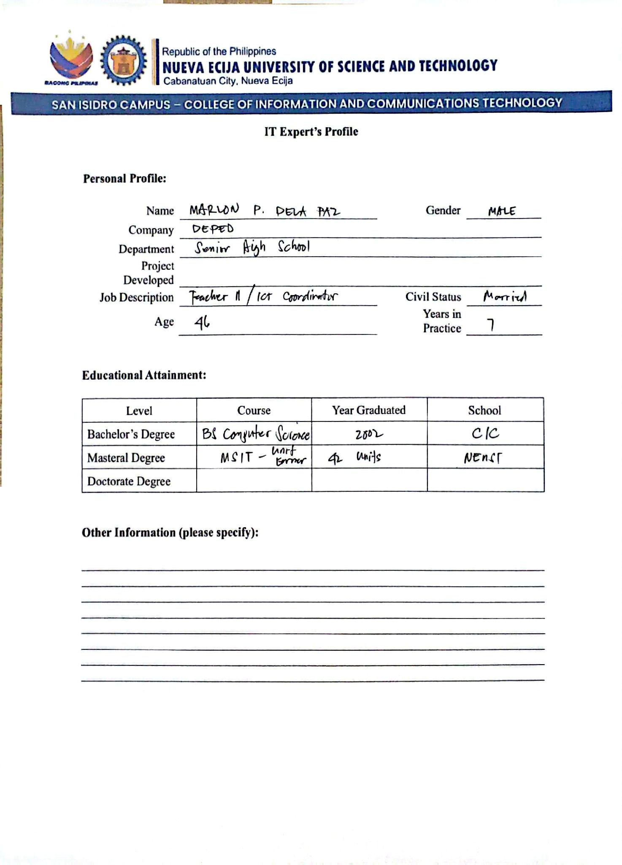
APPENDIX E
Evaluation Sheets for IT Experts




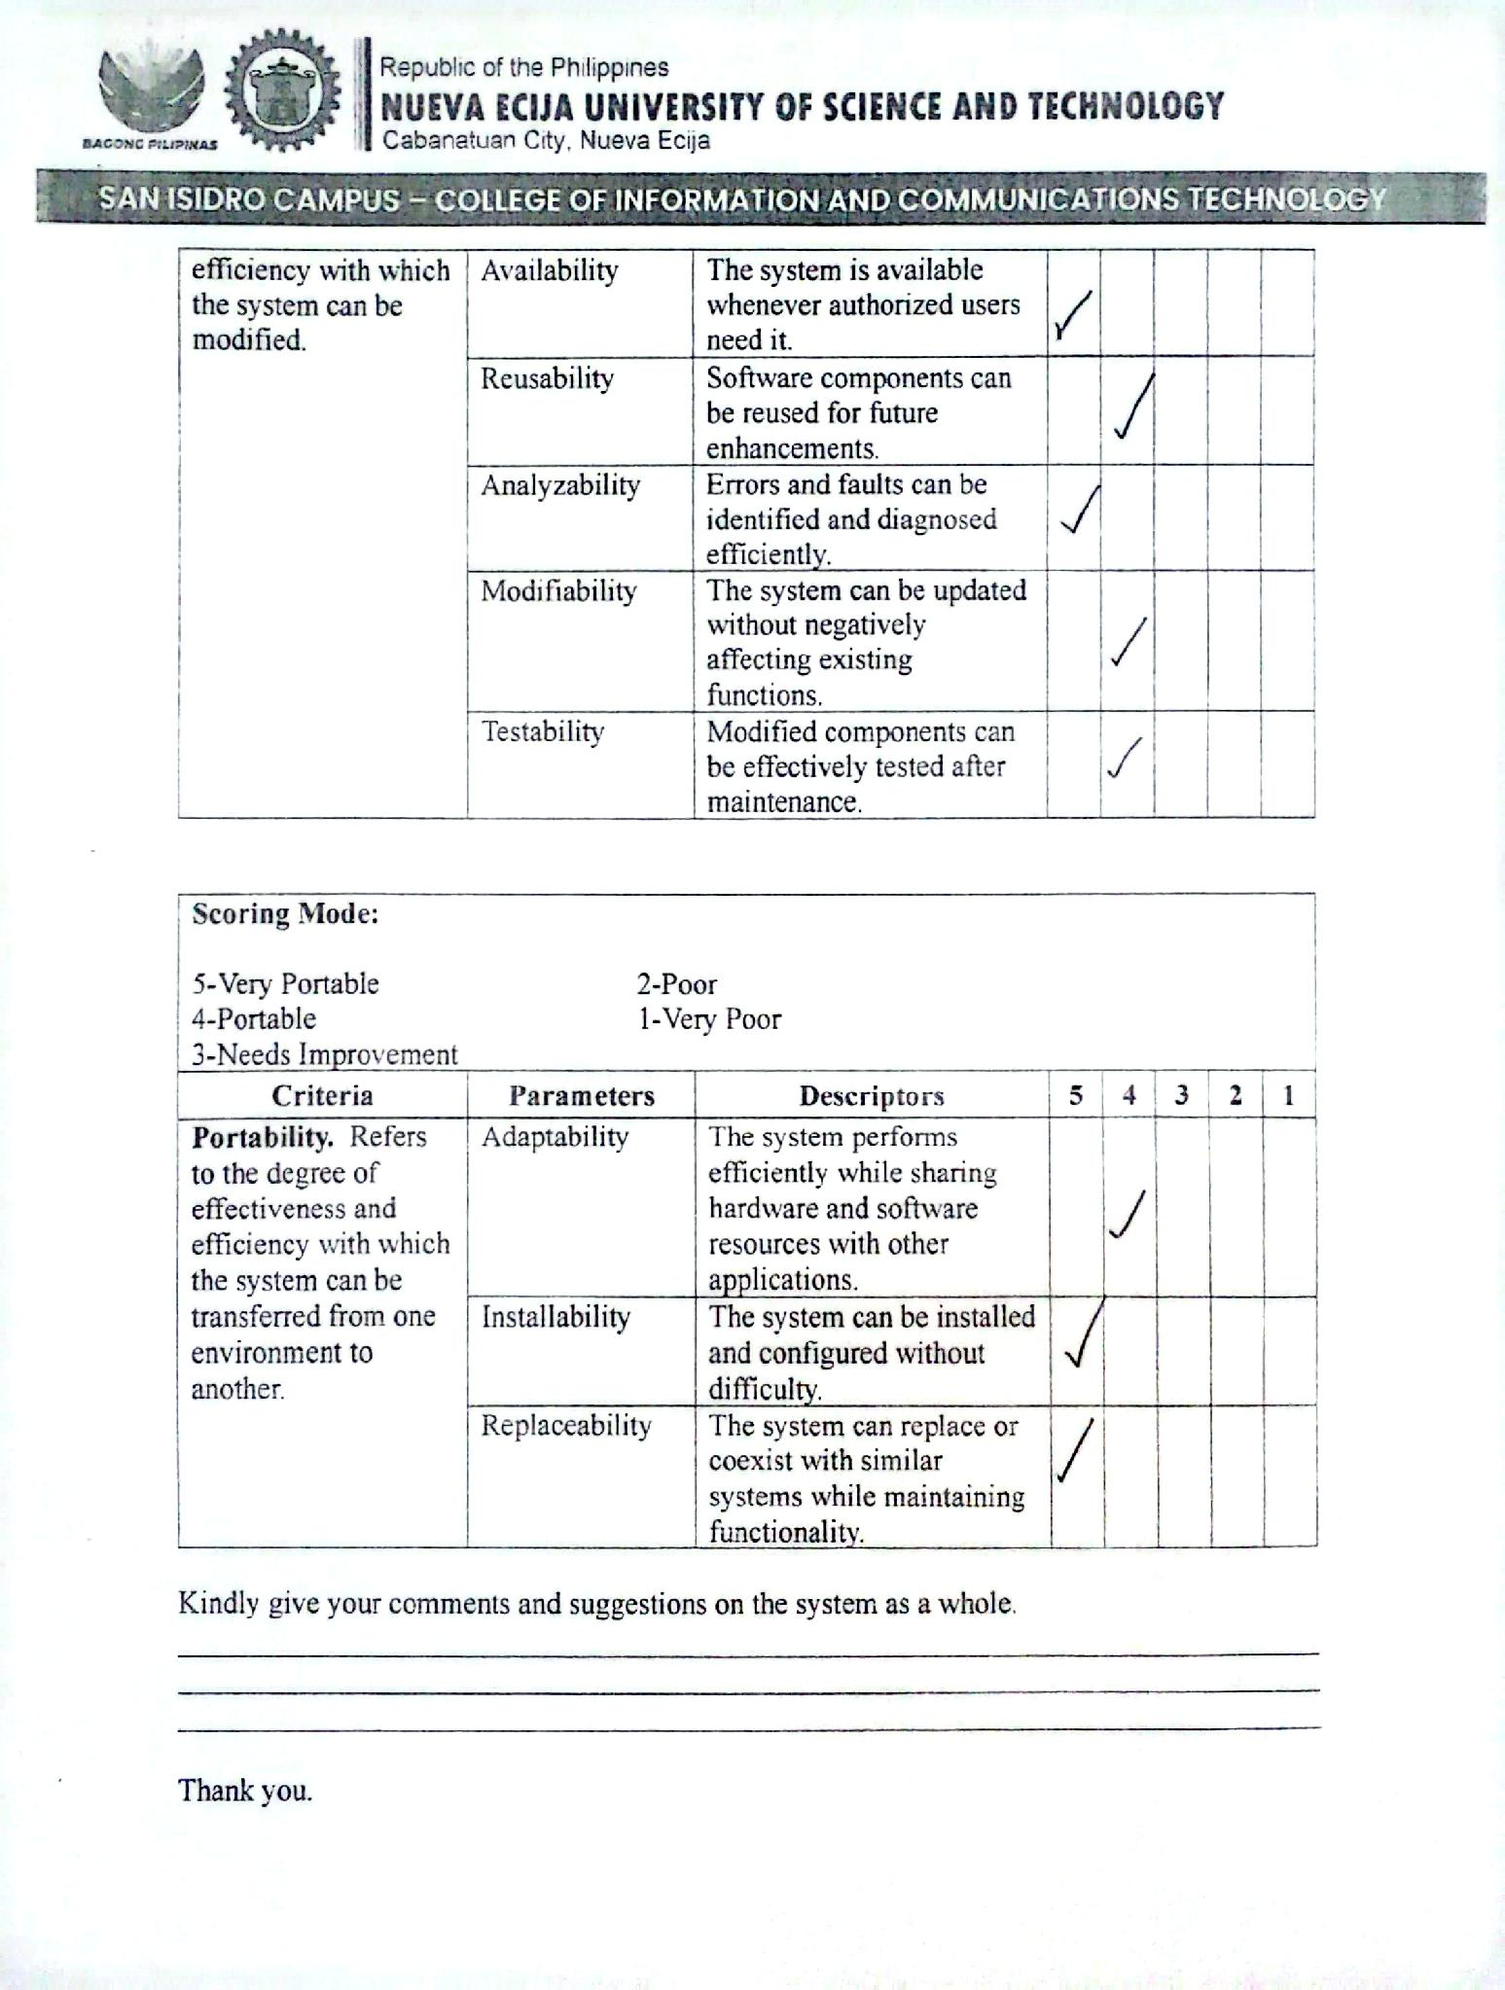

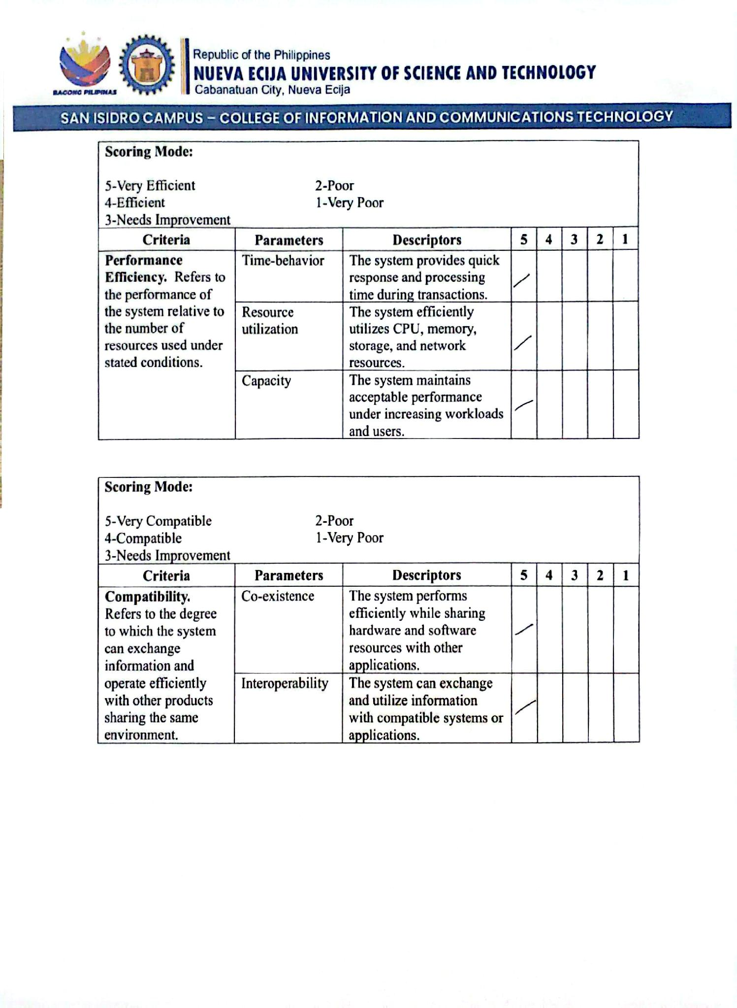
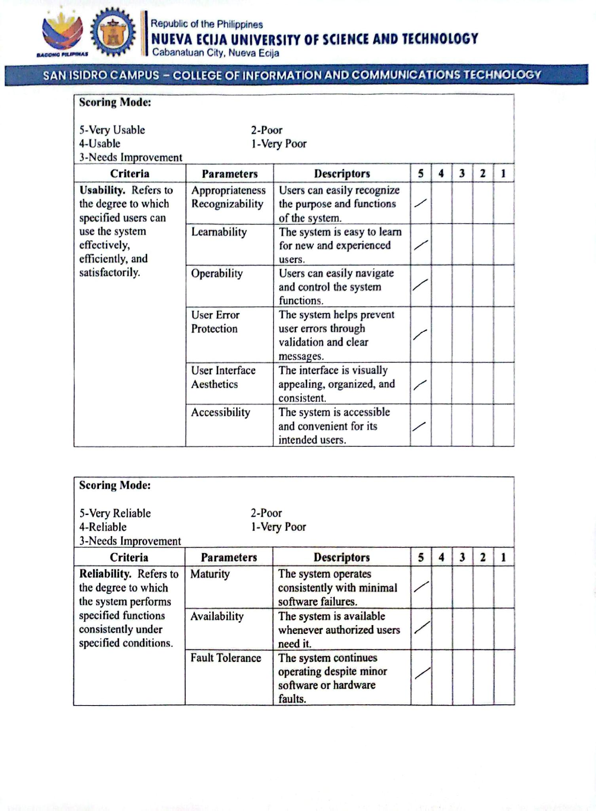



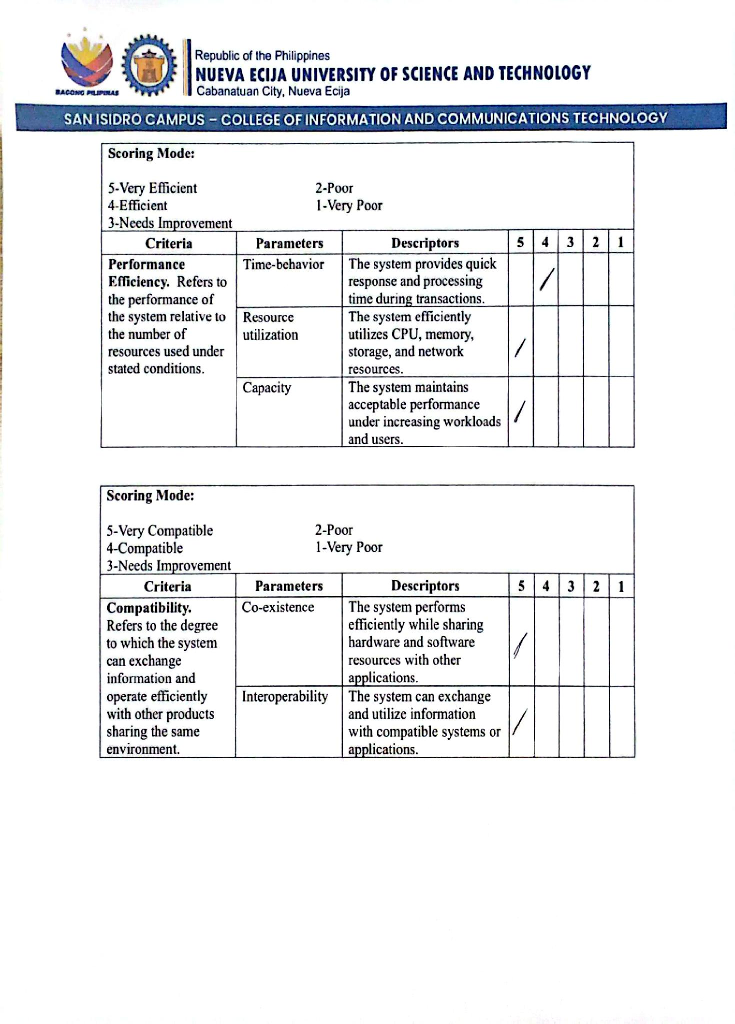

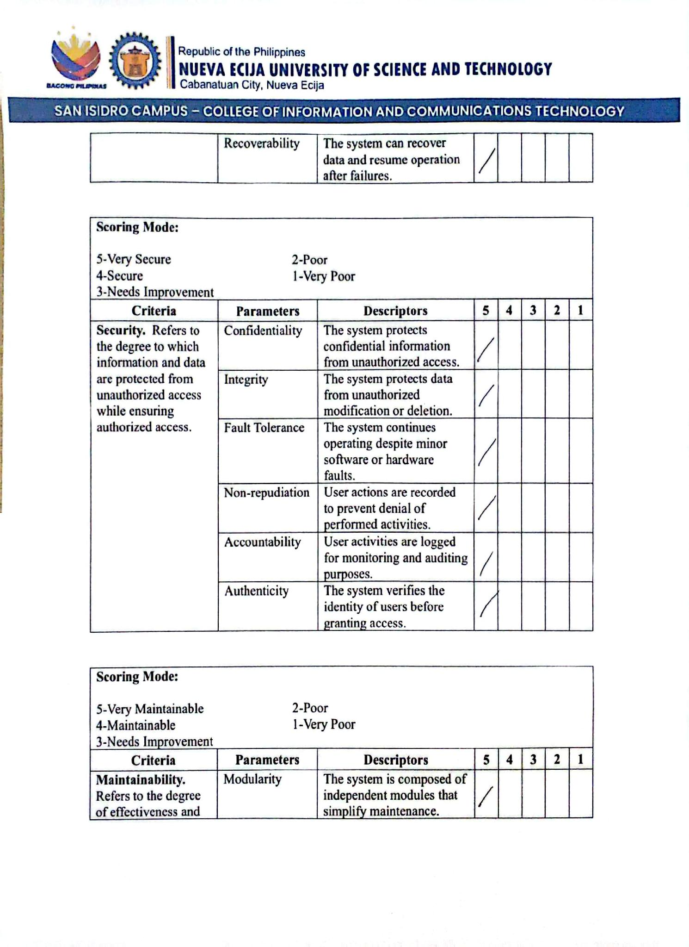
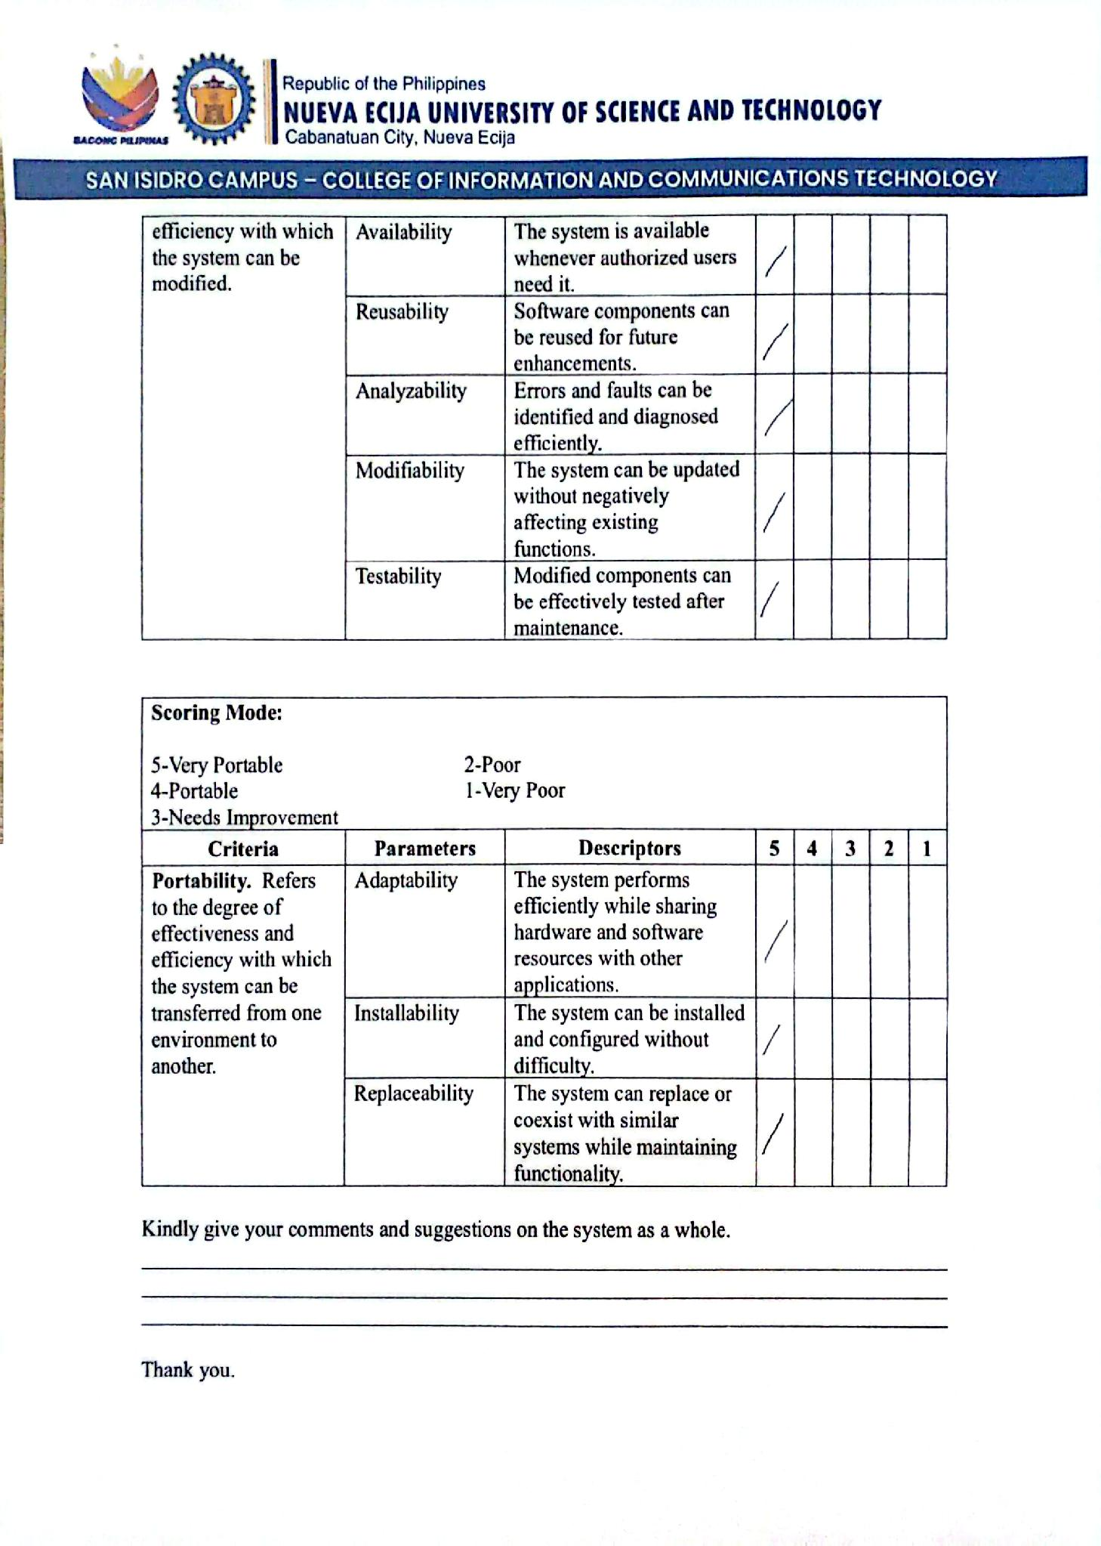
APPENDIX F
Evaluation Sheets for End Users
APPENDIX G
Letter for Thesis Adviser

APPENDIX H
Letter for English Critic
APPENDIX I
Actual IT Experts and User Validation Process
CARL ANDREW BERNALDO
PUROK 4, BRGY SAN CARLOS, CABIAO, NUEVA ECIJA
Mobile No: 09757215327
Email Address: bernaldocarlandrew@gmail.com
OBJECTIVES
To seek a challenging position where I can apply my skills, continuously learn and grow, exceed my limitations, and make meaningful contributions to the organization while enhancing my professional expertise.
PERSONAL BACKGROUND
Age: 21
Date of Birth: July 8, 2005
Place of Birth: Manila
Gender: Male
Height: 5'3
Weight: 55
Citizenship: Filipino
Civil Status: Single
Religion: Born Again Christian
Mother's Name: Cristy Bernaldo
Occupation: housewife
Father's Name: Anthony Bernaldo
Occupation: Driver
Guardian Contact No: Available upon request552751371
EDUCATIONAL BACKGROUND:
Tertiary Nueva Ecija University of Science and Technology Bachelor of Science in Technology with Specialization in Database Management System
2023 – Present
Senior High School Cabiao Senior High School
2021-2023
Junior High School Cabiao National High School
2017-2021
Elementary San Carlos Elementary School
2010-2017
STRENGTHS/SKILLS
Team Collaboration
Knowledge in programming fundamentals (HTML, CSS, JAVA)
Problem Solving
DELWIN FERMIN GALANG
Purok 2, Calabasa, Jaen, Nueva Ecija
Mobile No: 09605642944
Email Address: delwingalang08@gmail.com
OBJECTIVES
To seek a challenging position where I can apply my powerful drive to grow and exceed my limitations through continuous learning, and make significant and meaningful contributions towards the organization’s operations, while enhancing my personal expertise.
PERSONAL BACKGROUND
Age: 21
Date of Birth: October 4, 2004
Place of Birth: Jaen, Nueva Ecija
Gender: Male
Height: 5’6
Weight: 70
Citizenship: Filipino
Civil Status: Single
Religion: Unknown
Mother’s Name: Elvira Galang
Occupation: Housewife
Father’s Name: Danilo Galang
Occupation: Farmer
Guardian Contact No.: 09362560313
EDUCATIONAL BACKGROUND:
Tertiary Nueva Ecija University of Science and Technology Bachelor of Science in Technology with Specialization in Database Management System
2023 – Present
Senior High School Lambakin Senior High School
2021-2023
Junior High School Lambakin National High School
2017-2021
Elementary Calabasa Elementary School
2010-2017
ACHIEVEMENT BACKGROUND
Grade 8-With Honors
Grade 9-With Honors
Grade 10-With Honors
STRENGTHS/SKILLS
Team Collaboration
Knowledge in programming fundamentals (HTML, CSS, JAVA)
Problem Solving
JAYLEE TAGUD JAVIER
PUROK 3, BRGY. SAPANG, JAEN, NUEVA ECIJA
Mobile No.: 09241161400
Email Address: jayleetagudjavier@gmail.com
OBJECTIVES
To build a career where I can apply my technical skills, creativity, and willingness to learn while contributing meaningful solutions and growing with the organization.
PERSONAL BACKGROUND
Age: 21
Date of Birth: May 16, 2005
Place of Birth: Jaen, Nueva Ecija
Gender: Female
Height: 5’0
Weight: 58
Citizenship: Filipino
Civil Status: Single
Religion: Iglesia Ni Cristo
Mother’s Name: Liza Tagud Javier
Occupation: OFW
Father’s Name: Joel Javier
Occupation: Farmer
Guardian Contact No.: 09275629959
EDUCATIONAL BACKGROUND:
Tertiary Nueva Ecija University of Science and Technology Bachelor of Science in Technology with Specialization in Database Management System
2023 – Present
Senior High School Putlod – San Jose National High School
2021-2023
Junior High School Jaen National High School
2017-2021
Elementary Lambakin Elementary School 2010-2017
STRENGTHS/SKILLS
Team Collaboration
Knowledge in programming fundamentals (HTML, CSS, JAVA)
Problem Solving
ETHAN JEROME MEDINA
PUROK 1, BRGY. SINIPIT, CABIAO, NUEVA ECIJA
Mobile No: 09362560313
Email Address: medinaanidem2005@gmail.com
OBJECTIVES
To seek a challenging position where I can apply my powerful drive to grow and exceed my limitations through continuous learning, and make significant and meaningful contributions towards the organization’s operations, while enhancing my personal expertise.
PERSONAL BACKGROUND
Age: 21
Date of Birth: July 19, 2005
Place of Birth: Sto. Cristo, San Isidro, Nueva Ecija
Gender: Male
Height: 5’7
Weight: 58 kg
Citizenship: Filipino
Civil Status: Single
Religion: Catholic
Mother's Name: Julie Garcia Medina
Occupation: Maintenance Staff
Father's Name: Edwin Abunda Medina
Occupation: Call Center Agent
Guardian Contact No: Available upon request756623509
EDUCATIONAL BACKGROUND:
Tertiary Nueva Ecija University of Science and Technology Bachelor of Science in Technology with Specialization in Database Management System
2023 – Present
Senior High School College for Research and Technology
2021-2023
Junior High School Saint John Nepomuceno
2017-2021
Elementary Bagong Silang Element School
2010-2017
ACHIEVEMENT BACKGROUND
Grade 11 - With Honors
Grade 12 - With Honors
STRENGTHS/SKILLS
Soft Skills:
Attention to details
Data Modeling & Schema Design
Team Collaboration
Technical Skills:
Programming languages (SQL, Python, Java)
Documentation skills

RYZA MAE MIRANDA PONGCO
PUROK 4, BRGY. SAN CARLOS, CABIAO, NUEVA ECIJA
Mobile No: 09164003772
Email Address: ryzamaepongco@gmail.com
OBJECTIVES
To seek a challenging position where I can apply my powerful drive to grow and exceed my limitations through continuous learning, and make significant and meaningful contributions towards the organization’s operations, while enhancing my personal expertise.
PERSONAL BACKGROUND
Age: 21
Date of Birth: June 04, 2005
Place of Birth: San Carlos, Cabiao, Nueva Ecija
Gender: Female
Height: 5’2
Weight: 45 kg
Citizenship: Filipino
Civil Status: Single
Religion: Born Again Christian
Mother's Name: Rosemarie Miranda Pongco
Occupation: DWDS Worker
Father's Name: Reynald Manalastas Pongco
Occupation: Business Owner
Guardian Contact No: Available upon request
EDUCATIONAL BACKGROUND:
Tertiary Nueva Ecija University of Science and Technology Bachelor of Science in Technology with Specialization in Database Management System
2023 – Present
Senior High School Cabiao Senior High School
2021-2023
Junior High School Cabiao National High School
2017-2021
Elementary San Antonio Bagong Buhay Elementary School
2010-2017
STRENGTHS/SKILLS
Detail-oriented
Time Management
Active Listening

