FordaGO: Mobile-Based Gym Database Management System
for AFFORDA Gym – San Isidro Branch

A Thesis Proposal

GROUP MEMBERS:
BERNALDO, CARL ANDREW B.
GALANG, DELWIN F.
JAVIER, JAYLEE T.
MEDINA, ETHAN JEROME G.
PONGCO, RYZA MAE M.

CHAPTER I
INTRODUCTION

Fitness centers and gyms play an important role in promoting a healthy lifestyle by providing individuals with access to exercise facilities, workout programs, and fitness equipment. As more people become interested in maintaining their physical health, gyms continue to gain more members and expand their services. Because of this growth, gym administrators are required to manage various operational tasks such as member registration, attendance tracking, workout scheduling, and equipment guidance. To ensure efficient operations and better service for members, many fitness facilities are beginning to adopt technology-based systems that help simplify and organize their daily activities.
At present, the AFFORDA Gym – San Isidro Branch still relies on traditional or manual processes in managing several aspects of its operations. Member attendance is commonly recorded through manual logbooks, which may lead to errors, delays in checking records, and difficulty in monitoring member visits. In addition, gym members, especially beginners, may sometimes experience difficulty in understanding how to properly use certain gym equipment without proper guidance. This situation may affect their workout experience and confidence when using the facilities.
Another concern occurs when members miss their scheduled workout programs. Without proper reminders or guidance, some members may lose motivation or fail to maintain consistency in their exercise routines. Additionally, managing gym equipment and supplies without an organized digital system may create challenges in keeping track of available resources and maintaining proper records.
To address these concerns, the use of mobile technology can provide a more efficient and convenient solution for gym management and member support. The proposed system will introduce QR code technology to simplify certain gym processes. Members will be provided with a personal QR code that can be scanned to record their attendance upon entering the gym. In addition, gym equipment will have corresponding QR codes that members can scan to access instructions and information on how to properly use the equipment, helping beginners understand the correct way to perform exercises.
Furthermore, the system will include a notification feature that helps members stay consistent with their workout routines. If a member misses their scheduled workout program, the mobile application will automatically suggest alternative home workout exercises that they can perform even outside the gym. The system will also include an inventory cart management feature that allows gym administrators to manage and organize equipment and supplies more efficiently.
Therefore, this study proposes the development of a Mobile-Based Gym Database Management System for AFFORDA Gym – San Isidro Branch. The system aims to improve record management, enhance member convenience, and provide helpful workout guidance while supporting the gym in managing its operations more effectively.

STATEMENT OF THE PROBLEM
General Problem Statement
AFFORDA Gym – San Isidro Branch provides fitness services and workout facilities for individuals who aim to maintain a healthy and active lifestyle. However, several operational activities in the gym are still handled through manual or less organized methods. Member attendance is commonly recorded using logbooks, which can lead to errors, delays in checking records, and difficulty in maintaining accurate data. These manual processes may affect the efficiency of gym staff in managing member information and monitoring gym visits.
In addition, some gym members, particularly beginners, may encounter difficulties in understanding how to properly use certain gym equipment without clear guidance. This may cause confusion or improper usage of equipment during workouts. Another challenge occurs when members miss their scheduled workout sessions, as they may not receive reminders or alternative workout suggestions that can help them maintain consistency in their fitness routines.
Furthermore, the management of gym equipment and supplies may become difficult without an organized system for tracking and updating inventory records. Because of these issues, gym administrators may face challenges in managing gym operations efficiently while members may experience inconvenience in accessing helpful workout information and guidance.
Therefore, there is a need to develop a Mobile-Based Gym Database Management System for AFFORDA Gym – San Isidro Branch that can improve attendance recording, provide equipment usage guidance, support members in maintaining consistent workout routines, and assist administrators in managing gym inventory more effectively.

Specific Problem Statements
Specifically, this study seeks to answer the following questions:

- What problems are encountered in the current gym management process of AFFORDA Gym – San Isidro Branch in terms of:
- Member registration and attendance recording
- Availability of guidance in using gym equipment
- Member workout schedule monitoring
- Management of gym equipment and supplies
- What features and functionalities should be included in the proposed Mobile-Based Gym Database Management System to address the identified problems?
- How effective is the proposed system in terms of:
- Functionality
- Usability
- Reliability
- Security
- Performance efficiency

SIGNIFICANCE OF THE STUDY
The development of the Gym Management System will offer significant benefits to the following targets:

1. AffordaGym. The proposed project will greatly improve management operations by digitalizing registration, user credentials, membership tracking, maintenance schedules, and renewal processes. This will eliminate possible human errors, improve inventory tracking, and increase membership management accuracy. The project aims to help the gym be more organized and provide confidentiality for members' data.
2. Staff. The system will provide convenience for the staff by minimizing their workload through QR code scanning for member registration instead of manual forms, monitoring inventory stocks on a single page, and receiving membership subscription date notifications to easily monitor expired memberships and new registrations with greater accuracy and efficiency.
3. Gym-goers. The system ensures the security of gym-goers' personal information in a digital logbook. Quick tutorials on how to use gym machines are available, store products will have a catalogue for users to order, and transaction and calendar schedule features allow easy tracking of workout and fitness records.
4. Coaches. This system will help coaches efficiently monitor member attendance, track training progress, and organize workout schedules. By providing access to centralized member data and performance records, coaches can plan personalized fitness programs, leading to more effective decisions in teaching clients.
5. Owner. The proposed project will give the owner a centralized platform to monitor operations, manage finances, and analyze business performance and feedback through information stored in the database. The system will better support decision-making and optimize gym operations, driving long-term business development.

CONCEPTUAL FRAMEWORK
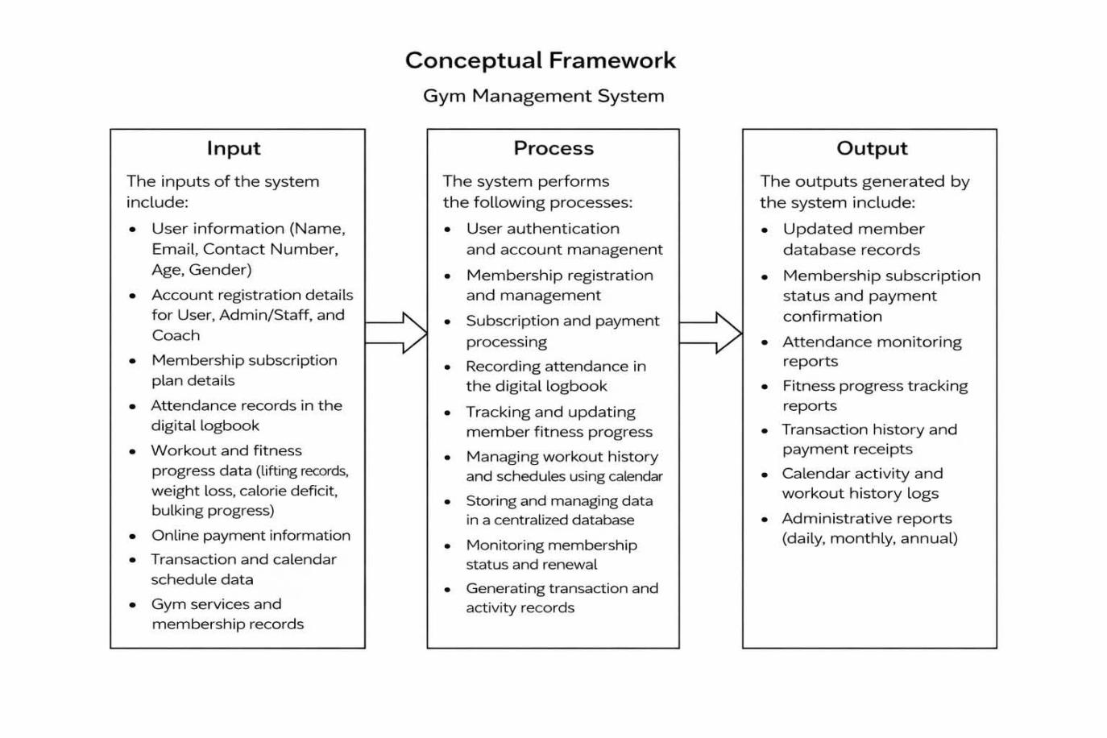

The proposed Gym Management System follows the Input–Process–Output (IPO) model. The inputs consist of member information, account registration data, subscription plans, attendance records in the digital logbook, fitness progress data, and online payment details. These inputs are processed through system modules such as authentication, membership management, attendance monitoring, payment processing, and progress tracking. The system then generates outputs including updated member records, attendance reports, fitness progress summaries, transaction receipts, and administrative reports. This framework ensures organized data management, improved monitoring of gym activities, and more efficient gym operations.
REVIEW OF RELATED LITERATURE
Information technology has significantly influenced the management of different organizations, including fitness centers and gyms. With the increasing number of gym members and services offered by fitness facilities, traditional methods of managing records and operations are gradually being replaced by computerized systems. These systems help organizations improve efficiency, accuracy, and accessibility of information. In the context of fitness centers, technology-based management systems can simplify administrative tasks such as membership registration, attendance monitoring, scheduling, and equipment management.
A Gym Management System is a digital platform designed to assist gym administrators in organizing and managing daily operations. These systems commonly include features such as member registration, membership tracking, attendance monitoring, and report generation. By replacing manual processes with computerized systems, gym management systems help reduce paperwork, minimize human error, and allow staff to monitor member activities more efficiently.
Database Management Systems (DBMS) play an important role in modern information systems because they allow organizations to store, manage, and retrieve large amounts of structured data efficiently. A DBMS provides a systematic way of organizing data through tables, relationships, and queries. In the case of a gym management system, the database can store important information such as member profiles, membership plans, attendance records, payment transactions, and equipment inventory. Through the use of relational databases, data redundancy can be minimized while ensuring data integrity and consistency.
Relational database design is an important concept in building efficient information systems. It organizes data into related tables that are connected through primary keys and foreign keys. Proper database design ensures that information is stored in a structured manner, which allows faster data retrieval and prevents duplication of records. In gym management systems, relational databases help manage connections between members, attendance records, subscription plans, and transaction histories.
Attendance monitoring systems are also widely used in organizations where tracking user presence is important. Traditional attendance systems rely on manual logbooks, which may lead to inaccurate records, lost data, or delays in retrieving information. Modern attendance systems use digital technologies such as QR codes, RFID, and biometric scanning to record attendance automatically. These technologies improve efficiency and accuracy while reducing the time required to record user attendance.
QR code technology has become a widely used tool in many information systems because of its ability to store data that can be easily accessed through scanning devices such as smartphones. QR codes are commonly used for identification, ticketing, payment systems, and attendance monitoring. In gym environments, QR codes can be assigned to individual members to allow quick attendance recording by scanning their personal code upon entering the facility. QR codes can also be attached to gym equipment to provide users with instructions or information about how to properly use the machines.
Mobile applications have also become an essential part of modern information systems. With the widespread use of smartphones, mobile-based systems provide users with convenient access to services anytime and anywhere. Mobile applications can help gym members view their workout schedules, track their attendance history, receive notifications, and access instructional materials related to fitness exercises. For administrators, mobile technology allows easier monitoring of gym operations and member activities.
Notification systems are another important feature in modern applications because they help users stay informed about updates, reminders, and scheduled activities. In the context of gym management, notification features can remind members about their scheduled workouts or inform them if they miss a training session. These reminders help improve consistency in exercise routines and encourage members to maintain their fitness goals.
Inventory management systems are also commonly used in organizations that manage equipment and physical resources. These systems help administrators monitor the availability, condition, and usage of equipment. In fitness centers, inventory management can assist gym staff in tracking workout machines, accessories, and other gym supplies. An organized inventory system ensures that equipment is properly maintained and available for members to use.
Data security is another important consideration in developing information systems. Organizations must ensure that user information, transaction data, and operational records are protected from unauthorized access or loss. Database systems often implement security features such as user authentication, access control, and data backup mechanisms to maintain the confidentiality and integrity of stored information.
Another important concept related to information systems is data analytics and reporting. Information systems allow organizations to generate reports that summarize operational data such as attendance trends, membership growth, and transaction history. These reports provide administrators with valuable insights that can support decision-making and improve overall management strategies.
The development of information systems commonly follows the System Development Life Cycle (SDLC), which is a structured approach used to design, develop, test, and implement software systems. The SDLC ensures that system requirements are carefully analyzed and that the final system meets the needs of its users. By following a systematic development process, developers can create reliable and effective solutions for organizational management.
Overall, the concepts and technologies discussed in this section—including gym management systems, database management systems, QR code technology, mobile applications, notification systems, inventory management, data security, and system development methodologies—provide the theoretical and technological foundation for developing a Mobile-Based Gym Database Management System. These technologies support the goal of improving operational efficiency, enhancing member experience, and assisting administrators in managing gym activities more effectively.
REVIEW OF RELATED SYSTEMS
1. Virtuagym Fitness Management System
Virtuagym is a comprehensive fitness management platform designed for gyms, fitness centers, and personal trainers. The system provides various features such as membership management, workout tracking, scheduling, and mobile application access for both administrators and members. Through its mobile platform, users can track their workouts, monitor their progress, and receive training programs from coaches. The system also allows administrators to manage member profiles, attendance records, and subscription payments within a centralized database.
One of the major advantages of Virtuagym is its ability to integrate workout tracking and gym management features into a single digital platform. This allows both gym staff and members to access important information through mobile devices. However, the system may require subscription fees and internet connectivity to access its full features, which may not be suitable for smaller gyms with limited resources.
Relation to the Proposed System: Virtuagym is related to the proposed FordaGO system because both systems aim to digitalize gym operations and provide a mobile platform for managing membership and workout information. However, the proposed FordaGO system focuses on QR code attendance monitoring and equipment instruction access through QR scanning, which specifically supports beginner gym users.
2. Zen Planner Gym Management Software
Zen Planner is a gym management system developed to assist fitness businesses in managing membership records, scheduling, billing, and attendance monitoring. The system allows gym administrators to track member activity, manage class schedules, and automate payment processing. It also provides reporting tools that help gym owners analyze membership data and operational performance.
The platform helps reduce manual administrative work by automating several processes such as membership renewal notifications and payment tracking. However, the system may require training for staff to fully understand its features and may involve subscription costs for long-term usage.
Relation to the Proposed System: Zen Planner is closely related to the proposed FordaGO system because both systems focus on membership management, attendance monitoring, and administrative reporting. The difference is that the FordaGO system integrates QR code scanning technology for faster attendance recording and equipment usage guidance within the gym environment.
3. Mindbody Gym Management Software
Mindbody is a widely used software platform designed for fitness centers, wellness facilities, and gyms. It provides tools for membership registration, scheduling classes, payment processing, and attendance monitoring. The system also allows gym administrators to manage customer profiles and track member visits through digital records.
One of the main advantages of Mindbody is its comprehensive set of business management tools that help gym owners manage operations efficiently. However, the platform may require significant financial investment due to subscription fees and additional costs for advanced features.
Relation to the Proposed System: Mindbody is related to the proposed FordaGO system because both systems aim to replace manual record-keeping with a digital management platform. However, FordaGO specifically incorporates QR code technology for attendance tracking and equipment instruction access, which focuses on improving member experience and operational efficiency at AFFORDA Gym.
4. Glofox Gym Management System
Glofox is a management platform developed for gyms and fitness studios to simplify daily business operations. The system offers features such as membership registration, class scheduling, digital check-ins, and payment processing. It also provides a mobile application that allows members to book classes, view schedules, and manage their memberships conveniently.
The system helps gym administrators monitor member engagement and attendance through digital records. However, some features may require additional integrations, and the system may not be fully customizable for smaller gym facilities.
Relation to the Proposed System: Glofox is similar to the proposed FordaGO system because both use mobile technology to manage gym operations and member interactions. However, FordaGO focuses on integrating QR code scanning for both attendance tracking and equipment usage guidance, which directly supports members who need assistance in using gym machines properly.
5. TeamUp Fitness Management System
TeamUp is a cloud-based gym and fitness studio management platform designed to help fitness businesses manage scheduling, memberships, and payments. The system allows administrators to track member attendance, manage bookings, and monitor subscription status through an organized digital dashboard.
The platform provides a user-friendly interface that helps gym owners manage their operations more efficiently compared to manual record systems. However, some advanced reporting features and integrations may require additional configurations.
Relation to the Proposed System: TeamUp is related to the proposed FordaGO system because both systems support digital membership management and attendance monitoring. However, FordaGO enhances these features by incorporating QR code technology for attendance recording and equipment information access, making the system more interactive and helpful for gym members.

REFERENCES
Gym Management Systems
Glofox. (2024). Gym management software. Retrieved from https://www.glofox.com/gym-management-software
Mindbody. (2024). Gym management software. Retrieved from https://www.mindbodyonline.com/business/fitness/gym-software
TeamUp. (2024). Fitness management software. Retrieved from https://goteamup.com
Virtuagym. (2024). Gym management software solutions. Retrieved from https://business.virtuagym.com/gym-software
Zen Planner. (2023). Gym management software guide. Retrieved from https://zenplanner.com/gymowner/gym-management-software-guide

Database Management Systems
Hoffer, J. A., Ramesh, V., & Topi, H. (2020). Modern database management (13th ed.). Pearson Education.
IBM. (2023). What is a database management system (DBMS)? https://www.ibm.com/topics/dbms
Oracle. (2023). What is a database? https://www.oracle.com/database/what-is-database/
Silberschatz, A., Korth, H. F., & Sudarshan, S. (2019). Database system concepts (7th ed.). McGraw-Hill Education.

Systems Analysis and Design / SDLC
Dennis, A., Wixom, B. H., & Tegarden, D. (2021). Systems analysis and design: An object-oriented approach with UML (6th ed.). Wiley.
Kendall, K. E., & Kendall, J. E. (2019). Systems analysis and design (10th ed.). Pearson.

QR Code Technology
DENSO WAVE. (2023). What is a QR code? https://www.qrcode.com/en/about/

Mobile Applications / Information Systems
IBM. (2023). What are mobile applications? https://www.ibm.com/topics/mobile-application
Laudon, K. C., & Laudon, J. P. (2021). Management information systems: Managing the digital firm (17th ed.). Pearson.

Inventory / Operations Management
Heizer, J., Render, B., & Munson, C. (2020). Operations management: Sustainability and supply chain management (13th ed.). Pearson.
Stevenson, W. J. (2021). Operations management (14th ed.). McGraw-Hill Education.

Gym / Fitness Management
Baechle, T. R., & Earle, R. W. (2020). Essentials of strength training and conditioning (4th ed.). Human Kinetics.
NASM (National Academy of Sports Medicine). (2022). NASM essentials of personal fitness training (7th ed.). Jones & Bartlett Learning.

Software / Mobile System Implementation
Pressman, R. S., & Maxim, B. R. (2020). Software engineering: A practitioner's approach (9th ed.). McGraw-Hill Education.
Sommerville, I. (2019). Software engineering (10th ed.). Pearson.

TERMS AND DEFINITION
Access Control – A security mechanism used in this study to restrict and manage the permissions of gym staff and members in accessing specific features, data, and functions within the FordaGO system.
Authentication – The process of verifying the identity of a user before granting access to the FordaGO system, ensuring that only registered gym members and authorized staff can log in and use the application.
Computerized Systems – Digital platforms and software-based solutions used to replace manual and paper-based processes in gym operations, including membership management, attendance tracking, and inventory monitoring.
Data Analytics – The process of examining and interpreting operational data collected by the FordaGO system, such as attendance trends and membership statistics, to support informed decision-making by gym administrators and owners.
Data Backup – A security feature integrated into the FordaGO system that creates copies of stored records, including member information and transaction data, to prevent data loss due to system errors or technical failures.
Digital Payment – An electronic method of processing membership fees and gym-related transactions within the FordaGO system, allowing members to complete payments conveniently through the mobile application.
Digital System – A technology-based platform used in this study to manage and organize gym operations at AFFORDA Gym, replacing traditional manual methods with automated and computerized processes through the FordaGO application.
Functional Modules – The individual components or sections of the FordaGO system that handle specific tasks, such as attendance monitoring, inventory management, membership tracking, and progress tracking, each working together to form the complete system.
Instructional Materials – Digital content provided through the FordaGO system, including equipment usage tutorials and workout guides, designed to assist gym members in properly performing exercises and using gym facilities.
Inventory Records – A digitally maintained database of gym equipment and supplies stored within the FordaGO system, allowing gym administrators to monitor availability, condition, and usage of physical resources at AFFORDA Gym.
QR Code – A two-dimensional barcode used in the FordaGO system to facilitate quick identification of gym members for attendance recording and to provide access to equipment usage instructions when scanned through the mobile application.
Renewal Process – The procedure by which gym members extend their membership subscriptions within the FordaGO system, supported by automated notifications that alert both staff and members about upcoming or expired membership plans.
Report Generation – A function of the FordaGO system that produces summarized outputs of operational data, including attendance reports, membership statistics, and transaction records, to assist gym administrators and owners in evaluating gym performance.

