SIM_Tugas_B_M0725040
Galang DR (M0725040)
2026-04-17
# ===============================
# CLUSTERING WILAYAH BERDASARKAN PERFORMA PRODUK
# ===============================
# 0. Load data
library(openxlsx)
## Warning: package 'openxlsx' was built under R version 4.5.3
Coffee_Chain_Datasets <- read.xlsx("C:/Users/User/OneDrive/Documents/UNS/SIM/Coffee_Chain_Datasets.xlsx")
# 1. Load package
if(!require(rlang)) install.packages("rlang")
## Loading required package: rlang
## Warning: package 'rlang' was built under R version 4.5.3
if(!require(dplyr)) install.packages("dplyr")
## Loading required package: dplyr
## Warning: package 'dplyr' was built under R version 4.5.2
##
## Attaching package: 'dplyr'
## The following objects are masked from 'package:stats':
##
## filter, lag
## The following objects are masked from 'package:base':
##
## intersect, setdiff, setequal, union
if(!require(tidyr)) install.packages("tidyr")
## Loading required package: tidyr
## Warning: package 'tidyr' was built under R version 4.5.3
if(!require(factoextra)) install.packages("factoextra")
## Loading required package: factoextra
## Warning: package 'factoextra' was built under R version 4.5.3
## Loading required package: ggplot2
## Warning: package 'ggplot2' was built under R version 4.5.2
## Welcome to factoextra!
## Want to learn more? See two factoextra-related books at https://www.datanovia.com/en/product/practical-guide-to-principal-component-methods-in-r/
library(rlang)
library(dplyr)
library(tidyr)
library(factoextra)
# ===============================
# 2. AGREGASI DATA
# ===============================
data_cluster <- Coffee_Chain_Datasets %>%
group_by(State, `Product.Line`) %>%
summarise(total_laba = sum(Profit, na.rm = TRUE), .groups = "drop") %>%
pivot_wider(names_from = `Product.Line`,
values_from = total_laba,
values_fill = 0)
# ===============================
# 3. SIMPAN NAMA STATE
# ===============================
state_names <- data_cluster$State
# ===============================
# 4. HAPUS KOLOM STATE
# ===============================
data_cluster <- data_cluster[, -1]
# ===============================
# 5. FILTER NUMERIK
# ===============================
data_cluster <- data_cluster[, sapply(data_cluster, is.numeric)]
# ===============================
# 6. CEK STRUKTUR DATA
# ===============================
cat("Dimensi data sebelum cleaning:", dim(data_cluster), "\n")
## Dimensi data sebelum cleaning: 20 2
print(head(data_cluster))
## # A tibble: 6 × 2
## Beans Leaves
## <dbl> <dbl>
## 1 14421 17364
## 2 11927 5816
## 3 3675 3946
## 4 7351 4959
## 5 18894 11927
## 6 2058 20154
# ===============================
# 7. HAPUS VARIANSI NOL
# ===============================
var_cols <- apply(data_cluster, 2, var)
if(all(var_cols == 0)){
stop("SEMUA VARIABEL MEMILIKI VARIANSI NOL")
}
data_cluster <- data_cluster[, var_cols != 0, drop = FALSE]
# ===============================
# 8. TRANSFORMASI
# ===============================
data_cluster <- log1p(data_cluster)
## Warning in FUN(X[[i]], ...): NaNs produced
# ===============================
# 9. CEK NA SEBELUM SCALING
# ===============================
cat("Jumlah NA sebelum scaling:", sum(is.na(data_cluster)), "\n")
## Jumlah NA sebelum scaling: 1
# ===============================
# 10. NORMALISASI
# ===============================
data_scaled <- scale(data_cluster)
# ===============================
# 11. HANDLE NA (AMAN)
# ===============================
idx <- complete.cases(data_scaled)
cat("Jumlah data valid:", sum(idx), "dari", length(idx), "\n")
## Jumlah data valid: 19 dari 20
if(sum(idx) == 0){
stop("SEMUA DATA TERHAPUS KARENA NA - CEK DATA!")
}
data_scaled <- data_scaled[idx, , drop = FALSE]
data_cluster <- data_cluster[idx, , drop = FALSE]
state_names <- state_names[idx]
# ===============================
# 12. ELBOW METHOD
# ===============================
n <- nrow(data_scaled)
max_k <- min(10, n - 1)
wss <- sapply(1:max_k, function(k){
kmeans(data_scaled, centers = k, nstart = 25)$tot.withinss
})
plot(1:max_k, wss, type="b", pch=19,
xlab="Jumlah Cluster",
ylab="Total Within Sum of Squares",
main="Elbow Method")
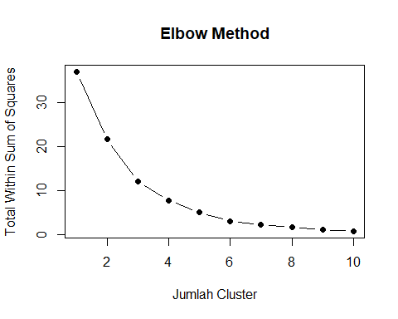
# ===============================
# 13. K-MEANS CLUSTERING
# ===============================
set.seed(123)
k <- min(3, n - 1)
kmeans_result <- kmeans(data_scaled, centers = k, nstart = 25)
# ===============================
# 14. HASIL CLUSTER (FIX FINAL)
# ===============================
hasil_cluster <- data.frame(
State = state_names,
data_cluster,
cluster = kmeans_result$cluster
)
print(hasil_cluster)
## State Beans Leaves cluster
## 1 California 9.576510 9.762212 1
## 2 Colorado 9.386644 8.668540 1
## 3 Connecticut 8.209580 8.280711 1
## 4 Florida 8.902728 8.509161 1
## 5 Illinois 9.846653 9.386644 1
## 6 Iowa 7.629976 9.911208 1
## 7 Louisiana 8.489822 7.820841 2
## 8 Massachusetts 9.607639 7.356280 2
## 9 Nevada 7.506592 9.082280 1
## 10 New Hampshire 7.335634 7.103322 3
## 11 New Mexico 5.407172 6.359574 3
## 12 New York 9.190240 9.239608 1
## 13 Ohio 8.421563 8.737292 1
## 14 Oklahoma 8.921858 6.971669 2
## 15 Oregon 8.505525 8.922525 1
## 16 Texas 9.555985 7.401842 2
## 17 Utah 8.782169 7.119636 2
## 18 Washington 8.496786 8.780787 1
## 19 Wisconsin 8.516793 8.217708 1
# ===============================
# 15. INTERPRETASI CLUSTER
# ===============================
cluster_summary <- aggregate(data_cluster,
by = list(cluster = kmeans_result$cluster),
mean)
print(cluster_summary)
## cluster Beans Leaves
## 1 1 8.682466 8.958223
## 2 2 9.071495 7.334053
## 3 3 6.371403 6.731448
# ===============================
# 16. VISUALISASI
# ===============================
fviz_cluster(kmeans_result,
data = data_scaled,
geom = "point",
repel = TRUE) +
labs(title = "Clustering State Berdasarkan Performa Produk")
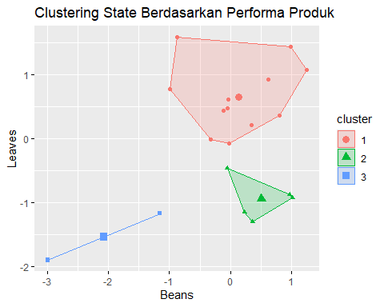
# ===============================
# 17. TAMBAHAN ANALISIS
# ===============================
cat("\nDistribusi cluster:\n")
##
## Distribusi cluster:
print(table(hasil_cluster$cluster))
##
## 1 2 3
## 12 5 2
cat("\nData per cluster:\n")
##
## Data per cluster:
print(hasil_cluster %>% arrange(cluster))
## State Beans Leaves cluster
## 1 California 9.576510 9.762212 1
## 2 Colorado 9.386644 8.668540 1
## 3 Connecticut 8.209580 8.280711 1
## 4 Florida 8.902728 8.509161 1
## 5 Illinois 9.846653 9.386644 1
## 6 Iowa 7.629976 9.911208 1
## 7 Nevada 7.506592 9.082280 1
## 8 New York 9.190240 9.239608 1
## 9 Ohio 8.421563 8.737292 1
## 10 Oregon 8.505525 8.922525 1
## 11 Washington 8.496786 8.780787 1
## 12 Wisconsin 8.516793 8.217708 1
## 13 Louisiana 8.489822 7.820841 2
## 14 Massachusetts 9.607639 7.356280 2
## 15 Oklahoma 8.921858 6.971669 2
## 16 Texas 9.555985 7.401842 2
## 17 Utah 8.782169 7.119636 2
## 18 New Hampshire 7.335634 7.103322 3
## 19 New Mexico 5.407172 6.359574 3

