Cloud Computing Docker course
Learning Outcomes Report — Labs 5 to 8
Student Name: Edouard CLEMENCEAU
Student email: eclemence001@univ-pau.fr
Course: SIGLIS M1 — Cloud Computing I (Docker & containers)
GitHub project: https://github.com/galaxie44/learning-analytics-educational-processes

1. Personal hub.docker.com registry
My Docker Hub account:
https://hub.docker.com/u/edouardclemenceau
Images I pushed for the labs / project:
- https://hub.docker.com/r/edouardclemenceau/lrs-api
- https://hub.docker.com/r/edouardclemenceau/analytics-api
- https://hub.docker.com/r/edouardclemenceau/la-dashboard

2. LAB 5 — Optimising a Dockerfile
A Dockerfile is Infrastructure-as-Code for container images: it declares the base image, dependencies, copied source files, exposed ports and the startup command. Docker builds a reproducible image from that recipe.
How I solved Lab 5
I optimised Dockerfiles for the Learning Analytics microservices (example: services/lrs-api): slim Python base image, dependency layer cached before source copy, --no-cache-dir pip install, and a HEALTHCHECK. This reduces image size and rebuild time.
Access / ports
- Local LRS API: http://localhost:8200/health
- Local Analytics API: http://localhost:8210/health
- EVA (VPN): http://10.3.16.179:8200 and :8210
Image URL
https://hub.docker.com/r/edouardclemenceau/lrs-api :latest
Screenshots
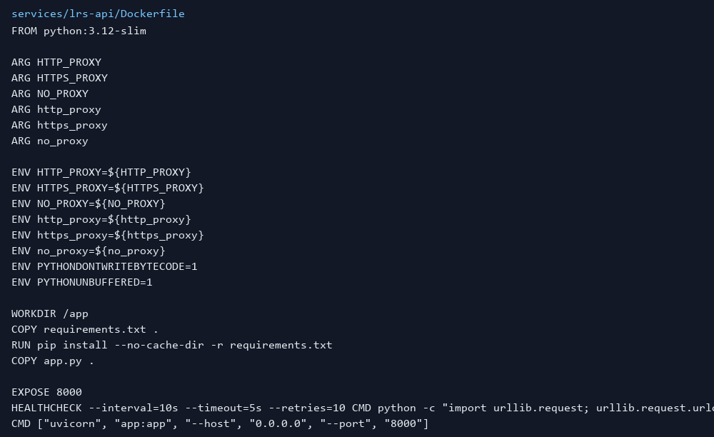
Figure Lab5 — Dockerfile (lrs-api)
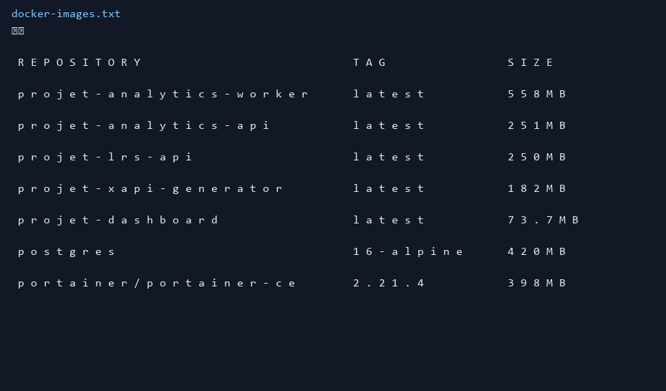
Figure Lab5 — Local Docker images after build

3. LAB 6 — Using the Compose specification
Docker Compose describes a multi-container application in YAML (services, networks, volumes, env). One command starts the whole stack: docker compose up --build -d.
How I solved Lab 6
I defined postgres + application services with a shared network and a named volume pgdata for external persistency. After docker compose down && up, analytics data remained available via /api/overview.
Access / ports
- http://localhost:8210/api/overview
- http://localhost:8300 (dashboard)
- Postgres localhost:5432
- EVA: http://10.3.16.179:8210 and :8300
Image / repo
postgres:16-alpine + https://hub.docker.com/r/edouardclemenceau/analytics-api
Screenshots
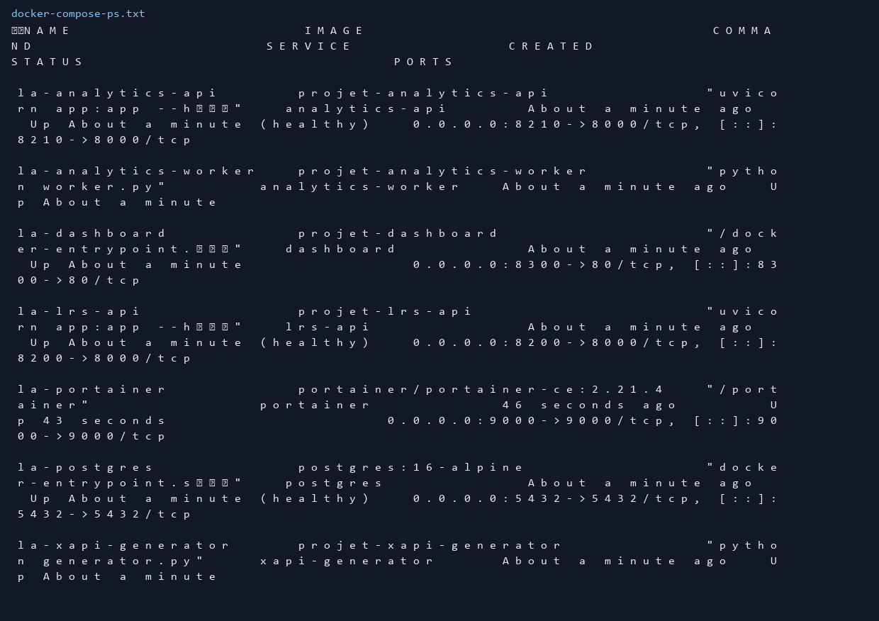
Figure Lab6 — docker compose ps
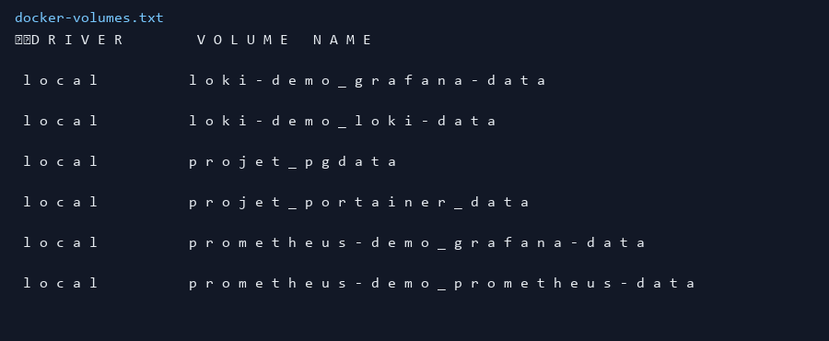
Figure Lab6 — named volumes (persistency)
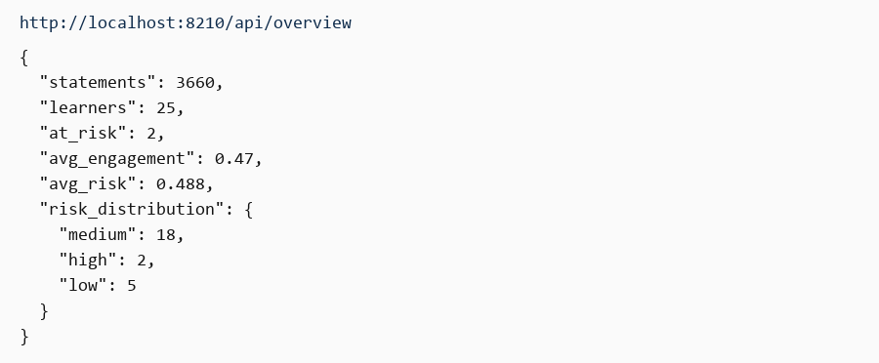
Figure Lab6/8 — API overview JSON

4. LAB 7 — Portal container to administer Docker (Portainer)
Lab 7 deploys Portainer, a web portal that administers Docker (containers, images, volumes, stacks) by mounting the Docker socket.
How I solved Lab 7
I enabled the Compose profile ops: docker compose --profile ops up -d. Portainer CE 2.21.4 listens on port 9000. I created the admin user and inspected the local environment (stacks / containers / volumes / images).
Access / ports
- http://localhost:9000
- EVA: http://10.3.16.179:9000 (VPN)
- Image: portainer/portainer-ce:2.21.4
Screenshots
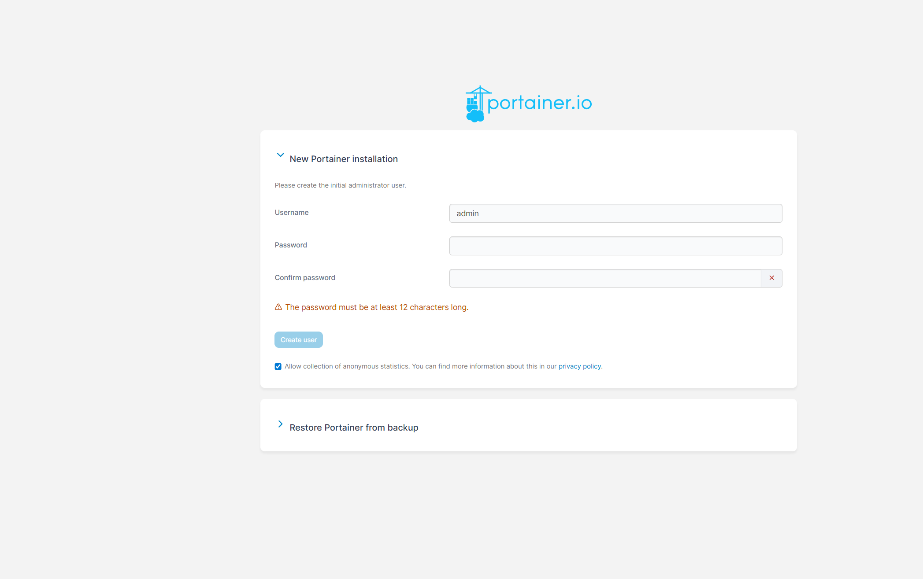
Figure Lab7 — Portainer initial admin setup
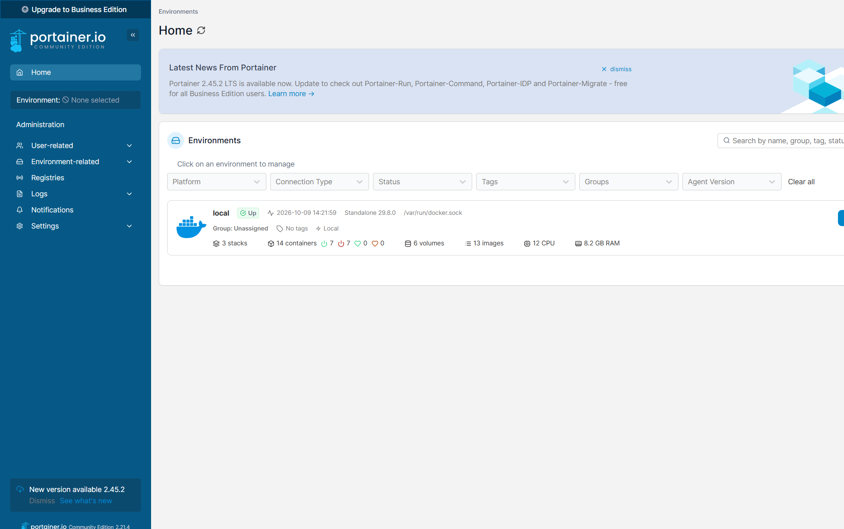
Figure Lab7 — Portainer Home (local environment)
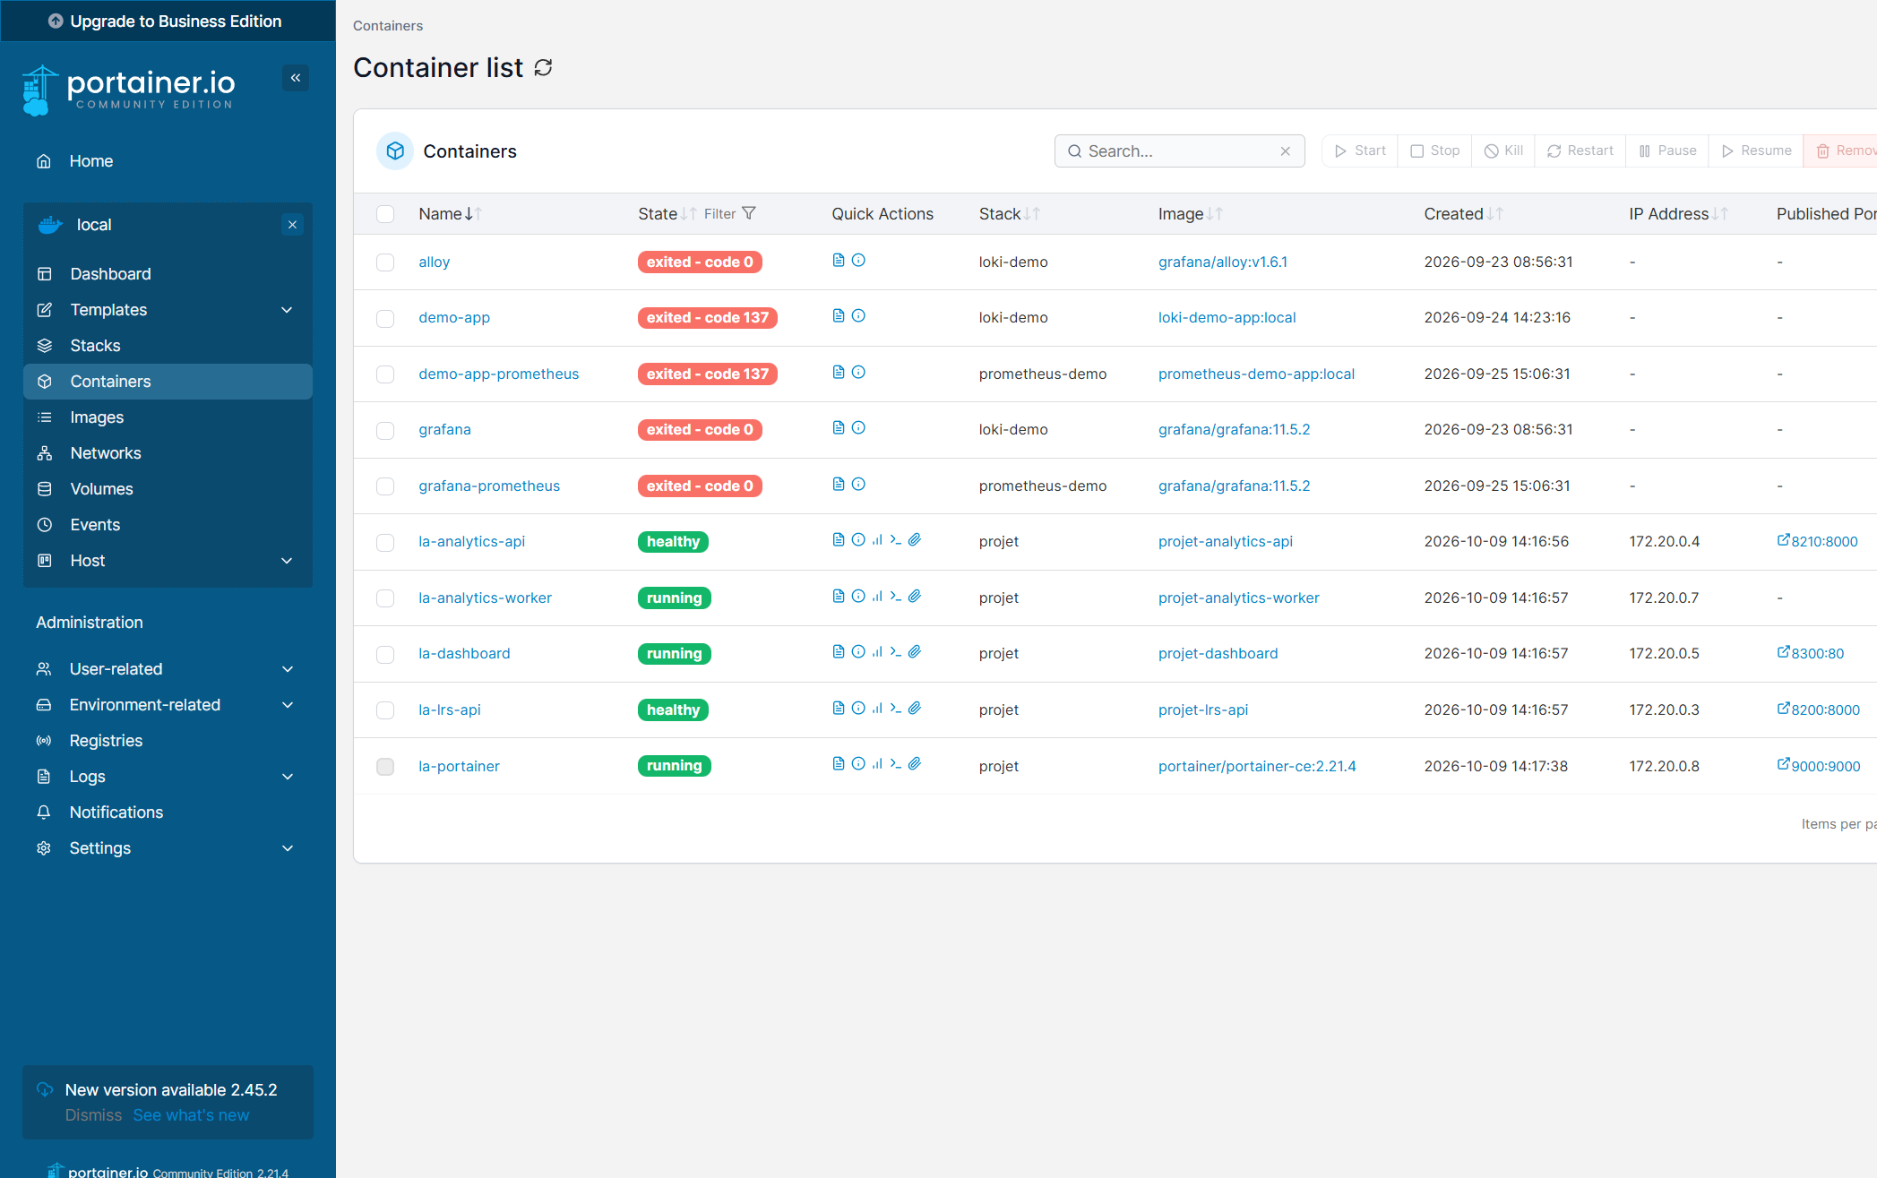
Figure Lab7 — Containers view

4. LAB 8 — Compose multi-container Learning Analytics stack
For Lab 8 I ran the full Compose SaaS stack: generator → LRS → Postgres → analytics worker → API → dashboard. Restart policy is on-failure:3 (not unlimited) to respect the EVA/Proxmox guidance.
Access / ports
- Dashboard: http://localhost:8300
- API overview: http://localhost:8210/api/overview
- LRS health: http://localhost:8200/health
- EVA: http://10.3.16.179:8300 / :8210 / :8200
Images pushed
- https://hub.docker.com/r/edouardclemenceau/lrs-api
- https://hub.docker.com/r/edouardclemenceau/analytics-api
- https://hub.docker.com/r/edouardclemenceau/la-dashboard
Screenshots
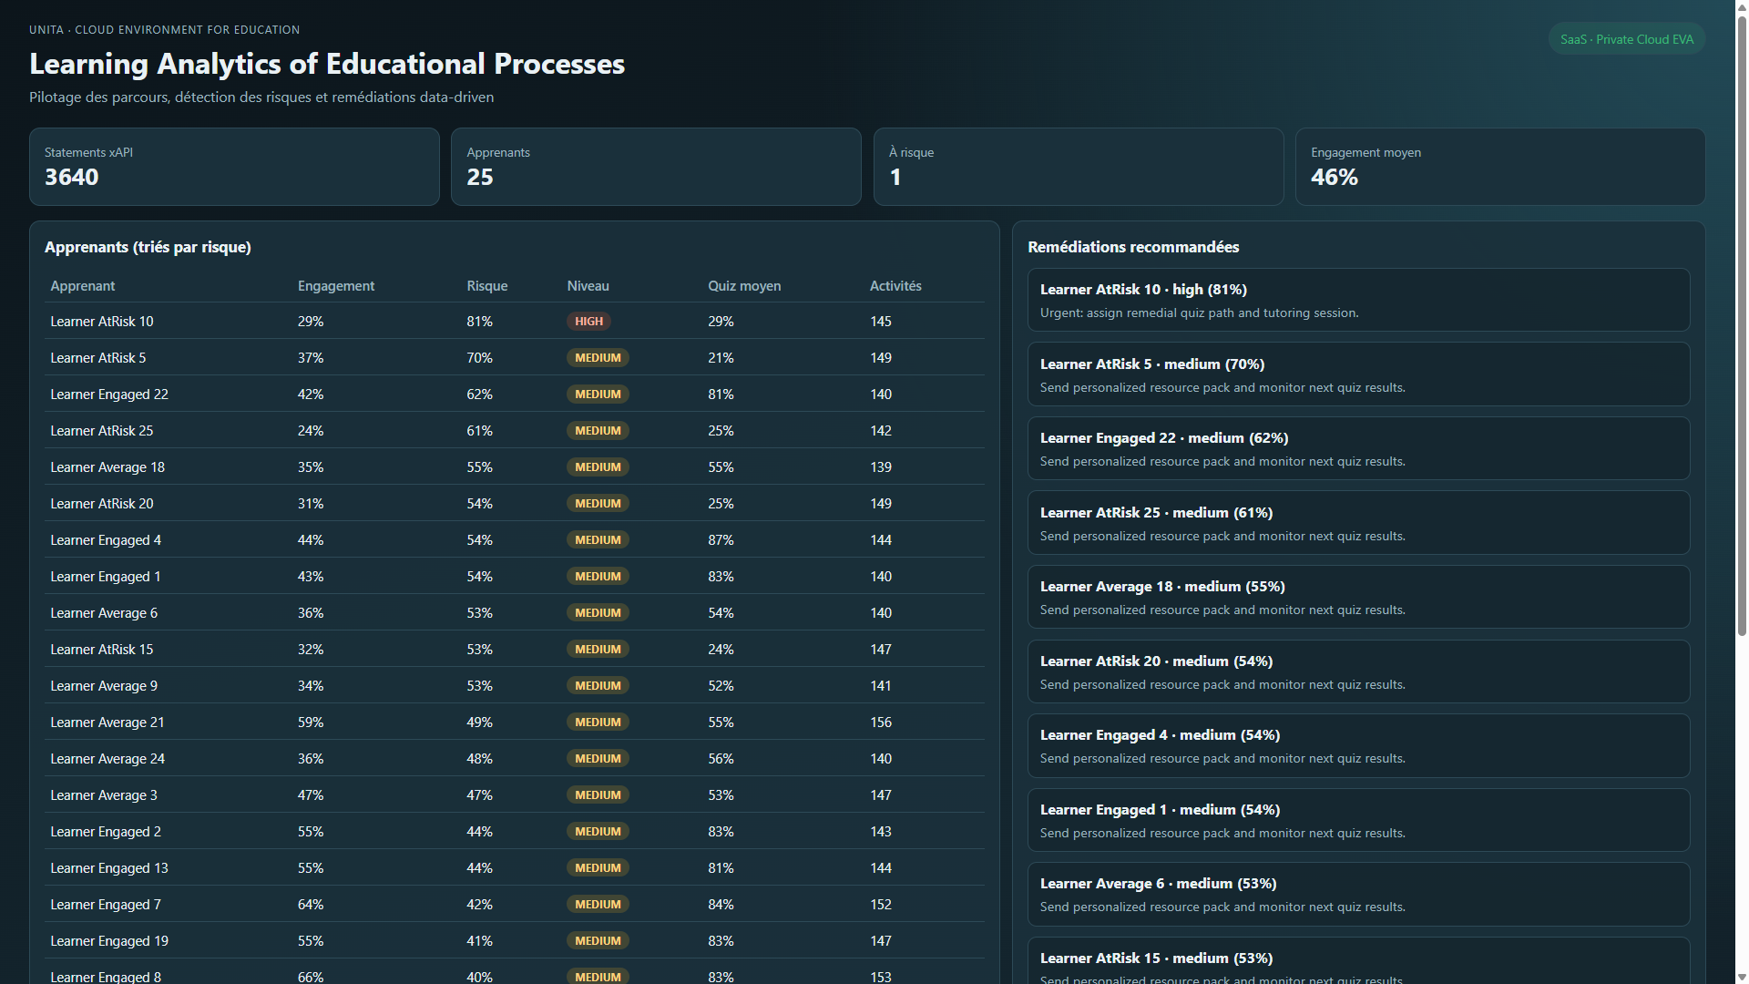
Figure Lab8 — Learning Analytics dashboard
Figure Lab8 — /api/overview KPIs
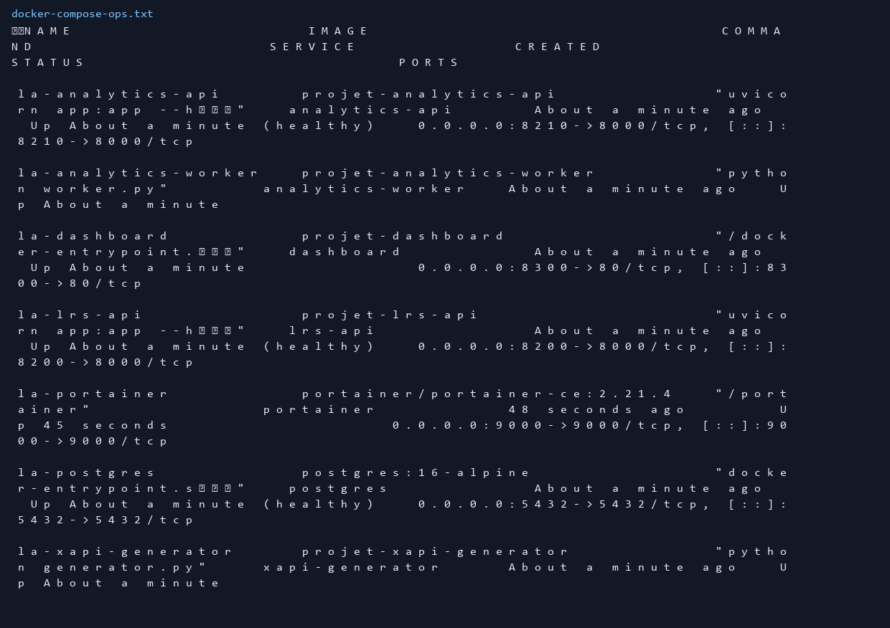
Figure Lab8 — Compose stack including Portainer profile

Conclusion
Labs 5–8 covered Dockerfile optimisation, Compose + persistency, Portainer administration, and a full multi-service Compose application. The same stack is used for our course project on EVA.

