# Complete Assembly Drawing of the IR polarimeter

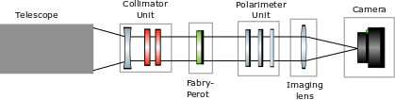

Figure 1 Optical layout of the He infrared polarimeter. The collimator unit consists of a collimating lens and two prefilters. The Fabry-Perot is used to tune the wavelength of observation. The polarimeter unit consists of two liquid crystal modulators and an analyzer. The output of the polarimeter is imaged onto the camera using an imaging lens

# The polarimeter mechanical components

## Collimator Unit –

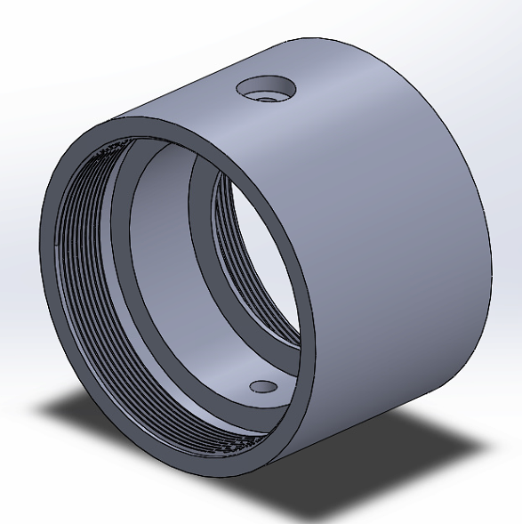

Figure 2 Collimator unit holds the collimating lens and the two prefilters

## Fabry-Perot –

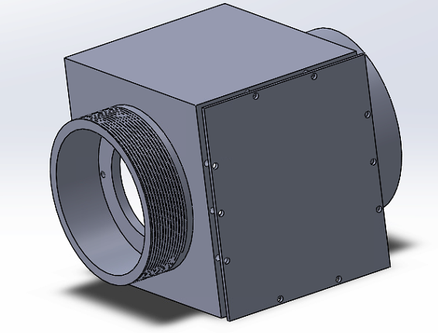

Figure 3 Fabry-Perot unit houses the fabry-perot

## Polarimeter Unit –

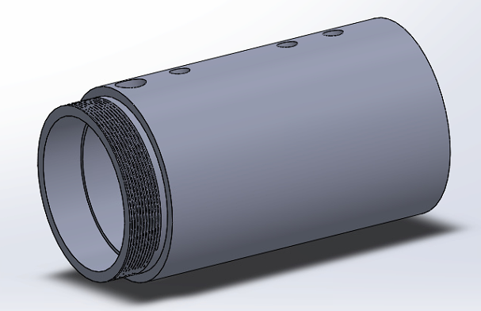

Figure 4 Polarimeter unit housing.

## Imaging lens Unit –

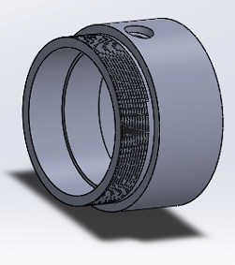

Figure 5 Imaging lens holder. Note- the length of the imaging lens holder is not decided as the focal length of the imaging lens is unknown

## Camera unit –

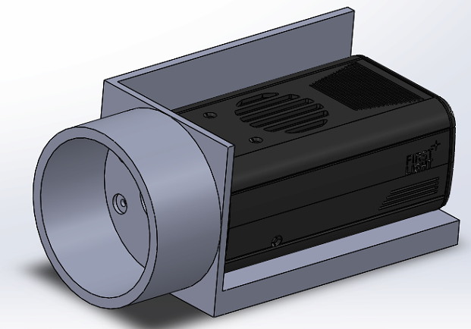

Figure 6 The Camera unit which holds firstlight camera is shown

## Final Assembly of all the components –

Figure 7 The complete assembly drawing of the polarimeter system

Camera unit

Imaging lens

Polarimeter unit

Fabry-perot

Collimator unit

Note- Components to be manufactured by the work shop is the collimator, imaging lens and camera unit