# Complete Assembly Drawing of the IR polarimeter

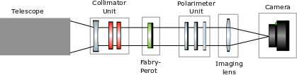

Figure 1 Optical layout of the He infrared polarimeter. The collimator unit consists of a collimating lens and two prefilters. The Fabry-Perot is used to tune the wavelength of observation. The polarimeter unit consists of two liquid crystal modulators and an analyzer. The output of the polarimeter is imaged onto the camera using an imaging lens. Note the CU represents a polarization calibration unit that can be inserted when calibration measurements are taken.

**CU**

# The polarimeter mechanical components

## Telescope connector -

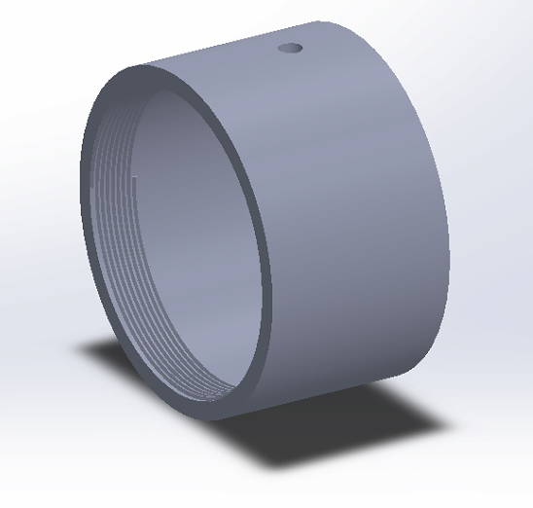

Figure 2 This unit connects the telescope and polarimeter unit

## Calibration Unit –

## 

Figure 3 Calibration unit. Note, the polarizer and retarder can be inserted when polcal is performed

## Collimator Unit –

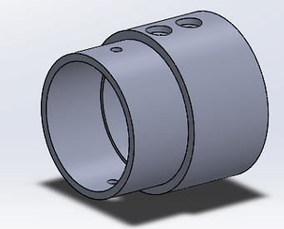

Figure 4 Collimator unit holds the collimating lens and the two prefilters

## Fabry-Perot –

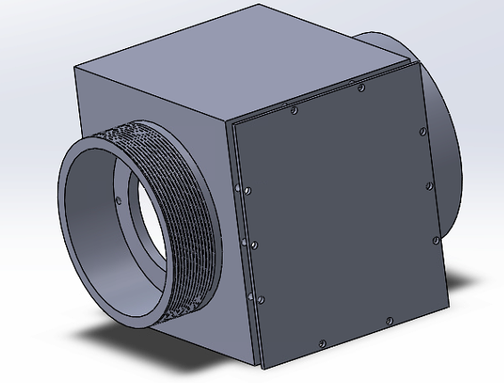

Figure 5 Fabry-Perot unit houses the fabry-perot

## Polarimeter Unit –

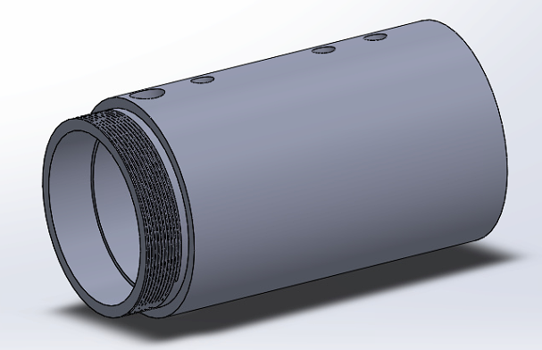

Figure 6 Polarimeter unit housing.

## Imaging lens Unit –

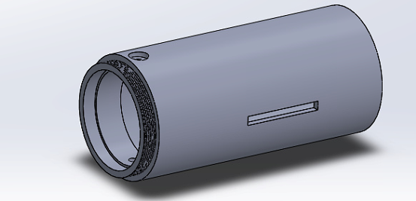

Figure 7 Imaging lens holder

## Camera unit –

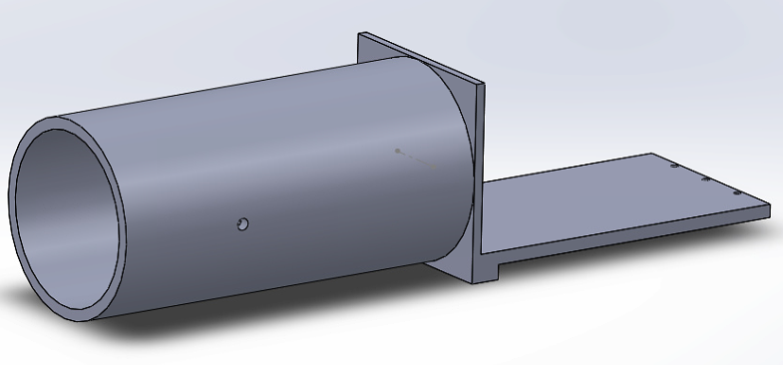

Figure 8 The Camera unit which holds firstlight camera is shown

## Final Assembly of all the components –

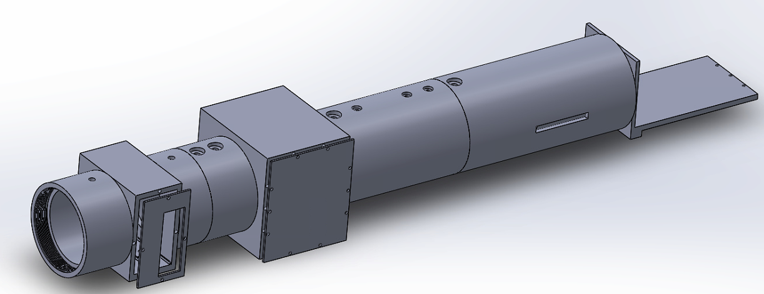

Telescope connector

Calibration Unit

Camera unit

Imaging lens unit

Polarimeter unit

FP unit

Collimator unit

Figure 9 The complete assembly drawing of the polarimeter system

Details of the drawing –

1. The collimator is KBC079AR.18 , f=-150mm from Newport
2. Imaging lens is LB1199-C , f=200 mm from Thorlabs
3. The focal length of the imager is 200 mm. But to allow for tolerance, the camera unit can be moved by ± 30mm to achieve the best focus of the image. A ¼ inch screw slot is cut in the imaging lens unit (see fig 6). The slot is 60 mm long. The camera unit can move by ±30mm in the slot.
4. The distance between the imaging and collimating lens is 250 mm

Additional details –

1. Distance between collimating lens and FP unit is 0.9 ±0.01 inches
2. Size of FP unit is 3.74 ±0.01 inches
3. Size of polarimeter is 4.26 ± 0.01 inches
4. Distance between polarimeter and imaging lens is 0.6 ±0.01 inches

Total distance between Collimator and imaging lens is 9.5 inches = 237.5 mm