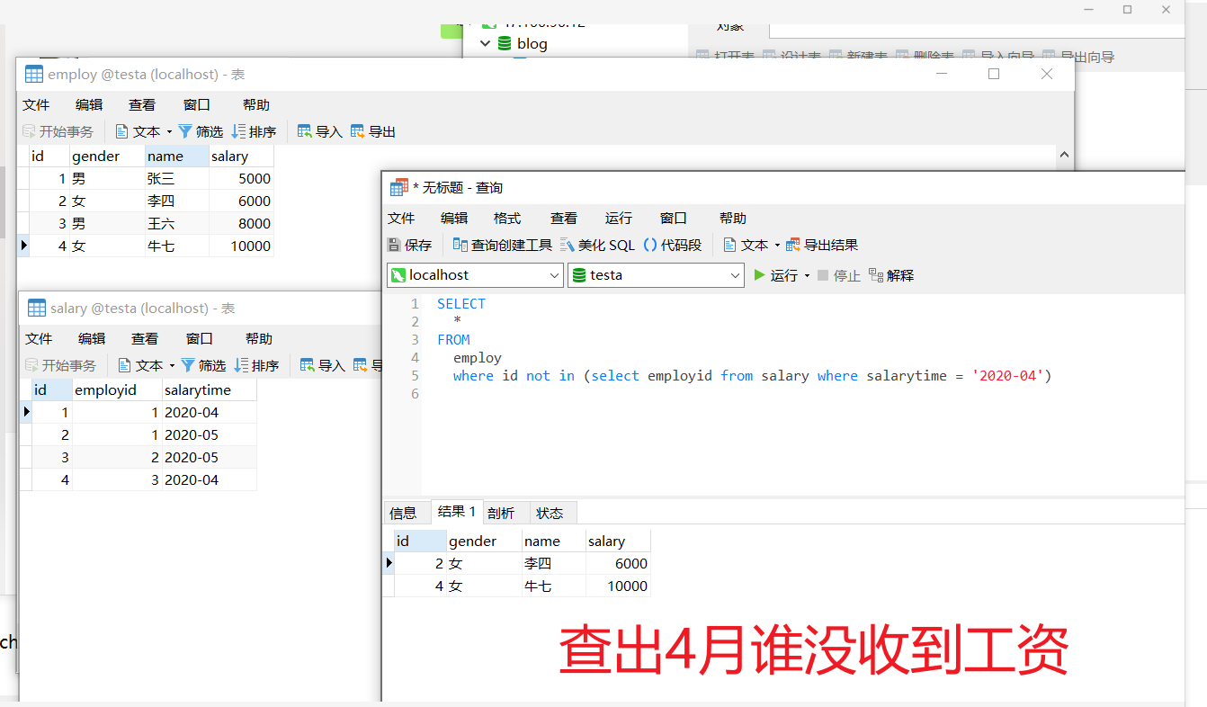

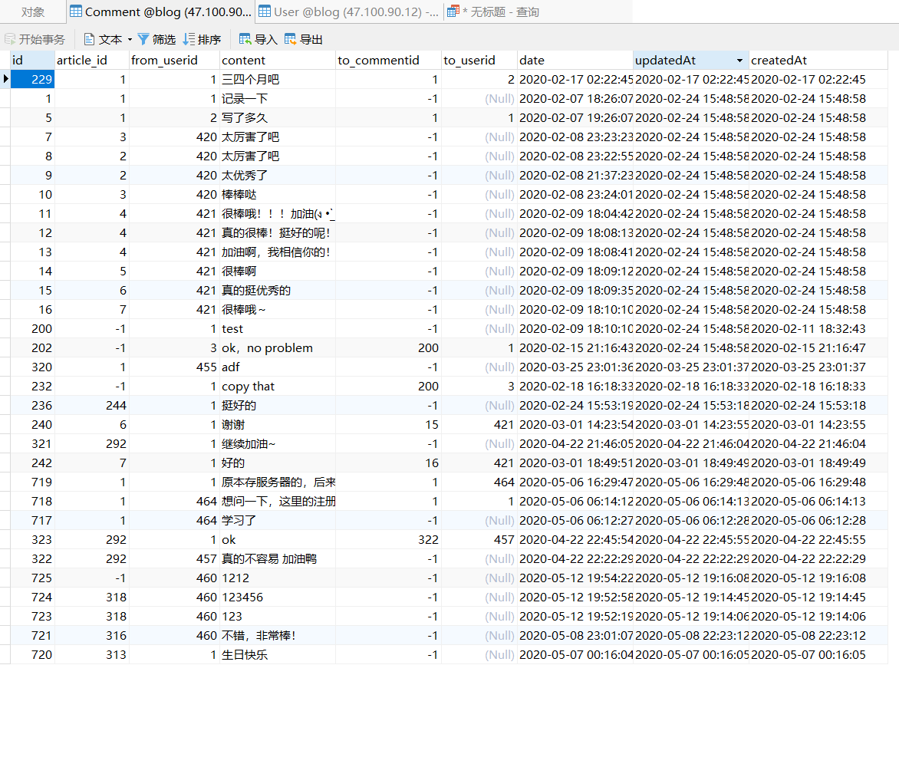

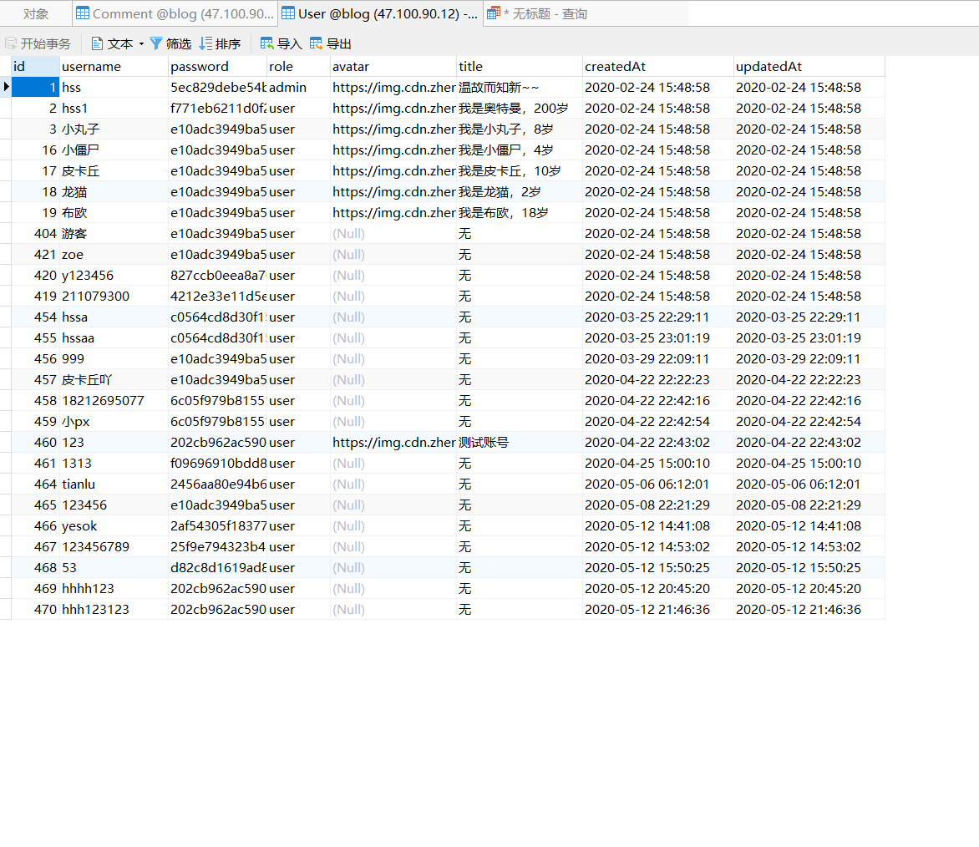

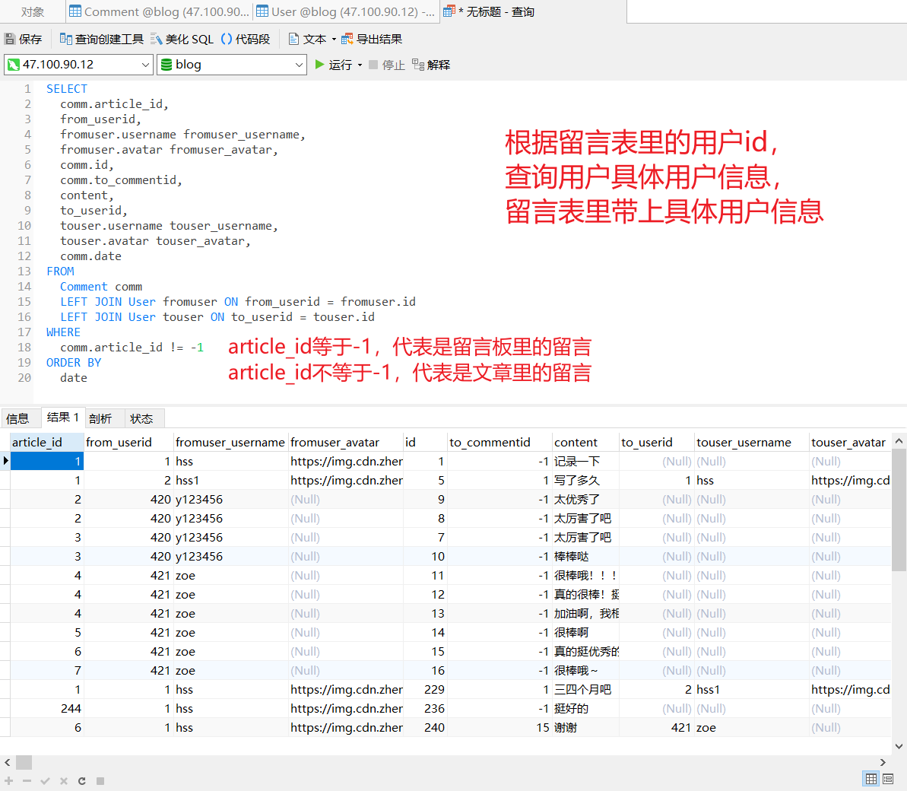

SELECT

comm.article_id,

from_userid,

fromuser.username fromuser_username,

fromuser.avatar fromuser_avatar,

comm.id,

comm.to_commentid,

content,

to_userid,

touser.username touser_username,

touser.avatar touser_avatar,

comm.date

FROM

Comment comm

LEFT JOIN User fromuser ON from_userid = fromuser.id

LEFT JOIN User touser ON to_userid = touser.id

WHERE

comm.article_id != -1

ORDER BY

date