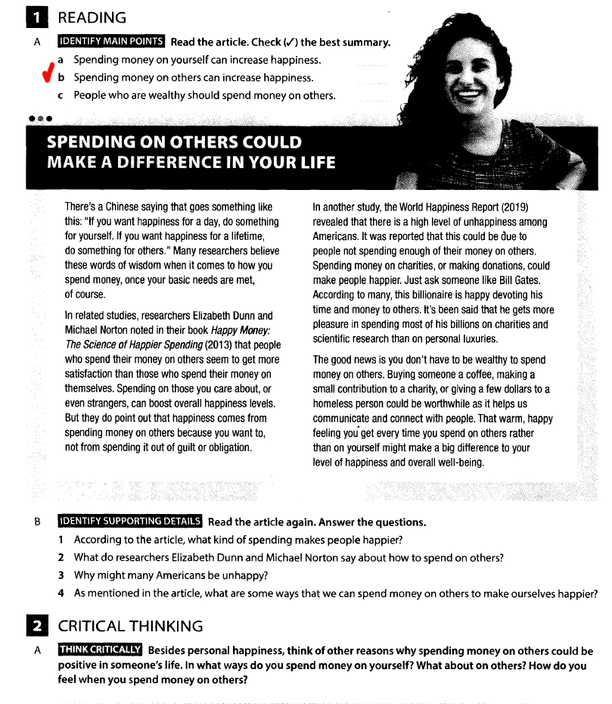

1. According to the article, spending money on those you are care about, or even strangers can make people happier
2. Elizabeth Dunn and Michael Norton says that people who spend their money on others seem to get more satisfaction than those who spend their money on themselves
3. A lot of Americans may be unhappy because they don't spend money on other people.
4. Buying someone a coffee, making a small contribution to a charity or giving a few dollars to a homeless person that’s are some ways to make ourselves happier

2

If we try to consider some arguments in favor of spending money on others, we can think of someone you are helping today who may help you in the future. Another argument for helping others is that a small amount of your money or even your time can help someone to do something important for the whole world. For example, there is a good tradition among the graduates of the Moscow Engineering Physics Institute who are already working abroad, to donate monthly the cost of a dinner to their alma mater. It can help young scientists to invent and make really important things for all mankind.

As for me, I don’t spend a lot of money on myself. I prefer not to buy expensive things because in my opinion they are not worth the money. On the other hand, I can spend money on traveling with my family, getting new experiences.

I have to admit, I've never understood people who squeeze all the juice out of their employees, make a lot of money, make their employees unhappy and then send their millions to Africa to help obscure people. That's why it's important to clarify who the "others" are. Others for me are my family, my friends, my employees. I always try to help them because it is a great pleasure to make someone happy. On the other hand, I will never help beggars on the street or charity funds.

