**Embedded systems lab**

*Project-Title: Arduino-based LED Inspector*

|  |  |  |  |
| --- | --- | --- | --- |
| Document-ID: | | Version: 0.1 |  |
| Project: | Arduino-based LED Inspector | From: Mohamed Marzouk | 2017-01-05 |
| State (draft, released, final): | [Status] | Document-owner: | Mohamed Marzou; Mohamed Adil |
| Classifikation (confidential, internal, public): [Category] | | |  |

Hinweis zu den diversen Dokumentenfelder: Diese sind unter „Properties“ zu pflegen, und zwar:

Projekt-Titel bzw. Projekt: übernimmt den Text vom Feld „Title“

Version: übernimmt den Text vom Feld „Version“ (Untermenü Advanced properties)

Dokument-Eigner: übernimmt den Text vom Feld „Author“

Status: übernimmt den Text vom Feld „Status“

Klassifikation: übernimmt den Text vom Feld „Category“

DOCUMENT VERSION CONTROL:

|  |  |  |  |
| --- | --- | --- | --- |
| Vers. Nr. | Description | Date | Author |
| 0.1 | Initial draft | 2017-04-26 | Mohamed Marzouk |
| 0.2 | Updates to reflect implementation changes | 2017.07.12 | Mohamed Marzouk |
|  |  |  |  |
|  |  |  |  |
|  |  |  |  |
|  |  |  |  |

Hinweis zur Vers.no.

Die Nummern unter 0 sind die NTS-internen Versionen während der Erstellung.

Die Version 1.0 ist die erste, die offiziell dem Kunden zugestellt wird.

Normalerweise werden dann die Einträge unter Version 1.0 entfernt.

Contents

Contents 3

1 Management Summary 4

1.1 Objectives and motivation 4

1.2 Project description / abstract 4

1.3 References 4

2 Assumptions/ Limitations 4

3 Solution description 4

3.1 General description 4

3.2 Overview Chart 5

3.2.1 System diagram 5

4 Detailed Processes 7

4.1 PRC01 – Declare and initialize variables 7

4.2 PRC02 – Reset variables 7

4.3 PRC03 – cALCULATE THE OPERATION VOLTAGE 7

4.4 PRC04 – cALCULATE THE serial resistor value 7

4.5 PRC05 – Display Test results 8

4.6 PRC06 – Identify, handle and display the error 8

# Management Summary

## Objectives and motivation

Light emitting diodes (LED) are widely used in various electronic devices. When connected incorrectly in the circuit, they could burn or even explode. The proposed device in this document will identify the best operating voltage for a given LED and will also suggest the suitable serial resistor for various source voltages.

## Project description / abstract

The device will offer the following functionalities:

1. Identification of LED operating voltage.
2. Proposing the suitable resistor to be connected in serial with the LED to maintain voltage at the proper operation point.

## References

TODO

# Assumptions/ Limitations

* TODO

# Solution description

## General description

The output voltage will be increased gradually by the Arduino software while measuring the current. Once the current reaches the rated value (20 mA), the current voltage minus the drop on the serial resistor is the operation voltage for the LED. Given the LED operation voltage, current and main voltage, the value of necessary serial resistor can be calculated.

## Overview Chart

### System diagram

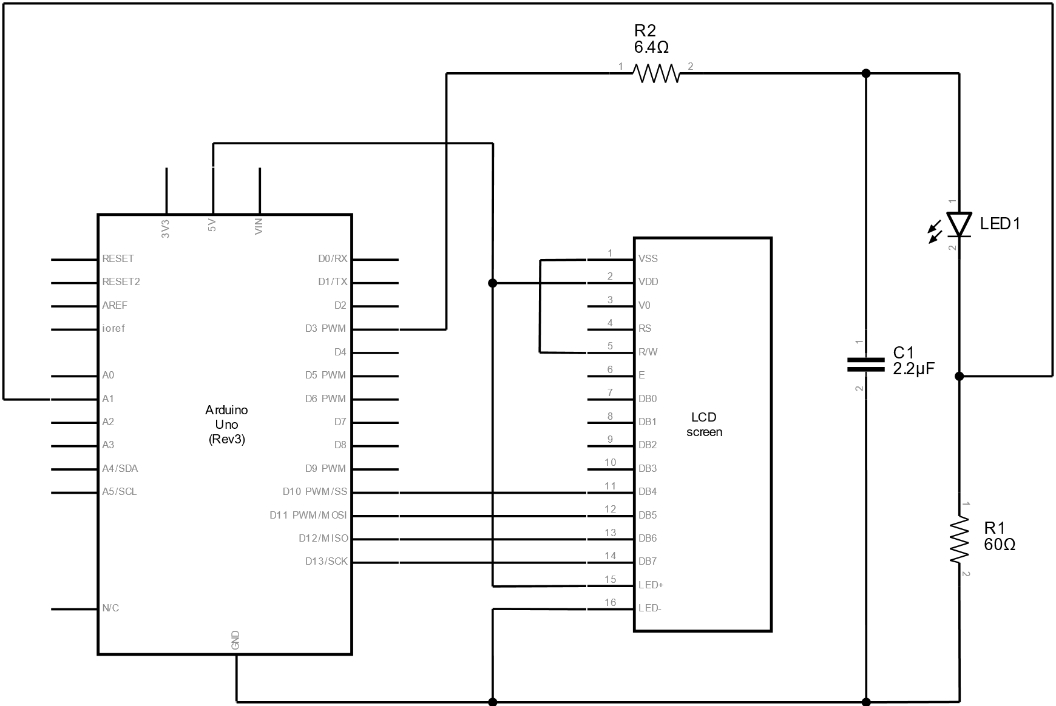

Figure 1: System diagram

The system has the following components:

1. The Arduino microcontroller
2. RC low pass filter (R2, C2): to filter out higher frequencies from the PWM output of the Arduino and to get a DC output.
3. LCD screen: to display the following:
   1. Calculated operation voltage for the LED
   2. Correct serial resistor for various values of the source voltage
   3. Any encountered errors
4. LED: provided by the user to be inspected.
5. Serial resistor (R1): used to limit the current passing through the LED during testing.

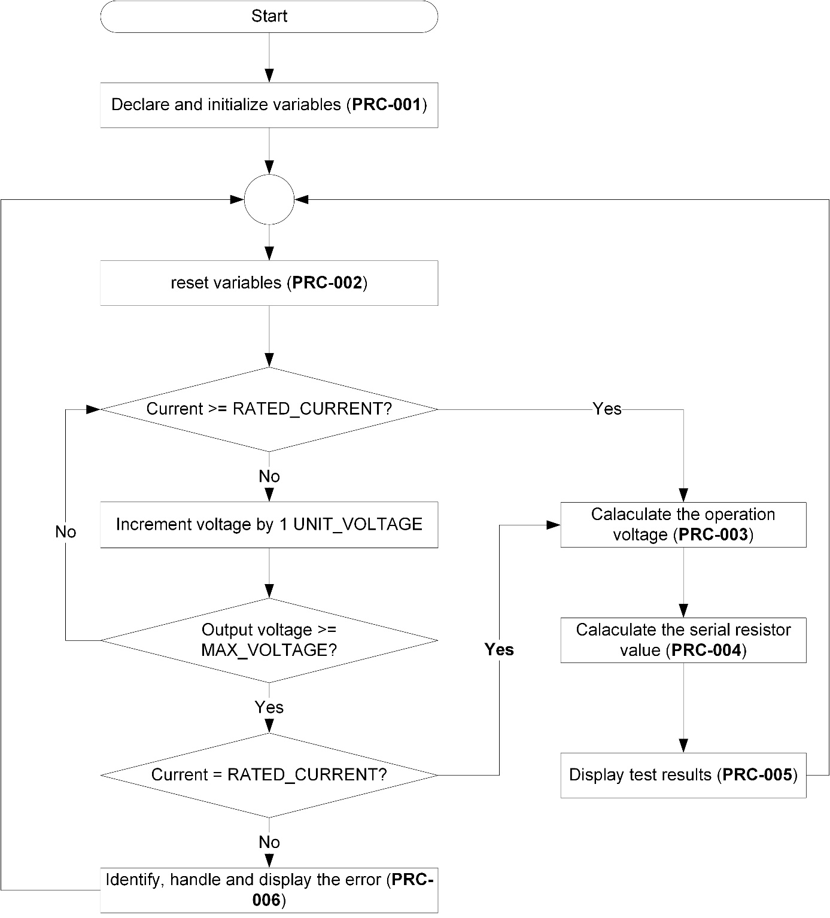

Figure 2: Process workflow

# Detailed Processes

## PRC01 – Declare and initialize variables

The following variables will be declared and initialized in the Arduino SETUP function:

* STARTING_VOLTAGE: the voltage applied to the LED and serial resistor at the beginning of the test
* UNIT_VOLTAGE: the increment step in voltage added in each iteration of testing.
* RATED_CURRENT: the maximum allowable current in Amperes passing through the LED (usually 20 mA)
* TEST_VOLTAGE: current voltage in volts applied to the LED and test serial resistor.
* MAX_VOLTAGE: maximum output voltage of Arduino in volt.
* Built-in resistor: the value in ohms of the test serial resistor
* Pins numbers for:
* Resistor voltage: pin connected to the serial test resistor to read its voltage
* PWM voltage source

## PRC02 – Reset variables

The following variables will be declared and initialized:

* TEST_VOLTAGE: current voltage in volts applied to the LED and test serial resistor to be reset to the STARTING_VOLTAGE.

## PRC03 – cALCULATE THE OPERATION VOLTAGE

* Operation voltage = current TEST_VOLTAGE – voltage over the test serial resistor (as read by Arduino)

## PRC04 – cALCULATE THE serial resistor value

* The recommended serial resistor to be connected to the tested LED in case of the following source voltage values will be calculated using ohm’s law
  + 5 V
  + 9 V
  + 12 V
* Serial resistor = (source voltage – LED operating voltage) / 0.02
* Where operating current = 0.02 Amps

## PRC05 – Display Test results

In case of successfully calculating the operating voltage, it will be displayed as follows:

|  |
| --- |
| Test Results:  Operating voltage: X.XX Volts.  Serial Resistor @ 5 Volts: XXX.XX Ohms.  Serial Resistor @ 9 Volts: XXX.XX Ohms.  Serial Resistor @ 12 Volts: XXX.XX Ohms. |

## PRC06 – Identify, handle and display the error

1. If the test did not produce a specific operating voltage, then an error is assumed to have occurred. This could be any of the following:
   1. LED is not connected (open circuit)
   2. LED is connected with incorrect polarity
   3. LED has an operating voltage that exceeds the maximum output voltage of Arduino (5 V)
2. In all of the above cases, the error message is the same and will be displayed both on the LCS screen and the serial port (to be displayed on the PC).