The find_path project has been developed by Symfony in the docker environment which means you can run it by using docker-compose.

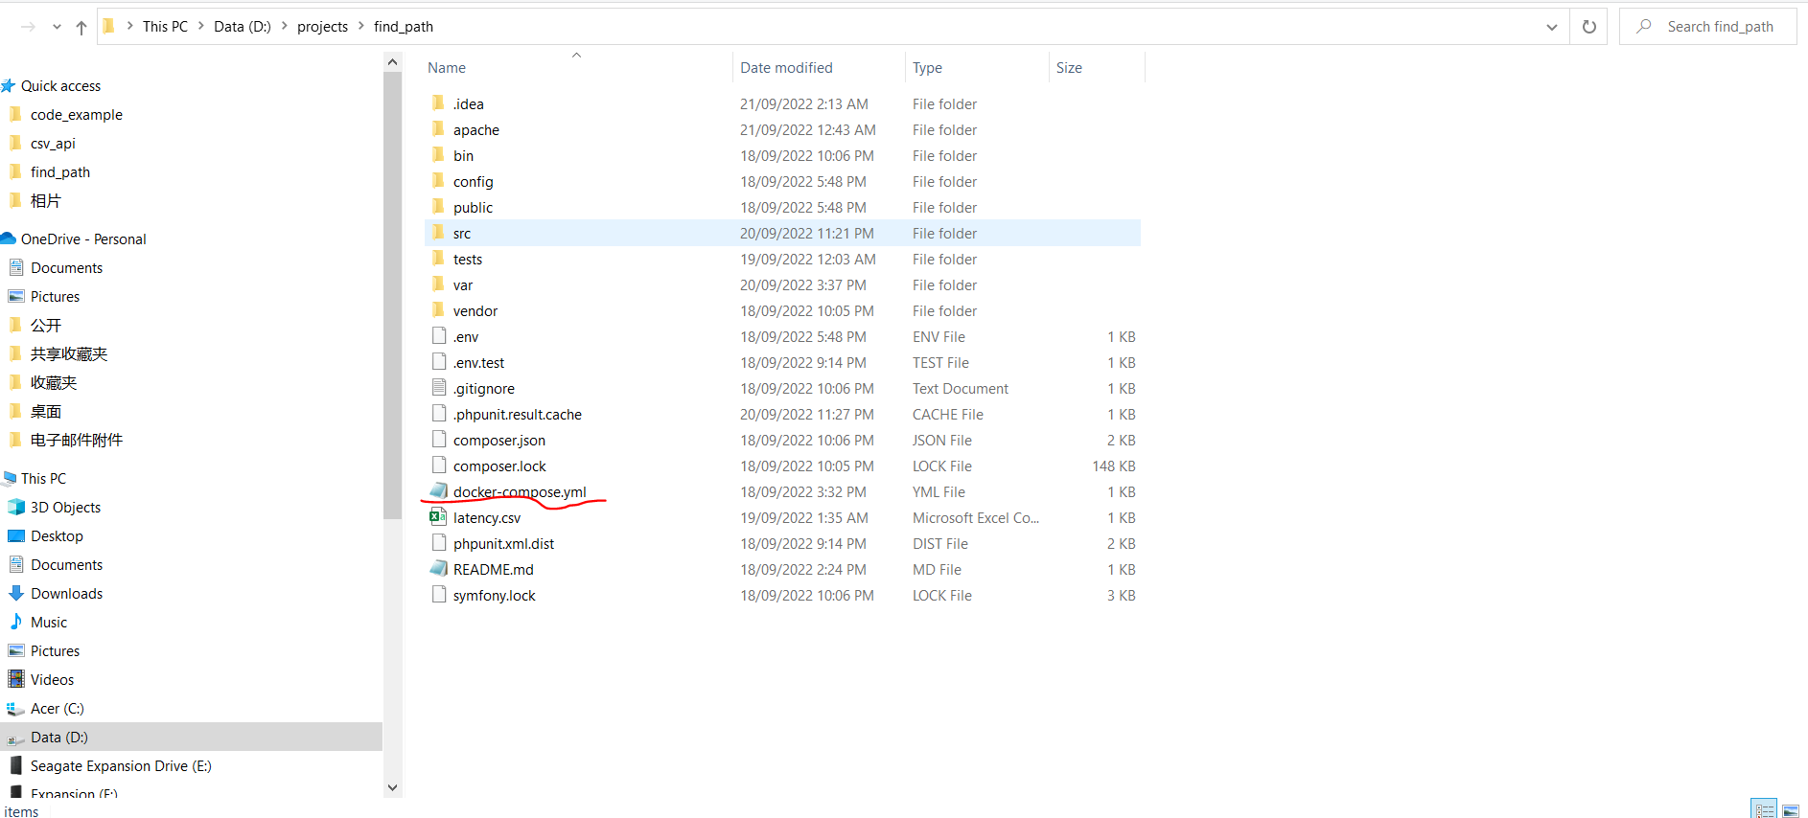

1, Please go to the project root folder and type the following command:

**docker-compose up -d**

2, After the images has been built and the container is up and running, please access the container for installing the library by typing the following command:

**docker-compose exec find_path bash**

3, Install the Symfony library by typing the following command:

**php -d memory_limit=-1 /usr/local/bin/composer install -vvv**

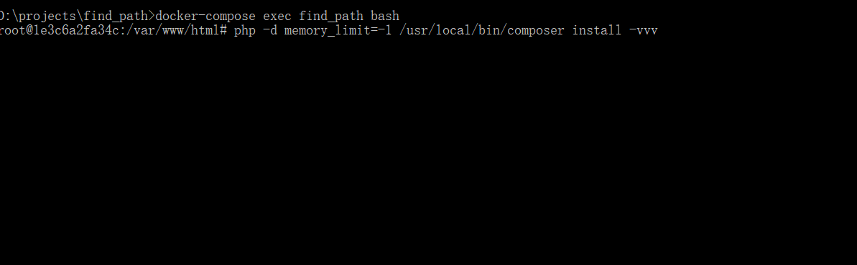

4, Start the program by typing the following command(latency.csv is the testing data csv file, you can refer to other csv file in your local):

**php bin/console app:find-path latency.csv**

5,Play around the command.

Finally, if you want to see the unit test result, please type the following command:

**php bin/phpunit**

Note: The shortest path implementation is based on Dijkstra algorithm.