REBYU: A Centralized AI-Driven Adaptive Learning and Examination Simulation System for Proficiency Certification

A Proposal Project
presented to the Faculty of the
College of Computer Studies, University of Cebu – Lapu-Lapu & Mandaue

In Partial Fulfillment of the Requirements
for the degree of Bachelor of Science in Information Technology

By:
Daniel Kane Isidore A. Mapano
Ivan Justine G. Cortes
Glyzel M. Galagar
Joshua I. Inoc

Erick Dayle R. Loon
Adviser

December 2026

APPROVAL SHEET

This Capstone Project study, titled REBYU: A Centralized AI-Driven Adaptive Learning and Examination Simulation System for Proficiency Certification prepared and submitted by Daniel Kane Isidore A. Mapano, Glyzel M. Galagar, Joshua I. Inoc, and Ivan Justine G. Cortes, has been examined and is recommended for approval and acceptance.

RECOMMENDED:

Erick Dayle R. Loon
Adviser

Alexander Y. Bucol, Ed. D.EM
IT Research Coordinator

APPROVED by the Examining Tribunal on Proposal Hearing with a group verdict of__________ on July 4, 2026.

RASTY P. DEMECILLO, PhD
Chairman

Christine M. Gepiga Shiela Mae C. Saga
Member Member

ACCEPTED and APPROVED in partial fulfillment of the requirements for the Bachelor of Science in Information Technology.

Janette Q. Tanquis, DIT
Dean, College of Computer Studies

Date: _______________________

ACKNOWLEDGEMENT
Foremost, heartfelt appreciation is expressed to the Almighty God for granting the steadfast resilience, wisdom, and structural guidance vital to enduring the intensive technical challenges and software engineering lifecycles encountered throughout this capstone journey. The researchers express their profound and heartfelt gratitude to their research adviser, Mr. Erick Dayle R. Loon, whose exemplary technical guidance, rigorous intellectual critiques, and steadfast mentorship were fundamental to the success of this study. His expertise in software evaluation and steady encouragement throughout our parallel development sprints heavily shaped this architecture and inspired our team to meet strict design standards. We also wish to honor Dr. Janette Q. Tanquis, Dean of the College of Computer Studies, for cultivating an academic ecosystem centered on technical excellence, innovative research, and industrial readiness, and for continuously supporting the advancement of information technology solutions within the college. To our fellow panel members and faculty assessors, thank you for sharing your rigorous analytical reviews and specialized technical feedback during our proposal metrics validation, which greatly enhanced the design and systematic traceability of our platform layers. This milestone would not have been realized without the outstanding cooperation, technical determination, and collective sacrifices of our development team—Daniel, Ivan, Glyzel, and Joshua. The long hours invested in database optimizations, layout revisions, and algorithmic configurations stand as a testament to our shared passion and collaborative trust. We express our deepest love and gratitude to our families, parents, and friends for their constant emotional backing, silent sacrifices, and motivational gestures that served as our primary sanctuary during exhausting development milestones. Finally, we are immensely grateful to the student body and administrative participants of the University of Cebu Lapu-Lapu and Mandaue (UCLM) who enthusiastically shared their valuable time, academic insights, and evaluative feedback during our data collection and baseline evaluation procedures. Your authentic contributions have fundamentally enriched our research findings and practical application goals. To everyone who walked alongside us, challenged us, and believed in our engineering vision—we are deeply humbled and forever grateful.
The Researchers

DEDICATION
The researchers proudly dedicate this technical endeavor to the mentors, loved ones, and institutions whose steadfast support made the successful completion of this study possible:
To the Almighty God, for granting us the physical resilience, mental clarity, and fortitude to navigate every development sprint of this capstone journey.
To our research adviser, Mr. Erick Dayle R. Loon, for generously sharing his technical expertise, sharpening our software methodology, and guiding our core system modules with infinite patience.
To Dr. Janette Q. Tanquis, Dean of the College of Computer Studies, for cultivating an innovative academic environment where computing theory seamlessly transforms into technical reality.
To the faculty and staff of the University of Cebu Lapu-Lapu and Mandaue (UCLM), for nurturing our growth and molding us into engineering-minded IT professionals.
To Ourselves, as a development team, for the relentless determination, late-night debugging marathons, and mutual sacrifices that brought this prototype to fruition.
To our beloved Families and Friends, for their silent sacrifices, financial backing, and enduring encouragement that sustained us whenever the work grew heavy.
To God be the highest glory!
The Researchers

TABLE OF CONTENTS
Title Page………………………………………………………………………………….i
Approval Sheet…………………………………………………………………………...ii
Acknowledgement……………………………………………………………………….iii
Dedication………………………………………………………………………………..iv
Table of Contents………………………………………………………………………...v
List of Tables…………………………………………………………………………….vi
List of Figures…………………………………………………………………………..vii
CHAPTER I: INTRODUCTION 1
Objectives of the Study 4
Scope and Limitations 5
Significance of the Study 7
DEFINITION OF TERMS 9
CHAPTER II: REVIEW OF RELATED LITERATURE AND STUDIES 12
Related Literatures 12
Conceptual Framework 17
Related Studies 19
Comparative Matrix 24
CHAPTER III: DESIGN AND METHODOLOGY 26
Research Design 26
Method 27
Flow of the Study 27
Research Environment 28
Respondents 29
Research Instrument 30
Research Procedure 31
Data Gathering 31
Treatment of Data 32
Ethical Considerations 33
Software Engineering Methodology 35
Planning/Conception-Initiation Phase 36
Business Model Canvas 36
Program Workflow 37
Validation Board 40
Business Roadmap 42
Functional Decomposition Diagram 44
Gantt Chart 45
Analysis-Design Phase 46
AI System Architecture 46
Use Case Diagrams 48
Storyboard 67
Database Design 103
Entity-Relationship Diagram 104
Data Dictionary 105
Network Design 159
Network Model 159
Network Topology 160
Development/Construction/Build Phase 161
Technology Stack 161
Software Specification 162
Hardware Specification 162
Program Specification 163
List of Modules 165
REFERENCES 167
CURRICULUM VITAE 170
APPENDICES 174
A. TRANSMITTAL LETTER 174
B. MAP OF RESEARCH ENVIRONMENT 175
C. SURVEY QUESTIONNAIRE ………….…………………………………..176

LIST OF TABLES
Update this List of Tables field to display the revised table entries.

LIST OF FIGURES
Figure No. | Name | Page No.
1 | REBYU’s Conceptual Framework | 17
2 | Moodle Multi-Tenant Extension (IOMAD) | 19
3 | Knewton Adaptive Learning Engine | 20
4 | Duolingo Max AI Framework | 21
5 | Coursera | 22
6 | Flow of the Study of REBYU | 26
7 | Local Map of University of Cebu Lapu-Lapu and Mandaue | 27
8 | Agile Methodology Diagram | 34
9 | The Macro System Operational Workflow | 38
10 | Multi-Tier Tenant Provisioning and Account Lifecycle | 39
11 | Admin Content Ingestion and Question Population Pipeline | 40
12 | Business Roadmap | 42
13 | Functional Decomposition Diagram | 44
14 | Proposed AI System Architecture | 46
15 | Business Use Case Diagram of REBYU | 50
16 | Log In Account | 51
17 | Register Account | 52
18 | Join Certification Review | 54
19 | Study Lessons | 56
20 | Take Quizzes and Exams | 58
21 | Request Partnership | 60
22 | Invite Learners | 62
23 | Manage Learners | 63
24 | Monitor Progress and Analytics | 66
25 | Approve Partnerships | 68
26 | Manage Certifications | 71
27 | Manage Question Bank | 73
28 | Login Page | 77
29 | Account Registration Page | 80
30 | Join Certification Catalog & Notification Drawer | 82
31 | Study Lessons Interface | 85
32 | Take Quizzes and Exams Interface | 87
33 | Request Partnership | 90
34 | Invite Learners | 94
35 | Manage Learners | 97
36 | Monitor Progress and Analytics | 100
37 | Approve Partnerships | 103
38 | Manage Certifications | 107
39 | Manage Question Bank | 110
40 | Entity Relationship Diagram of REBYU | 114
41 | Network Design of REBYU | 169
42 | Network Model of REBYU | 169
43 | Network Topology of REBYU | 169

CHAPTER 1
INTRODUCTION

Rationale of the Study
In today's modern world, technology has become one of the most influential drivers of change in professional education and technical training, reshaping how candidates approach high-stakes information technology certifications. According to Cavanagh et al. (2020), by incorporating sophisticated digital solutions—including digital competency tracking, online review systems, and Bayesian Knowledge Tracing (BKT) algorithms for adaptive mastery modeling—educational models can shift from passive study habits to highly engaging, metrics-driven preparation strategies. As emphasized by Mazlan et al. (2025), this transformation is vital because the global IT sector demands certified professionals with validated capabilities, placing intense pressure on academic institutions and independent examiners to meet the complex standards of both national and international institutions Investigating this topic is crucial because the core components of modern review systems—namely, structured curriculum distribution, progressive evaluation, and performance monitoring—remain incomplete unless they can accurately predict real-world test outcomes. According to Kamau et al. (2024), modern competency frameworks have already demonstrated that continuous diagnostic tracking can identify deep-seated knowledge gaps, highlighting how software innovations lead to higher passing rates and better psychological readiness among examinees. More broadly, as noted by Gerontakis et al. (2024), the role of interactive information technology in specialized education is critical to optimizing study habits, streamlining institutional administrative management, and ensuring that advanced review materials reach candidates efficiently. These developments highlight key areas of concentration, including intelligent performance data management, real-time telemetry screening, continuous concept reinforcement, and active learner engagement, all of which form the foundation of technology-enabled exam preparation.
In the local context, preparation for major technical certifications faces severe practical limitations due to inadequate self-assessment frameworks, high rates of student distraction, and a lack of visibility into true exam readiness. Local examinees frequently experience high failure rates because traditional review materials are static and linear, failing to measure deep cognitive retention or practical problem-solving under pressure. This issue is compounded by the fact that learners often display false overconfidence from superficial, passive reading, only to face failure during rigorous certification exams due to a complete lack of real-time diagnostics to verify genuine sincerity and engagement in their studies. According to Abdulaziz et al. (2024), passive study habits directly contribute to poor topic retention and reduced cognitive performance when executing complex technical tasks. Furthermore, a study conducted by Yu et al. (2023) established that a lack of continuous, unexpected monitoring allows students to easily skim materials without achieving true mastery, creating a substantial gap between perceived competence and actual analytical capability. According to Perevochtchikova et al. (2021), traditional review environments completely isolate historical exam scores from behavioral study metrics, leaving institutions and individual candidates without a unified diagnostic indicator for determining whether a learner is genuinely prepared to take their certification examinations. Consequently, as observed by Almalawi et al. (2024), local review strategies remain highly reactive, forcing users to discover critical knowledge deficiencies only after they have already failed their expensive, high-stakes certification attempts.
To address these structural review deficiencies and elevate passing rates, existing literature points toward the deployment of web-based Learning Management Systems (LMS) and gamified educational applications. According to Agrawal et al. (2022), current software solutions utilize structured module paths, static end-of-chapter quizzes, and performance dashboards to track completion progress and answer accuracy. Concurrently, an investigation by Yedatkar (2024) demonstrated that the inclusion of gamification mechanics—such as badges, daily streaks, and timed competitive challenge modes—increases user engagement and encourages continuous learning habits. According to Ko and Lee (2025), standard web implementations leverage open-source databases and real-time cloud analytics to render basic progress charts and identify historical strengths or weaknesses within a curriculum. Additionally, as detailed by Caspari-Sadeghi et al. (2022), adaptive learning platforms frequently incorporate automated assessment tools to recommend specific review materials based on past test scores. According to Rotar (2025), these existing solutions collectively prove that digital structure mitigates the disinstitutionanized nature of independent review, while embedded testing successfully reinforces fundamental concept recall before students attempt final assessments.
In response to these challenges, REBYU is introduced—a web-based, multi-tenant adaptive reviewer platform optimized for computing professional certifications, specifically tailored for computing students at the University of Cebu Lapu-Lapu and Mandaue. Unlike existing initiatives that focus on static, linear question banks or disconnected review repositories, REBYU offers an integrated approach by automatically monitoring continuous study behaviors through an embedded background telemetry node that logs active study time, reading pacing, attention indicators, and scrolling velocity as the user navigates section content. By capturing these real-time behavioral data streams, the system can algorithmically detect passive skimming or distraction and dynamically inject interactive evaluation checkpoints—such as rapid-fire queries and interactive diagram-building interfaces—directly within the learning stream to verify authentic cognitive retention. By combining scheduled module tests, lesson quizzes, and comprehensive mock examinations with automated, unannounced surprise challenges that catch learners off guard while they scroll, the system contributes to a more holistic understanding of an examinee's actual conceptual retention while actively working to reduce passive text-skimming habits. It provides a weighted, predictive Confidence Level metric derived from combined performance scores and logged background sincerity metrics, and uses a Bayesian Knowledge Tracing (BKT) framework to systematically track the student's specific topic weaknesses through algorithmic High Priority and Not Priority labeling. This contribution is particularly valuable for computing tracks such as TOPCIT, IT Passport, and IT Fundamentals, where access to highly interactive, institutional-grade tracking frameworks has historically been limited.
Furthermore, REBYU empowers Institution institutions with a turnkey platform to seamlessly monitor student cohorts, while providing Learners with an option-rich freemium ecosystem. Under this model, Learners can explore certification tracks, read lesson content, and take localized quizzes at no cost. At the same time, payment is simulated within a closed sandbox framework exclusively to unlock high-stakes mock exams and the predictive Confidence Level dashboard. Real-time remedial guidance is supported by an integrated, guarded Retrieval-Augmented Generation (RAG) based NLP AI Coach that is programmatically restricted to the pre-loaded curriculum database to eliminate hallucinations. On a broader scale, the study contributes to the growing body of knowledge on adaptive e-learning platforms and web-based educational technology in specialized technical domains by exploring the feasibility, effectiveness, and sustainability of an unexpected, multi-metric performance-monitoring system. In doing so, it offers data-driven insights that can inform not only future research into gamified pedagogical methods but also curriculum design and institutional training models that leverage technology to elevate technical education outcomes and professional readiness across the IT sector.

Objectives of the Study

General Objective
This study aims to design and develop REBYU: A Centralized AI-Driven Adaptive Learning and Examination Simulation System for Proficiency Certification, a web-based and mobile-responsive application for academic institutions, catering to multi-disciplinary professional and industry certification programs for students and examinees across various departments in the University of Cebu Lapu-Lapu and Mandaue.
Specific Objectives
Specifically, the study aims to:
- Identify the current or existing proficiency and professional certification review systems used by students across various academic departments in terms of:
  - processes; and
  - problems encountered.
- Determine the mechanisms and techniques to be utilized for the proposed system in relation to:
  - adaptive profiling and algorithmic content priority labeling;
  - behavioral attention tracking via real-time viewport scrolling telemetry;
  - sincerity interventions via automated scrolling, surprise challenge injections to reduce passive text skimming;
  - predictive topic mastery tracking using a pyBKT-driven Bayesian Knowledge Tracing framework;
  - conversational academic remediation using a bounded Natural Language Processing (NLP) AI Coach; and
  - institutional provisioning via data-isolated, multi-tiered tenant routing profiles supporting institutional and departmental access levels.
- Define the best features of the proposed REBYU platform.
- Establish the level of acceptability of the proposed system among UCLM computing students (Learners) in terms of functionality, usability, and reliability.

Scope and Limitations
The primary focus of this study is the design, development, and implementation of REBYU, a web-based and mobile-responsive, multi-tenant adaptive reviewer platform optimized for multi-disciplinary professional and industry certifications. The scope of the project is tailored to encompass various academic programs across the University of Cebu Lapu-Lapu and Mandaue (UCLM). Within this domain, the platform accommodates a multi-tiered role hierarchy: the Admin (representing the developers/researchers), who handles platform maintenance, global curriculum database management, and quotation negotiations; the Institution (representing the school), managing macro-level platform access and high-level license allocations; Department Heads (representing the Dean or any authorized personnel), who manage department-level student cohorts, distribute localized voucher codes, and monitor program-specific analytics; and Learners (students), who operate asynchronously to explore review tracks, read lesson content, and simulate certification exams via a personalized dashboard. Structurally, the platform supports a strict learning hierarchy consisting of Certification Courses, Modules, Lessons, and Sections. Although the software provides fully functional interfaces for multi-tenant monitoring, the data-gathering, empirical baseline evaluation, and acceptability survey metrics in this study are limited exclusively to responses from active UCLM Learners across participating academic departments.
Functionally, the system incorporates an adaptive learning framework powered by a Bayesian Knowledge Tracing (pyBKT) engine. This framework initiates a pre-module diagnostic test to profile Learners and algorithmically assign priority labels, distinguishing between high-priority and non-priority topics to track specific student weaknesses. The testing engine enforces a distinct passing threshold for standard quizzes, module tests, and mock exams, dynamically analyzing performance data to prioritize question targeting toward a Learner's specific weaknesses during adaptive retakes. Furthermore, the platform calculates a predictive readiness score, known as the Confidence Level metric, by combining cumulative assessment performance with behavioral metrics like active study time. To help reduce passive reading or text-skimming habits and support genuine conceptual retention, the system features native surprise challenges—such as rapid-fire questions or visual diagram-building interfaces—that pop up algorithmically as the user scrolls through sections. Real-time remedial guidance is further supported by an integrated Natural Language Processing (NLP) AI Coach built on a Retrieval-Augmented Generation (RAG) framework that provides interactive answers strictly based on the preloaded curriculum material.
While REBYU’s architecture is scalable to other academic fields, this study limits its institutional deployment scope to UCLM departments, focusing on industry and professional certification tracks (such as IT/computing certifications, business/office productivity credentials, technical/vocational skills, and safety/occupational standards) while strictly excluding national licensure board examinations. To preserve database integrity and deliver a streamlined product, tenant-specific curriculum customization is restricted within the user interface; instead, proprietary modifications are managed on the backend by the Admin during the negotiation phase.
The individual learning track utilizes a freemium model where core courses and standard quizzes are free, whereas unlocking the comprehensive Mock Exam Simulation and predictive Confidence Level Metric Dashboard requires a simulated payment upgrade. Research evaluation boundaries focus entirely on Learners, purposefully excluding Department Heads or Institution representatives from usability feedback. Behaviorally, the platform leverages automated viewport interventions to curb passive text skimming, while the integrated AI Coach uses a strictly bounded Retrieval-Augmented Generation (RAG) framework programmatically locked to preloaded modules to prevent AI hallucinations.
Architecturally, the platform remains fully self-contained within the native web interface, excluding any integrations with remote virtual machines or external third-party live code compilers. Similarly, the e-commerce infrastructure bypasses live production payment networks like GCash, Maya, or Stripe, routing all individual feature upgrades, course acquisitions, and bulk Institution licensing checkouts through a closed, simulated sandbox environment designed purely for prototype validation.

Significance of the Study
The development of REBYU provides a data-driven, interactive approach to exam preparation, shifting the paradigm from passive reading to active cognitive reinforcement. The findings and operational outputs of this study will provide significant value, offering critical insights and distinct practical advantages to the following stakeholders:
Learners. This study offers an active, responsive environment that directly helps reduce passive text skimming habits and false overconfidence. By engaging with the platform's diagnostic pre-tests, adaptive question-targeting retakes, and unannounced scrolling viewport challenges, students can accurately uncover deep-seated knowledge gaps before attempting high-stakes exams. Furthermore, the option-rich freemium model allows them to access foundational core course materials for free. At the same time, the simulated premium upgrade safely unlocks the predictive Confidence Level metric and full mock exam simulations. It provides them with an honest assessment of their readiness, helping them avoid the financial strain and psychological setbacks of failing expensive professional certifications such as TOPCIT, IT Passport, or IT Fundamentals.
Department Heads. This platform serves as a targeted pedagogical management asset. It provides Department Heads with an isolated workspace to manage program-specific class sections, monitor cohort analytics in real time, and track student consistency and reading pace. Instead of manual oversight, Department Heads can easily identify lagging student cohorts and deploy timely educational interventions to ultimately improve departmental passing rates on professional certification examinations.
Institution. The study provides the Institution with a centralized, multi-tenant software solution that elevates its overall academic quality and certification passing statistics. It offers top-level administration macro-visibility into cross-departmental license usage and student participation rates, ensuring that institutional resources invested in professional certification programs deliver tangible improvements in student competency and institutional prestige.
Industry and Professional Sectors. The study helps narrow the gap between academic preparation and industry expectations. By ensuring that candidates are evaluated through dynamic problem-solving mechanisms and interactive diagram-building interfaces rather than static memorization, the platform helps produce a workforce with validated technical capabilities. Employers are assured that certified entry-level professionals entering the field possess genuine technical retention and the analytical capability required to execute complex computing tasks under pressure.
Researchers. This study serves as a comprehensive venue for the researchers to apply theoretical computer science and software engineering methodologies to a high-density, real-world deployment. By architecting a multi-tenant cloud application, the researchers gain invaluable, hands-on experience with full-stack framework development, complex relational database optimization, and secure API data isolation. Furthermore, designing and configuring advanced system components—such as programmatic Retrieval-Augmented Generation (RAG) constraints, custom background telemetry tracking scripts, and algorithmic adaptive learning models—directly deepens their technical proficiency in modern AI integration and user behavioral analytics. Ultimately, the execution of this prototype equips the researchers with the practical engineering skills and architectural insight necessary to meet the demanding standards of the institution software development industry.
Future Researchers. This study establishes a foundational reference for the design and effectiveness of unexpected, multi-metric performance monitoring systems in specialized education. The methodologies, system architecture, and integration of background behavioral tracking metrics (such as scrolling-velocity analytics, attention indicators, and active-time data) provide a solid framework for future developers seeking to advance adaptive e-learning platforms. Furthermore, it opens new avenues for exploring gamified pedagogical methods, hybrid human-in-the-loop AI data-ingestion queues, and Retrieval-Augmented Generation (RAG)- based NLP frameworks within specific technical domains.

DEFINITION OF TERMS
To establish conceptual clarity and ensure a uniform interpretation throughout this study, the following terms are operationally defined according to their specific functional application within the REBYU platform:
Adaptive Learning Framework. Refers to the platform's dynamic system mechanism that evaluates performance via distinct passing thresholds, automatically diagnoses topical weaknesses, and structurally weights question targeting toward those specific deficiencies during test and quiz retakes.
AI-Assisted Quality Filter (Human-in-the-Loop). The data ingestion workflow where the system's NLP parser automatically isolates question strings, suggests difficulty tiers (Easy, Average, Hard), and detects answer keys from unstructured document uploads, sending them to an interactive staging area for global Admin verification and approval before database publication.
Background Telemetry Node. An embedded real-time tracking module within the application user interface that continuously logs discrete behavioral metrics during study sessions, specifically capturing reading pacing, active study seconds, and scrolling velocity patterns.
Bayesian Knowledge Tracing (BKT). A cognitive modeling framework, powered by the system's pyBKT engine, utilized to mathematically calculate and track a learner's probabilistic mastery level of a specific concept based on a chronological sequence of correct and incorrect assessment answers.
Confidence Level Metric. A weighted, predictive readiness score generated by the platform's analytics engine that combines a learner's cumulative examination performance with historical background sincerity data (active study time and challenge completion data) to verify genuine preparation for high-stakes certification exams.
Computing Programs. The specific technical academic disciplines targeted by this study strictly comprise Computer Science (CS), Information Technology (IT), and Computer Engineering (CpE) certification tracks at the University of Cebu Lapu-Lapu and Mandaue (UCLM).
Department/Faculty User. A middle-tier user role classification representing academic instructors, chairs, or advisors who receive seat allocations from their parent institution to distribute class voucher codes, invite student cohorts, and analyze localized learner performance metrics.
Diagram-Building Interface. A specialized, interactive drag-and-drop user interface component executed natively within the web application that serves as a surprise challenge module, evaluating a learner's cognitive capability to structurally map out computing concepts, entity relationships, or networking topologies.
Institution User. A top-tier multi-tenant user role classification representing academic institutions or institutions that manage macro-level bulk seat licensing allocations and delegate administrative profiles to specific university subdivisions.
Freemium Pricing Architecture. The platform's monetization model is inspired by Coursera, in which core certification learning tracks, lessons, and standard quizzes are completely free to access. At the same time, comprehensive Mock Exam Simulations and the predictive Confidence Level Dashboard are locked behind a premium tier.
Learner. The primary user role and research respondent classification representing asynchronous computing students who register on the platform to explore review tracks, read lesson content, and simulate certification exams via a personalized dashboard.
Learning Hierarchy. The rigid, four-tiered relational database taxonomy pre-configured within the centralized schema to institutionalize computing curriculum data, structurally flowing from Certification Courses, to Modules, to Lessons, down to discrete Sections.
Mock Exam Simulation. The premium-tier assessment module engineered to mimic real-world certification exam constraints (such as strict time limits and comprehensive question distribution), which triggers the calculation of the final predictive Confidence Level score.
Multi-tenant Architecture. A software architecture pattern wherein a single software instance serves multiple distinct institutional groups (tenants), ensuring complete data isolation, secure workspace routing, and private cohort analytics between separate academic entities while sharing the underlying technical infrastructure.
Priority Labeling. The algorithmic sorting of learning content following an initial pre-module diagnostic baseline test, which tags specific lesson nodes as either High Priority (unmastered topics requiring immediate focus) or Not Priority (mastered topics) to map out a personalized study roadmap.
pyBKT Engine. The specialized, programmatic Python-based framework integrated into the application's analytical backend to mathematically update and execute the parameters of the Bayesian Knowledge Tracing model.
Retrieval-Augmented Generation (RAG). A natural language processing framework that forces an AI language model to retrieve facts from a verified, preloaded database before generating a response; utilized to bind the system's AI Coach strictly to the computing curriculum and completely prevent hallucinations.
Scrolling Velocity Analytics. The quantitative behavioral metric calculated by dividing scrolled vertical pixels by time elapsed, utilized by the background telemetry node to identify abnormal navigation speeds indicative of text skimming.
Seat Licensing Workflow. The B2B administrative mechanism through which an Institution User requests, secures, and tracks bulk user voucher accounts for a designated cohort of student learners without modifying core system data.
Simulated Checkout. A mock e-commerce transaction interface within the application designed to process individual features or bulk licensing acquisitions using dummy data inside a closed sandbox environment, completely omitting active external financial payment gateway APIs (such as GCash, Maya, or Stripe).
Surprise Challenges. Unannounced, algorithmically triggered evaluation checkpoints—such as rapid-fire questions or visual diagram-building interfaces—that pop up and lock viewport navigation when a user displays rapid scrolling behaviors, functioning explicitly to reduce passive text skimming habits.
Rapid-Fire Queries. A time-constrained surprise challenge modality consisting of a quick succession of direct technical questions designed to disrupt cognitive passivity and instantly evaluate active information retrieval.
Viewport Lock. A native front-end UI restriction state, programmatically enforced when reading telemetry, flags an engagement drop and temporarily freezes page navigation to compel the user to complete a surprise challenge modal.

CHAPTER 2
REVIEW OF RELATED LITERATURE AND STUDIES
This chapter examines the architectural, algorithmic, and educational frameworks that govern modern web-based review configurations, with an emphasis on multi-tenant structures, adaptive evaluation mechanics, and natural language interfaces. According to Mavroudi et al. (2023), recent literature indicates that adaptive learning and learning analytics are closely connected, as both aim to improve learner-centered instruction through data-informed personalization and intervention. Furthermore, according to Kassab et al. (2023), studies on student engagement and predictive analytics likewise show that digital review systems can benefit from behavioral data, performance tracking, and early identification of learners who need support. Ultimately, this chapter establishes the theoretical and empirical baseline required to validate REBYU as a multi-metric, interactive remediation platform designed to reduce student passivity and improve examination readiness.

Review of Related Literature

Multi-Tenant Software Architectures

The transition from monolithic educational deployments to multi-tenant cloud systems has redefined how academic networks distribute curriculum resources. Managing localized routing profiles and secure administrative workflows is important for supporting cross-institutional tracking without unnecessary resource duplication or performance loss.
According to Liu et al. (2022), multi-tenant software architectures enable a single deployment instance to serve multiple independent institutions, or tenants, while maintaining strict data isolation boundaries and tenant-specific configuration layers. To ensure stability across these infrastructures, system designers employ data isolation and workload-sharing strategies to reduce overhead while preserving service quality during concurrent use (Li et al., 2022). These approaches support multiple users or institutions within a single deployment while preserving control over data and administration, with practical examples found in Moodle-based multi-tenant environments like the IOMAD extension that support separate institutional spaces within a shared LMS deployment (IOMAD, n.d.).
In the local environment of university networks—such as computing departments within the University of Cebu system—deploying separate server instances for individual student cohorts, tracking class sections, or manually distributing distinct license voucher accounts creates substantial administrative and resource overhead.
This literature provides the foundational architectural pattern for implementing REBYU’s nested B2B deployment model, which flows from Institution to Department/Faculty and down to Learners. Understanding the boundaries of isolated data routing ensures that academic entities, such as UCLM computing departments, can safely manage separate student cohorts, issue distinct license voucher accounts, and track localized class-section telemetry on a single server instance without risking cross-contamination of databases or over-provisioning hardware resources.

Algorithmic Pre-Module Diagnostic

Pre-module diagnostic testing forms the baseline of individualized educational pathways by converting preliminary score vectors into structured learning maps. By structuring content according to data-driven priorities, learning systems can replace fixed, rigid timelines with a more focused and efficient roadmap.
Rather than applying uniform content delivery timelines, adaptive learning systems use diagnostic data to profile a learner's starting level before full instruction begins, identifying exactly which topics a learner already understands and which require active practice (Mavroudi et al., 2023). This automated content-labeling approach groups concepts into targeted clusters and sorts lessons into priority tracks. Research on adaptive learning in LMS settings further demonstrates that personalized learning paths significantly improve the structure of online study by providing timely feedback, dynamic resources, and custom activities (Geinstitutionia Southern University, 2022).
For local IT and Computer Science examinees preparing for standardized professional baselines—such as the TOPCIT, IT Passport, and FE Exams—traditional manual review methods force students to sit through uniform lectures, wasting time on mastered competencies while neglecting critical knowledge deficiencies.
This literature validates the technical necessity of baseline evaluation before initiating any adaptive learning loop. For REBYU, diagnostic profiling removes the inefficiency of traditional linear reviewers by converting preliminary score vectors directly into an actionable database state. It provides the theoretical rationale for algorithmically assigning High Priority and Not Priority tags to curriculum nodes immediately after the learner's diagnostic run, creating an optimized, automated roadmap tailored to localized computing tracks.

Performance Thresholds in Adaptive Evaluation

Standard linear assessment methods often fail to reinforce long-term retention because they do not adjust to a student's changing error patterns during retakes. Moving digital testing away from passive score reporting requires an evaluation framework capable of continuous, dynamic adjustment based on active concept reinforcement.
Adaptive learning evaluation platforms use assessment and engagement data to adjust subsequent question sets and prioritize areas of weakness during review, making retakes more meaningful by exposing learners directly to concepts that still need reinforcement (Mavroudi et al., 2023). This dynamic adjustment alters the content mix of later assessments, ensuring that high-error topics reappear more frequently until the learner reaches a satisfactory level of mastery. Furthermore, predictive analytics models show that platform data—such as quiz submissions, interaction logs, attendance, and time spent on courses—can be successfully leveraged to support early identification and targeted intervention (Duch et al., 2024).
In local academic settings where students undergo intense board or certification simulations, standard practice exams merely report a final passing or failing grade, leaving the student without an automated mechanism to isolate and drill their specific technical blind spots.
This literature provides the structural framework for REBYU's adaptive testing engine during quiz and exam retakes. By demonstrating that continuous error-cluster tracking yields higher long-term cognitive retention than static testing, these studies justify implementing an automated backend matrix. This matrix alters the distribution of downstream questions to heavily target low-mastery topic IDs, thereby forcing active reinforcement of unmastered concepts until the student's performance crosses the platform's designated passing threshold.

Bounded AI Tutors for Academic Remediation

Integrating generative artificial intelligence into e-learning frameworks provides real-time tutoring capabilities, but it requires clear boundaries to ensure responses remain accurate and relevant. To maintain absolute academic accuracy, an intelligent tutoring system must restrict its response scope to verified course materials and curriculum-specific structures.
Recent AI-supported learning tools demonstrate that conversational features can explain answers, guide practice, and support learning through structured interaction (Duolingo Support, n.d.). Modern frameworks illustrate this principle by offering learning-focused AI features—such as Duolingo Max's "Explain My Answer" and "Roleplay"—rather than unrestricted, open-ended conversation (Duolingo Support, n.d.). This specific design constraint provides short explanations, corrective hints, and direct references while preventing the underlying language model from drifting away from the core lesson content.
In the context of local technical review, relying on open-ended public AI tools frequently introduces "hallucinations," where the AI generates incorrect programming syntax or misinterprets regional exam competencies (such as specific DICT or TOPCIT standards), confusing students during high-stakes preparation.
This literature establishes a design precedent for deploying conversational AI as an auxiliary study tool rather than an open-ended assistant. This concept directly supports the technical boundaries of REBYU's AI Coach. It justifies implementing strict programmatic constraints via a Retrieval-Augmented Generation (RAG) architecture, ensuring that code remediation and conceptual hints remain explicitly bounded to the preloaded curriculum database, thereby eliminating AI hallucinations during certification preparation.

Telemetry-Driven Attention Monitoring

Online independent study platforms are heavily affected by passive scrolling habits, distraction, and superficial reading. Because attention and participation are not always visible in test scores alone, counteracting passive student behavior requires modern educational platforms to monitor real-time, log-based behavioral signals.
Research on student engagement shows that online learning environments require log-based and behavioral measures to fully evaluate performance (Kassab et al., 2023). Furthermore, studies on online learning engagement demonstrate that autonomy and interaction choices heavily influence the true depth of learners' engagement with content (Lee et al., 2022). To counter passive skimming, platforms can monitor engagement-related signals such as time on task, interaction patterns, and navigation behavior; when weak engagement is detected, the system can trigger short prompts, checks, or questions to actively restore attention and encourage immediate recall (Kassab et al., 2023).
With the rise of self-paced review layouts in local computing programs, students frequently leave review tabs open or scroll rapidly through dense technical documentation without reading, creating a false impression of progress that fails to translate to exam readiness.
This literature highlights a major gap in standard learning systems: reliance on test scores alone ignores passive text skimming and attention drift. These studies provide empirical justification for REBYU's native background telemetry scripts. By establishing a clear correlation between viewport-scrolling behaviors and cognitive retention, this research provides a logical basis for implementing Viewport Locks and injecting unannounced surprise challenges when scrolling-velocity anomalies are flagged by the system.

Multi-Metric Readiness Evaluation in High-Stakes Certification
Relying solely on historical test scores can yield incomplete predictions of student performance because static scores may overlook engagement, consistency, and daily study behavior. A multi-metric readiness score solves this by combining accuracy, consistency, and behavioral engagement into a single, unified indicator of exam preparedness.
Predictive analytics in learning environments can combine data on quizzes, attendance, interaction logs, task completion, and time-on-course to estimate student performance more accurately than a single quiz score (Duch et al., 2024). Performance prediction improves significantly when systems aggregate multiple data sources, allowing platforms to identify at-risk students early and provide targeted support (Duch et al., 2024). In high-stakes exam preparation, readiness analytics provide a validated method to estimate whether a learner is genuinely prepared for a certification examination.
Local IT and engineering graduates often face significant financial barriers when paying for professional certification vouchers. Without a multi-metric dashboard to verify their actual preparedness, students frequently risk failing these expensive exams due to a lack of insights into their own exam readiness.
This literature demonstrates that multi-metric aggregation yields a substantially superior prediction of exam readiness compared to isolated historical test scores. It is highly critical for REBYU's individual monetization strategy, which mirrors the Coursera model. It provides the statistical backing required to build the premium-tier Confidence Level Metric Dashboard, verifying that combining cumulative accuracy averages with logged behavioral sincerity data produces a reliable diagnostic indicator before students take expensive professional certification exams.

Conceptual Framework
The conceptual framework of REBYU institutionanizes the multi-tenant architectural layers, adaptive review mechanisms, engagement monitoring, and predictive analytics identified in the literature. According to Liu et al. (2022), multi-tenant systems can effectively support multiple institutions or users within a single deployment while preserving strict data separation and ensuring efficient resource use. At the same time, according to Mavroudi et al. (2023) and Geinstitutionia Southern University (2022), adaptive learning and learning analytics are essential for supporting personalized pathways by continuously adjusting content and feedback based on learner performance data.
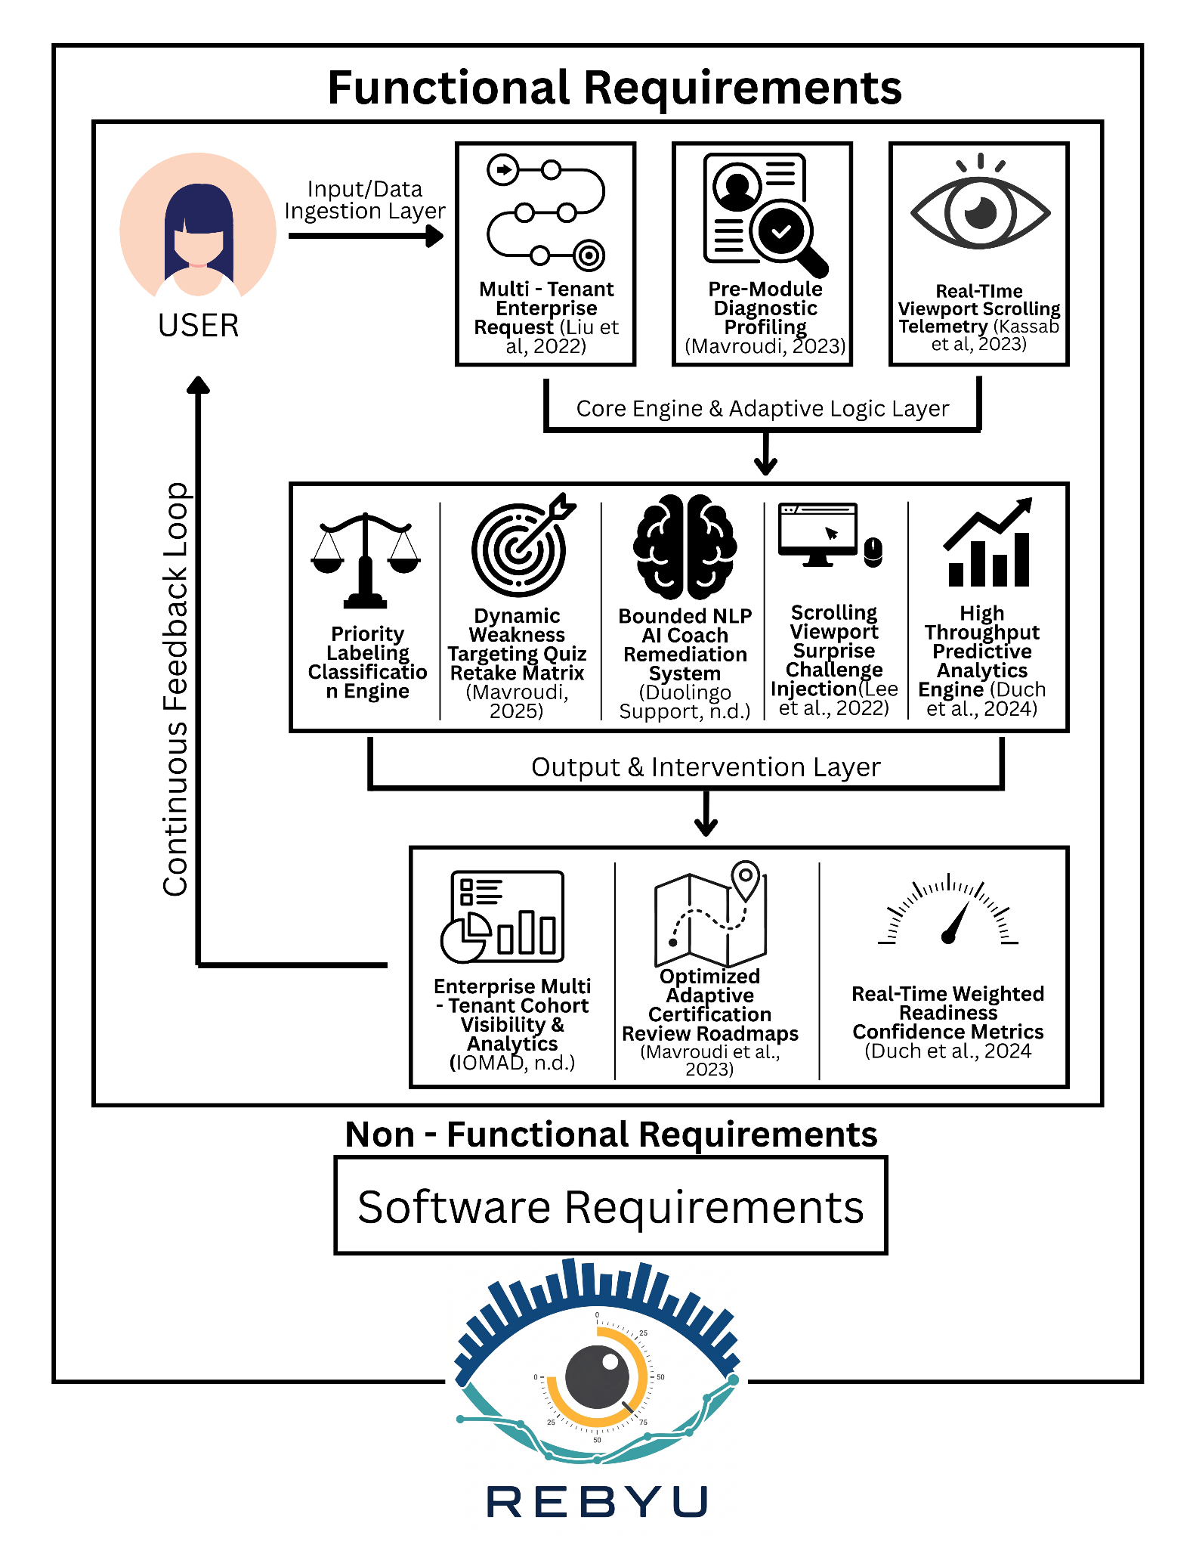
Figure 1: REBYU’s Conceptual Framework
The conceptual framework of the REBYU platform is structured around an Input-Process-Output (IPO) model that integrates multi-tenant architecture, adaptive evaluation, and behavioral telemetry to address the limitations of traditional, static review systems. The Input Layer serves as the primary data-ingestion point, establishing the initial system environment and user baselines. According to Li et al. (2022), handling Multi-Tenant Institution Requests is necessary to isolate institutional cohorts and their respective data securely. Furthermore, according to Mavroudi et al. (2023), conducting Pre-Module Diagnostic Profiling is vital for accurately determining a learner's preliminary knowledge boundaries. Simultaneously, this layer captures Real-Time Viewport Scrolling Telemetry because, according to Kassab et al. (2023), continuously logging active reading pacing and engagement metrics is required to track true participation.
These ingested baseline and behavioral variables are then routed into the Process Layer, which acts as the core analytical and interventional engine. Within this layer, the Dynamic Weakness-Targeting Quiz Retake Matrix processes performance data, thereby heavily weighting subsequent assessments toward specific error clusters. At the same time, a High-Throughput Predictive Analytics Engine evaluates continuous progress. To actively counteract passive study habits, the Scrolling Viewport Surprise Challenge Injection module programmatically disrupts reading patterns when telemetry flags attention drift, a mechanism validated according to Lee et al. (2022). Additionally, according to Duolingo Support (n.d.), a Bounded NLP AI Coach can be successfully utilized to provide strictly curriculum-aligned remediation without hallucinations.
Finally, the Output Layer translates these processed variables into actionable instructional data. According to IOMAD (n.d.), administrators have access to Institution Multi-Tenant Cohort Visibility and Analytics for macro-level institutional tracking. Concurrently, according to Duch et al. (2024), individual learners must be provided with Optimized Adaptive Certification Review Roadmaps and Real-Time Weighted Readiness Confidence Metrics to accurately estimate student performance. This continuous flow ensures that both cognitive performance and behavioral sincerity are measured, resulting in a highly responsive and data-driven ecosystem for examination preparation.

Review of Related Studies
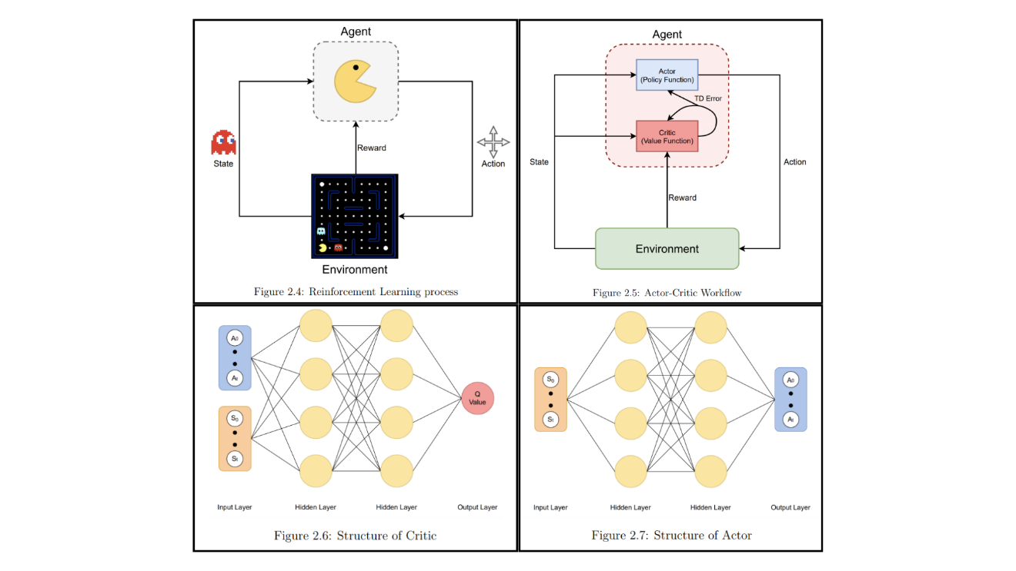
Figure 2: Algorithmic Knowledge Tracing by Farrell (2021)
According to Farrell (2021), an intelligent pedagogical system was investigated to conduct an empirical, comparative analysis of modern knowledge tracing (KT) algorithms and train adaptive recommendation agents without the early necessity of human learners or massive historical datasets. The study charts performance variations across Bayesian Knowledge Tracing (BKT), Performance Factors Analysis (PFA), and Deep Knowledge Tracing (DKT) using open-source student sequence datasets. Leveraging these mathematical baselines, the system develops a BKT-driven learner simulator that successfully models student skill states, guesses, and slips, which is then utilized to train an Actor-Critic reinforcement learning agent to optimize curriculum delivery using Temporal Difference (TD) error variables.
However, this research remains strictly confined to algorithmic simulations, backend data model validations, and open-source command-line outputs, lacking a production-grade web application deployment or secure authentication interface for end-users. The underlying simulation model also treats competencies as entirely independent nodes, ignoring institution-level cloud distribution or cross-institutional user management. While Farrell (2021) establishes the theoretical paradigm that learner simulators can successfully prepare reinforcement learning agents to combat informational overload, REBYU materializes this concept into a customer-facing, mobile-responsive web infrastructure that maps simulated validation data directly onto live, multi-tenant academic environments.
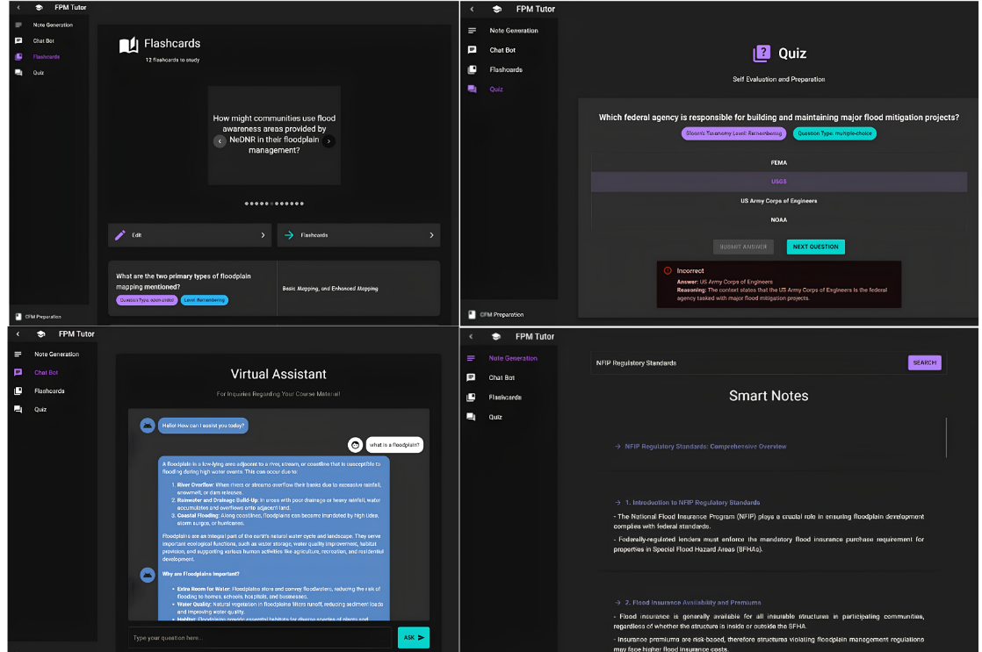
Figure 3: Bounded RAG Frameworks by Sajja et al. (2025)
According to Sajja et al. (2025), an AI-assisted vocational educational framework was engineered to streamline professional development and exam preparation for the Certified Floodplain Manager (CFM) certification. To establish a comprehensive, accurate knowledge base, the tool uses a sophisticated document parsing workflow (leveraging NOUGAT and Mathpix Markdown) to convert unstructured state and federal policy publications into clean, high-fidelity formats. These text segments are tokenized into high-dimensional numerical vectors using OpenAI embeddings, indexed in a Qdrant vector database, and processed via a Retrieval-Augmented Generation (RAG) pipeline with ChatGPT-4o-latest to automatically generate adaptive quizzes, dynamic study notes, personalized flashcards, and interactive tutoring responses.
Despite achieving high accuracy scores across both open-ended and structured multiple-choice question spaces, this framework is tied exclusively to a single professional regulatory domain and does not offer functional adaptivity outside its preloaded documentation. It also features no native background metrics to track learner interaction logs or evaluate cognitive engagement patterns during study sessions. While Sajja et al. (2025) validate that a domain-bounded RAG assistant can effectively enhance high-stakes vocational exam outcomes, REBYU transfers this methodology to the technical computing domain (targeting tracks like TOPCIT, IT Passport, and FE), pairing the RAG architecture with telemetry-driven attention monitoring and multi-metric readiness analytics.
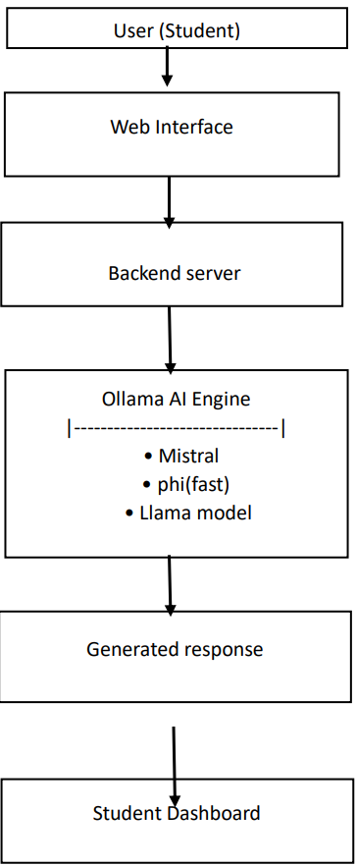
Figure 4: Local Ollama Chatbot by Rajapandian (2026)
According to Rajapandian and Priyadharshini (2026), an AI-powered learning and revision system was engineered leveraging Natural Language Processing (NLP) and chatbot technology to deliver instant academic doubt clarification and automated student revision guidance. The architecture integrates a lightweight Python Flask backend, a MySQL database configuration for storing user details, quiz states, and chat histories, and a user-facing frontend constructed using HTML, CSS, JavaScript, and Bootstrap. To generate contextual, dynamic educational explanations rather than rigid, predefined answers, the platform embeds open-source Large Language Models (LLMs)—specifically Mistral, Phi, and Llama—executed locally via the Ollama AI engine.
However, this implementation relies entirely on open-ended, local prompt execution without enforcing explicit database knowledge walls, leaving the framework vulnerable to language model limitations and potential generation inaccuracies. Furthermore, the platform operates as a standalone, single-tier system lacking structural mechanisms for cross-institutional grouping or advanced client-side behavioral monitoring. While Rajapandian and Priyadharshini (2026) illustrate the baseline viability of running open-source LLMs locally for student doubt resolution, REBYU distinguishes its architecture by implementing strict Retrieval-Augmented Generation (RAG) guardrails to eliminate hallucinations entirely, embedding these tools within a nested multi-tenant institution framework.
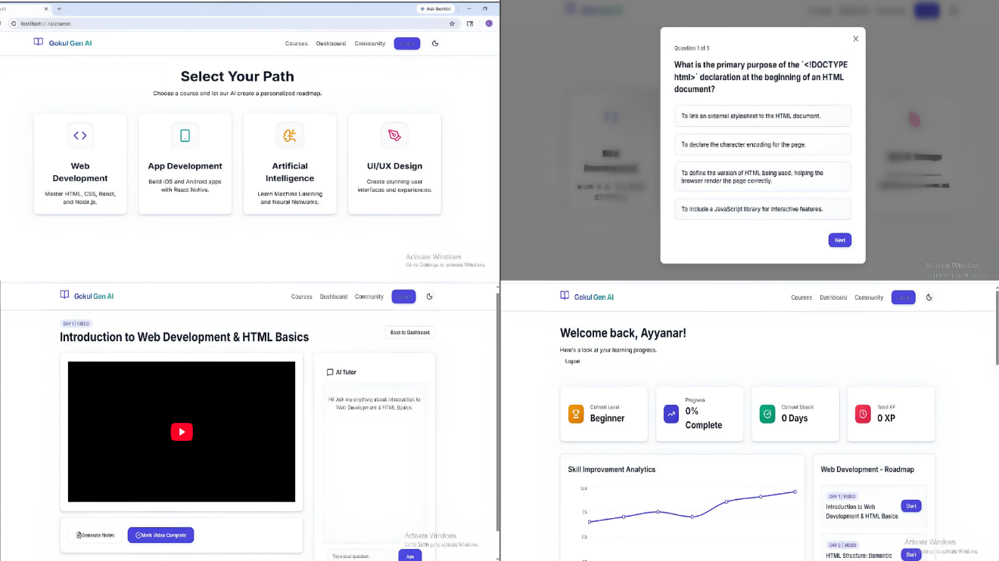

Figure 5: Gemini Adaptive Roadmaps by Kumar et al. (2026)
According to Kumar et al. (2026), an AI-powered adaptive e-learning platform was developed to resolve the one-size-fits-all limitations of traditional online systems by providing highly personalized learning paths. The platform utilizes the Google Gemini Large Language Model API to dynamically generate customized learning roadmaps and adaptive difficulty quizzes based on real-time student tracking, pace, and individual preferences. Built using a React frontend alongside a Node.js and Express backend server, the application maintains data persistence via a PostgreSQL database, secures user sessions with JWT encryption, and reinforces user retention through gamification components like XP rewards, milestone achievements, and streak tracking.
However, this system evaluates student progress using historical accuracy trends and lesson completion metrics, leaving it incapable of monitoring passive scrolling habits, distraction patterns, or superficial text skimming. Additionally, the architecture focuses on general technical bootcamps (such as basic UI/UX design and web development) without accommodating multi-tenant administrative isolation for distinct university networks. While Kumar et al. (2026) show how commercial APIs can personalize structured curriculum roadmaps, REBYU introduces native background telemetry scripts to capture client-side viewport locking velocity, providing multi-metric confidence analytics partitioned safely across independent university cohorts.

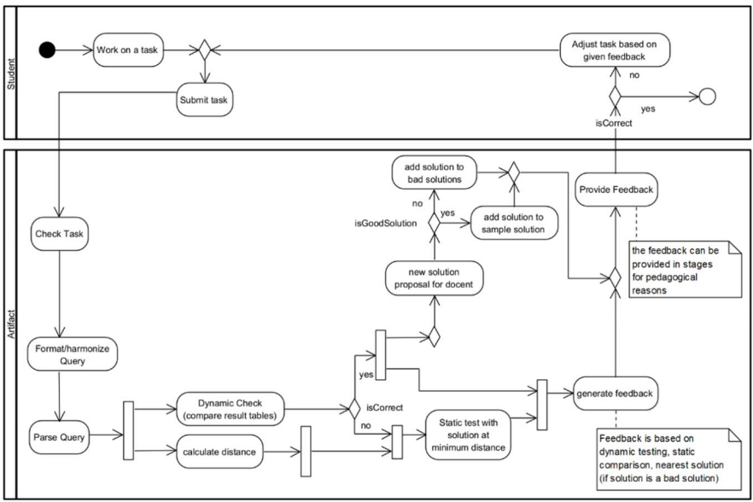
Figure 6: ItsSQL Platform by Aguirre Reid et al. (2023)
According to Aguirre Reid et al. (n.d.), an intelligent tutoring system named ItsSQL was engineered to guide database query learning and provide personalized, real-time feedback while minimizing instructor rule authoring overhead. The architecture employs a hybrid approach that combines dynamic execution testing—utilizing a test database with datasets unknown to students—with static tree analysis to parse code submissions into hierarchical syntax structures. To avoid forcing compliance to a single baseline answer, the platform maintains an automatically expanding repository of multiple "good" and "bad" reference solutions, mapping individual student approaches via clause-specific semantic distance metrics and an eighteen-rule query harmonization pipeline.
However, this implementation remains strictly confined to database-specific command syntax (specifically SELECT statements), rendering it incapable of evaluating open-ended technical tracks or accommodating broader non-query computer science curriculum modules. Furthermore, the system operates without conversational language processing models, multi-tenant institution isolation across separate university networks, or client-side attention telemetry to monitor physical user engagement logs. While Aguirre Reid et al. (n.d.) demonstrate how syntax tree alignment and query harmonization can successfully diagnose logical coding errors without restricting student creativity, REBYU advances this adaptive paradigm by utilizing background viewport tracking to detect passive text skimming, mapping student focus directly via programmatic Bayesian Knowledge Tracing inside a secure, nested multi-tenant cloud framework.
Table 1: Comparative Matrix of Related Systems

The comparative matrix below evaluates the technical features and unique capabilities of REBYU against those of established educational platforms and adaptive systems described in the contemporary literature.

Table 1
COMPARATIVE MATRIX
Features | REBYU Platform | Algorithmic Knowledge Tracing (Farrell, 2021) | Bounded RAG Frameworks (Sajja et al., 2025) | Local Ollama Chatbot (Rajapandian, 2026) | Gemini Adaptive Roadmaps (Kumar et al., 2026) | ItsSQL Platform (Aguirre Reid et al., 2023)
Multi-Tenant Routing & Account Isolation | ✓ | X | X | X | X | X
Algorithmic Content Priority Labeling | ✓ | X | X | X | ✓ | X
Dynamic Weakness-Targeting Retakes | ✓ | ✓ | ✓ | X | ✓ | ✓
Bounded NLP AI Coach Remediation | ✓ | X | ✓ | ✓ | X | X
Telemetry-based engagement monitoring | ✓ | X | X | X | X | X
Multi-Metric Confidence Analytics | ✓ | X | X | X | X | X
The data consolidated in Table 1 illuminates a pronounced operational and empirical divergence, separating traditional educational technology paradigms from the multi-layered, cohesive architecture underpinning the REBYU platform. While reviewed systems exhibit competence within isolated operational dimensions—such as Moodle IOMAD’s institution-grade multi-tenant routing, Knewton’s algorithmic priority pathing, and Duolingo Max’s bounded natural language processing (NLP) remediation—they present significant structural fragmentation and fail to synthesize backend administrative control with live behavioral analytics. Crucially, this matrix exposes a prominent gap in contemporary educational software research: the complete absence of native, telemetry-based engagement monitoring in multi-tenant architectures, leaving traditional platforms reliant solely on explicit test scores and ignoring implicit behavioral markers such as reading pacing and attention drift. REBYU resolves this systemic and pedagogical deficit by consolidating institution account isolation with continuous scrolling-viewport analytics, bounded conversational NLP, and a Bayesian Knowledge Tracing (BKT) framework. By unifying these components into a single, cohesive ecosystem, the platform bridges the gap between system functionality and end-user data, establishing a novel design benchmark for adaptive learning environments optimized explicitly for high-stakes technical proficiency certification review.

CHAPTER III
DESIGN AND METHODOLOGY

This chapter provides a comprehensive overview of the research design and methodology employed in this study. It encompasses the specific method used, the step-by-step study flow, the research environment, the characteristics of the respondents, the 5-point Likert scale instrument utilized for data collection, the detailed research procedure, the process of data collection, the statistical treatment involving weighted mean, and the ethical considerations that were evaluated and approved by the Research Ethics Committee.

Research Design
This study explores the analysis, design, development, and implementation of REBYU, a web-based, multi-tenant adaptive IT certification review platform optimized for computing professional certifications. The chosen framework is a descriptive-developmental research design that systematically merges the empirical observation and documentation of user behaviors with the engineering processes required to build an advanced software solution. This hybrid approach enables the observation, documentation, and analysis of current IT certification review practices, student preparation challenges, and user interactions with the adaptive system as they occur naturally, without manipulating variables, while simultaneously governing the technical execution of the platform's architecture.
A descriptive-developmental research design is uniquely suited for technological capstone projects that require both problem identification and system deployment. The descriptive component is used to systematically observe and interpret the current state of a phenomenon as it naturally occurs. It does not involve manipulating variables; instead, it focuses on gathering detailed information to help identify patterns, problems, and relationships. In this study, it is applied to understand existing exam-preparation practices, user experiences, and system performance within real-world academic conditions. Selecting this dual approach is critical in aligning the system objectives with user-centric feedback and performance evaluation, especially when dealing with AI-integrated and adaptive learning technologies.
Concurrently, the developmental component provides the operational structure for the system's software engineering lifecycle. It establishes the technical blueprint for prototyping, coding, and implementing REBYU's core automated behaviors—including the pre-module diagnostic profiling engine, pyBKT-driven latent topic mastery tracking, a bounded NLP AI Coach, viewport scrolling telemetry, and secure multi-tenant routing data isolation. Embedding Natural Language Processing (NLP) and predictive analytics within e-learning frameworks facilitates immediate data processing, seamless remote accessibility, and optimized decision-making dynamics that demand a comprehensive grasp of both technological infrastructures and human-centric variables. It underscores the importance of adopting a methodology that not only captures technical performance metrics but also reflects user experiences and operational ease. Consequently, this dual focus supports the study's reliance on a descriptive-developmental methodology, which is instrumental in gathering comprehensive, unbiased data on the performance, usability, and overall pedagogical impact of the REBYU system. By employing descriptive-developmental research, the study ensures a holistic assessment that successfully bridges the gap between software system functionality and end-user satisfaction.

Method. This investigation will employ a quantitative research design, utilizing the systematic collection and empirical analysis of numerical datasets to objectively clarify, model, and describe the observed system behaviors. The primary objective of this method is to present factual, objective insights, focusing on the application's measurable impact on student certification readiness rather than on subjective interpretations. Quantitative research emphasizes straightforward interpretations of data, avoiding subjective reasoning or the exploration of multiple methodologies. By using this approach, the study aims to produce clear, precise, and measurable findings that provide a reliable understanding of the REBYU platform's performance, usability, acceptability, and effectiveness in simulating proficiency certification environments for exams such as IT Passport, FE Exam, and TOPCIT.

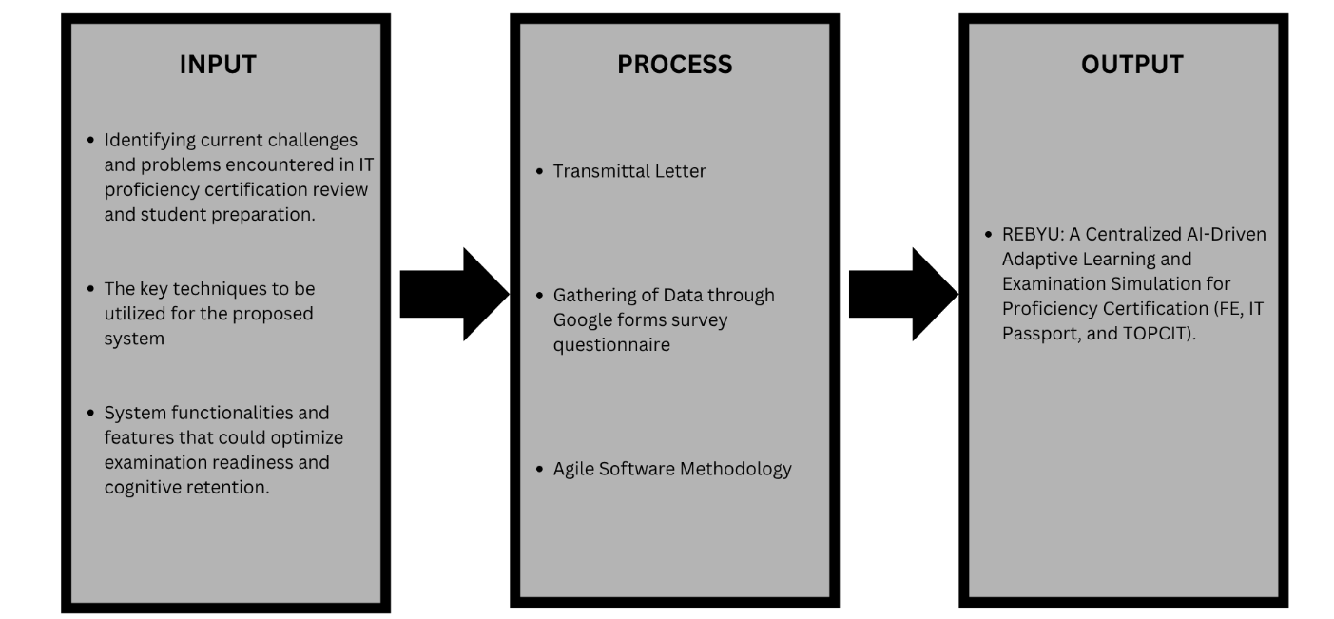
Flow of the Study. The diagram depicts a descriptive flow of the study addressing the modern paradigm of technical certification preparation. The study aims to develop REBYU, a centralized AI-driven adaptive learning and examination simulation system for proficiency certification.
Figure 7: Flow of the Study of REBYU
The flow starts by assessing the current landscape of IT certification review workflows and identifying specific student preparation needs, particularly in computing domains. To address these issues and systemic limitations, the study proposes REBYU. This platform utilizes an adaptive learning engine, an NLP-powered AI Coach, and unannounced scrolling surprise challenges to synthesize learner data and generate predictive readiness insights. In conducting the research, a descriptive-quantitative methodology will be employed, primarily relying on the administration of researcher-developed survey questionnaires. These questionnaires will be distributed via Google Forms to accommodate students’ workflows. Complementing this data collection strategy, the study also embraces an Agile Software Methodology as its framework for system development and project management. The outcome is REBYU, a fully functional multi-tenant application that bridges the gap between passive independent study and institutional-grade review metrics.

Research Environment

Figure 8: Local Map of the University of Cebu Lapu-Lapu and Mandaue
The study will be conducted at the University of Cebu Lapu-Lapu and Mandaue (UCLM), located along A.C. Cortes Ave., Looc, Mandaue City, Cebu. This research environment was selected because it is the most relevant setting for the proposed platform, as the target respondents are students enrolled in Computing Programs (Computer Science, Information Technology, and Computer Engineering) who are actively preparing for or are required to take proficiency certification exams like IT Passport, FE Exam, and TOPCIT. The university setting provides immediate access to a population with direct academic stakes in technical certification pipelines, making it appropriate for evaluating an adaptive software review framework.
UCLM is also a practical environment for the study because it allows the researchers to gather data from students within a structured academic context where technology-based instruction and e-learning systems are already integrated. Selecting this environment enables the researchers to gather real-world insights on user interactions with REBYU, highlighting potential student-centric challenges related to digital literacy, study habits, distraction, and engagement. By engaging directly with students and faculty inside their natural educational environment, the study can accurately evaluate the system's operational feasibility, institutional scalability, and potential to close service gaps in professional IT training.
Research Respondents. The study's respondents are drawn exclusively from certification examinees and participants within the computing domain at the University of Cebu Lapu-Lapu and Mandaue (UCLM). The target cohort is strictly limited to UCLM individuals aligned with the university's technical certification tracks. This includes participants from the BS Information Technology (BSIT) and BS Computer Science (BSCS) tracks under the College of Computer Studies, alongside the BS Computer Engineering (BSCpE) track under the College of Engineering. These participants are selected through purposive sampling, as the study requires individuals who are either planning to take, currently reviewing for, or have already completed high-stakes computing proficiency evaluations, namely the FE Exam, IT Passport, and TOPCIT. This sampling methodology ensures that the gathered data reflects highly informed, technically grounded evaluations regarding e-learning adaptivity, predictive diagnostics, and exam-simulation features. The study establishes an ultimate target of 500 clean, validated respondents for its final evaluation lifecycle. Accounting for the real-world demographic distribution at UCLM where the population is heavily concentrated in the Information Technology track with smaller, specialized cohorts in Computer Science and Computer Engineering, an initial partial pool of 112 raw responses has been collected. Following the application of data-preprocessing and algorithmic quality cleaning routines, 33 invalid or insincere entries were excluded, leaving a current progressive baseline of 79 validated examinees. The empirical distribution of this current partial sample size is structured as follows:

Table 2: Distribution of Respondents
DISTRIBUTION OF RESPONDENTS
College Affiliation | Specific Target Group | Sample Size (f) | Percentage (%)
College of Computer Studies | BS Information Technology (BSIT) | 57 | 72.15%
College of Computer Studies | BS Computer Science (BSCS) | 12 | 15.19%
College of Engineering | BS Computer Engineering (BSCpE) | 10 | 12.66%
Total |  | 79 | 100.00%
This weighted distribution ensures that the platform is heavily validated by the primary student demographic (BSIT) while still maintaining a proportional representation of evaluation from the smaller BSCS and BSCpE programs, alongside institutional oversight by institution administrators.
Research Instrument. Central to the empirical data acquisition process of this study is a custom-developed survey instrument, a researcher-developed questionnaire that uses a 5-point Likert scale to quantify participants’ agreement on existing review constraints, core system functionalities, technical usability, and the pedagogical efficacy of the REBYU platform. The questionnaire is systematically divided into five cohesive sections, each addressing a specific operational component of the research framework. Section 1 focuses on Demographics and Academic Profiling to collect baseline background information on the respondents, including fill-in-the-blank items for age, along with multiple-choice selections for gender, primary user classification, specific computing program tracks, and a multi-select checklist for target IT certification examinations. Section 2 explores Current Review Practices and Architectural Limitations by assessing the participants’ existing exam-preparation habits, measuring the primary format of currently used review materials, the perceived capability of users to track their true examination readiness, and targeted statements evaluating user dissatisfaction regarding linear content distribution, passive reading vulnerabilities, and productivity drops linked to scattered review files. Section 3 covers Feature Evaluation for the Adaptive Framework and Diagnostics to assess the perceived relevance and technical necessity of REBYU’s core automated algorithmic behaviors, using a balanced matrix of positive and negative statements evaluating pre-module diagnostic profiling, performance-threshold analytics during retakes, and the predictive capability of a confidence-level metric. Section 4 covers Feature Evaluation for Interactive System Modules, focusing directly on the native interface requirements, interaction workflows, and structural necessity of REBYU’s core functional components, where respondents rate the usability and design validity of the Viewport Scroll Injector, the Bounded NLP AI Coach, and the Isolated Multi-Tenant Routing setup. Finally, Section 5 presents Overall System Acceptability Criteria to assess the strategic potential and systemic impact of the complete REBYU learning architecture, and collects definitive user feedback on whether the system satisfies high-level acceptability criteria across four core dimensions: Functionality, Usability, and Reliability.
Research Procedure. The study employs a descriptive-quantitative research design to systematically observe, document, and analyze current IT examination preparation practices, student user needs, and the technical viability of the REBYU platform. This design focuses on gathering detailed information about digital learning barriers and user interactions without manipulating artificial variables, enabling accurate identification of core issues in proficiency training. A structured survey utilizing a 5-point Likert scale framework enhances the quantitative reliability of findings on learning retention and e-learning adaptivity.
The step-by-step process begins with assessing the contemporary IT certification review landscape through literature reviews and student needs analysis, followed by the architectural system design, multi-tenant prototype development, iterative usability evaluations, and acceptability testing across student groups. Survey questionnaires target specific computing demographics, passive study vulnerabilities, feature preferences, and adoption barriers and are distributed purposively to validate REBYU’s operational relevance. This procedural flow explicitly structures tracking parameters around key certification bodies like TOPCIT, IT Passport, and FE Exams.
Before data collection, the researchers secure formal ethical approval from the University Research office, including signed Proposal Hearing Forms from the project chairman and academic adviser, as well as standard protocol submissions and administrative review. Post-approval, formal transmittal letters are forwarded to the Dean of the College of Computer Studies and the relevant department heads to facilitate the seamless distribution of questionnaires and platform validation.
Gathering of Data. Data collection provides essential quantitative data for statistical analysis by capturing precise user insights into learning gaps, platform feature performance, and instructional usability. The researchers prepare formal transmittal documents and a researcher-made questionnaire for administrative approval by the Dean of the College of Computer Studies. Upon clearance, coordination is established with computing faculty members to facilitate systematic deployment.
The structured questionnaires are distributed to the identified respondents, comprising active computing students and institutional administrators, via Google Forms to maximize reach and ensure accurate submissions. The deployment targets specific student populations across the Computer Science, Information Technology, and Computer Engineering tracks who face critical resource-access issues, constraints on passive learning, or upcoming certification deadlines. Data cleaning is executed via strict integrity checks to eliminate blank, incomplete, or highly inconsistent entries before processing. The finalized, retrieved data sets populate specific analytical profiles covering computing tracks, historical preparation methods, behavioral vulnerability trends, and feature priorities (such as real-time AI remediation and scrolling surprise challenges).
Statistical Treatment of Data. To extract objective, data-driven conclusions from the collected quantitative profiles, the researchers employ frequency distributions, percentage calculations, weighted means, and structured Likert scoring intervals. These techniques transform raw customer feedback patterns into structured, actionable insights that validate REBYU’s core development objectives.
Frequency and Percentage. Frequency and percentage distributions illustrate the prevalence of responses across the validated respondent groups, effectively quantifying issues such as linear review limitations, student distraction rates, and technical access constraints. These distributions help categorize the baseline representation of specific computing tracks and historical exam failure rates, guiding feature optimization for the platform’s multi-tenant settings.
Weighted Mean. Weighted mean analysis is applied to interpret the 5-point Likert-scale data, calculating average agreement levels across all system parameters using the standard arithmetic formula:
$$\overline{x}=\frac{Σ(f∙w)}{Σf}$$
Where:
$\overline{x}$ = the calculated weighted mean
$f$ = the frequency of responses for a given score
$w$ = the assigned weight of the scale item (1 to 5)
This metric identifies critical feature priorities, verifies the perceived acceptability of the adaptive learning framework and viewport-scrolling challenge injectors, and assesses the accuracy of the predictive Confidence Level metric.
Scoring Procedure. Feedback concerning the proposed features, systemic usability, and pedagogical effectiveness in mitigating passive study habits through AI-driven tracking is structured using a consistent scoring matrix.
Table 3: Scoring Points
Scale | Description | Range Interpretation
5 | Strongly Agree (SA) | 4.21 – 5.00: Very Important / Highly Acceptable
4 | Agree (A) | 3.41 – 4.20: Important / Acceptable
3 | Neutral (N) | 2.61 – 3.40: Neutral / Undecided
2 | Disagree (D) | 1.81 – 2.60: Not Important / Not Acceptable
1 | Strongly Disagree (SD) | 1.00 – 1.80: Not at all Important / Unacceptable
This 5-point evaluation framework ensures consistent statistical interpretation across all questionnaire metrics targeting system functionality, reliability, and e-learning acceptance.
Ethical Considerations. Ethical research practices for REBYU: A Centralized AI-Driven Adaptive Learning and Examination Simulation System for Proficiency Certification adhere strictly to formal university and institutional protocols to protect all student and administrator respondents, ensuring maximum data integrity in learning analytics and examination logs. This alignment follows national educational technology research parameters emphasizing user anonymity and complete data confidentiality. The process begins with the University Research office contact, securing formal Proposal Hearing Form signatures from the project chairman and assigned academic adviser, and completing the required administrative processing payments.
A comprehensive research protocol submission is delivered directly to the UC Research System Ethics Committee Chair. This package contains the exhaustive system architecture protocol, the researcher’s curriculum vitae, and researcher-developed informed consent forms that explicitly highlight voluntary Participation and the right to withdraw or have data deleted at any juncture of the evaluation lifecycle. Post-review clearance confirms strict data anonymity, the total exclusion of Personally Identifiable Information (PII) sharing with external third parties, and secure data aggregation. It is vital when processing sensitive AI-driven adaptive learning metrics, including topic mastery levels, response times, and predictive proficiency scores involving student populations preparing for IT Passport, FE Exam, and TOPCIT certifications.
These protective safeguards fully comply with the guidelines of the Philippines’ Data Privacy Act of 2012 (RA 10173) for digital education systems and software engineering research involving student respondents, ensuring absolute institutional trust. Key ethical protections are systematically audited across several core principles:
Table 4: REBYU's Ethical Principle
Ethical Principle | Implementation in REBYU
Confidentiality | All student data is encrypted; no PII is shared with third parties
Voluntary Participation | Clear opt-in consent; users can withdraw and delete data anytime
Data Minimization | Only collect learning history, exam scores, and topic performance.
Algorithmic Fairness | AI adaptive recommendations audited for bias across gender/socioeconomic groups
Academic Integrity | Simulation questions are original; no copyrighted TOPCIT/DICT/FE content is used.
Transparency | AI explains why topics are recommended (e.g., "You scored 55% in networking")
Accessibility | WCAG 2.1 compliance; Filipino/Cebuano language options available
These measures ensure REBYU maintains ethical integrity while delivering adaptive learning and examination simulation for proficiency certification.

Software Engineering Methodology
To ensure the systematic, high-quality, and iterative development of the platform, this study adopts the Agile Software Development Methodology. Unlike rigid, traditional development models, the Agile framework enables researchers to respond to evolving user requirements, incorporate continuous feedback from test cohorts, and refine the AI analytics and multi-tenant routing modules through repeated development cycles.
Development is broken down into structured sprints, which are organized around the following core phases:
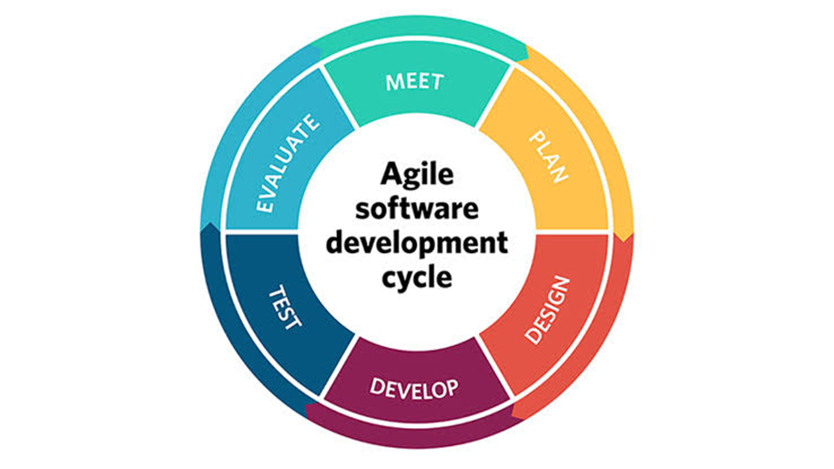
Figure 9: Agile Methodology Diagram
Planning Phase. The project lifecycle begins with identifying the explicit requirements of computing students and institution administrators. During this phase, the core scope of the three certification tracks (FE Exam, IT Passport, and TOPCIT) is outlined, and development timelines are mapped out using Gantt charts.
Analysis and Design Phase. The system architecture is established during this phase. Detailed Use Case Diagrams, Data Flow Diagrams (DFDs), and Entity Relationship Diagrams (ERDs) are designed to map out multi-tenant data isolation, user dashboards, and the logical integration of the NLP-powered AI Coach.
Development Phase. During this stage, the REBYU technology stack is actually coded. Key modules, such as the pre-module diagnostic profiling engine, the adaptive question-targeting retake engine, and the unannounced scrolling surprise challenge injector, are programmed in parallel sprints.
Testing Phase. Following Agile practices, testing is conducted iteratively throughout the development process. The platform undergoes rigorous unit, integration, and alpha testing to ensure the accuracy of AI-driven confidence-level metrics and the stability of the simulated checkout environment.
Deployment and Evaluation Phase. Once the prototype passes initial quality benchmarks, it is deployed in a closed sandbox environment. User Acceptance Testing (UAT) is then conducted with the target computing students and institution administrators at UCLM to evaluate the system’s overall usability, reliability, and pedagogical effectiveness.
Planning/Conception-Initiation Phase. For this study, the researchers will translate the identified structural review deficiencies, computing student needs, and multi-tenant system requirements into a structured development plan for REBYU. The planning will focus on the system’s approved functions: adaptive pre-module diagnostic profiling, algorithmic content priority labeling, dynamic weakness-targeting quiz retakes, pyBKT-driven latent topic mastery tracking, bounded NLP AI Coach remediation, real-time viewport scrolling telemetry, scrolling viewport surprise challenge injection, multi-tenant institution workspace provisioning, a simulated sandbox transactional checkout environment, and real-time weighted readiness confidence level metrics. The researchers will prepare the Business Model Canvas, program workflow, validation board, business roadmap, functional decomposition diagram, and Gantt chart to define REBYU’s user roles, preparation problems, proposed adaptive solution, feature priorities, development tasks, and project timeline. The team will also consider key system limitations, including the strict exclusion of certification tracks outside the computing domain, programmatic knowledge boundaries that restrict the AI Coach from answering out-of-scope queries, native web interface execution without external third-party code compilers or remote virtual machine sandboxes, and the complete exclusion of live financial payment gateways like GCash, Maya, or Stripe in favor of a closed, simulated transactional sandbox. These planning activities will systematically guide the succeeding design, development, testing, and evaluation of the system.
Business Model Canvas. Functioning as a core architectural tool, the Business Model Canvas maps the systemic mechanics of value generation, deployment, and acquisition, while exposing structural vulnerabilities and pathways for strategic adaptation.
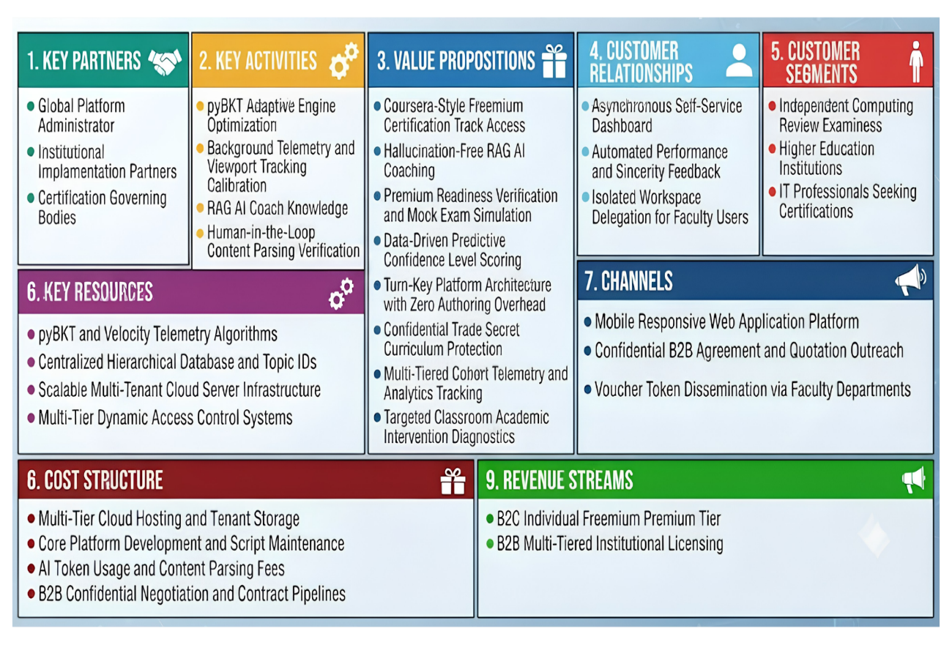
Figure 10: Business Model Canvas
The REBYU Business Model Canvas outlines a hybrid B2B/B2C framework for multi-departmental professional certification preparation within higher education Institutions, strictly excluding national board exams. The platform delivers value through a turn-key multi-tenant architecture featuring unexpected scrolling surprise challenges, hallucination-free RAG AI coaching, real-time cohort telemetry, and predictive Confidence Level scoring. These value propositions are sustained by the Admin team through pyBKT engine optimization and behavioral tracking, utilizing multi-tenant cloud infrastructure and telemetry algorithms. Delivered via a mobile-responsive web platform and voucher tokens managed by Department Heads, REBYU provides self-service dashboards for Learners alongside isolated cohort analytics workspaces for program heads. Finally, cloud hosting and AI operational costs are balanced by direct B2C Learner premium upgrades and B2B institutional licensing.

Program Workflow
The program workflow outlines the overall structure of the system being developed. It defines how the system's functionalities and interactions are organized and how they are intended to operate.

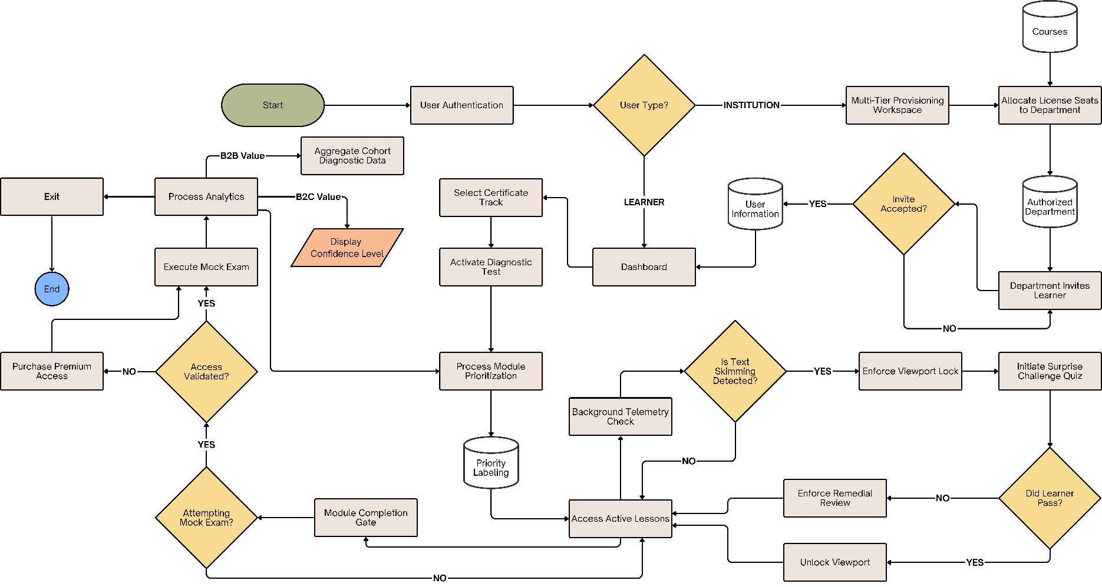
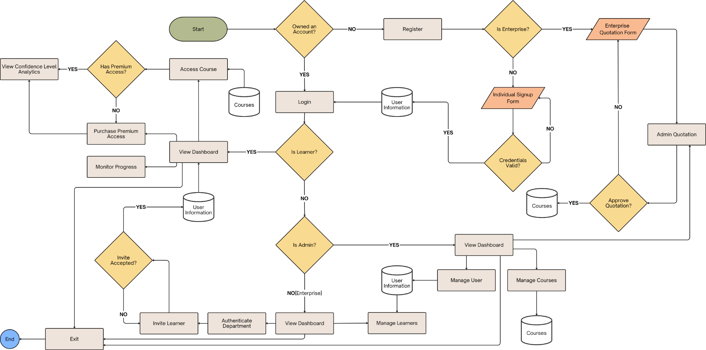

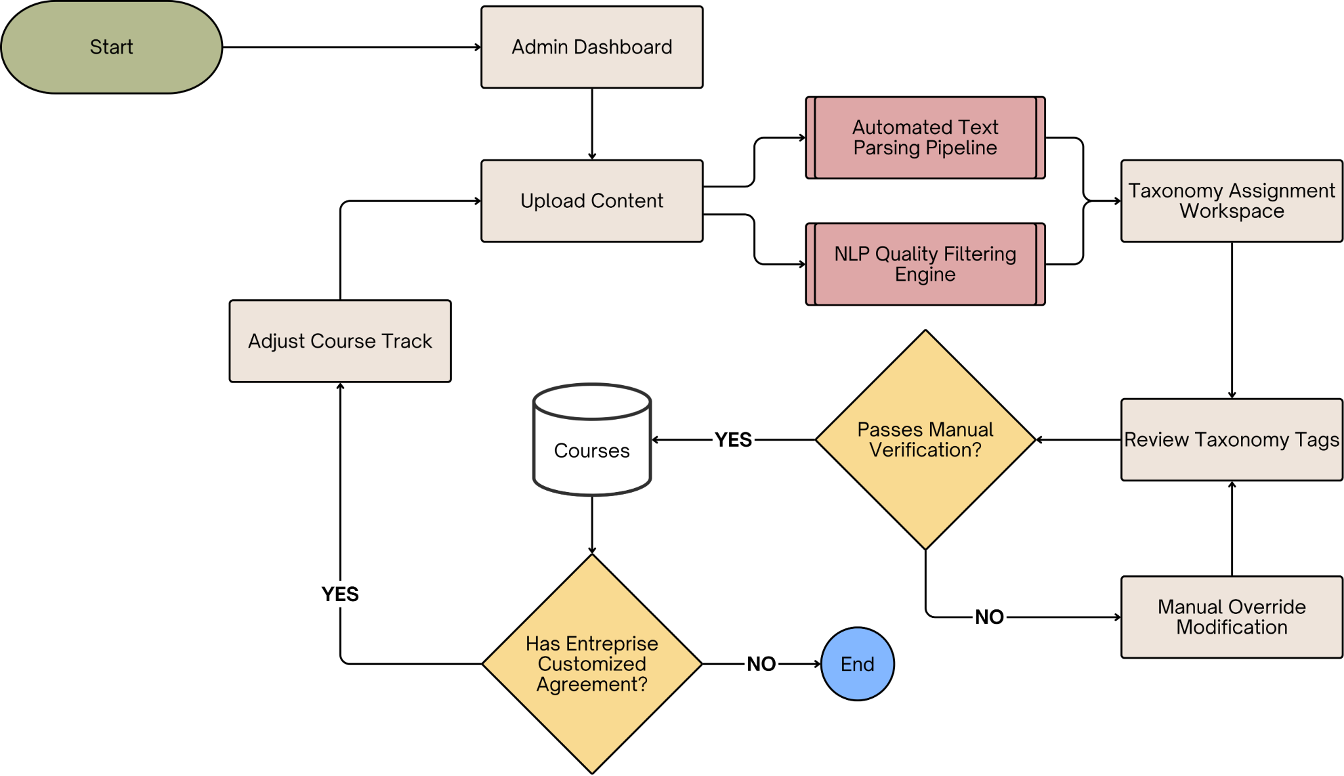
Figure 13: Admin Content Ingestion and Question Population Pipeline
This figure visualizes the platform's background data curation architecture, illustrating the process where unstructured source documents are ingested, programmatically parsed via an NLP quality filter, mapped to specific curriculum taxonomy IDs, and verified through a human-in-the-loop admin staging gate before being committed to the centralized hierarchical database.
Validation Board. A Validation Board functions as a lean, structured framework designed to systematically map, test, and refine core business assumptions before allocating extensive resources to full-scale development. By organizing a project or startup idea into evolving iterations of customer, problem, and solution hypotheses, it forces developers to isolate their riskiest assumptions and design objective experiments around them. As the development team gathers real-world feedback and telemetry, the board acts as a dynamic visual ledger where these critical hypotheses are explicitly marked as validated or invalidated based on strict, predefined success criteria. This continuous feedback loop prevents developmental echo chambers, ensuring the project team can dynamically execute a strategic pivot when evidence dictates a user misalignment, or confidently double down on system modules that demonstrate clear operational value.

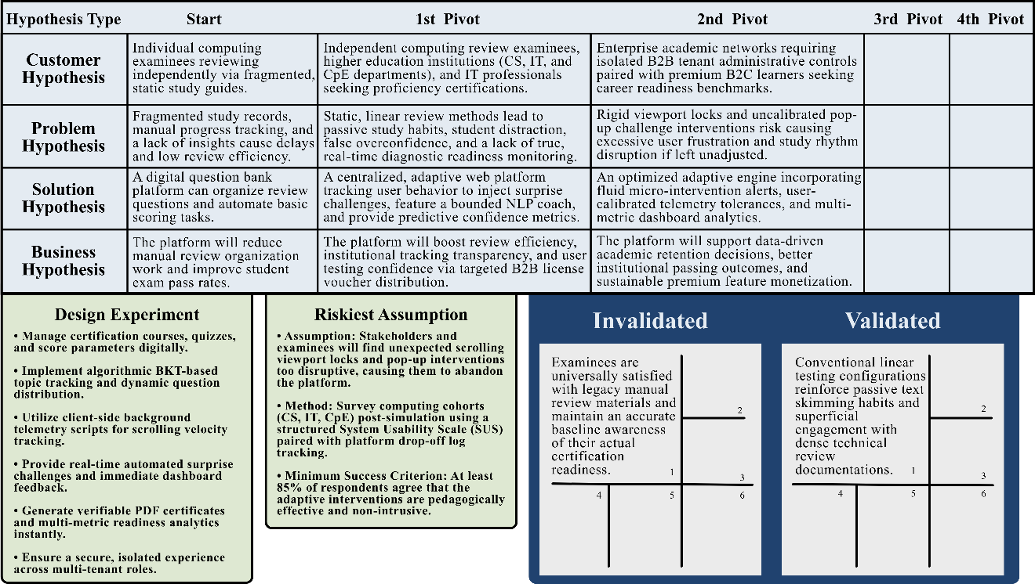

Figure 14: Validation Board of REBYU
The validation board maps the platform's empirical evolution from a basic question bank into a multi-tenant adaptive learning ecosystem. Moving beyond simple tracking delays, the matrix targets critical cognitive vulnerabilities like passive text skimming, student distraction, and false overconfidence by aligning its customer focus with institutional academic networks. The resulting architecture combines client-side viewport telemetry with a programmatic pyBKT framework to actively mitigate superficial reading habits and deliver automated surprise challenges. Tested against an 85% System Usability Scale success threshold, the design experiment successfully invalidated assumptions that examinees possess accurate self-awareness of their actual exam readiness or that background tracking causes interface workflow fatigue. Ultimately, the matrix verified that conventional linear testing directly reinforces passive skimming, while confirming that pyBKT matrices successfully isolate localized student blind spots and accurately map latent topic mastery nodes for robust certification preparation.
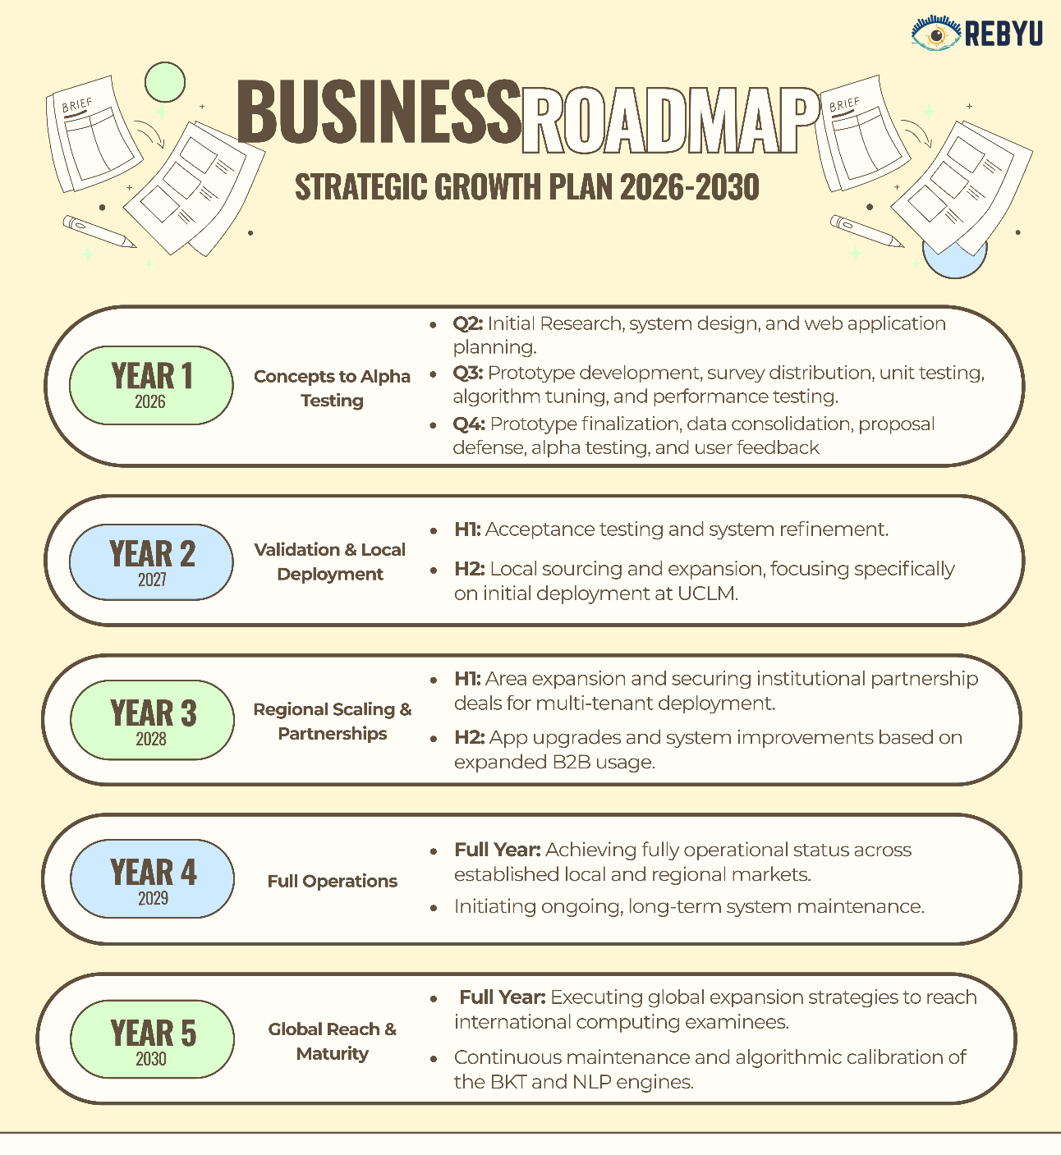
Business Roadmap. A business roadmap serves as a strategic framework that defines a clear objective and maps out the critical development milestones required to execute it. It serves as an essential alignment mechanism, providing high-level plan visibility to coordinate cross-functional efforts while explicitly articulating the rationale for the project's core objectives and implementation strategies.
Figure 15: Business Roadmap
The roadmap begins with initial research, system design, and platform planning in Quarter 2 of 2026. This phase essentially translates to web application planning and setting up a responsive UI environment. It is followed by survey distribution, performance testing, algorithm tuning (specifically calibrating the Bayesian Knowledge Tracing model), and unit testing in Quarter 3 of 2026. Data consolidation, the proposal defense, alpha testing, and the gathering of user feedback are conducted in Quarter 4 of 2026 to validate the system's core adaptive components.

The timeline then transitions to 2027, with acceptance testing, system refinement, and local sourcing/expansion in Quarter 1 of 2027. Subsequent phases focus on area expansion, securing institutional partnership deals for multi-tenant deployment, and system upgrades in Quarter 2 of 2027. This progression leads to a fully operational status, ongoing maintenance, and global expansion by Quarter 3 of 2027.

Ultimately, this structured flow of development and validation facilitates a data-driven instructional adjustment framework. By using learning analytics and predictive readiness metrics across these phases, the roadmap ensures continuous improvement in internal efficiency for institutional tenants and maximizes individual learners' preparedness for examinations.

Functional Decomposition Diagram
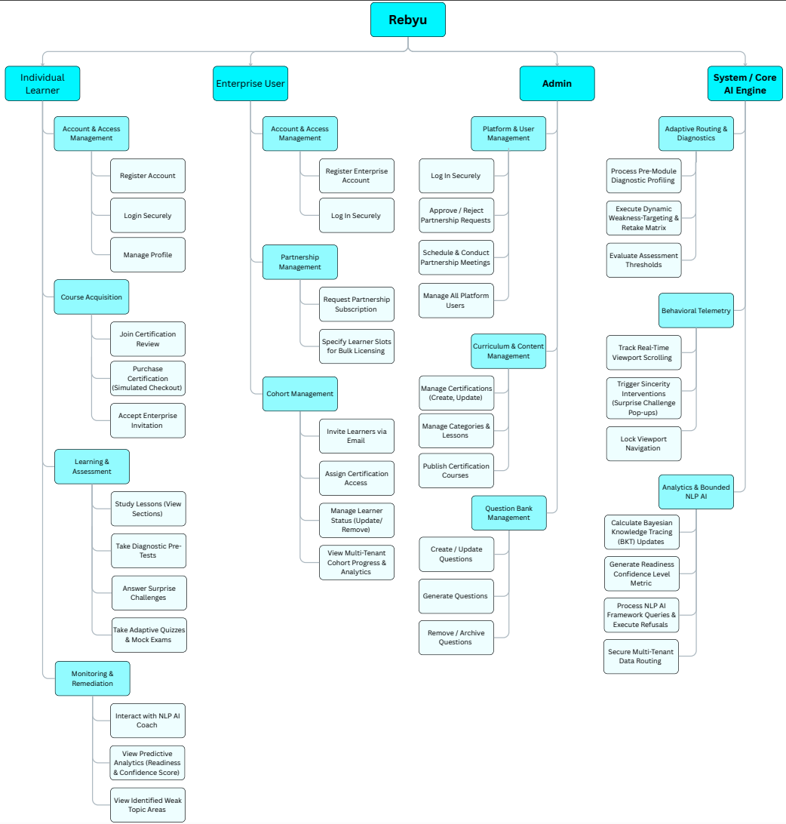
This Functional Decomposition Diagram illustrates the proposed application's capabilities for problem-solving and development.
Figure 16: Functional Decomposition Diagram

Gantt Chart
The Gantt chart is a powerful and prevalent tool in project management, considered essential for both foresight and oversight. It empowers project teams to create and adapt their plans by specifying activities, their durations, interconnections, necessary resources, and potential risks.


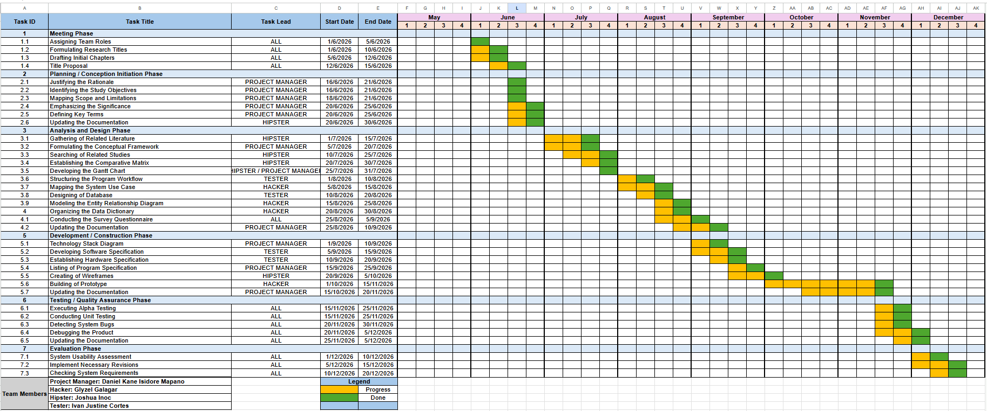


Analysis-Design Phase

The Analysis and Design Phase focuses on developing and organizing the requirements of the proposed application. It includes the AI System Architecture, Use Case Diagrams, Storyboard, Database Design, and Network Design. These diagrams and documents explain how the system will operate and guide the developers throughout the development and implementation process.

AI System Architecture
The of REBYU relies on a centralized, five-layer framework engineered to facilitate learner-centered adaptive review, topic mastery tracking, and real-time AI-assisted support for proficiency certification. The process initiates at the Data Sources layer, which serves as the system's ingestion boundary by continuously capturing comprehensive student performance and behavioral engagement metrics. This layer aggregates data from diverse assessment streams—including pre-assessments, quizzes, middle-category exams, challenges, and mock trials—alongside precise telemetry logs that record unique learner IDs, topic nodes, question variables, submitted answers, correctness results, and response timestamps. Additionally, behavioral logs capturing daily study time, consistency streaks, and physical lesson progression are compiled to provide the baseline records necessary for granular tracking per topic.
Upon collection, these multi-modal streams are immediately forwarded to the Data Processing Layer, which manages the pipeline sanitization and data preparation sequences required by downstream analytical engines. This layer systematically refines raw interaction inputs by removing duplicate logs, reconciling missing attributes, and validating assessment validation criteria. It then groups performance metrics into structured mathematical arrays categorized by unique lesson topic IDs to prepare them for algorithmic analysis. Once formatted, these optimized records are committed to the Centralized Learner Performance Database, a persistent storage repository that houses synchronized tables for student diagnostic scores, activity tracking logs, continuous topic mastery matrices, and localized weak-area records.
The AI Layer serves as the platform's core intelligence, driven by the Topic Weakness and Mastery Analysis Module and the AI Coach Support Module. The mastery module applies the Bayesian Knowledge Tracing (BKT) framework to compute latent topic mastery probabilities, programmatically offloading parameter fitting to the high-performance pyBKT Python library for dynamic updates after each question interaction. Concurrently, the AI Coach Support Module employs a conversational Retrieval-Augmented Generation (RAG) architecture programmatically restricted to preloaded, verified course documentation to deliver focused hints while completely eliminating AI hallucinations.
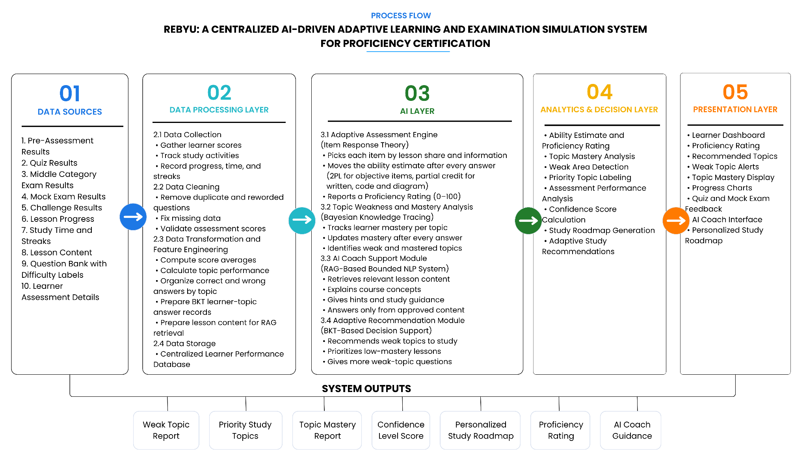
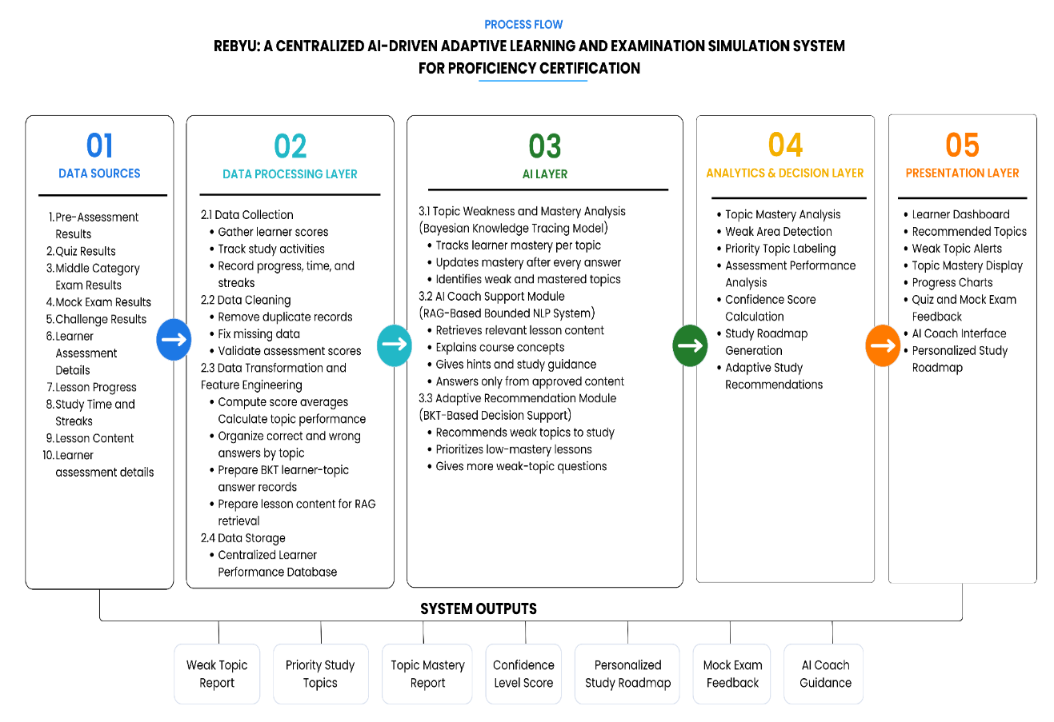
As illustrated in the system diagram, the architecture effectively bridges backend intelligence and actionable student insights through the synchronized downstream execution of the analytics and presentation frameworks. The Analytics and Decision Layer translates real-time cognitive models and RAG outputs into direct pedagogical interventions by evaluating pyBKT mastery indexes to isolate critical learning gaps. This assessment dynamically drives the adaptive recommendation mechanism, systematically increasing the distribution frequency of low-mastery topic IDs within future testing sequences, mock examinations, and surprise challenges. Concurrently, by cross-aggregating cumulative accuracy records with behavioral consistency logs, this layer formulates a multi-metric readiness indicator via the Confidence Score Dashboard. Ultimately, the Presentation Layer serves as the vital user-facing delivery boundary, materializing these complex operational metrics into clear progress tracking charts and customized study roadmaps engineered to streamline the certification pathway.
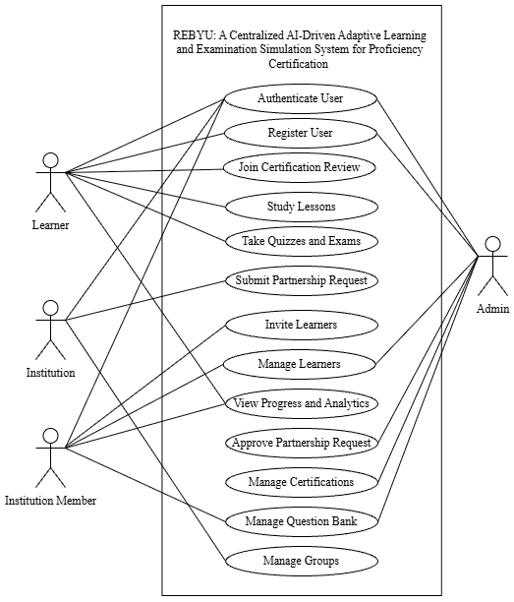
Use Case Diagram. Use case diagrams are also known as behavior diagrams. They illustrate behaviors that certain systems can perform in cooperation with one or more external users.
Figure 18: Business Use Case Diagram of REBYU
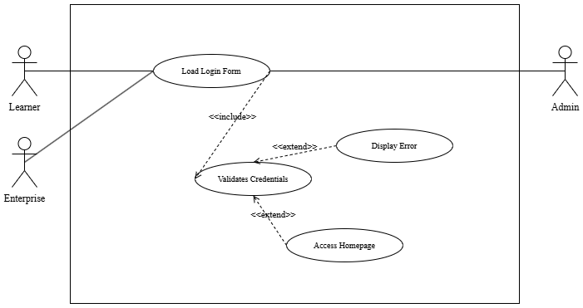
The figure presents the business use case diagram of REBYU, illustrating the interactions among its four primary actors: Institution, Institution Member, Learner, and Admin. It provides a high-level overview of the system’s key business processes and the responsibilities of each actor. The Institution manages partnerships, groups, and learners, while the Institution Member supports the management and monitoring of assigned learners and groups. The Learner accesses certification reviews, learning materials, assessments, and other learning activities. Meanwhile, the Admin oversees platform-wide operations, including partnerships, certifications, users, and other administrative functions.
Figure 19: System Use Case Model – Authenticate User
Use Case Name: | Authenticate and Recover Account
Actor: | Learner, Institution user, Administrator
Brief Description: | A registered user signs in through the Cognito-backed authentication flow. The client obtains a session token and routes the user to the role-appropriate portal; password reset and email verification are available from the authentication screens.
Trigger: | User submits the sign-in form or chooses password recovery.
Pre-Conditions: | The user has a registered account and network access.
Post Conditions / Steps: | A valid session is established or a safe error message is shown; no password is stored by the frontend.
Application
1. Validate credentials through the authentication provider.
2. Store the session securely.
3. Synchronize the current user and load the permitted portal.
4. Display a non-sensitive validation error when authentication fails.
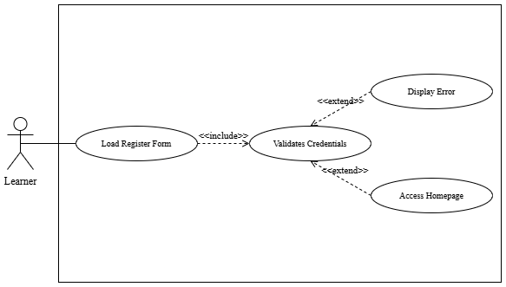Figure 20: System Use Case Model – Register User
Use Case Name: | Register and Verify Account
Actor: | Prospective learner
Brief Description: | A learner creates an account, receives a verification code, and confirms the account before using protected learning features.
Trigger: | User selects Sign Up.
Pre-Conditions: | The e-mail address is not already registered and required fields are supplied.
Post Conditions / Steps: | The account is registered and can be signed in after verification.
Application
1. Validate required fields.
2. Submit registration to the identity provider.
3. Send or resend a verification code.
4. Confirm the code and show the sign-in path.
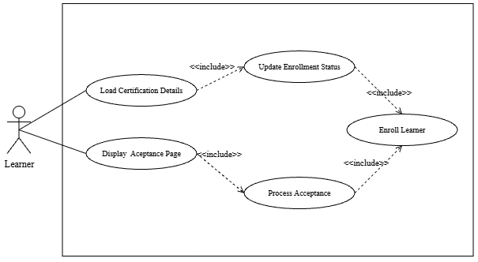
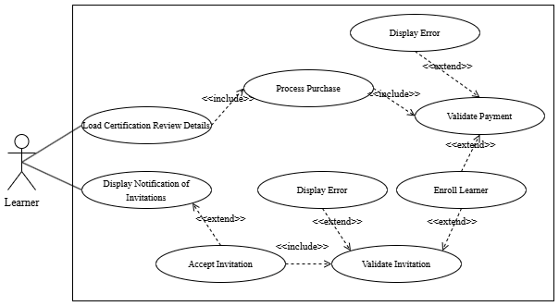
Figure 21: System Use Case Model – Join Certification Review
Use Case Name: | Obtain Certification Access
Actor: | Learner
Brief Description: | A learner accesses a certification through an individual entitlement, checkout flow, or an institution invitation. The portal uses the returned entitlement and enrollment state to control access.
Trigger: | Learner opens a certification, subscription, or invitation path.
Pre-Conditions: | The learner is authenticated; an available certification, entitlement, or valid invitation exists.
Post Conditions / Steps: | The learner receives the certification access permitted by the validated enrollment or invitation.
Application
1. Retrieve entitlement or invitation status.
2. Validate access and capacity when applicable.
3. Create or update the learner's certification access.
4. Return the accessible certification workspace or an error.
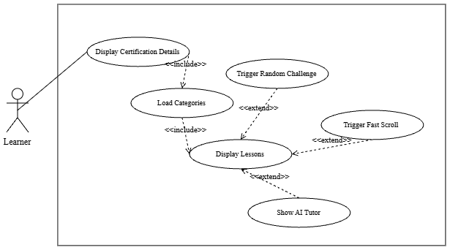
Figure 22: System Use Case Model – Study Lessons
Use Case Name: | Study Lessons and Track Reading
Actor: | Learner
Brief Description: | A learner navigates a published certification's categories, topics, lessons, and lesson components. The application records read sections and completed lessons through learner-progress services.
Trigger: | Learner selects a lesson in the learner workspace.
Pre-Conditions: | The learner is authenticated and has access to the selected certification.
Post Conditions / Steps: | Read-section and completion records are updated when the learner performs the corresponding action.
Application
1. Load the curriculum and lesson structure.
2. Load existing read-section state.
3. Persist read/unread and completion actions.
4. Refresh learner progress.
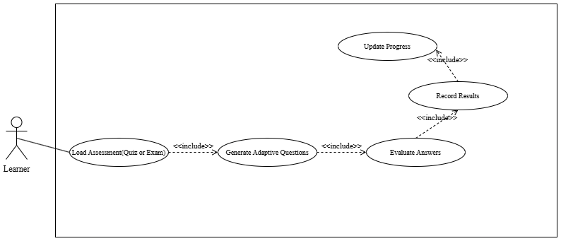
Figure 23: System Use Case Model – Take Quizzes and Exams
Use Case Name: | Take and Review Assessments
Actor: | Learner
Brief Description: | A learner starts an available assessment or practice set, submits responses, and views the result or review. The implementation supports multiple-choice, text, programming, and diagram question workflows where configured.
Trigger: | Learner selects an assessment, recall session, or generated practice set.
Pre-Conditions: | The learner is authenticated and the selected assessment is available under the learner's access rules.
Post Conditions / Steps: | The attempt, answers, result, and review information are persisted and shown according to assessment settings.
Application
1. Create or retrieve the attempt.
2. Save submitted answers and applicable execution/diagram results.
3. Grade the attempt and calculate the result.
4. Return result and review data.
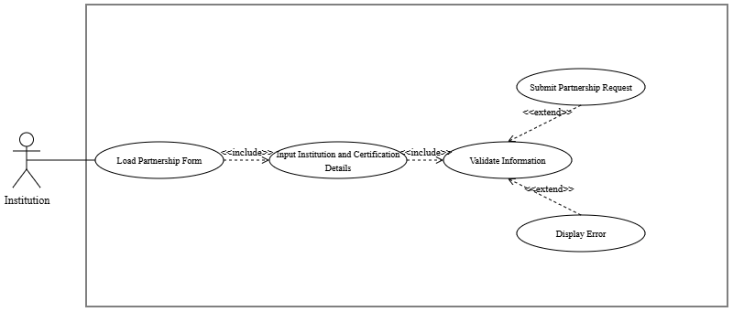 Figure 24: System Use Case Model – Submit Partnership Request
Use Case Name: | Submit Partnership Request
Actor: | Institution representative
Brief Description: | An institution representative submits a public partnership request with institution details and requested certification access. The request can later be checked using its reference information.
Trigger: | Representative opens the Request Access page.
Pre-Conditions: | Required institution and contact details are available.
Post Conditions / Steps: | A pending request and reference information are recorded for administrator review.
Application
1. Validate the request payload.
2. Record the partnership request and requested items.
3. Return a reference number and current status.
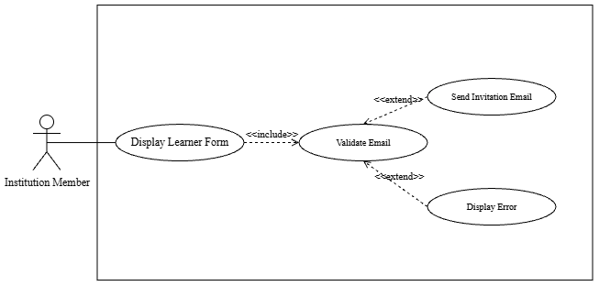
Figure 25: System Use Case Model – Invite Learners
Use Case Name: | Invite Learners
Actor: | Authorized institution or department user
Brief Description: | An authorized institution user sends invitations to learners for a department, section, or allocated certification. The service validates the selected scope and available access before creating invitations.
Trigger: | Authorized user opens the department learner-management view.
Pre-Conditions: | The user is authenticated, authorized, and has a valid allocation.
Post Conditions / Steps: | Invitation records are created; learners can accept the invitation through the account flow.
Application
1. Validate actor authority, recipient details, and allocation.
2. Create invitation records.
3. Return per-recipient success or validation feedback.
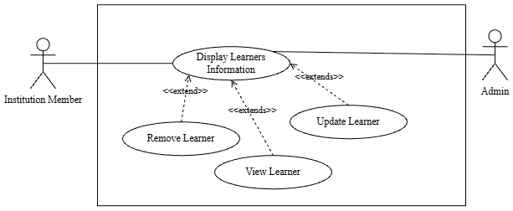
Figure 26: System Use Case Model – Manage Learners
Use Case Name: | Manage Learners and View Institutional Insights
Actor: | Administrator, authorized institution or department user
Brief Description: | Authorized users view permitted learner rosters and drill down into progress and assessment information. Administrators can additionally manage global learner records through administrator services.
Trigger: | Actor opens the learner or department workspace.
Pre-Conditions: | The actor is authenticated and has the required role and scope.
Post Conditions / Steps: | Permitted roster or learner insight data is displayed; an authorized management action is persisted when requested.
Application
1. Enforce role and tenant scope.
2. Retrieve roster and analytics data.
3. Apply the requested authorized change and refresh the view.
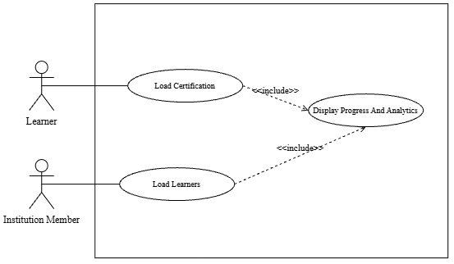
Figure 27: System Use Case Model – Monitor Progress and Analytics
Use Case Name: | Monitor Learning Progress
Actor: | Learner; authorized institution or department user
Brief Description: | The platform displays learner progress, lesson completion, assessments, mastery/priority signals, reward information, and available study-plan information. The exact tiles depend on the actor and available data.
Trigger: | Actor opens a progress, dashboard, or analytics page.
Pre-Conditions: | The actor is authenticated and has access to the relevant learner or institution scope.
Post Conditions / Steps: | Current analytics are displayed; viewing analytics does not change learning records.
Application
1. Retrieve scoped analytics and progress records.
2. Show an empty state when no data exists.
3. Render only data allowed by the actor's role.
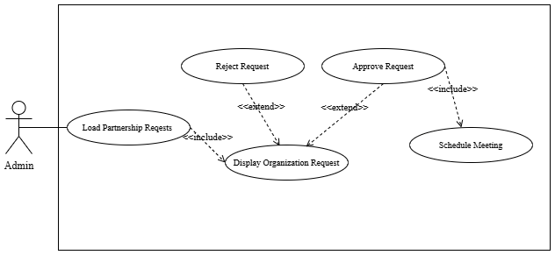
Figure 28: System Use Case Model – Approve Partnerships
Use Case Name: | Review Partnership Requests
Actor: | Administrator
Brief Description: | An administrator reviews submitted partnership requests and records an approval or rejection with remarks. Approval provisions the associated institution access according to the request workflow.
Trigger: | Administrator opens Partnership Requests.
Pre-Conditions: | The administrator is authenticated and a request exists.
Post Conditions / Steps: | The request status and associated provisioning state are updated or the request is rejected with recorded remarks.
Application
1. Retrieve the request detail.
2. Validate the administrator action.
3. Persist the decision and invoke the applicable provisioning workflow.
4. Return the updated status.
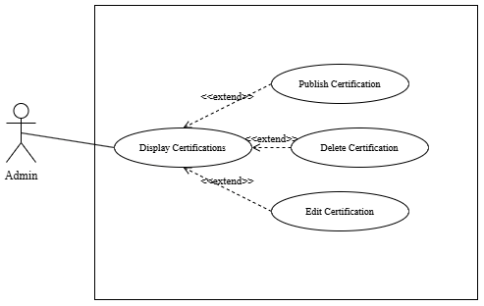
Figure 29: System Use Case Model – Manage Certifications
Use Case Name: | Manage Certifications and Curriculum
Actor: | Administrator; authorized institution or department user where scoped
Brief Description: | Content managers create, edit, publish, and organize certifications, categories, lessons, lesson media, and exam-format data. The application also supports AI-assisted certification generation workflows with review checkpoints.
Trigger: | Actor opens a certification workspace.
Pre-Conditions: | The actor is authenticated and has content-management authority.
Post Conditions / Steps: | Curriculum changes are saved; publication remains subject to the server-side publishing requirements.
Application
1. Enforce scope and validate content.
2. Persist curriculum changes.
3. Report publication requirements or publish the certification when satisfied.
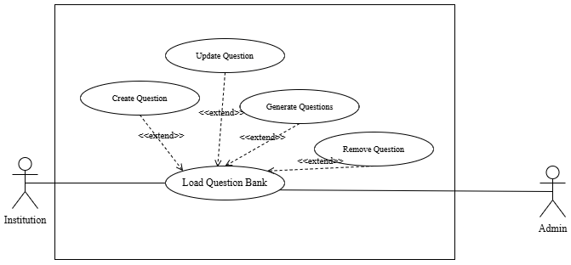
Figure 30: System Use Case Model – Manage Question Bank
Use Case Name: | Manage Question Bank and Assessment Content
Actor: | Administrator; authorized institution or department user where scoped
Brief Description: | Content managers create and edit reusable questions, choices, and type-specific configurations, then assemble and publish assessments. Document import, tagging, and AI-generation flows are available in the relevant workspaces.
Trigger: | Actor opens Question Bank or Assessment Builder.
Pre-Conditions: | The actor is authenticated, has authority over the selected scope, and referenced curriculum records exist.
Post Conditions / Steps: | Question-bank or assessment changes are saved; validation feedback is shown for incomplete or invalid content.
Application
1. Validate authority and data.
2. Persist question/configuration changes.
3. Maintain assessment-question links and return validation or publication status.
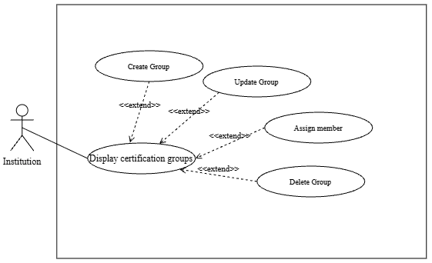
Figure 31: System Use Case Model – Manage Groups
Use Case Name: | Manage Departments, Sections, and Announcements
Actor: | Authorized institution or department user
Brief Description: | Institution users organize learners in departments and sections, assign authorized users, and publish group announcements. These structures determine the scope used by invitations and institutional views.
Trigger: | Actor opens the institution department workspace.
Pre-Conditions: | The actor is authenticated and belongs to the institution with the necessary authority.
Post Conditions / Steps: | Department/section, assignment, or announcement data is created, updated, or removed within the permitted institution scope.
Actor | Application
1. Open the department workspace.  2. Add or update a department, section, assignment, or announcement.  3. Save the change. | 1. Check tenant scope and authority.  2. Validate the selected certification and learner relationships.  3. Persist the change and refresh the scoped workspace.

Storyboard
The storyboard presents a visual narrative that captures the user's journey as they interact with the system. Through a sequence of thoughtfully designed panels, it illustrates how the platform guides users step by step—from initial interaction to successful completion of key tasks.

Screen No: 1

Screen Name: Login Page

Description: The primary gateway for registered users to securely access the REBYU system.

Figure 32: Login Page
Item | Type | Required? | Data Type | Implemented behavior
Email | Email input | Yes | String | Cognito sign-in identifier
Password | Password input | Yes | String | Submitted to authentication provider
Sign In | Button | Yes | Action | Starts credential sign-in
Forgot Password | Link | No | Action | Opens reset workflow
Create Account | Link | No | Action | Opens registration
Logic
- The user navigates to the REBYU web application link. The platform renders the authentication window.
- The user inputs their account email pattern and associated password characters into the corresponding input blocks.
- The user clicks the Sign In button to submit their payload.
  - If any mandatory input container (Email Address or Password) remains null, a dynamic form validation message appears beneath the missing field stating it is required.
  - If the backend service queries the user schema and returns no matching results or detects an invalid password hash combination, the login portal remains static, clears the password field, and displays an explicit error notification: "Invalid email or password structure detected."
  - If the input structures find an exact matching entry in the data tables, the Spring Boot security layer approves the session wrapper. The application's core Role Router reads the client type identifier attribute and swiftly transitions the user to their designated dashboard module.
- If an unauthenticated visitor selects "Forgot password"? Hyperlink: The current viewport dismisses the portal state and loads the standard password token recovery field.
- If the visitor clicks the Create an account redirect action, the browser interface pushes an instant state shift to load the new user registration layout.
Screen No: 2
Screen Name: Account Registration Page
Description: The account registration interface allows new computing candidates and institutional clients to instantiate an account workspace within the REBYU ecosystem.

Figure 33: Account Registration Page
Item | Type | Required? | Data Type | Implemented behavior
First and last name | Text inputs | Yes | String | Learner profile fields
E-mail | Email input | Yes | String | Account identifier
Password | Password input | Yes | String | Credential
Account type | Selection | Yes | String | Setup path
Create account | Button | Yes | Action | Starts registration and verification

Logic
- The user navigates to the signup viewport by selecting the redirect option on the login portal, which loads the displayed layout.
- The user inputs their baseline communication information, username handle, real first and last names, and security credentials into the text containers.
- The user clicks the registration execution button to dispatch the payload string to the application's Spring Boot backend engine.
  - If one or more mandatory field values are null, an inline alert prompts the user to correct the incomplete input.
  - If the text-matching sequences determine that the string values in Password and Confirm Password do not align symmetrically, validation flags a mismatch code.
  - If the text validation matches perfectly, the platform routes a verification sequence query against the central database server.
    - If the system scans existing entities and finds a matching record for the email or username variable, the workflow terminates with an account duplication exception.
    - Else, the PostgreSQL engine creates a unique record instance across the standard user definitions schema, salts/hashes the credential payload string, generates default profiling rows inside the learner profile structures, and transitions the active browser window back to the user login view.
Screen No: 3
Screen Name: Join Certification Catalog & Notification Drawer
Description: The primary catalog page where independent or institutionally sponsored learners browse available computing proficiency certification tracks (IT Passport, FE, and TOPCIT). This screen manages two entry pathways: individual course acquisition via a simulated checkout sandbox or instant enrollment by accepting a multi-tenant institution cohort invitation.


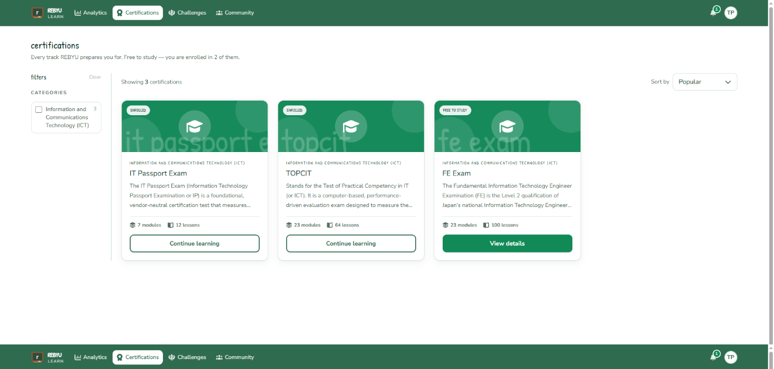
Figure 34: Join Certification Catalog
Item | Type | Required? | Data Type | Implemented behavior
Certification catalog | Card collection | Yes | Object array | Available certifications
Certification card | Card | Yes | Object | Opens selected certification
Subscription action | Button | Conditional | Action | Opens entitlement or checkout flow
Invitation entry | Route | Conditional | Action | Opens invitation acceptance

Logic
- The authenticated Learner navigates to the portal dashboard and triggers the Certifications option via the core sidebar navigation template. The platform renders the system framework.
- The application queries the CERTIFICATIONS schema table to retrieve all active tracks that match the computing program scopes and renders structural product boxes for IT Passport, FE Exam, and TOPCIT.
- The user executes one of three active input streams to modify account access boundaries:
  - Simulated Checkout Pathway: The Learner clicks a track's corresponding BUY REBYU option. The application halts page interactions and opens a mock transaction window modal to process a simulated sandbox payment without calling live finance network APIs.
  - Institutional Allocation Pathway: The Learner clicks the Accept button inside the open invitation notice. The Spring Boot backend checks the verification state string, validates that the institution allocation record has remaining_slots > 0, decreases the institution's slot count by 1, and flags the user's access_status as active.

Screen No: 4

Screen Name: Study Lessons Interface

Description: The interactive learning viewport where computing examinees read curriculum content, track their progress along a sequential timeline, and undergo real-time attention monitoring. The interface serves as the primary layout layer for content consumption, while background telemetry scripts track reading pace and dynamically trigger scrolling surprise challenges.

Figure 35: Study Lessons Interface
Item | Type | Required? | Data Type | Implemented behavior
Curriculum navigation | Tree/list | Yes | Nested object | Category, topic, lesson navigation
Lesson reader | Panel | Yes | JSON content | Renders lesson components
Read status | Control | No | Boolean | Marks a section read/unread
Completion | Button | No | Action | Records lesson completion
Learner tools | Panels | No | Object | Notes, tutor, and study tools

Logic
- The Learner clicks "Start Learning" from their personalized dashboard and selects an active certification track.
- The application executes the Load Certifications and Browse Categories sequences to map out the corresponding modules. The browser interface then instantiates the screen layout illustrated above.
- The left side panel maps out the exact lesson hierarchy node by node, fetching status tracking metadata from the database:
  - Completed blocks query the database and render a distinct green checkmark token with matching activation text timestamps.
  - The current active lesson maps to a filled circle element, while unreached downstream modules show as empty gray circles.
- The central scrollable container reads the specific lesson-structure JSON payload to render rich-text headers, definitions, corporate concepts, and core educational bullet frameworks.
- While the student actively navigates down the page view, the embedded Viewport Tracker telemetry node logs attention indicators and scrolling velocity.
  - If a telemetry drop indicates passive reading or rapid skimming, the platform triggers the Trigger Random Challenge logic node.
  - The application immediately locks viewport navigation. It injects an unannounced surprise challenge modal (such as a rapid-fire choice question or diagram compiler) directly over the active text zone to verify study sincerity.
  - Once the user submits an answer, the Retention Evaluator logs the correctness outcome, updates the student's Bayesian Knowledge Tracing (BKT) probability coordinates, dismisses the lock state, and restores reading controls.
Screen No: 5
Screen Name: Take Quizzes and Exams Interface
Description: The core assessment interface where computing learners simulate proficiency certification exams, complete category milestone modules, and execute technical critical-thinking problems like interactive diagram compilation. The viewport tracks the total response time for each item and pushes student input vectors directly into the evaluation layer to recalculate topic-mastery coordinates.
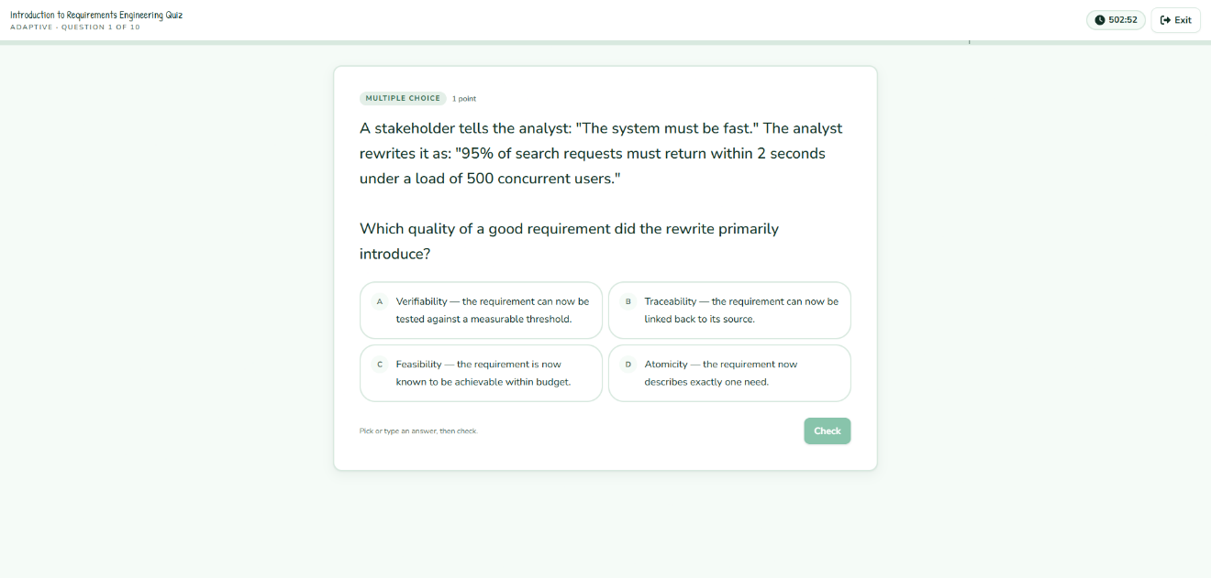
Figure 36: Take Quizzes and Exams Interface
Item | Type | Required? | Data Type | Implemented behavior
Assessment header | Header | Yes | Object | Attempt context
Timer | Display | Conditional | Duration | For timed assessments
Question workspace | Panel | Yes | Object | Configured question type
Answer control | Input | Yes | Structured | MCQ, text, programming, or diagram
Submit | Button | Yes | Action | Saves and grades attempt
Results/review | Page | After completion | Object | Displays returned result

Logic
- The Learner initiates an assessment module from the curriculum page, triggering the application backend to execute the Start Attempt transaction block. Because the assessment is adaptive, no paper is fixed in advance: the backend loads the learner's stored ability estimate (theta) and per-lesson BKT knowledge states for the certification and serves the first item together with a small reserve of upcoming items.
- The core AI execution layer selects each item with the Item Response Theory engine: it groups the certification's question bank by lesson, favours lessons the paper still owes and lessons whose mastery is uncertain, skips items the learner has already met or that are reworded twins of served items, and picks from the most informative items at the current ability estimate. The frontend instantiates the runner shown above with one question at a time.
- The application starts the countdown timer thread and renders the question card, the type and points badge, and the answer tiles or answer input.
- The Learner picks a tile or types an answer and clicks Check. The runner marks the answer instantly from the key served with the item, plays the correct or wrong sound, and reveals the verdict.
- In the background the runner posts every queued answer to the server in a single batched request. The server re-estimates the learner's ability (EAP), updates the lesson's BKT mastery, nudges the item's online difficulty, and returns the next items to hold in reserve, so the learner never waits on the server.
- The Learner clicks Next to advance. The header counter shows the position in the adaptive sequence (e.g., Question 3 of 10).
- When the quick items are exhausted, the engine serves the final round: programming, diagram, and written items in the workspace panel. These are saved and graded in the background after submission by Judge0, the diagram comparator, and the AI grader, so the result page opens immediately with those items marked as pending.
- The Learner clicks Finish on the last item. The Record Results logic node creates an attempt record containing the final percentage, elapsed seconds, pass/fail state, and the ability estimate before and after the attempt, updates the learner's stored ability and skill states, and enqueues the mastery events for the BKT service.
- If the final accuracy output meets the passing score, the system fires the Unlock Next Assessment event to make downstream curriculum items available.
- Else, the topic retains a High Priority classification label, and the portal displays a Retake Assessment prompt; the retake starts from the learner's updated ability and avoids the items already met.
Screen No: 6
Screen Name: Request Partnership Page
Description: The external intake gateway where academic institutions, corporate training divisions, or independent review centers initiate a multi-tenant subscription request. This interface handles the collection of institutional profiles, certification program pairing, and bulk cohort license tracking parameters before routing requests to global administrators for systematic approval processing.
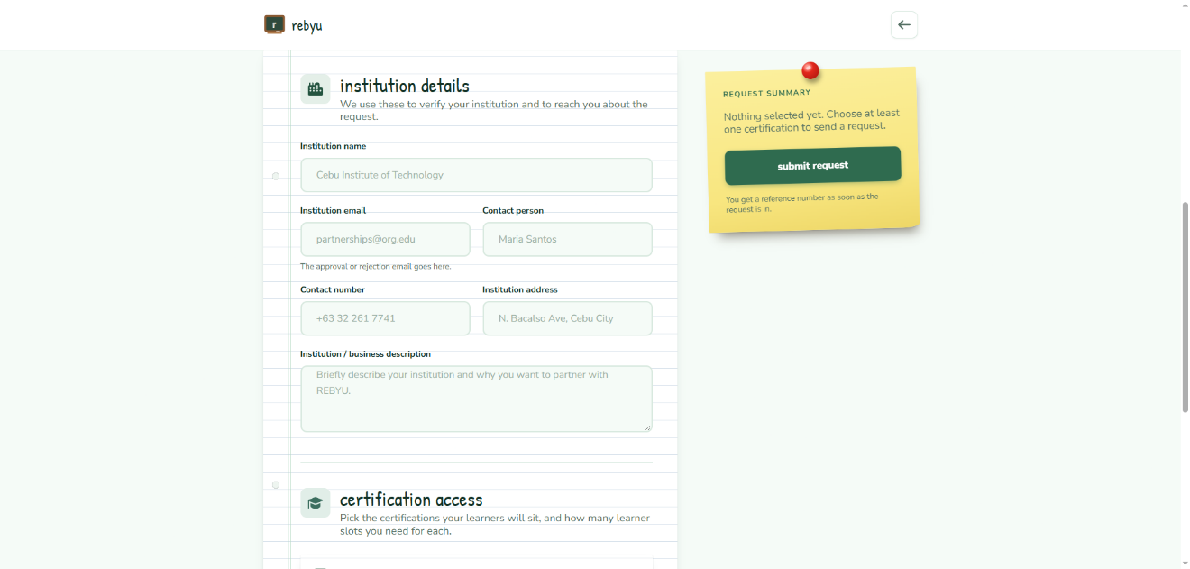
Figure 37: Submit Request Partnership
Item | Type | Required? | Data Type | Implemented behavior
Institution name | Text input | Yes | String | Partnership detail
Contact details | Text inputs | Yes | String | Primary contact
Certification selections | Selection | Yes | Array | Requested access
Slot request | Number input | Yes | Integer | Requested capacity
Submit request | Button | Yes | Action | Creates partnership request

Logic
- The external coordinator navigates to the public web landing view and selects the "Request Partnership for Institution" action, which commands the system to instantiate the page interface layout illustrated above.
- The representative interacts with the input array layer to perform the Enter Institution Information sequence, typing string literals to establish the institution's details.
- The coordinator executes the Select Certifications use case function by picking targeted computing tracks from the platform's certifications menu.
- For every custom track added to the active container, the coordinator triggers the Specify Number of Slots instruction block by increasing no of slots to request distinct volume licenses.
- The user verifies the accuracy of the completed parameters block and hits the Submit execution link button to dispatch the structural string stream.
  - If any required text box node within the document container is null, the browser cancels the submission and displays a validation error label.
  - Otherwise, the system compiles the payload array and transfers it to the cloud server, executing the backend Submit Partnership Request data ingestion flow.
  - The application inserts a new record with matching transactional keys into the PARTNERSHIP_REQUESTS and PARTNERSHIP_REQUEST_ITEMS database tables, anchoring its default processing field state to 'pending'.
  - The viewport resets local form attributes and shows an overlay prompt box confirming the application file has been saved and safely delivered to corporate admins for review.
Screen No: 7
Screen Name: Invite Learners (Department Heads Workspace)
Description: The invitation panel inside the group workspace that enables an institution member (group leader) to distribute certification access to candidate cohorts. The screen captures each invitee's name and email, checks the group's remaining slots, and dispatches onboarding invitations, listing pending invitations and enrolled learners underneath.
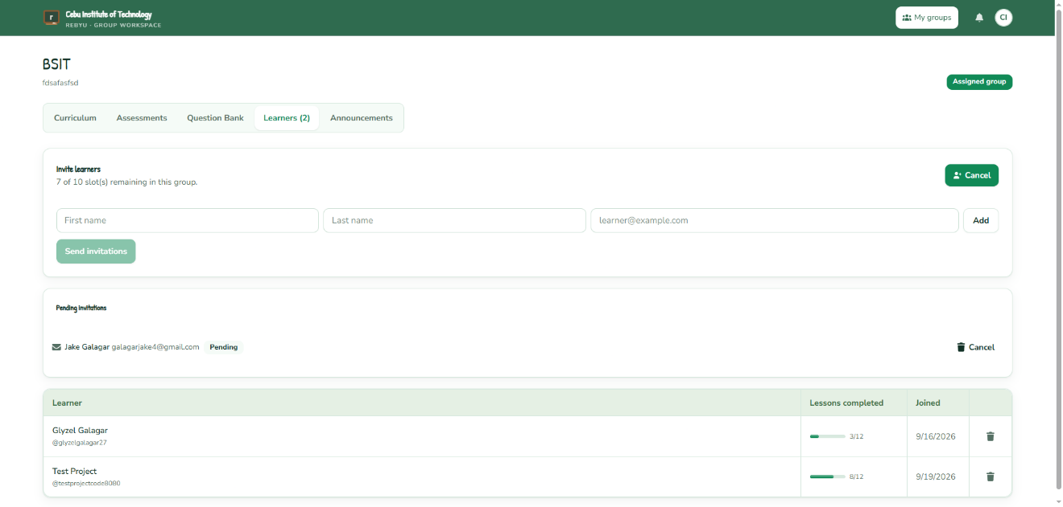
Figure 38: Invite Learners
Item | Type | Required? | Data Type | Implemented behavior
Department/section | Selector | Yes | Object | Scopes invitations
Learner identity | Text inputs | Yes | String | Name and e-mail
Certification allocation | Selection | Yes | Identifier | Assigned access
Invitation list | Collection | No | Object array | Pending/status rows
Send invitations | Button | Yes | Action | Validates and creates invitations

Logic
- The logged-in Institution Member (group leader) opens My Groups and selects the group they lead (e.g., BSIT), then clicks the Learners tab of the group workspace.
- The user clicks the Invite button, which expands the Invite learners panel and shows how many of the group's slots remain.
- The leader executes the Enter Learner Details process by typing the invitee's first name, last name, and email address and clicking Add; the row is appended to the list of invitees, and the process repeats for each learner.
- The user verifies the list and clicks Send invitations to pass the row data array to the application server.
- The system immediately invokes the Validate Email runtime validation thread to check the entries.
- If an entry violates standard email validation constraints, or the email already belongs to a learner in the group, frontend logic marks the problem row with an error.
- Otherwise, the system reads the group's slot allocation and the parent institution's certification allocation in the INSTITUTION_CERTIFICATES data rows.
- If the number of invitees exceeds the remaining slots, the transaction block halts processing and displays an error notification stating that there are insufficient slots for this group.
- Otherwise, the platform creates a LEARNER_INVITATIONS record for each invitee, reserves the slots, and lists the invitations as Pending in the panel beneath the form.
- The platform processes the Send Invitation Email hook request, passing the onboarding link out to the mailing gateway. When a learner accepts, the INSTITUTION_CERTIFICATION_LEARNERS record is created, the used_slots counter is incremented, and the learner appears in the roster with lesson progress and join date.
Screen No: 8
Screen Name: Manage Learners Interface (Institution / Admin Dashboard)
Description: The administrative tracking grid layout that allows institutional coordinators (Institution) and platform administrators (Admin) to execute cohort progress tracking, edit candidate state attributes, or revoke learner allocation licenses from a multi-tenant workspace.
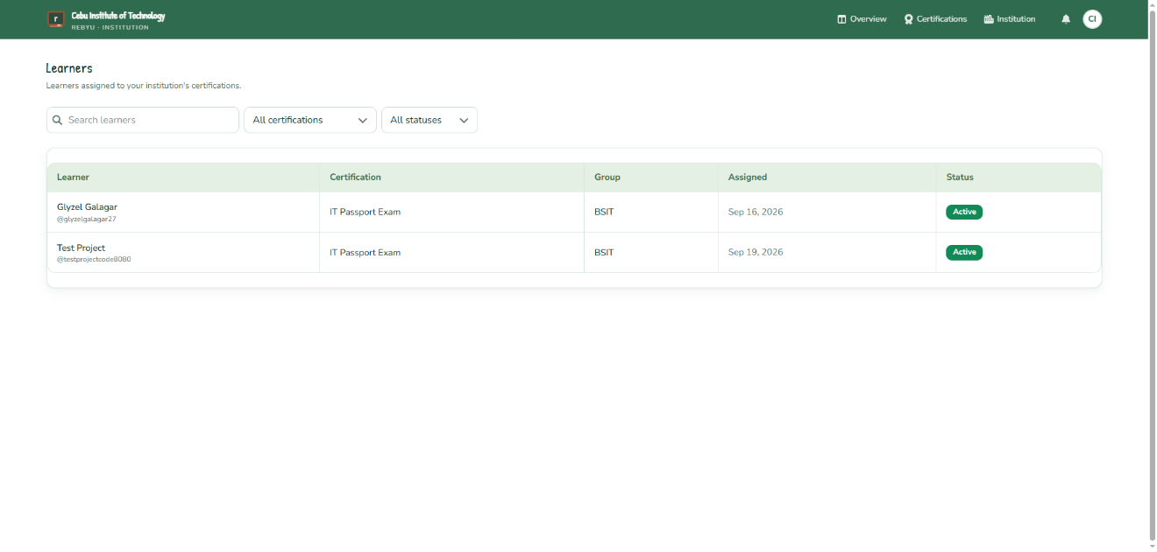
Figure 39: Manage Learners
Item | Type | Required? | Data Type | Implemented behavior
Roster | Table | Yes | Object array | Authorized learner records
Search/filter | Controls | No | String | Filters roster
Learner detail | Sheet/page | No | Object | Permitted insight data
Progress view | Action | No | Action | Opens scoped analytics
Administrative action | Action | Conditional | Action | Role-authorized change

Logic
- The privileged user authenticated into the administrative workspace clicks the "Learners" section link on the primary system navigation panel, commanding the backend database interface to parse rows via the View Learner List loop. The UI builds the table module shown in Figure 35.
- The software executes severe multi-tenant isolation verification:
  - If the active security wrapper context maps to an Institution Coordinator role, the system applies strict query filters, returning only learner entities matching the parent institution's structural ID.
  - Else if the identifier reads "global Admin authorization," the data server completely bypasses row-filtering constraints to populate all users system-wide.
- The coordinator types text variables into the inline table search field or opens the Filter Parameters dropdown to narrow rows by dynamic metadata arrays (Name, Date, or Email tracking markers).
- The coordinator handles student retention validation by clicking the inline information (i) icon button to map out the View Learner Progress sequence path. The framework requests that the analytics cluster layer compute real-time topic mastery graphs, quiz accuracy history logs, and current BKT-driven exam readiness scores across the dashboard window layout.
- The administrator modifies state constraints within the database tracking array by triggering a change to an account field parameter via the interactive status toggles, routing an immediate execution signal through the Update Learner Status extension block to transition entities between active tracking, offline, and wait parameters.
- The coordinator prunes active accounts by selecting the targeted checkbox modules and clicking the inline trash bin icon to initiate the Remove Learner transaction module.
  - The interface intercept component displays a modal overlay verification window on the screen view to prevent accidental record destruction.
  - If the supervisor executes the deletion step, the application calls the PostgreSQL transaction controller to systematically set the student's association profile status to 'revoked'.
  - The application server decreases the tenant's global volume usage allocation record count by an assignment unit value (used_slots = used_slots - 1) and automatically drops the deleted learner node row entity out of the visible frontend view layout state.
Screen No: 9
Screen Name: Learner Analytics & Progress Dashboard
Description: The core data visualization hub for independent and sponsored computing examinees to monitor their longitudinal proficiency development, identify knowledge deficiencies, and review automated optimization metrics. This interface translates continuous background behavioral telemetry and BKT score probability arrays into interactive, actionable dashboards to manage final exam readiness.

Figure 40: Monitor Progress and Analytics
Item | Type | Required? | Data Type | Implemented behavior
Certification selector | Selection | Conditional | Identifier | Analytics scope
Progress tiles | Cards | Yes | Metrics | Completion and assessments
Mastery/priority | Cards/charts | Conditional | Metrics | BKT-derived data when available
Streaks/rewards | Cards | Conditional | Metrics | Gamification data
Study plan | Card/action | Conditional | Object | Active plan and tasks
Continue learning | Action | No | Action | Navigates to lesson

Logic
- The examinee logs in and selects "Progress" via the core sidebar array node, dispatching a server request to initiate the Monitor Progress and Analytics instruction loop. The frontend instantiates the complex analytics framework illustrated above.
- The user modifies the active curriculum scope toggle (e.g., swapping to IT Passport, FE Exam, or TOPCIT). The engine executes the View Learning Progress sequence to fetch database matrices specific to the chosen track.
- The platform processes raw assessment table inputs through the analytics subsystem to compute the primary dashboard summary cards:
  - It checks accumulated section completion metrics to output Overall Progress.
  - It pulls real-time mastery_probability float vectors from the LEARNER_LESSON_MASTERY data array to compute the aggregate Topic Mastery matrix.
  - It processes accuracy metrics and total accumulated active study seconds through a predictive calculation layer to output the real-time Confidence Level Metric.
  - It maps transaction timestamps from historical activity blocks to evaluate student consistency trends and update the Study Streak display counters.
- The line series engine executes the sub-use cases View Quiz Results and View Exam Results, drawing score histories over a monthly time block layer to display progress trends.
- The system automatically performs data mining filters via the View Weak Topic Areas path loop to identify structural study vulnerabilities:
  - The application matches sub-threshold scoring outputs against category clusters, ranking deficiencies inside the Weak Areas bar graph module.
  - The pipeline updates the Topics in the REBYU sidebar box, organized them by high-priority deficiency flags to explicitly highlight knowledge gaps.
- If the core analytics architecture flags a lesson state as an active weak area profile string, it triggers the Receive AI recommendations extension handler. This component communicates with the bounded NLP framework to generate context-specific remedial guidance prompts within the user layout interface.
Screen No: 10
Screen Name: Institution Partnership Approval Console
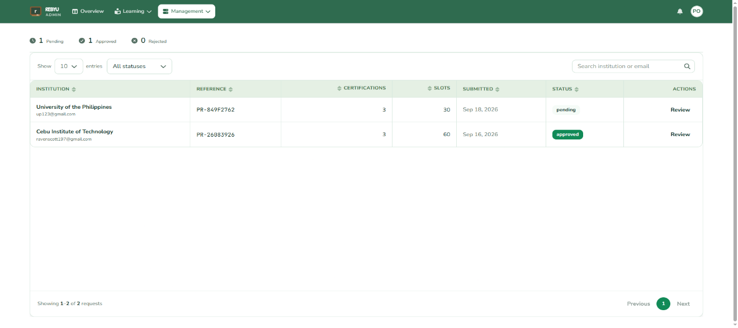
Description: The centralized administrative control interface allows global platform administrators to review incoming institutional intake requests, audit institutional legitimacy details, and process bulk license configurations to provision isolated multi-tenant institution environments.
Figure 41: Approve Partnership Requests
Item | Type | Required? | Data Type | Implemented behavior
Request list | Table | Yes | Object array | Administrator-visible requests
Request detail | Sheet/page | Yes | Object | Institution and request items
Remarks | Text input | Conditional | String | Decision context
Approve | Button | Conditional | Action | Approves/provisions workflow
Reject | Button | Conditional | Action | Rejects with remarks

Logic
- The platform administrator logs in to the backend dashboard and selects the "Partnership Requests" option from the primary navigation menu. The system backend performs the View Partnership Requests data ingestion task, loading pending rows from the PARTNERSHIP_REQUESTS schema collection onto the template frame displayed above.
- The Admin selects a specific institutional entry from the grid layout and clicks the inline information icon to trigger the structured Verify Institution Details routine sequence. The admin dashboard pulls business permits, requested seat caps, and primary contact records for verification.
- If the audited field attributes fail to meet standard operational criteria, the Admin can execute the Reject Request branch module. This action updates the core workspace status flag to 'rejected' and issues a cancellation message to the client email endpoint.
- Alternatively, if the institutional profile strings check out successfully, the Admin clicks the inline table checkbox row and selects the contextual Approve control. The system interrupts page focus and injects the "Approve Pending Requests" modal overlay box directly onto the screen view layout state.
- The Admin marks validation preferences in the pop-up modal and triggers the final Approve confirmation button, which transitions execution down the main Approve Request handler path.
- The centralized cloud framework enforces strict contractual deployment sequences to instantiate the client's dedicated workspace container:
  - The application routes automated communication routines to process the Schedule Meeting and Conduct Meeting use case nodes, thereby finalizing target service parameters with the institutional tenant.
  - If final system negotiation hooks fail, or if either stakeholder entity declines the contract terms during the meeting sync, the Admin commits the Cancel Partnership instruction to archive the request log record gracefully.
  - When the consultation concludes successfully, the Admin saves the confirmed request state parameters to launch the downstream Confirm Partnership structural automated workflow:
    - The PostgreSQL database controller executes the Activate Institution Account transaction routine, securely setting the targeted institution row's status column to 'active'.
    - The system initiates the internal Allocate Certification Slots function loop, generating approved volume caps within the INSTITUTION_CERTIFICATES tracking matrices to assign exact seat counts for computing.
    - The application server dispatches a final programmatic task flag to fire the Notify Institution callback function, sending automated workspace onboarding credentials directly to the primary client contact email address.
Screen No: 11
Screen Name: Admin Certification Creation & Management Portal
Description: The centralized administrative control viewport that empowers platform administrators to provision new certification tracks. The Admin names the certification, maps its industry classification, describes it, uploads the source documents, chooses the question formats, and starts the AI generation run that builds the curriculum, lessons, quizzes, exams, and question bank as drafts. This interface acts as the baseline step of an integrated content configuration setup before deploying learning modules to individual and Institution learners.

Figure 42: Manage Certifications
Item | Type | Required? | Data Type | Implemented behavior
Certification details | Form | Yes | Object | Title, description, industry, status
Exam format | Form | No | Object | Exam structure details
Curriculum editor | Tree/editor | Yes | Nested object | Categories and lessons
Document upload | Upload | Conditional | File | AI/import workflows
Generation mode | Selection | Conditional | String | Workflow mode
Publish | Button | Conditional | Action | Requests publication validation

Logic
- The platform administrator selects the "Certification" options hub from the sidebar menu to launch the primary Manage Certifications task loop. The frontend instantiates the split-panel configuration view illustrated above.
- The Admin populates the input nodes to record the official certification name, the industry alignment from the dropdown, and the contextual course overview description.
- The Admin drags the source documents onto the document drop zone or clicks Select documents to bind them. The interface validator accepts only PDF, DOC, DOCX, or CSV files, at most ten of them and 50 MB each, and lists every accepted file with its size.
- Optionally the Admin ticks the question formats the generated bank should use (multiple choice, short answer, descriptive, critical thinking) and chooses the run mode: Generate everything, which builds the whole certification unattended, or Review each step, which pauses for approval after the curriculum, each category, each lesson, and the question bank.
- The Admin clicks Generate Certification. If any required node evaluates as null (name shorter than 3 characters, no industry, description shorter than 20 characters, or no document), form validation drops inline errors and freezes the submission.
- Else, the backend stores the certification as a DRAFT row in the CERTIFICATIONS table, ingests the documents into KNOWLEDGE_DOCUMENTS with their extracted images, records a GENERATION_REQUESTS row, and hands the run to the Python workflow service, which tracks it in WORKFLOW_RUNS and streams its events to the drawer.
- The workflow reads the documents, writes the exam structure and the major and middle categories, generates each lesson's content, then the quizzes, category exams, mock exam, and question bank, and deduplicates reworded items against what is already stored. In guided mode the Admin approves, edits, or regenerates each part before the run continues.
- When the run completes, the administrator reviews the drafts from the certification card: the Manage Categories and Manage Lessons tasks edit the curriculum and lesson blocks, and the Question Bank tab edits the generated items.
- When the lesson structures and the question bank pass the publish validation (every adaptive assessment has a large enough bank), the supervisor triggers the Publish Certification action. This transaction sets the certification's status to PUBLISHED and makes it available in the learner catalog and to institution allocations.
Screen No: 12
Screen Name: Admin Question Bank Management Workspace
Description: The centralized curriculum management workspace where platform administrators view, populate, organize, and update assessment items mapped to specific lesson nodes. The console hosts interactive configuration tools for multiple question archetypes—including multiple-choice grids, short text inputs, code assessment sandboxes, and structural diagram validation tasks—to feed raw data to the Bayesian Knowledge Tracing (BKT) engine.
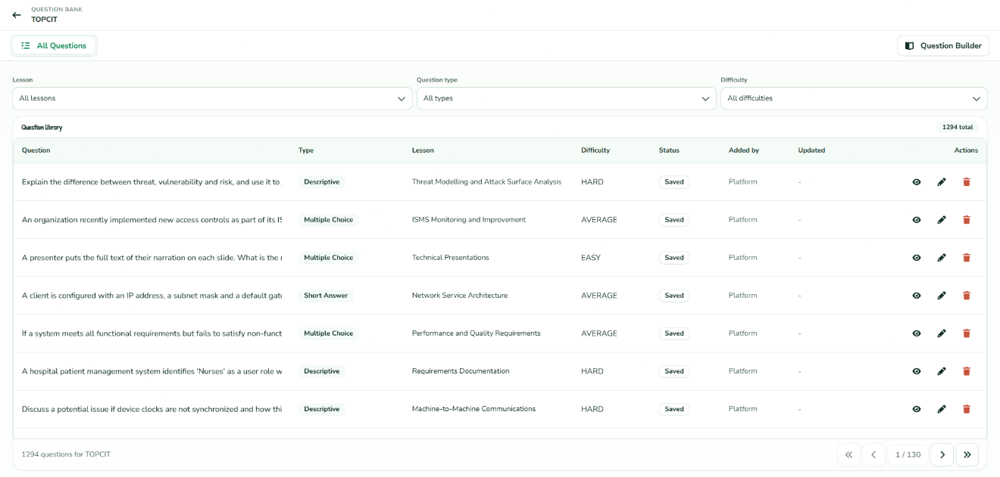
Figure 43: Manage Question Bank
Item | Type | Required? | Data Type | Implemented behavior
Curriculum selector | Tree | Yes | Nested object | Selects owning lesson
Question editor | Form | Yes | Object | Question content
Question type | Selection | Yes | String | MCQ, text, programming, diagram
Difficulty/points | Inputs | Yes | String/number | Question metadata
Choices/configuration | Editor | Conditional | Object array | Type-specific configuration
Save | Button | Yes | Action | Persists question
Assessment builder | Workspace | No | Object | Links questions to assessment

Logic
- The authenticated administrator selects the "Question Bank" link module via the system manager layout, directing the application server to call the View Question Bank database retrieval loop. The web frontend instantiates the comprehensive configuration canvas shown above.
- The Admin navigates the multi-level hierarchical tree layout in the Course Structure block, selecting a target certification type, core category domain folder, and specific destination lesson (e.g., TOPCIT -> Software Development -> Database Fundamentals -> ERD Fundamentals).
- To configure a brand new evaluation metric query item, the supervisor clicks a targeted row option within the right-hand ADD QUESTION selector matrix, initializing a creation framework process:
  - If standard text options are selected (Multiple Choice, Short Answer, or Descriptive), the template appends matching string input fields or multiple-choice configuration options.
  - If a specialized engineering workspace type, such as Diagram Problem, is triggered, the system invokes the Create Question logic block, loading dedicated diagram parameter modules (such as diagram validation type radio targets, instruction string fields, and Draw.io reference canvas XML handlers) directly into the main builder viewport.
- The Admin types custom problem parameters, inputs numeric point values, sets the baseline difficulty classification tier string, and maps strict execution guidelines into the Student Instructions container node.
- The supervisor commits or stages their data using the available global save action triggers located on the workspace top control bar:
  - Local Schema Caching: The Admin clicks the Save Draft option. The pipeline intercepts the local layout parameters string and writes the payload to staging tables within the PostgreSQL QUESTIONS and DIAGRAM_QUESTION_CONFIGS array registers, securely caching the draft state without making it available to active examinees.
  - Production Pool Release: The Admin clicks Publish. The validation layer runs checks to ensure that no mandatory attributes are null and that the configuration checks match exactly. Once approved, the record's deployment flag changes to active, updating the live Lesson Summary metric dashboard blocks at the base of the sidebar right panel.
- For pre-existing data entities stored in the active lesson rows, the administrator can select alternative action paths. The Admin clicks inline record nodes to launch the Update Question pipeline or selects the terminal delete icon to call the Remove Question workflow routine. If active client examination history tables contain an evaluation score linked to the target question item's row ID, the relational database prevents permanent record removal and forces the record to be archived to protect the integrity of historical user log data.

Database Design
Database design is a group of procedures that facilitates institution data management system design, development, deployment, and maintenance. It physically implements the data model as a database schema (Chen, 2023).
Entity Relationship Diagram. An Entity-Relationship Diagram (ERD) serves as a critical conceptual blueprint that visually models complex data schemas and their logical associations within an information system, functioning as a foundational asset for structural relational database engineering. By mapping out the data architecture of a platform, an ERD explicitly defines discrete system entities—representing primary operational objects, user roles, or transactional events—alongside their specific attributes, which capture the granular information vectors unique to each node.
Furthermore, it structuralizes the precise rules governing how these entities interact by defining logical relationships, structural constraints, and numerical cardinalities using formalized notations such as Crow's Foot syntax. This visual modeling technique plays an indispensable role in database design by translating ambiguous, high-level business requirements into precise physical tables, primary-foreign key relationships, and normalized data relations. Consequently, the ERD acts as both a vital technical communication bridge between software architects and database administrators and a preventative diagnostic framework that mitigates data redundancy, enforces relational integrity, and optimizes query routing structures before the physical database deployment takes place.

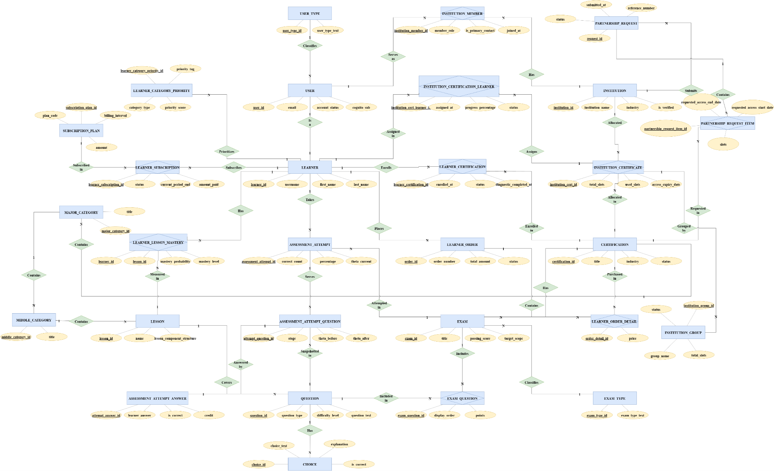

Data Dictionary
The following tables retain the manuscript's original table format while reflecting only the data entities represented by the current application code.
DATA DICTIONARY OF USER_TYPES
Table 6: Data Dictionary of User Types
Field Name | Constraints | Data Type | Allow Nulls | Description
user_type_id | PK, identity | BIGINT | No | Unique identifier for a user type.
user_type_text | NOT NULL | VARCHAR(20) | No | Name of the role, such as learner, admin, or institution.
DATA DICTIONARY OF USERS
Table 7: Data Dictionary of Users
Field Name | Constraints | Data Type | Allow Nulls | Description
user_id | PK, identity | BIGINT | No | Unique identifier for a user account.
account_status | NOT NULL | VARCHAR(20) | No | Account state: active, inactive, or suspended. Defaults to active.
cognito_sub | UNIQUE | VARCHAR(64) | Yes | Stable Amazon Cognito subject linked to this account; null for pre-Cognito accounts until their first federated sign-in.
email | UNIQUE, NOT NULL | VARCHAR(254) | No | Login e-mail address of the account.
joined_at | NOT NULL | TIMESTAMP | No | Date and time the account was created.
password_hash | NOT NULL | VARCHAR(255) | No | Hashed password of the account.
phone_number | — | VARCHAR(30) | Yes | Contact number of the user.
user_type_id | FK → USER_TYPES, NOT NULL | BIGINT | No | Role of the account (learner, admin, institution).
last_seen_at | — | TIMESTAMP | Yes | Date and time the account last made a signed-in request; used to show who is online.
DATA DICTIONARY OF LEARNERS
Table 8: Data Dictionary of Learners
Field Name | Constraints | Data Type | Allow Nulls | Description
learner_id | PK, identity | BIGINT | No | Unique identifier for a learner profile.
first_name | NOT NULL | VARCHAR(50) | No | Learner's first name.
last_name | NOT NULL | VARCHAR(50) | No | Learner's last name.
username | UNIQUE, NOT NULL | VARCHAR(50) | No | Public display username of the learner.
user_id | FK → USERS, UNIQUE | BIGINT | Yes | Account that owns this learner profile (one-to-one).
avatar_key | — | VARCHAR(512) | Yes | Storage (S3) key of the learner's profile picture; null shows the learner's initials instead.
DATA DICTIONARY OF AUDIT_LOG
Table 9: Data Dictionary of Audit Log
Field Name | Constraints | Data Type | Allow Nulls | Description
log_id | PK, identity | BIGINT | No | Unique identifier for an audit log.
action | — | VARCHAR(255) | Yes | Action performed, such as an account, content, or billing change.
details | — | VARCHAR(255) | Yes | Free-text details of what changed.
entity_id | — | BIGINT | Yes | Identifier of the record the action was performed on.
entity_type | — | VARCHAR(255) | Yes | Kind of record the action was performed on.
ip_address | — | VARCHAR(255) | Yes | IP address the action was performed from.
timestamp | — | TIMESTAMP | Yes | Date and time the action was performed.
user_id | — | BIGINT | Yes | Account that performed the action.
DATA DICTIONARY OF USER_ACTIVITY_DAYS
Table 10: Data Dictionary of User Activity Days
Field Name | Constraints | Data Type | Allow Nulls | Description
user_activity_day_id | PK, identity | BIGINT | No | Unique identifier for an user activity day.
activity_date | NOT NULL | DATE | No | Calendar day on which the user was active.
user_id | NOT NULL | BIGINT | No | Account that was active on that day.
DATA DICTIONARY OF USER_DASHBOARD_LAYOUTS
Table 11: Data Dictionary of User Dashboard Layouts
Field Name | Constraints | Data Type | Allow Nulls | Description
layout_id | PK, identity | BIGINT | No | Unique identifier for an user dashboard layout.
board | NOT NULL | VARCHAR(40) | No | Dashboard the layout applies to.
tile_order | NOT NULL | TEXT | No | Placement of each dashboard tile (position and size), as a JSON array.
updated_at | NOT NULL | TIMESTAMP WITH TIME ZONE | No | Date and time the record was last updated.
user_id | FK → USERS, NOT NULL | BIGINT | No | Reference to the user this record belongs to.
DATA DICTIONARY OF CERTIFICATIONS
Table 12: Data Dictionary of Certifications
Field Name | Constraints | Data Type | Allow Nulls | Description
certification_id | PK, identity | BIGINT | No | Unique identifier for a certification.
date_created | — | TIMESTAMP | Yes | Date and time the certification was created.
date_updated | — | TIMESTAMP | Yes | Date and time the certification was last updated.
description | NOT NULL | TEXT | No | Full description of the certification.
exam_structure | — | JSONB | Yes | Structure of the real certification exam (number of items, question types, notes), as JSON; written by the AI curriculum planner.
status | — | SMALLINT | Yes | Lifecycle state: 0 = PUBLISHED, 1 = DRAFT. Defaults to DRAFT.
department | — | VARCHAR(255) | Yes | Department (college) the certification belongs to, used to match it to an institution's departments.
title | UNIQUE, NOT NULL | VARCHAR(150) | No | Title of the certification.
badge_image_key | — | VARCHAR(500) | Yes | Storage (S3) key of the certification's badge image; null until an admin uploads one.
DATA DICTIONARY OF CERTIFICATION_EXAM_FORMATS
Table 13: Data Dictionary of Certification Exam Formats
Field Name | Constraints | Data Type | Allow Nulls | Description
certification_id | PK, FK → CERTIFICATIONS | BIGINT | No | Certification whose real exam this describes (one-to-one).
total_items | — | INTEGER | Yes | Number of items on the real exam.
duration_minutes | — | INTEGER | Yes | Time limit of the real exam in minutes.
passing_score | — | NUMERIC(5,2) | Yes | Score needed to pass the real exam.
question_types | — | VARCHAR(200) | Yes | Question types the real exam uses.
coverage | — | TEXT | Yes | Topics the real exam covers.
notes | — | TEXT | Yes | Further notes on the exam format.
source | — | VARCHAR(1000) | Yes | Where the format details were taken from.
origin | — | VARCHAR(20) | Yes | Who wrote the record: the AI curriculum planner or an admin.
updated_at | — | TIMESTAMP | Yes | Date and time the record was last updated.
DATA DICTIONARY OF CERTIFICATION_EXAM_SECTIONS
Table 14: Data Dictionary of Certification Exam Sections
Field Name | Constraints | Data Type | Allow Nulls | Description
exam_section_id | PK, identity | BIGINT | No | Unique identifier for an exam section.
certification_id | FK → CERTIFICATIONS, NOT NULL | BIGINT | No | Certification whose exam this section is part of.
display_order | NOT NULL | INTEGER | No | Position of the section within the exam.
name | NOT NULL | VARCHAR(200) | No | Name of the section, such as Subject A or the Technology field.
total_items | — | INTEGER | Yes | Number of items in the section.
duration_minutes | — | INTEGER | Yes | Time limit of the section when it is timed separately.
question_types | — | VARCHAR(200) | Yes | Question types used in the section.
notes | — | TEXT | Yes | Further notes on the section.
DATA DICTIONARY OF MAJOR_CATEGORIES
Table 15: Data Dictionary of Major Categories
Field Name | Constraints | Data Type | Allow Nulls | Description
major_category_id | PK, identity | BIGINT | No | Unique identifier for a major category.
title | NOT NULL | VARCHAR(150) | No | Title of the major category.
certification_id | FK → CERTIFICATIONS, NOT NULL | BIGINT | No | Certification this major category belongs to.
owner_department_id | FK → DEPARTMENTS | BIGINT | Yes | Group that owns the category; null for official, platform-wide content.
DATA DICTIONARY OF MIDDLE_CATEGORIES
Table 16: Data Dictionary of Middle Categories
Field Name | Constraints | Data Type | Allow Nulls | Description
middle_category_id | PK, identity | BIGINT | No | Unique identifier for a middle category.
title | NOT NULL | VARCHAR(150) | No | Title of the middle category.
major_category_id | FK → MAJOR_CATEGORIES, NOT NULL | BIGINT | No | Major category this middle category belongs to.
DATA DICTIONARY OF MIDDLE_REFLECTIONS
Table 17: Data Dictionary of Middle Reflections
Field Name | Constraints | Data Type | Allow Nulls | Description
reflection_id | PK, identity | BIGINT | No | Unique identifier for a reflection.
middle_category_id | FK → MIDDLE_CATEGORIES, UNIQUE, NOT NULL | BIGINT | No | Topic (middle category) the reflection belongs to; one per topic.
title | NOT NULL | VARCHAR(255) | No | Title of the reflection.
scenario | NOT NULL | TEXT | No | Scenario the learner reflects on.
prompt | NOT NULL | TEXT | No | Question the learner answers.
parts | NOT NULL | JSONB | No | Parts the answer must address, as a JSON list. Defaults to [].
rubric | NOT NULL | JSONB | No | Grading criteria (title, description, zero-point and one-point descriptors), as JSON. Defaults to [].
pass_percent | NOT NULL | INTEGER | No | Score percent needed to pass. Defaults to 80.
created_at | NOT NULL | TIMESTAMP | No | Date and time the record was created.
updated_at | NOT NULL | TIMESTAMP | No | Date and time the record was last updated.
DATA DICTIONARY OF REFLECTION_SUBMISSIONS
Table 18: Data Dictionary of Reflection Submissions
Field Name | Constraints | Data Type | Allow Nulls | Description
submission_id | PK, identity | BIGINT | No | Unique identifier for a submission.
reflection_id | FK → MIDDLE_REFLECTIONS, NOT NULL | BIGINT | No | Reflection that was answered.
learner_id | FK → LEARNERS, NOT NULL | BIGINT | No | Learner who submitted the answer.
answer | NOT NULL | TEXT | No | Text the learner wrote.
score_percent | NOT NULL | NUMERIC(5,2) | No | Score the answer earned, as a percent.
passed | NOT NULL | BOOLEAN | No | Whether the score met the reflection's pass percent.
feedback | — | TEXT | Yes | Overall AI feedback on the answer.
grades | NOT NULL | JSONB | No | Points earned and feedback per rubric criterion, as JSON. Defaults to [].
submitted_at | NOT NULL | TIMESTAMP | No | Date and time the answer was submitted.
DATA DICTIONARY OF LESSONS
Table 19: Data Dictionary of Lessons
Field Name | Constraints | Data Type | Allow Nulls | Description
lesson_id | PK, identity | BIGINT | No | Unique identifier for a lesson.
lesson_component_structure | NOT NULL | JSONB | No | JSON structure of the lesson's content components (sections, text, media). Defaults to [].
name | NOT NULL | VARCHAR(150) | No | Name of the lesson.
middle_category_id | FK → MIDDLE_CATEGORIES, NOT NULL | BIGINT | No | Middle category this lesson belongs to.
DATA DICTIONARY OF LESSON_IMAGES
Table 20: Data Dictionary of Lesson Images
Field Name | Constraints | Data Type | Allow Nulls | Description
lesson_image_id | PK, identity | BIGINT | No | Unique identifier for a lesson image.
image_key | NOT NULL | VARCHAR(500) | No | S3 key of the stored image file.
lesson_id | NOT NULL | INTEGER | No | Identifier of the lesson the image belongs to.
section_name | NOT NULL | VARCHAR(255) | No | Lesson section where the image is placed.
tool_id | NOT NULL | VARCHAR(255) | No | Editor tool/block identifier that references the image.
DATA DICTIONARY OF LESSON_VIDEOS
Table 21: Data Dictionary of Lesson Videos
Field Name | Constraints | Data Type | Allow Nulls | Description
lesson_video_id | PK, identity | BIGINT | No | Unique identifier for a lesson video.
lesson_id | NOT NULL | INTEGER | No | Identifier of the lesson the video belongs to.
section_name | NOT NULL | VARCHAR(255) | No | Lesson section where the video is placed.
tool_id | NOT NULL | VARCHAR(255) | No | Editor tool/block identifier that references the video.
video_key | NOT NULL | VARCHAR(500) | No | S3 key of the stored video file.
DATA DICTIONARY OF REFERENCE_OPTIONS
Table 22: Data Dictionary of Reference Options
Field Name | Constraints | Data Type | Allow Nulls | Description
reference_option_id | PK, identity | BIGINT | No | Unique identifier for a reference option.
active | NOT NULL | BOOLEAN | No | Whether the option is currently offered in forms.
kind | NOT NULL | VARCHAR(40) | No | List the option belongs to, such as industry or institution type.
label | NOT NULL | VARCHAR(150) | No | Text shown for the option.
sort_order | NOT NULL | INTEGER | No | Position of the option within its list.
code | — | VARCHAR(40) | Yes | Short code of the option, such as BSIT for a degree program.
description | — | VARCHAR(500) | Yes | Longer description of the option.
category | — | VARCHAR(150) | Yes | Grouping of the option; for degree programs, the college code.
DATA DICTIONARY OF QUESTIONS
Table 23: Data Dictionary of Questions
Field Name | Constraints | Data Type | Allow Nulls | Description
question_id | PK, identity | BIGINT | No | Unique identifier for a question.
created_at | — | TIMESTAMP | Yes | Date and time the record was created.
difficulty_level | NOT NULL | VARCHAR(10) | No | Difficulty rating of the question (e.g. easy, medium, hard).
image_key | — | VARCHAR(255) | Yes | S3 key of an image attached to the question.
question_text | NOT NULL | TEXT | No | The question prompt shown to the learner.
question_type | NOT NULL | VARCHAR(30) | No | Type of question (multiple choice, short answer, descriptive, programming, diagram, etc.).
created_by | FK → USERS | BIGINT | Yes | Account that authored the question; null for questions created before authorship was recorded.
lesson_id | FK → LESSONS, NOT NULL | BIGINT | No | Lesson the question belongs to.
owner_department_id | FK → DEPARTMENTS | BIGINT | Yes | Group that owns the question; null for official, platform-wide questions.
parent_question_id | FK → QUESTIONS | BIGINT | Yes | Parent question when this row is a sub-question (e.g. critical-thinking sets).
DATA DICTIONARY OF CHOICES
Table 24: Data Dictionary of Choices
Field Name | Constraints | Data Type | Allow Nulls | Description
choice_id | PK, identity | BIGINT | No | Unique identifier for an answer choice.
choice_text | NOT NULL | TEXT | No | Text of the answer option.
is_correct | NOT NULL | BOOLEAN | No | Whether this choice is the correct answer.
explanation | — | TEXT | Yes | Explanation shown when reviewing the answer.
image_key | — | VARCHAR(255) | Yes | S3 key of an image attached to the choice.
question_id | FK → QUESTIONS, NOT NULL | BIGINT | No | Question this choice belongs to.
DATA DICTIONARY OF TEXT_QUESTION_CONFIGS
Table 25: Data Dictionary of Text Question Configs
Field Name | Constraints | Data Type | Allow Nulls | Description
text_question_config_id | PK, identity | BIGINT | No | Unique identifier for a text-question configuration.
accepted_variations | — | TEXT | Yes | Optional exact-match alternative answers, one per line.
checking_method | NOT NULL | VARCHAR(30) | No | How the answer is checked (e.g. EXACT_MATCH, AI). Defaults to EXACT_MATCH.
correct_answer | NOT NULL | TEXT | No | The expected correct answer text.
question_id | FK → QUESTIONS, UNIQUE, NOT NULL | BIGINT | No | Question this configuration belongs to (one-to-one).
DATA DICTIONARY OF PROGRAMMING_QUESTION_CONFIGS
Table 26: Data Dictionary of Programming Question Configs
Field Name | Constraints | Data Type | Allow Nulls | Description
programming_question_config_id | PK, identity | BIGINT | No | Unique identifier for a programming-question configuration.
starter_code | — | TEXT | Yes | Starter code pre-loaded in the learner's editor.
question_id | FK → QUESTIONS, UNIQUE, NOT NULL | BIGINT | No | Question this configuration belongs to (one-to-one).
language | — | VARCHAR(255) | Yes | Programming language the learner answers in.
DATA DICTIONARY OF PROGRAMMING_TEST_CASES
Table 27: Data Dictionary of Programming Test Cases
Field Name | Constraints | Data Type | Allow Nulls | Description
programming_test_case_id | PK, identity | BIGINT | No | Unique identifier for a test case.
expected_output | NOT NULL | TEXT | No | Expected standard output for the test to pass.
input_data | NOT NULL | TEXT | No | Standard input fed to the learner's program.
is_sample | NOT NULL | BOOLEAN | No | Whether the case is a learner-visible sample; hidden otherwise. Defaults to false.
programming_question_config_id | FK → PROGRAMMING_QUESTION_CONFIGS, NOT NULL | BIGINT | No | Programming configuration this test case belongs to.
DATA DICTIONARY OF DIAGRAM_QUESTION_CONFIGS
Table 28: Data Dictionary of Diagram Question Configs
Field Name | Constraints | Data Type | Allow Nulls | Description
diagram_question_config_id | PK, identity | BIGINT | No | Unique identifier for a diagram-question configuration.
diagram_type | NOT NULL | VARCHAR(30) | No | Type of diagram expected (e.g. ERD, flowchart, UML).
instructions | — | TEXT | Yes | Additional drawing instructions for the learner.
reference_diagram_json | NOT NULL | JSONB | No | Reference diagram as structured JSON used for grading.
reference_diagram_xml | NOT NULL | TEXT | No | Reference (correct) diagram in XML form.
question_id | FK → QUESTIONS, UNIQUE, NOT NULL | BIGINT | No | Question this configuration belongs to (one-to-one).
DATA DICTIONARY OF QUESTION_RUBRIC_CRITERIA
Table 29: Data Dictionary of Question Rubric Criteria
Field Name | Constraints | Data Type | Allow Nulls | Description
rubric_criterion_id | PK, identity | BIGINT | No | Unique identifier for a rubric criterion.
display_order | NOT NULL | INTEGER | No | Ordering of the criterion in the rubric. Defaults to 1.
max_points | NOT NULL | DECIMAL(5,2) | No | Maximum points awardable for this criterion. Defaults to 1.00.
name | NOT NULL | VARCHAR(150) | No | Name of the grading criterion.
question_id | FK → QUESTIONS, NOT NULL | BIGINT | No | Question this rubric line belongs to.
DATA DICTIONARY OF EXAM_TYPES
Table 30: Data Dictionary of Exam Types
Field Name | Constraints | Data Type | Allow Nulls | Description
exam_type_id | PK, identity | BIGINT | No | Unique identifier for an exam type.
exam_type_text | UNIQUE, NOT NULL | VARCHAR(50) | No | Name of the exam type, such as quiz, diagnostic, or mock exam.
DATA DICTIONARY OF EXAMS
Table 31: Data Dictionary of Exams
Field Name | Constraints | Data Type | Allow Nulls | Description
exam_id | PK, identity | BIGINT | No | Unique identifier for an exam/assessment.
description | — | TEXT | Yes | Description shown to learners.
duration_minutes | — | INTEGER | Yes | Time limit in minutes; null means untimed.
instructions | — | TEXT | Yes | Instructions shown before starting.
is_generated | NOT NULL | BOOLEAN | No | Whether the exam was AI-generated. Defaults to false.
passing_score | NOT NULL | DECIMAL(5,2) | No | Passing percentage. Defaults to 70.00.
published_at | — | TIMESTAMP | Yes | Date and time the exam was published.
release_answers_after_submit | — | BOOLEAN | Yes | Whether answer keys are released after submission; null is treated as true.
status | — | VARCHAR(20) | Yes | Lifecycle state: DRAFT, PUBLISHED, or ARCHIVED; null is treated as DRAFT.
target_scope | — | VARCHAR(20) | Yes | Scope of the assessment: LESSON, MIDDLE_CATEGORY, MAJOR_CATEGORY, or CERTIFICATION.
title | NOT NULL | VARCHAR(150) | No | Title of the exam.
total_questions | NOT NULL | INTEGER | No | Number of questions in the exam.
updated_at | — | TIMESTAMP | Yes | Date and time the exam was last updated.
certification_id | FK → CERTIFICATIONS, NOT NULL | BIGINT | No | Certification the exam belongs to.
exam_type_id | FK → EXAM_TYPES, NOT NULL | BIGINT | No | Type of the exam (quiz, diagnostic, mock, etc.).
learner_id | FK → LEARNERS | BIGINT | Yes | Learner who generated the exam through the AI tutor; null for authored exams.
lesson_id | FK → LESSONS | BIGINT | Yes | Lesson scope; required for QUIZ-type exams.
major_category_id | FK → MAJOR_CATEGORIES | BIGINT | Yes | Set for major-category-scoped assessments.
middle_category_id | FK → MIDDLE_CATEGORIES | BIGINT | Yes | Set for middle-category-scoped assessments.
owner_department_id | FK → DEPARTMENTS | BIGINT | Yes | Group that owns the exam; null for official, platform-wide exams.
DATA DICTIONARY OF EXAM_QUESTIONS
Table 32: Data Dictionary of Exam Questions
Field Name | Constraints | Data Type | Allow Nulls | Description
exam_question_id | PK, identity | BIGINT | No | Unique identifier for an exam–question link.
display_order | NOT NULL | INTEGER | No | Position of the question in the exam.
points | — | DECIMAL(5,2) | Yes | Per-assessment point override; null falls back to the question's own total points.
exam_id | FK → EXAMS, NOT NULL | BIGINT | No | Exam the question is placed in.
question_id | FK → QUESTIONS, NOT NULL | BIGINT | No | Question bank item placed in the exam.
DATA DICTIONARY OF EXAM_RESULTS
Table 33: Data Dictionary of Exam Results
Field Name | Constraints | Data Type | Allow Nulls | Description
attempt_no | PK | INTEGER | No | Sequence number of the attempt.
duration_seconds | NOT NULL | INTEGER | No | Time spent on the exam in seconds.
is_passed | NOT NULL | BOOLEAN | No | Whether the score met the passing score.
score | NOT NULL | DECIMAL(5,2) | No | Final percentage score of the attempt.
taken_at | NOT NULL | TIMESTAMP | No | Date and time the exam was taken.
exam_id | PK, FK → EXAMS | BIGINT | No | Exam that was taken.
learner_id | PK, FK → LEARNERS | BIGINT | No | Learner who took the exam.
rating | — | DECIMAL(5,2) | Yes | Proficiency measured by an adaptive exam, from 0 to 100; null for fixed papers.
DATA DICTIONARY OF ASSESSMENT_ATTEMPTS
Table 34: Data Dictionary of Assessment Attempts
Field Name | Constraints | Data Type | Allow Nulls | Description
assessment_attempt_id | PK, identity | BIGINT | No | Unique identifier for an attempt.
attempt_number | NOT NULL | INTEGER | No | Sequence number of this attempt per exam and learner.
current_question_id | — | BIGINT | Yes | Attempt-question id the learner last viewed, used for resume.
duration_seconds | — | INTEGER | Yes | Time spent on the attempt in seconds.
earned_points | — | DECIMAL(8,2) | Yes | Points earned by the learner.
enrollment_id | — | BIGINT | Yes | LEARNER_CERTIFICATIONS id backing this attempt, when one exists.
expires_at | — | TIMESTAMP | Yes | Deadline after which the attempt expires.
idempotency_key | UNIQUE | VARCHAR(100) | Yes | Key preventing duplicate attempt creation from retried requests.
learner_id | NOT NULL | BIGINT | No | Learner taking the attempt.
passed | — | BOOLEAN | Yes | Whether the attempt met the passing score.
percentage | — | DECIMAL(5,2) | Yes | Score percentage (0–100) across all snapshot points; pending items score 0.
started_at | NOT NULL | TIMESTAMP | No | Date and time the attempt started.
status | NOT NULL | VARCHAR(20) | No | Attempt state: IN_PROGRESS, SUBMITTED, EXPIRED, or CANCELLED.
submitted_at | — | TIMESTAMP | Yes | Date and time the attempt was submitted.
total_points | — | DECIMAL(8,2) | Yes | Total possible points of the attempt.
version | NOT NULL | BIGINT | No | Version counter guarding concurrent updates.
exam_id | FK → EXAMS, NOT NULL | BIGINT | No | Published exam being attempted.
adaptive | NOT NULL | BOOLEAN | No | Whether the attempt is served one item at a time by the adaptive engine. Defaults to false.
adaptive_state_json | — | TEXT | Yes | Adaptive engine's in-progress session state, as JSON.
final_round_count | — | INTEGER | Yes | Number of items in the attempt's final, batch-graded round.
phase | — | VARCHAR(10) | Yes | Phase of an adaptive attempt: MAIN, FINAL, or DONE; null for fixed papers.
target_question_count | — | INTEGER | Yes | Number of items the adaptive engine aims to serve in this attempt.
theta_current | — | DOUBLE PRECISION | Yes | Current estimate of the learner's ability (IRT theta) during the attempt.
theta_se | — | DOUBLE PRECISION | Yes | Standard error of the current ability estimate.
theta_start | — | DOUBLE PRECISION | Yes | Ability estimate (IRT theta) at the start of the attempt.
grading_pending | NOT NULL | BOOLEAN | No | Whether written, coded, or diagram answers are still being graded; the result is provisional until false. Defaults to false.
item_count | — | INTEGER | Yes | Number of items served in the attempt.
answered_count | — | INTEGER | Yes | Number of items the learner has answered so far.
correct_count | — | INTEGER | Yes | Number of items answered correctly so far.
bank_cycle | — | INTEGER | Yes | Pass through the certification's question bank this attempt drew from.
DATA DICTIONARY OF ASSESSMENT_ATTEMPT_QUESTIONS
Table 35: Data Dictionary of Assessment Attempt Questions
Field Name | Constraints | Data Type | Allow Nulls | Description
attempt_question_id | PK, identity | BIGINT | No | Unique identifier for a snapshotted attempt question.
display_order | NOT NULL | INTEGER | No | Position of the question in the attempt.
flagged | NOT NULL | BOOLEAN | No | Learner marked this item for review. Defaults to false.
lesson_id | — | BIGINT | Yes | Lesson the source question belongs to, for analytics.
points | — | DECIMAL(5,2) | Yes | Points this item is worth in the attempt.
question_data_snapshot | — | TEXT | Yes | Learner-safe JSON: choices without correct flags, starter code, etc.
question_text_snapshot | NOT NULL | TEXT | No | Question text frozen at attempt start.
question_type | NOT NULL | VARCHAR(30) | No | Type of the snapshotted question.
skipped | NOT NULL | BOOLEAN | No | Learner intentionally moved past this item without answering. Defaults to false.
source_question_id | NOT NULL | BIGINT | No | Question bank id the snapshot was taken from.
assessment_attempt_id | FK → ASSESSMENT_ATTEMPTS, NOT NULL | BIGINT | No | Attempt this snapshot belongs to.
item_information | — | DOUBLE PRECISION | Yes | Fisher information the item contributed at the ability level it was served at.
selection_reason | — | TEXT | Yes | Why the adaptive engine chose this item, kept for review.
served_at | — | TIMESTAMP | Yes | Date and time the item was shown to the learner.
stage | — | VARCHAR(10) | Yes | Stage of an adaptive attempt the item was served in: MAIN or FINAL; null for fixed papers.
theta_after | — | DOUBLE PRECISION | Yes | Ability estimate after the learner answered this item.
theta_before | — | DOUBLE PRECISION | Yes | Ability estimate when this item was served.
DATA DICTIONARY OF ASSESSMENT_ATTEMPT_ANSWERS
Table 36: Data Dictionary of Assessment Attempt Answers
Field Name | Constraints | Data Type | Allow Nulls | Description
attempt_answer_id | PK, identity | BIGINT | No | Unique identifier for an attempt answer.
answered_at | — | TIMESTAMP | Yes | Date and time the answer was first recorded.
diagram_grading_result | — | TEXT | Yes | JSON per-element (node/edge) grading breakdown from the diagram grading service.
diagram_submission_data | — | TEXT | Yes | Submitted diagram data for diagram items.
execution_result | — | TEXT | Yes | JSON Judge0 execution payload: code hash, mode, status, output, error, time/memory, per-test results.
feedback | — | TEXT | Yes | AI grading feedback for descriptive/critical-thinking answers (learner-safe).
is_correct | — | BOOLEAN | Yes | Correctness set only by server-side scoring; null until scored or while pending manual evaluation.
last_saved_at | — | TIMESTAMP | Yes | Date and time the answer was last saved.
learner_answer | — | TEXT | Yes | Free-text answer (short answer, descriptive, sub-question JSON).
pending_manual_evaluation | NOT NULL | BOOLEAN | No | Whether the answer awaits manual/AI evaluation. Defaults to false.
programming_language | — | VARCHAR(30) | Yes | Language of the submitted code.
selected_choice_id | — | BIGINT | Yes | Choice id selected for multiple-choice items.
sub_answer_scores | — | TEXT | Yes | JSON array of per-sub-question AI scores for critical-thinking answers.
submitted_code | — | TEXT | Yes | Code submitted for programming items.
assessment_attempt_id | FK → ASSESSMENT_ATTEMPTS, NOT NULL | BIGINT | No | Attempt this answer belongs to.
attempt_question_id | FK → ASSESSMENT_ATTEMPT_QUESTIONS, NOT NULL | BIGINT | No | Snapshotted question being answered.
credit | — | DECIMAL(5,4) | Yes | Share of the item's credit the answer earned, from 0 to 1; partial credit comes from the AI, code, and diagram graders.
DATA DICTIONARY OF ASSESSMENT_ATTEMPT_EXECUTIONS
Table 37: Data Dictionary of Assessment Attempt Executions
Field Name | Constraints | Data Type | Allow Nulls | Description
execution_id | PK, identity | BIGINT | No | Unique identifier for a code execution.
created_at | NOT NULL | TIMESTAMP | No | Date and time the execution was triggered.
language | — | VARCHAR(30) | Yes | Programming language used.
mode | NOT NULL | VARCHAR(10) | No | Execution mode: RUN or CHECK.
output | — | TEXT | Yes | Program output or error text.
passed_tests | — | INTEGER | Yes | Number of test cases passed.
status | NOT NULL | VARCHAR(30) | No | Execution state: UNAVAILABLE, QUEUED, RUNNING, COMPLETED, or ERROR.
submitted_code | — | TEXT | Yes | Code that was executed.
total_tests | — | INTEGER | Yes | Total number of test cases run.
assessment_attempt_id | FK → ASSESSMENT_ATTEMPTS, NOT NULL | BIGINT | No | Attempt the execution belongs to.
attempt_question_id | FK → ASSESSMENT_ATTEMPT_QUESTIONS, NOT NULL | BIGINT | No | Programming item the code was run against.
DATA DICTIONARY OF LEARNER_BANK_CYCLES
Table 38: Data Dictionary of Learner Bank Cycles
Field Name | Constraints | Data Type | Allow Nulls | Description
learner_bank_cycle_id | PK, identity | BIGINT | No | Unique identifier for a learner bank cycle.
certification_id | NOT NULL | BIGINT | No | Certification whose question bank the cycle runs through.
cycle_no | NOT NULL | INTEGER | No | Which pass through the question bank the learner is on; questions are not repeated within a pass.
learner_id | NOT NULL | BIGINT | No | Learner the cycle belongs to.
started_at | NOT NULL | TIMESTAMP | No | Date and time the pass began; questions served since then count as seen.
DATA DICTIONARY OF LEARNER_SKILL_STATES
Table 39: Data Dictionary of Learner Skill States
Field Name | Constraints | Data Type | Allow Nulls | Description
learner_skill_state_id | PK, identity | BIGINT | No | Unique identifier for a learner skill state.
evidence_count | NOT NULL | INTEGER | No | Number of graded answers that have updated this estimate.
learner_id | NOT NULL | BIGINT | No | Learner the estimate belongs to.
lesson_id | NOT NULL | BIGINT | No | Lesson the estimate is for.
p_known | NOT NULL | DOUBLE PRECISION | No | Estimated probability that the learner has mastered the lesson (0 to 1).
updated_at | NOT NULL | TIMESTAMP | No | Date and time the record was last updated.
DATA DICTIONARY OF ACHIEVEMENTS
Table 40: Data Dictionary of Achievements
Field Name | Constraints | Data Type | Allow Nulls | Description
achievement_id | PK, identity | BIGINT | No | Unique identifier for an achievement.
description | NOT NULL | TEXT | No | Description of how the achievement is earned.
title | UNIQUE, NOT NULL | VARCHAR(100) | No | Title of the achievement badge.
DATA DICTIONARY OF LEARNER_ACHIEVEMENTS
Table 41: Data Dictionary of Learner Achievements
Field Name | Constraints | Data Type | Allow Nulls | Description
earned_at | NOT NULL | TIMESTAMP | No | Date and time the achievement was earned.
achievement_id | PK, FK → ACHIEVEMENTS | BIGINT | No | Achievement that was earned.
learner_id | PK, FK → LEARNERS | BIGINT | No | Learner who earned the achievement.
DATA DICTIONARY OF LEARNER_COMPLETED_LESSONS
Table 42: Data Dictionary of Learner Completed Lessons
Field Name | Constraints | Data Type | Allow Nulls | Description
completed_at | NOT NULL | TIMESTAMP | No | Date and time the lesson was completed.
learner_id | PK, FK → LEARNERS | BIGINT | No | Learner who completed the lesson.
lesson_id | PK, FK → LESSONS | BIGINT | No | Lesson that was completed.
DATA DICTIONARY OF LEARNER_READ_SECTIONS
Table 43: Data Dictionary of Learner Read Sections
Field Name | Constraints | Data Type | Allow Nulls | Description
section_key | PK | VARCHAR(191) | No | Unique identifier for a learner read section.
read_at | NOT NULL | TIMESTAMP | No | Date and time the learner finished reading the section.
learner_id | PK, FK → LEARNERS | BIGINT | No | Unique identifier for a learner read section.
lesson_id | PK, FK → LESSONS | BIGINT | No | Unique identifier for a learner read section.
DATA DICTIONARY OF LEARNER_REWARD_BALANCES
Table 44: Data Dictionary of Learner Reward Balances
Field Name | Constraints | Data Type | Allow Nulls | Description
learner_id | PK, identity | BIGINT | No | Unique identifier for a learner reward balance.
ai_credit_balance | NOT NULL | INTEGER | No | AI tutor credits the learner can spend.
coin_balance | NOT NULL | BIGINT | No | Coins the learner currently holds.
updated_at | NOT NULL | TIMESTAMP WITH TIME ZONE | No | Date and time the record was last updated. Defaults to now().
xp_balance | NOT NULL | BIGINT | No | Total experience points the learner has earned.
DATA DICTIONARY OF LEARNER_REWARD_LEDGER
Table 45: Data Dictionary of Learner Reward Ledger
Field Name | Constraints | Data Type | Allow Nulls | Description
reward_ledger_id | PK, identity | BIGINT | No | Unique identifier for a learner reward ledger.
amount | NOT NULL | INTEGER | No | Amount credited (positive) or spent (negative).
created_at | NOT NULL | TIMESTAMP WITH TIME ZONE | No | Date and time the record was created. Defaults to now().
currency | NOT NULL | VARCHAR(16) | No | Which balance changed: XP, coins, or AI credits.
learner_id | NOT NULL | BIGINT | No | Learner whose balance changed.
reason | NOT NULL | VARCHAR(48) | No | Why the reward was given or spent, such as a completed lesson or a passed exam.
source_key | NOT NULL | VARCHAR(180) | No | Identifier of the event that produced the entry; unique, so one event is never rewarded twice.
DATA DICTIONARY OF NOTIFICATION_PREFERENCE
Table 46: Data Dictionary of Notification Preference
Field Name | Constraints | Data Type | Allow Nulls | Description
pref_id | PK, identity | BIGINT | No | Unique identifier for a notification preference.
achievement_notifications | — | BOOLEAN | Yes | Whether the learner is notified about achievements. Defaults to true.
daily_reminder | — | BOOLEAN | Yes | Whether the learner receives a daily study reminder. Defaults to true.
daily_reminder_time | — | VARCHAR(255) | Yes | Time of day the daily reminder is sent. Defaults to 09:00.
social_notifications | — | BOOLEAN | Yes | Whether the learner is notified about community activity. Defaults to true.
streak_reminder | — | BOOLEAN | Yes | Whether the learner is reminded before losing a streak. Defaults to true.
learner_id | FK → LEARNERS, UNIQUE | BIGINT | Yes | Reference to the learner this record belongs to.
DATA DICTIONARY OF STREAK
Table 47: Data Dictionary of Streak
Field Name | Constraints | Data Type | Allow Nulls | Description
streak_id | PK, identity | BIGINT | No | Unique identifier for a streak.
best_streak | — | INTEGER | Yes | Longest streak of consecutive study days the learner has reached.
current_streak | — | INTEGER | Yes | Number of consecutive study days in the current streak.
last_activity_date | — | DATE | Yes | Most recent day the learner studied.
streak_start_date | — | DATE | Yes | First day of the current streak.
learner_id | FK → LEARNERS, UNIQUE | BIGINT | Yes | Reference to the learner this record belongs to.
DATA DICTIONARY OF STUDY_PLAN
Table 48: Data Dictionary of Study Plan
Field Name | Constraints | Data Type | Allow Nulls | Description
plan_id | PK, identity | BIGINT | No | Unique identifier for a study plan.
certification_id | — | BIGINT | Yes | Certification the plan prepares for.
completed_at | — | TIMESTAMP | Yes | Date and time the plan was completed.
created_at | — | TIMESTAMP | Yes | Date and time the record was created.
goal | — | VARCHAR(255) | Yes | Goal the learner set for the plan, such as an exam date or a target score.
schedule | — | TEXT | Yes | Scheduled study events of the plan, stored as JSON.
status | — | VARCHAR(255) | Yes | Lifecycle status of the plan, such as active or completed.
learner_id | FK → LEARNERS | BIGINT | Yes | Reference to the learner this record belongs to.
DATA DICTIONARY OF STUDY_PLAN_TASK_STATUS
Table 49: Data Dictionary of Study Plan Task Status
Field Name | Constraints | Data Type | Allow Nulls | Description
task_status_id | PK, identity | BIGINT | No | Unique identifier for a study plan task statu.
completed_at | — | TIMESTAMP | Yes | Date and time the task was completed.
event_id | NOT NULL | VARCHAR(255) | No | Identifier of the scheduled event within the plan.
started_at | — | TIMESTAMP | Yes | Date and time the learner started the task.
status | NOT NULL | VARCHAR(255) | No | Progress of the task, such as pending, started, or done.
updated_at | — | TIMESTAMP | Yes | Date and time the record was last updated.
learner_id | FK → LEARNERS | BIGINT | Yes | Learner the task belongs to.
plan_id | FK → STUDY_PLAN | BIGINT | Yes | Reference to the study plan this record belongs to.
DATA DICTIONARY OF LEARNER_ORDERS
Table 50: Data Dictionary of Learner Orders
Field Name | Constraints | Data Type | Allow Nulls | Description
order_id | PK, identity | BIGINT | No | Unique identifier for a purchase order.
discount_amount | NOT NULL | DECIMAL(10,2) | No | Discount applied to the order. Defaults to 0.
idempotency_key | UNIQUE | VARCHAR(100) | Yes | Key preventing duplicate purchase transactions from retried requests.
order_number | UNIQUE, NOT NULL | VARCHAR(50) | No | Human-readable order number.
ordered_at | NOT NULL | TIMESTAMP | No | Date and time the order was placed.
paid_at | — | TIMESTAMP | Yes | Date and time payment was confirmed.
payment_reference | — | VARCHAR(100) | Yes | External payment reference number.
status | NOT NULL | VARCHAR(20) | No | Order state: pending, completed, cancelled, or refunded. Defaults to pending.
subtotal | NOT NULL | DECIMAL(10,2) | No | Sum of item prices before discount.
total_amount | NOT NULL | DECIMAL(10,2) | No | Final amount charged.
learner_id | FK → LEARNERS, NOT NULL | BIGINT | No | Learner who placed the order.
DATA DICTIONARY OF LEARNER_ORDER_DETAILS
Table 51: Data Dictionary of Learner Order Details
Field Name | Constraints | Data Type | Allow Nulls | Description
order_detail_id | PK, identity | BIGINT | No | Unique identifier for an order line item.
price | NOT NULL | DECIMAL(10,2) | No | Price of the certification at purchase time.
certification_id | FK → CERTIFICATIONS, NOT NULL | BIGINT | No | Certification being purchased.
order_id | FK → LEARNER_ORDERS, NOT NULL | BIGINT | No | Order the line item belongs to.
DATA DICTIONARY OF LEARNER_CERTIFICATIONS
Table 52: Data Dictionary of Learner Certifications
Field Name | Constraints | Data Type | Allow Nulls | Description
learner_certification_id | PK, identity | BIGINT | No | Unique identifier for an enrollment.
diagnostic_attempt_id | — | BIGINT | Yes | Attempt id of the completed diagnostic.
diagnostic_completed_at | — | TIMESTAMP | Yes | Set once the learner submits the certification's diagnostic assessment.
enrolled_at | NOT NULL | TIMESTAMP | No | Date and time of enrollment.
status | NOT NULL | VARCHAR(20) | No | Enrollment state: active, expired, or revoked. Defaults to active.
certification_id | FK → CERTIFICATIONS, NOT NULL | BIGINT | No | Certification enrolled in.
learner_id | FK → LEARNERS, NOT NULL | BIGINT | No | Enrolled learner.
order_detail_id | FK → LEARNER_ORDER_DETAILS, UNIQUE, NOT NULL | BIGINT | No | Order line item that paid for this enrollment (one-to-one).
DATA DICTIONARY OF INSTITUTION_CERTIFICATION_LEARNERS
Table 53: Data Dictionary of Institution Certification Learners
Field Name | Constraints | Data Type | Allow Nulls | Description
institution_cert_learner_id | PK, identity | BIGINT | No | Unique identifier for an institution certification learner.
assigned_at | NOT NULL | TIMESTAMP | No | Date and time the learner was assigned the certification.
completed_at | — | TIMESTAMP | Yes | Date and time the learner completed the certification.
progress_percentage | NOT NULL | DECIMAL(5,2) | No | Learner's progress through the certification, from 0 to 100.
status | NOT NULL | VARCHAR(20) | No | Status of the assignment. Defaults to active.
learner_id | FK → LEARNERS, NOT NULL | BIGINT | No | Reference to the learner this record belongs to.
institution_cert_id | FK → INSTITUTION_CERTIFICATES, NOT NULL | BIGINT | No | Reference to the institution certificate this record belongs to.
DATA DICTIONARY OF LEARNER_CERTIFICATION_AWARDS
Table 54: Data Dictionary of Learner Certification Awards
Field Name | Constraints | Data Type | Allow Nulls | Description
award_id | PK, identity | BIGINT | No | Unique identifier for a learner certification award.
learner_id | FK → LEARNERS, NOT NULL | BIGINT | No | Reference to the learner this record belongs to.
certification_id | FK → CERTIFICATIONS, NOT NULL | BIGINT | No | Reference to the certification this record belongs to.
assessment_attempt_id | FK → ASSESSMENT_ATTEMPTS | BIGINT | Yes | Reference to the assessment attempt this record belongs to.
score_percentage | — | DECIMAL(5,2) | Yes | Mock exam score that earned the award.
badge_awarded_at | — | TIMESTAMP | Yes | Date and time the certification badge was awarded.
certificate_number | UNIQUE | VARCHAR(40) | Yes | Unique number printed on the certificate of completion.
certificate_awarded_at | — | TIMESTAMP | Yes | Date and time the certificate of completion was issued.
created_at | NOT NULL | TIMESTAMP | No | Date and time the record was created. Defaults to now().
DATA DICTIONARY OF SUBSCRIPTION_PLANS
Table 55: Data Dictionary of Subscription Plans
Field Name | Constraints | Data Type | Allow Nulls | Description
subscription_plan_id | PK, identity | BIGINT | No | Unique identifier for a plan.
amount | NOT NULL | DECIMAL(12,2) | No | Price per billing interval. Defaults to 0.
billing_interval | NOT NULL | VARCHAR(20) | No | Billing cycle: NONE, MONTHLY, QUARTERLY, SEMI_ANNUAL, ANNUAL, or CUSTOM. Defaults to NONE.
created_at | NOT NULL | TIMESTAMP | No | Date and time the plan was created.
currency | NOT NULL | VARCHAR(3) | No | ISO currency code. Defaults to PHP.
customer_type | NOT NULL | VARCHAR(20) | No | Who the plan targets: INDIVIDUAL (B2C) or INSTITUTION (B2B).
description | — | TEXT | Yes | Marketing description of the plan.
display_order | NOT NULL | INTEGER | No | Ordering of the plan in pricing pages. Defaults to 0.
is_custom_pricing | NOT NULL | BOOLEAN | No | Whether pricing is negotiated per contract. Defaults to false.
is_free | NOT NULL | BOOLEAN | No | Whether the plan is free. Defaults to false.
plan_code | UNIQUE, NOT NULL | VARCHAR(50) | No | Machine-readable code of the plan.
plan_name | NOT NULL | VARCHAR(150) | No | Display name of the plan.
status | NOT NULL | VARCHAR(20) | No | Plan availability state. Defaults to ACTIVE.
updated_at | NOT NULL | TIMESTAMP | No | Date and time the plan was last updated.
DATA DICTIONARY OF PLAN_ENTITLEMENTS
Table 56: Data Dictionary of Plan Entitlements
Field Name | Constraints | Data Type | Allow Nulls | Description
plan_entitlement_id | PK, identity | BIGINT | No | Unique identifier for an entitlement.
enabled | NOT NULL | BOOLEAN | No | Whether the entitlement is switched on. Defaults to true.
entitlement_code | NOT NULL | VARCHAR(60) | No | Code of the feature or limit (e.g. SEAT_LIMIT).
limit_value | — | INTEGER | Yes | Capacity limit value when the entitlement is a limit (e.g. 75 seats).
subscription_plan_id | FK → SUBSCRIPTION_PLANS, NOT NULL | BIGINT | No | Plan granting the entitlement.
DATA DICTIONARY OF LEARNER_SUBSCRIPTIONS
Table 57: Data Dictionary of Learner Subscriptions
Field Name | Constraints | Data Type | Allow Nulls | Description
learner_subscription_id | PK, identity | BIGINT | No | Unique identifier for a subscription.
cancel_at_period_end | NOT NULL | BOOLEAN | No | Whether the subscription cancels at the period end. Defaults to false.
canceled_at | — | TIMESTAMP | Yes | Date and time cancellation was requested.
created_at | NOT NULL | TIMESTAMP | No | Date and time the record was created.
current_period_end | — | TIMESTAMP | Yes | End of the current billing period.
current_period_start | — | TIMESTAMP | Yes | Start of the current billing period.
ended_at | — | TIMESTAMP | Yes | Date and time the subscription fully ended.
provider | — | VARCHAR(30) | Yes | Payment provider handling the subscription.
provider_subscription_id | — | VARCHAR(100) | Yes | Subscription id on the payment provider.
started_at | — | TIMESTAMP | Yes | Date and time the subscription started.
status | NOT NULL | VARCHAR(20) | No | Lifecycle: PENDING, TRIALING, ACTIVE, PAST_DUE, SUSPENDED, CANCELED, EXPIRED, or PAYMENT_FAILED. Defaults to PENDING.
updated_at | NOT NULL | TIMESTAMP | No | Date and time the record was last updated.
learner_id | FK → LEARNERS, NOT NULL | BIGINT | No | Subscribing learner.
subscription_plan_id | FK → SUBSCRIPTION_PLANS, NOT NULL | BIGINT | No | Individual plan subscribed to.
amount_paid | — | DECIMAL(12,2) | Yes | Amount the learner paid for the subscription.
paid_at | — | TIMESTAMP | Yes | Date and time the payment was received.
review_note | — | VARCHAR(500) | Yes | Admin note recorded when the payment was reviewed.
reviewed_at | — | TIMESTAMP | Yes | Date and time an admin reviewed the payment.
reviewed_by_user_id | — | BIGINT | Yes | Admin account that reviewed the payment.
refund_id | — | VARCHAR(100) | Yes | Payment provider's identifier for the refund, if refunded.
refunded_at | — | TIMESTAMP | Yes | Date and time the payment was refunded.
DATA DICTIONARY OF INSTITUTIONAL_LICENSES
Table 58: Data Dictionary of Institutional Licenses
Field Name | Constraints | Data Type | Allow Nulls | Description
institutional_license_id | PK, identity | BIGINT | No | Unique identifier for a license.
cancel_at_period_end | NOT NULL | BOOLEAN | No | Whether the license cancels at the period end. Defaults to false.
canceled_at | — | TIMESTAMP | Yes | Date and time cancellation was requested.
contract_number | — | VARCHAR(60) | Yes | Internal contract reference number.
created_at | NOT NULL | TIMESTAMP | No | Date and time the record was created.
current_period_end | — | TIMESTAMP | Yes | End of the current contract period.
current_period_start | — | TIMESTAMP | Yes | Start of the current contract period.
custom_authority_limit | — | INTEGER | Yes | Contract override of the plan's authority limit.
custom_certification_limit | — | INTEGER | Yes | Contract override of the plan's certification limit.
custom_group_limit | — | INTEGER | Yes | Contract override of the plan's group limit.
custom_seat_limit | — | INTEGER | Yes | Contract override of the plan's seat limit; null uses the plan's limit.
license_status | NOT NULL | VARCHAR(20) | No | Lifecycle: PENDING, TRIALING, ACTIVE, PAST_DUE, SUSPENDED, CANCELED, EXPIRED, or PAYMENT_FAILED. Defaults to PENDING.
updated_at | NOT NULL | TIMESTAMP | No | Date and time the record was last updated.
institution_id | FK → INSTITUTIONS, NOT NULL | BIGINT | No | Institution holding the license.
subscription_plan_id | FK → SUBSCRIPTION_PLANS, NOT NULL | BIGINT | No | Institution plan licensed.
DATA DICTIONARY OF AI_GENERATION_USAGE
Table 59: Data Dictionary of Ai Generation Usage
Field Name | Constraints | Data Type | Allow Nulls | Description
ai_generation_usage_id | PK, identity | BIGINT | No | Unique identifier for an ai generation usage.
created_at | NOT NULL | TIMESTAMP | No | Date and time the record was created.
kind | NOT NULL | VARCHAR(20) | No | Kind of AI generation used, such as a quiz or flashcards.
learner_id | NOT NULL | BIGINT | No | Learner who used the AI generation.
usage_date | NOT NULL | DATE | No | Day the generation counts against, for daily limits.
DATA DICTIONARY OF INSTITUTIONS
Table 60: Data Dictionary of Institutions
Field Name | Constraints | Data Type | Allow Nulls | Description
institution_id | PK, identity | BIGINT | No | Unique identifier for an institution.
address | — | TEXT | Yes | Physical address of the institution.
institution_name | UNIQUE, NOT NULL | VARCHAR(150) | No | Registered name of the institution.
is_verified | NOT NULL | BOOLEAN | No | Whether the institution has passed verification. Defaults to false.
joined_at | — | TIMESTAMP | Yes | Date and time the institution was onboarded.
institution_type | NOT NULL | VARCHAR(50) | No | Kind of institution, such as a school, university, or company.
primary_contact_email | NOT NULL | VARCHAR(254) | No | E-mail of the primary contact person.
primary_contact_name | NOT NULL | VARCHAR(100) | No | Name of the primary contact person.
primary_contact_phone | — | VARCHAR(30) | Yes | Phone number of the primary contact person.
DATA DICTIONARY OF DEPARTMENT_HEADS
Table 61: Data Dictionary of Department Heads
Field Name | Constraints | Data Type | Allow Nulls | Description
department_head_id | PK, identity | BIGINT | No | Unique identifier for a membership.
first_name | — | VARCHAR(100) | Yes | Department head's first name.
is_primary_contact | NOT NULL | BOOLEAN | No | Whether this member is the primary contact. Defaults to false.
joined_at | NOT NULL | TIMESTAMP | No | Date and time the member joined the institution.
last_name | — | VARCHAR(100) | Yes | Department head's last name.
head_role | NOT NULL | VARCHAR(20) | No | Role in the institution: owner, manager, or staff. Defaults to manager.
institution_id | FK → INSTITUTIONS, NOT NULL | BIGINT | No | Institution the member belongs to.
user_id | FK → USERS, NOT NULL | BIGINT | No | User account of the member.
DATA DICTIONARY OF PARTNERSHIP_REQUESTS
Table 62: Data Dictionary of Partnership Requests
Field Name | Constraints | Data Type | Allow Nulls | Description
request_id | PK, identity | BIGINT | No | Unique identifier for a partnership request.
admin_remarks | — | TEXT | Yes | Admin notes on approval or rejection.
business_description | — | TEXT | Yes | Description of the requesting business.
contact_number | — | VARCHAR(40) | Yes | Contact phone number on the request.
contact_person_name | — | VARCHAR(150) | Yes | Contact person named on the request.
idempotency_key | UNIQUE | VARCHAR(64) | Yes | Prevents duplicate submissions of the same request.
institution_address | — | TEXT | Yes | Address of the institution requesting the partnership.
institution_email | — | VARCHAR(254) | Yes | Contact e-mail of the requesting institution.
institution_name | — | VARCHAR(150) | Yes | Name of the requesting institution.
reference_number | UNIQUE | VARCHAR(32) | Yes | Public reference number returned to the requester for status lookup.
reviewed_at | — | TIMESTAMP | Yes | Date and time an admin reviewed the request.
reviewed_by | — | VARCHAR(150) | Yes | Name of the admin who reviewed the request.
status | NOT NULL | VARCHAR(25) | No | Request state: PENDING, UNDER_REVIEW, MEETING_SCHEDULED, APPROVED, REJECTED, or CANCELLED. Defaults to PENDING.
submitted_at | NOT NULL | TIMESTAMP | No | Date and time the request was submitted.
version | NOT NULL | BIGINT | No | Optimistic-locking version, incremented on every update.
institution_id | FK → INSTITUTIONS | BIGINT | Yes | Null until the request is approved and an institution record is created.
request_type | — | VARCHAR(20) | Yes | Kind of request: a new partnership or a top-up of an existing one.
DATA DICTIONARY OF PARTNERSHIP_REQUEST_ITEMS
Table 63: Data Dictionary of Partnership Request Items
Field Name | Constraints | Data Type | Allow Nulls | Description
partnership_request_item_id | PK, identity | BIGINT | No | Unique identifier for a request line item.
requested_access_end_date | — | DATE | Yes | Requested end of access.
requested_access_start_date | — | DATE | Yes | Requested start of access; the admin sets the real window on approval.
slots | NOT NULL | INTEGER | No | Number of learner slots requested.
certification_id | FK → CERTIFICATIONS, NOT NULL | BIGINT | No | Certification being requested.
request_id | FK → PARTNERSHIP_REQUESTS, NOT NULL | BIGINT | No | Partnership request the item belongs to.
DATA DICTIONARY OF INSTITUTION_INVOICES
Table 64: Data Dictionary of Institution Invoices
Field Name | Constraints | Data Type | Allow Nulls | Description
institution_invoice_id | PK, identity | BIGINT | No | Unique identifier for an invoice.
institution_id | FK → INSTITUTIONS, NOT NULL | BIGINT | No | Institution being billed.
invoice_number | UNIQUE, NOT NULL | VARCHAR(50) | No | Human-readable invoice number.
invoice_type | NOT NULL | VARCHAR(30) | No | Reason for the invoice: initial_access or renewal.
partnership_request_id | FK → PARTNERSHIP_REQUESTS | BIGINT | Yes | Approved partnership request that generated the invoice.
bill_to_name | NOT NULL | VARCHAR(150) | No | Billing contact name.
bill_to_email | NOT NULL | VARCHAR(254) | No | Billing contact e-mail.
currency | NOT NULL | VARCHAR(3) | No | Currency of the amounts. Defaults to PHP.
subtotal | NOT NULL | DECIMAL(12,2) | No | Sum of line items before discount and tax.
discount_amount | NOT NULL | DECIMAL(12,2) | No | Discount applied. Defaults to 0.
tax_rate | NOT NULL | DECIMAL(5,2) | No | Tax rate applied. Defaults to 0.
tax_amount | NOT NULL | DECIMAL(12,2) | No | Tax amount charged. Defaults to 0.
total_amount | NOT NULL | DECIMAL(12,2) | No | Final amount due.
issued_at | NOT NULL | TIMESTAMP | No | Date and time the invoice was issued.
due_at | — | TIMESTAMP | Yes | Date and time payment is due.
payment_reference | — | VARCHAR(100) | Yes | Payment reference submitted by the institution.
payment_proof_key | — | VARCHAR(500) | Yes | S3 key of the uploaded payment proof.
verified_by_user_id | FK → USERS | BIGINT | Yes | Admin who verified the payment.
paid_at | — | TIMESTAMP | Yes | Date and time payment was confirmed.
status | NOT NULL | VARCHAR(30) | No | Invoice state: draft, issued, payment_submitted, paid, rejected, cancelled, or VOID. Defaults to issued.
checkout_session_id | — | VARCHAR(100) | Yes | Payment provider's checkout session identifier.
checkout_url | — | TEXT | Yes | Payment page the institution is sent to.
provider_payment_id | — | VARCHAR(100) | Yes | Payment provider's identifier for the payment.
refund_reference | — | VARCHAR(120) | Yes | Reference number of the refund, if refunded.
refunded_amount | — | DECIMAL(12,2) | Yes | Amount refunded to the institution.
refunded_at | — | TIMESTAMP | Yes | Date and time the refund was made.
refund_status | — | VARCHAR(20) | Yes | Status of the refund, if one was requested.
DATA DICTIONARY OF INSTITUTION_INVOICE_ITEMS
Table 65: Data Dictionary of Institution Invoice Items
Field Name | Constraints | Data Type | Allow Nulls | Description
institution_invoice_item_id | PK, identity | BIGINT | No | Unique identifier for an invoice line item.
institution_invoice_id | FK → INSTITUTION_INVOICES, NOT NULL | BIGINT | No | Invoice the line item belongs to.
certification_id | FK → CERTIFICATIONS, NOT NULL | BIGINT | No | Certification being billed.
certification_title | NOT NULL | VARCHAR(150) | No | Title of the certification billed, kept as it was at invoicing.
learner_slots | NOT NULL | INTEGER | No | Number of learner slots billed.
unit_price | NOT NULL | DECIMAL(12,2) | No | Price per learner slot.
line_total | NOT NULL | DECIMAL(12,2) | No | Total for the line: slots multiplied by unit price.
access_start_date | — | DATE | Yes | First day of the access the line pays for.
access_end_date | — | DATE | Yes | Last day of the access the line pays for.
DATA DICTIONARY OF LEARNER_INVITATIONS
Table 66: Data Dictionary of Learner Invitations
Field Name | Constraints | Data Type | Allow Nulls | Description
invitation_id | PK, identity | BIGINT | No | Unique identifier for an invitation.
accepted_at | — | TIMESTAMP | Yes | Date and time the invitation was accepted.
email | NOT NULL | VARCHAR(254) | No | E-mail address the invitation was sent to.
expires_at | NOT NULL | TIMESTAMP | No | Date and time the invitation expires.
first_name | — | VARCHAR(100) | Yes | Invited learner's first name.
last_name | — | VARCHAR(100) | Yes | Invited learner's last name.
sent_at | NOT NULL | TIMESTAMP | No | Date and time the invitation was sent.
status | NOT NULL | VARCHAR(20) | No | Invitation state: PENDING, ACCEPTED, EXPIRED, or REVOKED. Defaults to PENDING.
token_hash | UNIQUE, NOT NULL | VARCHAR(255) | No | Hashed acceptance token of the invitation link.
department_id | FK → DEPARTMENTS | BIGINT | Yes | Group the learner joins on accepting the invitation.
invited_by | FK → USERS | BIGINT | Yes | Group leader who sent the invitation.
learner_id | FK → LEARNERS | BIGINT | Yes | Learner account, once the invitee has one.
institution_cert_id | FK → INSTITUTION_CERTIFICATES, NOT NULL | BIGINT | No | Reference to the institution certificate this record belongs to.
section_id | FK → INSTITUTION_SECTIONS | BIGINT | Yes | Section the learner joins on accepting, if the invitation was sent for one.
DATA DICTIONARY OF INSTITUTION_CERTIFICATES
Table 67: Data Dictionary of Institution Certificates
Field Name | Constraints | Data Type | Allow Nulls | Description
institution_cert_id | PK, identity | BIGINT | No | Unique identifier for an institution certificate.
access_expiry_date | NOT NULL | DATE | No | Last day the institution's learners can access the certification.
access_start_date | NOT NULL | DATE | No | First day the institution's learners can access the certification.
remaining_slots | — | INTEGER | Yes | Learner slots still free; computed by the database as total minus used.
status | NOT NULL | VARCHAR(20) | No | Status of the institution's access. Defaults to active.
total_slots | NOT NULL | INTEGER | No | Learner slots the institution purchased.
used_slots | NOT NULL | INTEGER | No | Learner slots already assigned. Defaults to 0.
version | NOT NULL | BIGINT | No | Optimistic-locking version; prevents two invitation batches from over-allocating slots at the same time.
certification_id | FK → CERTIFICATIONS, NOT NULL | BIGINT | No | Reference to the certification this record belongs to.
institution_id | FK → INSTITUTIONS, NOT NULL | BIGINT | No | Reference to the institution this record belongs to.
DATA DICTIONARY OF INSTITUTION_FILES
Table 68: Data Dictionary of Institution Files
Field Name | Constraints | Data Type | Allow Nulls | Description
institution_file_id | PK, identity | BIGINT | No | Unique identifier for an institution file.
content_type | — | VARCHAR(120) | Yes | MIME type of the file.
created_at | NOT NULL | TIMESTAMP WITH TIME ZONE | No | Date and time the record was created.
file_name | NOT NULL | VARCHAR(255) | No | Original file name.
file_size | NOT NULL | BIGINT | No | Size of the file in bytes.
storage_key | NOT NULL | VARCHAR(500) | No | Storage (S3) key of the file.
institution_id | FK → INSTITUTIONS, NOT NULL | BIGINT | No | Reference to the institution this record belongs to.
uploaded_by_user_id | FK → USERS | BIGINT | Yes | Reference to the user this record belongs to.
DATA DICTIONARY OF DEPARTMENTS
Table 69: Data Dictionary of Departments
Field Name | Constraints | Data Type | Allow Nulls | Description
department_id | PK, identity | BIGINT | No | Unique identifier for a group.
created_at | NOT NULL | TIMESTAMP | No | Date and time the group was created.
department_description | — | VARCHAR(500) | Yes | Description of the group.
department_name | NOT NULL | VARCHAR(150) | No | Name of the group.
status | NOT NULL | VARCHAR(20) | No | Group state: active or archived. Defaults to active.
total_slots | NOT NULL | INTEGER | No | Learner slots allocated to the group. Defaults to 0.
used_slots | NOT NULL | INTEGER | No | Learner slots the group has assigned. Defaults to 0.
created_by | FK → USERS, NOT NULL | BIGINT | No | User who created the group.
institution_id | FK → INSTITUTIONS, NOT NULL | BIGINT | No | Institution that owns the group.
DATA DICTIONARY OF DEPARTMENT_PROGRAMS
Table 70: Data Dictionary of Department Programs
Field Name | Constraints | Data Type | Allow Nulls | Description
program_id | PK, identity | BIGINT | No | Unique identifier for a degree program.
department_id | FK → DEPARTMENTS, NOT NULL | BIGINT | No | Department the program belongs to.
program_name | NOT NULL | VARCHAR(150) | No | Name of the program, such as BS Information Technology.
program_code | — | VARCHAR(30) | Yes | Short code of the program, such as BSIT.
description | — | TEXT | Yes | Description of the program.
created_at | NOT NULL | TIMESTAMP | No | Date and time the program was created.
status | NOT NULL | VARCHAR(20) | No | Program state: active or archived. Defaults to active.
DATA DICTIONARY OF DEPARTMENT_HEAD_INVITATIONS
Table 71: Data Dictionary of Department Head Invitations
Field Name | Constraints | Data Type | Allow Nulls | Description
department_head_invitation_id | PK, identity | BIGINT | No | Unique identifier for an invitation.
department_id | FK → DEPARTMENTS, NOT NULL | BIGINT | No | Department the invitee will head.
email | NOT NULL | VARCHAR(254) | No | E-mail address the invitation was sent to.
code | UNIQUE, NOT NULL | VARCHAR(20) | No | Invitation code the invitee redeems.
invited_by | FK → USERS, NOT NULL | BIGINT | No | User who sent the invitation.
status | NOT NULL | VARCHAR(20) | No | Invitation state: PENDING, REDEEMED, or CANCELLED.
created_at | NOT NULL | TIMESTAMP | No | Date and time the invitation was created.
expires_at | NOT NULL | TIMESTAMP | No | Date and time the invitation expires.
redeemed_at | — | TIMESTAMP | Yes | Date and time the invitation was redeemed.
DATA DICTIONARY OF DEPARTMENT_HEAD_ASSIGNMENTS
Table 72: Data Dictionary of Department Head Assignments
Field Name | Constraints | Data Type | Allow Nulls | Description
department_head_assignment_id | PK, identity | BIGINT | No | Unique identifier for an authority assignment.
assigned_at | NOT NULL | TIMESTAMP | No | Date and time the authority was granted.
removed_at | — | TIMESTAMP | Yes | Date and time the authority was removed.
status | NOT NULL | VARCHAR(20) | No | Assignment state: active or archived. Defaults to active.
assigned_by | FK → USERS, NOT NULL | BIGINT | No | User who granted the authority.
department_id | FK → DEPARTMENTS, NOT NULL | BIGINT | No | Group being managed.
user_id | FK → USERS, NOT NULL | BIGINT | No | User granted authority over the group.
DATA DICTIONARY OF DEPARTMENT_LEARNERS
Table 73: Data Dictionary of Department Learners
Field Name | Constraints | Data Type | Allow Nulls | Description
department_learner_id | PK, identity | BIGINT | No | Unique identifier for a group membership.
assigned_at | NOT NULL | TIMESTAMP | No | Date and time the learner was assigned.
removed_at | — | TIMESTAMP | Yes | Date and time the learner was removed from the group.
role | NOT NULL | VARCHAR(20) | No | Learner's role within the group. Defaults to member.
status | NOT NULL | VARCHAR(20) | No | Membership state: active or archived. Defaults to active.
assigned_by | FK → USERS, NOT NULL | BIGINT | No | User who assigned the learner.
department_id | FK → DEPARTMENTS, NOT NULL | BIGINT | No | Group the learner is assigned to.
institution_cert_learner_id | FK → INSTITUTION_CERTIFICATION_LEARNERS, NOT NULL | BIGINT | No | Reference to the institution certification learner this record belongs to.
section_id | FK → INSTITUTION_SECTIONS | BIGINT | Yes | Section within the group the learner belongs to; null if unsectioned.
DATA DICTIONARY OF DEPARTMENT_ANNOUNCEMENTS
Table 74: Data Dictionary of Department Announcements
Field Name | Constraints | Data Type | Allow Nulls | Description
department_announcement_id | PK, identity | BIGINT | No | Unique identifier for a department announcement.
body | NOT NULL | TEXT | No | Text of the announcement.
created_at | NOT NULL | TIMESTAMP | No | Date and time the record was created.
pinned | NOT NULL | BOOLEAN | No | Whether the announcement is pinned to the top. Defaults to false.
status | NOT NULL | VARCHAR(20) | No | Status of the announcement. Defaults to active.
title | NOT NULL | VARCHAR(200) | No | Title of the announcement.
updated_at | — | TIMESTAMP | Yes | Date and time the record was last updated.
created_by | FK → USERS | BIGINT | Yes | Account that wrote the announcement; null if that account was deleted.
department_id | FK → DEPARTMENTS, NOT NULL | BIGINT | No | Reference to the department this record belongs to.
DATA DICTIONARY OF INSTITUTION_SECTIONS
Table 75: Data Dictionary of Institution Sections
Field Name | Constraints | Data Type | Allow Nulls | Description
section_id | PK, identity | BIGINT | No | Unique identifier for an institution section.
department_id | FK → DEPARTMENTS, NOT NULL | BIGINT | No | Reference to the department this record belongs to.
institution_cert_id | FK → INSTITUTION_CERTIFICATES | BIGINT | Yes | Department certification the section is for; its learners are enrolled in it.
program_id | FK → DEPARTMENT_PROGRAMS | BIGINT | Yes | Program the section belongs to; null for sections made before programs existed.
section_name | NOT NULL | VARCHAR(150) | No | Name of the section within the group.
description | — | TEXT | Yes | Description of the section.
created_by | FK → USERS | BIGINT | Yes | Reference to the user this record belongs to.
created_at | NOT NULL | TIMESTAMP | No | Date and time the record was created. Defaults to now().
status | NOT NULL | VARCHAR(20) | No | Status of the section. Defaults to active.
DATA DICTIONARY OF COMMUNITY_CIRCLES
Table 76: Data Dictionary of Community Circles
Field Name | Constraints | Data Type | Allow Nulls | Description
circle_id | PK, identity | BIGINT | No | Unique identifier for a study circle.
created_at | NOT NULL | TIMESTAMP WITH TIME ZONE | No | Date and time the circle was created.
description | NOT NULL | VARCHAR(1000) | No | Description of the circle.
name | NOT NULL | VARCHAR(120) | No | Name of the circle.
topic | NOT NULL | VARCHAR(120) | No | Topic the circle focuses on.
owner_learner_id | FK → LEARNERS, NOT NULL | BIGINT | No | Learner who created and owns the circle.
visibility | — | VARCHAR(16) | Yes | Who can see the circle: PUBLIC or PRIVATE. Defaults to PUBLIC.
DATA DICTIONARY OF COMMUNITY_CIRCLE_MEMBERS
Table 77: Data Dictionary of Community Circle Members
Field Name | Constraints | Data Type | Allow Nulls | Description
joined_at | NOT NULL | TIMESTAMP WITH TIME ZONE | No | Date and time the learner joined.
circle_id | PK, FK → COMMUNITY_CIRCLES | BIGINT | No | Circle the learner joined.
learner_id | PK, FK → LEARNERS | BIGINT | No | Learner who joined the circle.
DATA DICTIONARY OF COMMUNITY_POSTS
Table 78: Data Dictionary of Community Posts
Field Name | Constraints | Data Type | Allow Nulls | Description
post_id | PK, identity | BIGINT | No | Unique identifier for a post.
attachment_key | — | VARCHAR(500) | Yes | S3 key of the uploaded attachment; null when the post has none.
attachment_name | — | VARCHAR(255) | Yes | Original filename of the attachment.
attachment_size | — | BIGINT | Yes | Size of the attached file in bytes.
attachment_type | — | VARCHAR(16) | Yes | File type of the attachment (pdf, docx).
body | NOT NULL | TEXT | No | Body content of the post.
created_at | NOT NULL | TIMESTAMP WITH TIME ZONE | No | Date and time the post was created.
moderation_status | NOT NULL | VARCHAR(16) | No | Moderation state of the post: VISIBLE or HIDDEN.
post_type | NOT NULL | VARCHAR(24) | No | Kind of post: discussion, quizzes, notes, docx, or circle.
title | NOT NULL | VARCHAR(180) | No | Title of the post.
updated_at | NOT NULL | TIMESTAMP WITH TIME ZONE | No | Date and time the post was last edited.
author_learner_id | FK → LEARNERS, NOT NULL | BIGINT | No | Learner who authored the post.
circle_id | FK → COMMUNITY_CIRCLES | BIGINT | Yes | Circle the post belongs to; null for public feed posts.
shared_library_item_id | FK → LEARNER_LIBRARY_ITEMS | BIGINT | Yes | Generated quiz or flashcard set shared by the post, if any.
attachments_json | — | TEXT | Yes | Every file attached to the post (name, storage key, size), as a JSON array.
DATA DICTIONARY OF COMMUNITY_COMMENTS
Table 79: Data Dictionary of Community Comments
Field Name | Constraints | Data Type | Allow Nulls | Description
comment_id | PK, identity | BIGINT | No | Unique identifier for a comment.
body | NOT NULL | VARCHAR(2000) | No | Text of the comment.
created_at | NOT NULL | TIMESTAMP WITH TIME ZONE | No | Date and time the comment was created.
updated_at | NOT NULL | TIMESTAMP WITH TIME ZONE | No | Date and time the comment was last edited.
author_learner_id | FK → LEARNERS, NOT NULL | BIGINT | No | Learner who wrote the comment.
parent_comment_id | FK → COMMUNITY_COMMENTS | BIGINT | Yes | Parent comment when this is a reply.
post_id | FK → COMMUNITY_POSTS, NOT NULL | BIGINT | No | Post being commented on.
DATA DICTIONARY OF COMMUNITY_POST_LIKES
Table 80: Data Dictionary of Community Post Likes
Field Name | Constraints | Data Type | Allow Nulls | Description
created_at | NOT NULL | TIMESTAMP WITH TIME ZONE | No | Date and time the like was made.
learner_id | PK, FK → LEARNERS | BIGINT | No | Learner who liked the post.
post_id | PK, FK → COMMUNITY_POSTS | BIGINT | No | Post that was liked.
DATA DICTIONARY OF COMMUNITY_SAVED_POSTS
Table 81: Data Dictionary of Community Saved Posts
Field Name | Constraints | Data Type | Allow Nulls | Description
created_at | NOT NULL | TIMESTAMP WITH TIME ZONE | No | Date and time the post was saved.
learner_id | PK, FK → LEARNERS | BIGINT | No | Learner who saved the post.
post_id | PK, FK → COMMUNITY_POSTS | BIGINT | No | Post that was saved.
DATA DICTIONARY OF COMMUNITY_POST_REPORTS
Table 82: Data Dictionary of Community Post Reports
Field Name | Constraints | Data Type | Allow Nulls | Description
report_id | PK, identity | BIGINT | No | Unique identifier for a community post report.
created_at | NOT NULL | TIMESTAMP WITH TIME ZONE | No | Date and time the record was created. Defaults to now().
details | — | TEXT | Yes | Reporter's explanation of the problem.
reason | NOT NULL | VARCHAR(48) | No | Reason category chosen by the reporter.
reviewed_at | — | TIMESTAMP WITH TIME ZONE | Yes | Date and time a moderator reviewed the report.
status | NOT NULL | VARCHAR(16) | No | Moderation status of the report. Defaults to OPEN.
post_id | FK → COMMUNITY_POSTS, NOT NULL | BIGINT | No | Reference to the community post this record belongs to.
reporter_learner_id | FK → LEARNERS, NOT NULL | BIGINT | No | Reference to the learner this record belongs to.
reviewed_by_user_id | FK → USERS | BIGINT | Yes | Reference to the user this record belongs to.
DATA DICTIONARY OF COMMUNITY_POST_VIEWS
Table 83: Data Dictionary of Community Post Views
Field Name | Constraints | Data Type | Allow Nulls | Description
created_at | NOT NULL | TIMESTAMP WITH TIME ZONE | No | Date and time the record was created.
last_viewed_at | NOT NULL | TIMESTAMP WITH TIME ZONE | No | Date and time the learner last viewed the post.
learner_id | PK, FK → LEARNERS | BIGINT | No | Unique identifier for a community post view.
post_id | PK, FK → COMMUNITY_POSTS | BIGINT | No | Unique identifier for a community post view.
DATA DICTIONARY OF LEARNER_COMMUNITY_NOTIFICATIONS
Table 84: Data Dictionary of Learner Community Notifications
Field Name | Constraints | Data Type | Allow Nulls | Description
notification_id | PK, identity | BIGINT | No | Unique identifier for a learner community notification.
body | NOT NULL | TEXT | No | Text of the notification.
created_at | NOT NULL | TIMESTAMP WITH TIME ZONE | No | Date and time the record was created.
href | — | VARCHAR(240) | Yes | Page the notification links to.
read_at | — | TIMESTAMP WITH TIME ZONE | Yes | Date and time the learner read the notification.
title | NOT NULL | VARCHAR(180) | No | Title of the notification.
learner_id | FK → LEARNERS, NOT NULL | BIGINT | No | Reference to the learner this record belongs to.
DATA DICTIONARY OF LEARNER_LIBRARY_ITEMS
Table 85: Data Dictionary of Learner Library Items
Field Name | Constraints | Data Type | Allow Nulls | Description
library_item_id | PK, identity | BIGINT | No | Unique identifier for a library item.
created_at | NOT NULL | TIMESTAMP WITH TIME ZONE | No | Date and time the item was created.
description | — | VARCHAR(1000) | Yes | Description or note body of the item.
item_type | NOT NULL | VARCHAR(24) | No | Kind of item: quiz, flashcard, file, link, or note.
resource_url | — | VARCHAR(1000) | Yes | A pasted URL for link items, or a raw S3 key for file items.
title | NOT NULL | VARCHAR(180) | No | Title of the library item.
updated_at | NOT NULL | TIMESTAMP WITH TIME ZONE | No | Date and time the item was last updated.
certification_id | FK → CERTIFICATIONS | BIGINT | Yes | Certification the item is tagged to.
learner_id | FK → LEARNERS, NOT NULL | BIGINT | No | Learner who owns the item.
lesson_id | FK → LESSONS | BIGINT | Yes | Lesson the item is tagged to.
DATA DICTIONARY OF LEARNER_MISTAKE_REVIEWS
Table 86: Data Dictionary of Learner Mistake Reviews
Field Name | Constraints | Data Type | Allow Nulls | Description
reviewed_at | NOT NULL | TIMESTAMP WITH TIME ZONE | No | Date and time the mistake was marked as reviewed.
learner_id | PK, FK → LEARNERS | BIGINT | No | Learner who reviewed the mistake.
source_question_id | PK, FK → QUESTIONS | BIGINT | No | Question the mistake was made on.
DATA DICTIONARY OF GENERATED_STUDY_ITEMS
Table 87: Data Dictionary of Generated Study Items
Field Name | Constraints | Data Type | Allow Nulls | Description
study_item_id | PK, identity | BIGINT | No | Unique identifier for a generated study item.
accepted_answers_json | — | JSONB | Yes | Accepted answers for a written item, as JSON.
choices_json | — | JSONB | Yes | Answer choices for a multiple-choice item, as JSON.
correct_answer | — | TEXT | Yes | Correct answer of the item.
difficulty | — | VARCHAR(16) | Yes | Difficulty level of the item.
display_order | NOT NULL | INTEGER | No | Position of the item within its set.
explanation | — | TEXT | Yes | Explanation shown after the item is answered.
item_type | NOT NULL | VARCHAR(32) | No | Kind of item, such as a multiple-choice question or a flashcard.
question_text | NOT NULL | TEXT | No | Question or flashcard prompt.
study_set_id | FK → GENERATED_STUDY_SETS, NOT NULL | BIGINT | No | Reference to the generated study set this record belongs to.
DATA DICTIONARY OF GENERATED_STUDY_SETS
Table 88: Data Dictionary of Generated Study Sets
Field Name | Constraints | Data Type | Allow Nulls | Description
study_set_id | PK, identity | BIGINT | No | Unique identifier for a generated study set.
created_at | NOT NULL | TIMESTAMP WITH TIME ZONE | No | Date and time the record was created. Defaults to now().
generation_version | — | VARCHAR(64) | Yes | Version of the generator that produced the set.
source | NOT NULL | VARCHAR(24) | No | What generated the set. Defaults to TUTOR_AI.
study_type | NOT NULL | VARCHAR(24) | No | Kind of set: a quiz or a flashcard deck.
title | NOT NULL | VARCHAR(180) | No | Title of the study set.
updated_at | NOT NULL | TIMESTAMP WITH TIME ZONE | No | Date and time the record was last updated. Defaults to now().
certification_id | FK → CERTIFICATIONS, NOT NULL | BIGINT | No | Reference to the certification this record belongs to.
learner_id | FK → LEARNERS, NOT NULL | BIGINT | No | Reference to the learner this record belongs to.
lesson_id | FK → LESSONS, NOT NULL | BIGINT | No | Reference to the lesson this record belongs to.
DATA DICTIONARY OF LEARNER_DASHBOARD_LAYOUTS
Table 89: Data Dictionary of Learner Dashboard Layouts
Field Name | Constraints | Data Type | Allow Nulls | Description
layout_id | PK, identity | BIGINT | No | Unique identifier for a learner dashboard layout.
tile_order | NOT NULL | TEXT | No | Order the learner arranged their analytics tiles in.
updated_at | NOT NULL | TIMESTAMP WITH TIME ZONE | No | Date and time the record was last updated.
learner_id | FK → LEARNERS, UNIQUE, NOT NULL | BIGINT | No | Reference to the learner this record belongs to.
DATA DICTIONARY OF LEARNER_NOTES
Table 90: Data Dictionary of Learner Notes
Field Name | Constraints | Data Type | Allow Nulls | Description
note_id | PK, identity | BIGINT | No | Unique identifier for a learner note.
body | NOT NULL | TEXT | No | Text of the note.
certification_id | NOT NULL | BIGINT | No | Certification the note is kept under.
completed_at | — | TIMESTAMP WITH TIME ZONE | Yes | Date and time the note was marked done.
created_at | NOT NULL | TIMESTAMP WITH TIME ZONE | No | Date and time the record was created.
done | NOT NULL | BOOLEAN | No | Whether the note has been marked done.
learner_id | FK → LEARNERS, NOT NULL | BIGINT | No | Reference to the learner this record belongs to.
DATA DICTIONARY OF LEARNER_PRACTICE_ANSWERS
Table 91: Data Dictionary of Learner Practice Answers
Field Name | Constraints | Data Type | Allow Nulls | Description
practice_answer_id | PK, identity | BIGINT | No | Unique identifier for a learner practice answer.
answered_at | NOT NULL | TIMESTAMP WITH TIME ZONE | No | Date and time the answer was given. Defaults to now().
flashcard_rating | — | VARCHAR(16) | Yes | Learner's self-rating of a flashcard: AGAIN, HARD, GOOD, or EASY.
is_correct | — | BOOLEAN | Yes | Whether the answer was correct.
learner_answer | — | TEXT | Yes | Answer as the learner gave it.
normalized_answer | — | TEXT | Yes | Answer normalised for comparison (case and spacing).
score | — | DECIMAL(38,2) | Yes | Score the answer earned.
attempt_id | FK → LEARNER_PRACTICE_ATTEMPTS, NOT NULL | BIGINT | No | Reference to the learner practice attempt this record belongs to.
study_item_id | FK → GENERATED_STUDY_ITEMS | BIGINT | Yes | Reference to the generated study item this record belongs to.
DATA DICTIONARY OF LEARNER_PRACTICE_ATTEMPTS
Table 92: Data Dictionary of Learner Practice Attempts
Field Name | Constraints | Data Type | Allow Nulls | Description
attempt_id | PK, identity | BIGINT | No | Unique identifier for a learner practice attempt.
bkt_event_id | — | VARCHAR(128) | Yes | Identifier of the mastery event sent for this attempt, if any.
coin_earned | NOT NULL | INTEGER | No | Coins the attempt earned.
completed_at | — | TIMESTAMP WITH TIME ZONE | Yes | Date and time the attempt was finished.
mastery_eligible | NOT NULL | BOOLEAN | No | Whether the attempt counts as mastery evidence.
percentage | — | DECIMAL(38,2) | Yes | Score of the attempt as a percentage.
score | — | DECIMAL(38,2) | Yes | Number of items answered correctly.
source_id | NOT NULL | BIGINT | No | Identifier of the practiced material, in the table named by source_type.
source_type | NOT NULL | VARCHAR(32) | No | Kind of practice: TUTOR_QUIZ, COMMUNITY_QUIZ, FLASHCARD_RECALL, CODING_CHALLENGE, DIAGRAM_CHALLENGE, or OFFICIAL_ASSESSMENT.
started_at | NOT NULL | TIMESTAMP WITH TIME ZONE | No | Date and time the attempt began. Defaults to now().
status | NOT NULL | VARCHAR(16) | No | Progress of the attempt: IN_PROGRESS, COMPLETED, or ABANDONED.
total_items | NOT NULL | INTEGER | No | Number of items in the attempt.
xp_earned | NOT NULL | INTEGER | No | Experience points the attempt earned.
certification_id | FK → CERTIFICATIONS | BIGINT | Yes | Reference to the certification this record belongs to.
learner_id | FK → LEARNERS, NOT NULL | BIGINT | No | Reference to the learner this record belongs to.
lesson_id | FK → LESSONS | BIGINT | Yes | Reference to the lesson this record belongs to.
DATA DICTIONARY OF LEARNER_REVIEW_ITEMS
Table 93: Data Dictionary of Learner Review Items
Field Name | Constraints | Data Type | Allow Nulls | Description
review_item_id | PK, identity | BIGINT | No | Unique identifier for a learner review item.
certification_id | — | BIGINT | Yes | Certification the review item belongs to.
created_at | — | TIMESTAMP | Yes | Date and time the record was created.
due_on | NOT NULL | DATE | No | Day the item is next due for review.
ease_factor | NOT NULL | DOUBLE PRECISION | No | Spaced-repetition ease factor; higher means longer gaps between reviews.
interval_days | NOT NULL | INTEGER | No | Days until the next review.
lapses | NOT NULL | INTEGER | No | Times the learner has forgotten the item after learning it.
last_reviewed_at | — | TIMESTAMP | Yes | Date and time the item was last reviewed.
lesson_id | — | BIGINT | Yes | Lesson the reviewed question belongs to.
repetitions | NOT NULL | INTEGER | No | Number of successful reviews in a row.
updated_at | — | TIMESTAMP | Yes | Date and time the record was last updated.
learner_id | FK → LEARNERS, NOT NULL | BIGINT | No | Reference to the learner this record belongs to.
source_question_id | FK → QUESTIONS, NOT NULL | BIGINT | No | Reference to the question this record belongs to.
DATA DICTIONARY OF LESSON_DIALOGUE_SESSIONS
Table 94: Data Dictionary of Lesson Dialogue Sessions
Field Name | Constraints | Data Type | Allow Nulls | Description
session_id | PK, identity | BIGINT | No | Unique identifier for a dialogue session.
learner_id | NOT NULL | BIGINT | No | Learner who held the dialogue.
lesson_id | NOT NULL | BIGINT | No | Lesson the dialogue was about.
topics | — | JSONB | Yes | Talking points the AI tutor covered, as a JSON list.
history | — | JSONB | Yes | Full transcript of the dialogue, as JSON.
summary | — | JSONB | Yes | Summary of the dialogue, as JSON.
completed_at | NOT NULL | TIMESTAMP | No | Date and time the dialogue was finished.
DATA DICTIONARY OF KNOWLEDGE_DOCUMENTS
Table 95: Data Dictionary of Knowledge Documents
Field Name | Constraints | Data Type | Allow Nulls | Description
knowledge_document_id | PK, identity | BIGINT | No | Unique identifier for an ingested document.
certification_id | — | BIGINT | Yes | Certification the document's knowledge belongs to.
chunk_count | — | INTEGER | Yes | Number of text chunks embedded from the document.
content_type | NOT NULL | VARCHAR(255) | No | MIME type of the document (PDF, DOCX).
file_size | — | BIGINT | Yes | Size of the file in bytes.
filename | NOT NULL | VARCHAR(255) | No | Stored filename of the document.
original_filename | NOT NULL | VARCHAR(255) | No | Filename as uploaded by the admin.
processed_at | — | TIMESTAMP | Yes | Date and time ingestion finished.
s3_key | — | VARCHAR(255) | Yes | S3 key of the stored file.
status | NOT NULL | VARCHAR(255) | No | Ingestion state: PROCESSING, READY, or FAILED. Defaults to PROCESSING.
uploaded_at | NOT NULL | TIMESTAMP | No | Date and time the document was uploaded.
use_case | NOT NULL | VARCHAR(255) | No | What the document is used for in AI generation: LESSON or QUESTION. Defaults to LESSON.
DATA DICTIONARY OF KNOWLEDGE_DOCUMENT_IMAGES
Table 96: Data Dictionary of Knowledge Document Images
Field Name | Constraints | Data Type | Allow Nulls | Description
knowledge_document_image_id | PK, identity | BIGINT | No | Unique identifier for an extracted image.
content_type | — | VARCHAR(100) | Yes | MIME type of the image.
created_at | NOT NULL | TIMESTAMP | No | Date and time the image record was created.
image_key | UNIQUE, NOT NULL | VARCHAR(255) | No | S3 key of the image; the same identifier saved as a question or choice image key.
nearby_text | — | TEXT | Yes | Short text captured near the image at extraction time (caption/context for the AI prompt).
order_in_page | — | INTEGER | Yes | Position of the image within its page.
page_number | — | INTEGER | Yes | Page the image was found on.
knowledge_document_id | FK → KNOWLEDGE_DOCUMENTS, NOT NULL | BIGINT | No | Document the image was extracted from.
DATA DICTIONARY OF GENERATION_REQUESTS
Table 97: Data Dictionary of Generation Requests
Field Name | Constraints | Data Type | Allow Nulls | Description
generation_request_id | PK, identity | BIGINT | No | Unique identifier for a generation request.
certification_id | NOT NULL | BIGINT | No | Certification the generation is for.
completed_at | — | TIMESTAMP | Yes | Date and time the generation finished.
created_at | NOT NULL | TIMESTAMP | No | Date and time the record was created.
error_message | — | TEXT | Yes | Error reported if the generation failed.
params_json | — | TEXT | Yes | Parameters of the request, as JSON.
request_type | NOT NULL | VARCHAR(20) | No | Kind of generation requested.
status | NOT NULL | VARCHAR(20) | No | Progress of the request. Defaults to PENDING.
triggered_by_user_id | — | BIGINT | Yes | Admin account that started the generation.
updated_at | — | TIMESTAMP | Yes | Date and time the record was last updated.
DATA DICTIONARY OF BKT_EVENT_OUTBOX
Table 98: Data Dictionary of Bkt Event Outbox
Field Name | Constraints | Data Type | Allow Nulls | Description
id | PK, identity | BIGINT | No | Unique identifier for an outbox row.
attempt_no | — | INTEGER | Yes | Attempt number of the source submission.
batch_id | — | VARCHAR(120) | Yes | Groups every event produced by one submitted attempt.
certification_id | — | BIGINT | Yes | Certification context of the event.
created_at | NOT NULL | TIMESTAMP | No | Date and time the event was enqueued.
event_id | UNIQUE, NOT NULL | VARCHAR(200) | No | Deterministic identity (attempt + attempt-question + grade version) so re-delivery never duplicates mastery evidence.
event_type | NOT NULL | VARCHAR(40) | No | Kind of event. Defaults to MASTERY.
exam_id | — | BIGINT | Yes | Exam context of the event.
exam_result_id | — | BIGINT | Yes | Attempt id used as the stable result grouping for reconciliation.
last_error | — | TEXT | Yes | Last delivery error message.
learner_id | NOT NULL | BIGINT | No | Learner the mastery evidence belongs to.
locked_at | — | TIMESTAMP | Yes | Time the row was claimed by a dispatcher.
locked_by | — | VARCHAR(100) | Yes | Identifier of the dispatcher instance holding the row.
next_retry_at | — | TIMESTAMP | Yes | Earliest time the next retry may run (backoff).
payload_json | NOT NULL | TEXT | No | Serialized mastery event forwarded verbatim to the FastAPI BKT service.
processed_at | — | TIMESTAMP | Yes | Date and time delivery succeeded.
retry_count | NOT NULL | INTEGER | No | Number of delivery retries so far. Defaults to 0.
status | NOT NULL | VARCHAR(20) | No | Delivery state: PENDING, PROCESSING, PROCESSED, FAILED, or DEAD_LETTER. Defaults to PENDING.
DATA DICTIONARY OF CHALLENGE_ARENA_CONFIGS
Table 99: Data Dictionary of Challenge Arena Configs
Field Name | Constraints | Data Type | Allow Nulls | Description
arena_id | PK | VARCHAR(40) | No | Identifier of the arena the settings apply to.
node_layout_json | — | TEXT | Yes | Layout of the arena's challenge nodes, as JSON.
settings_json | — | TEXT | Yes | Arena settings such as timing and scoring weights, as JSON.
updated_at | — | TIMESTAMP | Yes | Date and time the record was last updated.
disabled_tracks_json | — | TEXT | Yes | Tracks turned off in the arena, as JSON.
live | — | BOOLEAN | Yes | Whether the arena is open to learners.
DATA DICTIONARY OF WORLD_CUP_BRACKETS
Table 100: Data Dictionary of World Cup Brackets
Field Name | Constraints | Data Type | Allow Nulls | Description
bracket_id | PK, identity | BIGINT | No | Unique identifier for a world cup bracket.
certification_id | NOT NULL | BIGINT | No | Certification the bracket is played on.
completed_at | — | TIMESTAMP | Yes | Date and time the bracket finished.
created_at | NOT NULL | TIMESTAMP | No | Date and time the record was created.
current_round | NOT NULL | VARCHAR(20) | No | Round the bracket is currently in.
edition_id | — | BIGINT | Yes | Weekly edition the bracket belongs to.
players_json | NOT NULL | TEXT | No | Learners seeded into the bracket, as JSON.
winner_learner_id | — | BIGINT | Yes | Learner who won the bracket.
DATA DICTIONARY OF WORLD_CUP_EDITIONS
Table 101: Data Dictionary of World Cup Editions
Field Name | Constraints | Data Type | Allow Nulls | Description
edition_id | PK, identity | BIGINT | No | Unique identifier for a world cup edition.
certification_id | NOT NULL | BIGINT | No | Certification the edition is played on.
created_at | NOT NULL | TIMESTAMP | No | Date and time the record was created.
lesson_id | NOT NULL | BIGINT | No | Lesson that questions generated for the edition are filed under.
published | NOT NULL | BOOLEAN | No | Whether the edition is open to learners.
published_at | — | TIMESTAMP | Yes | Date and time the edition was published.
stages_json | — | TEXT | Yes | Stages of the edition and their settings, as JSON.
updated_at | — | TIMESTAMP | Yes | Date and time the record was last updated.
week_start | UNIQUE, NOT NULL | DATE | No | First day of the week the edition runs.
DATA DICTIONARY OF WORLD_CUP_MATCHES
Table 102: Data Dictionary of World Cup Matches
Field Name | Constraints | Data Type | Allow Nulls | Description
match_id | PK, identity | BIGINT | No | Unique identifier for a world cup matche.
bracket_id | NOT NULL | BIGINT | No | Bracket the match belongs to.
completed_at | — | TIMESTAMP | Yes | Date and time the match ended.
match_index | NOT NULL | INTEGER | No | Position of the match within its round.
player1_attempt_id | — | BIGINT | Yes | First player's assessment attempt for the match.
player1_id | — | BIGINT | Yes | First player of the match.
player1_score | — | DOUBLE PRECISION | Yes | First player's score.
player2_attempt_id | — | BIGINT | Yes | Second player's assessment attempt for the match.
player2_id | — | BIGINT | Yes | Second player of the match.
player2_score | — | DOUBLE PRECISION | Yes | Second player's score.
round | NOT NULL | VARCHAR(20) | No | Round of the bracket the match is in.
started_at | — | TIMESTAMP | Yes | Date and time the match started.
status | NOT NULL | VARCHAR(20) | No | Progress of the match.
winner_learner_id | — | BIGINT | Yes | Learner who won the match.
DATA DICTIONARY OF WORLD_CUP_QUEUE
Table 103: Data Dictionary of World Cup Queue
Field Name | Constraints | Data Type | Allow Nulls | Description
queue_id | PK, identity | BIGINT | No | Unique identifier for a world cup queue.
certification_id | NOT NULL | BIGINT | No | Certification the learner queued for.
joined_at | NOT NULL | TIMESTAMP | No | Date and time the learner joined the queue.
learner_id | NOT NULL | BIGINT | No | Learner waiting for a match.
points | NOT NULL | DOUBLE PRECISION | No | Points that seed the learner into a bracket.
DATA DICTIONARY OF NOTIFICATIONS
Table 104: Data Dictionary of Notifications
Field Name | Constraints | Data Type | Allow Nulls | Description
notification_id | PK, identity | BIGINT | No | Unique identifier for a notification.
body | NOT NULL | TEXT | No | Text of the notification.
created_at | NOT NULL | TIMESTAMP WITH TIME ZONE | No | Date and time the record was created.
href | — | VARCHAR(240) | Yes | Page the notification links to.
read_at | — | TIMESTAMP WITH TIME ZONE | Yes | Date and time the user read the notification.
title | NOT NULL | VARCHAR(180) | No | Title of the notification.
user_id | FK → USERS, NOT NULL | BIGINT | No | Reference to the user this record belongs to.
Network Design
The network design of the REBYU system uses a cloud server connected through the Internet. Learners, institute users, and administrators can access the system using a desktop, laptop, or mobile phone through a wireless router. The cloud server stores and manages user accounts, lessons, assessments, progress, invitations, invoices, and other system data. Secure login, HTTPS, role-based access, and database backups help protect the information. This design allows users to access REBYU securely from different locations.
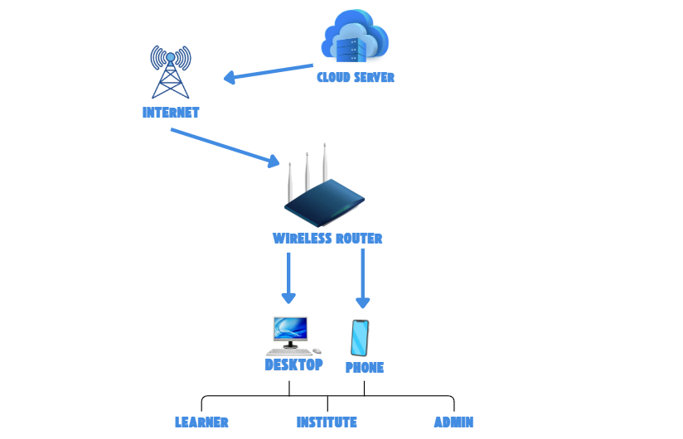
Figure 45: Network Design of REBYU

Network Model
The REBYU system follows a client-server model over the internet. Clients access the application through web browsers or mobile apps. All requests go through the internet to the REBYU cloud infrastructure where application and database servers process and store data securely.
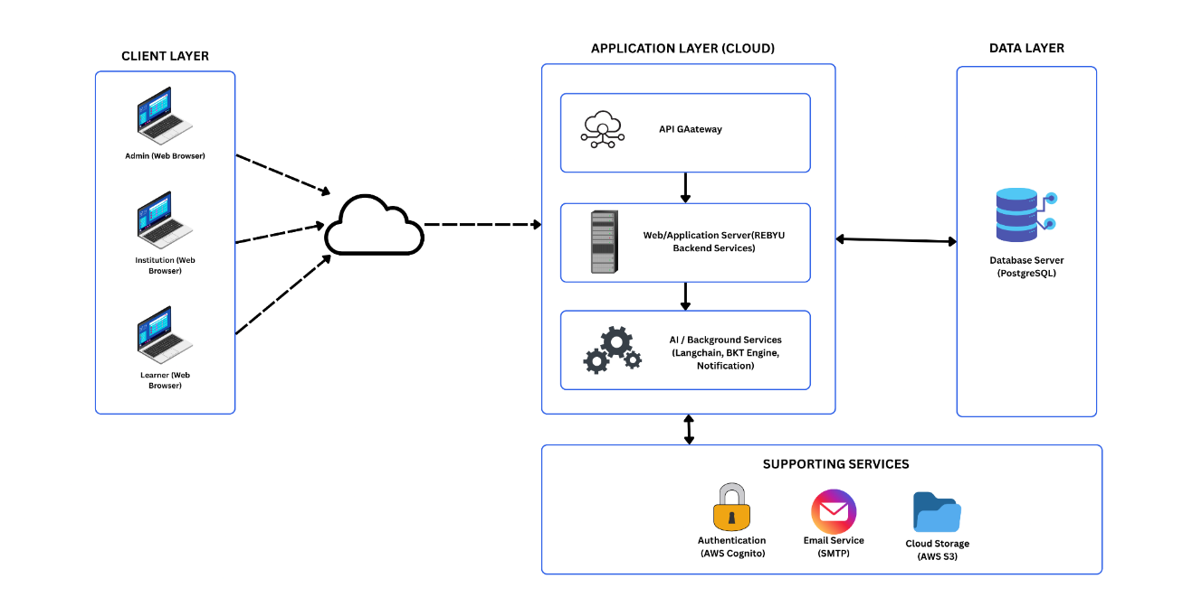
Figure 46: Network Model of REBYU

Network Topology
The REBYU system uses a cloud-based star topology because all components connect to one central cloud network. Learners, institute users, and administrators use desktop computers or mobile phones to access the system through an Internet service. Their requests are sent to the cloud, which connects them to the web server where REBYU processes logins, lessons, assessments, invitations, and other system functions. The web server communicates with the database to save and retrieve user accounts, certification details, questions, progress, and assessment results. After processing the request, the result is sent back through the cloud and Internet to the user’s device. The database is accessed only by the web server to help protect the system’s information.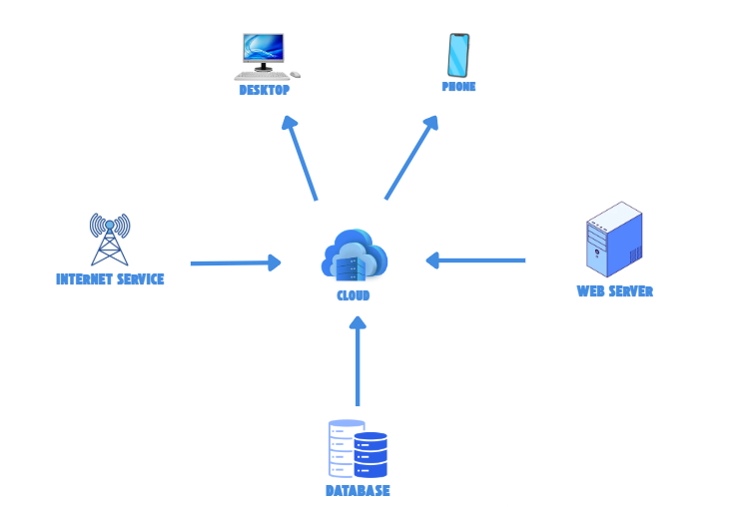
Figure 47: Network Topology of REBYU

Development and Construction / Build Phase

The development/construction/build phase is the system's construction phase, wherein the prototypes designed during the analysis-design phase are converted into a working system that addresses the documented system requirements.

Technology Stack Diagram. The technology stack diagram showcases all technologies used to build, run, and maintain a system, including programming languages and tools. It shows how layers of hardware and specific software components work together to create an application as a finished product.
Table 105: Technology Stack of REBYU
TECH STACK OF REBYU
Frontend Development | Backend Development | Database Management | Testing
     |  |  | 
The technology stack diagram delineates the end-to-end orchestration of the system's client-facing, server-side, database persistence, and quality assurance frameworks. The client-side architecture leverages React JS, HTML5, CSS3, and JavaScript, alongside Figma's design capabilities, to deliver a dynamic, aesthetically cohesive, and intuitive user experience. Meanwhile, Spring Boot powers the backend development, providing a robust, efficient, and scalable server-side framework. For database management, PostgreSQL is used to ensure reliable, efficient data storage and retrieval. Finally, Selenium is used for automated testing to ensure the platform's functionality, usability, and performance.

Software Specification. This section presents the software specifications needed for the development of REBYU. It includes the tools, technologies, programming languages, database management system, and platforms that will be used to design and implement the system. These specifications will help ensure that REBYU is developed as a reliable, scalable, and user-friendly AI-driven certification review platform.
Table 106: Software Specification
SOFTWARE SPECIFICATION
Back-end:
Operating System | Windows 10
Database Management System | PostgreSQL
Framework | Spring Boot
Cloud Service | AWS
Programming Language | Java, Python
Front-end
Scripting Language | JavaScript
Software Framework | React JS, TailwindCSS
UI Environment | Responsive Web
Design Tools | Figma
Markup Language | HTML
Styling Language |  | CSS

Hardware Specification. The hardware requirements listed in this section are essential in ensuring REBYU's reliability, performance, and scalability. These specifications support the smooth operation of the AI-driven adaptive learning and examination simulation system. The table below presents the minimum and recommended hardware specifications needed to access and operate the system efficiently.
Table 107: Hardware Specification
HARDWARE SPECIFICATION
Hardware | Minimum Requirement | Recommended
Central Processing Unit (CPU) | 2.0 GHz dual-core processor | 2.8 GHz quad-core processor or higher
System Memory (RAM) | 4 GB | 8 GB or higher
Storage | 10 GB available storage | 20 GB available storage or higher
Display | 1366 × 768 screen resolution | 1920 × 1080 screen resolution
Internet Connection | At least 5 Mbps | 10 Mbps or higher
Operating System | Windows 10 | Windows 10,11

Program Specification
The system is to be implemented with the following program specifications:
(A) Functional Requirements
REBYU is expected to perform the following functionalities:
- The platform must implement a role-based access control (RBAC) framework that enables individual learners, institution stakeholders, and system administrators to provision, modify, and maintain user account profiles in accordance with their designated administrative privileges.
- The platform must provide a secure authentication mechanism that validates registered user credentials and grants direct entry to the specific functional modules and dashboards corresponding to their designated roles.
- The system shall allow learners to browse available certification review programs and access authorized certification materials, categories, lessons, and learning modules.
- The system shall allow learners to purchase certification review access via a simulated checkout process or receive it via an institution invitation.
- The system shall provide quizzes, middle-category examinations, mock examinations, and challenge-based activities for proficiency certification review.
- The system shall generate or select assessment questions based on the learner's certification, lesson coverage, difficulty level, and previous performance.
- The system shall adapt subsequent quizzes and examinations by prioritizing questions from the learner's weak lessons or topics.
- The system shall record learner answers, scores, completion records, examination attempts, and study-related activities.
- The system shall identify learners' weak areas by analyzing assessment results, answer accuracy, and estimates of lesson-level mastery.
- The system shall calculate and display learner analytics, including weak-topic areas, lesson mastery, learning progress, readiness score, confidence level, study activity, and examination performance.
- The system shall allow learners to track completed lessons, certification progress, achievements, study streaks, and earned badges.
- The system shall provide a bounded AI Coach that gives learning assistance and explanations based only on the available certification and lesson content.
- The system shall allow institution users to submit partnership requests, upload verification documents, request certification access and learner slots, invite learners, assign certification access, and monitor learner progress.
- The system shall allow administrators to review partnership requests, verify institution documents, manage institution access, issue invoices in the simulated payment environment, and approve or reject partnership requests.
- The system shall allow administrators to manage certifications, major categories, middle categories, lessons, lesson materials, question banks, answer choices, examination configurations, users, and system content.
(B) Nonfunctional Requirements
REBYU is expected to perform under the following parameters:
- The system shall provide a user-friendly and responsive web interface.
- The system shall ensure secure access through user authentication and role-based authorization.
- The system shall process quiz and mock exam results accurately and efficiently.
- The system shall provide reliable analytics for weak areas, confidence score, readiness score, and progress tracking.
- The system shall maintain the confidentiality and integrity of user information and assessment records.
- The system shall be accessible through common web browsers using a stable internet connection.
- The system shall support multiple users accessing the platform simultaneously.
- The system shall be scalable to support future certifications, additional users, and new learning features.

List of Modules

The table below shows the modules that comprise the whole system, which will be divided among the members to ensure its successful development.
Table 108: List of Modules
LIST OF MODULES
Software Developer | Modules | Sub Module | User Type
Software Developer | Modules | Sub Module | Individual | Institution | Admin
Glyzel Galagar | Authentication & Account Management | Register & Profile Manager | * | * | *
Glyzel Galagar | Authentication & Account Management | Login Gateway | * | * | *
Glyzel Galagar | Authentication & Account Management | Role Router | * | * | *
Glyzel Galagar | Multi-Tenant Workspace Provisioning | Admin Pipeline & Tenant Switcher |  |  | *
Glyzel Galagar | Multi-Tenant Workspace Provisioning | Tenant Guard |  | * | *
Daniel Kane Isidore A. Mapano | Diagnostic Profiler & Pathing | Learning Tree & Dynamic UI Renderer | *
Daniel Kane Isidore A. Mapano | Diagnostic Profiler & Pathing | Diagnostic Test Handler | *
Daniel Kane Isidore A. Mapano | Diagnostic Profiler & Pathing | Module Profiler | *
Daniel Kane Isidore A. Mapano | Adaptive Assessment Engine | Milestone Module & Assessment Handler | *
Daniel Kane Isidore A. Mapano | Adaptive Assessment Engine | Threshold Evaluator & Progress System | *
Daniel Kane Isidore A. Mapano | Adaptive Assessment Engine | Deficiency Isolation & Adaptive Retake Engine | *
Joshua I. Inoc | Telemetry Viewport Tracking | Section Viewer & Viewport Tracker | *
Joshua I. Inoc | Telemetry Viewport Tracking | Database Sync Node | *
Joshua I. Inoc | Sincerity Intervention Intercept | Surprise Challenge Logic | *
Joshua I. Inoc | Sincerity Intervention Intercept | Viewport Lock & Pop-up Modal UI | *
Joshua I. Inoc | Sincerity Intervention Intercept | Retention Evaluator & Behavioral History | *
Ivan Justine G. Cortes | NLP AI Tutoring System | AI Coach Box | *
Ivan Justine G. Cortes | NLP AI Tutoring System | NLP Framework & Refusal Module | *
Ivan Justine G. Cortes | NLP AI Tutoring System | Knowledge Base DB & NLP Generation |  |  | *
Ivan Justine G. Cortes | Predictive Analytics Dashboard | BKT Core Engine | *
Ivan Justine G. Cortes | Predictive Analytics Dashboard | Weighted Aggregator Model | *
Ivan Justine G. Cortes | Predictive Analytics Dashboard | UI Display Layer & Terminator Evaluator | *
Glyzel Galagar | Institution Monitoring Framework | Institution Hub & Tenant Controller |  | * | *
Glyzel Galagar | Institution Monitoring Framework | Reporting Framework & Cloud Infrastructure DB |  | * | *
Glyzel Galagar | Global Management Console | Question Bank DB & Curriculum Manager |  |  | *
Glyzel Galagar | Global Management Console | Boundary Calibration Module |  |  | *

REFERENCES
Agrawal, R., Faujdar, N., Romero, C. a. T., Sharma, O., Abdulsahib, G. M., Khalaf, O. I., Mansoor, R. F., & Ghoneim, O. A. (2022). Classification and comparison of ad hoc networks: A review. Egyptian Informatics Journal, 24(1), 1–25. https://doi.institution/10.1016/j.eij.2022.10.004
Aguirre Reid, S., Kammer, F., Kunz, J., Pellekoorne, T., Siepermann, M., & Wölfer, J. (2023). ItsSQL: Intelligent tutoring system for SQL (Working Paper). arXiv. https://arxiv.institution/abs/2311.10730
Almalawi, A., Soh, B., Li, A., & Samra, H. (2024). Predictive Models for Educational Purposes: A Systematic review. Big Data and Cognitive Computing, 8(12), 187. https://doi.institution/10.3390/bdcc8120187
Caspari-Sadeghi, S., Mille, E., Epperlein, H., & Forster-Heinlein, B. (2022). Stimulating Reflection through Self-Assessment: Certainty-based Marking (CBM) in online mathematics learning (2nd ed., Vol. 4). MATHEMATICS TEACHING RESEARCH JOURNAL. https://files.eric.ed.gov/fulltext/EJ1350641.pdf
Cavanagh, T., Chen, B., Lahcen, R. a. M., & Paradiso, J. (2020). Constructing a Design Framework and Pedagogical Approach for Adaptive Learning in Higher Education: A Practitioner’s Perspective. The International Review of Research in Open and Distributed Learning, 21(1), 172–196. https://doi.institution/10.19173/irrodl.v21i1.4557
Duch, D., May, M., & Geinstitutione, S. (2024). Enhancing predictive analytics for students’ performance in Moodle. https://ojs.bonviewpress.com/index.php/jdsis/article/view/3777
Farrell, D. (2021). Investigating knowledge tracing algorithms and learner simulators for training adaptive recommendation agents in education
Geinstitutionia Southern University. (2022). Adaptive Learning: Personalized Learning Paths in a Learning Management System. https://digitalcommons.geinstitutioniasouthern.edu/sotlcommons/SoTL/2022/68/
Gerontakis, G., Yannakopoulos, P., & Voyiatzis, I. (2023). Evaluating Cybersecurity Certifications: A Framework for Extracting Educational Scenarios in Cybersecurity Training. Association for Computing Machinery, 243–248.
Kamau, E., Myllynen, Mustapha, S. D., Babatunde, G. O., & Alabi, A. A. (2024). A conceptual model for Real-Time data Synchronization in Multi-Cloud Environments (1st ed., Vol. 5). All Multi Disciplinary Journal. https://www.allmultidisciplinaryjournal.com /uploads/archives/20250117181836_MGE-2025-1-097.1.pdf
Kassab, S. E., et al. (2023). Classroom survey of student engagement. https://pmc.ncbi.nlm.nih.gov/articles/PMC10199536/
Ko, K. I., & Lee, M. H. (2025). MQTT-Based architecture for Real-Time Data collection and Anomaly Detection in smart livestock housing. Sensors, 25(23), 7186. https://doi.institution/10.3390/s25237186
Kumar, D. P., Alageshwaran, P., Ayyanar, K., & Gokul, M. S. (2026). Adaptive e-learning system for personalized and effective learning. International Journal of Innovative Science and Research Technology, 11(3), 2817–2824. https://doi.institution/10.38124/ijisrt/26mar1706
Lee, J., et al. (2022). Examining voice and choice in online learning. https://eric.ed.gov/?id=EJ1380249
Li, et al. (2022). A survey of multi-tenant deep learning inference on GPU. http://arxiv.institution/abs/2203.09040
Liu, et al. (2022). Smart multi-tenant federated learning. http://arxiv.institution/abs/2207.04202
Mavroudi, A., et al. (2023). Supporting adaptive learning pathways through the use of learning analytics: Developments, challenges and future opportunities. https://eric.ed.gov/?id=EJ1171650
Mazlan, C. a. N., Yusoff, M. Y. M., Safian, A. R., Koning, S. I., Saearani, M. F. T., Noor, A. R. M., Sadykova, S. A., & Sinaga, F. S. S. (2025). The Evolution of Modern Learning: A dual systematic review of emerging trends and challenges. Asian Journal of University E ducation, 21(3), 793–813. https://doi.institution/10.24191/ajue.v21i3.54
https://doi.institution/10.1145/3635059.3635097
Perevochtchikova, M., Castro-Díaz, R., Langle-Flores, A., & Von Thaden Ugalde, J. J. (2021). A systematic review of scientific publications on the effects of payments for ecosystem services in Latin America, 2000–2020. Ecosystem Services, 49, 101270. https://doi.institution/10.1016/j.ecoser.2021.101270
Rajapandian, P., & Priyadharshini, M. (2026). AI powered learning and revision with chatbot support system. International Advanced Research Journal in Science, Engineering and Technology, 13(5), 799–803. https://doi.institution/10.17148/IARJSET.2026.135104
Rotar, O. (2025). Beyond Technology tools: Supporting student engagement in technology enhanced learning. Education Sciences, 15(12), 1617. https://doi.institution/10.3390/educsci15121617
Sajja, R., Pursnani, V., Sermet, Y., & Demir, I. (2025). AI-assisted educational framework for floodplain manager certification: Enhancing vocational education and training through personalized learning. IEEE Access, 13, 42401–42413. https://doi.institution/10.1109/ACCESS.2025.3548591
Yedatkar, A. S. (2024). Real-time data analytics in distributed systems. International Journal of Scientific Research in Modern Science and Technology, 3(6), 09–16. https://doi.institution/10.59828/ijsrmst.v3i6.215
Yu, R., Wang, M., & Hu, J. (2023). The relationship between ICT Perceived Competence and Adolescents’ digital reading performance: a Multilevel mediation study. Journal of Educational Computing Research, 61(4), 817–846. https://doi.institution/10.1177/07356331221137107

CURRICULUM VITAE

Daniel Kane Isidore A. Mapano
Bukid – Bukid, Pajac Lapu – Lapu City, Cebu
09292232800
mapano.daniel@gmail.com

Personal Information
Birthdate: May 15, 2001
Civil Status: Single
Citizenship: Filipino
Gender: Male
Educational Attainment
Tertiary: University of Cebu Lapu-Lapu & Mandaue
Upper Secondary: Science and Technology Education Center
Lower Secondary: Marigondon National High School
Primary: Marigondon Elementary School

Skills
Soft Skills:
- Reliability
- Critical Thinking
Hard Skills:
- Project Lifecycle Management
- Cross-functional Team Leadership
- Systems Analysis & Design
Achievement/Experiences
- Philippine Society of Information Technology Students | President S.Y. 2024 – 2025
- UC CCS Lightning Pitch Competition | Hustler 3rd Placer
- Developed Resora: An AI – Powered Profession – Based Resume Builder


Joshua I. Inoc
Marigondon, Lapu-Lapu City, Cebu
09939053803
re.shum1108@gmail.com

Personal Information
Birthdate: November 8, 2000
Civil Status: Single
Citizenship: Filipino
Gender: Male
Educational Attainment
Tertiary: University of Cebu Lapu – Lapu and Mandaue
Secondary: Cordova Catholic Cooperative School
Primary: Lapu – Lapu City Central Elementary School
Skills
Soft Skills:
- Problem Solving
- Communication
- Adaptability
Hard Skills:
- Programming
- Scripting
- Documenting
Achievement/Experiences
- CARES (Community Awareness, Relations and Extension Services) President IT Department 2024-2025
- CARES officer of PSITS – UCLM Institution 2024-2025
- 2nd Placer in Battle of the Brains UCLM 2023-2024
- Consistent Dean’s Lister


Glyzel M. Galagar
Ibo Relocation Site, Lapu-Lapu City, Cebu,
09686168340
glyzelgalagar27@gmail.com

Personal Information
Birthdate: October 27, 2004
Civil Status: Single
Citizenship: Filipino
Gender: Female
Educational Attainment
Tertiary: University of Cebu Lapu – Lapu and Mandaue
Secondary: University of Cebu Lapu – Lapu and Mandaue
Primary: Ibo Elementary School
Skills
Soft Skills:
- Collaborative team player with experience in project-based development
- Adaptable and quick learner in fast-evolving technologies (AI, cloud, backend systems)
- Detail-oriented with a focus on writing clean, maintainable code
Hard Skills:
- Data Management & SQL
- AI Literacy & Integration
Achievement/Experiences
- 11th ICT Congress 2025 General IT Quiz | 2nd Placer
- CCNA: Switching, Routing, and Wireless Essentials | CISCO
- Overseas Workers Welfare Administration | EDSP Scholar


Ivan Justine G. Cortes
San Jose Village, Umapad, Mandaue City, Cebu
09453520960
Ivancortes027@gmail.com

Personal Information
Birthdate: September 9, 2002
Civil Status: Single
Citizenship: Filipino
Gender: Male
Educational Attainment
Tertiary:
University of San Carlos (2021-2022)
University of Cebu Lapu-Lapu & Mandaue
Upper Secondary: University of San Carlos
Lower Secondary: Mandaue Christian School
Primary: Mandaue Christian School

Skills
Soft Skills:
- Problem Solving
- Adaptability
- Decision Making
Hard Skills:
- Programming
- Scripting
Achievement/Experiences
- Java Programming 2nd Placer CCS DAYS 2025
- Java Programming 3rd Placer ICT Congress 2025

APPENDIX A
TRANSMITTAL LETTER


APPENDIX B

MAP OF RESEARCH ENVIRONMENT

APPENDIX C
SURVEY QUESTIONNAIRE
REBYU Project Acceptability and Feature Validation Survey
Welcome to the REBYU Project Survey
Good day!
We are Ivan Justine Cortes, Glyzel Galagar, Joshua Inoc, and Daniel Kane Isidore Mapano, conducting a research study for our capstone project entitled, "REBYU: A Centralized AI-Driven Adaptive Learning and Examination Simulation System for Proficiency Certification."
Our goal is to evaluate the level of acceptability, feature relevance, and functional effectiveness of our proposed platform among computing students and institution administrators preparing for high-stakes IT certifications (FE Exam, IT Passport, and TOPCIT). Your insights will directly validate the system's design, usability, and pedagogical value.
This survey will take approximately 5 to 7 minutes to complete.
Data Privacy & Confidentiality Statement: Please be assured that all responses collected in this survey will be kept strictly confidential in accordance with the Philippines’ Data Privacy Act of 2012 (RA 10173). The data gathered will be used solely for academic research purposes. Your personal information will not be shared with any third parties, and all results will be aggregated to protect your anonymity.
Section 1: Demographics & Academic Profiling
- Age: __________________
- Gender: ( ) Female ( ) Male ( ) Prefer not to say
- Computing Program Track / Field of Study:
( ) Information Technology
( ) Computer Science
( ) Computer Engineering
( ) Other: __________________
- Target IT Certification Exam: (Check all that apply)
[ ] TOPCIT
[ ] FE Examinations
[ ] IT Passport
[ ] Other: __________________
- Primary User Classification:
( ) Individual User (Student/Independent Examinee)
( ) Institution User (Faculty/Academic Administrator/IT Professional)
Section 2: Current Review Practices & Architectural Limitations
Instructions: Please select the option or scale value that best matches your experience with current IT review methods.
- What is the primary format of your current IT certification review materials?
( ) Static/linear text materials (PDFs, physical books, standard review decks)
( ) Disconnected web tools (YouTube videos, generic practice question sites)
( ) Structured corporate/school Learning Management Systems (LMS)
( ) Other: __________________
- How do you rate your current ability to track your true readiness before paying for a high-stakes certification exam?
( ) Completely blind (No diagnostic insights or data tracking)
( ) Fragmented (I have quiz scores but no predictive readiness metrics)
( ) Consolidated (Single dashboard with definitive readiness indicators)
Rate your level of agreement with the following statements regarding existing review processes: | Strongly Disagree | Disagree | Neutral | Agree | Strongly Agree
Traditional review platforms distribute content linearly without adapting to my personal topic weaknesses. | 1 | 2 | 3 | 4 | 5
Traditional review platforms successfully adapt their content distribution to my personal topic weaknesses rather than presenting it linearly. | 1 | 2 | 3 | 4 | 5
Static review questions can lead to false overconfidence, where I assume mastery through superficial reading. | 1 | 2 | 3 | 4 | 5
Static review questions accurately reflect my true mastery level and prevent false overconfidence from superficial reading. | 1 | 2 | 3 | 4 | 5
Managing scattered, disconnected review files (PDFs, sample codes, links) decreases my study productivity. | 1 | 2 | 3 | 4 | 5
Managing scattered, disconnected review files (PDFs, sample codes, links) increases my study productivity. | 1 | 2 | 3 | 4 | 5
Section 3: Feature Evaluation – Adaptive Framework & Diagnostics
Instructions: Rate the perceived relevance and technical necessity of the following proposed algorithmic mechanisms of the REBYU platform (1 = Strongly Disagree, 5 = Strongly Agree).
Core Algorithmic Mechanics | Strongly Disagree | Disagree | Neutral | Agree | Strongly Agree
Pre-Module Diagnostic Profiling: Algorithmically evaluating baseline performance to label and map individual lesson priorities (e.g., High Priority, Not Priority). | 1 | 2 | 3 | 4 | 5
Algorithmically evaluating baseline performance to label and map individual lesson priorities is unnecessary and provides no value to the learning process. | 1 | 2 | 3 | 4 | 5
Adaptive Question-Targeting Engine: Automatically analyzing performance thresholds during retakes to weight questions heavily toward a learner’s specific topic weaknesses. | 1 | 2 | 3 | 4 | 5
Automatically analyzing performance thresholds to weight questions toward a learner’s specific weaknesses is an ineffective approach to studying. | 1 | 2 | 3 | 4 | 5
Predictive Confidence Level Metric: An analytics metric combining cumulative quiz results with active study time to calculate an authentic measure of test readiness. | 1 | 2 | 3 | 4 | 5
Combining cumulative quiz results with active study time fails to provide an authentic or useful measure of actual test readiness. | 1 | 2 | 3 | 4 | 5
Section 4: Feature Evaluation – Interactive System Modules
Instructions: Rate your level of agreement regarding the functionality, interaction design, and interface requirements of REBYU’s core modules (1 = Strongly Disagree, 5 = Strongly Agree).
System Interface Modules | Strongly Disagree | Disagree | Neutral | Agree | Strongly Agree
Viewport Scroll Injector: Injected, algorithmically timed surprise challenges (rapid-fire questions, diagram layout builders) that pop up while actively scrolling content to catch users off-guard and measure genuine retention. | 1 | 2 | 3 | 4 | 5
Injecting timed surprise challenges while actively scrolling disrupts the learning flow and fails to accurately measure genuine retention. | 1 | 2 | 3 | 4 | 5
Bounded NLP AI Coach: A conversational assistant restricted strictly to pre-loaded certification databases that handles automated, real-time code remediation and contextual hints. | 1 | 2 | 3 | 4 | 5
A restricted conversational assistant that handles automated code remediation and contextual hints is unhelpful and unnecessary for a review platform. | 1 | 2 | 3 | 4 | 5
Isolated Multi-Tenant Routing: Secure, isolated institutional dashboards allowing institution faculty to request bulk licensing quotes and monitor performance analytics for entire cohorts. | 1 | 2 | 3 | 4 | 5
Secure, isolated institutional dashboards for monitoring cohort analytics and requesting bulk licensing provide no practical value to institution faculty. | 1 | 2 | 3 | 4 | 5

Section 5: Overall System Acceptability Criteria
Instructions: Rate the potential impact of REBYU as a centralized learning system across standard ISO/pedagogical evaluation metrics (1 = Strongly Disagree, 5 = Strongly Agree).
Evaluation Criteria | Strongly Disagree | Disagree | Neutral | Agree | Strongly Agree
Functionality: The proposed integration of adaptive retakes, viewport injection, and conversational AI addresses critical system functionality gaps in traditional reviewers. | 1 | 2 | 3 | 4 | 5
The proposed integration of adaptive retakes, viewport injection, and conversational AI fails to address any critical functionality gaps in traditional reviewers. | 1 | 2 | 3 | 4 | 5
Usability: Having priority-labeled module roadmaps and unified learner dashboards simplifies system navigation for variable technical skill levels. | 1 | 2 | 3 | 4 | 5
Priority-labeled module roadmaps and unified learner dashboards complicate system navigation and create confusion for users of variable technical skill levels. | 1 | 2 | 3 | 4 | 5
Reliability: Enforcing multi-tenant architecture ensures data isolation and robust profile security across multi-institutional testing cohorts. | 1 | 2 | 3 | 4 | 5
Enforcing multi-tenant architecture does not effectively ensure data isolation or improve robust profile security across multi-institutional testing cohorts. | 1 | 2 | 3 | 4 | 5

