Pass for level14: 4wcYUJFw0k0XLShlDzztnTBHiqxU3b3e

Localhost – is only name and not 127.0.0.1 like we know

Step1:

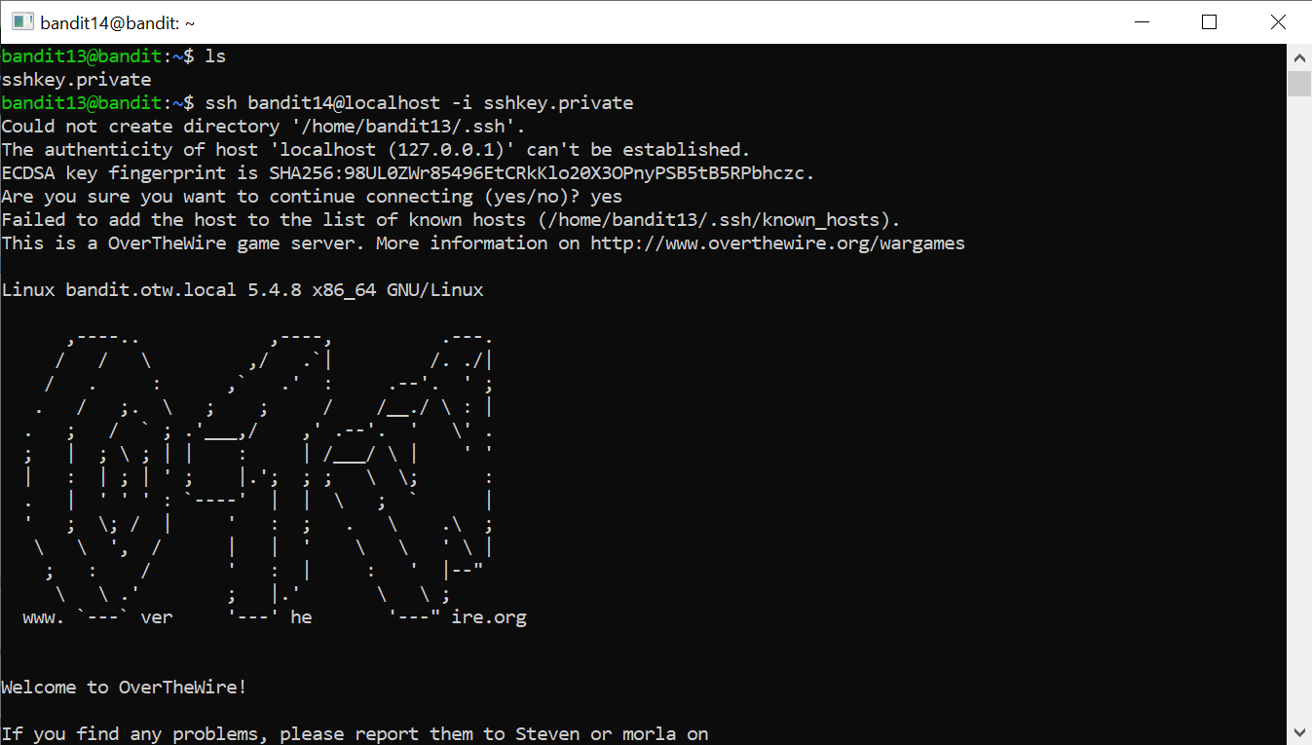

Step2:

