Pass for level 17: xLYVMN9WE5zQ5vHacb0sZEVqbrp7nBTn

Using "nmap -A -T4 -p 31000-32000 localhost"

I scanned the localhost in this range of ports and got the following output:

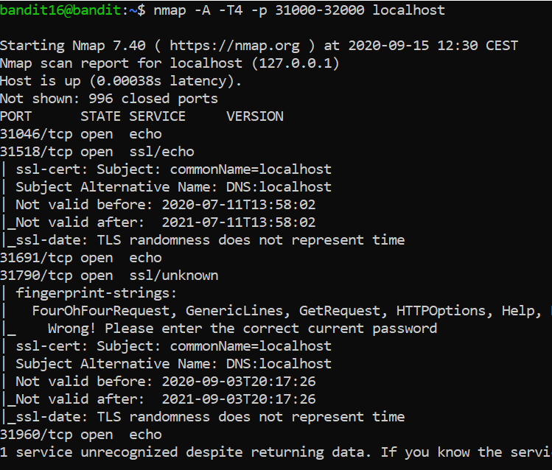

Then I realized that the only port that speak ssh and will not echo me back my pass is port 31790

Hence I run "openssl s_client -connect localhost:31790"

And input the password from level 16 and got:

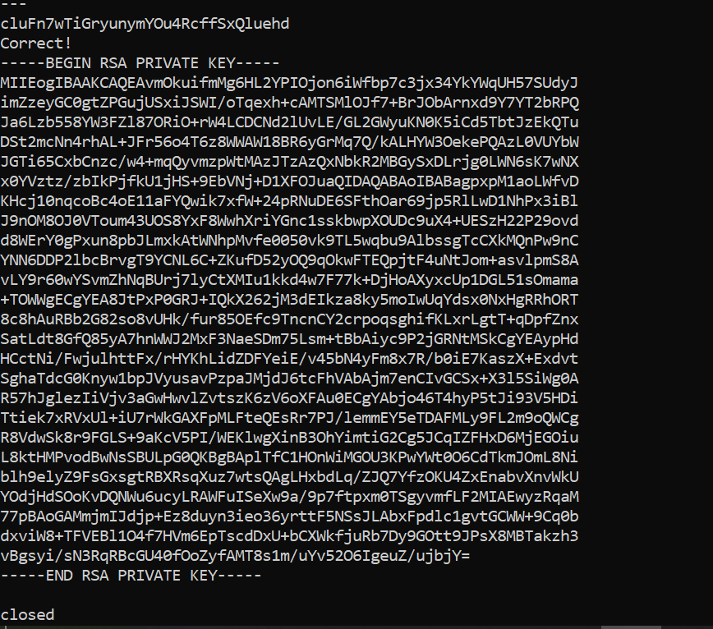

I stored the credentials in /tmp/key/ssh.private

And like I should I edit file permissions using chmod 400 or 600

Then I execute the following ssh: "ssh -i ssh.private bandit17@localhost"

When I logged in I " cat /etc/bandit_pass/bandit**17"**

**And got:** xLYVMN9WE5zQ5vHacb0sZEVqbrp7nBTn