Pass for level 21: gE269g2h3mw3pwgrj0Ha9Uoqen1c9DGr

Client:

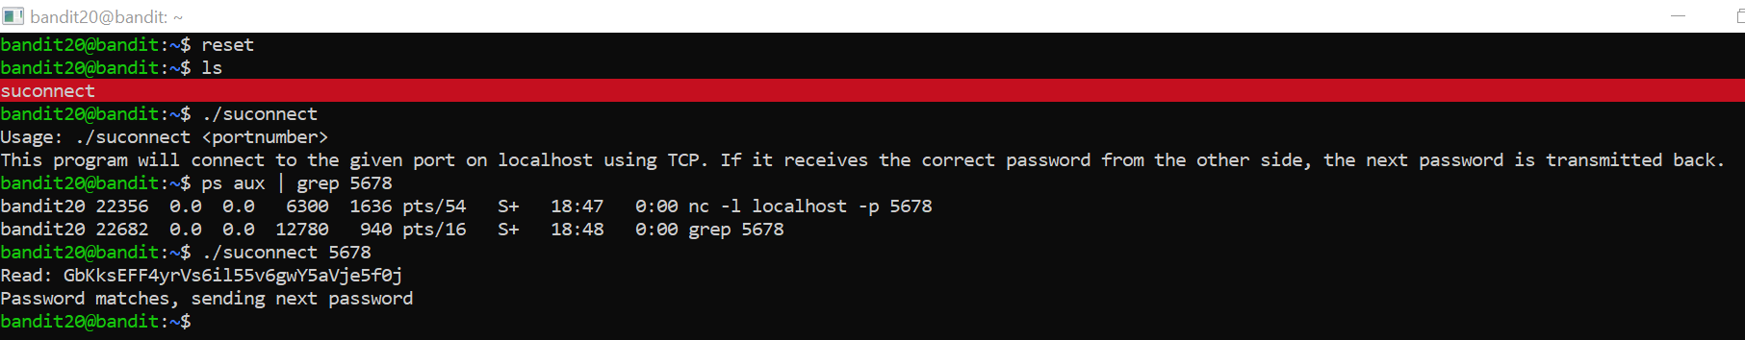

Server:

