Pass for level 24: UoMYTrfrBFHyQXmg6gzctqAwOmw1IohZ

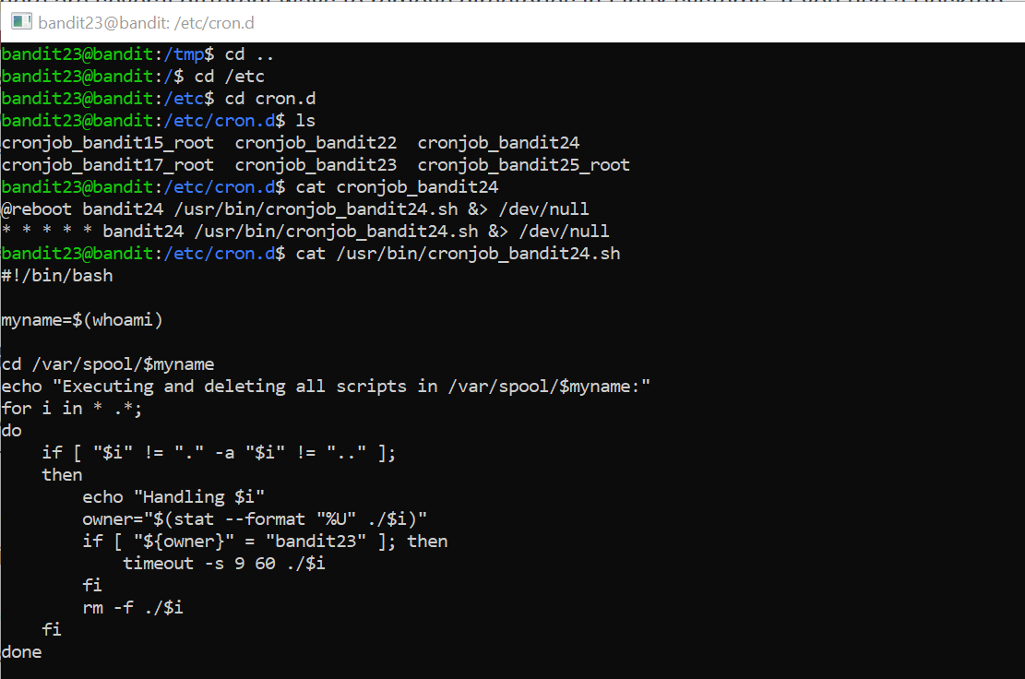

Now we know that every file in /var/spool/bandit23 execute once and then deleted.

So my conclusion is to make shell script that will copy the pass with root permission and store it where I want.

I created shell script called hack.sh with read write and execute permissions and pass file with write and read permissions then I copy the file to /var/spool/bandit24 to execute it as root then the following illustrate the actions:

